Software Architecture and Design Specification
Project: Blood Bank Management System
Version: 1.0
Authors: Gurudath A N, M Sangamesh Prasad, R Sai Pranav Reddy, Abhiram Kolalapudi
Date: 09-10-2026
Status: Project Submission

Revision History
Version |  |  | Date | Author |  | Change Summary
1.0 |  |  | 09-10-2026 | Gurudath AN, M Sangamesh Prasad, R Sai Pranav Reddy, Abhiram Kolalapudi |  | Initial version of the SAD specification for the Blood Bank Management System.

Approvals
2. Approvals
Replace Role | Name | Signature/Date with this table.
Role | Name | Signature / Date
Project Guide/Supervisor | To be filled
Team Member | Gurudath A N
Team Member | M Sangamesh Prasad
Team Member | R Sai Pranav Reddy
Team Member | Abhiram Kolalapudi

1.Introduction
1.1 Purpose
This document describes the software architecture and design of the Blood Bank Management System (BBMS).
1.2 Scope
The system manages user registration, donor profiles, donation records, blood inventory, blood availability searches, hospital blood requests, request approval, blood issue and dispatch, alerts, reporting, and administrative functions.
1.3 Audience
Developers, QA engineers, blood bank staff, authorized hospital requesters, system administrators, and project evaluators.
1.4 Definitions
BBMS: Blood Bank Management System
UI: User Interface
API: Application Programming Interface
RBAC: Role-Based Access Control
HTTPS: Hypertext Transfer Protocol Secure
TLS: Transport Layer Security

2. Document Overview
2.1 How to use this document
This document describes the architecture, major components, design decisions, security mechanisms, interfaces, and workflows of the Blood Bank Management System.
2.2 Related Documents
- Software Requirements Specification (SRS)
- Software Test Plan (STP)
- Requirements Traceability Matrix (RTM)

3. Architecture
3.1 Goals & Constraints
The goals are to provide secure access, accurate blood inventory, reliable request processing, data consistency, and maintainable software. The system must prevent unauthorized access and the issue of expired, unavailable, or incompatible blood units.

3.2 Stakeholders & Concerns
Donors: registration, eligibility, appointments, and donation history.
- Hospital requesters: blood availability and request status.
- Blood bank staff: donation records, inventory, approvals, and issue/dispatch.
- Administrators: user management, monitoring, reports, and audit logs.
- Developers and QA engineers: maintainability, reliability, and verification.

3.3 Component (UML) Diagram

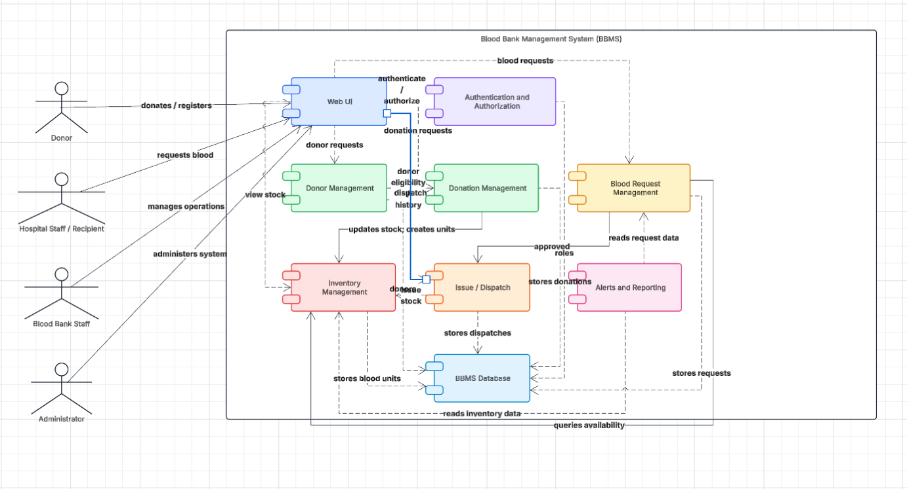

3.4 Component Descriptions
- Web UI: accepts user input and displays results.
- Authentication and Authorization: validates users and enforces roles.
- Donor Management: manages donor profiles and eligibility.
- Donation Management: records donations and creates unit records.
- Inventory Management: tracks available, reserved, issued, and expired units.
- Request Management: records and processes blood requests.
- Issue/Dispatch: validates and records blood unit allocation and issue.
- Alerts and Reporting: provides stock alerts, expiry alerts, reports, and audit information.
- Database: stores users, donors, donations, blood units, requests, and transactions.

3.5 Chosen Architecture Pattern and Rationale
A layered architecture separates the user interface, business logic, and data storage. This supports modularity, testing, and maintenance.

3.6 Technology Stack & Data Stores
Use the actual frontend, backend, database, and supporting technologies implemented by the project team. The SRS identifies Python/Django and/or JavaScript/Node.js and a relational database as possible technologies.

3.7 Risks & Mitigations
Risks include server downtime, unauthorized access, inconsistent inventory, and invalid requests. Mitigations include secure authentication, role-based access, database transactions, validation, backups, and audit logging.
.

3.8 Traceability to Requirements
- BBMS-F-001 and BBMS-F-002: registration and authentication.
- BBMS-F-003: role-based permissions.
- BBMS-F-006 and BBMS-F-007: donation recording and inventory updates.
- BBMS-F-009 to BBMS-F-013: requests, approval, reservation, and issue/dispatch.
- BBMS-F-014 and BBMS-F-015: alerts, reports, audit logs, and administration.

3.9 Security Architecture
Use HTTPS/TLS for communication, secure password hashing, role-based access control, session timeout, input validation, and audit logging. Sensitive information must not be exposed in logs.

4. Design

4.1 Design Overview
The BBMS uses separate modules for user management, donations, inventory, blood requests, issue/dispatch, alerts, and administration. Modules interact through defined interfaces and use persistent database storage.

4.2 UML Sequence Diagrams
At least 2 sequence diagrams covering 2 flows specific to your project
1. UML Sequence Diagram for User Login and Authentication workflow of a Blood Bank Management System.
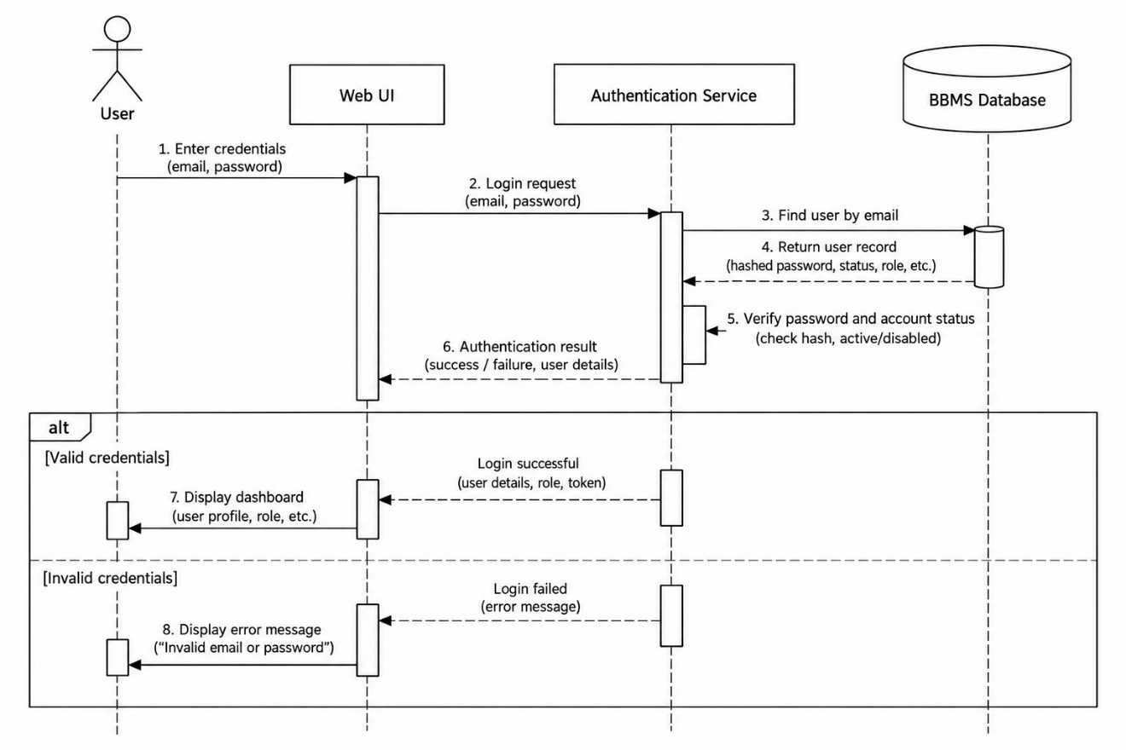

2.UML Sequence Diagram for Blood Request, Approval and Issue/Dispatch in Blood Bank Management System (BBMS).
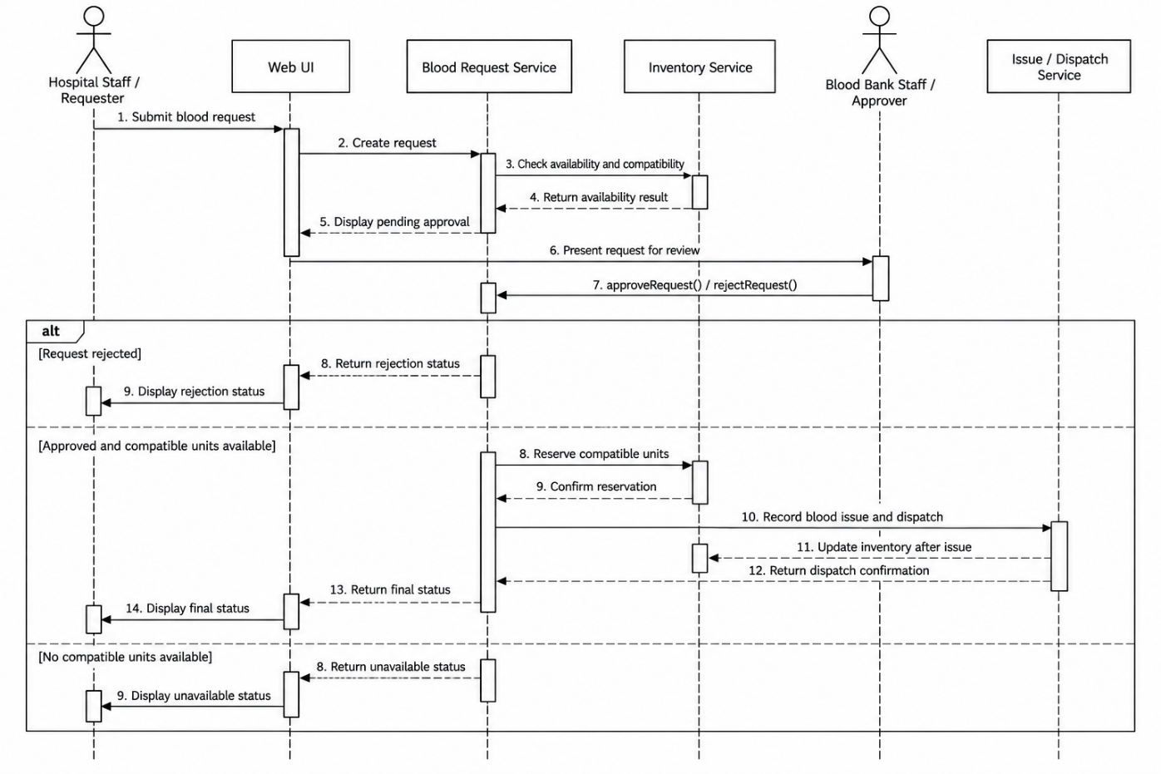

4.3 API Design
Interface definition for at least 2 components.
Example 1:
- Endpoint: /api/login
- Method: POST
- Request: user credentials.
- Response: authentication status and authorized user information.
- Errors: invalid credentials or unauthorized access.
Example 2:
- Endpoint: /api/blood-requests
- Method: POST
- Request: required blood group, component, quantity, and authorized requester details.
- Response: request ID and request status.
- Errors: invalid input, unauthorized access, or unavailable service.

4.4 Error Handling, Logging & Monitoring
Validate user input, return suitable error messages, log important operations, and monitor failed requests and service availability. Never log plaintext passwords.

4.5 UX Design
Provide role-specific navigation, clear forms, readable status messages, blood availability search, request tracking, and responsive layouts.

4.6 Open Issues & Next Steps
Potential improvements include hospital system integration, barcode/QR-based blood unit identification, enhanced notifications, and improved reporting.

5. Appendices
5.1 Glossary
- BBMS: Blood Bank Management System
- SRS: Software Requirements Specification
- STP: Software Test Plan
- RTM: Requirements Traceability Matrix
- API: Application Programming Interface
- RBAC: Role-Based Access Control
- TLS: Transport Layer Security
5.2 References
- Blood Bank Management System SRS, Version 1.0.
- Blood Bank Management System STP, Version 1.0.
- OWASP security guidance.
- UML documentation and diagrams.net documentation.
5.3 Tools
- Microsoft Word: document preparation.
- diagrams.net: UML diagrams.
- GitHub: source code hosting.

