Download and Configure pivotal serve on sts:

1 – Download

https://network.pivotal.io/products/tc-server-3x-core

2 – choose a selected option

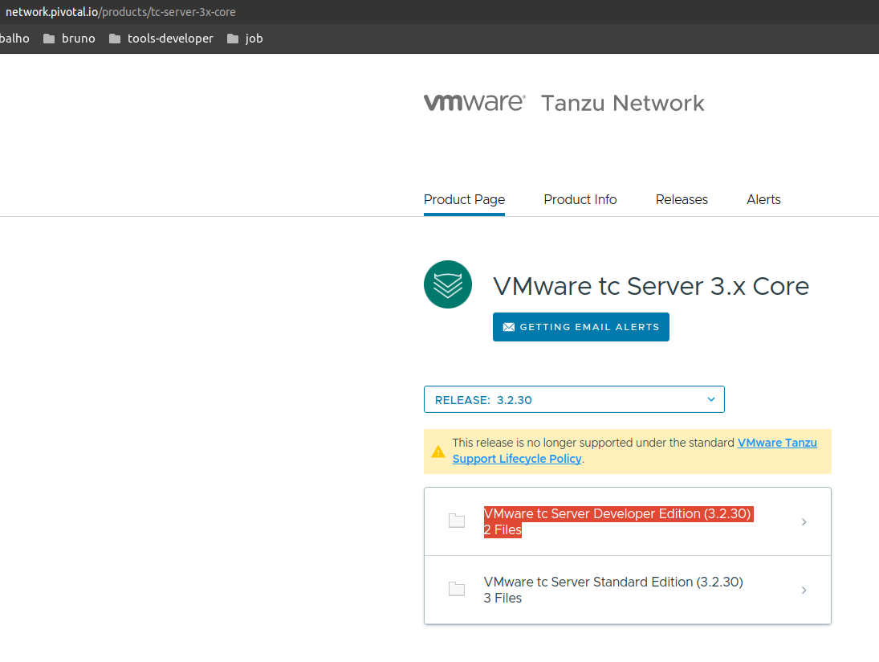You need create a account.

3 – unzip



4 – Add new Server, choose pivotal tc server v3,0-v3,2

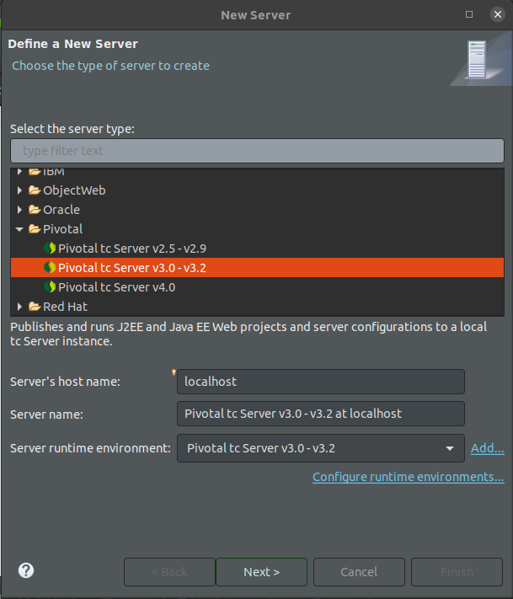

5 – Click in add, it’s a server that you did a download and unzip.

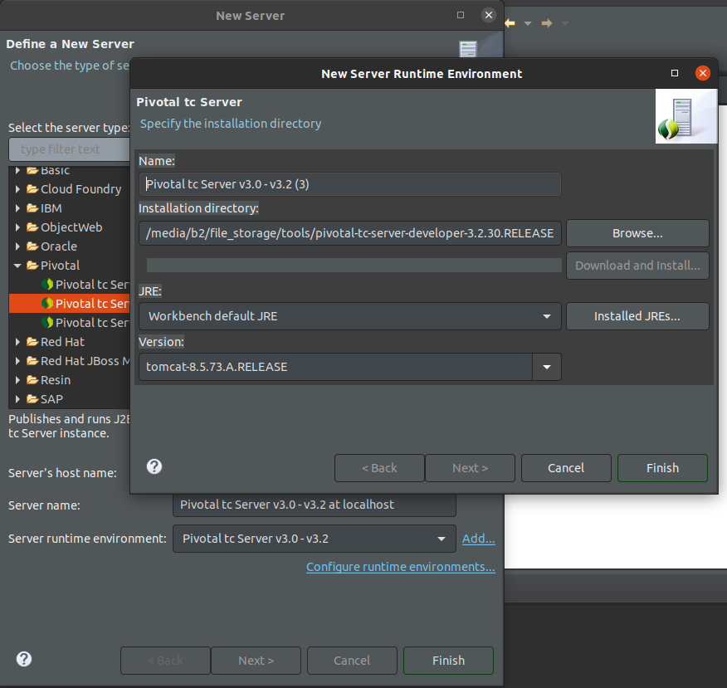

5.1 – Go until your folder where you put a binary pivotal

After finish and go to:

6 - Next, Next, now you need choose base and give a name for server:

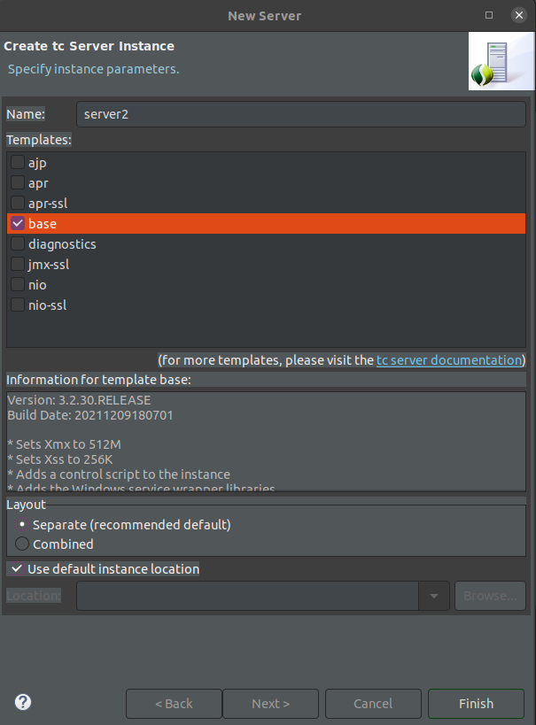

Click on finish to conclued a configuration.

7 – RUN a project in pivotal server

right mouse on the project, go to run as and run server

8- Click in finish.

