March 6, 2006

LFC evaluation as CMS Data Location Service

Draft version (preliminary)

Alessandra Fanfani
Universita’ di Bologna and INFN-Bologna, ITALY

Stefano Belforte
INFN-Trieste, ITALY

Antonio Delgado, Flavia Donno, Andrea Sciaba’
EIS, CERN

Marco Verlato
EGEE-SA1, INFN-Padova, ITALY

Fabio Farina
INFN-Milano Bicocca, ITALY

Abstract
This note describes the evaluation of the LCG Local File catalog LFC as Data Location Service (DLS)
component of the CMS Data Management (DM) project.

Contents
1The DLS prototype based on LFC 2
1.1CMS replica data structure in DLS 2
1.2 DLS server 2
1.3DLS client 3
1.3.1CLI and API 3
1.3.1.1 LFC client installation requirements 3
1.3.2 DLI client 4
1.3.2.1 DLI client installation requirements 4
1.4 Support for attributes 4
2 Testing of performances 5
2.1 Inserting replicas 5
2.2 Getting SE location with LFC Python APIs 6
2.3 Getting SE location with lcg-lr client 6
2.4 Getting SE location with DLI client 7
2.5 Deleting fileblocks with LFC Python APIs 8
2.6 Summary of performance tests 8
2.7 Stress tests 10
3 Open Issues 10
References
Appendix A : CLI and API specification preliminary proposal
CLI specification
API specification

- The DLS prototype based on LFC

The Data Location Service (DLS) is part of the CMS Data Management system and allows discovering where replicas of the data may be located in the distributed computing system, as described in [1].
A first prototype implementing the basic DLS functionalities using LFC [2][3] was developed.

  - CMS replica data structure in DLS
The mapping of CMS index (block-replica) data structure into LFC fields is:
- block identifier, blockID (string) < -- > LFCs’ LFN
- location, SE (string) < -- > LFC’s replica table (SURL or rather host field)
- creation timestamp (high precision time) < -- > there is no correspondence
- last update timestamp (high precision time) < -- > LFC’s replica last access
- “custodial” attribute < -- > f type field of the LFC’s replica (“P” permanent, “V” volatile, etc..)
- other attributes < -- > ?? ( user defined metadata, one field of 255chars, are associated to the LFN and not to the replica)

  - DLS server
The DLS server is a global LFC instance.
- The host is specified with the environment variable $LFC_HOST.
- The path is specified with the environment variable $LFC_HOME.
A global LFC instance can also run a Data Location Interface (DLI).
The DLI is the common catalog interface used by the Workload Management System for match-making. The DLI is a web service interface, as described in [4].
The DLI server implemented for LFC only authenticates via the GSI mechanism with the LFC server through the host certificates. Secure connections with the clients are neither implemented nor planned.

For local DLS instances installation LFC server RPMs are available for MySQL and Oracle backend. In addition, the installation of the LFC server for a MySQL backend is also possible via YAIM.
GSI security as in LCG-2 is required on all LFC servers thus a valid host certificate is needed.

  - DLS client
    - CLI and API
There is a client command-line interface, that wrap python modules based on LFC python API, to perform the basic operations. These python APIs are based on a SWIG interface, that wraps the C APIs provided together with the LFC client software. A valid user proxy for the used VO is required to run the commands since the user access the LFC server in secure mode.
The operations supported are:
- Add a Replica:
dlslfc-add <fileblock1> <SEnameA>
Transactions are used if specified with option -t, otherwise sessions are used. Attributes can optionally be specified (the specific syntax to use is under definition). The –p option that allows to automatically create the LFC dir if the fileblock name has a hierarchical structure, should become the default.
It makes use of the following LFC APIs: lfc_filestatg, lfc_statg, lfc_mkdirg, lfc_creatg, lfc_setfsizeg, lfc_addreplica, lfc_setptime, lfc_starttrans, lfc_aborttrans, lfc_endtrans, lfc_startsess, lfc_endsess.
- Remove a Replica:
dlslfc-delete <fileblock1> <SEnameA>
Several options are provided to drive the deletion behavior, for example to remove all the replicas of a fileblock, to force the deletion of a custodial replica. However the deletion behavior is under definition.
It makes use of the following LFC APIs: lfc_delreplica, lfc_unlink, lfc_getreplica, lfc_getlinks, lfc_startsess, lfc_endsess.
- Get location (SEs) hosting a file-block:
dlslfc-get-se <fileblock1>
Attributes can be optionally listed.
It makes use of the following LFC APIs: lfc_getreplica, lfc_startsess, lfc_endsess.
- Get file-blocks on a SE:
dlslfc-get-datablock <SEname>
It makes use of the following LFC APIs: lfc_list, lfc_listreplicax, lfc_getpath, lfc_chdir, lfc_getreplica, lfc_startsess, lfc_endsess.
- Update attributes:
dlslfc-update <fileblock1> [attr1=val1 ...] <SEname> [attr1=val1 ...]
It makes use of the following LFC APIs: lfc_filestatg, lfc_statg, lfc_setfsizeg, lfc_access, lfc_list, lfc_listreplica, lfc_setptime, lfc_atime, lfc_setratime, lfc_starttrans, lfc_aborttrans, lfc_endtrans, lfc_startsess, lfc_endsess,

The specification of DLS API is under definition (see Appendix A).

      - LFC client installation requirements
In addition to the DLS client tools, the LFC client is needed. The LFC client is installed by default in an LCG UI.
To install the LFC client the following RPMs are required.
- GSI security and VOMS related RPMs:
  - Globus security, i.e. the vdt globus essentials and gpt-VDT RPMs
  - Certification Authority RPMs and the crontab that keeps CA's certificates and CRL's up to date
  - gLite VOMS security: i.e. glite-security-voms-api and glite-security-voms-api-c RPMs
- LFC client related RPMs:
  - the lcg-dm-common RPM
  - the LFC-client RPM
  - the LFC-interfaces RPM, if you are using the Python or Perl interface
All these RPMs are relocatable.

In particular, the DLS clients using LFC have the following API chain:
- C APIs: liblfc.so in LFC-client-x.y.z RPM contains lfc_getreplica, lfc_addreplicla, lfc_delreplica, etc.
- SWIG interface: lfc.so and _lfc.so from LFC-interfaces-x.y.z RPM make available to Perl and Python lfc_getreplica, lfc_addreplica, etc.
- Python APIs: dlslfc_add.py, dlslfc_get_se.py, dlslfc_update.py, dlslfc_get_data_block.py dlslfc_delete.py are written making use of the SWIG interface, and are available in the CMS CVS (project CMSSW DLS/Client/LFCClient)
- Python command line: dlslfc-add, dlslfc-get-se, dlslfc-get-data-block, dlslfc-update and dlslfc-delete are basic wraps of the above Python APIs (e.g. a script calling sys.exit(dlslfc_add.main(sys.argv[1:])), and are available in the CMS CVS.

A LCG-2.6.0 UI has been enabled to operate with LFC version 1.4.1 or 1.4.5 installing under the home area the lcg-dm-common, LFC-client and LFC-interfaces 1.4.1(5)-1 RPMs and setting properly the $PATH e $PYTHONPATH environment variables.

    - DLI client
There is a DLI client (C program available in the CMS CVS) that queries the LFC via the DLI giving an LFN and returning the associated SFNs. This client has the real code the WMS uses, so it has been used to measure how long it takes for the LFC to reply to single queries.
A valid user proxy for the used VO is not required to run the command, since it performs insecure read operation to the DLI server.
The command syntax is:
lfc-dli-client [--verbose] [--help] [--endpoint endpoint] logical_file
where the logical_file is in the form lfn:$LFC_HOME/fileblock.
A wrapper to this DLI client command could be provided in order to have a faster alternative to the dlslfc-get-se command mentioned in section 1.3.1.

      - DLI client installation requirements
To use the DLI client lfc-dli-client the following RPMs are required.
- Globus security, i.e. the vdt globus essentials and gpt-VDT RPMs
- CGSI gSOAP RPM
All these RPMs are relocatable.

  - Support for attributes
- custodial
The “custodial” attribute of a replica can be specified using the f type field of the LFC’s replica (“P” permanent, “V” volatile, etc…)
The f type attribute and the pin time (that could be used to somehow estimate access cost) were intended for DPM rather than LFC use, so one has to decide whether or not to use them for custodial and access cost estimation although they were not intended for that.
Check if the following statement is still true: The replica permanent/volatile attribute is set at creation time now, and cannot be modified afterwards. There is currently no way to update that attribute. The work around is to delete the existing replica and create a new one with the attribute modified. A new method to modify this attribute could be also added, if it is a CMS requirement.
[Not a requirement for the time being]
- timestamps
The replica last update timestamp is described by the LFC’s replica last access.
The replica creation timestamp doesn’t exist. It could be added to the catalog if it is a CMS requirement.
[Not a requirement for the time being]
- additional attributes
The addition of new replica attributes is not foreseen, since LFC is not a metadata catalog. Other solutions can be found for that.

- Testing of performances
The role and the expected requirements for a CMS DLS service are described in [1]. A brief summary is that the DLS should be able to cope with:
- number of entries / year : O(10⁴)- O(10⁵)
- average query rate: O(0.1Hz) realistic scenario , O(10Hz) worst case scenario
- query time: ~ 1 sec per fileblock
- concurrent queries: up to 100 simultaneous queries
- average insert rate : O(0.001Hz) (it could be higher for local DLS instances where managed fileblocks could have a smaller size, thus increasing their number)
It is expected that the most typical and demanding use case be the concurrent query about the location of one or more fileblocks from several client applications, as a result of a massive and chaotic analysis job submission over the grid by CMS physicists spread around the world.

In this section preliminary tests on performances when several clients are concurrently accessing the LFC/DLS server are reported. These tests were performed from a UI over the WAN, where the round trip time was 131 ms.
Currently the LFC server has only 20 threads, thus only 20 clients can be served at the same time.
An increase in the number of threads served by the LFC server is planned. As long as the machine itself can handle the load and the DB does not become a bottleneck, the number of threads is almost arbitrary.

  - Inserting replicas
The dlslfc-add command was tested using the –t option (i.e. using transactions).
The following tables show:
- Table 1: the performance of LFC/DLS for increasing number of concurrent clients when each client thread inserts 100 fileblocks with 1 replica When using 60 and 100 threads some “Connection timed out” errors happened, nevertheless all fileblocks were added properly.
The most interesting numbers concern the Rate (number of fileblocks added / total time) and the Average Time for insertion. The Rate reaches a plateau around 10 Hz above 20 threads, i.e. increasing the number of concurrent clients above 20 slows down the LFC server response time in such a way that it cannot perform more than 10 insertions per second.
- Table 2: the performance of LFC/DLS for 30 client threads, each one inserting 100 fileblocks with 1, 10 and 30 replicas. The loss in performance (lower Rate and higher Average Time) when adding more replicas to a given fileblock in a single command can be considered acceptable for CMS needs.

# errors | # thr | # blocks | Total  Time (s) | Rate  (Hz) | Average  Time (s) | Max  Time | Min  Time | Rate x  Av.Time
 | 1 | 100 | 59,9 | 1,7 | 0,6 | 0,8 | 0,57 | 1,0
 | 2 | 200 | 65,4 | 3,1 | 0,6 | 3,6 | 0,57 | 1,9
 | 4 | 400 | 77,6 | 5,2 | 0,7 | 3,8 | 0,57 | 3,9
 | 8 | 800 | 115,9 | 6,9 | 1,1 | 10,1 | 0,59 | 7,8
 | 10 | 1000 | 140,7 | 7,1 | 1,4 | 4,4 | 0,59 | 9,6
 | 20 | 2000 | 227,0 | 8,8 | 2,1 | 22,4 | 0,58 | 18,9
 | 21 | 2100 | 241,9 | 8,7 | 2,2 | 21,9 | 0,57 | 19,4
 | 30 | 3000 | 299,3 | 10,0 | 2,9 | 22,0 | 0,56 | 28,7
3 | 60 | 6000 | 608,3 | 9,9 | 5,2 | 215,4 | 0,56 | 51,7
37 | 100 | 10000 | 993,8 | 10,1 | 8,7 | 390,6 | 0,58 | 87,9
Table 1: dlslfc-add command performance as a function of concurrent clients (#thr)

# thr | # blocks | # replicas/  block | Total  Time (s) | Rate  (Hz) | Average  Time (s) | Max  Time | Min  Time | Rate x  Av.Time
30 | 3000 | 1 | 299,3 | 10,0 | 2,9 | 22,0 | 0,56 | 28,7
30 | 3000 | 10 | 327,0 | 9,2 | 3,1 | 22,8 | 0,81 | 28,6
30 | 3000 | 30 | 409,6 | 7,3 | 3,9 | 48,4 | 1,12 | 28,8
Table 2: dlslfc-add performance as a function of #replicas/block

  - Getting SE location with LFC Python APIs
The following tables show:
- Table 3: the performance of LFC/DLS for increasing client threads when each client thread gets the location of 100 fileblocks with 1 replica. As in previous Table 1, the Rate reaches a plateau around 10 Hz above 20 threads.
- Table 4: the performance of LFC/DLS for 30 client threads, each one getting the location of 100 fileblocks with 1, 10 and 30 replicas. The loss in performance (lower Rate and higher Average Time) in the case of more replicas per fileblock is found to be negligible.

# thr | # blocks | Total  Time (s) | Rate  (Hz) | Average  Time (s) | Max  Time | Min  Time | Rate x  Av.Time
1 | 100 | 53,4 | 1,9 | 0,5 | 1,1 | 0,49 | 1,0
2 | 200 | 50,2 | 4,0 | 0,5 | 3,5 | 0,43 | 1,9
4 | 400 | 61,1 | 6,5 | 0,6 | 0,9 | 0,44 | 4,0
8 | 800 | 100,0 | 8,0 | 0,9 | 9,7 | 0,43 | 7,6
10 | 1000 | 129,2 | 7,7 | 1,2 | 22,2 | 0,43 | 9,3
20 | 2000 | 209,1 | 9,6 | 2,0 | 13,4 | 0,44 | 19,0
21 | 2100 | 218,1 | 9,6 | 2,0 | 22,5 | 0,43 | 19,6
30 | 3000 | 282,5 | 10,6 | 2,7 | 23,3 | 0,43 | 28,3
60 | 6000 | 529,9 | 11,3 | 4,8 | 191,9 | 0,43 | 54,1
100 | 10000 | 889,1 | 11,2 | 7,8 | 223,2 | 0,43 | 87,8
Table 3: dlslfc-get-se command performance as a function of concurrent clients (#thr)

# thr | # blocks | # replicas/  block | Total  Time (s) | Rate  (Hz) | Average  Time (s) | Max  Time | Min  Time | Rate x  Av.Time
30 | 3000 | 1 | 282,5 | 10,6 | 2,7 | 23,3 | 0,43 | 28,3
30 | 3000 | 10 | 293,3 | 10,2 | 2,8 | 24,8 | 0,44 | 28,2
30 | 3000 | 30 | 315,6 | 9,5 | 2,9 | 23,8 | 0,41 | 27,8
Table 4: dlslfc-get-se command performance as a function of #replicas/block

  - Getting SE location with lcg-lr client
For comparison with the above Python APIs the command lcg-lr from the lcg_util RPM was also tested.
The following tables show:
- Table 5: the performance of LFC/DLS for increasing client threads when each client thread gets the location of 100 fileblocks with 1 replica via the lcg-lr command. When using 60 and 100 threads some “Connection timed out” and “No valid credential found”errors happened. The Rate reaches a plateau around 6 Hz above 20 threads, to be compared with the ~10 Hz using the previous Python API. The difference is due to the lcg-lr command build on lfc_listreplica instead of the more performing lfc_getreplica C API, included in the new 1.4.1 LFC version and adopted by the Python API.
- Table 6: the performance of LFC/DLS for 30 client threads, each one getting the location of 100 fileblocks with 1, 10 and 30 replicas via the lcg-lr command. Again the loss in performance (lower Rate and higher Average Time) in the case of more replicas per fileblock is found to be negligible.

# errors | # thr | # blocks | Total  Time (s) | Rate  (Hz) | Average  Time (s) | Max  Time | Min  Time | Rate x  Av.Time
 | 1 | 100 | 83,9 | 1,2 | 0,84 | 3,9 | 0,71 | 1,0
 | 2 | 200 | 76,0 | 2,6 | 0,76 | 1,0 | 0,71 | 2,0
 | 4 | 400 | 102,7 | 3,9 | 1,00 | 6,1 | 0,71 | 3,9
 | 8 | 800 | 169,9 | 4,7 | 1,62 | 22,4 | 0,71 | 7,6
 | 10 | 1000 | 197,7 | 5,1 | 1,89 | 11,3 | 0,72 | 9,6
 | 20 | 2000 | 341,4 | 5,9 | 3,29 | 24,2 | 0,72 | 19,3
 | 21 | 2100 | 365,3 | 5,7 | 3,44 | 24,2 | 0,71 | 19,8
 | 30 | 3000 | 501,8 | 6,0 | 4,88 | 24,9 | 0,71 | 29,2
10 | 60 | 6000 | 1004,7 | 6,0 | 8,87 | 200,1 | 0,71 | 53,0
104 | 100 | 10000 | 1687,5 | 5,9 | 14,70 | 287,7 | 0,70 | 87,1
Table 5: lcg-lr command performance as a function of concurrent clients (#thr). The first column shows the number of query failures

# thr | # blocks | # replicas/  block | Total  Time (s) | Rate  (Hz) | Average  Time (s) | Max  Time | Min  Time | Rate x  Av.Time
30 | 3000 | 1 | 501,8 | 6,0 | 4,88 | 24,9 | 0,71 | 29,2
30 | 3000 | 10 | 521,0 | 5,8 | 5,06 | 72,7 | 0,91 | 29,1
30 | 3000 | 30 | 539,6 | 5,6 | 5,12 | 51,4 | 1,27 | 28,4
Table 6: lcg-lr command performance as a function of #replicas/block

  - Getting SE location with DLI client
Better performances are expected using the DLI client, as no authentication is required to query the DLI server.
The following tables show:
- Table 7: the performance of LFC/DLS for increasing client threads when each client thread gets the location of 100 fileblocks with 1 replica via the DLI interface. Compared to the Python API case, the performances here are quite higher, as expected by the lack of GSI mechanism in the DLI interface. The Rate reaches a plateau around 100 Hz above 20 threads.
- Table 8: the performance of LFC/DLS for 30 client threads, each one getting the location of 100 fileblocks with 1, 10 and 30 replicas via the DLI client interface. The loss in performance (lower Rate and higher Average Time) in the case of more replicas per fileblock is found to be not negligible, as it was for the Python API case. Nevertheless it is still by far acceptable for CMS needs.

# thr | # blocks | Total  Time (s) | Rate  (Hz) | Average  Time (s) | Max  Time | Min  Time | Rate x  Av.Time
1 | 100 | 16,4 | 6,1 | 0,16 | 0,2 | 0,16 | 1,0
2 | 200 | 16,2 | 12,3 | 0,16 | 0,2 | 0,15 | 2,0
4 | 400 | 17,1 | 23,5 | 0,17 | 0,5 | 0,15 | 4,0
8 | 800 | 17,1 | 46,7 | 0,17 | 0,5 | 0,15 | 7,8
10 | 1000 | 19,6 | 51,0 | 0,17 | 3,2 | 0,15 | 8,7
20 | 2000 | 21,8 | 91,7 | 0,20 | 3,2 | 0,15 | 18,0
21 | 2100 | 20,0 | 104,8 | 0,19 | 0,5 | 0,15 | 20,2
30 | 3000 | 28,8 | 104,2 | 0,25 | 3,2 | 0,15 | 26,5
60 | 6000 | 60,5 | 99,1 | 0,46 | 4,2 | 0,15 | 45,8
100 | 10000 | 109,5 | 91,4 | 0,83 | 9,7 | 0,15 | 75,4
Table 7: DLI client performance as a function of concurrent clients (#thr)

# thr | # blocks | # replicas/  block | Total  Time (s) | Rate  (Hz) | Average  Time (s) | Max  Time | Min  Time | Rate x  Av.Time
30 | 3000 | 1 | 28,8 | 104,2 | 0,25 | 3,2 | 0,15 | 26,5
30 | 3000 | 10 | 43,4 | 69,1 | 0,39 | 3,4 | 0,28 | 27,0
30 | 3000 | 30 | 77,0 | 39,0 | 0,74 | 3,8 | 0,52 | 28,9
Table 8: DLI Client performance as a function of # replicas/block

  - Deleting fileblocks with LFC Python APIs
The following tables show:
- Table 9: the performance of LFC/DLS for increasing client threads when each client thread deletes 100 fileblocks with 1 replica. When using 60 and 100 threads some “Connection timed out” errors happened, nevertheless all fileblocks were deleted properly. The Rate reaches a plateau around 10 Hz above 20 threads.
- Table 10: the performance of LFC/DLS for 30 client threads, each one deleting 100 fileblocks with 1, 10 and 30 replicas. As in Table 2 for the insertion case, the loss in performance (lower Rate and higher Average Time) when there are more replicas per fileblock is not negligible, but can be considered acceptable for CMS needs.

# errors | # thr | # blocks | Total  Time (s) | Rate  (Hz) | Average  Time (s) | Max  Time | Min  Time | Rate x  Av.Time
 | 1 | 100 | 52,6 | 1,9 | 0,5 | 0,8 | 0,48 | 1,0
 | 2 | 200 | 67,3 | 3,0 | 0,7 | 6,6 | 0,49 | 1,9
 | 4 | 400 | 68,8 | 5,8 | 0,7 | 3,7 | 0,49 | 3,9
 | 8 | 800 | 112,0 | 7,1 | 1,1 | 9,7 | 0,48 | 7,6
 | 10 | 1000 | 135,6 | 7,4 | 1,3 | 10,4 | 0,49 | 9,4
 | 20 | 2000 | 229,2 | 8,7 | 2,2 | 22,8 | 0,50 | 18,9
 | 21 | 2100 | 236,3 | 8,9 | 2,2 | 22,9 | 0,48 | 19,9
 | 30 | 3000 | 302,6 | 9,9 | 2,9 | 24,0 | 0,52 | 28,4
6 | 60 | 6000 | 589,9 | 10,2 | 5,0 | 207,9 | 0,49 | 51,3
37 | 100 | 10000 | 945,5 | 10,6 | 8,2 | 263,7 | 0,49 | 87,0
Table 9: dlslfc-delete command performance as a function of concurrent clients (#thr). The first column shows the number of fileblock’s deletion error messages

# thr | # blocks | # replicas/  block | Total  Time (s) | Rate  (Hz) | Average  Time (s) | Max  Time | Min  Time | Rate x  Av.Time
30 | 3000 | 1 | 302,6 | 9,9 | 2,9 | 24,0 | 0,52 | 28,4
30 | 3000 | 10 | 341,5 | 8,8 | 3,2 | 49,2 | 0,71 | 28,4
30 | 3000 | 30 | 441,9 | 6,8 | 4,3 | 48,6 | 1,01 | 29,0
Table 10: dlslfc-delete command performance as a function of #replicas/block

  - Summary of performance tests
The following figures summarize the above tables for the case with 1 replica per fileblock:
- Figure 1: the overall execution rate as a function of increasing client threads when each client thread handle 100 fileblocks with 1 replica per fileblock.
- Figure 2: the average execution time for increasing client threads when each client thread handle 100 fileblocks with 1 replica per fileblock.

As stated in the previous sections, the much better performance of the DLI client, compared with the analogous LFC python client for the “get location” queries, is due to the insecure mode availability of the DLI server for the read-only operations. The gain in performance ranges from a factor 3 to 10 depending on the number of concurrent clients. Nevertheless, the performances obtained in secure mode with the LFC python APIs still satisfies the expected requirements for a CMS DLS service listed above, even in the worst scenario.

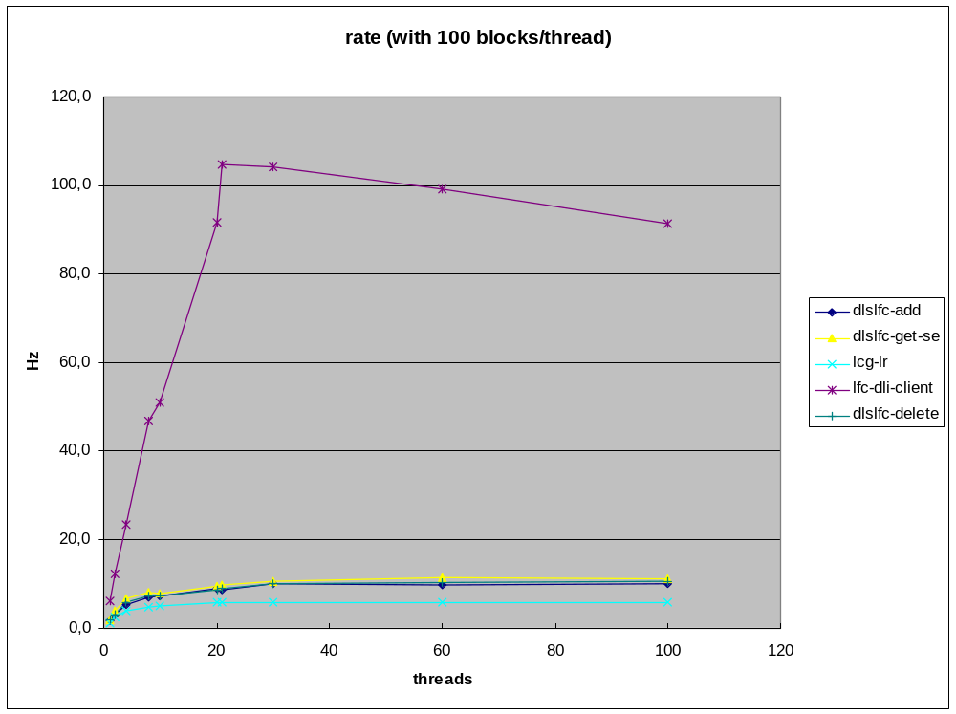
Figure 1: execution rate VS number of concurrent clients
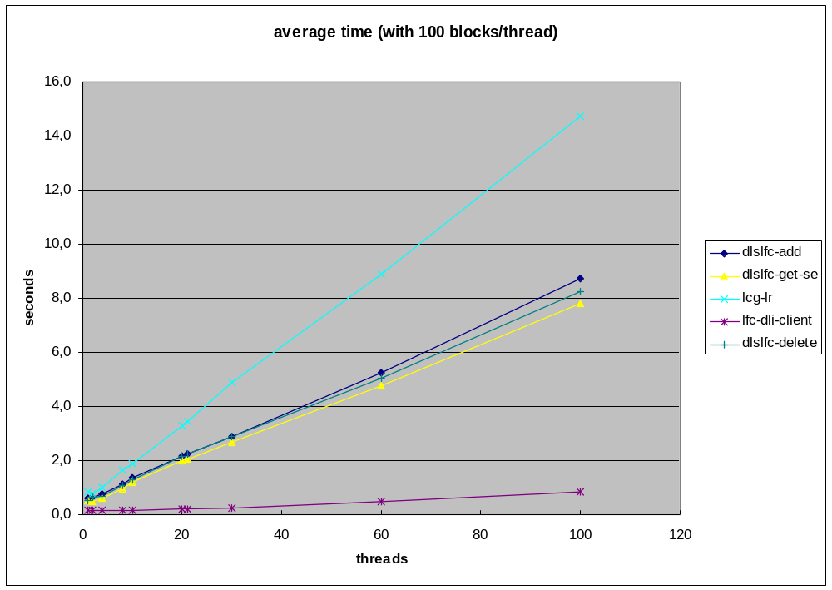
Figure 2: average execution time VS number of concurrent clients

  - Stress tests
A test suite to perform more realistic testing scenarios and massive stress tests is under development.

- Open Issues
- Reliable error handling from the Server is needed. The occurrence of unreliable exit code makes the use of the client tools by automatic agents rather hard.
- Specification of the DLS python API and syntax (Appendix A) and improvements for error handling
- Handling of timeout: Does the LFC server timeout the client commands? Implementation of timeout and retry mechanism to be done on the client side?
- Understand implications and deployment issues for “local” scopes DLS

Appendix A :CLI and API specification preliminary proposal
CLI specification
It might be desirable to avoid using positional arguments; i.e. to distinguish what is a fileblock or a SE, and to which SE (or fileblock) belongs the different attributes specified, based on the order in which they were specified in the command line. For example using options rather than arguments:
dlslfc-add –fileblock <fileblock1> –se <SEnameA>
The most convenient syntax for specifying the attributes has to be defined.
API specification
Current methods have complicated arguments due to the need to specify complex relations like: several replicas for 1 logical filename, having each replica several key=val pairs for its attributes, and also having the lfn a different list of attribute pairs.
One possibility for the API would be to define python objects to group things. For example:
- DlsEntry class:
  - DlsFileblock
  - DlsReplica list
- DlsFileblock class:
  - LFN*
  - GUID
  - DlsAttribute list
- DlsReplica class:
  - Host
  - SFN*
  - DlsAttribute list
- DlsAttribute class:
  - Key
  - Value
The DLS API then could look like:
- dls-add(DlsEntry)
- dls-delete(DlsEntry)
- dls-getse(DlsFileblock)
- dls-getblock(DlsReplica)

*GUID or SFN could be just another attribute in the list, or be explicit (to ensure it’s not null/default)

References

- The CMS Data Location Service note: http://cmsdoc.cern.ch/cms/LCG/DLS/docs/20060227/dm-dls-tech-design.pdf
- LFC documentation : https://twiki.cern.ch/twiki/bin/view/LCG/DataManagementDocumentation
- LFC Administrative Guide https://twiki.cern.ch/twiki/bin/view/LCG/LfcAdminGuide
LCG-2 User guide https://edms.cern.ch/file/454439//LCG-2-UserGuide.html
- DLI WSDL description : http://cmsdoc.cern.ch/cms/grid/docs/DataLocationInterface.wsdl
- CERN/LHCC 2005-023, CMS Computing Technical Design Report
- CMS Note 2004/031, C. Grandi, D. Stickland, L. Taylor, The CMS Computing Model

