LDA Tuning on Democrats dataset

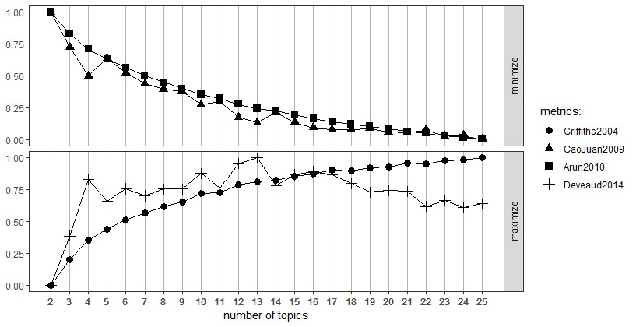

**Figure 14: LDA Tuning on Democrats dataset**

LDA Tuning for the Republicans-Tweets data gave us the K value to be 13 and we have done topic modelling with K=13 and the results of the topic modelling are as follows:

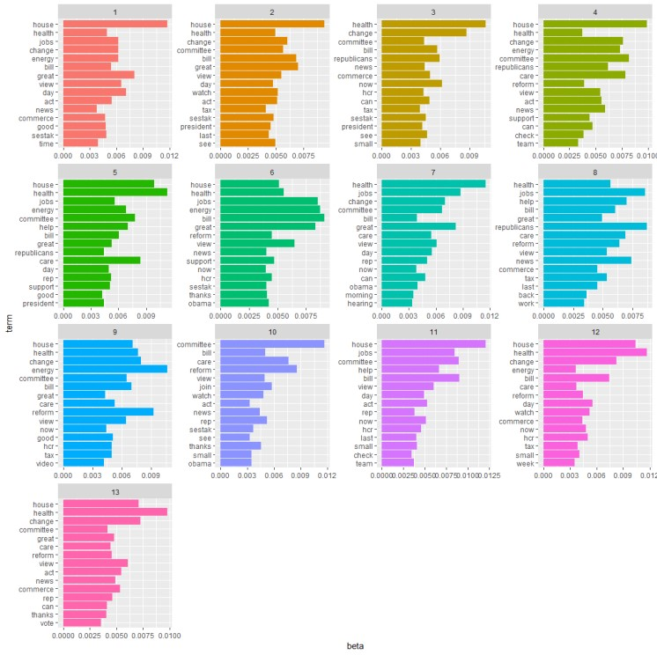

**Figure 15: Topic modelling on Democrats dataset**

● After fetching the topics and running the topic models, we have run the sentiment analysis on the data to fetch the polarization of the tweets of the members of each party towards the given topic. The results of sentiment analysis for each of the three topics can be visualized as follows:

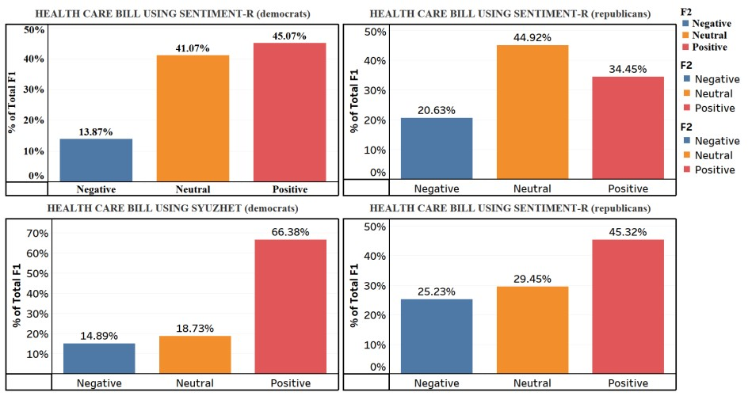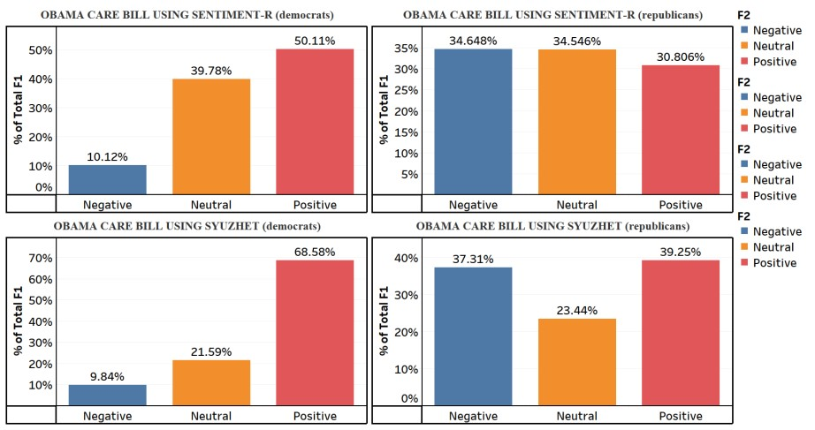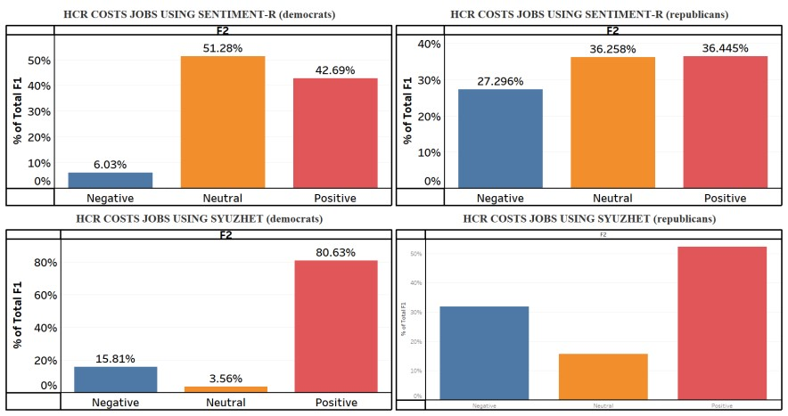

From the above tweets we can observe that the democrats and republicans tend to disagree on the health care bill act and there is a significant amount of polarization that is observed between the two parties for the above analyzed topics.