historical epidemiology of plague
1 December 2025

plague: first pandemic
- Yersinia pestis
- causative agent of the Black Death
- Plague of Justinian (541) - approx. 750 (ancient DNA)

Harbeck et al. (2013)
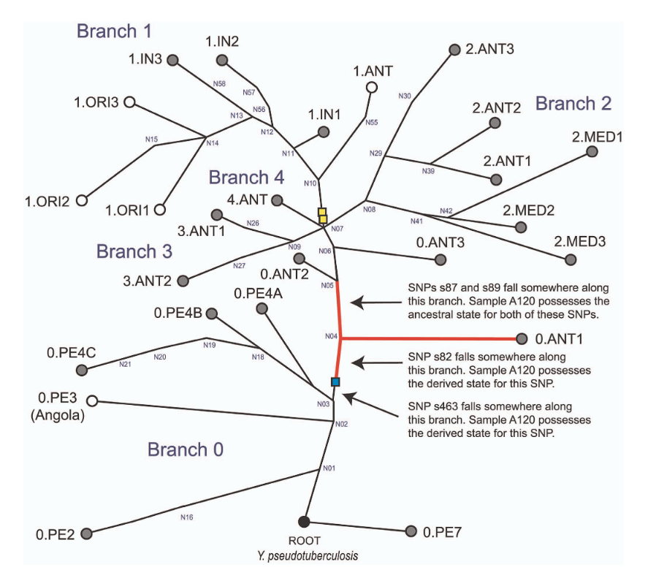

second pandemic
- Black Death! 1347 onward
- human pop 450M → 350-375M by 1400
- continues until late 18th c.
- Shakespeare, Isaac Newton, etc. etc.
- also validated from ancient DNA

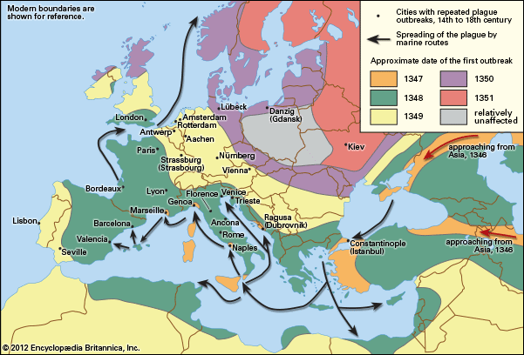
Britannica

acceleration (Earn et al., 2020)
- get historical details on plague from wills, parish records, London Bills of Mortality …



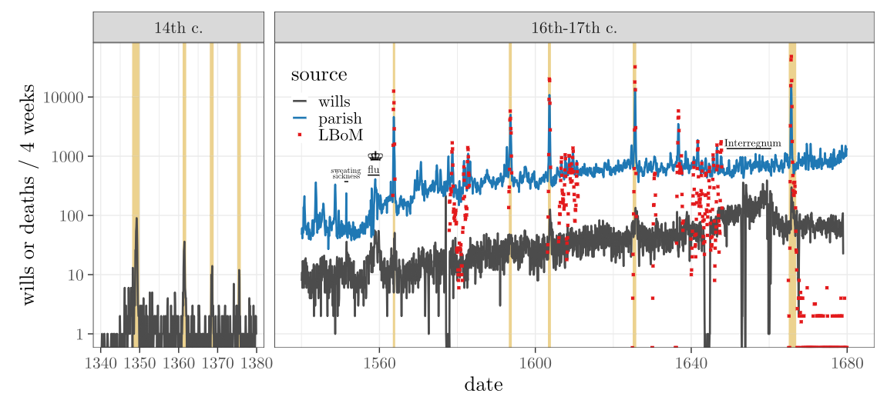

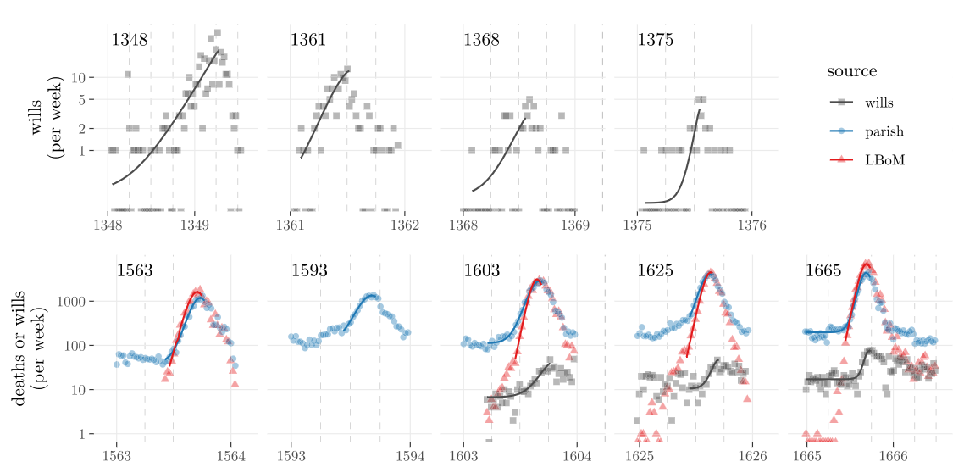

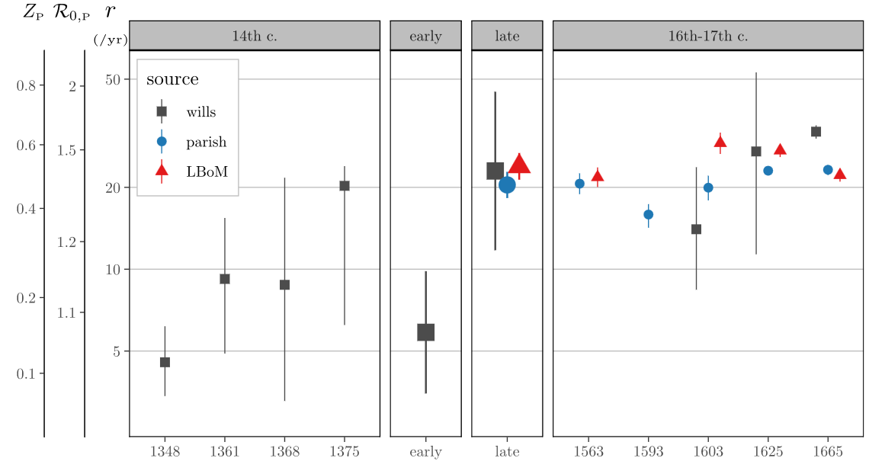

acceleration: conclusions
- wills seem to be an adequate (if noisy) proxy for parish records/plague-specific mortality records (London Bills)
- epidemic speed ($r$) increased from $≈$ 10/year to 20/year (doubling time from $≈$ 4 weeks to $≈$ 2 weeks)

Y. pestis transmission
- Classic story: rat-flea transmission, human spillover
- Possible pneumonic transmission
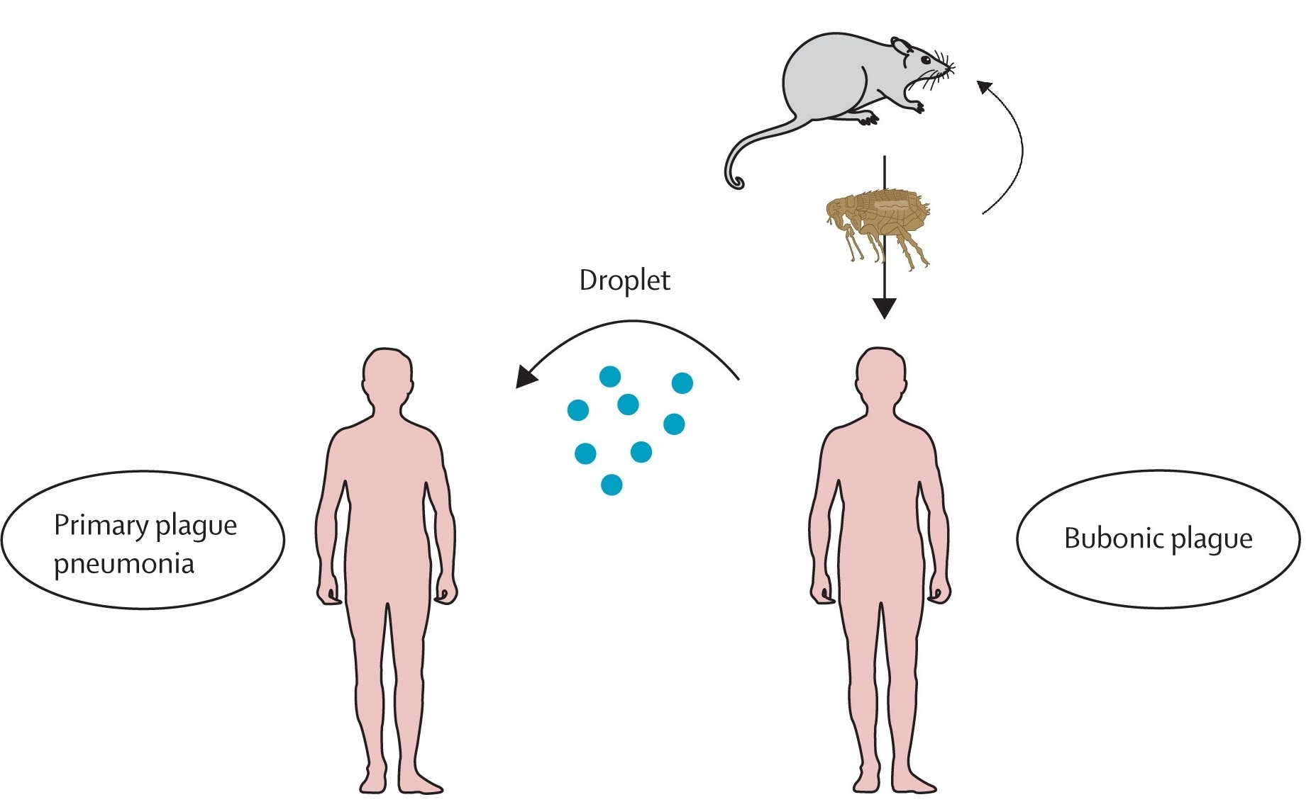

Human-ectoparasite transmission
Human-to-human transmission via ectoparasites (e.g. lice)
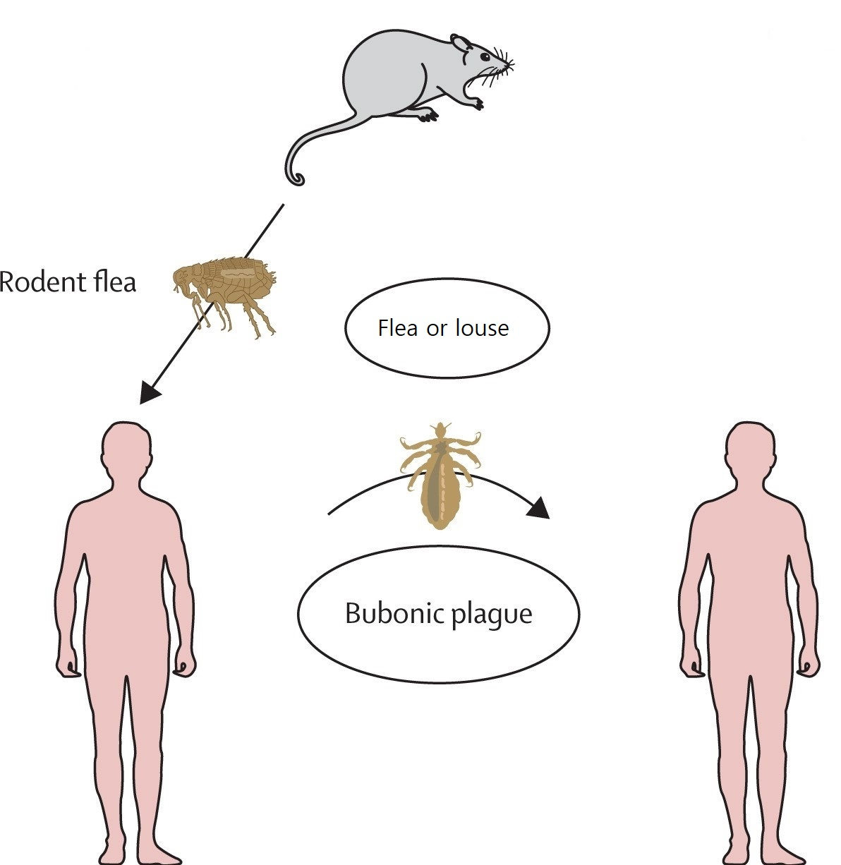

data fits (Dean et al., 2018; Dean, 2019)
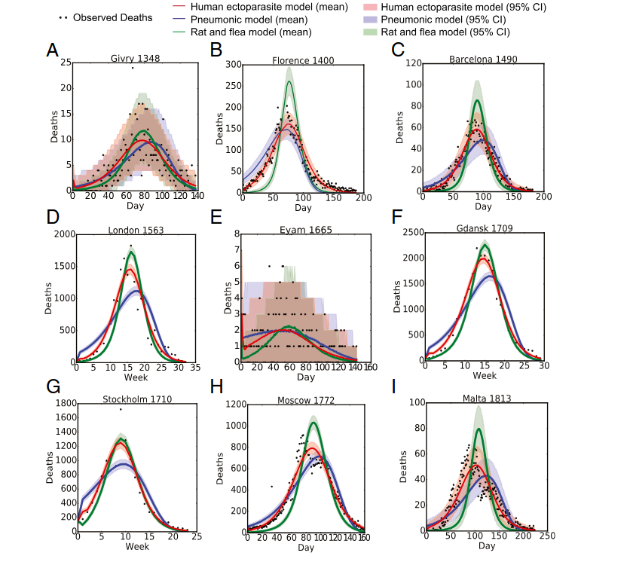

combined model
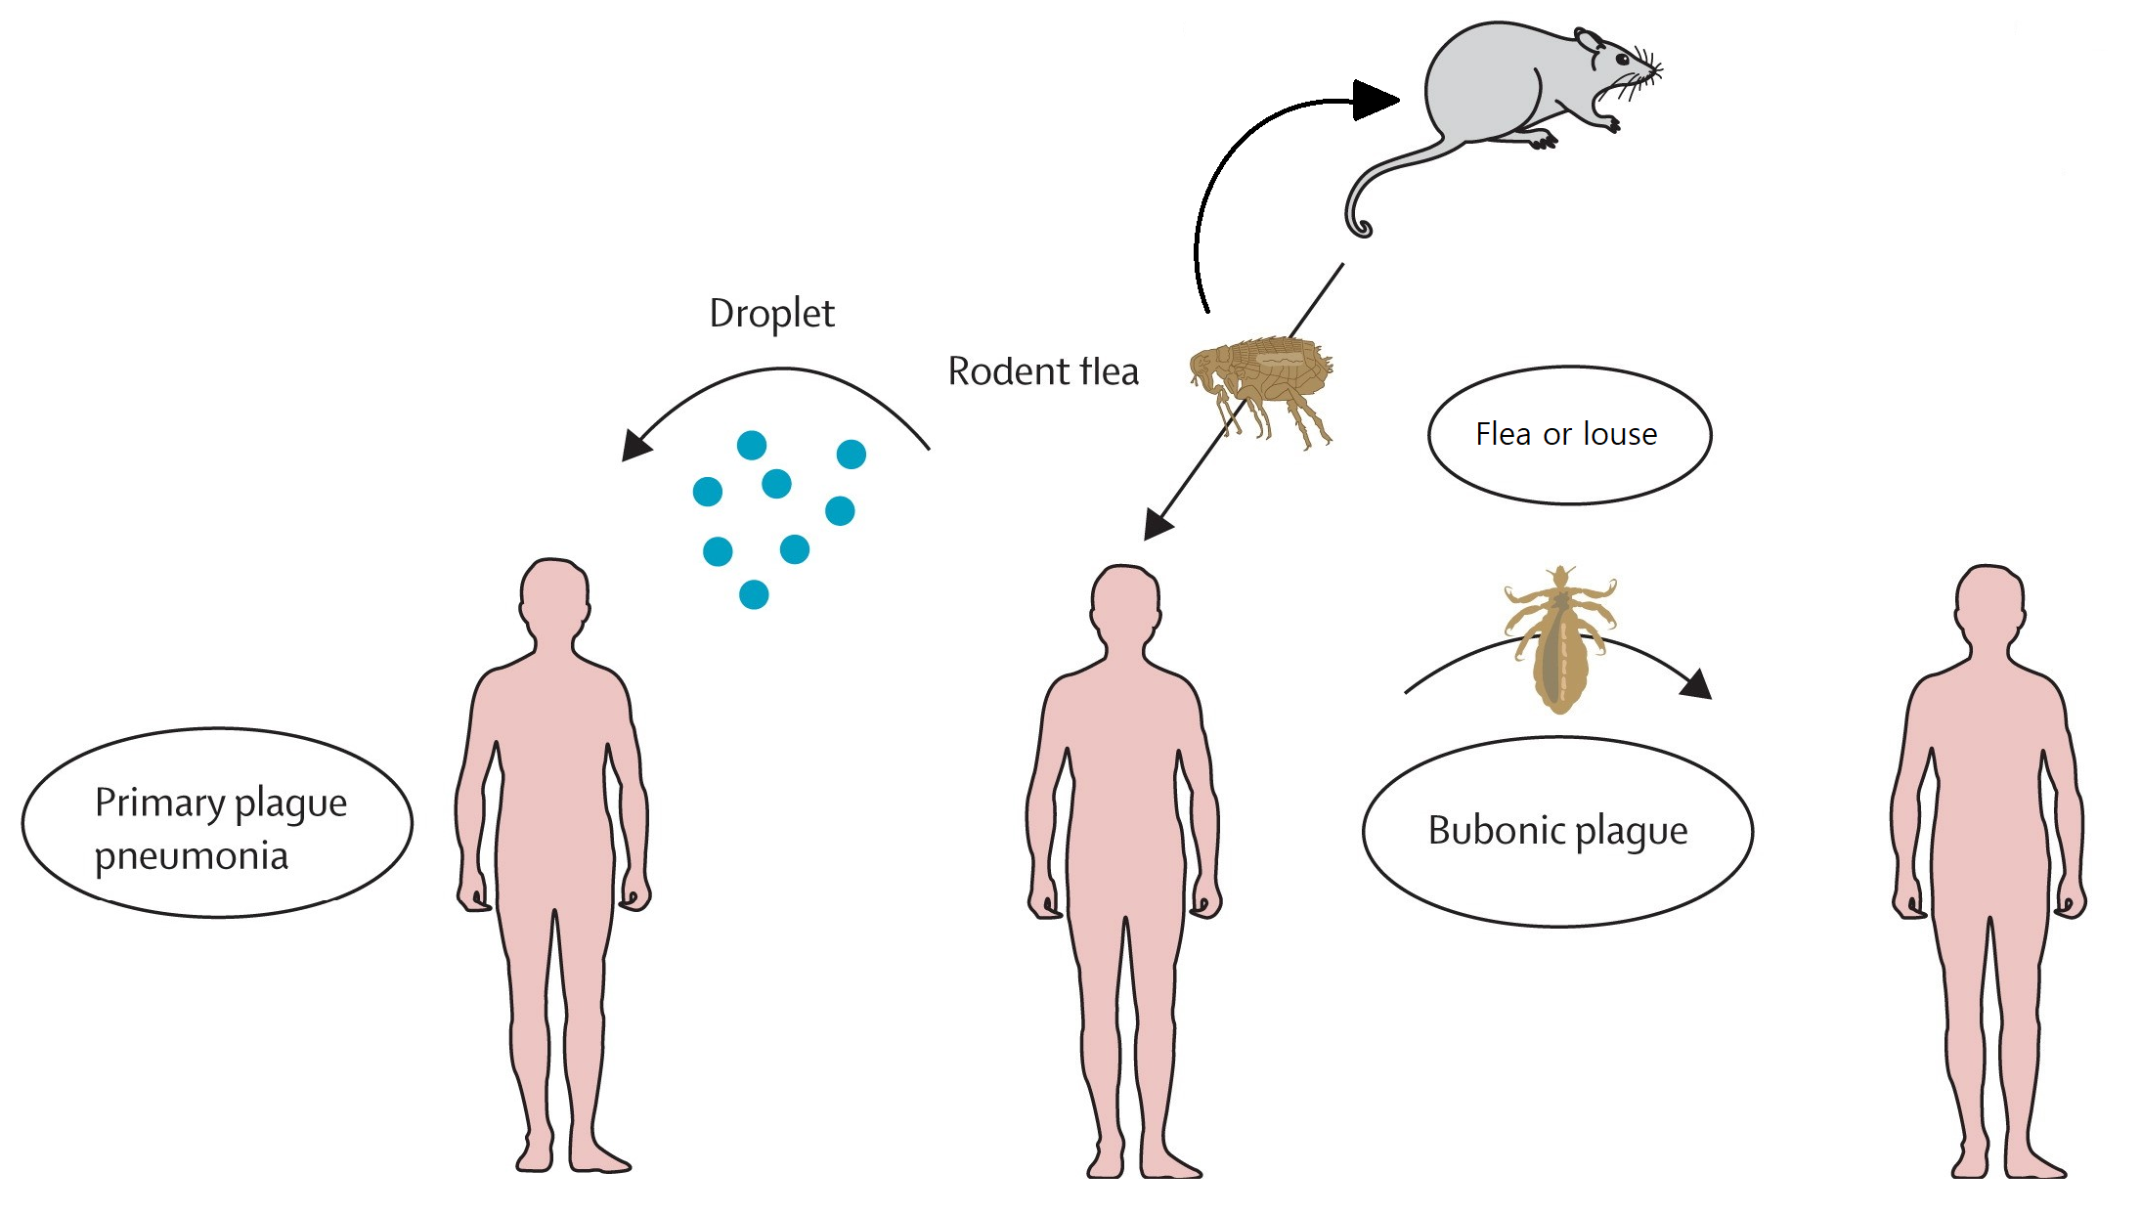

box diagram
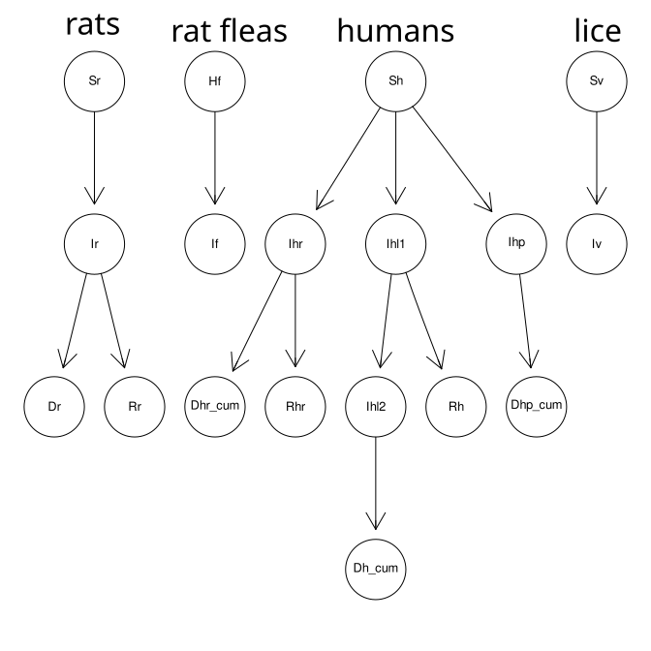

priors
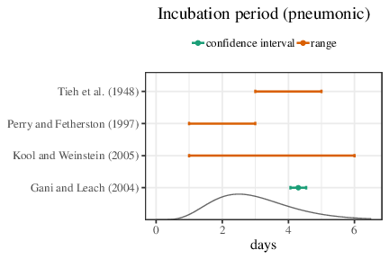

results (example)
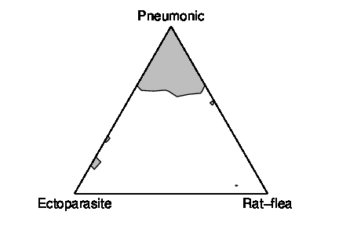

results (all)
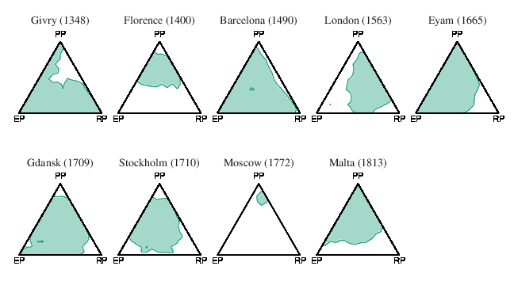

virulence evolution
- Sidhu et al. (2025)
- repeated evolution of PLA (plasminogen activator) depletion across pandemics

PLA results: first pandemic
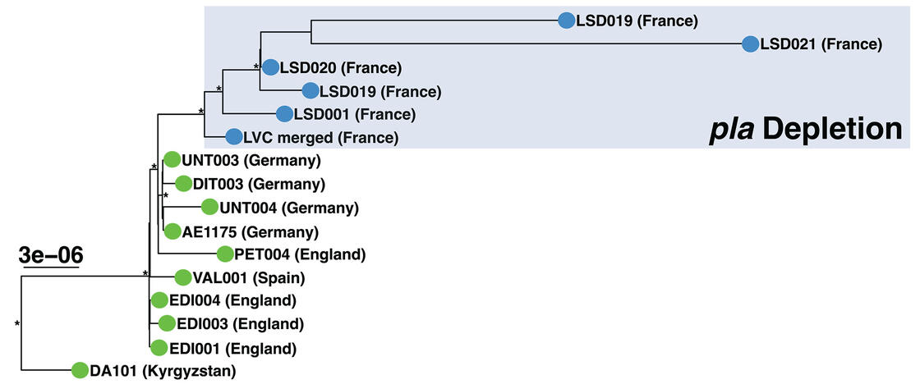

second pandemic
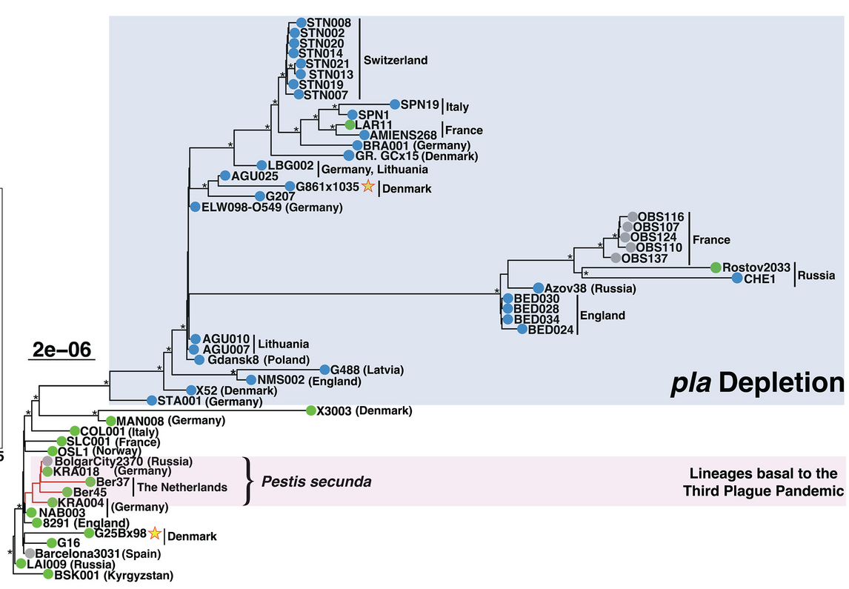

third pandemic
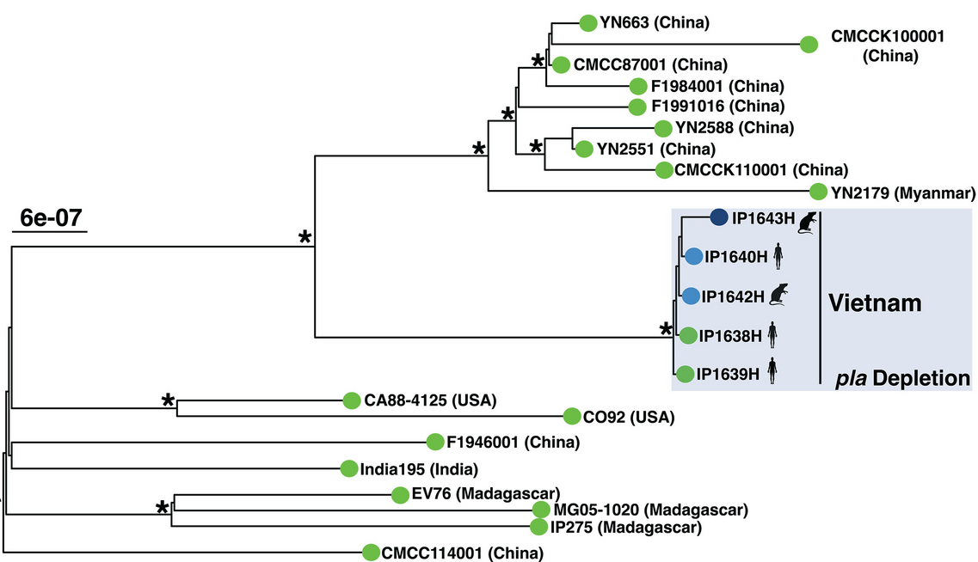

PLA phenotypes
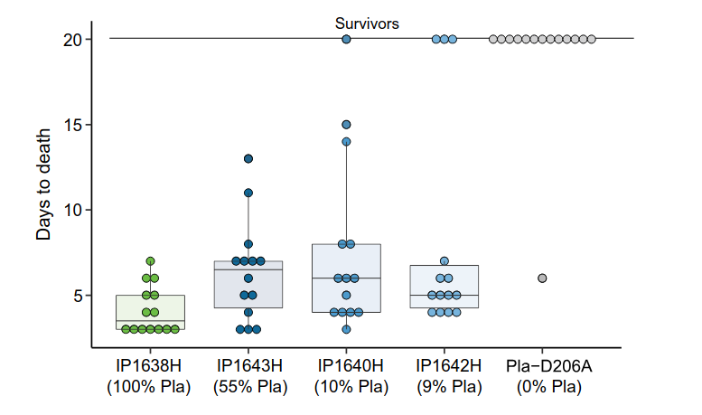

evolutionary mechanisms?
- tradeoff theory doesn’t work
- most transmission is via fleas leaving dying rats
- ‘infectious period’ is a burst at the end of the infection
- how can PLA-depleted strains evolve (repeatedly)?

burnout theory
Parsons et al. (2024)
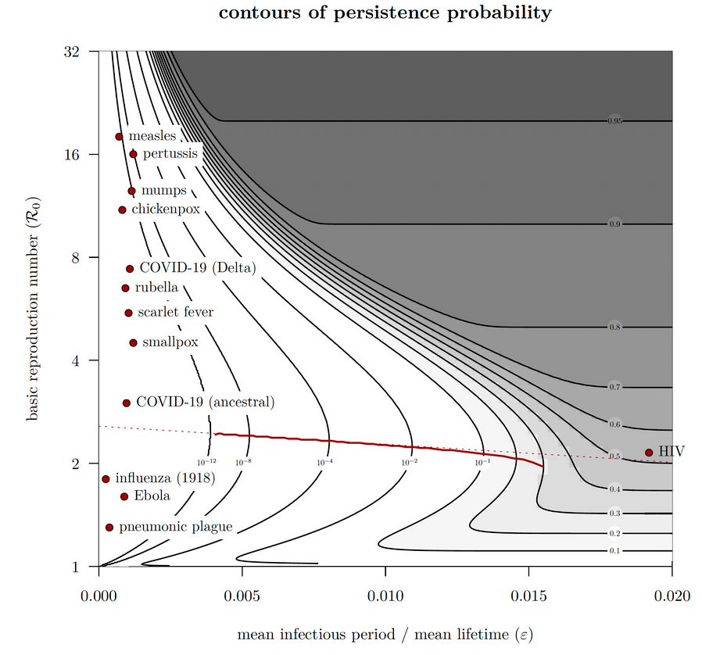

metapopulation model

metapopulation results
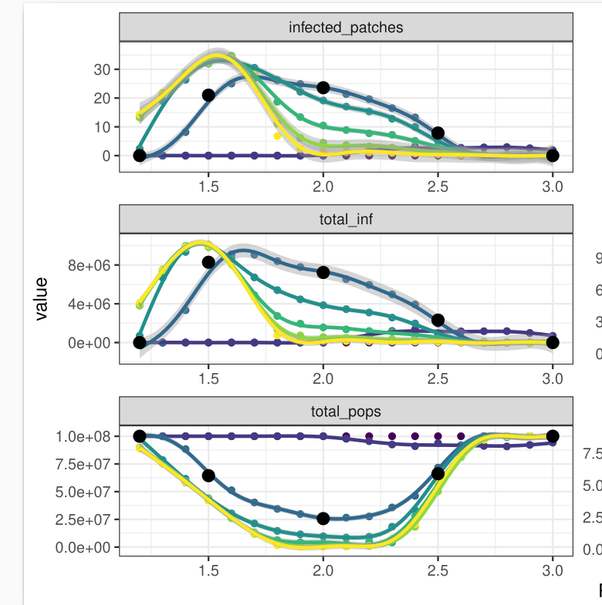

References
Dean, K. R. (2019). The epidemiology of plague in Europe: Inferring transmission dynamics from historical data [Doctoral Thesis].
Dean, K. R., Krauer, F., Walløe, L., Lingjærde, O. C., Bramanti, B., Stenseth, N. C., & Schmid, B. V. (2018). Human ectoparasites and the spread of plague in Europe during the Second Pandemic. Proceedings of the National Academy of Sciences, 201715640. https://doi.org/10.1073/pnas.1715640115
Earn, D. J. D., Ma, J., Poinar, H., Dushoff, J., & Bolker, B. M. (2020). Acceleration of plague outbreaks in the second pandemic. Proceedings of the National Academy of Sciences, 117(44), 27703–27711. https://doi.org/10.1073/pnas.2004904117
Harbeck, M., Seifert, L., Hänsch, S., Wagner, D. M., Birdsell, D., Parise, K. L., Wiechmann, I., Grupe, G., Thomas, A., Keim, P., Zöller, L., Bramanti, B., Riehm, J. M., & Scholz, H. C. (2013). Yersinia pestis DNA from Skeletal Remains from the 6th Century AD Reveals Insights into Justinianic Plague. PLOS Pathogens, 9(5), e1003349. https://doi.org/10.1371/journal.ppat.1003349
Parsons, T. L., Bolker, B. M., Dushoff, J., & Earn, D. J. D. (2024). The probability of epidemic burnout in the stochastic SIR model with vital dynamics. Proceedings of the National Academy of Sciences, 121(5), e2313708120. https://doi.org/10.1073/pnas.2313708120
Sidhu, R. K., Mas Fiol, G., Lê-Bury, P., Demeure, C. E., Bougit, E., Beau, R., Balière, C., Kwasiborski, A., Caro, V., Klunk, J., Salkeld, D. J., Carmichael, A., Varlık, N., Poinar, D., Earn, D. J. D., Bolker, B. M., Dushoff, J., Golding, G. B., Rascovan, N., … Poinar, H. N. (2025). Attenuation of virulence in Yersinia pestis across three plague pandemics. Science, 388(6750), eadt3880. https://doi.org/10.1126/science.adt3880

Last updated: 2025-12-01 10:14:33.494363

