BIO4AE3 extras

Ben Bolker

### coalescent methods

Basic idea: build a phylogenetic (gene) tree based on (ideally) neutral genomic samples. The **shape** of the tree (rate of branching per unit time) tells us whether the population is decreasing, increasing, or stable.

* times with small population size have more branching
* times with large population size have less branching

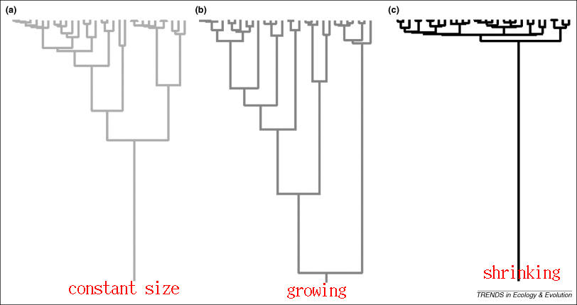

See Elliot and Mooers (n.d.) (intro, a little mathy, but very clear); Kuhner (2009) (intro journal article); Volz et al. (2009) (using coalescents for epidemics); Stadler et al. (2013) (ditto)

Elliot, Mick, and Arne Mooers. n.d. “Introduction to Coalescent Theory.” <https://web.archive.org/web/20170919050032/http://www.sfu.ca/biology/courses/bisc869/869_lectures/MHP_Coalescent.pdf>.

Kuhner, Mary K. 2009. “Coalescent Genealogy Samplers: Windows into Population History.” *Trends in Ecology & Evolution* 24 (2): 86–93. <https://doi.org/10.1016/j.tree.2008.09.007>.

Stadler, Tanja, Denise Kühnert, Sebastian Bonhoeffer, and Alexei J. Drummond. 2013. “Birth–Death Skyline Plot Reveals Temporal Changes of Epidemic Spread in HIV and Hepatitis C Virus (HCV).” *Proceedings of the National Academy of Sciences* 110 (1): 228–33. <https://doi.org/10.1073/pnas.1207965110>.

Volz, Erik M, Sergei L Kosakovsky Pond, Melissa J Ward, Andrew J Leigh Brown, and Simon D W Frost. 2009. “Phylodynamics of Infectious Disease Epidemics.” *Genetics* 183 (4): 1421–30. <https://doi.org/10.1534/genetics.109.106021>.