Definitions

9 January 2023

# What are ecology and evolution?

## ecology

“the study of the processes determining the distribution and abundance of organisms” (Krebs) or of “the interaction among organisms and between organisms and their environment” (Poulin)

In infectious disease (ID) context: **incidence** (number of new infections per unit time) and **prevalence** (number of infected individuals in the population). We may also be interested in the **parasite burden** or **intensity** of infection: how many bugs/host on average?

How do we get this information?

* case reports
* proxies (deaths, hospitalizations, wills)
* **serosurveys**
* counting eggs in feces, or worms in gut contents
* viral titers (e.g. by quantitative PCR)
* population genetic methods (Volz et al. 2009)

## evolution

“changes in genotype frequency in a population between generations” - due primarily to **mutation**, **selection**, **drift**, etc.[1] or more broadly, the change in characteristics of organisms over time due to genetic change.

In ID context, we will be interested in the evolution of pathogens, of hosts, and the **coevolution** of pathogens and their hosts.

How do we find out about evolution?

* experiments (*in vitro*)
* changes in phenotype frequencies (e.g. parasite strains)
* measuring **serotype** frequency
* detection of ancient DNA
* detection by sequencing (e.g. S-gene target failure)
* genome sequencing
* inferring **selective sweeps** from low-variation regions in the genome
* phylogenetic reconstruction (time to **most recent common ancestor**, relationships)
* inference about phenotypes by modelling protein structures

# What is an infectious disease?

* **disease**: departure of an organism from its “normal” functioning (genetic, environmental, …). An **infectious disease** is a disease that can be transmitted (**horizontally**) among organisms. (**Vertical** transmission = parent-to-offspring, usually maternal (e.g. Wayne et al. (2011)))
* **symbiont**: an organism that lives in close association with its host, in contrast with **free-living** organisms ( $≠$“mutualist”)
* **parasite**: an organism that *lives in close association with its* **host** and *harms its host* (reduces **fitness** but doesn’t kill)
* **pathogen**: “a microorganism that causes disease” (Oxford English Dictionary).
* **natural enemy**: any organism that benefits (increase in fitness) from association with its victim (loss of fitness)

|  |  |  |  |  |
| --- | --- | --- | --- | --- |
|  | **kills** | **harms** | **no effect** | **benefits** |
| **close** | parasitoid | parasite | commensal | symbiotic mutualist (‘symbiont’) |
| **not close** | predator | grazer |  | free-living mutualist |

* **Biochemical** parasites: prions (chronic wasting disease, scrapie, bovine spongiform encephalopathy), transposable elements, cancer (including *transmissible* ([Wikipedia](https://en.wikipedia.org/wiki/Clonally_transmissible_cancer)) cancers, e.g. Tasmanian devil facial tumour disease)
* **Biochemically obligate** parasites: phages, viruses
* Other **microparasites**: bacteria, fungi, protozoans
* Classical **macroparasites** (nematodes, schistosomes, trematodes, acanthocephalans, molluscs …)
* **Ectoparasites**/grazers (leeches, fleas)
* **Phytophagous insects** (aphids, *Lepidoptera* etc.)
* **Behavioral** parasites (“scroungers”): brood parasites (intraspecific and cuckoos, cowbirds, etc.) and **kleptoparasites** (skuas)
* **Cheaters** in animal societies (e.g. reproducing worker bees)
* **Cheaters** in mutualisms (ant-plant scroungers)

## Why do we care?

Because close association qualitatively changes the ecological/evolutionary relationship between host and parasite to a chronic, biochemically mediated arms race. We will expect the evolutionary trajectories of parasites, parasitoids, and predators to be extremely different (cf. anthrax and tuberculosis).

## Why are we talking about parasites in general when this course is about infectious disease?

1. parasites have a major impact on **morbidity** (disease) and **mortality**, albeit mostly in less-developed countries (should we care less?)
2. understanding parasitism in general gives broader scope for understanding eco/evo
3. parasites are cool (complex life cycles etc.)

## microparasites and macroparasites

* **microparasite** (**intensity-independent** parasite): typically, a parasitic microorganism (virus/bacterium/protozoan/fungus) but more generally a parasite where we count hosts as uninfected/infected. (Counterexample: viral load)
* **macroparasite** (**intensity-dependent** parasite): typically, a metazoan parasite (cestode/nematode/copepod/insect) but more generally a parasite where we track the intensity of infection per host

**Why do we care?** Because we have to model the interaction differently

# Origins of parasitism

Why be a parasite?

The **biotic** environment of a parasite may seem ideal (the host maintains **homeostasis** and provides resources), but the biotic environment is *actively hostile*, unlike the **abiotic** environment of free-living organisms

* Did symbionts become enemies, or enemies become symbionts?
* How easy is it to switch between (1) **free-living** and **symbiotic** lifestyles or between (2) mutualism and parasitism?
* **Comparative analysis** tries to answer such questions by looking at organismal traits in a **phylogenetic** context.
* **phoresis**: the use of a (**phoretic**) host for transport (or a stable environment) only (e.g. some mites, nematodes)
* Combes describes the progressive intensification of parasitism in 12 species of prosobranch molluscs
* chronic (**obligate**) symbionts are stuck, but **opportunistic** symbionts can easily flip between mutualism/commensalism and parasitism (Moran and Wernegreen 2000)

## parasite/mutualism shifts

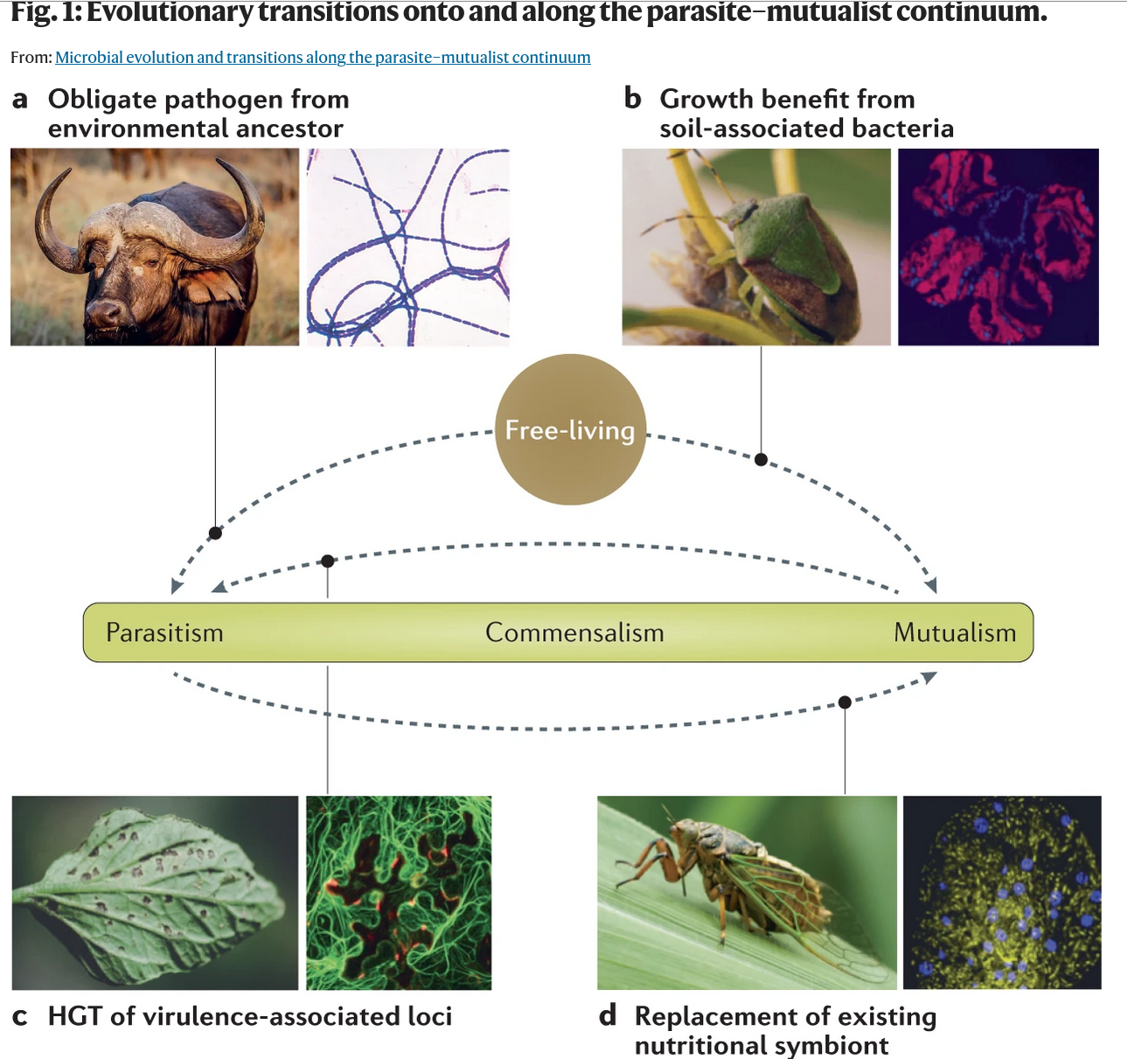

Fig 1, Drew, Stevens, and King (2021)

## References

Drew, Georgia C., Emily J. Stevens, and Kayla C. King. 2021. “Microbial Evolution and Transitions Along the Parasite–Mutualist Continuum.” *Nature Reviews Microbiology* 19 (10): 623–38. <https://doi.org/10.1038/s41579-021-00550-7>.

Moran, Nancy A., and Jennifer J. Wernegreen. 2000. “Lifestyle Evolution in Symbiotic Bacteria: Insights from Genomics.” *Trends in Ecology & Evolution* 15 (8): 321–26. [https://doi.org/{10.1016/S0169-5347(00)01902-9}](https://doi.org/%7B10.1016/S0169-5347(00)01902-9%7D).

Volz, Erik M, Sergei L Kosakovsky Pond, Melissa J Ward, Andrew J Leigh Brown, and Simon D W Frost. 2009. “Phylodynamics of Infectious Disease Epidemics.” *Genetics* 183 (4): 1421–30. <https://doi.org/10.1534/genetics.109.106021>.

Wayne, Marta L., Gabriela M. Blohm, Mollie E. Brooks, Kerry L. Regan, Brennin Y. Brown, Michael Barfield, Robert D. Holt, and Benjamin M. Bolker. 2011. “The Prevalence and Persistence of Sigma Virus, a Biparentally Transmitted Parasite of Drosophila Melanogaster.” *Evolutionary Ecology Research* 13: 323–45.

Last updated: 2023-01-08 12:59:21.000444

1. does anyone remember the other two assumptions of Hardy-Weinberg equilibrium?