emerging infectious disease

3 April 2022

## emerging and re-emerging disease

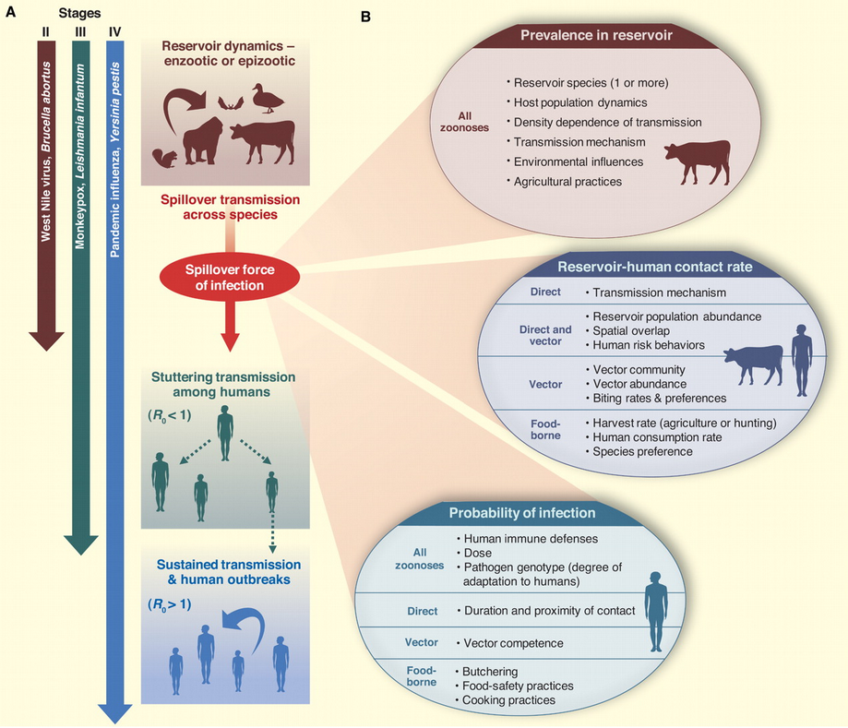

basically, anything we’re worried about

* new mutations
* change in environment
* resistant strains
* species jumps (encounter and compatibility: changes via recombination, mutation)

Do we need to understand *everything*?

* reservoir ecology
* pathogen biology
* human-reservoir interactions

How do we understand? How do we predict?

## *Batrachochytrium dendrobatidis*

**Reminders**

* fungal pathogen
  + most other chytrids are saprophytes, plant pathogens
  + *B. salamandrivorans*: salamander pathogen (more restricted)
* first discoved in poison dart frogs
* caused die-offs in E Australia, Central America, Colorado, California …
* association with high altitude?
* occurred in pristine areas (probably not anthropogenic?)
* pathogenesis via screwed-up osmoregulation

Very confusing …

* some species decline in the absence of Bd
* some species stable in the presence of Bd  
  (Bd may have been there all along?)
* susceptibility:
  + ability to bask
  + antimicrobial peptides

**tipping point hypothesis**: in populations all the time, but something happened to increase virulence/reduce tolerance or resistance

* climate change/El Niño ?
* ultraviolet radiation?
* cooler temperatures? (basking etc.)
* pesticides?
* combination (species × temperature × U/V × pesticide × …)
* Pounds et al. (2006): “chytrid-thermal-optimum hypothesis”
* Rohr et al. (2008): “numerous other variables, including regional banana and beer production, were better predictors of these extinctions”
* Rohr & Raffel (2010)

**novel pathogen hypothesis**: mutation/speciation + dispersal

* “Out of Africa” hypothesis
* earlier/broader detection in historical specimens: CA/bullfrog, Brazil …
* genomics (challenging!)
* Asian sampling

## monkeypox

## climate change

* warming
  + ‘good’ or ‘bad’ for pathogens?
  + vector biology
    - extended range
    - higher activity?
* changes in seasonality, hydrological cycles
* local landscape change
  + hydrology
  + land cover (Lyme disease)
  + forest cover
* changes in reservoir communities

## dilution effect (Keesing & Ostfeld, 2021)

* does increased biodiversity decrease disease?
* variation in reservoir competence
* high-quality hosts decrease with increasing biodiversity
  + encounter reduction; host regulation; vector preferences

Kain & Bolker (2019)

Rohr et al. (2020)

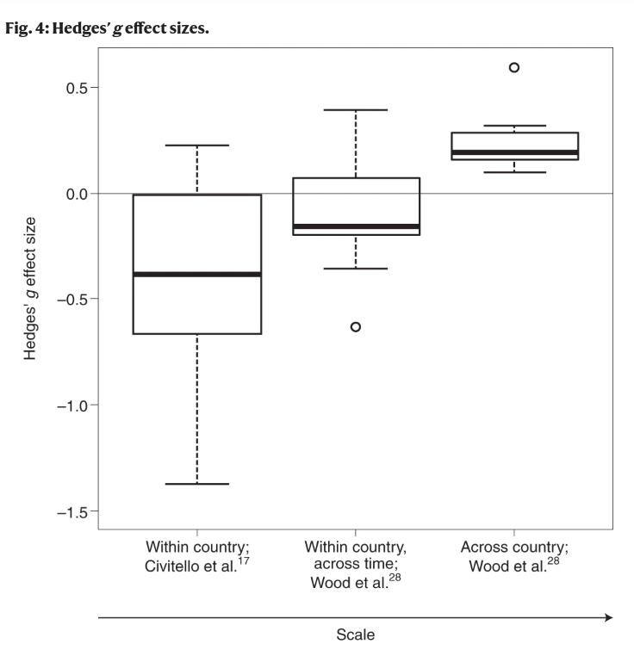

## prediction

Pulliam & Dushoff (2009)

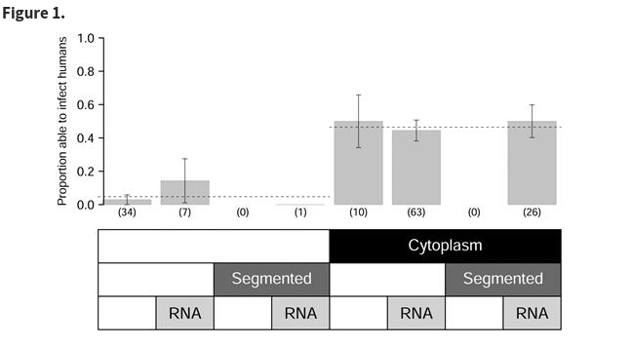

Walker et al. (2018)

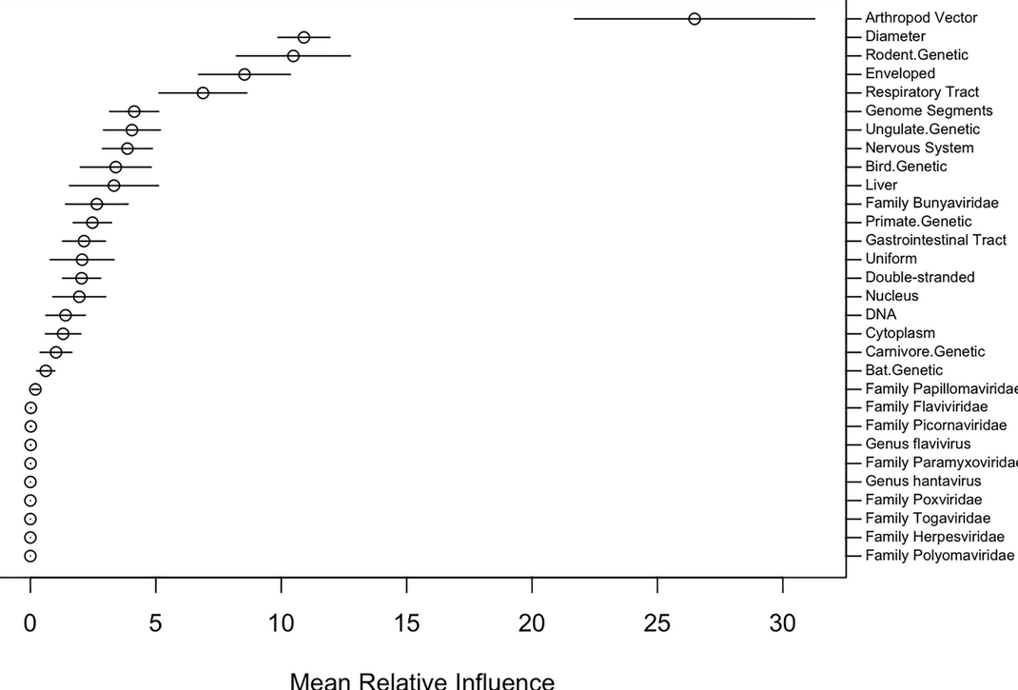

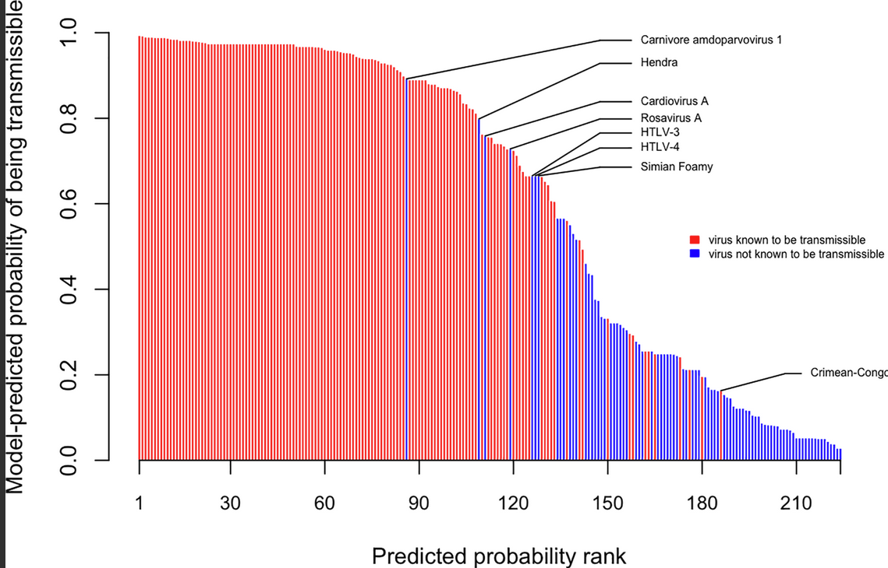

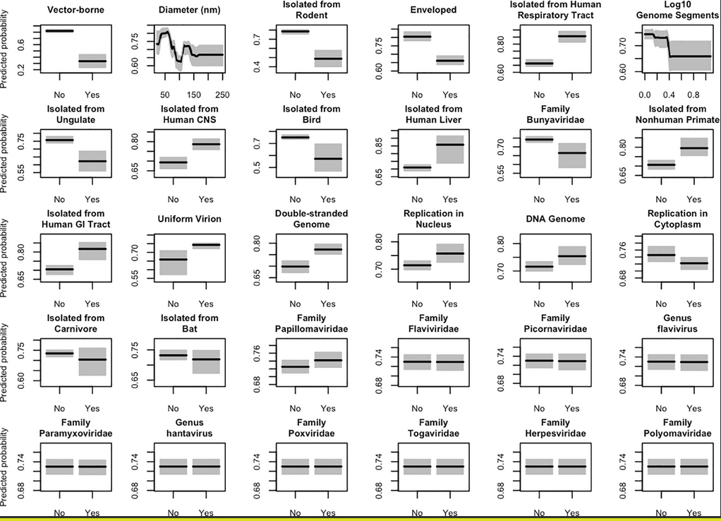

Han et al. (2020)

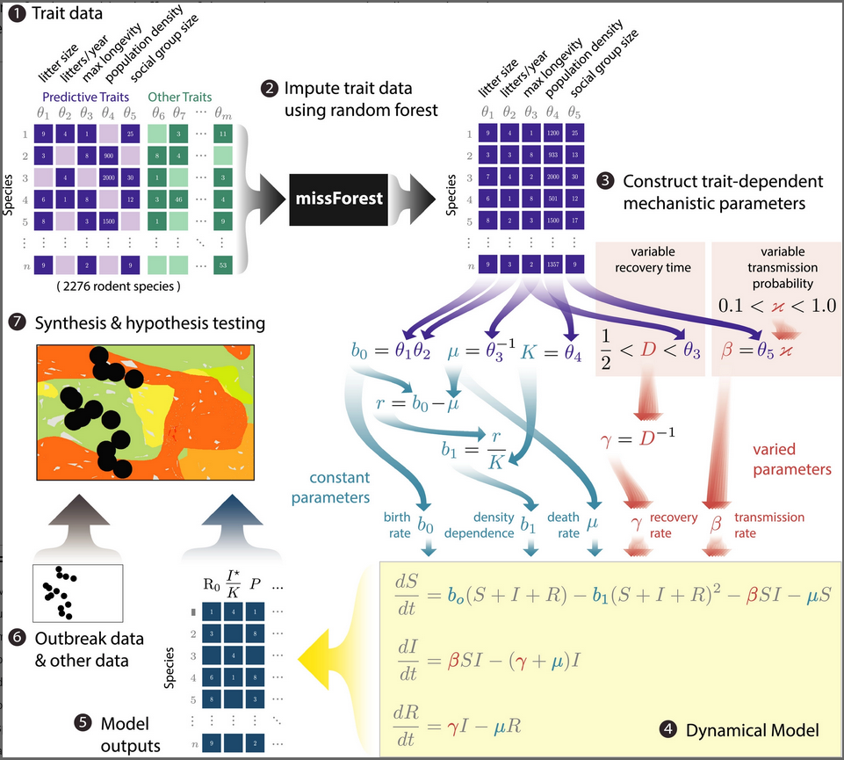

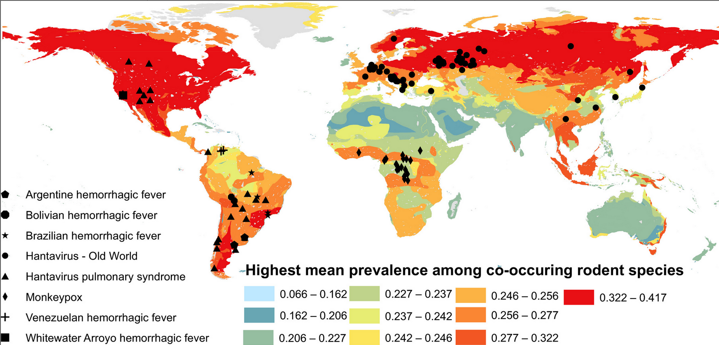

## References

Han, B. A., O’Regan, S. M., Paul Schmidt, J., & Drake, J. M. (2020). Integrating data mining and transmission theory in the ecology of infectious diseases. *Ecology Letters*, *23*(8), 1178–1188. <https://doi.org/10.1111/ele.13520>

Kain, M. P., & Bolker, B. M. (2019). Predicting West Nile virus transmission in North American bird communities using phylogenetic mixed effects models and eBird citizen science data. *Parasites & Vectors*, *12*(1), 395. <https://doi.org/10.1186/s13071-019-3656-8>

Keesing, F., & Ostfeld, R. S. (2021). Dilution effects in disease ecology. *Ecology Letters*, *24*(11), 2490–2505. <https://doi.org/10.1111/ele.13875>

Pounds, A. J., Bustamante, M. R., Coloma, L. A., Consuegra, J. A., Fogden, M. P. L., Foster, P. N., La Marca, E., Masters, K. L., Merino-Viteri, A., Puschendorf, R., Ron, S. R., Sánchez-Azofeifa, G. A., Still, C. J., & Young, B. E. (2006). Widespread amphibian extinctions from epidemic disease driven by global warming. *Nature*, *439*(7073), 161–167. <https://doi.org/10.1038/nature04246>

Pulliam, J. R. C., & Dushoff, J. (2009). Ability to Replicate in the Cytoplasm Predicts Zoonotic Transmission of Livestock Viruses. *The Journal of Infectious Diseases*, *199*(4), 565–568. <https://doi.org/10.1086/596510>

Rohr, J. R., Civitello, D. J., Halliday, F. W., Hudson, P. J., Lafferty, K. D., Wood, C. L., & Mordecai, E. A. (2020). Towards common ground in the biodiversity–disease debate. *Nature Ecology & Evolution*, *4*(1), 24–33. <https://doi.org/10.1038/s41559-019-1060-6>

Rohr, J. R., & Raffel, T. R. (2010). Linking global climate and temperature variability to widespread amphibian declines putatively caused by disease. *Proceedings of the National Academy of Sciences*, *107*(18), 8269–8274. <https://doi.org/10.1073/pnas.0912883107>

Rohr, J. R., Raffel, T. R., Romansic, J. M., McCallum, H., & Hudson, P. J. (2008). Evaluating the links between climate, disease spread, and amphibian declines. *Proceedings of the National Academy of Sciences*, *105*(45), 17436–17441. <https://doi.org/10.1073/pnas.0806368105>

Walker, J. W., Han, B. A., Ott, I. M., & Drake, J. M. (2018). Transmissibility of emerging viral zoonoses. *PLOS ONE*, *13*(11), e0206926. <https://doi.org/10.1371/journal.pone.0206926>

Last updated: 2022-04-06 10:44:25