epidemic model basics

11 Sep 2023

## Basics

Group individuals into categories; figure out the rates at which various events (infection, recovery, death, etc.) occur, and how they move individuals between categories/change the population sizes; write down equations based on these rates. “All models are wrong but some are useful” (Tukey), but they can help us figure out the rate of spread, or the equilibrium prevalence.

Some distinctions: micro- or macroparasite? Include *vital dynamics* (birth/death)? Life cycle (direct, vector, complex)? Virulence/effects on host? Genetics? Heterogeneity?

## Compartmental (“box”) models

Box models divide the host population up into boxes according to epidemiological status, e.g. **S**usceptible, **I**nfective, **R**emoved (**SIR** models). Could also include e.g. **E**xposed (**SEIR** model).

Depending on the host-parasite biology of a particular disease (is there an incubation period? do any hosts recover, and if so do they acquire immunity or do they become susceptible again?), we can write down a box model, for example:

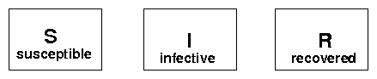

SIR boxes (no arrows)

Alphabet soup: SI (e.g. tuberculosis), SIS (e.g. gonorrhea), S(E)IR (e.g. measles), SIRV (vaccine), etc..

Now consider the transitions (**vital dynamics**: {birth, natural mortality}, disease-induced mortality, infection, recovery, vaccination).

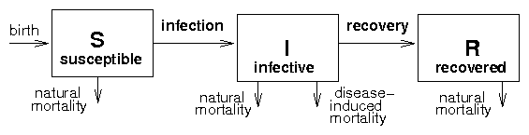

SIR boxes (arrows)

Finally, quantify the *transition rates* (e.g. constant birth rates (), constant *per capita* recovery etc., **mass-action** transmission ()).

We end up with the following model:

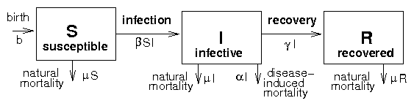

SIR boxes (arrows and rates)

Write down balance equations: incoming - outgoing.

How do we deal with these equations? We can do algebra, or simulate.

Build up basic dynamics: SI, SIR, SIR with vital dynamics.

* Beginning of epidemic: *exponential* growth (assuming well-mixed population, etc.)
* Simple (SI) epidemic: *logistic* growth
* SIR without vital dynamics: epidemic grows, then collapses
* SIS, SIR with vital dynamics: equilibrium (maybe)
* latent/exposed classes: SEIR
* seasonal variation, other feedbacks: epidemic cycles
* COVID: asymptomatic, presymptomatic, mild/severe, hospital, ICU …

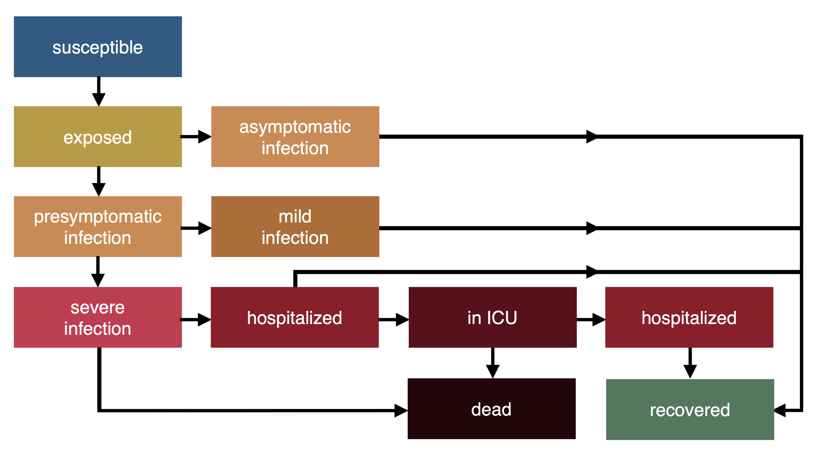

COVID flowchart)

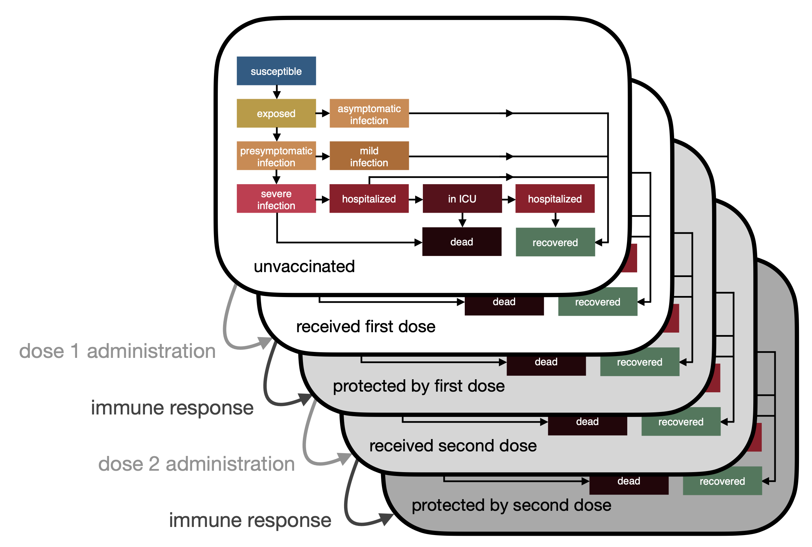

COVID flowchart with vax)

(pictures: Irena Papst)

Hethcote (1994)

**In groups: try to come up with a compartmental model for malaria!**

# Conclusions from basic epidemic models

## Basics

* + per-generation fitness
  + disease establishes if
  + depends on host, parasite, environment …
  + (growth rate) or *doubling time* also useful
  + critical control fraction is

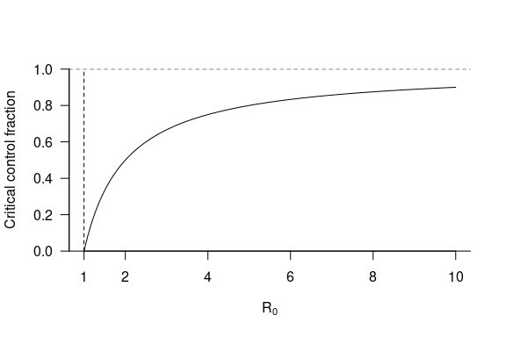

critical control fraction

* models without vital dynamics
  + parasite dies out before it infects all hosts
  + **final size** depends only on (in simple cases)

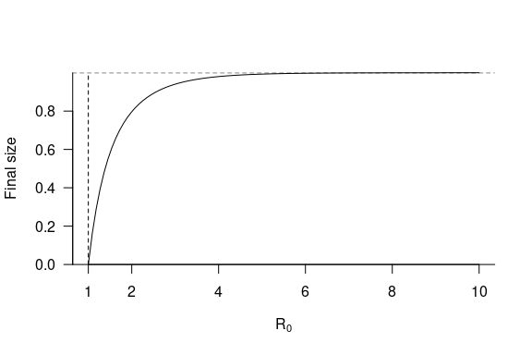

final size of SIR model

* models with vital dynamics
  + equilibrium when

## Variants on basic epidemic models

* Macroparasite models: have to build in a way to track average parasite burden, variability in parasite burden, and processes like intensity-dependent mortality. May also have more complex life cycles (multiple hosts, free-living stages, etc.).
* Transmission modes: e.g. vector-borne, sexually transmitted diseases (**STD**s). STDs have **frequency-dependent** transmission, instead of , which means there is no population density threshold — disease can persist in small populations, drive populations extinct. (Antonovics, Iwasa, and Hassell 1995)
* Mixing models (STDs, age-structured, geographic, …) — who infects whom?
* Demography: how does disease affect population growth? Malthus; HIV/AIDS. Depends on what ages are affected, who dies, effects on fecundity, behavioral responses.
* Ecology: how many species are in the model? Predator/prey dynamics?

# Estimating

## Estimating all model parameters

In principle, all of the parameters of the model (b, , , ) can be estimated from lab or field studies. The host demographic parameters (, ) are basic host ecology. Virulence () can be determined from experimental infections or from observational studies in the field, although both methods have their problems. Virulence might be lower in experimental infections because of differences in nutrition or environmental conditions in the lab.

Estimating is hard. Exceptions are vector-borne diseases like malaria (estimate (1) biting rates, (2) probability of a mosquito being infected when it takes a blood meal from an infected host, (3) probability of a host being infected when it is bitten by an infected mosquito) and HIV/AIDS (estimate sexual contact rates, partner change rates, and probability of infection per partnership).

## Observing epidemic curves

During the initial phase of the epidemic, the number of infected individuals should increase by a factor of for every parasite generation. For example, if = 3 and the generation time is one week then the numbers of infected individuals starting from a single infected would be 1, 3, 9, 27, …

Examples: AIDS, bubonic plague, foot and mouth disease in feral pigs, phocine distemper virus, smallpox, SARS.

## Exposure surveys

If you know the fraction susceptible (i.e. those who have never had the disease, ), you can use . You can also use the *age-exposure curve* of a population-the cumulation fraction of individuals that have been infected (and possibly recovered) by a given age to estimate , using (e.g. if host lifespan is 10 years and the average at which individuals are infected is 2 years, ). In human populations we can sometimes get age-exposure curves by following cohorts or sending out questionnaires, but *serological* studies are more powerful (work for any vertebrates, if we have the antibodies).

Examples: many human diseases, brucellosis in bison.

# More on long-term dynamics

* SIR epidemic with birth; initial epidemic outbreak, followed by a “trough”, followed by population recovery. **Damped** or **sustained** oscillations depend on details.
* 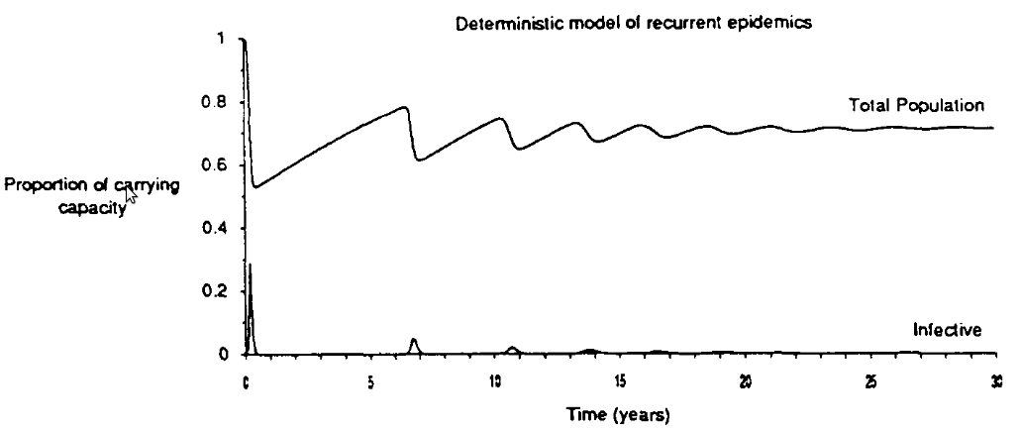
* damped oscillations
* Simplest expectation is that epidemics will eventually settle down to a stable equilibrium (“endemic”) state
* Size of fluctuations/damping rate depends on ratio of two scales: disease generation time (rate at which epidemic spreads) and population generation time (rate at which population turns over/new susceptibles appear)

## Stochastic extinction thresholds

* constraint on is a *deterministic* threshold: assumes large (infinite) population size
* what if population is finite? Chance of *stochastic fade-out* — disease goes extinct locally by chance ( infective)
* *Critical community size* — depends on epidemic parameters, but hard to figure out. Approx. 250,000 for measles (based on data on islands/cities in US and UK) [especially large]. Probably not even relevant for diseases with latent stages, asymptomatic forms, etc.. Perhaps important for staged eradication of disease. (Persistence threshold: suggests some more virulent/acute diseases may have emerged since human populations have become big enough to support them? Hard to understand early persistence of childhood diseases …)

## Recurrent epidemics

What explains recurrent epidemics (or **epidemic waves**)?

* Slow damping (e.g. measles, phocine distemper virus)
* **Demographic stochasticity** (e.g. whooping cough)
* Strain shifts — e.g. rhinovirus, influenza (SARS-COV-2!)
* Seasonality — esp. schools (e.g. measles, lots of others)
* Behaviour (SARS-COV-2!, influenza (He et al. 2013))

Details of recurrent epidemics can range from really simple (similar seasonal epidemics every year) to complex (chaos) (Olsen and Schaffer 1990)

## Longer-term epidemic shifts

Dynamics of epidemics can change over longer (decadal/century-long) Once again, can come from a variety of mechanisms:

* evolution/emergence — e.g. *antigenic shifts* in influenza
* changes in ecological setting/epidemic parameters (demography, culture, climate change?) (Earn et al. 2000, 2020)

## Dynamics pictures

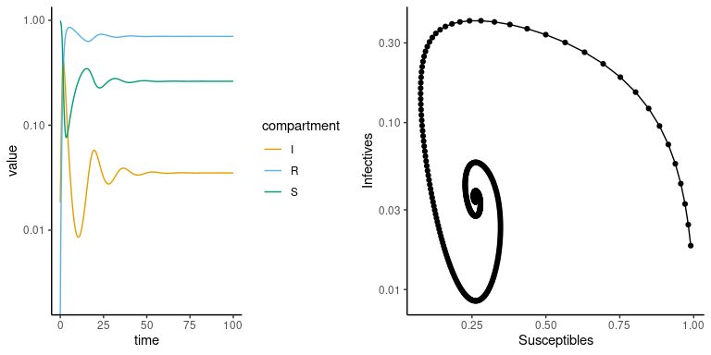

basic SIR dynamics

## Persistence (of hosts and parasites)

* When do hosts persist vs going extinct?
* When do pathogens persist vs going extinct?
* How do population dynamics interact with disease dynamics?
* Simple vs density-dependent host growth
* Briggs, Knapp, and Vredenburg (2010)
* Tanner et al. (2019)

## References

Antonovics, Janis, Yoh Iwasa, and Michael P. Hassell. 1995. “A Generalized Model of Parasitoid, Venereal, and Vector-Based Transmission Processes.” *The American Naturalist* 145 (5): 661–75. <https://doi.org/10.1086/285761>.

Briggs, Cheryl J., Roland A. Knapp, and Vance T. Vredenburg. 2010. “Enzootic and Epizootic Dynamics of the Chytrid Fungal Pathogen of Amphibians.” *Proceedings of the National Academy of Sciences* 107 (21): 9695–9700. <https://doi.org/10.1073/pnas.0912886107>.

Earn, David J. D., Junling Ma, Hendrik Poinar, Jonathan Dushoff, and Benjamin M. Bolker. 2020. “Acceleration of Plague Outbreaks in the Second Pandemic.” *Proceedings of the National Academy of Sciences* 117 (44): 27703–11. <https://doi.org/10.1073/pnas.2004904117>.

Earn, David J. D., Pejman Rohani, Benjamin M. Bolker, and Bryan T. Grenfell. 2000. “A Simple Model for Complex Dynamical Transitions in Epidemics.” *Science* 287 (5453): 667–70. <https://doi.org/10.1126/science.287.5453.667>.

He, Daihai, Jonathan Dushoff, Troy Day, Junling Ma, and David J. D. Earn. 2013. “Inferring the Causes of the Three Waves of the 1918 Influenza Pandemic in England and Wales.” *Proceedings of the Royal Society B: Biological Sciences* 280 (1766): 20131345. <https://doi.org/10.1098/rspb.2013.1345>.

Hethcote, Herbert W. 1994. “A Thousand and One Epidemic Models.” In *Frontiers in Mathematical Biology*, edited by Simon A. Levin, 504–15. Lecture Notes in Biomathematics 100. Springer Berlin Heidelberg. <https://link-springer-com.libaccess.lib.mcmaster.ca/chapter/10.1007/978-3-642-50124-1_29>.

Olsen, L. F., and W. M. Schaffer. 1990. “Chaos Versus Noisy Periodicity: Alternative Hypotheses for Childhood Epidemics.” *Science*, New Series, 249 (4968): 499–504. <http://www.jstor.org/stable/2874489>.

Tanner, Eleanor, Andy White, Peter W. W. Lurz, Christian Gortázar, Iratxe Díez-Delgado, and Mike Boots. 2019. “The Critical Role of Infectious Disease in Compensatory Population Growth in Response to Culling.” *The American Naturalist* 194 (1): E1–E12. <https://doi.org/10.1086/703437>.

Last updated: 2023-09-11 11:37:21.462269