host manipulation by parasites

15 March 2023

A common conclusion about parasite life history is that parasites must have high fecundity in order to ensure their transmission from one host to another. However, there is another alternative – improving the probability of transmission for each offspring by investing resources in quality, rather than quantity. How can a parasite do this?

## Encouraging transmission: upstream/downstream

Combes: where does the stimulus/signal for transmission come from (e.g., downstream host or downstream host’s environment)? Which host is manipulated (**upstream** or **downstream**)?

Free-living infective stages can’t necessarily manipulate hosts, but parasite larvae can home in on the host’s environment (e.g. ticks crawling to the top of a grass stalk) or on the host itself (e.g. by detecting chemical signals given off by the host).

For non-free-living infective stages (particularly in the case of trophic transmission), parasites can try to manipulate either the upstream or the downstream host’s behavior. However, they only have access to their own physiology and to the physiology of the upstream host (which they are currently inhabiting); if they want to manipulate the downstream host, they have to present it with a **signal**. If a trematode makes a killifish behave strangely, thus increasing its chance of parasitism by a bird, who is being manipulated? The killifish or the bird?

## Examples

**Dicrocoelium dendriticum**

* gut fluke
* life cycle: mammal $→$ snail $→$ ants
* ruminants (mostly cows) are the **definitive host**, but humans are also infected
* modifies ant behavior so that they crawl up grass stalks to improve their chances of being ingested “accidentally” by a cow and thus transmitting the parasite. The upstream host (ant) is having its physiology and behavior modified to bring it into the environment of the downstream host (cow), which behaves normally. The “signal” that ants respond to is gravity (ants move up stalks).
  + “a phylogenetically old sleeping behaviour typical for some non-social Hymenoptera (e. g. Ammophila)” (Wickler, 1976)
  + *kin selection* operating: the cercaria that modifies behaviour isn’t transmitted … (cf. slime mold, *Dictyostelium*)

**Fungal entomopathogens**

* *Ophiocordyceps* is the poster child
* de Bekker (2019), de Bekker et al. (2021), de Bekker et al. (2014), Araújo & Hughes (2019) ([link](https://ars.els-cdn.com/content/image/1-s2.0-S0960982219311649-gr1_lrg.jpg))

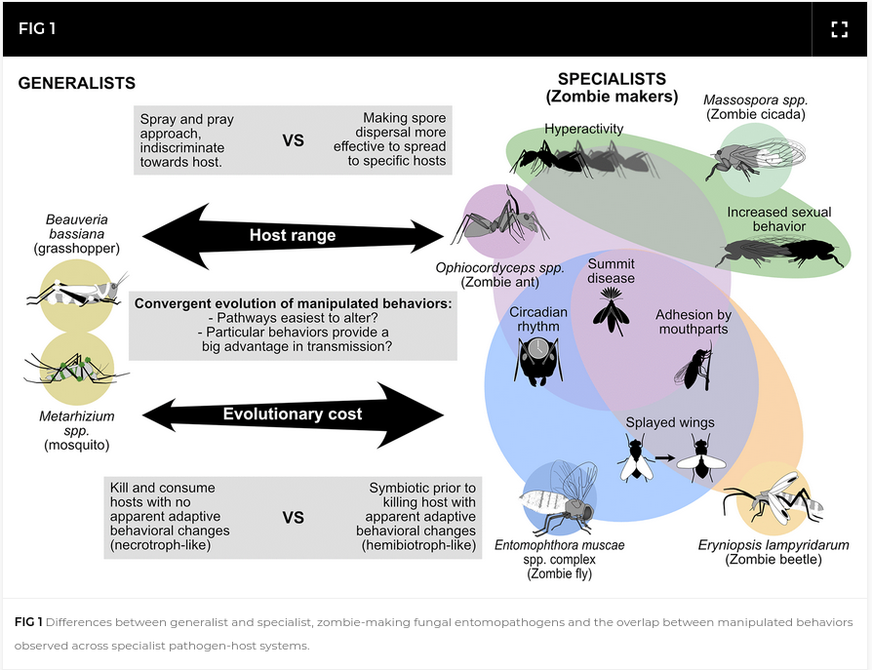

**Toxoplasma gondii**

* intracellular parasite of neurons
* in rats, attraction to feline urine (only!) and hyper-aggression (House et al., 2011; Lamberton et al., 2008; Vyas et al., 2007)
* by sexual attraction? (House et al., 2011)
* neuroimmunological mechanisms
* association with mental disorders in humans?? culture?? (Burgdorf et al., 2019; Lafferty, 2006; Torrey, 2022)

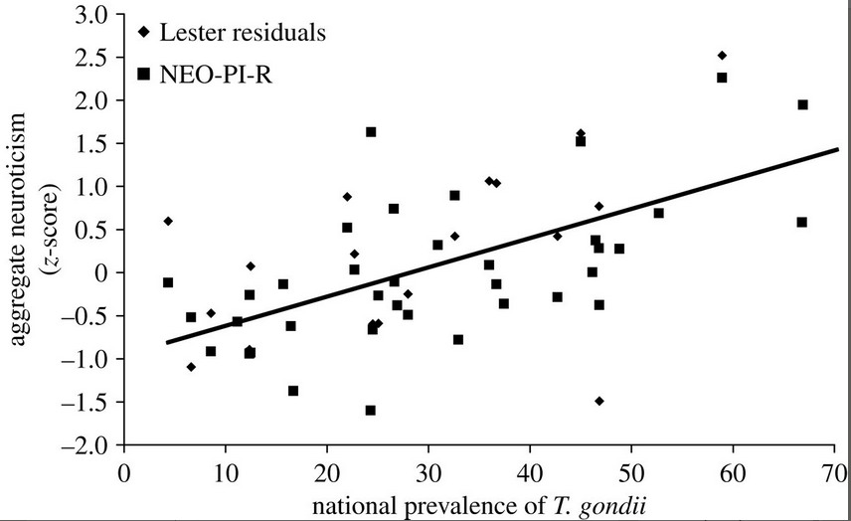

**Curtuteria australis**

* trematode parasites of bivalve molluscs
* specific to ‘feet’: stunting (Thomas & Poulin, 1998)
  + maybe cockles with small feet are more likely to be parasitized?
* reduces burrowing behaviour; *not* photophilia
* similar effects in closely related parasite/host species pairs
* **ecosystem engineer** (Lefèvre et al., 2009; Selbach & Mouritsen, 2020)

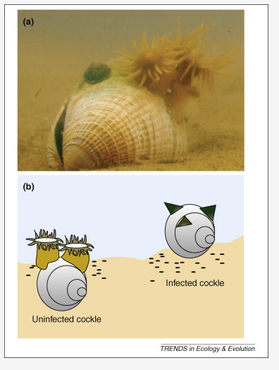

## Categories of behavioral change

* *Change in activity* (up or down): reduction in speed/distance travelled/etc. or increased activity, exploration etc. (rats with *Toxoplasmosis*, mice with *Trichinella*): may increase predation
* Many examples of changes in fish behavior (Kuhn et al., 2015))
* Acanthocephalans in invertebrates (good to test *difference* in activity patterns among species rather than just increase/decrease, which are more likely to be caused by pathology): amphipods, cockroaches
* Vectors can be affected: fly less (mosquitoes with filaria, *Plasmodium* (malaria) fly less) or bite more, or change host preferences
* *Conspicuous behavior:* Height-seeking behavior (fish, ants). Side effect of pathology (e.g. hypoxia in fish)? Photophilia (light-seeking), heat-seeking behavior: *behavioral fever* (Hart, 1988; Boorstein and Ewald, 1987; McClain et al 1988). Changes in color (loss of camouflage). Changes in size.
* *Changes in social behavior:* castration, changes in mating behavior (host or parasite or compensation?), changes in dominance; do parasites drive host social behavior (group size, etc.)?

# Mechanisms of host manipulation

What structures are affected by parasites? What are the proximal mechanisms by which parasites change behavior?

* Organ disruption or damage:
  + Sensory organs (can increase or decrease transmission: *Onchocerca volulus*)
  + Gonads (castrators)
  + Central nervous system (CNS): rabies. Much CNS destruction is just nasty and not apparently adaptive: e.g. syphilis, prion disease, *Parelaphostrongylus tenuis* in moose. CNS pathologies, or ear pathologies, caused by trematodes may also be implicated in some dolphin strandings (they may interfere with echolocation).
  + muscles: e.g. lemmings (*Dicrostonyx richardsoni*) increase exploratory activity, mice with *Trichinella pseudospiralis* travel farther. These could also be compensatory reactions to changes in nutrient status (see below).
* Changes in nutritional or metabolic status: the host may increase activity to compensate for nutrient losses to parasites, or decreasing it because it is starving, or change metabolic rate to try to kill the parasite. Changes in nutritional status come from:
  + damage to assimilation organs (e.g. gut destruction)
  + anorexia (host response? more common in poorly fed animals)
  + change in metabolic processes: e.g. malarial fever increases basal metabolic rates by 40% (this example is caused by host resistance, not by parasite manipulation)
  + Interference with control systems (the coolest!) (esp neuroendocrine or growth factor) e.g. *Gammarus*, *Dicrocoelium*.

# But is it really manipulation?

Suppose a parasite species inhabits the CNS and changes host behavior. Is the parasite in the CNS to avoid host defenses, with changes in behavior being a coincidental result of tissue damage, or are they actively changing host behavior?

To answer these questions we can quantify changes in parasite and host fitness. In order to determine whether a change in host physiology and/or behavior deserves to be called “manipulation”, we have to classify its effects on host and parasite fitness. Here is one such possible classification:

|  |  |  |
| --- | --- | --- |
| **Parasite fitness** | **Host fitness** | **Explanation** |
| + (transmission) | - | Parasite manipulation |
| + (survivorship) | 0/- | Parasite site selection |
| - (survivorship) | + | Host behavioral resistance |
| - (transmission) | ? | Host inclusive-fitness reactions? |
| 0/- | - | Host pathology? |
| 0/+ | + | Host compensation (tolerance) |

# Testing hypotheses

## Testing behavioral changes

Host behavioral changes in the presence of parasites are well documented. However, ecological (correlational) studies might get the direction of causality wrong: do hosts change their behavior when they are infected, or does behaviour increase their chances of infection? The ideal experiment would be to compare the transmission of parasites that do or don’t influence host behavior in a particular way. There are many obstacles to this kind of experiment:

* it’s not usually possible to turn off host manipulation, although maybe possible in cases where we know the detailed mechanisms of manipulation;
* hard to set up a complete artificial environment to allow transmission in the lab, particularly for heteroxenous parasites;
* transmission is sensitive to environment in a way that is hard to replicate in the lab (harder than measuring physiology of a single life stage in the lab).

Best-case scenario (?): study the transmission of two closely related parasites, either in the lab or in the wild. (Also: before-and-after studies, parasitized behaviors that are outside the usual repertoire.)

Other possibilities:

* field epidemiological or observational studies (Moore, 1983); or the seal study reported in Combes (Des Clers & Wootten, 1990), or the comparisons done by Lafferty and Morris of predation on infected vs. uninfected fish) – these kinds of studies give you accurate information, but not detailed information, about what’s happening in natural systems
* phylogenetically controlled studies (e.g. Moore and Gotelli 1996), which measure behaviors in a range of related species to test whether they represent adaptations or mere phylogenetic constraints.

## Testing effects on host and parasite fitness

A common assumption is that host behavior changes are driven by and for parasites, to increase parasite survivorship and transmission. However, their fitness consequences for the parasite or the host can be either positive, neutral, or negative: these behavioral changes can constitute adaptations by either the host or the parasite, or they can be “coincidental” side-effects of the host-parasite relationship.

In many cases behavioral changes of hosts are side-effects of parasite pathology, or host reactions, and do not necessarily enhance parasite fitness.

* check to make sure that the observed reaction is actually most consistent with a transmission-increasing adaptation. For example,
* increased predation rates of parasitized hosts (assumed to be an adaptation for transmission to the next host) is not necessarily by the right host (Brassard et al., 1982).
* Parasites may select particular host organs (that have strong effects on host behavior) for reasons other than influencing host behavior. For example, parasites in host CNS tissues, or in the lens of the eye, are often isolated from host defenses: ‘immunological privilege’ (Dunsmore et al., 1983; Szidat, 1969).
* if a change in a control system is a parasite adaptation, then any changes in behavior should be postponed until the parasite is actually *in an infective stage*, ready to infect the next host in the life cycle.
* Mechanistic explanations, really nailing down the biochemical or other changes leading to behavioral change, are also powerful. For example, parasitized *Gammarus* have modified escape responses. Injecting *Gammarus* with serotonin produces similar results; octopamine can block the results (Helluy & Holmes, 1990; Perrot-Minnot et al., 2014) Similarly, *S. mansoni* leads to higher opioid levels in hamsters, although this could be either a host response or a parasite manipulation (Kavaliers & Podesta, 1988). In some cases (growth hormone in rodents), parasites actually directly produce proteins that act like host hormones (Phares, 1996), which makes it pretty clear that it is a case of parasite manipulation.

# Comparative/phylogenetic analysis

Not much exists, people have been too busy looking at the amazingly cool detailed mechanisms of manipulation of host behavior by parasites.

Some of the difficulties with doing comparative analysis are (1) the lack of good phylogenies of parasites (which has come up before) and (2) the lack of standardized measures of behavioral change; in the case of life history or virulence, at least there are more standard benchmarks (longevity, size, fecundity, etc.) for people to measure.

Moore & Gotelli (1996)

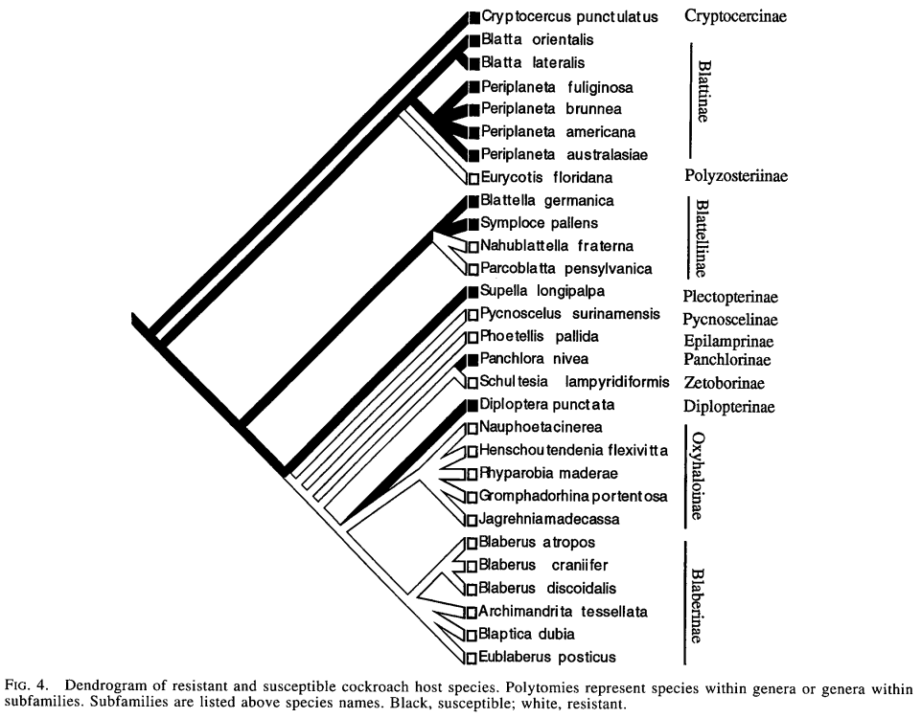

Acanthocephalans are transmitted from cockroaches to other hosts by predation, which makes them a good candidate for (parasite-) adaptive parasite-induced behavioral change driven by predation success. Moore and Gotelli took a morphological study of cockroaches, constructed a cockroach phylogeny, and mapped their own studies of a variety of different behavioral responses (substrate choice, etc.) onto the phylogeny. They found that at the family level there was little *phylogenetic inertia*, although there was some at the subfamily level; overall conclusion, behavioral responses to parasitism evolve fairly rapidly relative to the time scale of speciation and higher-taxon divergence.

# Costs of manipulation

The value of host manipulation, and the optimal/adaptive level of manipulation, depends on costs and benefits to the parasite (of course).

The costs of host manipulation may lead to kin/group selection of parasites: e.g. costs of producing host hormones. Kin/group selection must be especially strong in parasites of the central nervous system, because typically the individual parasites that are in the CNS doing the manipulation (latching on to neurons or whatever) are *not* successfully transmitted to the next host in the cycle: they provide an opportunity for their neighbors, but don’t themselves get to hitch a ride.

*Dicrocoelium dendriticum* is one example of a CNS parasite where one manipulator benefits all the other parasites in the host. Interspecies free riding occurs too: e.g. *Microphallus* and *Macrotremata*, where there are potential free riders both within and between species.

Brown (1999) gives a game-theoretic treatment of whether it’s worth a parasite’s effort to invest in host manipulation, on the basis of how many individuals it shares the host with and how related they are. The main prediction is that there can be a group size/relatedness threshold below which manipulation is not worth it for the parasite. Brown suggests that we look for variation in manipulation as a function of parasite number. **Q: how might hormonal and direct control of behavior differ in the individual and group pressures they put on parasites?**

# Parasitic castration

* The reproductive apparatus is the most “expendable” organ from parasite’s point of view; doesn’t interfere with any of the functions the parasite cares about
* may divert energy into life span/somatic growth, which increases the time the parasite has to reproduce (this decouples virulence in the sense of loss of fitness and virulence in the sense of host mortality)
* Dawkins has called parasitic castration (and other parasite-induced changes in host behavior) part of the *extended phenotype*: although it’s not part of the parasite’s body, it can still be coded for by the parasite’s genes and it still affects the parasite’s fitness.
* Are behavior and morphological changes under parasitic castration really a function of parasite manipulation, or are they partly controlled by the host? Host gigantism may be an adaptation for outliving the parasite and salvaging some reproductive ability.
* *Diplostomum phoxini* (Ballabeni, 1995) generates gigantism only in local (adapted) host populations (this rules out coincidental changes but doesn’t necessarily settle the question of host vs parasite adaptation).

## Sex ratio distortion

**Fisher’s principle**: most organisms do best with even sex ratios (on average), unless they do a lot of inbreeding

There are variants of parasitic castration: male-killing (the “pharaoh strategy”), or **feminization**: turning males into females (genetically or phenotypically). The host will try to compensate (by producing more males) if it can, to reach its optimal sex ratio; the parasite will fight back.

In *Gammarus* infected with *Octosporea effeminans* (a microsporidian), 90% of offspring of parasitized mothers become females (as opposed to 50–80% in unparasitized broods).

*Wolbachia* is an incredibly common intracellular, vertically transmitted bacter ium of arthropods that has a huge range of sex ratio distortion tricks.

Charlat et al. (2003)

[In the pill woodlouse *Armadillidium vulgare*] The spread of the feminizing Wolbachia has caused the loss of the female-determining W chromosome from infected populations, and all individuals in these populations are ZZ. The female-determining factor has switched from being the W chromosome to the feminizing Wolbachia: individuals are female if Wolbachia is present and active, and male if it is either absent or inactive.

There is a problem at the lineage level with this strategy: unless females can reproduce parthenogenetically, you may be dooming your host population if you’re too effective at feminizing it. For plants there is another way out: encourage clonal growth or selfing. This both increases transmission efficiency and reduces the potential for the evolution of parasite resistance (Kover and Clay call this “capturing the Red Queen”); in the end, though, it might also lead to reduced virulence because it ensures vertical transmission.

## References

Araújo, J. P. M., & Hughes, D. P. (2019). Zombie-Ant Fungi Emerged from Non-manipulating, Beetle-Infecting Ancestors. *Current Biology*, *29*(21), 3735–3738.e2. <https://doi.org/10.1016/j.cub.2019.09.004>

Ballabeni, P. (1995). Parasite-Induced Gigantism in a Snail: A Host Adaptation? *Functional Ecology*, *9*(6), 887–893. <https://doi.org/10.2307/2389987>

Brassard, P., Rau, M. E., & Curtis, M. A. (1982). Parasite-induced susceptibility to predation in diplostomiasis. *Parasitology*, *85*(3), 495–501. <https://doi.org/10.1017/S0031182000056274>

Brown, S. P. (1999). Cooperation and conflict in host–manipulating parasites. *Proceedings of the Royal Society of London. Series B: Biological Sciences*, *266*(1431), 1899–1904. <https://doi.org/10.1098/rspb.1999.0864>

Burgdorf, K. S., Trabjerg, B. B., Pedersen, M. G., Nissen, J., Banasik, K., Pedersen, O. B., Sørensen, E., Nielsen, K. R., Larsen, M. H., Erikstrup, C., Bruun-Rasmussen, P., Westergaard, D., Thørner, L. W., Hjalgrim, H., Paarup, H. M., Brunak, S., Pedersen, C. B., Torrey, E. F., Werge, T., … Ullum, H. (2019). Large-scale study of Toxoplasma and Cytomegalovirus shows an association between infection and serious psychiatric disorders. *Brain, Behavior, and Immunity*, *79*, 152–158. <https://doi.org/10.1016/j.bbi.2019.01.026>

Charlat, S., Hurst, G. D. D., & Merçot, H. (2003). Evolutionary consequences of Wolbachia infections. *Trends in Genetics*, *19*(4), 217–223. <https://doi.org/10.1016/S0168-9525(03)00024-6>

de Bekker, C. (2019). Ophiocordyceps-ant interactions as an integrative model to understand the molecular basis of parasitic behavioral manipulation. *Current Opinion in Insect Science*, *33*, 19–24. <https://doi.org/10.1016/j.cois.2019.01.005>

de Bekker, C., Beckerson, W. C., & Elya, C. (2021). Mechanisms behind the Madness: How Do Zombie-Making Fungal Entomopathogens Affect Host Behavior To Increase Transmission? *mBio*, *12*(5), e01872–21. <https://doi.org/10.1128/mBio.01872-21>

de Bekker, C., Merrow, M., & Hughes, D. P. (2014). From Behavior to Mechanisms: An Integrative Approach to the Manipulation by a Parasitic Fungus (Ophiocordyceps unilateralis s.l.) of Its Host Ants (Camponotus spp.). *Integrative and Comparative Biology*, *54*(2), 166–176. <https://doi.org/10.1093/icb/icu063>

Des Clers, S. A., & Wootten, R. (1990). Modelling the population dynamics of the sealworm *Pseudoterranova decipiens*. *Netherlands Journal of Sea Research*, *25*(1), 291–299. <https://doi.org/10.1016/0077-7579(90)90028-F>

Dunsmore, J. D., Thompson, R. C. A., & Bates, I. A. (1983). The accumulation of *Toxocara canis* larvae in the brains of mice. *International Journal for Parasitology*, *13*(5), 517–521. <https://doi.org/10.1016/S0020-7519(83)80017-4>

Helluy, S., & Holmes, J. C. (1990). Serotonin, octopamine, and the clinging behavior induced by the parasite *Polymorphus paradoxus* (Acanthocephala) in *Gammarus lacustris* (Crustacea). *Canadian Journal of Zoology*, *68*(6), 1214–1220. <https://doi.org/10.1139/z90-181>

House, P. K., Vyas, A., & Sapolsky, R. (2011). Predator Cat Odors Activate Sexual Arousal Pathways in Brains of Toxoplasma gondii Infected Rats. *PLOS ONE*, *6*(8), e23277. <https://doi.org/10.1371/journal.pone.0023277>

Kavaliers, M., & Podesta, R. (1988). Opioid involvement in parasite-induced behavioural modifications: Evidence from hamsters infected with *Schistosoma mansoni*. *Canadian Journal of Zoology*, *66*(12), 2653–2657. <https://doi.org/10.1139/z88-390>

Kuhn, T., Klapper, R., Münster, J., Dörge, D. D., Kochmann, J., & Klimpel, S. (2015). Remote Control: Parasite Induced Phenotypic Changes in Fish. In H. Mehlhorn (Ed.), *Host Manipulations by Parasites and Viruses* (pp. 117–148). Springer International Publishing. <https://doi.org/10.1007/978-3-319-22936-2_9>

Lafferty, K. D. (2006). Can the common brain parasite, Toxoplasma gondii, influence human culture? *Proceedings of the Royal Society B: Biological Sciences*, *273*(1602), 2749–2755. <https://doi.org/10.1098/rspb.2006.3641>

Lamberton, P. H. L., Donnelly, C. A., & Webster, J. P. (2008). Specificity of the *Toxoplasma gondii*-altered behaviour to definitive versus non-definitive host predation risk. *Parasitology*, *135*(10), 1143–1150. <https://doi.org/10.1017/S0031182008004666>

Lefèvre, T., Lebarbenchon, C., Gauthier-Clerc, M., Missé, D., Poulin, R., & Thomas, F. (2009). The ecological significance of manipulative parasites. *Trends in Ecology & Evolution*, *24*(1), 41–48. <https://doi.org/10.1016/j.tree.2008.08.007>

Moore, J. (1983). Responses of an Avian Predator and Its Isopod Prey to an Acanthocephalan Parasite. *Ecology*, *64*(5), 1000–1015. <https://doi.org/10.2307/1937807>

Moore, J., & Gotelli, N. J. (1996). Evolutionary Patterns of Altered Behavior and Susceptibility in Parasitized Hosts. *Evolution*, *50*(2), 807–819. <https://doi.org/10.1111/j.1558-5646.1996.tb03890.x>

Perrot-Minnot, M.-J., Sanchez-Thirion, K., & Cézilly, F. (2014). Multidimensionality in host manipulation mimicked by serotonin injection. *Proceedings of the Royal Society B: Biological Sciences*, *281*(1796), 20141915. <https://doi.org/10.1098/rspb.2014.1915>

Phares, K. (1996). An unusual host-parasite relationship: The growth hormone-like factor from plerocercoids of spirometrid tapeworms. *International Journal for Parasitology*, *26*(6), 575–588. <https://doi.org/10.1016/0020-7519(96)00025-2>

Selbach, C., & Mouritsen, K. N. (2020). Mussel Shutdown: Does the Fear of Trematodes Regulate the Functioning of Filter Feeders in Coastal Ecosystems? *Frontiers in Ecology and Evolution*, *8*. <https://www.frontiersin.org/article/10.3389/fevo.2020.569319>

Szidat, L. (1969). Structure, Development, and Behaviour of New Strigeatoid Metacercariae from Subtropical Fishes of South America. *Journal of the Fisheries Research Board of Canada*, *26*(4), 753–786. <https://doi.org/10.1139/f69-074>

Thomas, F., & Poulin, R. (1998). Manipulation of a mollusc by a trophically transmitted parasite: Convergent evolution or phylogenetic inheritance? *Parasitology*, *116*(5), 431–436. <https://doi.org/10.1017/S003118209800239X>

Torrey, E. F. (2022). *Parasites, Pussycats and Psychosis: The Unknown Dangers of Human Toxoplasmosis*. Springer Nature. <https://doi.org/10.1007/978-3-030-86811-6>

Vyas, A., Kim, S.-K., Giacomini, N., Boothroyd, J. C., & Sapolsky, R. M. (2007). Behavioral changes induced by *Toxoplasma* infection of rodents are highly specific to aversion of cat odors. *Proceedings of the National Academy of Sciences*, *104*(15), 6442–6447. <https://doi.org/10.1073/pnas.0608310104>

Wickler, W. (1976). Evolution-oriented Ethology, Kin Selection, and Altruistic Parasites. *Zeitschrift Für Tierpsychologie*, *42*(2), 206–214. <https://doi.org/10.1111/j.1439-0310.1976.tb00966.x>

Last updated: 2023-03-16 19:00:21.852049