evolution of host resistance and tolerance

7 March 2022

# Definitions/questions

* **resistance**: host’s ability to resist or minimize infection
* **tolerance**: host’s ability to support parasite infection without losing fitness
* **competence**: host’s ability to support *and transmit* parasites (especially vector-borne)
* encounter and compatibility filters: avoiding parasites vs killing vs tolerating them

## Mechanisms

* active defense (*plastic* or *facultative* defenses): **recognition systems** and **effectors**
  + recognition systems are the *qualitative* component of host defense: does the host recognize that the parasite (specifically, a parasite **antigen**) is present? These will typically evolve by Red Queen dynamics (i.e., via an inverse matching allele model). In vertebrates: **antibodies**
  + must be **specific** (self/non-self recognition), trigger proportionate response
  + coded by the **major histocompatibility complex** (self/non-self recognition), **somatic recombination**, deletion of host-specific antigens (Borghans, Beltman, and De Boer 2004; Acevedo-Whitehouse and Cunningham 2006; Rauch, Kalbe, and Reusch 2006; Spurgin and Richardson 2010)
  + *effectors*: what does the host do once the parasite is detected?
* passive/always-on defense (*constitutive* defenses)
  + changing cell surface receptors (e.g. CCR5-Δ32 (HIV, Hummel et al. (2005)); matching-allele model
* parasite countermeasures (immune evasion [trypanosomes], immune suppression [measles, anthrax, …]) (Schmid-Hempel 2009)

## Costs and tradeoffs

What are the **costs** of resistance and tolerance? (= Why aren’t all hosts tolerant/resistant to all parasites?)

(Klemme, Hyvärinen, and Karvonen 2020)

* cost of maintaining recognition mechanisms
* cost of choosing different habitats
* tradeoffs (RQ-related or ?)

## Population-level evolution (eco-evolution)

Stahl et al. (1999); Roy and Kirchner (2000)

* resistance lowers prevalence - selects against itself; expect *polymorphism*
* tolerance increases prevalence - selects for itself (*apparent competition* with non-tolerant genotypes); expect *fixation*. (Is tolerance evolution-proof? (Schneider and Ayres 2008))

## Measuring quantitative resistance/tolerance

* tolerance: loss of fitness **per unit parasite load**
* resistance: level of parasite load

(Raberg, Sim, and Read 2007, @raberg_decomposing_2009)

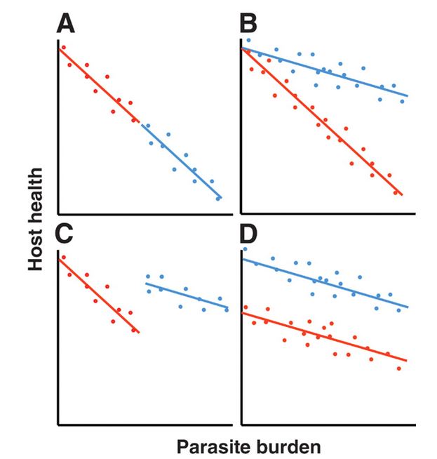

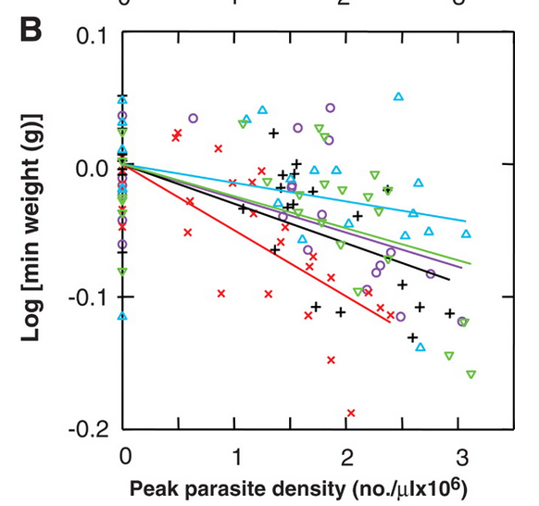 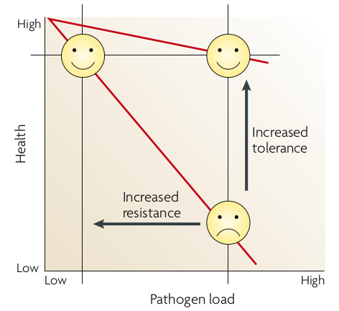

## Disentangling the history/origin of deleterious recessive Mendelian alleles

* Genetic *polymorphisms* are interesting; why haven’t they been eliminated or fixed?

## hypotheses

* genetic drift (null)
  + historic size of populations? (historical records, population genetics [*coalescents*])
  + strength of selection/maintenance in large populations?
* heterozygote advantage
* frequency-dependent selection (RQ vs. arms race)

## Tay-Sachs disease

* Lethal abnormality in hexosaminidase A (lipid metabolism); early (infant/toddler) death
* Mendelian, recessive lethal ()
* allele frequency 1/300 in US population, 1/30 in Ashkenazi (E. European) Jews: also high in French Canadians, Cajuns, Pennsylvania Dutch …
* Population-genetic evidence suggests drift
* (Terrible!) speculation about **overdominance** or **heterozygote advantage**: Tb resistance, intelligence: ???  
  (Spyropoulos 1988; Frost 2012; Frisch et al. 2004)

## phenylketonuria (PKU)

* metabolic disorder (phenylalanine)
* many different mutations
* homozygous PKU historically lethal (**selection coefficient** = 1)
* PKU alleles are old

## PKU incidence (Hillert et al. 2020)

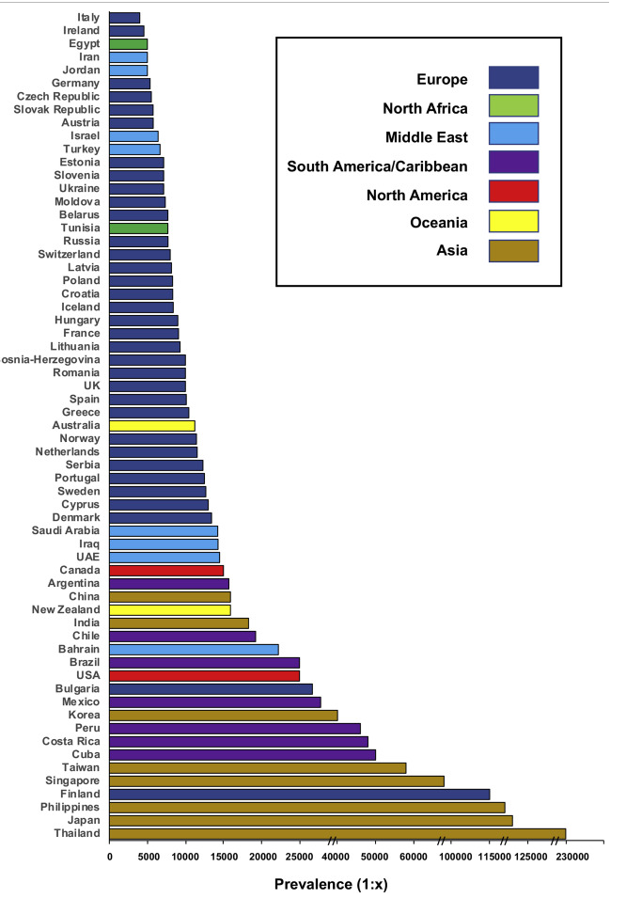

## PKU genetics

why not drift? (Krawczak and Zschocke 2003)

* many different mutations
* present across many populations
* populations without history of being small
  + e.g. Irish gene pool from 2500 BC
  + population size was 100K-200K
  + current expected frequency 0.6% is twice as high as expected

## PKU genetics: conclusion

* calculation from genetic models
* heterozygote advantage probably 1.5%
* hard to measure directly!
* probably due to higher phenylalanine levels in heterozygotes
* phenotypic effects?
  + higher birth weight
  + mycotoxin resistance?
  + starvation resistance?

## Sickle-cell

* overdominance  
  (heterozygote advantage)
* selection for *falciparum* malaria resistance
* geographic patterns;  
  consistency with malaria distribution
* mechanistic basis for protection
* evidence for positive selection (age??)

## Balanced polymorphisms

* Sickle-cell (and all cases of overdominance) depends on genetic makeup of the *population*
* chance of mating with a carrier is higher when allele is more common
* easier to do the math at the level of alleles

## Selective sweeps

* strong selection on an allele
* individuals carrying that allele have high fitness
* lower (gene-specific) **effective population size**
* neighbouring loci carried along as **haplotypes**: **hitchhiking**
* haplotypes gradually erode (narrow) by recombination
* e.g. MHC class I variability in chimpanzees decreased ~ 2-3 mya (Groot et al. 2002)

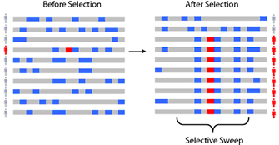

## Selective sweep: chromosome pattern

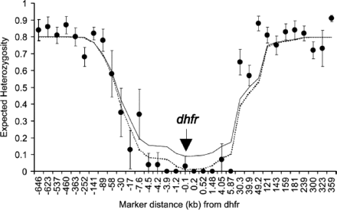

(Nair et al. 2003)

## Other malaria-protective variation

* hemoglobin variants:
  + blood groups, Rh-negativity  
    (older than malaria)
  + thalassemia
* enzyme variants:
  + GP6D deficiency/favism
    - Mediterranean populations
    - X-linked
    - arose 5-10K years ago: agriculture?
* Duffy antigens (protection against *vivax* malaria)

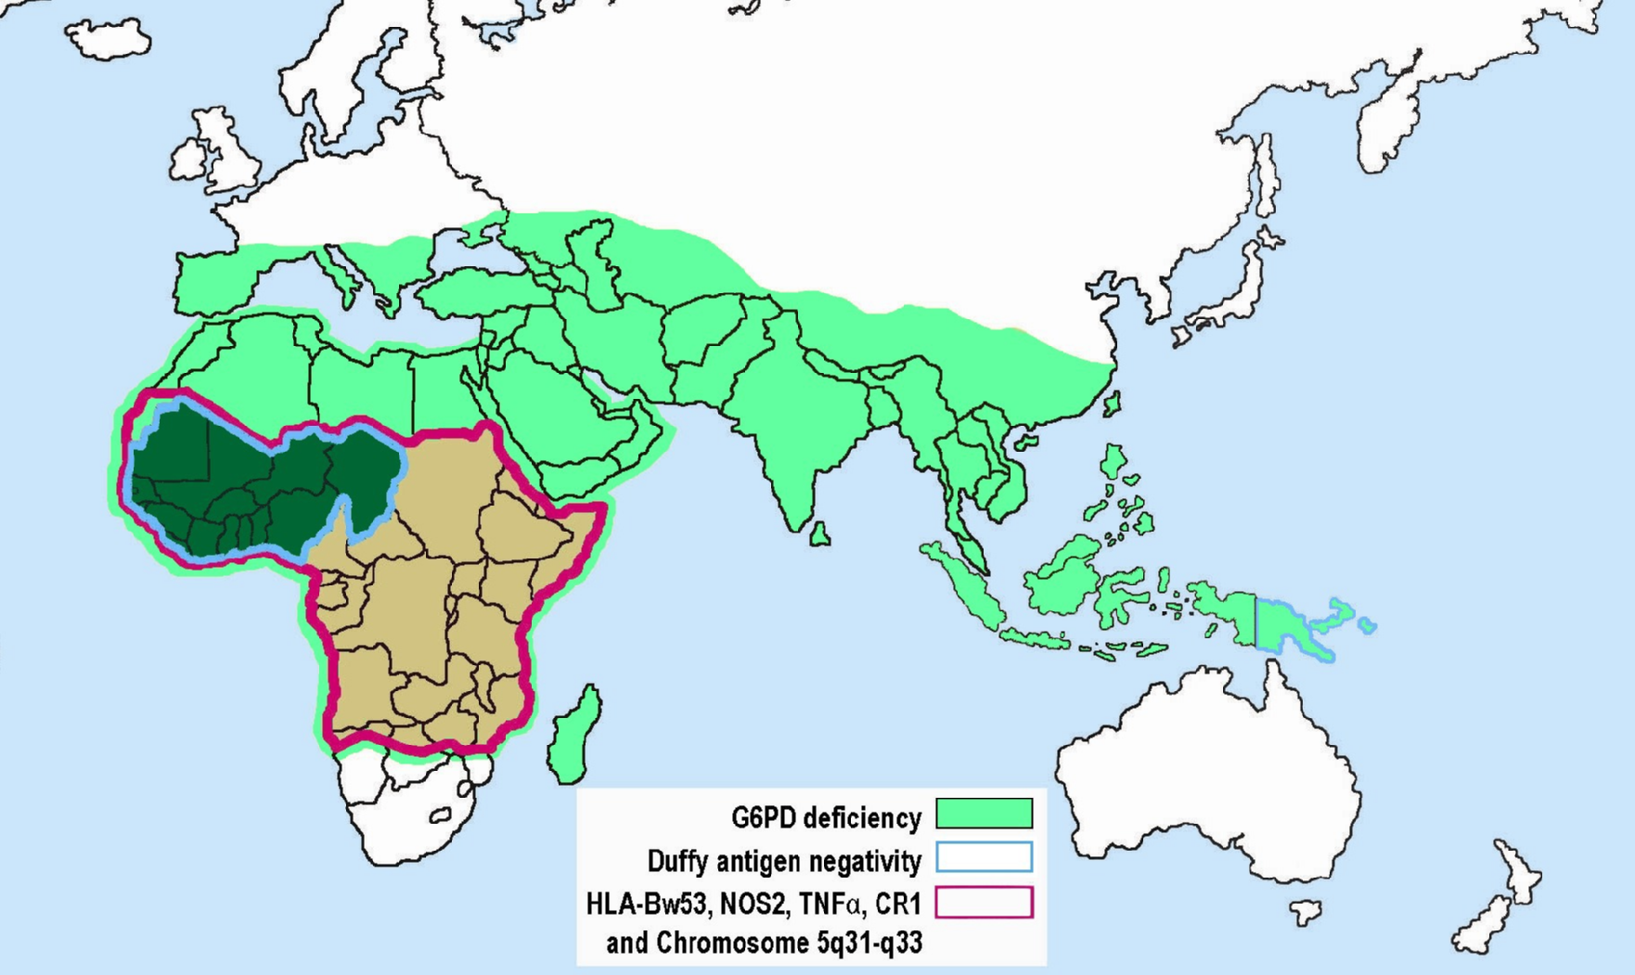

[Wikipedia](https://en.wikipedia.org/wiki/Genetic_resistance_to_malaria)

## Cystic fibrosis

* Lethal lung disease: mucus build-up  
  (1/4 chance of death before 30, previously much higher)
* 4% carriers in European whites (1/2500 diseased: )
* Mutated cftr gene, changes chloride metabolism;  
  age approx. 50 KYA
* Protection from cholera? (First European cholera epidemic 1817) Dehydrating intestinal diseases? Typhoid?
* **Pleiotropy** (multiple effects from one gene)

## HIV

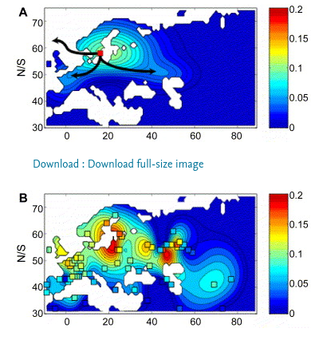

* where does CCR5-Δ32 come from?
* homozygous individuals are healthy …
* at least 5000 years old; Hummel et al. (2005); Novembre, Galvani, and Slatkin (2005); Galvani and Novembre (2005); Lidén, Linderholm, and Götherström (2006)
  + “If Δ32 were neutral, population genetics theory predicts it would have to be much older given its frequency.”
* high dispersal, sustained strong selection (); what selective agent? plague? smallpox?

## Summary: variation in Mendelian traits

* (relatively) simple inheritance
  + recessive/dominant, autosomal/X/Y-linked
* mechanisms
  + drift
  + heterozygote advantage
  + balancing selection/tradeoffs; gene × environment interaction
* evidence
  + ancient DNA
  + phylogenetic patterns/*coalescent* methods to estimate origin times/places
  + biogeography/history of disease/environment
  + mechanism
  + population history

## References

Acevedo-Whitehouse, K., and A. A Cunningham. 2006. “Is MHC Enough for Understanding Wildlife Immunogenetics?” *Trends in Ecology & Evolution* 21 (8): 433–38.

Borghans, J. A. M, J. B Beltman, and R. J De Boer. 2004. “MHC Polymorphism Under Host-Pathogen Coevolution.” *Immunogenetics* 55 (11): 732–39.

Frisch, Amos, Roberto Colombo, Elena Michaelovsky, Mazal Karpati, Boleslaw Goldman, and Leah Peleg. 2004. “Origin and Spread of the 1278insTATC Mutation Causing Tay-Sachs Disease in Ashkenazi Jews: Genetic Drift as a Robust and Parsimonious Hypothesis.” *Human Genetics* 114 (4): 366–76. <https://doi.org/10.1007/s00439-003-1072-8>.

Frost, Peter. 2012. “Tay-Sachs and French Canadians: A Case of Gene-Culture Co-Evolution?” *Advances in Anthropology* 02 (03): 132–38. <https://doi.org/10.4236/aa.2012.23016>.

Galvani, Alison P., and John Novembre. 2005. “The Evolutionary History of the CCR5-δ32 HIV-Resistance Mutation.” *Microbes and Infection* 7 (2): 302–9. <https://doi.org/10.1016/j.micinf.2004.12.006>.

Groot, Natasja G. de, Nel Otting, Gaby G. M. Doxiadis, Sunita S. Balla-Jhagjhoorsingh, Jonathan L. Heeney, Jon J. van Rood, Pascal Gagneux, and Ronald E. Bontrop. 2002. “Evidence for an Ancient Selective Sweep in the MHC Class I Gene Repertoire of Chimpanzees.” *Proceedings of the National Academy of Sciences* 99 (18): 11748–53. <https://doi.org/10.1073/pnas.182420799>.

Hillert, Alicia, Yair Anikster, Amaya Belanger-Quintana, Alberto Burlina, Barbara K. Burton, Carla Carducci, Ana E. Chiesa, et al. 2020. “The Genetic Landscape and Epidemiology of Phenylketonuria.” *The American Journal of Human Genetics* 107 (2): 234–50. <https://doi.org/10.1016/j.ajhg.2020.06.006>.

Hummel, S., D. Schmidt, B. Kremeyer, B. Herrmann, and M. Oppermann. 2005. “Detection of the CCR5-δ32 HIV Resistance Gene in Bronze Age Skeletons.” *Genes & Immunity* 6 (4): 371–74. <https://doi.org/10.1038/sj.gene.6364172>.

Klemme, Ines, Pekka Hyvärinen, and Anssi Karvonen. 2020. “Negative Associations Between Parasite Avoidance, Resistance and Tolerance Predict Host Health in Salmonid Fish Populations.” *Proceedings of the Royal Society B: Biological Sciences* 287 (1925): 20200388. <https://doi.org/10.1098/rspb.2020.0388>.

Krawczak, Michael, and Johannes Zschocke. 2003. “A Role for Overdominant Selection in Phenylketonuria? Evidence from Molecular Data.” *Human Mutation* 21 (4): 394–97. <https://doi.org/10.1002/humu.10205>.

Lidén, Kerstin, Anna Linderholm, and Anders Götherström. 2006. “Pushing It Back. Dating the CCR5–32 Bp Deletion to the Mesolithic in Sweden and Its Implications for the Meso\Neo Transition.” *Documenta Praehistorica* 33 (December): 29–37. <https://doi.org/10.4312/dp.33.5>.

Nair, Shalini, Jeff T. Williams, Alan Brockman, Lucy Paiphun, Mayfong Mayxay, Paul N. Newton, Jean-Paul Guthmann, et al. 2003. “A Selective Sweep Driven by Pyrimethamine Treatment in Southeast Asian Malaria Parasites.” *Molecular Biology and Evolution* 20 (9): 1526–36. <https://doi.org/10.1093/molbev/msg162>.

Novembre, John, Alison P. Galvani, and Montgomery Slatkin. 2005. “The Geographic Spread of the CCR5 δ32 HIV-Resistance Allele.” *PLOS Biology* 3 (11): e339. <https://doi.org/10.1371/journal.pbio.0030339>.

Råberg, Lars, Andrea L Graham, and Andrew F Read. 2009. “Decomposing Health: Tolerance and Resistance to Parasites in Animals.” *Philosophical Transactions of the Royal Society B: Biological Sciences* 364 (1513): 37–49. <https://doi.org/10.1098/rstb.2008.0184>.

Raberg, Lars, Derek Sim, and Andrew F. Read. 2007. “Disentangling Genetic Variation for Resistance and Tolerance to Infectious Diseases in Animals.” *Science* 318 (5851): 812–14. <https://doi.org/10.1126/science.1148526>.

Rauch, G., M. Kalbe, and T. B. H Reusch. 2006. “Relative Importance of MHC and Genetic Background for Parasite Load in a ﬁeld Experiment.” *Evolutionary Ecology Research* 8 (2): 373–86.

Roy, B. A., and J. W. Kirchner. 2000. “Evolutionary Dynamics of Pathogen Resistance and Tolerance.” *Evolution* 54 (1): 51–63. <https://doi.org/10.1111/j.0014-3820.2000.tb00007.x>.

Schmid-Hempel, Paul. 2009. “Immune Defence, Parasite Evasion Strategies and Their Relevance for ‘Macroscopic Phenomena’ Such as Virulence.” *Philosophical Transactions of the Royal Society B: Biological Sciences* 364 (1513): 85–98. <https://doi.org/10.1098/rstb.2008.0157>.

Schneider, David S., and Janelle S. Ayres. 2008. “Two Ways to Survive Infection: What Resistance and Tolerance Can Teach Us About Treating Infectious Diseases.” *Nature Reviews Immunology* 8 (11): 889–95. <https://doi.org/10.1038/nri2432>.

Spurgin, Lewis G., and David S. Richardson. 2010. “How Pathogens Drive Genetic Diversity: MHC, Mechanisms and Misunderstandings.” *Proceedings of the Royal Society B: Biological Sciences* 277 (1684): 979–88. <https://doi.org/10.1098/rspb.2009.2084>.

Spyropoulos, B. 1988. “Tay-Sachs Carriers and Tuberculosis Resistance.” *Nature* 331 (6158): 666. <https://doi.org/10.1038/331666a0>.

Stahl, Eli A., Greg Dwyer, Rodney Mauricio, Martin Kreitman, and Joy Bergelson. 1999. “Dynamics of Disease Resistance Polymorphism at the Rpm1 Locus of Arabidopsis.” *Nature* 400 (6745): 667–71. <https://doi.org/10.1038/23260>.

Last updated: 2022-03-06 19:23:09