host population dynamics

## Host populations

So far we have been talking about the population dynamics of the pathogens themselves; now we’ll discuss how parasites affect the population dynamics of their hosts, whether wildlife (animal or plant) or human.

## Regulation

Do parasites control population size? How?

High infection rate, *intermediate* virulence (disease-induced death rate) have the greatest impact on a population (because virulence lowers $R_{0}$ by killing hosts “too quickly”).

Can parasites *regulate* a population (i.e., create density-dependent mortality)? Historically controversial because parasites thought to evolve towards benign (commensal) association. Many lab studies show dramatic results (e.g. 90% reduction of mouse population with nematode *Heligmosomoides polygyrus* (Scott 1987): what about in the field? Easiest to detect with direct life cycles (**monoxenic**), mortality-producing.

Biocontrol with pathogens (e.g. rabbit myxomatosis, calicivirus) does work — although parasitoids (or toxins derived from microorganisms – Bt) are also common. Another example: *Cactoblastis* moth, introduced to Australia in 1925 to control non-native *Opuntia* cactus. But … both myxomatosis and *Cactoblastis* are also causing problems in places where their hosts are valued (native cactus), Iberian lynx that depend on rabbits in Spain (Zimmermann, Moran, and Hoffmann 2000; Cooke 2002; Real et al. 2009).

## Extinction

The simplest epidemic models suggest that parasites should go extinct before their hosts do (density threshold), so parasites should not be able to drive their hosts extinct. However, there are many exceptions to the rule.

* small populations (e.g. golden toad/Bd, black-footed ferret/CDV, arctic fox/mange)
* reservoir hosts (e.g. Hawai’ian birds/malaria)
* frequency-dependent transmission (e.g.? koala/chlamydia)

## Humans: historical and modern

Plague of Athens (430-429 BC) killed 25% of the population of 155,000 (measles?); also 25% in Rome in AD 165-180 (smallpox). Black Death (1347) killed 25%-50% of the population of Europe (setting back centuries of growth since 800). Population of Mexico dropped from 20 million to 3 million between 1518 and 1568, then to 1.6 million.

Malthus comments on effects of *crowding* on disease.

Demographic impact of HIV/AIDS is extremely significant: can convert positive to negative growth rates in worst-affected countries.

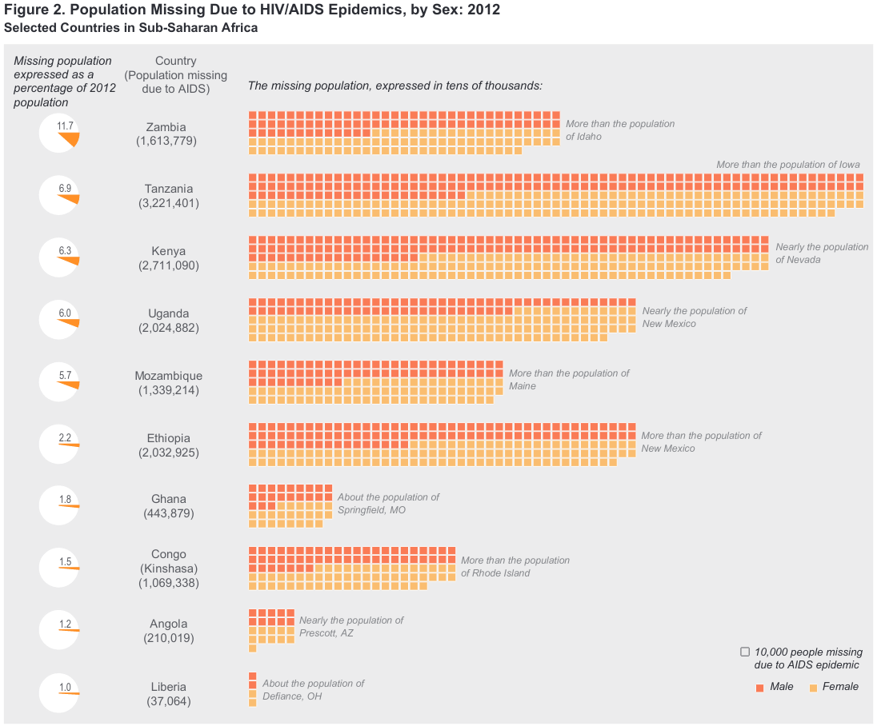

(U.S. Census Bureau 2013)

# Cycles

Simple models of “natural enemies” strongly suggest that enemy-victim interactions can lead to population cycles. These cycles are well established for epidemics in human populations (e.g. measles, rubella, chickenpox — the cycles are not in populations of humans, but in the populations of parasites or “infectives”) and for predator-prey systems (lynx-hare). Do infectious diseases drive host population cycles?

## Seals and phocine distemper virus

Harbor seals in northern Europe underwent a severe outbreak of a previously unrecognized morbillivirus, now called phocine distemper virus, in 1998.

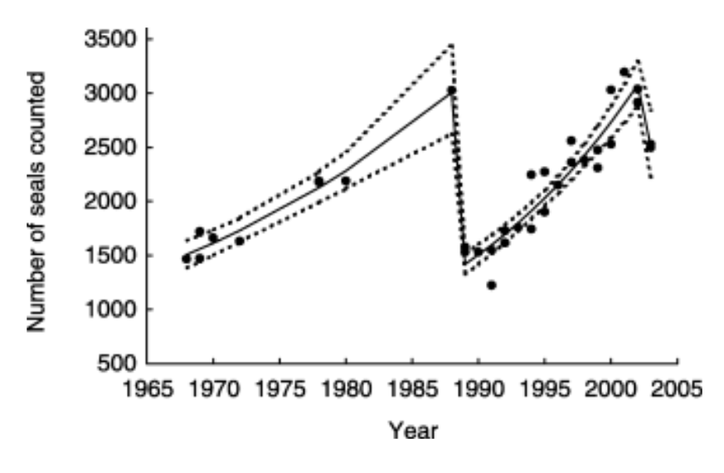

harbour seal pop dynamics

(Thompson, Lonergan, and Duck 2005). There was another major epidemic in 2002. Harwood and Hall (1990) present evidence of sporadic outbreaks of die-offs and pneumonias in seals (ca. 1758, 1813, 1836, 1869–70, 1930s). The epidemics are consistent with population die-offs and recovery, although the detailed epidemiology and demography is still an active area of research.

## Forest lepidoptera

Another example (Myers 1988) cycles of forest lepidoptera. About 80 species (1-2%) of forest lepidoptera (caterpillars) experience outbreak dynamics; of these, 18 species display regular, cyclic fluctuations.

The cycles are very clear (8–11 years, often highly synchronized across broad geographic regions). Possible hypotheses for why this happens include:

* **top-down control** (predators): changes in predator populations (e.g. birds) (probably not: bird population densities don’t change fast enough to control caterpillars. Parasitoids??)
* **bottom-up control**: changes in plant density *or* plant quality (plant density doesn’t work - very few trees die from caterpillars - but plant quality might. However, experimenters have had extremely mixed results manipulating food quality)
* **weather** (doesn’t work by itself; wide variation in local conditions) or interactions of weather with other factors
* changes in **insect quality**, possibly as a result of changes in plant quality or other competitive effects
* **parasites**: specifically, nuclear polyhedrosis viruses *Entomophaga maimaiga* (fungus)

The only time that an outbreak has been stopped by experimental manipulation is by spraying with NPV (an outbreak of tussock moths in 1981).

## Red grouse and *Trichostrongylus tenuis*

What about regular *cycling* in time? (Hudson, Dobson, and Newborn 1998)

## Basic natural history

Not much “natural” about the demography and ecology of Scottish red grouse (*Lagopus lagopus scoticus*) in the 20th century. Red grouse live on heather moors in northern England and Scotland. They are herbivores, eating only heather, with special intestinal adaptions (*caeca*, which are fermenting chambers off the main intestines) for subsisting on the relatively woody vegetation. The nematode *Trichostrongylus tenuis* lives in these caeca in (typically) large numbers. *T. tenuis* is monoxenic, with free-living stages (pooped out by the grouse) that crawl up to the top of the heather to be eaten by grouse. Grouse live at relatively high densities, protected from predators (foxes, raptors) by gamekeepers. They are shot every year by rich people with shotguns.

*Bag records*, numbers of grouse shot on each moor in each year, have been recorded in some cases since 1880. They show clear patterns, with 4-6 year cycles in the north of England and 7-10 year cycles in Scotland. The bag records are reasonable, although not perfect, measurements of population density: hunting effort is relatively constant between years, although it does drop if grouse numbers are too low and it historically dropped between First and Second World Wars, because either the aristocracy or the gamekeepers went off to war.

There are multiple hypotheses for the cyclic changes in population density; the two main ones are changes in behavior (aggression etc.) and host-parasite cycles.

Evidence for host-parasite cycles:

* Higher survivorship of grouse treated with anthelminthics
* Higher fecundity of grouse treated with anthelminthics
* Parasite densities (mean worm burdens) oscillate out of phase with population densities
* Treatment experiment: reduces amplitude of fluctuations
* General consistency of model predictions with data, including variation of cycles from south (northern England) to north (Scotland); seems to be related to *arrested development* of nematode larvae in cold weather, which slows things down

This is not the last word, but there’s a lot of evidence.

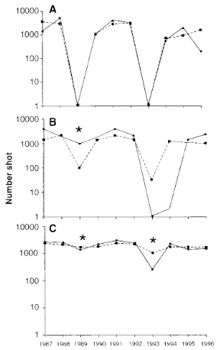

grouse dynamics

## References

Cooke, B. D. 2002. “Rabbit Haemorrhagic Disease: Field Epidemiology and the Management of Wild Rabbit Populations.” *Revue Scientifique et Technique (International Office of Epizootics)* 21 (2): 347–58. <https://doi.org/10.20506/rst.21.2.1337>.

Harwood, John, and Ailsa Hall. 1990. “Mass Mortality in Marine Mammals: Its Implications for Population Dynamics and Genetics.” *Trends in Ecology & Evolution* 5 (8): 254–57. <https://doi.org/10.1016/0169-5347(90)90066-M>.

Hudson, P. J., Andy Dobson, and D. Newborn. 1998. “Prevention of Population Cycles by Parasite Removal.” *Science* 282 (5397): 2256–8. <https://doi.org/10.1126/science.282.5397.2256>.

Myers, Judith H. 1988. “Can a General Hypothesis Explain Population Cycles of Forest Lepidoptera?” In *Advances in Ecological Research*, edited by M. Begon, A. H. Fitter, E. D. Ford, and A. Macfadyen, 18:179–242. Academic Press. <https://doi.org/10.1016/S0065-2504(08)60181-6>.

Real, Raimundo, A. Márcia Barbosa, Alejandro Rodríguez, Francisco J. García, J. Mario Vargas, L. Javier Palomo, and Miguel Delibes. 2009. “Conservation Biogeography of Ecologically Interacting Species: The Case of the Iberian Lynx and the European Rabbit.” *Diversity and Distributions* 15 (3): 390–400. <https://doi.org/10.1111/j.1472-4642.2008.00546.x>.

Scott, Marilyn E. 1987. “Regulation of Mouse Colony Abundance by Heligmosomoides Polygyrus.” *Parasitology* 95 (1): 111–24. <https://doi.org/10.1017/S0031182000057590>.

Thompson, David, Mike Lonergan, and Callan Duck. 2005. “Population Dynamics of Harbour Seals Phoca Vitulina in England: Monitoring Growth and Catastrophic Declines.” *Journal of Applied Ecology* 42 (4): 638–48. <https://doi.org/10.1111/j.1365-2664.2005.01025.x>.

U.S. Census Bureau. 2013. “Data Visualization: HIV/AIDS Impact in Africa.” *Census.gov*. <https://www.census.gov/newsroom/archives/2013-pr/cb13-tps101.html>.

Zimmermann, H. G., V. C. Moran, and J. H. Hoffmann. 2000. “The Renowned Cactus Moth, *Cactoblastis Cactorum*: Its Natural History and Threat to Native *Opuntia* Floras in Mexico and the United States of America.” *Diversity and Distributions* 6 (5): 259–69. <https://doi.org/10.1046/j.1472-4642.2000.00088.x>.

Last updated: 2022-01-27 20:34:36