evolution of parasite countermeasures

14 March 2022

# General principles

* two stages of evolution: *de novo* mutation and selection
* limiting factors in *de novo* mutation
  + mutation rate (per locus/per genome)
  + population size
  + generation time
  + rate appearance of new mutations = (mutation rate × pop size)/(generation time)
  + mutational **spectrum**: what can mutations achieve?
* limiting factors in selection:
  + selection differential
    - benefits (= prob of encountering antibiotic × benefit of resistance)
    - costs [metabolic/energetic; reduced efficiency]
      * **compensatory** mutations (reduce cost)
  + pop size (drift vs selection; bottlenecks in between-host transmission)
  + variation in selection (within- vs between-host)
  + recombination and/or horizontal transmission via mobile elements (plasmids etc.)
* competition between susceptible and resistant strains (Lipsitch and Samore 2002)

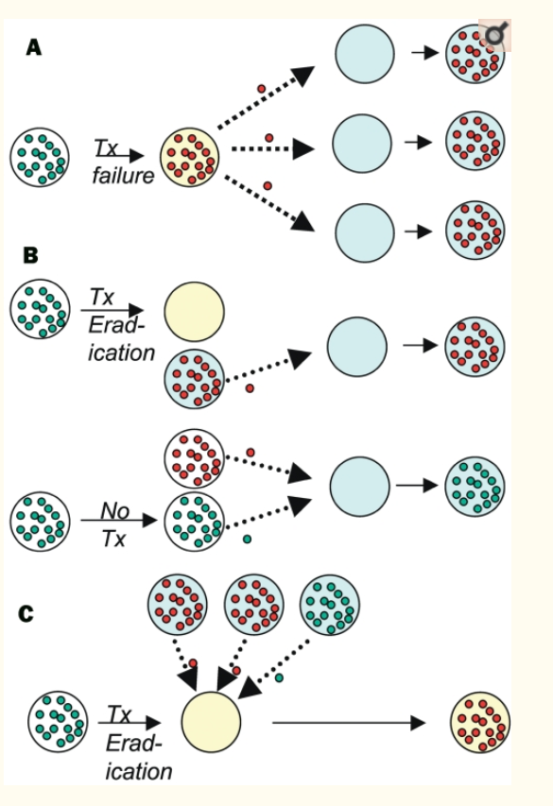 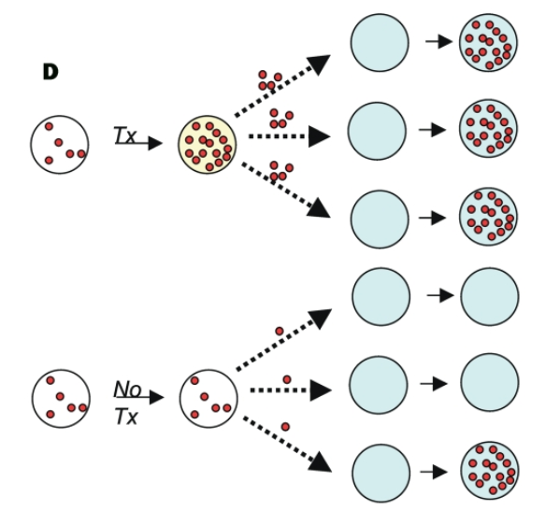

# Bacteria

## Mechanisms

* because bacteria and animals are biochemically different, can use substances that disrupt bacterial but not animal metabolic processes
* many biologically derived
  + fungi (penicillin!) (Karwehl and Stadler 2016)
  + soil bacteria (esp *Streptomyces*; streptomycin, tetracycline)
  + (also chemical/synthetic, e.g. derived from dyes - *sulfa drugs*)
* because antibiotics have been around “forever”, so has antibiotic resistance (D’Costa et al. 2011)
  + but presence **as mobile elements** may be recent, human/animal derived (Ebmeyer, Kristiansson, and Larsson 2021)
  + often present in antibiotic *producers* (Benveniste and Davies 1973)
* huge problem, e.g. mdrMRSA ([multi-drug resistant], methicillin-resistant *Staphylococcus aureus*), extensively drug-resistant (XDR) tuberculosis (Centers for Disease Control 2020)
  + threatens to wipe out disease cures …
* horizontal transfer is rampant
  + resistance gene can be anywhere in the microbiome …
  + **collateral** or **non-target selection** (Llewelyn et al. 2017)
  + also makes it easier to lose resistance when no longer required
  + thus resistance is usually/often pre-existing
* mechanisms of action:
  + pumps (“efflux system”: remove toxic substances from the cell)
  + inactivation or degradation/detoxification
  + altered pathways?
* antibiotics are *effectors* (not recognizers)
* cost of resistance; are resistance alleles lost or compensated in the absence of antibiotics? (Bjorkholm et al. 2001; Levin, Perrot, and Walker 2000)

## Implications for antibiotic use

* avoid overuse! “antibiotic conservation”
* regulate agricultural use
  + for human-to-human transmission, regulating agriculture may be too late once resistance is already established in humans (Smith et al. 2002)
* 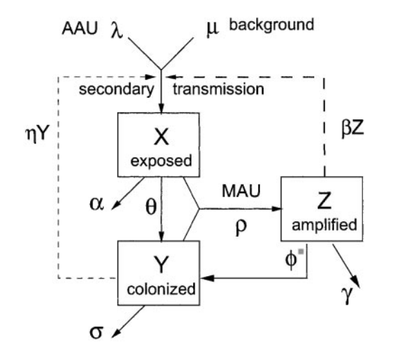
  + but regulation still helps with spillover infections (Lipsitch, Singer, and Levin 2002)
* “the long-term benefit of single drug treatment from introduction of the antibiotic until a high frequency of resistance precludes its use is almost independent of the pattern of antibiotic use” (Sebastian Bonhoeffer, Lipsitch, and Levin 1997)
* “cocktails” may be best; varying treatments in space is better than cycling (Bergstrom, Lo, and Lipsitch 2004)
* treating for longer increases collateral selection (Llewelyn et al. 2017)
* contrast: Tb (chronic disease, resistance from point mutations)

# Viruses

* similar biochemistry to hosts
  + often fought by priming immune system, i.e. *vaccination*
  + resistance via **recognition escape** rather than disabling effectors
  + usually **strain replacement** rather than within-lineage selection on escape alleles
* very high mutation rate
  + *de novo* mutation is a bigger problem
* HIV
  + single-drug resistance evolves quickly (S Bonhoeffer, Coffin, and Nowak 1997)
  + target non-host-like biochemistry: nucleoside and non-nucleoside resistance transcriptase inhibitors; protease, integrase inhibitors
  + HAART (Eggleton and Nagalli 2022); e.g. standard South African regimen includes tenofovir, lamivudine (nucleotide analog), dolutegravir (integrase inhibitor) (South Africa National Department of Health 2019)
  + keeping load low reduces transmission *and* within-host evolution of resistance
  + between-host transmission maybe less important because of early infectivity
* strain replacement
  + COVID-19! alpha, delta, omicron (Ferguson et al. 2021)
  + influenza, every year (*antigenic drift*)/pandemic (*antigenic shift*)
  + other examples: *Haemophilus influenzae B* (Adam et al. 2010)
  + human papilloma virus: maybe not? (Covert et al. 2019; Man et al. 2021)
  + **not**: smallpox (gone), rinderpest, chickenpox, measles, rubella

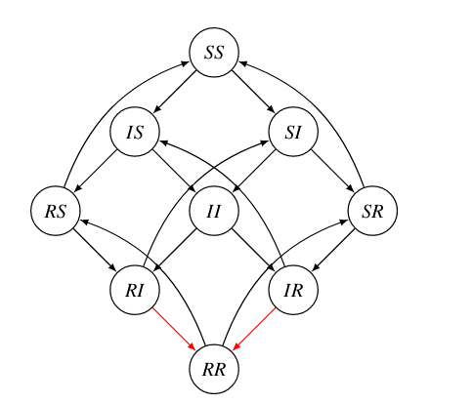

* back to bacteria: vaccine-preventable *Bordetella pertussis*, resurgence and evolution of immune evasion (?) (Gent et al. 2012)

(**to be added, maybe**)

## malaria control

[Twitter](https://twitter.com/ProfDavidLSmith/status/1504110201875562504):

reading various malaria documents that discuss having endemic malaria today despite spending ~$4.1B/yr, I always want to insert the comment, “Well, WTF did you expect? No one who understands malaria believes elimination would be possible without spending at least $10B/yr”

Main components:

* antimalarial drugs
* vaccine (children only, max effectiveness 40%, safety concerns …) (Seo, Baker, and Ngo 2014; Jarry 2021)
* vector control
  + indoor residual spraying (lethality + avoidance)
  + treated bednets (lethality + avoidance)
  + biocontrol (e.g. *Gambusia*, “mosquito fish”)
  + improved housing? (Musiime et al. 2022)

## malaria resistance to antimalarial drugs

* protozoan parasite
* quinine, chloroquine (Achan et al. 2011; Ashley et al. 2014)
* artemisinin (and combination therapy, ACT)

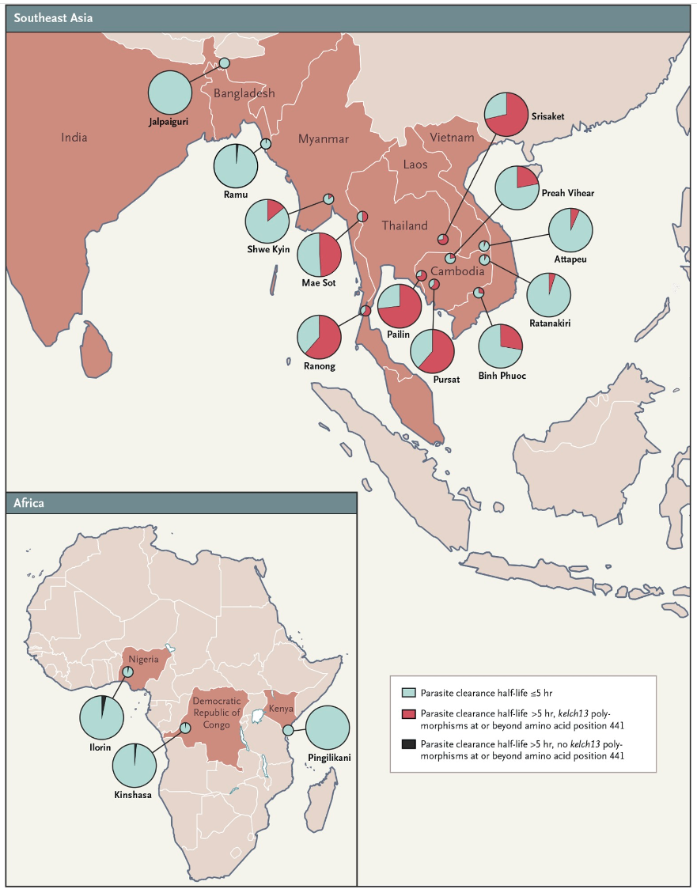

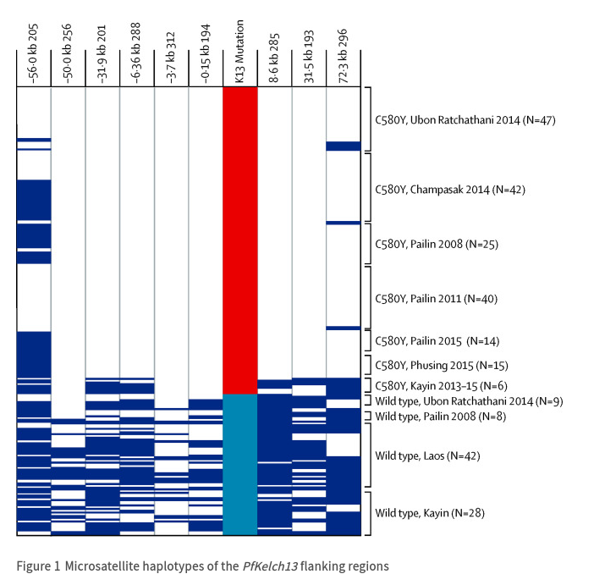

containment strategies: eliminate *falciparum* malaria from Greater Mekong region or “firewall”?

## vectors and resistance to insecticides

* DDT [Wikipedia](https://en.wikipedia.org/wiki/DDT#Mosquito_resistance)
  + environmental side effects
    - fast evolution of resistance: 6-7 years (Gladwell 2001)
* other methods?
  + sterile male release (irradiation, *Wolbachia*) (Atyame et al. 2016)
  + **gene drive** (Burt et al. 2018) and/or bacterial infection (Dennison, Jupatanakul, and Dimopoulos 2014)
    - reduce vector competence
    - shift sex ratios toward males
  + evolution-resistant insecticides: shorten host life span (McMeniman et al. 2009; Koella et al. 2009)
    - weak selection against late-acting processes (Medawar 2019)
    - late-acting insecticides (W. or fungal)
    - larvicides: resistant phenotypes are smaller/short-lived

## References

Achan, Jane, Ambrose O. Talisuna, Annette Erhart, Adoke Yeka, James K. Tibenderana, Frederick N. Baliraine, Philip J. Rosenthal, and Umberto D’Alessandro. 2011. “Quinine, an Old Anti-Malarial Drug in a Modern World: Role in the Treatment of Malaria.” *Malaria Journal* 10 (1): 144. <https://doi.org/10.1186/1475-2875-10-144>.

Adam, H. J., S. E. Richardson, F. B. Jamieson, P. Rawte, D. E. Low, and D. N. Fisman. 2010. “Changing Epidemiology of Invasive Haemophilus Influenzae in Ontario, Canada: Evidence for Herd Effects and Strain Replacement Due to Hib Vaccination.” *Vaccine* 28 (24): 4073–8. <https://doi.org/10.1016/j.vaccine.2010.03.075>.

Ashley, Elizabeth A., Mehul Dhorda, Rick M. Fairhurst, Chanaki Amaratunga, Parath Lim, Seila Suon, Sokunthea Sreng, et al. 2014. “Spread of Artemisinin Resistance in Plasmodium Falciparum Malaria.” *New England Journal of Medicine* 371 (5): 411–23. <https://doi.org/10.1056/NEJMoa1314981>.

Atyame, Célestine M., Pierrick Labbé, Cyrille Lebon, Mylène Weill, Riccardo Moretti, Francesca Marini, Louis Clément Gouagna, Maurizio Calvitti, and Pablo Tortosa. 2016. “Comparison of Irradiation and Wolbachia Based Approaches for Sterile-Male Strategies Targeting Aedes Albopictus.” *PLOS ONE* 11 (1): e0146834. <https://doi.org/10.1371/journal.pone.0146834>.

Benveniste, Raoul, and Julian Davies. 1973. “Aminoglycoside Antibiotic-Inactivating Enzymes in Actinomycetes Similar to Those Present in Clinical Isolates of Antibiotic-Resistant Bacteria.” *Proceedings of the National Academy of Sciences* 70 (8): 2276–80. <https://doi.org/10.1073/pnas.70.8.2276>.

Bergstrom, Carl T., Monique Lo, and Marc Lipsitch. 2004. “Ecological Theory Suggests That Antimicrobial Cycling Will Not Reduce Antimicrobial Resistance in Hospitals.” *Proceedings of the National Academy of Sciences* 101 (36): 13285–90. <https://doi.org/10.1073/pnas.0402298101>.

Bjorkholm, Britta, Maria Sjölund, Per G. Falk, Otto G. Berg, Lars Engstrand, and Dan I. Andersson. 2001. “Mutation Frequency and Biological Cost of Antibiotic Resistance in Helicobacter Pylori.” *Proceedings of the National Academy of Sciences of the United States of America* 98 (25): 14607–12. <https://doi.org/10.1073/pnas.241517298>.

Bonhoeffer, S, J M Coffin, and M A Nowak. 1997. “Human Immunodeficiency Virus Drug Therapy and Virus Load.” *Journal of Virology* 71 (4): 3275–8. <http://www.ncbi.nlm.nih.gov/pmc/articles/PMC191463/>.

Bonhoeffer, Sebastian, Marc Lipsitch, and Bruce R. Levin. 1997. “Evaluating Treatment Protocols to Prevent Antibiotic Resistance.” *Proceedings of the National Academy of Sciences* 94 (22): 12106–11. <https://doi.org/10.1073/pnas.94.22.12106>.

Burt, Austin, Mamadou Coulibaly, Andrea Crisanti, Abdoulaye Diabate, and Jonathan K. Kayondo. 2018. “Gene Drive to Reduce Malaria Transmission in Sub-Saharan Africa.” *Journal of Responsible Innovation* 5 (sup1): S66–S80. <https://doi.org/10.1080/23299460.2017.1419410>.

Centers for Disease Control. 2020. “Extensively Drug-Resistant Tuberculosis (XDR TB).” <https://www.cdc.gov/tb/publications/factsheets/drtb/xdrtb.htm>.

Covert, Courtney, Lili Ding, Darron Brown, Eduardo L. Franco, David I. Bernstein, and Jessica A. Kahn. 2019. “Evidence for Cross-Protection but Not Type-Replacement over the 11 Years After Human Papillomavirus Vaccine Introduction.” *Human Vaccines & Immunotherapeutics*.

D’Costa, Vanessa M., Christine E. King, Lindsay Kalan, Mariya Morar, Wilson W. L. Sung, Carsten Schwarz, Duane Froese, et al. 2011. “Antibiotic Resistance Is Ancient.” *Nature* 477 (7365): 457–61. <https://doi.org/10.1038/nature10388>.

Dennison, Nathan J, Natapong Jupatanakul, and George Dimopoulos. 2014. “The Mosquito Microbiota Influences Vector Competence for Human Pathogens.” *Current Opinion in Insect Science*, Vectors and medical and veterinary entomology, 3 (September): 6–13. <https://doi.org/10.1016/j.cois.2014.07.004>.

Ebmeyer, Stefan, Erik Kristiansson, and D. G. Joakim Larsson. 2021. “A Framework for Identifying the Recent Origins of Mobile Antibiotic Resistance Genes.” *Communications Biology* 4 (1): 1–10. <https://doi.org/10.1038/s42003-020-01545-5>.

Eggleton, Julie S., and Shivaraj Nagalli. 2022. “Highly Active Antiretroviral Therapy (HAART).” In *StatPearls*. Treasure Island (FL): StatPearls Publishing. <http://www.ncbi.nlm.nih.gov/books/NBK554533/>.

Ferguson, Neil, Azra Ghani, Anne Cori, Alexandra Hogan, Wes Hinsley, and Erik Volz. 2021. “Report 49 - Growth, Population Distribution and Immune Escape of Omicron in England.” *Imperial College London*. <http://www.imperial.ac.uk/medicine/departments/school-public-health/infectious-disease-epidemiology/mrc-global-infectious-disease-analysis/covid-19/report-49-omicron/>.

Gent, Marjolein van, Marieke J. Bart, Han G. J. van der Heide, Kees J. Heuvelman, and Frits R. Mooi. 2012. “Small Mutations in *Bordetella Pertussis* Are Associated with Selective Sweeps.” *PLOS ONE* 7 (9): e46407. <https://doi.org/10.1371/journal.pone.0046407>.

Gladwell, Malcolm. 2001. “The Mosquito Killer.” *The New Yorker*, July. <https://web.archive.org/web/20160416165010/http://gladwell.com/the-mosquito-killer/>.

Jarry, Jonathan. 2021. “The Malaria Vaccine’s Success Story Hides Legitimate Concerns.” *McGill University Office for Science and Society*. <https://www.mcgill.ca/oss/article/health-and-nutrition/malaria-vaccines-success-story-hides-legitimate-concerns>.

Karwehl, Sabrina, and Marc Stadler. 2016. “Exploitation of Fungal Biodiversity for Discovery of Novel Antibiotics.” In *How to Overcome the Antibiotic Crisis : Facts, Challenges, Technologies and Future Perspectives*, edited by Marc Stadler and Petra Dersch, 303–38. Current Topics in Microbiology and Immunology. Cham: Springer International Publishing. <https://doi.org/10.1007/82_2016_496>.

Koella, Jacob C., Penelope A. Lynch, Matthew B. Thomas, and Andrew F. Read. 2009. “Towards Evolution-Proof Malaria Control with Insecticides.” *Evolutionary Applications* 2 (4): 469–80. <https://doi.org/10.1111/j.1752-4571.2009.00072.x>.

Levin, B. R, V. Perrot, and N. Walker. 2000. “Compensatory Mutations, Antibiotic Resistance and the Population Genetics of Adaptive Evolution in Bacteria.” *Genetics* 154 (3): 985–97.

Lipsitch, Marc, and Matthew H. Samore. 2002. “Antimicrobial Use and Antimicrobial Resistance: A Population Perspective.” *Emerging Infectious Diseases* 8 (4): 347–54. <https://doi.org/10.3201/eid0804.010312>.

Lipsitch, Marc, Randall S. Singer, and Bruce R. Levin. 2002. “Antibiotics in Agriculture: When Is It Time to Close the Barn Door?” *Proceedings of the National Academy of Sciences of the United States of America* 99 (9): 5752–4. <https://doi.org/10.1073/pnas.092142499>.

Llewelyn, Martin J., Jennifer M. Fitzpatrick, Elizabeth Darwin, SarahTonkin-Crine, Cliff Gorton, John Paul, Tim E. A. Peto, Lucy Yardley, Susan Hopkins, and Ann Sarah Walker. 2017. “The Antibiotic Course Has Had Its Day.” *BMJ* 358 (July): j3418. <https://doi.org/10.1136/bmj.j3418>.

Man, Irene, Simopekka Vänskä, Matti Lehtinen, and Johannes A. Bogaards. 2021. “Human Papillomavirus Genotype Replacement: Still Too Early to Tell?” *The Journal of Infectious Diseases* 224 (3): 481–91.

McMeniman, Conor J., Roxanna V. Lane, Bodil N. Cass, Amy W. C. Fong, Manpreet Sidhu, Yu-Feng Wang, and Scott L. O’Neill. 2009. “Stable Introduction of a Life-Shortening Wolbachia Infection into the Mosquito *Aedes Aegypti*.” *Science* 323 (5910): 141–44. <https://doi.org/10.1126/science.1165326>.

Medawar, P. B. 2019. *The Uniqueness of the Individual*. London: Routledge. <https://doi.org/10.4324/9780429299759>.

Musiime, Alex K., Paul J. Krezanoski, David L. Smith, Maxwell Kilama, Melissa D. Conrad, Geoffrey Otto, Patrick Kyagamba, et al. 2022. “House Design and Risk of Malaria, Acute Respiratory Infection and Gastrointestinal Illness in Uganda: A Cohort Study.” *PLOS Global Public Health* 2 (3): e0000063. <https://doi.org/10.1371/journal.pgph.0000063>.

Seo, Mikyung K., Peter Baker, and Karen Ngoc-Lan Ngo. 2014. “Cost-Effectiveness Analysis of Vaccinating Children in Malawi with RTS,S Vaccines in Comparison with Long-Lasting Insecticide-Treated Nets.” *Malaria Journal* 13 (1): 66. <https://doi.org/10.1186/1475-2875-13-66>.

Smith, David L., Anthony D. Harris, Judith A. Johnson, Ellen K. Silbergeld, and J. Glenn Morris. 2002. “Animal Antibiotic Use Has an Early but Important Impact on the Emergence of Antibiotic Resistance in Human Commensal Bacteria.” *Proceedings of the National Academy of Sciences of the United States of America* 99 (9): 6434–9. <https://doi.org/10.1073/pnas.082188899>.

South Africa National Department of Health, Republic of. 2019. “2019 ART Clinical Guidelines for the Management of HIV in Adults, Pregnancy, Adolescents, Children, Infants and Neonates.” <https://www.nicd.ac.za/wp-content/uploads/2019/11/2019-ART-Clinical-Guidelines-25-Nov.pdf>.

Last updated: 2022-03-20 17:59:58