Host-parasite coevolution; origin and maintenance of sex

## Antagonistic coevolution

The costs of parasitism lead to **antagonistic coevolution** between hosts and parasites.

Hosts can evolve **resistance** (typically by closing the compatibility filter) or **tolerance** (focusing on resistance this week).

* **Red Queen** (cyclic)
  + new alleles arise frequently
  + *frequency-dependent selection*: rare alleles in the parasite, or host, have an advantage
  + resistance alleles tend to be *monomorphic*
  + different possible genetic systems: gene-for-gene, matching alleles, etc.

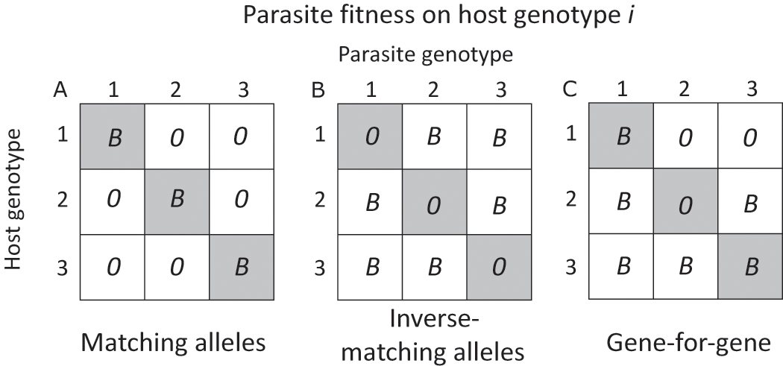

(Gibson and Lively (2019); see also Dybdahl and Storfer (2003))

* **matching alleles**: e.g. host has a **self-nonself recognition system** (typical in inverts); parasite succeeds if it matches (i.e. looks like host). Favors local adaptation, cycling/variation, dilution effects.
* **inverse matching alleles**: host matches many parasite signals (e.g. vertebrate antibody/antigen matching); parasite succeeds if it **does not** match any of the host antibodies. Doesn’t favour rare host genotypes, anti-dilution effects.
* **gene-for-gene**: like inverse matching, but there is a “universal infector” that doesn’t match anything (i.e. infects everything) (Plants: R genes, Avr genes). [Wikipedia](https://en.wikipedia.org/wiki/Gene-for-gene_relationship):

Because there would be no evolutionary advantage to a pathogen keeping a protein that only serves to have it recognised by the plant, it is believed that the products of Avr genes play an important role in virulence in genetically susceptible hosts.

Stahl et al. (1999): **Arms races** in a disease-resistance locus of *Arabidopsis*

* **trench warfare**/arms race (unidirectional)
  + resistance builds up until benefits balanced by costs
  + resistance alleles *polymorphic*
  + short-term *stabilizing* selection
  + long-term frequency cycling

## Antagonistic coevolution and sex

**Sex and variations**: we consider **dioecy** or **gonochory** (individuals are either male or female), but there are many variations: individuals may be **sequential** or **simultaneous** hermaphrodites. They may **self-fertilize** or **outcross** to different degrees.

**Costs of sex**: mating failure (vs. *reproductive assurance*), cost of males, **cost of meiosis** (when only half your genes make it into your offspring, you essentially pay a 50% fitness cost). Cost of outbreeding (breaking up co-adapted gene complexes).

Simplest if we just think of cost of meiosis and advantages of recombination, although other costs and benefits do apply.

**Advantages of sex** (not necessarily parasite-related)

* **Muller’s ratchet** (fixation of deleterious alleles within lineages) [small (10–100 individuals) populations only];
* “Kondrashov’s hatchet” (Kondrashov 1993) (an analogue that works in large populations, with epistasis); natural selection is *more* effective at purging deleterious mutations. Also see Keightley and Otto (2006) on mutation purging.
* Hard (frequency-independent) habitat selection: allows sexual populations to inhabit transient niches that may not be available to asexuals; increases probability of making it through bad years
* Soft (frequency-dependent) or “tangled bank” habitat selection: allows sexual populations to avoid competition better, since they can use a wider variety of niches

**Requirements for RQ dynamics**

* heritable variation in host resistance to parasites
* heritable variation in parasite infectivity
* specificity

## Snails and trematodes

Lively, Dybdahl and others have studied the interaction of parasitism and sexual reproduction extensively in New Zealand lakes (they started collecting about 15 years ago) where there are mixed clonal (triploid) and sexual (diploid) populations of New Zealand mud snail, *Potamopyrgus antipodarum* which are parasitized by a castrating cestode, *Microphallus* spp. Genetic (electrophoretic) variability exists in hosts; gene flow of parasites is higher than gene flow of hosts, which helps the RQ work

Primary theories for the variation in frequency of sexual snails among and within lakes:

* **Resistance tradeoffs:** tradeoff between competitive ability and resistance to parasites. *Predicts:* (A1) negative correlations between competitive ability (or frequency of asexuals) and parasite load
* **Reproductive assurance:** asexuals ensure reproduction and avoid costs of mating (assuming sexuals have some other advantage). *Predicts:* (B1) asexuals more common at low population densities; (B2) asexuals more common in less stable environments (more frequent extinction and recolonization)
* **Lottery:** (= tangled bank) sexuals survive in a wider range of (micro)habitats *Predicts:* (C1) asexuals will fail to survive alone in some habitats that are occupied by sexuals; (C2) asexuals more common in environments that are more variable in time
* **Tangled bank:** rare offspring of sexuals experience less competition *Predicts*: (D1) sexuals will be more common in (variable) environments where competition is stronger
* **Red Queen:** sexuals resist parasites better (E1) sexuals will be more common in environments with more parasites; (E2) **time-lagged host-parasite matching**: formerly common clones more susceptible to current parasites; (E3) **local adaption**: parasites should infect local (**sympatric**) hosts better than faraway (**allopatric**) hosts

## Lively et al’s experiments and observations

* Lively 1987: More sexuals in lakes (A2: no, C2: no, D1: yes, E1: yes); sexuals correlated with parasites between lakes (E1: yes)
* Lively 1989: parasites infect local hosts better, regardless of distance (E3: yes)
* Lively 1992: no correlation between pop. density and sexuality (B1: no)
* Jokela and Lively 1995, Fox et al. 1996: Sexuals correlated with parasites within lakes (E1: yes)
* Dybdahl and Lively 1995: Time-lagged association between parasites and common clones in different lakes (E2: yes)
* Jokela et al 1997: Sexuals don’t outcompete asexuals in the absence of parasites
* Dybdahl and Lively 1998: association between parasites and previously common clones (E2: yes)
* Krist et al 2000: snails in shallow water more susceptible
* Dybdahl and Lively 2000: association between parasites and (previously) common *local* hosts, but not (previously) common non-local hosts (E3: Yes)
* Dybdahl et al 2004: meta-analysis: asex more resistant than sex to allopatric parasites
* Koskella et al. 2007: parasites less infective to experimental host populations that they co-occur with than to “lagged” host populations (E2)

## Potential problems for the Red Queen

* RQ may not work without strong parasite effects on host fitness
* can sexuals compete against a diverse set of clones?
* is a tiny bit of sex enough to maintain variation without losing the advantages of asexuality?
* why is there so much *obligate* sexuality/outcrossing?
* persistent asexual lineages (e.g. bdelloid rotifers, but see Schwander (2016))

## Other theories (Meirmans and Neiman 2006)

* **Muller’s ratchet plus RQ:** Parasites drive population fluctuations which tend to fix deleterious mutations in asexual lineages. *Predicts:* Frequent parasite-induced population crashes (removing parasites should remove the crashes); Relative fitness of the population should be *higher* after crashes
* **Tangled bank plus RQ**: *Mechanism:* parasite resistance determines competitive ability. *Predicts:* competitive outcomes (between common and rare clones, or between sexuals and asexuals) should vary in the presence and absence of parasites

In all of this, we need to be careful distinguishing the true effects of sexual reproduction. Ecologists tend to assume it produces “more variable” offspring, but this is not necessarily the case. What sex really does is to allow recombination of different genotypes … what is the true relationship between sexual reproduction and variability? It depends on population size, how frequently asexual lineages are split off from the sexual population and how, etc. etc.. (Importance of **epistasis**: (Metzger et al. 2016))

## References

Dybdahl, Mark F., and Andrew Storfer. 2003. “Parasite Local Adaptation: Red Queen Versus Suicide King.” *Trends in Ecology & Evolution* 18 (10): 523–30. <https://doi.org/10.1016/S0169-5347(03)00223-4>.

Gibson, Amanda K., and Curtis M. Lively. 2019. “Genetic Diversity and Disease Spread: Epidemiological Models and Empirical Studies of a Snail–Trematode System.” In *Wildlife Disease Ecology: Linking Theory to Data and Application*, edited by Andy Fenton, Dan Tompkins, and Kenneth Wilson, 32–57. Ecological Reviews. Cambridge: Cambridge University Press. <https://doi.org/10.1017/9781316479964.002>.

Keightley, Peter D., and Sarah P. Otto. 2006. “Interference Among Deleterious Mutations Favours Sex and Recombination in Finite Populations.” *Nature* 443 (7107): 89–92. <https://doi.org/10.1038/nature05049>.

Kondrashov, A. S. 1993. “Classification of Hypotheses on the Advantage of Amphimixis.” *Journal of Heredity* 84 (5): 372–87. <https://doi.org/10.1093/oxfordjournals.jhered.a111358>.

Meirmans, Stephanie, and Maurine Neiman. 2006. “Methodologies for Testing a Pluralist Idea for the Maintenance of Sex.” *Biological Journal of the Linnean Society* 89 (4): 605–13. <https://doi.org/10.1111/j.1095-8312.2006.00695.x>.

Metzger, César M. J. A., Pepijn Luijckx, Gilberto Bento, Mahendra Mariadassou, and Dieter Ebert. 2016. “The Red Queen Lives: Epistasis Between Linked Resistance Loci.” *Evolution* 70 (2): 480–87. <https://doi.org/10.1111/evo.12854>.

Schwander, Tanja. 2016. “Evolution: The End of an Ancient Asexual Scandal.” *Current Biology* 26 (6): R233–R235. <https://doi.org/10.1016/j.cub.2016.01.034>.

Stahl, Eli A., Greg Dwyer, Rodney Mauricio, Martin Kreitman, and Joy Bergelson. 1999. “Dynamics of Disease Resistance Polymorphism at the Rpm1 Locus of Arabidopsis.” *Nature* 400 (6745): 667–71. <https://doi.org/10.1038/23260>.

Last updated: 2023-03-06 12:56:34.175156