evolution of virulence

23 October 2023

# Definitions

* **virulence**
  + (broad): decrease in a host’s fitness caused by a parasite.
  + (narrow): *per capita* rate of parasite-induced host mortality
* **resistance**: host’s ability to resist or minimize infection
* **tolerance**: host’s ability to support parasite infection without losing fitness
* **case mortality** (CM): fraction of hosts killed by infection
* Parasite-host interaction complicates the definition of virulence (assumes that a more virulent parasite is more virulent for *all* host genotypes/species)
* conceptually:
  + parasite load depends on balance between parasite *within-host reproduction rate* and host’s *parasite clearance rate*
  + virulence depends on parasite load and per-copy parasite *pathogenicity* and host *tolerance*
  + this establishes the terms of the arms race, but these components can’t be separated if we look at a single host-parasite pair (parasite virulence is often confounded with host tolerance)
* all in an arms race rather than RQ context

# Classical dogma

* Parasites evolve lower virulence over time “for the good of the species”. Group-selectionist *but* some evidence?
  + syphilis; first seen in Europe in 1495 (the “Great Pox”) (Knell 2004)
    - origins? (previously misdiagnosed; evolved increased virulence; from Africa; from the New World)
    - virulence decreased rapidly over 50 years (maybe even 5-7 years?)
  + *virgin-soil epidemics*: smallpox, etc. (Crosby 1976; Ostler 2020) (probably *not* virulence: lack of genetic resistance, previous exposure, societal breakdown, effects of colonization?)
* sampling bias?
  + biocontrol examples always select for maximal virulence
  + mild introductions may not be noticed

# Tradeoff theory

* Intermediate virulence evolves due to host-level selection (group theory returns); a tradeoff between transmission *rate* (infections/host/time) and virulence (*defined as mortality/time*) leads to maximum $R_{0}$ (total transmission per generation) at **intermediate** virulence.
* conceptually, mediated by parasite replication rate or load (cf spore production/*Daphnia* fecundity example (Decaestecker et al. 2007)

## Example: myxomatosis

Viral disease; mild in Brazilian rabbits (*Sylvilagus brasiliensis*), virulent in European rabbits (*Oryctolagus cuniculus*). Mosquito- and flea-borne. Introduced (several times) in Australia to control introduced rabbits, finally spread 1950-1951. Case mortality originally >99%, populations initially decreased by 90%. CM initially dropped to 90%, then further. Resistance: test by infecting laboratory rabbits that haven’t evolved. CM of grade III strain drops from 90% to about 50% as populations experience more epizootics. At the same time mean virus grade drops from I to III, then rebounds.

Evidence for tradeoff theory: Higher grades (higher case mortality) also have faster mortality (<13 days to >50 day survival as CM goes from >99% to <50%). Skin virus *titer* is also higher (and increases faster with time) for higher grades. Mosquito infection probability is proportional to skin titer. (Some biological complications.)

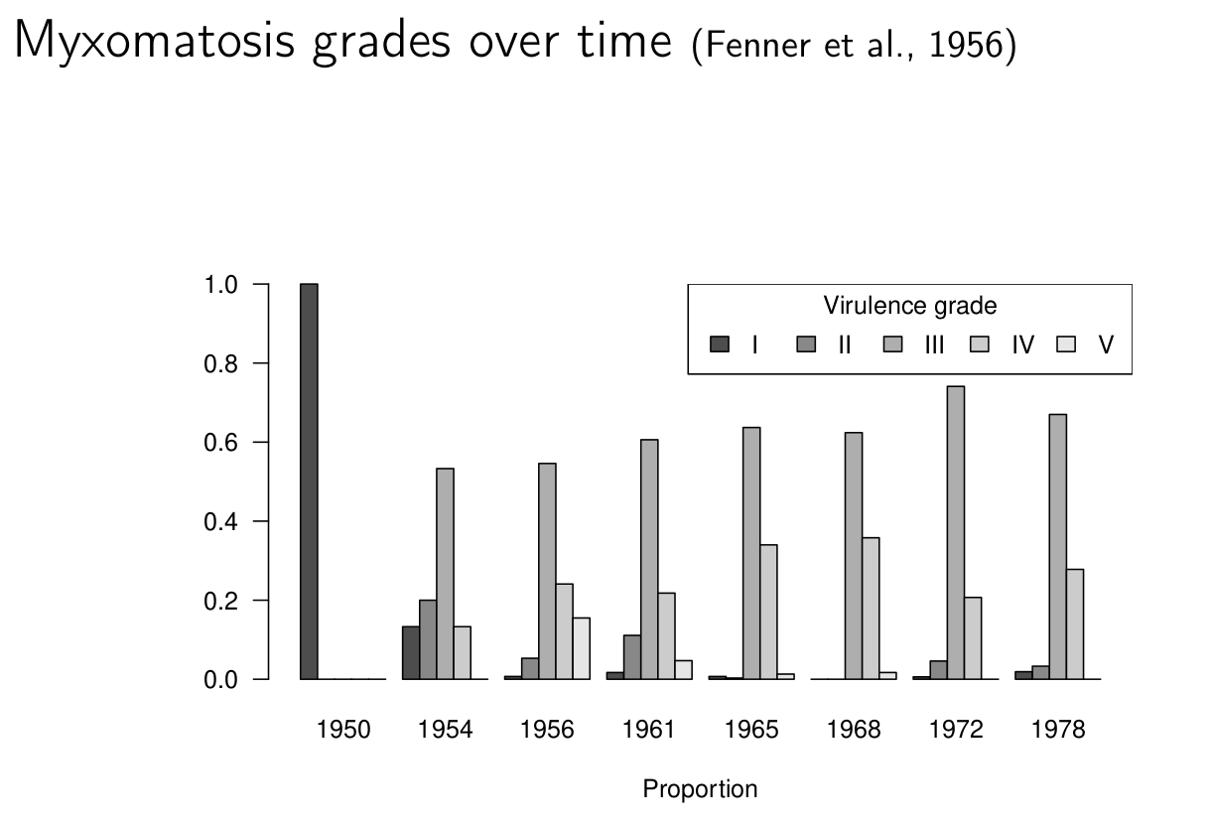

Bottom line: myxomavirus probably still reduces populations somewhat, but the Australians continue to look for other biocontrol solutions (calicivirus, rabbit haemhorrhagic disease).

Lab experiments on titers, transmission probabilities, etc. etc. etc. (Fenner, Day, and Woodroofe 1956); simulation model (Dwyer, Levin, and Buttel 1990)

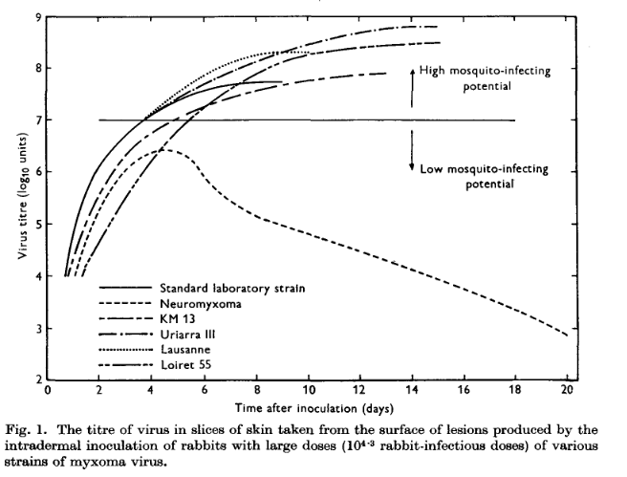

Genomic analysis: Kerr et al. (2012), Kerr et al. (2013), Kerr et al. (2022)

* Australia
  + some mutations with clear virulence effects (insertion disrupts reading frame involving cell cycle; deletion affects immunosuppressive pathway)
  + **probably** “attenuation-restoration” in Australia: attenuating mutations fixed, then restored
* Britain
  + premature stop codon disrupts immunosuppression
  + parallel evolutions, but different substitutions

## Example: HIV

* Correlations among
  + *setpoint viral load*
  + *time to progression* or *rate of CD4 decline* (mechanisms still poorly understood! within-host evolution for diversity, virulence, immune escape? immune aging?? accumulation of opportunistic infections?)
  + *transmission probability* (as measured in *serodiscordant couples*; *Rakai cohort*)
* no longer ethically measurable

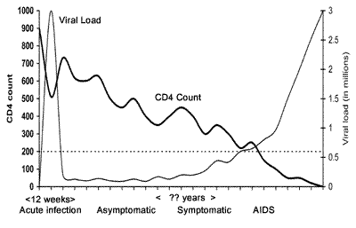

<https://www.thebodypro.com/article/course-hiv-disease>

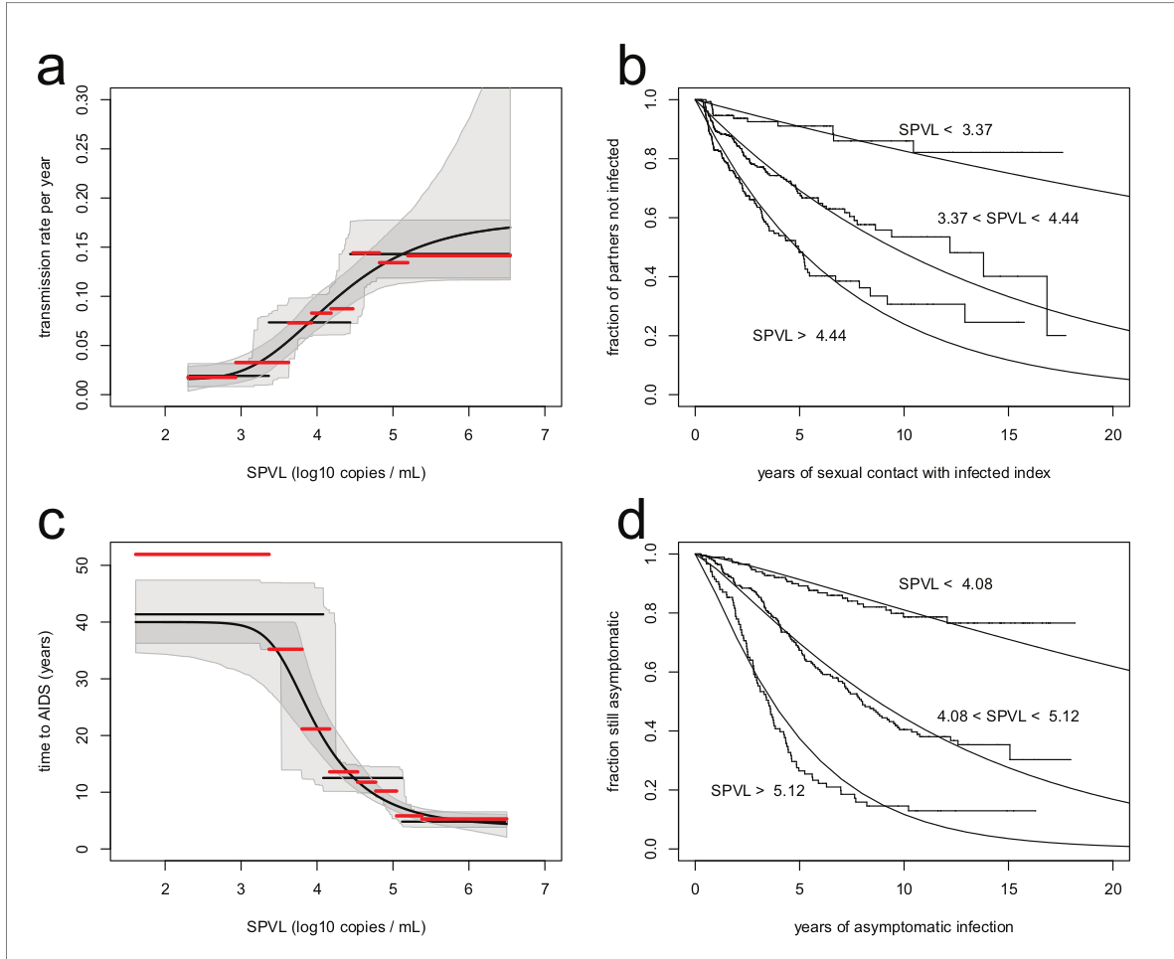

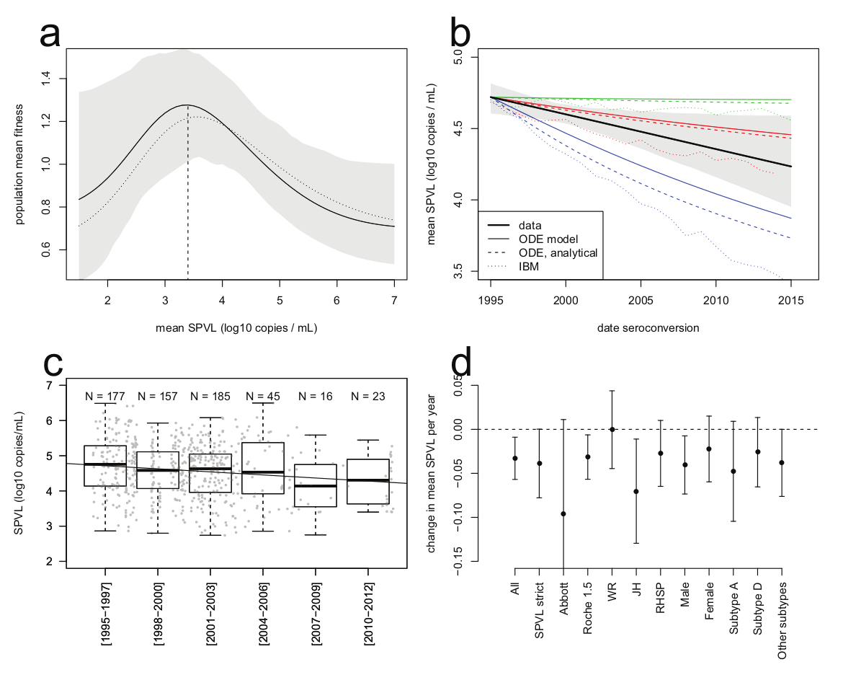

* some suggestion of overall increase in virulence (decreased CD4 count/increased viral load)
* highly variable (e.g. increasing in Italy (Müller et al. 2009)? attenuating due to spread of less virulent subtype C (Ariën, Vanham, and Arts 2007)? decreasing in Uganda (Blanquart et al. 2016)? increasing overall (Herbeck et al. 2012)?

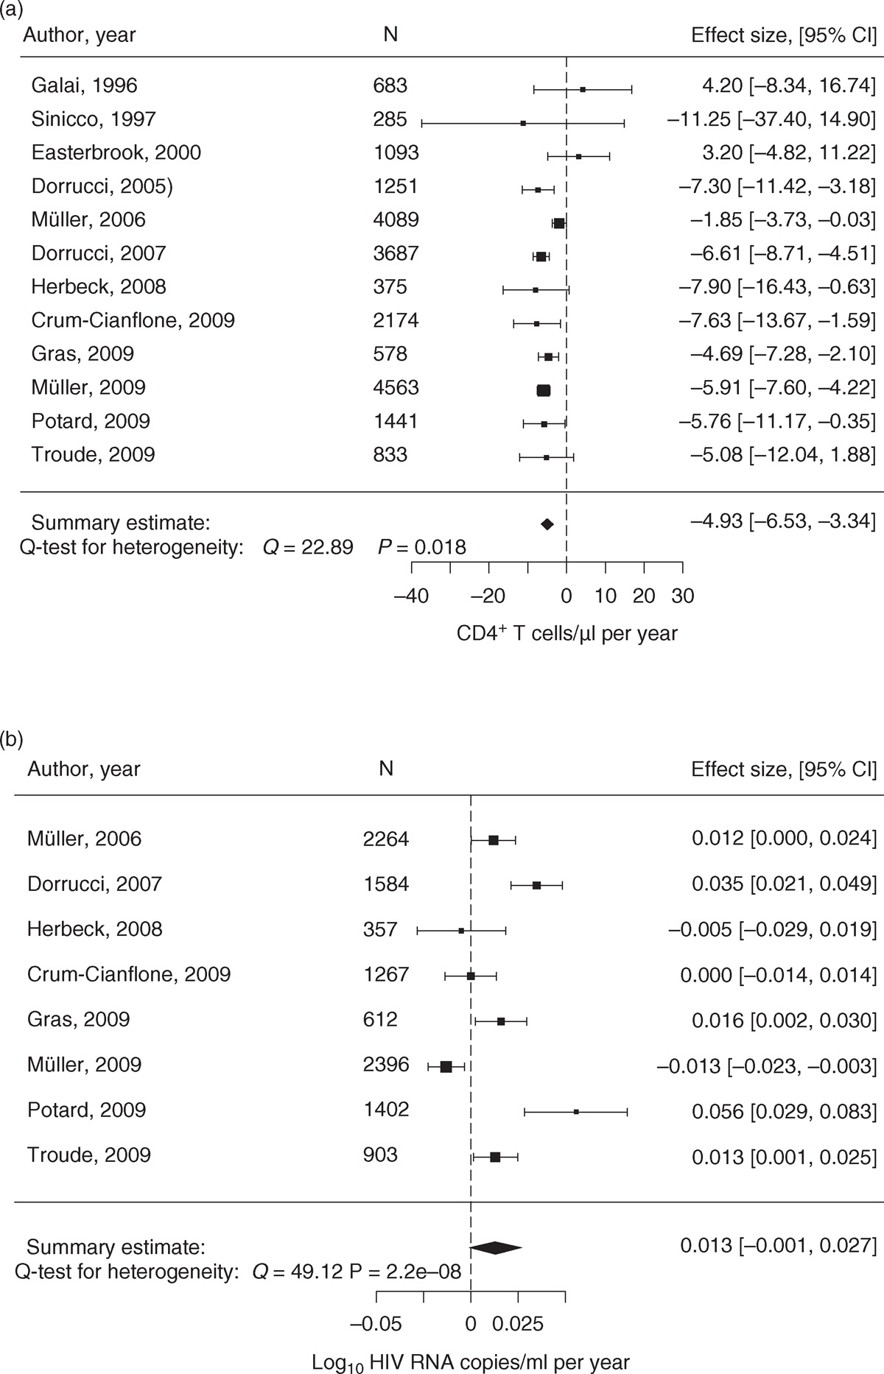

## Theory

* if there is a tradeoff, we would expect expect strong effects of **transmission mode**
  + vector-borne > direct
  + high virulence for “necrotransmission” (via dead hosts: anthrax, chronic wasting disease)
  + horizontal transmission > vertical
  + needle-borne > STD?
  + environmental (water-borne, e.g. cholera) > direct
* does higher overall transmission rate (due to population density, poor hygiene, etc.) select for higher transmission?
* **facultative** parasites (e.g. soil-borne microbes with a **facultative** stage) should be more virulent
* “curse of the pharaoh”: effect of resting stages? (Bonhoeffer, Lenski, and Ebert 1996)
* spatial restriction should? decrease virulence (Kamo and Boots 2006)
* Maximizing $R_{0}$:

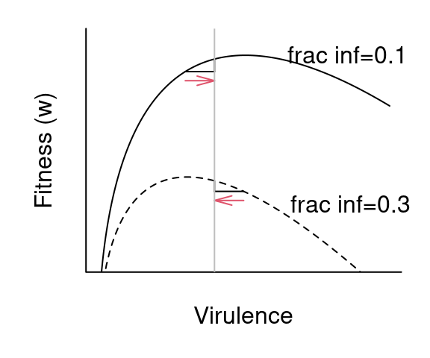

* “Virulence” could be effect of host mortality, or rapid clearance.

## Within-host competition

* basic tradeoff theory assumes one infection/strain per host
* effects of mutation, **superinfection**: within-host competition
* tends to *increase* optimal virulence

## Short-sighted evolution

* sometimes evolution is just stupid (Levin and Bull 1994)
* meningitis-producing, paralytic polio strains (central nervous system tropism)
* HIV [most transmission probably occurs during acute phases]

## Epidemic vs. endemic phases; transient virulence

* Most theory assumes that disease is at an *endemic equilibrium*, so that *lifetime fitness* (i.e.  maximization) is what matters
  + this also means that increasing overall transmission (due to population density, poor hygiene, etc.) **doesn’t** select for higher virulence
* During the exponential growth phase of an epidemic, *speed of increase* ( maximization) is what matters
  + optimal virulence is higher than for endemic equilibrium
* We expect *transient* selection for higher virulence at the beginning of an epidemic

(Frank 1996; Bolker, Nanda, and Shah 2010; Visher et al. 2021; Day and Proulx 2004; Berngruber et al. 2013; Park and Bolker 2017)

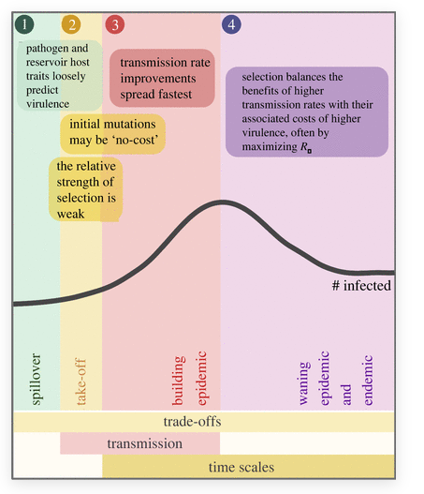

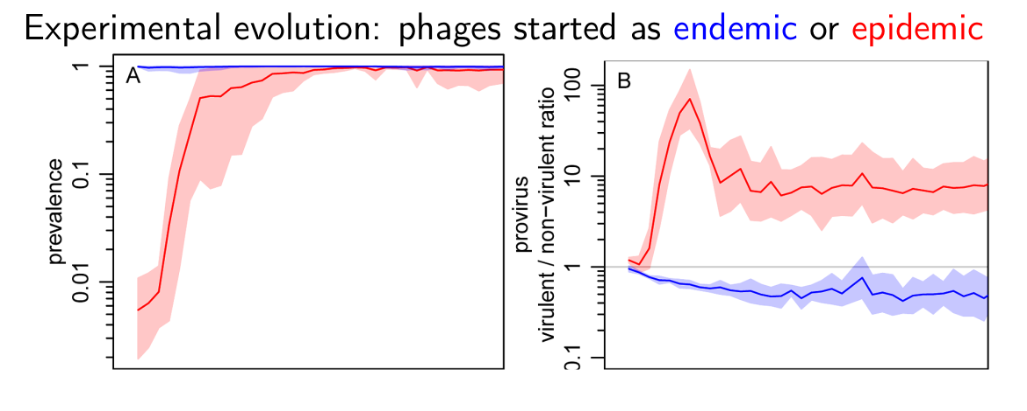

## Effects of vaccines and treatment

* evolution due to **risk compensation** (Massad et al. 2006)?
* evolution of higher virulence in unvaccinated people due to “leaky” vaccination (Gandon et al. 2001)?
* mouse malaria: (Margaret J. Mackinnon and Read 2004; M. J. Mackinnon, Gandon, and Read 2008); consistent with “arms race” upregulation of replication
* increased virulence in Marek’s disease: reduced host generation time or effects of leaky vaccine? (Atkins et al. 2013)
* [in HIV due to antiretroviral therapy](herbeck_evolution_2016)?

M. J. Mackinnon, Gandon, and Read (2008):

a cautionary approach to the widespread use of anti-replication or anti-disease vaccines seems justified. Ideally, this means combining such vaccines with transmission-blocking vaccines, bednets, drugs, housing improvements and other transmission-reducing measures

## References

Ariën, Kevin K., Guido Vanham, and Eric J. Arts. 2007. “Is HIV-1 Evolving to a Less Virulent Form in Humans?” *Nature Reviews Microbiology* 5 (2): 141–51. <https://doi.org/10.1038/nrmicro1594>.

Atkins, Katherine E., Andrew F. Read, Nicholas J. Savill, Katrin G. Renz, AFM Fakhrul Islam, Stephen W. Walkden-Brown, and Mark E. J. Woolhouse. 2013. “Vaccination and Reduced Cohort Duration Can Drive Virulence Evolution: Marek’s Disease Virus and Industrialized Agriculture.” *Evolution* 67 (3): 851–60. <https://doi.org/10.1111/j.1558-5646.2012.01803.x>.

Berngruber, Thomas W., Rémy Froissart, Marc Choisy, and Sylvain Gandon. 2013. “Evolution of Virulence in Emerging Epidemics.” *PLoS Pathog* 9 (3): e1003209. <https://doi.org/10.1371/journal.ppat.1003209>.

Blanquart, François, Mary Kate Grabowski, Joshua Herbeck, Fred Nalugoda, David Serwadda, Michael A. Eller, Merlin L. Robb, et al. 2016. “A Transmission-Virulence Evolutionary Trade-Off Explains Attenuation of HIV-1 in Uganda.” *eLife* 5 (November): e20492. <https://doi.org/10.7554/eLife.20492>.

Bolker, Benjamin M., Arjun Nanda, and Dharmini Shah. 2010. “Transient Virulence of Emerging Pathogens.” *Journal of the Royal Society Interface* 7 (46): 811–22. <https://doi.org/10.1098/rsif.2009.0384>.

Bonhoeffer, S., R. E Lenski, and D. Ebert. 1996. “The Curse of the Pharaoh : The Evolution of Virulence in Pathogens with Long Living Propagules.” *Proceedings of the Royal Society of London. Series B: Biological Sciences* 263 (1371): 715–21. <https://doi.org/10.1098/rspb.1996.0107>.

Crosby, Alfred W. 1976. “Virgin Soil Epidemics as a Factor in the Aboriginal Depopulation in America.” *The William and Mary Quarterly* 33 (2): 289–99. <https://doi.org/10.2307/1922166>.

Day, Troy, and Stephen R. Proulx. 2004. “A General Theory for the Evolutionary Dynamics of Virulence.” *The American Naturalist* 163 (4): E40–63. <http://www.jstor.org/stable/10.1086/382548>.

Decaestecker, Ellen, Sabrina Gaba, Joost A. M. Raeymaekers, Robby Stoks, Liesbeth Van Kerckhoven, Dieter Ebert, and Luc De Meester. 2007. “Host–Parasite ‘Red Queen’ Dynamics Archived in Pond Sediment.” *Nature* 450 (7171): 870–73. <https://doi.org/10.1038/nature06291>.

Dwyer, G., S. A. Levin, and L. Buttel. 1990. “A Simulation Model of the Population Dynamics and Evolution of Myxomatosis.” *Ecological Monographs* 60: 423–47.

Fenner, Frank, M. F. Day, and Gwendolyn M. Woodroofe. 1956. “Epidemiological Consequences of the Mechanical Transmission of Myxomatosis by Mosquitoes.” *J. Hyg. (London)* 54 (2): 284–302.

Frank, S. A. 1996. “Models of Parasite Virulence.” *Quarterly Review of Biology* 71 (1): 37–78.

Gandon, Sylvain, Margaret J. Mackinnon, Sean Nee, and Andrew F. Read. 2001. “Imperfect Vaccines and the Evolution of Pathogen Virulence.” *Nature* 414: 751–55.

Herbeck, Joshua T., Viktor Müller, Brandon S. Maust, Bruno Ledergerber, Carlo Torti, Simona Di Giambenedetto, Luuk Gras, et al. 2012. “Is the Virulence of HIV Changing? A Meta-Analysis of Trends in Prognostic Markers of HIV Disease Progression and Transmission.” *AIDS (London, England)* 26 (2): 193–205. <https://doi.org/10.1097/QAD.0b013e32834db418>.

Kamo, M., and M. Boots. 2006. “The Evolution of Parasite Dispersal, Transmission, and Virulence in Spatial Host Populations.” *Evolutionary Ecology Research* 8 (7): 1333–47.

Kerr, Peter J., Isabella M. Cattadori, Derek Sim, June Liu, Edward C. Holmes, and Andrew F. Read. 2022. “Divergent Evolutionary Pathways of Myxoma Virus in Australia: Virulence Phenotypes in Susceptible and Partially Resistant Rabbits Indicate Possible Selection for Transmissibility.” *Journal of Virology* 96 (20): e00886–22. <https://doi.org/10.1128/jvi.00886-22>.

Kerr, Peter J., Elodie Ghedin, Jay V. DePasse, Adam Fitch, Isabella M. Cattadori, Peter J. Hudson, David C. Tscharke, Andrew F. Read, and Edward C. Holmes. 2012. “Evolutionary History and Attenuation of Myxoma Virus on Two Continents.” *PLoS Pathog* 8 (10): e1002950. <https://doi.org/10.1371/journal.ppat.1002950>.

Kerr, Peter J., Matthew B. Rogers, Adam Fitch, Jay V. DePasse, Isabella M. Cattadori, Peter J. Hudson, David C. Tscharke, Edward C. Holmes, and Elodie Ghedin. 2013. “Comparative Analysis of the Complete Genome Sequence of the California MSW Strain of Myxoma Virus Reveals Potential Host Adaptations.” *Journal of Virology* 87 (22): 12080–89.

Knell, Robert J. 2004. “Syphilis in Renaissance Europe: Rapid Evolution of an Introduced Sexually Transmitted Disease?” *Proceedings of the Royal Society of London. Series B: Biological Sciences* 271 (suppl_4). <https://doi.org/10.1098/rsbl.2003.0131>.

Levin, Bruce R., and James J. Bull. 1994. “Short-Sighted Evolution and the Virulence of Pathogenic Microorganisms.” *Trends in Microbiology* 2 (3): 76–81. <https://doi.org/10.1016/0966-842X(94)90538-X>.

Mackinnon, M. J., S. Gandon, and A. F. Read. 2008. “Virulence Evolution in Response to Vaccination: The Case of Malaria.” *Vaccine*, The Evolutionary Consequences of Vaccination, 26 (July): C42–52. <https://doi.org/10.1016/j.vaccine.2008.04.012>.

Mackinnon, Margaret J., and Andrew F. Read. 2004. “Immunity Promotes Virulence Evolution in a Malaria Model.” *PLOS Biology* 2 (9): e230. <https://doi.org/10.1371/journal.pbio.0020230>.

Massad, E., F. A. B Coutinho, M. N Burattini, L. F Lopez, and C. J Struchiner. 2006. “The Impact of Imperfect Vaccines on the Evolution of HIV Virulence.” *Medical Hypotheses* 66 (5): 907–11.

Müller, Viktor, Franco Maggiolo, Fredy Suter, Nicoletta Ladisa, Andrea De Luca, Andrea Antinori, Laura Sighinolfi, Eugenia Quiros-Roldan, Giampiero Carosi, and Carlo Torti. 2009. “Increasing Clinical Virulence in Two Decades of the Italian HIV Epidemic.” *PLOS Pathogens* 5 (5): e1000454. <https://doi.org/10.1371/journal.ppat.1000454>.

Ostler, Jeffrey. 2020. “Disease Has Never Been Just Disease for Native Americans.” *The Atlantic*. <https://www.theatlantic.com/ideas/archive/2020/04/disease-has-never-been-just-disease-native-americans/610852/>.

Park, Sang Woo, and Benjamin M. Bolker. 2017. “Effects of Contact Structure on the Transient Evolution of HIV Virulence.” *PLOS Computational Biology* 13 (3): e1005453. <https://doi.org/10.1371/journal.pcbi.1005453>.

Visher, Elisa, Claire Evensen, Sarah Guth, Edith Lai, Marina Norfolk, Carly Rozins, Nina A. Sokolov, Melissa Sui, and Michael Boots. 2021. “The Three Ts of Virulence Evolution During Zoonotic Emergence.” *Proceedings of the Royal Society B: Biological Sciences* 288 (1956): 20210900. <https://doi.org/10.1098/rspb.2021.0900>.

Last updated: 2023-10-30 12:12:09.800148