Within-host dynamics

Understanding within-host host-parasite interactions (focus on dynamics)

Lots of molecular biology, genetics (*recognition* mechanisms and *effector* mechanisms), won’t deal with that now.

Interaction between different components of the immune system (modeled at different levels of detail/realism), parasite populations (maybe in multiple compartments?)

Longitudinal data (relatively rare), distributional data.

## HIV dynamics under (ineffective) treatment

Bonhoeffer, Coffin, and Nowak (1997)

* Early HIV antivirals: relatively ineffective due to rapid mutation
* Large decline in virus loads (up to 300-fold decline in viral RNA in some patients)
* but no clearance
* **within-host**

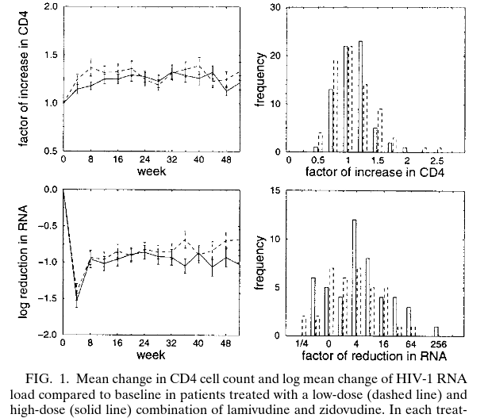

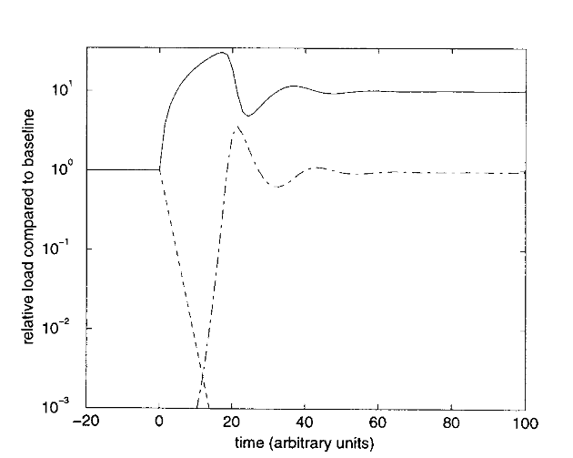

* “virus load paradox”: if is initially 50, we would have to reduce it to slightly above 1 but never **below** 1 to see these results.
* add a drug-resistant type to the model
* add mutation (and back-mutation) to the model
* add immune responses ()
* homeostasis of infectible cells (logistic growth)
* virus-induced killing of uninfected cells (e.g. gp120 shedding)
* differential effects of drug on different types
* distribution of infectibility

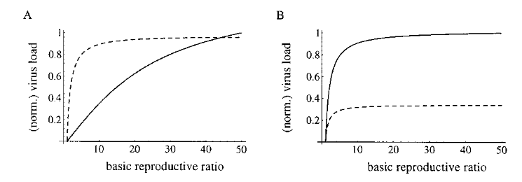

## Within-host (and within-cell) dynamics of salmonella

* intracellular bacterium

Brown et al. (2006)

* model:

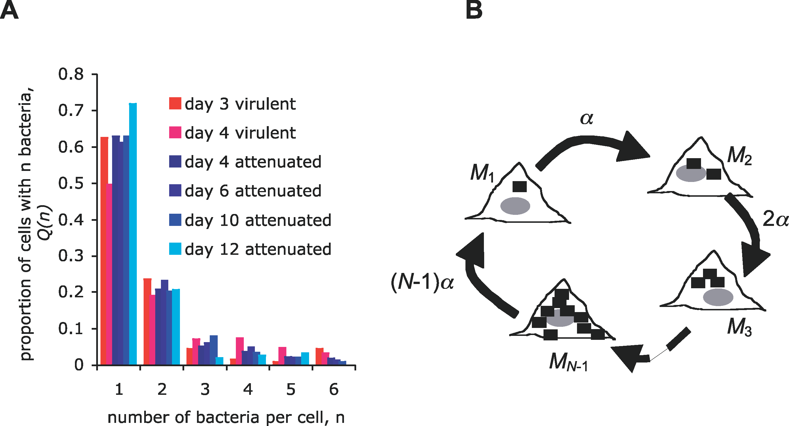

* assume that host cells are always available (infinite )

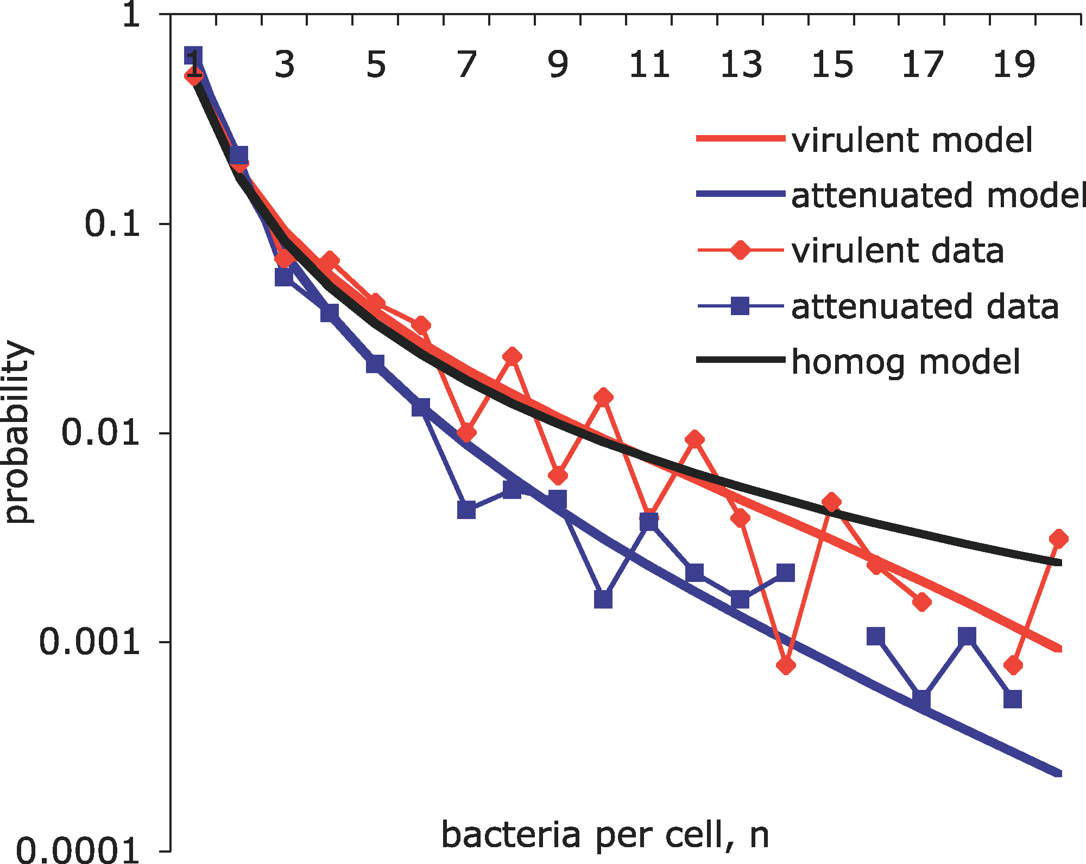

* distribution: two categories, or a range of **burst sizes** ? 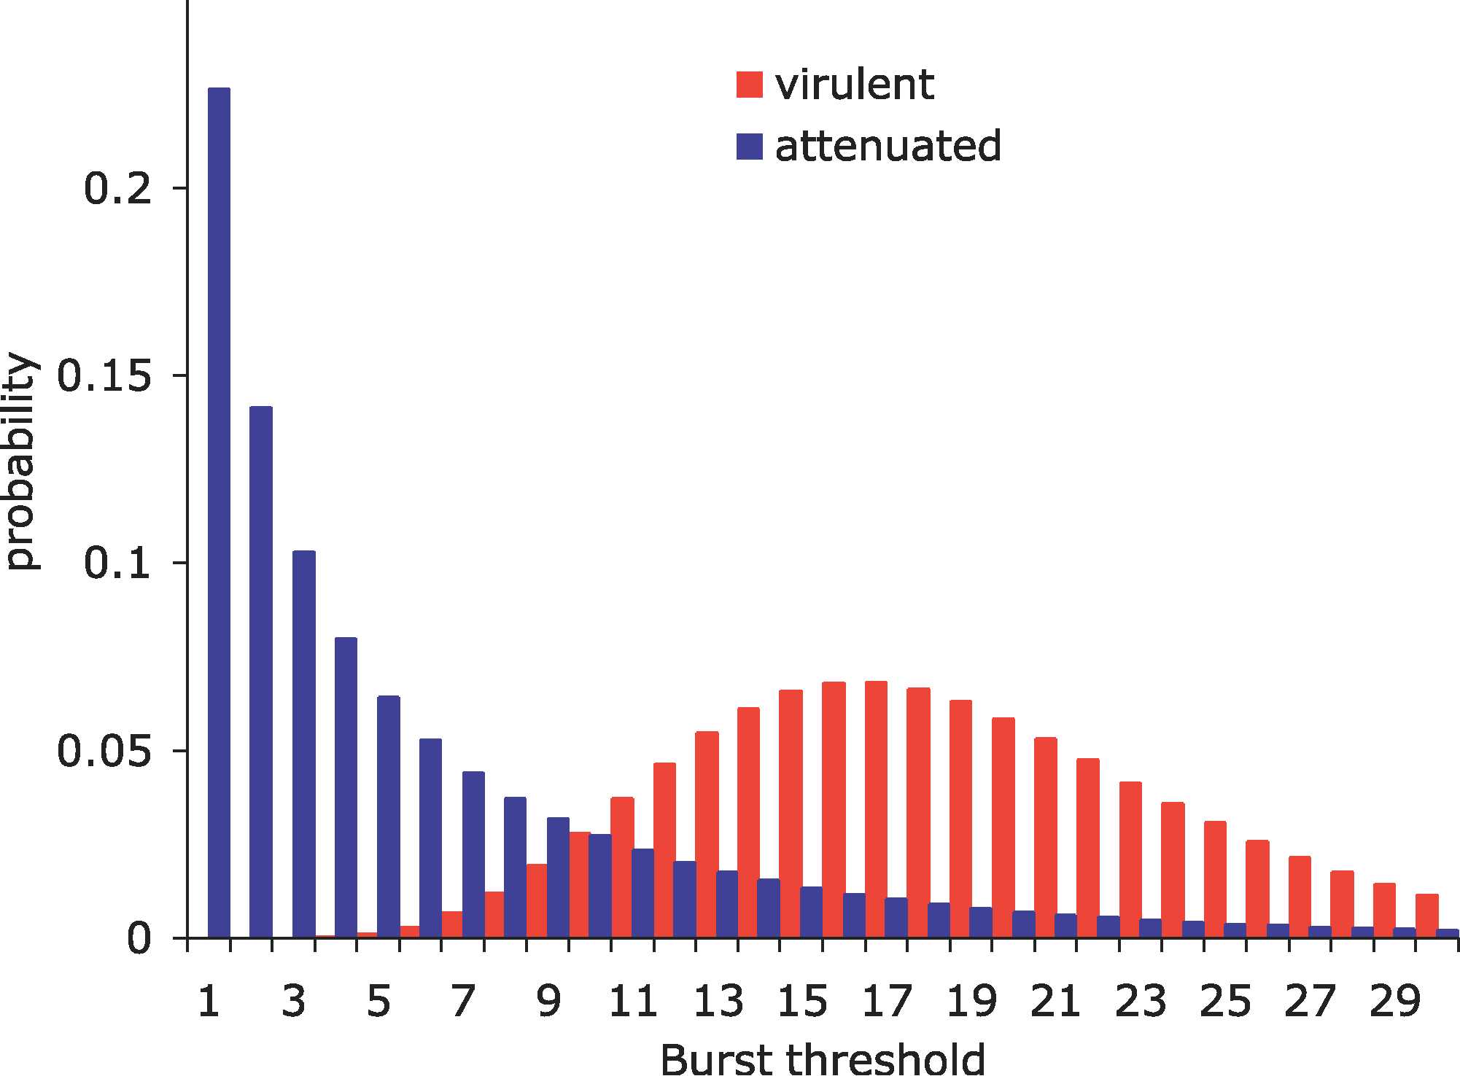
* “constitutive” vs “stochastic” models
* density-dependence in growth and/or burst probability?
* extracellular killing (bactericidal) vs slowing/preventing intracellular growth (bacteriostatic)

our analysis predicts that the efficacy of common extracellular antibiotics can be enhanced by supplementation with antibiotics slowing intracellular bacterial division [bacteriostatic drugs]. This implies that both bacteriostatic and bactericidal drugs can potentiate the therapeutic efficacy of extracellular antibiotics.

## References

Bonhoeffer, S, J M Coffin, and M A Nowak. 1997. “Human Immunodeficiency Virus Drug Therapy and Virus Load.” *Journal of Virology* 71 (4): 3275–78. <http://www.ncbi.nlm.nih.gov/pmc/articles/PMC191463/>.

Brown, Sam P, Stephen J Cornell, Mark Sheppard, Andrew J Grant, Duncan J Maskell, Bryan T Grenfell, and Pietro Mastroeni. 2006. “Intracellular Demography and the Dynamics of Salmonella Enterica Infections.” *PLoS Biol* 4 (11): e349. <https://doi.org/10.1371/journal.pbio.0040349>.

Last updated: 2023-10-02 12:17:43.244645