matplotlib

Ben Bolker

11 November 2019

## /usr/lib/python3/dist-packages/matplotlib/__init__.py:1352: UserWarning: This call to matplotlib.use() has no effect  
## because the backend has already been chosen;  
## matplotlib.use() must be called *before* pylab, matplotlib.pyplot,  
## or matplotlib.backends is imported for the first time.  
##   
## warnings.warn(_use_error_msg)

## matplotlib

* matplotlib is the Python module for making graphics and plotting data
* we’ve already used it, in the primewalk example at the beginning of the course
* we will explore some basic capabilities of matplotlib, especially the matplotlib.pyplot submodule
* resources: [matplotlib cheat sheet](https://bit.ly/python_cs), [gallery](http://matplotlib.org/gallery.html), [tutorial](https://matplotlib.org/tutorials/introductory/pyplot.html)

## basic setup

* if you have Anaconda installed, matplotlib should already be installed (for use in Spyder or Jupyter notebooks
* matplotlib is already install on syzygy
* once installed, use

import matplotlib.pyplot as plt  
import numpy as np ## we almost always use matplotlib with numpy

* plotting basics (“hello, world” for plots)

x = np.arange(5)  
plt.plot(x)

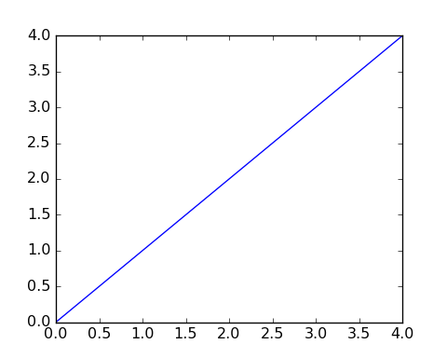

## showing/saving plots

* if using Spyder (or PyCharm), plots might just show up
* in Jupyter notebooks, put the magic %matplotlib inline in a code chunk to display plots
* use plt.show() to show plots otherwise
* use plt.savefig("filename.png") to save the figure to a file on disk (you can click to open it, or include it in a Word document, or …)

## basic plots

* a list, tuple, or 1-D ndarray will be treated as the y-axis values for a plot; the indices (0, … len(x)-1) are the x-axis points

y = np.array([1,3,2,4,8,5])  
plt.plot(y)  
plt.show(y)

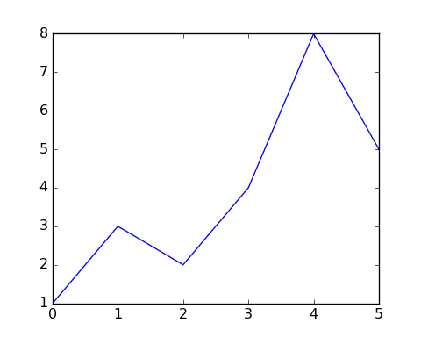

plt.savefig("example1.png")  
plt.close()

## more principled plots

* plt.plot, plt.show are “magic” functions
* better to use plt.subplots()
* returns a *tuple* with an object representing the whole **figure** and an object representing the **axes** (plot area)

fig, ax = plt.subplots()  
ax.plot(y) ## create plot  
fig.savefig("example2.png") ## save figure

## scatter plots

* .scatter() produces a *scatterplot*
* points instead of lines
* adds a margin around the points

fig, ax = plt.subplots()  
np.random.seed(101)  
x = np.random.randint(5,size=len(y))  
ax.scatter(x,y) ## create plot

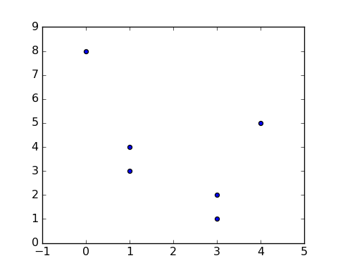

## Putting more than one thing on a plot

You can put more than one .plot() or .scatter() on the same set of axes

fig, ax = plt.subplots()  
x = np.arange(0,5*np.pi,0.1)  
y = np.sin(x)  
ax.plot(x,y)  
ax.plot(x+np.pi/2,y,color="red")

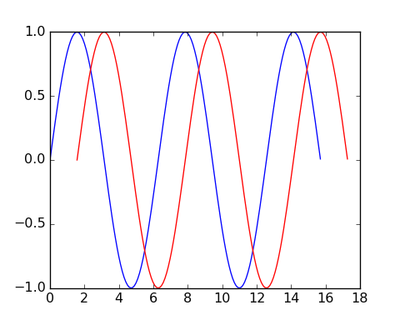

## Modifying plot appearance

* color
* marker (+, o, x, …)
* linewidth
* linestyle (-, --, -., None, …)

fig, ax = plt.subplots()  
x = np.arange(0,5*np.pi,0.1)  
y = np.sin(x)  
ax.plot(x,y,marker="x",linestyle="--",color="purple")  
ax.plot(x+np.pi/2,y,linewidth=2,color="blue")

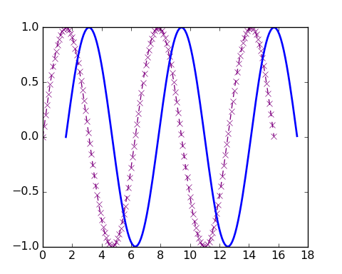

## More modifications

Shortcuts for color (first letter), marker, line style … see [plot documentation](https://matplotlib.org/api/_as_gen/matplotlib.pyplot.plot.html#matplotlib.pyplot.plot)

x = np.arange(0., 5., 0.2)  
plt.plot(x, x, "r--")  
plt.plot(x, x ** 2, "bs")  
plt.plot(x, x ** 3, "g^")

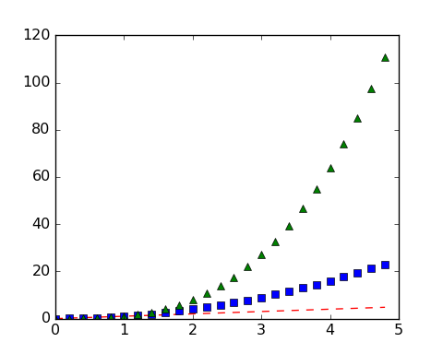

## More decorations

* add titles, axis labels …
* titles (ax.set_xlabel(), ax.set_ylabel())
* change limits
* title: fig.suptitle() (refers to figure, not individual axes)
* legend: need to specify label= for each plot element, e.g.

fig, ax = plt.subplots()  
x = np.arange(0,5*np.pi,0.1)  
y = np.sin(x)  
ax.plot(x,y,label="first")  
ax.plot(x+np.pi/2,y,color="red",label="second");  
ax.set_xlim([0,25])

ax.legend(fontsize=8)  
ax.set_xlabel("the x-axis label")  
ax.set_ylabel("the y-axis label")  
fig.suptitle("my plot")

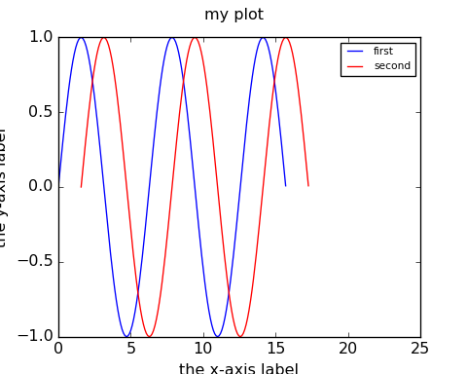

## other plot types

* matplotlib can also make bar charts, histograms, and pie charts
* plt.bar(cat, values) produces a bar chart with the items from the list or array cat (for “categories”) displayed along the x-axis, and above each category, a bar with height equal to value[i], for the i’th category.
* Here’s a bar chart with categories a through e and values given by an array of random integers:

fig, ax = plt.subplots()  
cat = np.array(["a", "b", "c", "d", "e"])  
values = np.random.randint(10, size=5)  
x_pos = np.arange(len(values))  
ax.set_xticklabels(cat);

ax.bar(x_pos,values);

fig.savefig("bar.png")

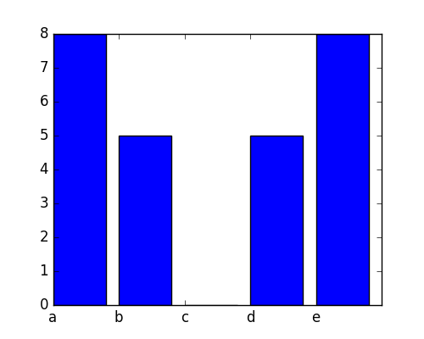

bar plot

## histograms

* a **histogram** is a visual representation of the distribution of continuous numerical data ([Wikipedia](https://en.wikipedia.org/wiki/Histogram))
* it’s a bar graph whose categories are intervals that divide some specified range into disjoint bins
* bins are usually (but not always) of equal width
  + each bin shows a bar or rectangle whose height is proportional to the frequency of the numbers falling within that range

fig, ax = plt.subplots()  
f = open("../data/cherrytree.txt", "r")  
height = []  
diam = []  
for L in f:  
 vals = np.array(L.split(),dtype="float")  
 diam.append(vals[1])  
 height.append(vals[2])  
ax.hist(height);

fig.savefig("hist.png")

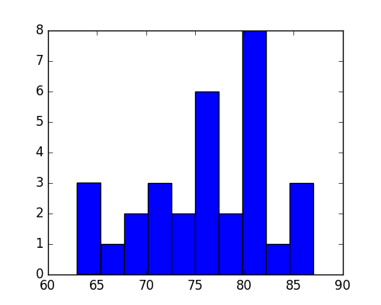

## better bin widths

fig, ax = plt.subplots()  
ax.hist(height,bins=6);

fig.savefig("hist2.png")

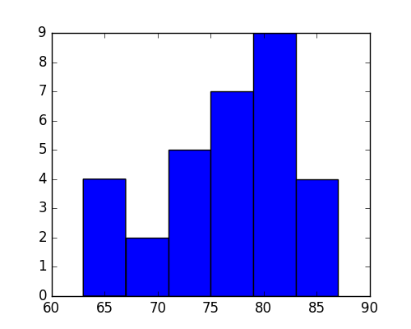

## multiple subfigures in a plot

fig, ax = plt.subplots(1,3)  
fig.set_size_inches((6,3))  
ax[0].hist(height,bins=6);

## (array([4., 2., 5., 7., 9., 4.]), array([63., 67., 71., 75., 79., 83., 87.]), <a list of 6 Patch objects>)

ax[0].set_xlabel("height")  
ax[1].hist(diam,bins=6);

## (array([ 3., 12., 7., 3., 5., 1.]), array([ 8.3 , 10.35, 12.4 , 14.45, 16.5 , 18.55, 20.6 ]), <a list of 6 Patch objects>)

ax[1].set_xlabel("diameter")  
ax[2].scatter(height,diam)  
ax[1].set_xlabel("height")  
ax[2].set_xlabel("diameter")  
fig.savefig("hist3.png")

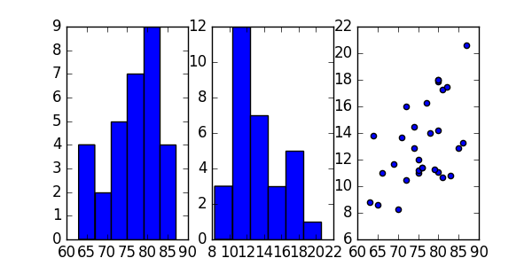

## The logistic map

* The *discrete logistic map*, $x_{t+1}=rx_{t}(1−x_{t})$, is a simple model for populations that has interesting dynamical properties.
* It is similar to the continuous *logistic model $\frac{dx}{dt}=rx(1−x)$* , but has very different dynamics when $r$ is large.
* It has equilibria at $0$ and $x^{*}=1−1/r$. For $r>1$ it mimics exponential (geometric) growth for $x_{t}≪1$.

## logistic function

* return the sequence of numbers obtained by applying the logistic map repeatedly (nt times), starting with x0 and using the value r:

def logist_map(r,nt=100,x0=0.5):  
 """ run the logistic map """  
 x = np.zeros(nt)  
 x[0] = x0  
 for t in range(1,nt):  
 x[t] = r*x[t-1]*(1-x[t-1])  
 return(x)

x = logist_map(r=1.5, nt=8)  
print(x[:4],"\n",x[4:])

## [0.5 0.375 0.3515625 0.34194946]   
## [0.33753004 0.33540527 0.33436286 0.33384651]

It’s easier if we plot the sequences:

fig, ax = plt.subplots()  
y1 = logist_map(1.5)  
y2 = logist_map(2)  
y3 = logist_map(3)  
ax.plot(y1)  
ax.plot(y2)  
ax.plot(y3,'r')  
fig.savefig("pix/lm0.png")

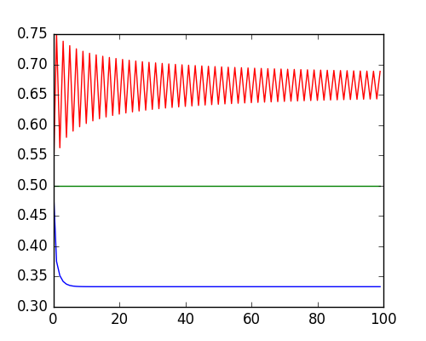

What if we make a function to do this?

* The behaviour of the sequence generated by the discrete logistic map depends strongly on $r$
* Let’s plot the elements of these sequences for a range of $r$ values.
* In the following, rvals is an array of r values ranging from 1.1 to 3.9 in steps of 0.05.
* For the ith value in this array, the ith column of the array b will hold the sequence of numbers generated with this r value. A scatter plot, with r values along the x-axis, and sequence values along the y-axis can be used to visualize the sequences generated for each r value in the array.

rvals = np.arange(1.1,3.9,0.05)  
b = np.zeros((500,len(rvals)))  
for i in range(len(rvals)):  
 b[:,i] = logist_map(r=rvals[i],nt=500)

* np.tile(x,s) takes a vector and replicates it a number of times specified by the tuple s

fig, ax = plt.subplots()  
rmat = np.tile(rvals,(500,1))  
ax.scatter(rmat,b)  
fig.savefig("pix/lm1.png")

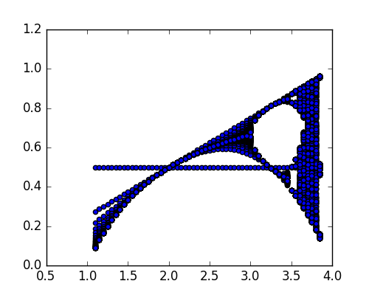

## now without the transient

fig,ax = plt.subplots()  
b2 = b[250:,]  
rmat2 = np.tile(rvals,(250,1))  
ax.scatter(rmat2,b2)  
fig.savefig("pix/lm2.png")

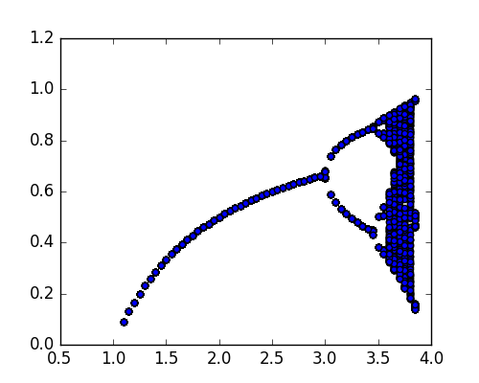

## now as an image plot

fig,ax = plt.subplots()  
ax.imshow(b2,aspect="auto",extent=[1.1,3.9,250,500],interpolation="none")  
fig.savefig("pix/lm3.png")

