numerical integration; Game of Life

Ben Bolker

17 November 2019

## numerical integration

In first year calculus the definite integral of a function over the interval is defined to be the limit of a sequence of *Riemann sums*:

where and - So the definite integral can be approximated using Riemann sums for suitably large values of

## coding Riemann sums in numpy

import numpy as np  
def num_int(f, a, b, n):  
 dx = (b-a)/n  
 x = np.arange(a, b, step = dx)  
 y = f(x)  
 return y.sum() * dx

Note this takes a *function* f as input.

## example

Try approximating with

def x_squared(x):  
 return x ** 2  
approx1 = num_int(x_squared, 0, 1, 10)  
approx2 = num_int(x_squared, 0, 1, 50)  
approx3 = num_int(x_squared, 0, 1, 5000)  
print(approx1, approx2, approx3)

## 0.2850000000000001 0.3234 0.33323334

We could create an *adaptive* version of this that keeps trying larger values of n until the results are “close enough”

## refinements

* num_int uses the *left endpoint* rule to compute Riemann sums for a function
* In Section 7.7 of Dr. Stewart’s Calculus textbook, several other methods are presented.
* The *right endpoint* and *midpoint* rules are simple variations of the left endpoint rule:

## other rules

* **trapezoid rule**: use the average of the approximations obtained by using the left and right endpoint rules
* **Simpson’s method**: use quadratic functions (parabolas) instead of linear functions to interpolate

We’ll write a function that implements any of these rules, and check it with and .

## area of a circle

* what if we want to figure out the area of a circle with radius 1?
* (we already know it’s 1)
* because , one quadrant is traced out by the function from to 1
* (we could do this symbolically: = )
* let’s try it with our integrator from above

## Monte Carlo integration

* “Monte Carlo” in general refers to **any** algorithm that uses (pseudo) random numbers
* a Monte Carlo method to approximate :
* draw a square of area 1
* inscribe a quarter circle (with radius = 1)
* the area of the quarter-circle is equal to
* randomly throw darts in the square and count the number of them that fall within the circle (i.e. )
* the ratio of the number that fall into the circle to the total number thrown should be close to the ratio of the area of the circle to the area of the square
* the more darts thrown, the better the approximation.

## 

import matplotlib.pyplot as plt  
import numpy.random as npr  
x = np.linspace(0,1,101)  
y = np.sqrt(1-x**2)  
fig, ax = plt.subplots()  
ax.plot(x,y)  
xr = npr.uniform(size=200)  
yr = npr.uniform(size=200)  
incirc = xr**2+yr**2<1  
plt.plot(xr[incirc],yr[incirc],"b-*")  
plt.plot(xr[np.logical_not(incirc)],yr[np.logical_not(incirc)],"r-*")

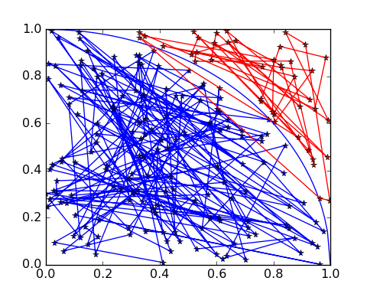

import matplotlib.pyplot as plt  
import numpy as np  
x = np.linspace(0,1,101)  
y = np.sqrt(1-x**2)  
plt.figure(figsize=(4,4))  
plt.plot(x,y)  
plt.savefig("pix/qtrcirc.png")

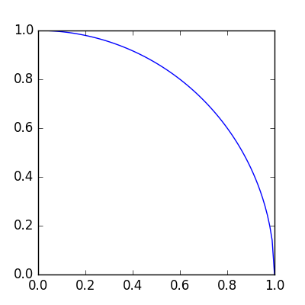

quarter circle

## another example

Overlap of circles at (1.5,2.5) (radius 1), (4,3) (radius 3), (1,2) (radius 2)

## (-2, 8)

## (-2, 8)

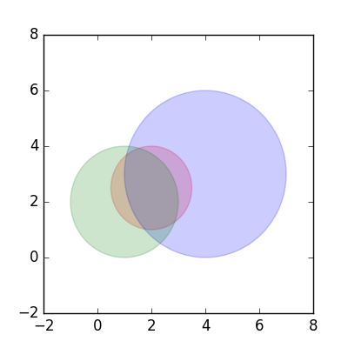

import numpy.random as npr  
import numpy as np  
c = ((2,2.5),(4,3),(1,2))  
r = (1.5,3,2)  
npr.seed(101)  
x = npr.uniform(c[0][0]-r[0],c[0][0]+r[0],size=1000000)  
y = npr.uniform(c[0][1]-r[0],c[0][1]+r[0],size=1000000)  
tests = np.tile(True,10**6)  
def incirc(x,y,ctr,radius):  
 dsq = (x-ctr[0])**2+(y-ctr[1])**2  
 return(dsq<radius**2)  
for c0,r0 in zip(c,r):  
 tests = tests & incirc(x,y,c0,r0)  
 print(np.mean(tests))

## 0.78613  
## 0.658081  
## 0.48976

print(r[0]**2*np.mean(tests))

## 1.10196

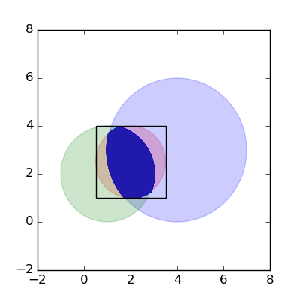

## Conway’s game of life

Rules:

* set up a rectangular array of cells
* set some cells to 1 (“alive”) and some to 0 (“dead”)
* live cells with exactly 2 or 3 neighbours live; others die
* dead cells with exactly 2 neighbours become living; others stay dead

## pieces

* life_init(size, init_dens): set up a size*size 2D array of zeros; set a density init_dens to 1
* life_step(w,nw): run the Conway rules on an array w and return the new array nw
* count_nbr(w,i,j): count the number of neighbours in the 3x3 square around w[i,j]
* life_show(w, ax): plot an image of the current array w on axes ax

## examples

import os  
import matplotlib.pyplot as plt  
os.chdir("../code")  
from life import *  
os.chdir("../notes")  
w = life_init()  
fig, ax = plt.subplots()  
life_show(w, ax)  
fig.savefig("pix/life1.png")

nw = w.copy()  
(nw, w) = life_step(w,nw)  
life_show(w, ax)  
fig.savefig("pix/life2.png")

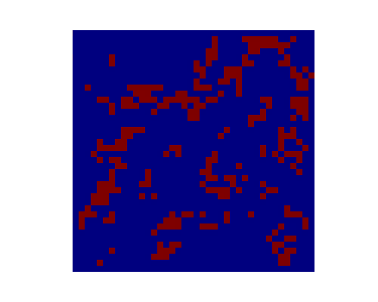

fig, ax = plt.subplots(5,5)  
for i in range(ax.shape[0]):  
 for j in range(ax.shape[1]):  
 nw, w = life_step(w,nw)  
 life_show(w, ax[i][j])  
fig.savefig("pix/life3.png")

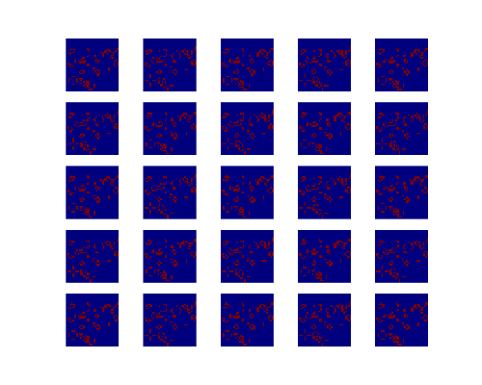

fig, ax = plt.subplots(5,5)  
for i in range(ax.shape[0]):  
 for j in range(ax.shape[1]):  
 for k in range(10):  
 life_show(w, ax[i][j])  
 nw, w = life_step(w,nw)  
fig.savefig("pix/life4.png")

