functions and modules

Ben Bolker

15:35 17 September 2019

## Functions

Reference: [Python tutorial section 4.6](https://docs.python.org/3/tutorial/controlflow.html#default-argument-values)

* *the* most important tool for structuring programs
* allows *modularity*
* basic definition: def function_name(args): plus indented code block
* inputs are called **arguments**. outputs are called **return values**
* when function is called, go to the function, with the arguments, run code until you hit return() (return None if you get to the end without a return)

## Return values

* most functions return values
* might not … *side effects*
  + input/output (create a plot, write output to a file, turn on a machine, …)
  + changing a (mutable!) variable

## Function arguments

* basic arguments: *unnamed*, *mandatory*
* think of them as dummy variables; could be the same or different from the name in the calling environment

## examples (try in Python tutor)

def add_one(x):  
 x = x+1  
 return(x)  
x = 2  
print("add_one=",add_one(x),", x=",x)

## add_one= 3 , x= 2

z = 2  
print("add_one=",add_one(x),", x=",x)

## add_one= 3 , x= 2

z is **immutable** (a number), so it doesn’t change; if you want it to change, use z=add_one(z)

## mutability and functions

Changes within functions follow the standard mutability rules:

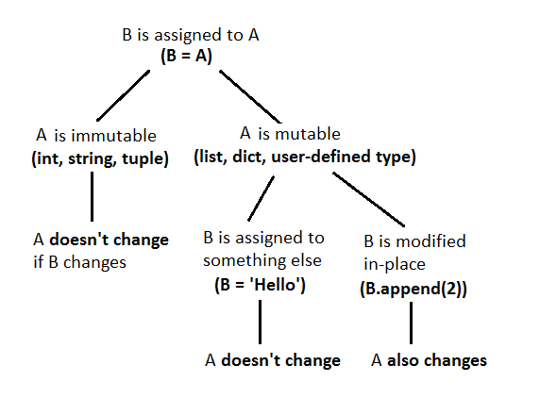

mutability mnemonic

Compare:

def no_return(x):  
 x = [2,3,4]  
 return(None)  
  
z = [1,2,3]  
no_return(z)  
z

## [1, 2, 3]

With:

def no_return(x):  
 x[0] = 7  
 return(None)  
  
z = [1,2,3]  
no_return(z)  
z

## [7, 2, 3]

## optional arguments

* give *default* values
* for user convenience
* e.g. logarithm: def log(value,math.e)

## Docstrings

* always say something about what your function does. (Feel free to give me a hard time in class if I don’t.)

def documented_function():  
 """this is a function that does  
 nothing very useful  
 """  
 return(None)

## Example

def add_function(a, b):  
 """ the sum of two numbers  
 Parameters  
 ----------  
 a : num  
 b : num  
 Returns  
 -------  
 sum : num  
 The sum of a and b  
 Examples  
 --------  
 >>> add_function(2, 5)  
 7  
 >>> add_function(3, -1.4)  
 1.6  
 """  
 sum = a + b  
 return sum

## retrieving docstring

print(add_function.__doc__)

## the sum of two numbers  
## Parameters  
## ----------  
## a : num  
## b : num  
## Returns  
## -------  
## sum : num  
## The sum of a and b  
## Examples  
## --------  
## >>> add_function(2, 5)  
## 7  
## >>> add_function(3, -1.4)  
## 1.6  
##

# Errors

## Example code to work with

## Types of errors

* **syntax errors** vs. **logic errors**
* a working [matrix sum function](code/sum_matrix_good.py)
* failure modes from logic errors:
  + obvious failure
    - program stops with an error partway through: [bad matrix sum #0](../code/sum_matrix_noinit.py)
    - Python crashes
    - machine crashes
    - program never stops (infinite loop)
  + wrong answer
    - always vs. sometimes (obvious categories) vs. sometimes (mysterious)
    - obvious vs. subtle

Next section follows [this presentation](http://space.wccnet.edu/~pmillis/cps120/presentations/program_logic_errs.ppt)

* infinite loops:

print("Please enter (y)es or (n)o")  
cin = input()  
while ((response != "y") or (response != "n")):  
 print("Please try again")

[bad matrix #1](../code/sum_matrix_infloop.py) * operator precedence mistakes, e.g. $Δfahrenheit=ΔCelsius×1.8$

fahrdiff = celsius_high - celsius_low * 1.8

* off-by-one error (“fencepost problem”)
* … more generally, **edge** or **corner cases**
* code incorrectly inside/outside loops:
* [bad matrix #2](../code/sum_matrix_bad2.py)
* [bad matrix #3](../code/mandelbrot_bad3.py)
* array index error (outside bounds)

## Error messages

* error messages are *trying* to tell you something
* Google error messages (with quotation marks)

## Debugging

* *brute-force logic* (“Feynman method”): stare at your code, try to figure out what’s wrong  
  (test cases: why is it failing in one specific situation?)
* flow charts, *pseudocode*
* tracing (print() statements)
  + put print statements before and after if conditions
  + before and after loops
  + in places where you suspect something might go wrong
* interactive tracing
* debugging tools (breakpoints/watchpoints/watches)

## Searching for/asking for help

## Searching for help

* Google (or your search engine of choice)
* be as specific as possible

## Asking for help

* reproducible/minimal workable examples
  + right amount of context
  + “how to ask” ([StackOverflow](http://stackoverflow.com/help/how-to-ask))
* browse/lurk in forums first!
* tone
* where:
  + forums
  + StackOverflow

## Testing

* Simplify, simplify, simplify
* Reduce the size of your problem
* Cases with easy/known answers
* “corner” & “edge” cases
* Random tests ([fuzz testing](http://en.wikipedia.org/wiki/Fuzz_testing))
* Automatic testing framework: nose
  + built-in Python package
  + define test file
    - basic: assert <condition>
    - extra: from nose.tools import assert_equal, assert_raises (or something)
    - (generating an error: raise ErrorType("message"), e.g. raise ValueError("non-conformable matrices")
    - each test or set of tests as a separate function
    - see [test_mm.py](../code/test_mm.py)
  + nosetests/run in PyCharm
* Test-driven development: write tests **first**!

## Additional resources

* <http://stackoverflow.com/questions/1623039/python-debugging-tips>
* <https://www.udacity.com/course/cs259>
* <http://www.cs.yale.edu/homes/aspnes/pinewiki/C%282f%29Debugging.html>
* <http://www.cs.cf.ac.uk/Dave/PERL/node149.html>