Benoit Bourdin

Agile/DevOps transformation lead at DXC

*(remote from Asturias, Spain)*

**This resume is leveraging DevOps**: *Automatically built from* [*source code by a CI/CD pipeline*](https://github.com/bbourdin/resume/)*), and can be downloaded as* [*HTML*](https://bbourdin.github.io/resume//index.html)*,* [*PDF*](Benoit-Bourdin-resume.pdf)*,* [*Markdown*](https://github.com/bbourdin/resume//blob/gh-pages/Benoit-Bourdin-resume.md) *or* [*Word*](Benoit-Bourdin-resume.docx)*. One-slide view formats:* [*HTML*](Benoit-Bourdin-slide.html)*,* [*Powerpoint*](Benoit-Bourdin-slide.pptx)*,* [*PDF*](Benoit-Bourdin-slide.pdf) *or* [*PNG*](Benoit-Bourdin-slide.png)*. To be notified on updates, go to* [*the repository*](https://github.com/bbourdin/resume/) *and* [*click on Watch*](https://docs.github.com/en/get-started/quickstart/be-social#watching-a-repository)*.*

## Profile

[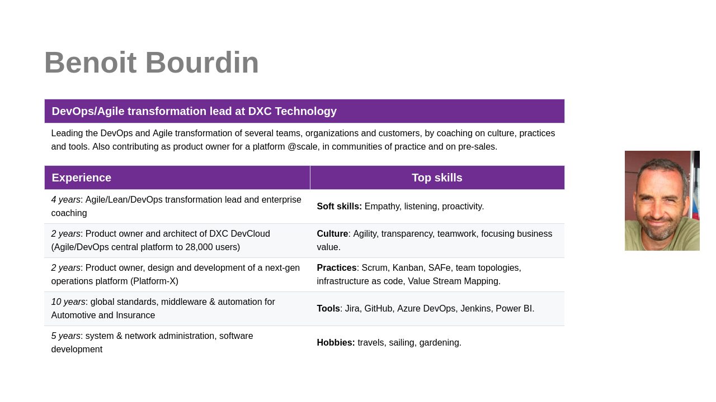](Benoit-Bourdin-slide.html)

|  |  |
| --- | --- |
| **Total experience:** 18 Years | **Experience in DXC:** 14 Years |
| **Current Job Title: Agile/DevOps transformation lead** | **Time in Current Role:** 3 years |
| **Visa/Work permit:** N/A | **Validity Date of Visa/Work Permit:** N/A |
| **Willing to relocate:** No | **Willing to travel:** Yes |

### Contact

|  |  |
| --- | --- |
| Email ID | Contact |
| [benoit.bourdin@gmail.com](mailto:benoit.bourdin@gmail.com) | [GitHub](https://github.com/bbourdin) / [LinkedIn](https://www.linkedin.com/in/benoit-bourdin-b9b2642/) |

### 100-word biography/profile presentation

Benoit is leading the DevOps and Agile transformation of several DXC teams, organizations and customers, by coaching on the Agile/Lean/DevOps culture, practices and the tools. He is also contributing as product owner of the DXC central DevOps/Agile platform to 28,000 active users, in several communities of practice and for pre-sales.

Previously, Benoit has also worked as middleware & automation SME in DXC, leading projects for large customers, global standards for all customers, architectural roadmap of an automation platform and led all the automation initiatives. Before DXC, Benoit worked as system administrator, after several experiences in software development and network administration.

## Quotes

Here are some quotes from our customers or account executive during 2022:

“*Sharing thanks and appreciation for Benoit’s good work for [this customer]. He is contributing and supporting in a great way for my team.*”

Regional Account Delivery Lead - Manufacturing

“*I would like to also thanks Benoit for all his help completing the VSM for our team. His deep knowledge and understanding help us achieve this in a very reasonable and short time. I can’t wait to continue working with him as we move to the next step. [It is an] outstanding job you are doing when coaching us that benefits DXC and [the customer].*”

Application Development lead - Manufacturing

“*Benoit is very responsive and helpful - anytime we have questions or need help looking into solutions, he provides detailed responses and includes multiple options/choices for solutions that make it easier for us to make informed decisions.*”

Director of IT applications - Media & Entertainment

“*Benoit is very knowledgeable within his domain, he is able to answer all the questions we have. If he doesn’t have the answer, he will diligently research them and respond without us having to remind him.*”

Project manager - Media & Entertainment

## Experience

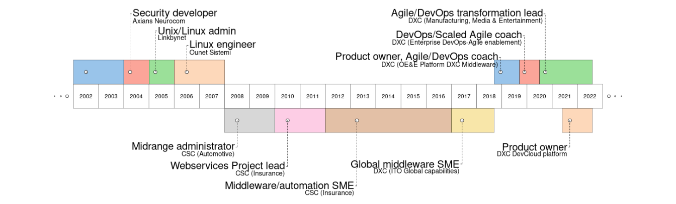

### Key Roles Performed

* Agile/Lean/DevOps transformation lead and coach (4 years)
* Product owner (2 years)
* Supervisor/team leader (2 years)
* Global Middleware SME (2 years)
* Middleware/automation SME (10 years)
* System administrator (5 years), Software Developer (2 years), Network administrator (2 years)

## Skills

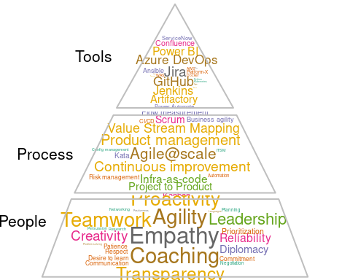

### Top Skills (Technical/Nontechnical skills)

* DevOps culture, practices and tools (4 years)
* Agile culture, methods and tools (4 years)
* Lean method, Value Stream Management (2 years)
* Product management, engineering and development (2 years)
* Middleware: web servers, application servers (11 years)
* ITSM practice (10 years)
* Unix/Linux (10+ years), Software development (Java, C, Shell… - 2 years), Networking (2 years)

## Experience detailed

### DXC Technology

* *Large manufacturing customer* (from 2020) - **Agile and DevOps transformation lead**
  + Leading the DevOps/Lean/Agile enablement team (team of coaches) for this account. Weekly consulting on agility, scaling agile and team topologies, Kanban for flow management, training, agile tooling (Azure DevOps, Jira, Jira Cloud, Planner), value stream mapping, measurement of leading (flow metrics) and lagging indicators (business outcomes).
  + Led two Value Stream Mapping (VSM) workshops, clarified team APIs, implementation of a continuous improvement framework with the leaders, leveraging transformation patterns for small and specific improvements using a Kata template.
  + Identification of the transformation expected outcomes in partnership with the customer, and implementation of the measurements.
* [*DXC DevCloud*](https://github.dxc.com/pages/Platform-DXC/devcloud-docs/) (from 2021) - **Product owner of the Agile/DevOps central platform**
  + Product owner of the Agile/DevOps central platform, to 28,000 (active) users. Consisted of tools (hosted on AWS) for agile (Jira), source code (GitHub), CI/CD (Jenkins), artifacts (Artifactory), documentation management (Confluence)
  + Managing a team of 3 proxy product owners, 15 DevOps engineers plus a bot and 38 CI/CD pipelines we develop and maintain.
  + Outcomes and value-driven, created and managing a backlog of features, defects, risks and technical debt. Balancing priorities, distribution and knowledge gaps. Continuous management of risks and technical debt thanks to an impact/probability matrix. Measuring/reviewing the customer experience (UX/DX) and the flows/increments of development/operations (flow metrics) on an automated dashboard after every sprint of 2 weeks (using Power BI, R, Grafana, AWS and Confluence).
  + Created a vision of Freemium model to regulate the cost and demand. Leading the internal marketing.
  + Leveraging our existing communities of practices to empathize with our customers and the business context.
* *Entertainment industry customer* (from 2020) - **Scaled Agile coach and agile platform lead**
  + Coaching the customer for improved workflows, SAFe implementation (with Jira BigPicture/Advanced roadmaps) and employee experience (with Jira service desk). Leading the agile platform admin team (Jira) on daily support and the community of practice. Advising on the process/tooling strategy and licensing.
* *DXC community (from 2017)* - **agile/DevOps coach and leader of communities of practice**
  + Pre-sales of coaching services, delivery of coaching services (also called advisory or enablement services). Value Stream Mapping workshops for several customers.
  + Agile and DevOps coaching for other customers and internal organization, for their specific question or use case, leveraging many other different patterns, practices and tools.
  + Co-leader of the main DevOps/Lean/Agile and of the team topologies community of practice in DXC. Contributor to all the other DevOps/Lean/Agile communities of practice (presentations, consulting, creation of re-usable assets…) including Agile contracting, Value Stream Mapping, [Agile@scale](mailto:Agile@scale), SRE… Speaker on different topics like asynchronous communication, agile metrics, GitOps, DataOps.
  + Speaker and part of the staff (scrum master) of the DXC Agile Marathon every year, which is a global event of 24 hours with presentations from all our best agile champions. Driving the staff to be an high performance agile team using innovation, Scrum (ex: sprints of 2 days), Azure DevOps.
* [*Enterprise DevOps/Agile enablement*](https://github.dxc.com/pages/bionix/storefront/products/DevOps/) *team* (2019-2020) - **DevOps/Scaled Agile coach**
  + Coaching at scale, coaching coaches, targeting 200,000+ employees to embrace the DevSecOps and Scaled Agile transformation to maximize the value stream.
  + Participating on the product owning (of the [DXC Jira](https://github.dxc.com/pages/Platform-DXC/devcloud-docs/jira/%20platform), Scrum/Kanban flow (Dev and Ops), architecture (Jira cloud), engineering of our [DevCloud platform](https://github.dxc.com/pages/Platform-DXC/devcloud-docs/), a ready-to-use platform to easily achieve the DevSecOps/Agile practice to 20,000+ users by doing both Dev (Node.JS, Groovy, Python, Java…) and Ops (AWS, Docker, Linux, middleware, DB…). Co-leading the [major migration to Jira 8](https://dxc.workplace.com/groups/DevCloud/permalink/690211148207878/).
  + Improved practice by collaboration to our communities on most of the Agile and DevOps culture and principles, including Lean, CI/CD, everything as code, Value Stream Mapping, team topologies.
  + Scaled Agile coaching, embracing the Lean/Agile practice by being a principal support in [OE&E Scaled Agile](https://github.dxc.com/Platform-DXC/ScaledAgile/) (1500+ individuals), coaching the PMO, Program and Teams.
  + Scrum master and then Release Train Engineer (RTE) for the team during a transition period of 6 months. Managed the challenges of attrition, knowledge transfer/gaps, COVID, quick changes on priorities and ways of working, risk management. No outage visible to the users, met critical deadlines, ensured a continuous flow of delivery using Kanban, supported the product manager/owners and management on the changes.
* *OE&E (Operations Engineering and Excellence)* (2018-2019) - **Platform DXC middleware product owner, Agile/DevOps coach**
  + Product owner of the Platform DXC/CVA middleware content (strategic [end-to-end monitoring](https://github.dxc.com/Platform-DXC/architecture/blob/master/Cross-Pillar-Processes-and-Flows/Discovery-to-RBA.md) product - only [the middleware piece](https://github.dxc.com/Platform-DXC/monitoring-catalog#middleware)), supervisor of the middleware team. Optimizing the ROI by setting priorities and optimizing resources. Roadmapping, risk and dependencies management. Team building, facilitating the communication and onboarding new resources.
  + Automation and Middleware chief architect, working on the end to end DevOps automation chain integrated in the next digital transformation platform of our global company (Platform DXC/Platform-X and the Customer Virtual Appliance - CVA/Edge-X).
  + Supporting/improving the [development process](https://github.dxc.com/OEE-Content-Factory/PDXC-Content-Process/), ROI (by being product owner), and design of these solutions to be onboarded to new and existing customers, spread across 70 countries and delivered though a network of digital transformation delivery centers.
  + DevOps and ScaledAgile coach, daily supporting programs, scrum masters, leads and teams of 100+ developers to their Agile/DevOps transformation. Improving their Agile maturity, embracing and improving the [Scaled Agile implementation](https://github.dxc.com/Platform-DXC/ScaledAgile/) of the organization. Leading the DevOps implementation, bringing innovation, for example by deploying [testing pipelines](https://github.dxc.com/OEE-Content-Factory/PDXC-Content-testing/), [test automation](https://github.dxc.com/Ansible-Global/jenkins-ansibletest-lib) or [GitOps](https://github.dxc.com/OEE-Content-Factory/GitOps-PDXC-ansible-lib).
* *IT Operations global capabilities* (2017-2018) - **Global capability middleware SME**
  + Optimization of the delivery operations for the middleware capability, in all the service management areas. Establishing standards and best practices globally for all the middleware installations in DXC. Supporting the development of automation (python, shell) and the delivery team of all the accounts worldwide for any technical concern.
  + Leading the middleware automation (DevOps and Bionix) initiatives, supporting the digital transition by building new standards using new methods (Agile) and tools (Jenkins, GitHub, Artifactory, Ansible/IAF/Raffia, docker, AWS, Jira, Azure DevOps …).
  + Scrum master, improving transparency and delivery flow of the team

### Computer Sciences Corporation (CSC)

Prior to the merge of CSC to DXC Technology:

* *Large insurance customer* (2012- 2017) - **Middleware and automation SME**
  + Leading middleware automation & DevOps solutions. Suitable for provisioning, configuration and deployments on the middleware, and integration with the Cloud (DXC Agility). Mainly using Ansible, GIT, Bitbucket, Bamboo.
  + Building standards and solutions for WAS, tomcat , JBoss, Weblogic, Apache.
  + Worked on high-scale/pressure projects, under a direct visibility from the CIO, including :
    - Kolumbus: application modernization program, automation of the end-to-end provisioning and configuration of the middleware+application (100+ instances) using DevOps/Ansible, $5.5M revenue, Benoit received an award for the Project Management Excellence FY18
    - Data center move: coordination of the middleware activities and application troubleshooting during the data center move events (1000+ applications), automation of the network assignment. F2F recognition from the customer CIO, our CEO directly recognized our team for this project in a meeting call.
  + Third level support, problem solving, optimization.
* *Large insurance customer* (2010-2012) - **European Webservices Project lead** 
  + Leading infrastructure projects and architecture decision of Webservices team for half of the Insurance business units. Time and resource management (nearshore+offshore).
  + Communication with the client, and all DXC teams (SM, PM, architects…)
  + IBM Websphere application server 8.5 + apache full installation and administration. Third level support, problem solving, optimization.
  + Building standards and solutions for WAS, JBoss, Tomcat, Weblogic
* *Large automotive customer* (2008-2010) - **JavaEE and Websphere expert, midrange administrator**
  + IBM Websphere application server (WAS3,4,5,6,7 and WAS CE1,2) + apache full installation and administration. Third level support : analyzing, optimization and fine troubleshooting.
  + Training and supervising a technical team in India.
  + Leading technical projects, with direct communication to the client and Service Delivery Managers.
  + Application management : documentation revision, monitoring management, incident and problem solving, RCA owning.
  + JBoss and tomcat administration. Shell and JACL+ Jython scripting, occasional Unix/Linux and network activities.

### Previous Relevant Work Experience

* *OUnet Sistemi (Rome, Italy) - Novell Partner* (2006-2008) - **Linux/Windows engineer** Monitoring systems (Nagios), wireless (Cisco WLC) and SLES/OES servers installation and administration, user support.
* *Linkbynet (Saint Denis, France)* (2005-2006) - **Linux/Windows engineer** Installing OS&applications (Apache/MySQL, Oracle, Websphere…) in a production network (450 servers, 1000 clients). Bash and Perl programming, network security.
* *Axians Neurocom (Le Pecq, France), Vinci Energies* (2005) - **Linux/Windows engineer** Monitoring systems (Nagios), wireless (Cisco WLC) and SLES/OES servers installation and administration, user support.
* *Several companies in Paris, France* (2002-2004) - **Several roles** Technical trainer, C++/network programming, C programming for Nagios+Squid, Linux clustering administration, networking (cisco) administration.

### Previous work Rewards/Recognition

* [FY20Q3 recognition in the organization (OE&E)](https://dxcportal.sharepoint.com/sites/bionics/_layouts/15/Doc.aspx?sourcedoc=%7BC62D4844-44AD-4CA0-BE9F-71B27AA193A2%7D&file=OE%26E%20All%20Employee%20Town%20Hall%20-%20January%2028th%202020.pptx&action=edit&mobileredirect=true) as Middleware SME and Agile/DevOps coach
* [FY18 Project Management Excellence](https://my.dxc.com/our-company/operating-model/deliver/2018-pm-award-winners-.html) for the Kolumbus Guidewire Program in the Large insurance customer

### Industry Experience

* Manufacturing – 2 years
* Media/Entertainment – 1 year
* Insurance – 7 years
* Automotive – 3 years
* Legal service – 2 years

## Education and other

09/2005 Master’s degree in Networks and Telecommunications, Paris XI university, Orsay, France.

07/2004 Degree and master’s in computer science Paris XI, Orsay, France.

07/2002 Polytechnic university (DUT informatique), IUT Orsay, France.

07/1999 A Level of Science (Baccalaureat), Saint Vincent school, Senlis, France.

### Certifications (Professional Activities, Certifications, and Training Attended)

* Agile practices (official training) - 2019
* Architecting on AWS (official training) - 2016
* IBM Websphere Application Server (official trainings) :
  + V6 - 2008
  + V8.5 - 2014
  + performance tuning and security - 2015
* Oracle Weblogic administration 12c (official training) - 2015
* IBM Filenet (official training) - 2015
* IBM ITCAM – 2014
* Information Technology Infrastructure Library (ITIL, training+certification) – 2014
* Solaris (official training) – 2008
* Novell Suse 10 (CLP and CLE certifications) - 2008

### Languages

French: mother tongue

Spanish: fluent (living&working in Spain since 2008)

Italian : fluent (2 years living&working in Italy)

English: high (12 years working in English, 4 years for customers in US)

German : good skills/A1

### Hobbies/personal

I use to spend most of my personal time taking care of my two kids (7 and 9 years), but also in gardening at home and sailing in the Cantabrian Sea.