开源硬件总结

##第一天

####学习内容

·为什么要学习开源硬件

·如何学习开源硬件

·三个软件

arduino

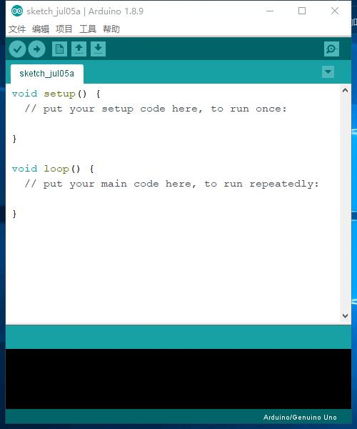

Fritzing

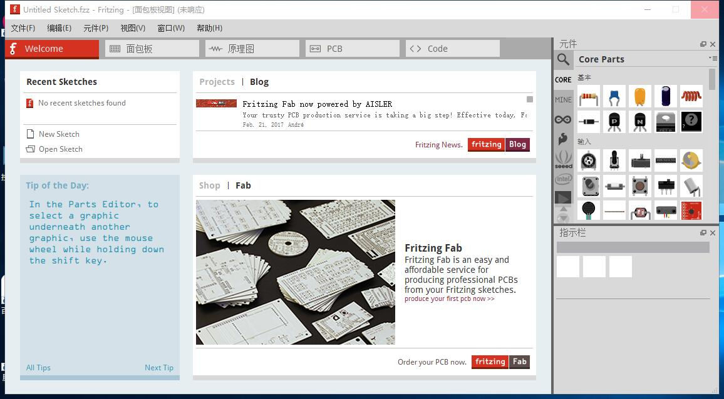

Processing

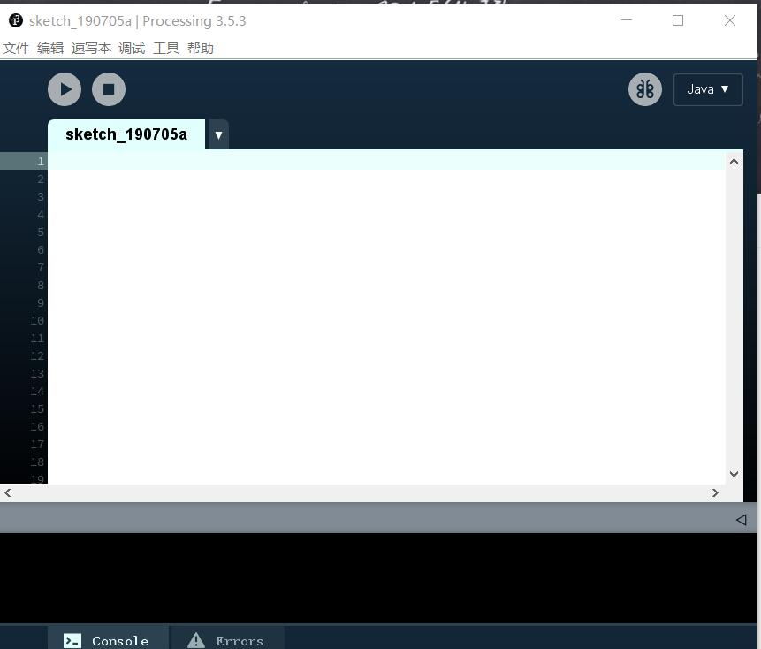

·几个常用网站

[arduino网址](https://arduino.cc)

[fritzing网址](https://fritzing.org)

[processing网址](https://processing.org)

创建了github账号、安装了arduino、fritzing、processing.

##第二天

arduino编程

#include<Morse.h>

主要内容：

Morse代码，库函数形式。

Morse morse(13);

//定义莫尔斯电码表

char MORSE[][4]={

{'.', '-', '*', '*'}, //A

{'-', '.', '.', '.'}, //B

{'-', '.', '-', '.'}, //C

{'-', '.', '.', '*'}, //D

{'.', '*', '*', '*'}, //E

{'.', '.', '-', '.'}, //F

{'-', '-', '.', '*'}, //G

{'.', '.', '.', '.'}, //H

{'.', '.', '*', '*'}, //I

{'.', '-', '-', '-'}, //J

{'-', '.', '-', '*'}, //K

{'.', '-', '.', '.'}, //L

{'-', '-', '*', '*'}, //M

{'-', '.', '*', '*'}, //N

{'-', '-', '-', '*'}, //O

{'.', '-', '-', '.'}, //P

{'-', '-', '.', '-'}, //Q

{'.', '-', '.', '*'}, //R

{'.', '.', '.', '*'}, //S

{'-', '*', '*', '*'}, //T

{'.', '.', '-', '*'}, //U

{'.', '.', '.', '-'}, //V

{'.', '-', '-', '*'}, //W

{'-', '.', '.', '-'}, //X

{'-', '.', '-', '-'}, //Y

{'-', '-', '.', '.'},//Z

};

void setup() {

Serial.begin(9600); // put your setup code here, to run once:

}

void loop() {

String str = "";

String morse_s = "";

int i, t, temp = 0;

int n = 0;

while(Serial.available()>0){

temp = 1;

str += char(Serial.read());

delay(2);

n++;// put your main code here, to run repeatedly:

}

if (temp){

for (i=0;i<n;i++)

{

for(t=0;t<4;t++)

{

if(str[i]>=97 && str[i]<=122)

{

morse_s +=char(MORSE[int(str[i]-97)][t]);

}

}

morse_s +=' ';

}

Serial.println(morse_s);

for (i=0;morse_s[i]!='\0';i++)

{

if(morse_s[i] =='.')morse.dot();

else if(morse_s[i]=='-')morse.dash();

else if(morse_s[i]==' ')morse.w_space();

if(morse_s[i] !=' ' && str[i] != '*')morse.c_space();

}

Serial.println("发送完毕");

delay(2);

}

}

##第三天

小车代码和电路图

void setup()

{

pinMode(0,OUTPUT);

pinMode(1,OUTPUT);

pinMode(2,OUTPUT);

pinMode(3,OUTPUT);

pinMode(4,OUTPUT);

pinMode(5,OUTPUT);

Serial.begin(9600);

}

byte income=0;

void loop()

{

if(Serial.available()>0)

{income=Serial.read();

income=income-'0';

if(income&0x1)

{

digitalWrite(1,HIGH);

}

else

{

digitalWrite(1,LOW);

}

if((income>>1)&0x1)

{

digitalWrite(2,HIGH);

}

else

{

digitalWrite(2,LOW);

}

if((income>>2)&0x1)

{

digitalWrite(3,HIGH);

}

else

{

digitalWrite(3,LOW);

}

if((income>>3)&0x1)

{

digitalWrite(4,HIGH);

}

else

{

digitalWrite(4,LOW);

}

}

delay(10);

digitalWrite(0,HIGH);

delay(10);

}

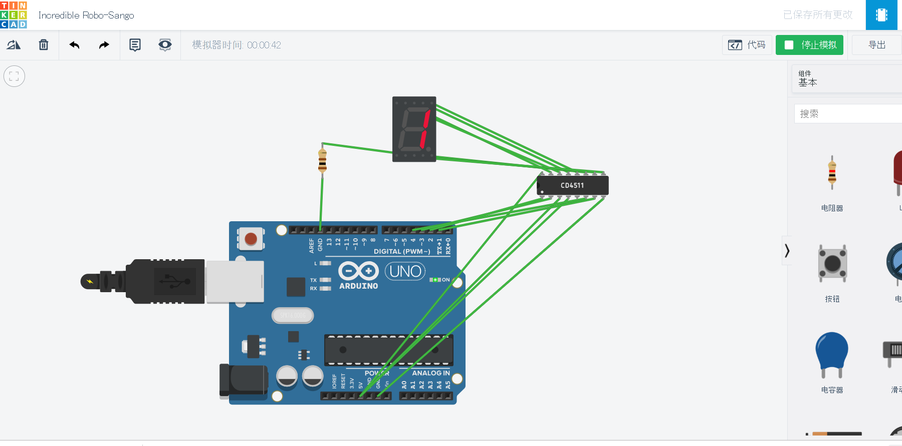

##第四天

MORSE代码tinkercad可运行代码

int _pin=13;

int _dottime=250;

void dot()

{

digitalWrite(_pin,HIGH);

delay(_dottime);

digitalWrite(_pin,LOW);

delay(_dottime);

}

void dash()

{

digitalWrite(_pin,HIGH);

delay(_dottime*4);

digitalWrite(_pin,LOW);

delay(_dottime);

}

void c_space()

{

digitalWrite(_pin,LOW);

delay(_dottime*3);

}

void w_space()

{

digitalWrite(_pin,LOW);

delay(_dottime*7);

}

char MORSE[][4] = {

{'.', '-', '*', '*'}, //A

{'-', '.', '.', '.'}, //B

{'-', '.', '-', '.'}, //C

{'-', '.', '.', '*'}, //D

{'.', '*', '*', '*'}, //E

{'.', '.', '-', '.'}, //F

{'-', '-', '.', '*'}, //G

{'.', '.', '.', '.'}, //H

{'.', '.', '*', '*'}, //I

{'.', '-', '-', '-'}, //J

{'-', '.', '-', '*'}, //K

{'.', '-', '.', '.'}, //L

{'-', '-', '*', '*'}, //M

{'-', '.', '*', '*'}, //N

{'-', '-', '-', '*'}, //O

{'.', '-', '-', '.'}, //P

{'-', '-', '.', '-'}, //Q

{'.', '-', '.', '*'}, //R

{'.', '.', '.', '*'}, //S

{'-', '*', '*', '*'}, //T

{'.', '.', '-', '*'}, //U

{'.', '.', '.', '-'}, //V

{'.', '-', '-', '*'}, //W

{'-', '.', '.', '-'}, //X

{'-', '.', '-', '-'}, //Y

{'-', '-', '.', '.'} //Z

};

void setup()

{ pinMode(_pin,OUTPUT);

Serial.begin(9600);

}

void loop()

{

String str = "";

String morse_s = "";

int i, t , temp = 0;

int n = 0;

while (Serial.available() > 0)

{

temp = 1;

str += char(Serial.read());

delay(2);

n++;

}

if (temp)

{

for (i = 0; i < n; i++)

{

for (t = 0; t < 4; t++)

{

if (str[i] >= 97 && str[i] <= 122)

{

morse_s += char(MORSE[int(str[i] - 97)][t]);

}

}

morse_s += ' ';

}

Serial.println(morse_s);

for (i = 0; morse_s[i]!='\0' ; i++)

{

if (morse_s[i] == '.')dot();

else if (morse_s[i] == '-')dash();

else if (morse_s[i] == ' ')w_space();

if (morse_s[i] != ' ' && str[i] != '*')c_space();

}

Serial.println("发送完毕");

delay(2);

}

}

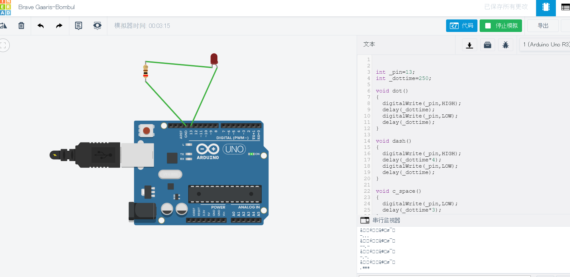

##以上，就是为期四天的开源硬件学习课程，虽然时间很短，但是感觉还是学到了很多东西，也许有一些只是入门，但是万事开头难，这些东西为让我再以后的空闲时间里能够有一些更有趣的事情可做

Morse:7.3号课下作业，

Car：7.4号课堂作业

7.4课下作业：7月四号的课下作业

7.5作业：7月五号在[www.tinkercad.com模拟morse](http://www.tinkercad.com模拟morse)码的作业