Network Design Proposal
Benjamin A. Boyer
Framingham State University (FSU)

Table of Contents
Introduction 2
Corporate Business Description 2
Network Requirements Specification 2
Network Components and Features 2
Floor Space and Layout 6
LAN Configuration 7
Overall Cabling Layout (Internet & POE) 7
Employee Computer Systems 8
Employee Voice Systems 8
Corporate & Internet Servers 8
WAN Connection 9
Cost Breakdown 9
Conclusion 9
References 10
Appendix 11

Introduction
This document will provide a network design for Boyer Technologies, a small electrical components manufacturer in Milford, MA, USA. There are 20 employees total across the company. The documentation will provide a detailed plan and drawing of the network for the company. Each employee has an office room, a cell telephone, and a laptop computer with a wireless network card as well as a wired network card so that it can be used as both a desktop inside the office and a mobile laptop.

Corporate Business Description
The company name is Boyer Technologies and the industry that the company operates in is electronics manufacturing. The location is in Milford, MA, with a size totaling 20 employees total, 5 within manufacturing and shipping, 15 in corporate positions. Boyer Technologies specializes in manufacturing electronic components, specifically CAT6 cabling, display adapters, and lithium batteries. Boyer Technologies operational scope is within a local reach, emphasizing value to local businesses.

Network Requirements Specification
- Scalability – Ensure Boyer Technologies has the capacity to easily expand and accommodate for future employee growth
- Security – Utilize best practices in terms of network security such as utilizing:
  - Firewall Protection
  - Intrustion Prevention System
- Performance – High-speed (Gigabit ethernet) is mandatory, low latency wired connections where possible, otherwise utilize robust wireless signal strength
- Redundancy – Utilize best practices in terms of redundancy such as:
  - Backup Power (UPS)
  - Data backup solutions (RAID on servers)

Network Components and Features
Network Components list: (See Full Table Below)
Router, Firewall, Core Switch, Wireless Access Point, Ethernet Cabling (CAT6) , Server, Laptops, VoIP phones, UPS

Component | Requirement | Vendor | Product Name | Specs/Features | Cost | Pros | Cons | Select?
Router | Business grade router with gigabit ports and VLAN support | TP-Link | TP-Link Archer AXE75 | 802.11ax with 6E  MU-MIMO, IPv6 Compatible, Quality of Service, VPN Client Pre-Installed, Anti-Malware Tools, Wireless Parental Controls, Beamforming, Guest Networking | $199 | Easy to install, Reasonably priced, 6GHz transmissions, Solid throughput performance | Middling file transfer performance, No multi-gig ports, Some features require a subscription | No
Router |  | Synology | Synology WRX560 | 802.11ax  MU-MIMO, IPv6 Compatible, Quality of Service, VPN Client Pre-Installed, Anti-Malware Tools, Wireless Parental Controls, Link Aggregation, Beamforming, Guest Networking | $219 | Easy installation, Excellent throughput and signal performance, Built-in parental-control and network-security software, Mesh-ready, Multi-gig WAN/LAN | Middling file transfer performance, Top heavy design | Yes
Router |  | ASUS | Asus ZenWiFi BQ16 Pro | MU-MIMO, IPv6 Compatible, Anti-Malware Tools | $1099 | Excellent performance and wide coverage, Dual 6GHz bands, Lots of networking ports plus USB connectivity, Network security and parental control software included | Expensive, No 2.5GbE ports | No
Firewall | Enterprise level protection and small business scalability built in | Ubiquiti | UniFi Dream Machine | Integrated firewall, VPN, VLANs, Deep Packet Inspection, IDS/IPS, QoS | $299 | Easy to manage, all in one security + routing, integrates with UniFi ecosystem | No advanced config compared to pro gear | No
Firewall |  | Fortinet | FortiGate 40F | Stateful firewall, SSL inspection, IPS, SD-WAN, 5x GE RJ45 ports, 950 Mbps throughput | $389 | Excellent security features, enterprise grade for SMB, FortiOS interface | Slightly higher price | Yes
Firewall |  | Netgate | Netgate 1100 (pfSense) | pfSense firewall OS, VLANs, OpenVPN, IDS/IPS (snort/suricata), 3x gigabit ports | $179 | Very customizable, open source software, low power usage | Steeper learning curve for beginners | No
Switch | Managed gigabit switch with VLAN & QoS support | TP-Link | TL-SG2210MP | 8x Gigabit POE + ports, 2x SFP slots, VLAN, 802.1Q, QoS, DHCP snooping, IGMP | $129 | PoE support for VoIP/WAP, VLANs, fanless silent design | Only 8 ports + 2 uplinks | Yes
Switch |  | Cisco | CBS250-16T-2G Smart Switch | 16x Gigabit ports, 2x Gigabit SFP uplinks, VLANs, Layer 2 switching, Cisco Business Dashboard support | $209 | Great manageability, high reliability, industry standard | Slightly higher price, steep learning curve for new users | No
Switch |  | Netgear | GS316EP | 16x Gigabit ports, 8x POE+, VLAN, QoS, Loop Prevention, Web GUI | $169 | Budget friendly, PoE support, plug and play with GUI | Less feature depth than Cisco/TP-Link for VLAN management | No
Wireless AP | Dual-Band Wi-Fi 6, VLAN tagging, PoE Compatible | TP-Link | Omada EAP650 | Wi-Fi 6 (802.11ax), 2.4GHz + 5GHz, Gigabit Ethernet, VLAN support, PoE+, MU-MIMO, Omada SDN platform | $109 | Excellent price, strong performance, centralized management, PoE+ support | Requires Omada controller for full management | Yes
Wireless AP |  | Ubiquiti | UniFi U6 Lite | Wi-Fi 6 (802.11ax), Dual-band, VLANs, Central management via UniFi Controller, PoE+ | $129 | Sleek design, reliable coverage, integrates into UniFi network | Requires controller setup, no 2.5GBe | No
Wireless AP |  | Cisco | CBW150AX | Wi-Fi 6, VLANs, 2x2 MU-MIMO, WPA3, Cisco Business Dashboard, PoE+ | $189 | Enterprise-level features, WPA3, seamless mesh integration | Expensive, advanced setup may not be beginner freidnly | No
Ethernet Cabling | CAT6 Rated 1000+ ft spool, UTP, solid copper | Monoprice | Monoprice Bulk CAT6 1000ft | UTP, Solid Copper, 23AWG, 550MHz, Bare Copper, CMR Rated | $140/spool | Affordable, reliable, compliant with commercial install standards | Slightly stiffer than stranded cable | Yes
Ethernet Cabling |  | Cable Matters | Cable Matters Cat6 UTP cable (1000ft) | UTP, Bare Copper, 23AWG, 550MHz, CMR, Blue | $159 | High quality, easy to pull box, solid performance | Slightly higher price | No
Ethernet Cabling |  | TrueCable | TrueCable Cat6 Riser (CMR) 1000ft | Solid Bare Copper, UTP, 550MHz, ANSI/TIA Certified, Riser Rated | $169 | Best in class shielding, highly rated for durability | Pricey compared to others | No
Server | Small business server with RAID, ECC RAM, and remote management | Dell | PowerEdge T150 | Intel Xeon E-2314, 16GB ECC DDR4, 2TB HDD (RAID-capable), iDRAC 9 Basic, 4x Gigabit NICs | $1199 | Reliable, expandable, ECC RAM, remote mgmt, enterprise-grade | No SSD by default (but easily upgradeable) | Yes
Server |  | HP | ProLiant ML30 Gen10 Plus | Xeon E-2324G, 16GB ECC RAM, 1TB HDD, iLO5, RAID 0/1/10/5, 4x PCIe | $1289 | Excellent expandability, proven HP reliability | Slightly higher cost, no OS included | No
Server |  | Lenovo | ThinkSystem ST50 V2 | Intel Xeon E-2314, 16GB ECC, 1TB HDD, 3.5" drive bays, RAID support | $1099 | Budget-friendly, solid base specs | Limited future upgrade potential | No
VoIP Phones | SIP-Based VoIP phone with PoE, HD audio, and display | Yealink | T33G | 2.4" LCD, Dual Gigabit Ethernet, PoE, HD Voice, SIP support, Opus codec | $89 | Affordable, HD audio, dual-port Gigabit, easy setup | Basic screen, no USB or Wi-Fi | Yes
VoIP Phones |  | Cisco | 8841 IP Phone | 5" color display, 5 lines, PoE, SIP support, Gigabit Ethernet | $169 | Excellent call quality, large screen, trusted brand | More expensive, may be overkill | No
VoIP Phones |  | Grandstream | GXP2135 | 2.8" LCD, 8 lines, PoE, Gigabit, Bluetooth, HD Audio | $119 | More features, Bluetooth headset support | Slightly higher learning curve | No
UPS | Line-interactive UPS with AVR, ~600W output, network surge protection | APC | APC Smart-UPS SMT1000C | 1000VA / 700W, LCD screen, Pure Sine Wave, SmartConnect cloud monitoring, 8 outlets | $479 | Reliable brand, sine wave output, cloud monitoring, long battery | Pricier than basic models | Yes
UPS |  | Cyberpower | CP1000PFCLCD | 000VA / 600W, Pure Sine Wave, AVR, LCD, 10 outlets, USB/Serial ports | $239 | Great Value, pure sine wave, LCD stats | Shorter runtime than APC | No
UPS |  | Tripp Lite | SMART1000LCD | 1000VA / 500W, AVR, LCD, 8 outlets, USB port | $199 | Affordable, decent features | No pure sine wave output | No
Laptop | Business laptop with Wi-Fi 6, SSD, 8+ GB RAM | Lenovo | ThinkPad E4  Gen4 | AMD Ryzen 5, 16GB RAM, 512GB SSD, Wi-Fi 6, USB-C, HDMI, Windows 11 Pro | $729 | Durable, great keyboard, Wi-Fi 6, solid specs for price | No native RJ-45 (needs dongle) | Yes
Laptop |  | HP |  | Intel i5, 16GB RAM, 512GB SSD, Wi-Fi 6, USB-C, HDMI, RJ-45 | $849 | Native Ethernet, good security features, business-grade | Slightly higher cost | No
Laptop |  | Dell |  | Intel i5, 8GB RAM, 256GB SSD, Wi-Fi 6, USB-C, HDMI | $689 | Budget-Friendly, Dell Reliability | Only 8GB RAM, limited storage | No
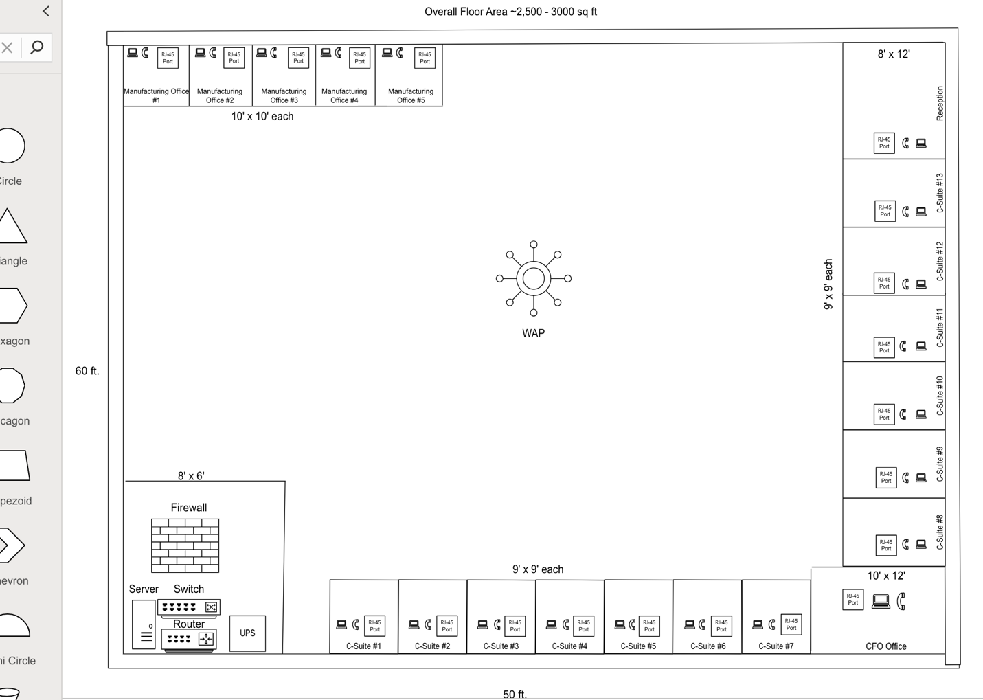
Floor Space and Layout
LAN Selection
Wired LAN
- Standard: IEEE 802.3 (Gigabit Ethernet)
- Cable Type: CAT6 UTP (Unshielded Twisted Pair)
- Speed: Up to 1 Gbps (Gigabit Ethernet)
- Topology: Star topology using a central Core Switch
Wireless LAN
- Standard: IEEE 802.11ax (Wi-Fi 6)
- Frequency Bands: 2.4 GHz and 5 GHz dual-band
- Coverage: One centrally placed WAP provides full coverage to all 20 employees

LAN Configuration
IP Addressing Scheme
- Private IPv4 block: 192.168.10.0/24
- Subnet mask: 255.255.255.0
- DHCP range (for laptops/phones): 192.168.10.50-192.168.10.200
- Static IPs reserved for:
  - Servers: 192.168.10.2-10.10
  - Router: 192.168.10.1
  - UPS: 192.168.10.11-10.20
  - Network devices: 192.168.10.21-10.30
- Default Gateway: 192.168.10.1
- DNS Server: External (Google: 8.8.8.8)
Department | VLAN ID | Subnet
Manufacturing | VLAN 10 | 192.168.10.0/26
C-Suites | VLAN 20 | 192.168.10.64/26
Management (CFO) | VLAN 30 | 192.168.10.128/27
Server & Infrastructure | VLAN 40 | 192.168.10.160/28
Guest Wi-Fi | VLAN 50 | 192.168.10.176/28

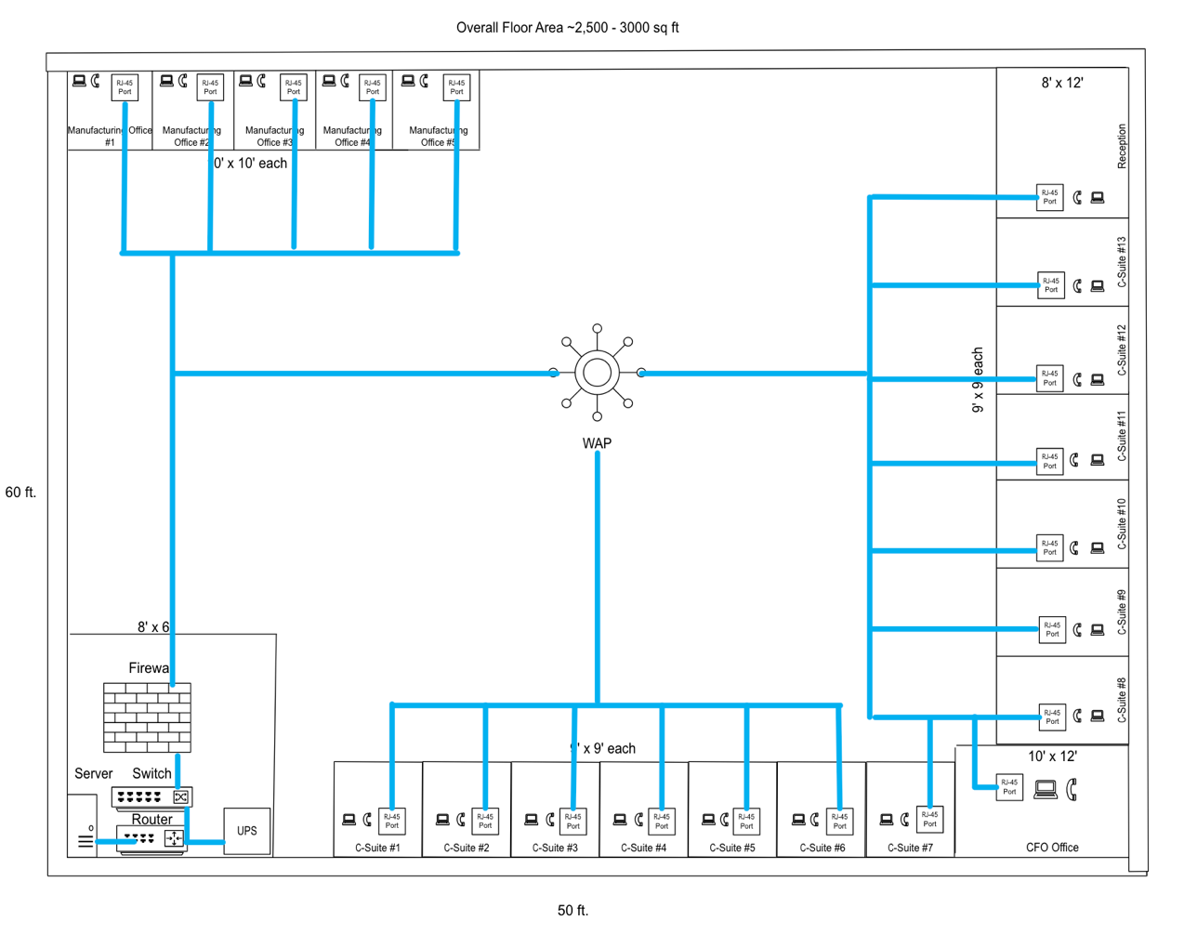
Overall Cabling Layout (Internet & POE)

Employee Computer Systems
Each employee at Boyer Technologies will be provided with a standerized computing setup optimized for productivity, collaboration, and media interaction.
Hardware Specification
Laptop: Lenovo ThinkPad E14 Gen 4
CPU: AMD Ryzen 5 5625U
RAM: 16 GB DDR4
Storage: 512 GB SSD
Display: 14” Full HD (1920x1080)
Networking:
- Wi-Fi 6 (802.11ax)
- USB-C to RJ-45 Gigabit ethernet adapter
Ports: HDMI, USB-C, USB 3.2 Audio Jack
Audio/Video:
- Integrated 720p HD webcame with dual-array microphones
- Built-in stereo speakers with Dolby Audio
Software Stack
OS: Windows 11 Pro (64bit)
Productivity Suite: Microsoft 365 (Word, Excel, PowerPoint, Outlook, Teams)
Browser: Microsoft Edge
Communication: Microsoft Teams, VoIP client
Security Tools:
- Bitlocker Disk Encryption
- Windows Defender Antivirus

Employee Voice Systems
Boyer Technologies utilizes a modern VoIP (Voice over Internet Protocol) phone system across all departments to ensure a quick, cost effective, and high quality voice communication in the office. This system aims to replace the typical analog phone, and integerates directly with the company’s LAN and PoE enabled switch infrastructure.

Corporate & Internet Servers
Boyer Technologies utilizes a single centralized tower server to handle both internal and external operations, as well as service hosting. This server is located within a 8’ x 6’ server room, connected via CAT6 cabling to the core switch, and powered through a managed UPS system.

WAN Connection
Boyer Technologies aims to maintain a high speed business internet connection to support communication for voice, data, and video. The connection is routed through a secure firewall with VLAN assignments to manage traffic priority as well as maintain security throughout the departments.

Cost Breakdown
Component | Unit Cost | Quantity | Total Cost
Router (Synology WRX560) | $219 | 1 | $219
Firewall (Fortinet FortiGate 40F) | $389 | 1 | $389
Managed PoE Switch (TP-Link TL-SG2210MP) | $129 | 1 | $129
Wireless AP (TP-Link Omada EAP650) | $109 | 1 | $109
Ethernet Cabling (Monoprice CAT6 1000ft) | $140 | 2 spools | $280
Server (Dell PowerEdge T150) | $1,199 | 1 | $1,199
UPS (APC Smart-UPS SMT1000C) | $479 | 1 | $479
Laptops (Lenovo ThinkPad E14 G4) | $729 | 20 | $14,580
VoIP Phones (Yealink T33G) | $89 | 20 | $1,780
Patch Panel & Rack Accessories | $200 (est.) | 1 | $200
Cable Installation Labor | $100/hr | 20 hrs | $2,000
Total Estimate |  |  | $21,364

Conclusion
With the given network design proposal Boyer Technologies’ goal is to provide a scalable, secure, and efficient infrastructure to meet the organizations operational needs. With a focus on high performance, high speed connections, and reliability, this proposal involves the best practices to be had in network security.
Key decisions involved using a centralized core switch for wired connections (as seen in the STAR topology) and Wi-Fi 6 for modern and adaptable coverage for non-cable orieneted devices. Additionally, Boyer Technologies has selected to implement VLANs to segment traffic and enhance security to ensure that the company operations remain protected.
Lastly, the estimated total cost of $21,364 reflects the level of importance that Boyer Technologies has placed on developing necessary and functionable network design.
Ultimately this proposal ensures Boyer Technologies can continue to provide high quality products and services to its local clients while maintain a secure and scalable network environment that supports long term growth.

References
PCMag. (2024). The best wireless routers. PCMag. https://www.pcmag.com/picks/the-best-wireless-routers
TP-Link. (n.d.). TL-SG2210MP | 8-Port Gigabit Easy Smart PoE+ Switch. https://www.tp-link.com/us/business-networking/easy-smart-switch/tl-sg2210mp/
Cisco. (n.d.). Cisco Business 250 Series Smart Switches. https://www.cisco.com/c/en/us/products/switches/business-250-series-smart-switches/index.html
Netgear. (n.d.). GS316EP Smart Managed Plus Switch. https://www.netgear.com/business/wired/switches/smart/gs316ep/
Netgate. (n.d.). Netgate 1100. https://www.netgate.com/pfsense/netgate-1100
Fortinet. (n.d.). FortiGate 40F. https://www.fortinet.com/products/next-generation-firewall/fortigate-40f
Ubiquiti Inc. (n.d.). UniFi Dream Machine. https://store.ui.com/products/unifi-dream-machine
Ubiquiti Inc. (n.d.). UniFi 6 Lite Access Point. https://store.ui.com/us/en/products/unifi-ap-6-lite
Cisco. (n.d.). Cisco Business 150AX Access Point Datasheet. https://www.cisco.com/c/en/us/products/collateral/wireless/business-150ax-access-point/datasheet-c78-743474.html
Monoprice. (n.d.). Cat6 Ethernet Cable – 1000ft. https://www.monoprice.com/product?p_id=109439
Cable Matters. (n.d.). Cat6A Bulk Ethernet Cable – 1000ft. https://www.cablematters.com/pc-533-128-cat6a-bulk-ethernet-cable.aspx
trueCABLE. (n.d.). Cat6 Riser Cable. https://www.truecable.com/collections/cat6-cable/products/cat6-riser-blue
Dell. (n.d.). PowerEdge T150 Server. https://www.dell.com/en-us/work/shop/povw/poweredge-t150
Hewlett Packard Enterprise. (n.d.). ProLiant ML30 Gen10 Plus Server. https://www.hpe.com/us/en/product-catalog/servers/proliant-ml-servers/pip.hpe-proliant-ml30-gen10-plus-server.1012099863.html
Lenovo. (n.d.). ThinkSystem ST50 V2. https://www.lenovo.com/us/en/p/servers-storage/servers/tower-servers/thinksystem-st50-v2/7d8ha003na/
Yealink. (n.d.). T33G IP Phone. https://www.yealink.com/product/ip-phone-t33g
Cisco. (n.d.). Unified IP Phone 8800 Series. https://www.cisco.com/c/en/us/products/collaboration-endpoints/unified-ip-phone-8800-series/index.html
Grandstream Networks. (n.d.). GXP2135 Enterprise IP Phone. https://www.grandstream.com/products/ip-voice-telephony/enterprise-ip-phones/product/gxp2135

Appendix
https://www.pcmag.com/picks/the-best-wireless-routers
https://www.tp-link.com/us/business-networking/easy-smart-switch/tl-sg2210mp/
https://www.cisco.com/c/en/us/products/switches/business-250-series-smart-switches/index.html
https://www.netgear.com/business/wired/switches/smart/gs316ep/
https://www.netgate.com/pfsense/netgate-1100
https://www.fortinet.com/products/next-generation-firewall/fortigate-40f
https://store.ui.com/products/unifi-dream-machine
https://store.ui.com/us/en/products/unifi-ap-6-lite
https://www.cisco.com/c/en/us/products/collateral/wireless/business-150ax-access-point/datasheet-c78-743474.html
https://www.monoprice.com/product?p_id=109439
https://www.cablematters.com/pc-533-128-cat6a-bulk-ethernet-cable.aspx
https://www.truecable.com/collections/cat6-cable/products/cat6-riser-blue
https://www.dell.com/en-us/work/shop/povw/poweredge-t150
https://www.hpe.com/us/en/product-catalog/servers/proliant-ml-servers/pip.hpe-proliant-ml30-gen10-plus-server.1012099863.html
https://www.lenovo.com/us/en/p/servers-storage/servers/tower-servers/thinksystem-st50-v2/7d8ha003na/
https://www.yealink.com/product/ip-phone-t33g
https://www.cisco.com/c/en/us/products/collaboration-endpoints/unified-ip-phone-8800-series/index.html
https://www.grandstream.com/products/ip-voice-telephony/enterprise-ip-phones/product/gxp2135

