A New Era of Cloud Computing: The Local Centralized Private Cloud Model

Benjamin A. Boyer
Framingham State University
Department of Business, Framingham State University

Abstract

The purpose of this research paper to analyze the over reliance on publicly centralized cloud structures for data storage and to explore alternative solutions. The scope includes personal users, small businesses, corporations, and educational institutions. This paper aims to demonstrate how private, locally centralized cloud structures can offer end users at all levels a secure and private environment for data storage, minimizing exposure to the vulnerabilities of the public internet, especially in the age of data scraping and the advent of Artificial Intelligence machines.

The research method being used will be mixed-methods research methodology: (1) a quantitative analysis of 200 companies as it relates to security breaches to analyze security trends and (2) a qualitative analysis utilizing a Likert scale survey to gauge trust and perceptions of cloud security. A portion of the paper will be dedicated to analyzing the gaps that companies have between data regulation standards and securing user data supported by a trend in the US specifically that prioritizes quantity over quality. As a result, we must take action to retain autonomy over the individual’s right to privacy, and as this paper will highlight, local private centralized cloud structures can be one of the core structures that protects the individual and our data. The ultimate goal of this paper is to push the needle forward in terms of research and remind professionals that while cloud providers have their place, we cannot become over reliant on other people to protect our data.

Security Benefits of Locally Centralized Cloud Structures
What is the cloud? Why does the cloud matter? Cloud storage is slowly becoming a crucial pillar in our day to day lives. To understand its growing role, it’s important to define what cloud computing involves. According to NIST cloud computing is “A model for enabling ubiquitous, convenient, on-demand network access to a shared pool of configurable computing resources (e.g., networks, servers, storage, applications, and services) that can be rapidly provisioned and released with minimal management effort or service provider interaction.” (NIST). In other words, the cloud enables the delegation of data handling and receiving to a third party as a means to enhance scalability and usability.
When it comes to cloud computing, there are three core models that must be understood for the purpose and scope of this research. There is public, private, and hybrid clouds. Public clouds are similar to services such as One Drive by Microsoft, Google Drive by Google, or Dropbox. Private clouds are dedicated environments to a set of users within an organization. Formats usually consist of an on-premises environment or a remotely secured environment by a third-party company. Last is the hybrid environment which is a blend of both public and private, meaning that some services are available remotely and off premise, while other resources such as financial documents are only accessible on-premises.
In terms of the benefits to a localized cloud solution, is the fact that the user maintains autonomy over their own data, and it never touches the outside internet. Storing data on a local cloud solution ensures greater control over data and reduces reliance on third-party providers, which is essential in securing privacy (Olowu et al., 2019). A study on secure cloud environments highlights how data integrity, data confidentiality, and data redundancy are crucial in ensuring private cloud reliability (Sun et al., 2014). As a result, local cloud structures by nature meet a vast majority of compliance checks without any external setup or configuration. This also lowers the cost to entry, as private environments do tend to be more costly but in the case of a local centralized private cloud solution, cost can be met with innovation and cost cutting practices that make it a long term viable solution as compared to something like a public or hybrid cloud environment.
Private Cloud Solutions
Private cloud can be defined as “A private cloud is a cloud in which only the authorized users can access the services from the provider.” (Guangyu et al., 2014). Private clouds can either be hosted on-premises, meaning it is provided by a dedicated private network and server only accessible within that area, or it can be delegated to a dedicated environment.
When it comes to private cloud solutions the main idea is that users do not need to be in a physical location when accessing the cloud resources, this results in “cost reduction, improved user experience (ux), staff effectiveness, and file sharing with organizational collaborations from remote sites.” (M. Olowu et al., 2019).
Private clouds provide the most control over data, security, and compliance. The reason is because the entire private cloud is developed solely for the reason of storing an organization or individuals’ data. This means that access is only granted to individuals to control authorization management for security purposes.
The biggest drawback to a private cloud infrastructure is that it is the most expensive of all the models due to its initial start cost. The equipment and materials required can be costly, and the general maintenance can drive costs high as well. Though the cost does level off as compared to a public or hybrid cloud model that utilizes a ‘Pay as you go’ model.
Local Storage Benefits
As most people know the cloud, it is through public cloud hosting but there are many benefits to storing data on a local cloud solution. Users can retain full control over their data without relying on third party provider. This is an important concept to review as while the corporations that run public clouds are generally secure, they are the biggest targets. Maintaining autonomy is not only a cloud security concept, but also what maintains our basic human right of privacy.
Storing data locally also reduces surface attack area. Public cloud providers are often prime targets for attackers, making local cloud solutions a more secure alternative (Sun et al., 2014). In other words, if you choose to store data on a local cloud solution, the chances that an adversary is going to first find your local cloud, and then attack, are extremely low compared to the likes of a public cloud.
With a local storage solution, the data is by a product of the local model, stored closer to the users. This means that there is a reduced latency between the cloud and the end users’ data. Most importantly, it reduces the reliance on an active internet connection.
Lastly, organizations and individuals can make the device as secure or as unsecure as they see fit as long as it is within the scope of regulatory and compliance standards. This removes the risk of vendor-imposed restrictions. The scenario would be similar to something like your third-party cloud provider halting your cloud services if you chose to opt out of buying more external storage.
Security Measures (RAID, Encryption)
RAID stands for a Redundant Array of Independent Disks. The purpose of mentioning RAID is to cover the baseline definitions and standards for protecting data in the cloud. The key terms are disks and disk arrays. As defined by the RAID Advisory Board in 1996, “a disk is a non-volatile, randomly accessible, block-addressable, rewriteable storage device…A disk array is a collection of disks from one or more disk systems combined with the body of Array Management Software which has access to all of them.” (Massaglia, 1996). Fundamentally, RAID serves as a barrier of protection against random drive failures that can result in data loss. Without using overly technical language, there is a concept within drive storage in which the drive can be expected to fail this is also known as the Mean Time Between Failures. Minimizing and reducing this performance indicator is crucial to keeping data safe in the cloud. While RAID is a solid solution to reducing MTBF, it still poses a threat to startups and small businesses as RAID arrays drive cost, and that is a valuable resource that not all cloud providers can leverage.
Outside of RAID technologies, encryption is a crucial component of cloud security and internet security in general. There are two main encryption standards that I want to cover, and that is encryption at rest and encryption in transit. Encryption at rest refers to stored data that is not actively being transmitted. This includes data saved on hard drives, SSDs, cloud storage, or databases. The most secure encryption standard for data at rest currently is AES-256 (Advanced Encryption Standard with a 256-bit key). It is utilized by the government and implemented into military level applications, it is highly resistant to brute force attacks due to the long key length, and it has high performance and efficiency for encrypting large volumes of data which is critical in today’s era of Big Data. (Google Cloud, 2022)
As mentioned, prior, the second encryption standard is data in transit. This refers to the data actively being transmitted between systems such as a user to a server or between two networked devices. The encryption standards are defined as TLS (Transport Layer Security) and SSL (Secure Sockets Layer) which are a result of the 7 Layer OSI model that defines the structure of the internet. (Google Cloud, 2022) While SSL is now an outdated standard, TLS is the modern standard and is more secure than older SSL versions. The reason for using TLS/SSL is because of the data encryption it provides such as the standard of HTTPS, it prevents man in the middle attacks which is crucial with MFA (multi-factor authentication) being used as an industry standard, and lastly it provides strong cryptographic algorithms such as AES, RSA, ECC. (Google Cloud, 2022)
Building Consumer Confidence in Private Cloud Security
The reality of working with the cloud technology space is that no matter the organization or individual, there is going to be a gap of trust between cloud providers and consumers. The general disposition of business owners considering cloud environments is one that lacks established trust in the security between cloud-based systems and cloud providers (M. Olowu et al., 2019).
There are ways to approach building consumer confidence as it relates to cloud security, and one of those ways is promoting an open discourse on current security measures the provider is implementing to maintain data privacy. When cloud providers clearly communicate their security measures, such as encryption and access controls, consumer confidence increases (Sun et. al., 2014).
Businesses hesitate to adopt cloud solutions due to security concerns; therefore, clear security policies that explain data handling practices can mitigate these fears (Sun et al., 2014). Fundamentally there should be a data cloud, whether that be hybrid, public, or private, which then adheres to data security and privacy measures that fall under four core categories. These categories can be defined as: (1) Data Integrity, (2) Data Confidentiality, (3) Data Availability, and (4) Data Privacy (Sun et al., 2014). These four categories should be referential to not only one another through software and hardware, but also through the data security and privacy policy through the cloud.
By adopting this clear division and organization of security policies, it creates clear visibility as to what the business needs to know in terms of maintaining data secure in the cloud and can help alleviate lack of trust or areas of concern for business owners.
Public vs. Enterprise Perspectives on Cloud Risks
When it comes to cloud environments, the general public exhibits a cautious and skeptic perspective on cloud environments. This at large is due to the lack of understanding and general lack of control that most users of the cloud experience. With this in mind, it is clear that there is a gap between cloud providers and end users. In order to bridge this gap, there needs to be more communication, education, and transparency between parties. Businesses can start implementing their part of change by communicating to shareholders and customers what: (1) security measures (2) compliance practices (3) potential risks are involved with their cloud environment.
The enterprise perspective on cloud environments is aptly summarized, “The United Kingdom (UK) government similar to other countries such as the United States (US), Australia and other European countries have called for public sector organizations to strategically embrace cloud computing to reap its benefits (Mendoza 2014; Kundra 2011; Cabinet Office 2011a). The UK national government has made particular reference to the Government Cloud (G-Cloud) where the architects of this UK government strategy have predicted that significant savings of approximately £3.2bn can be made by switching to this initiative (Kepes 2015; Cabinet Office 2011a).” (Jones et al., 2019). To summarize, governments must adopt and implement cloud environments, and while there are inherent risks that increase the attack surface of certain countries, the money saved outweighs the security risk. This is what is concerning to a majority of the cloud computing community, as stated in 2011 by Carroll, M., Kotzé, P., & van der Merwe, A. the biggest concern when it comes to cloud computing is security (Carrol & van der Merwe, 2011).
Regulatory Influences (GPDR, NIST)
To formally define the role of GPDR (General Data Protection Regulation), the following definition is given “The GDPR represents one of the most rigorous data privacy regulations in the world. Its purpose is to protect the privacy and personal data of individuals within the EU and give them control over how their data is used. Non-compliance with the GDPR can lead to hefty fines, up to €20 million or 4% of a company’s annual global turnover, whichever is higher.” (GPDR Advisor, 2023). It is important to note that GPDR does not only apply to EU members rather it is a broad application of security standards to any infrastructure of technology that plans to interact with EU members.
There are two key articles that are worth mentioning in the literature review of this paper. 33 & Articles 34 of the GPDR guidelines essentially states that if a breach occurs and the data is (1) not accessible due to keys remaining intact and (2) the data breach does not impact the sovereignty of the persons the organization will not be required to report the breach to either the supervisory authority, or the individuals compromised in the breach.
NIST (National Institute of Standards and Technology) is the core set of standards that help provide frameworks for organizations and user alike to utilize for best practices in cyber security. Two key frameworks that will be mentioned as stand out candidates for aligning this research are NIST cloud security reference architecture (Special Publication 500-299) which highlights a comprehensive framework for the core components that help to secure cloud environments. (Liu et al., 2013). The second framework that helped align this research case, is the Guidelines on Security and Privacy in Public Cloud Computing (NIST Special Publication 800-144) which addresses the key technical challenges in public clouds. These sets of frameworks are just a small portion of the vast frameworks that are provided by NIST (Jansen & Grance, 2011).
Cloud Security Issues
In the cloud nothing is fully secure and risk-free, as such, these dynamics are applicable to all areas of technology, but when it comes to storing personal data, minimizing this risk to the smallest margin is the best strategy, “Management is responsible for taking care of security risks to protect systems and data. Governance, risk and control of cloud computing are therefore critical in the performance of any assurance management process.”
In a publicly posted publication by CSA (Cloud Security Alliance) from 2019, they identify 11 categories that pose as issues and threats to the realm of cloud security. These 11 are identified as “The latest report highlights the Egregious Eleven ranked in order of significance per survey results (with applicable previous rankings): Data Breaches, Misconfiguration and Inadequate Change Control, Lack of Cloud Security Architecture and Strategy, Insufficient Identity, Credential, Access and Key Management, Account Hijacking, Insider Threat, Insecure Interfaces and APIs, Weak Control Plane, Meta structure and Applistructure Failures, Limited Cloud Usage Visibility, and Abuse and Nefarious Use of Cloud Services” (Cloud Security Alliance, 2019).
Case Studies (Capital One)
The set core ideology in the IT industry is that most organizations face unprecedented amounts of regulatory pressure from the government and outside agencies. This is due to the fact that 90% of the internet as of 2019 was developed in the last 2 years (2017-2019) indicating that there’s a clear need for this regulatory compromise on organizations. (Novaes, 2019). Specifically, Capital One was one of these organizations in which they experienced a SSRF attack due to a misconfigured firewall (Novaes, 2019).
The specific series of events that lead to the attack was coordinated and clearly executed. The attack was able to utilize the proxy connection to act as a remote user enabling access to non-public endpoints. The best way to think of this, is if you had to log into your router but someone outside your network found a way to access your network from a proxy server and log into your router via a misconfigured setting in the ISP router.
The takeaway from this case study is to understand what threats are dealt with in the cyber space. Misconfigurations, improper compliance controls, not keeping controls up to date, and not developing multidisciplinary skills are core aspects of deploying a cloud environment that must be taken seriously.

Public Cloud Risks
The risk of utilizing a public cloud is not inherently due to the lack of security around public cloud infrastructure, but more so is a result of the attack surface that is caused by the nature of a public cloud. As stated by NIST Special Publication 800-144, “Public cloud computing represents a significant paradigm shift from the conventional norms of an organizational data center to a de-parameterized infrastructure open to use by potential adversaries.” (Jansen & Grace, 2011).
Furthermore, there is the security risk of lack of control over cloud infrastructure. What this results in is companies that once were able to log into their own server or data center for direct access, no longer have this ability due to the increasing levels of complexity that can come of a public cloud infrastructure. Essentially, companies are fully reliant on a third-party provider to manage, protect, and backup their data.
Managing the risks of public cloud can be especially difficult because of the appeal that it creates. There is great opportunity for economies of scale utilizing a public cloud environment, but it must be carefully curated and adhere to regulations not as a means to check a box, but as a means to stay systemically competitive.
Emerging Security Innovations: Blockchain & AI
With technology rapidly developing, it is clear that fire must be fought with fire. It can be confidently stated that within the next century we will see quantum systems, and by this time technologies such as artificial intelligence mechanisms and block chain technologies will be the equivalent to what cloud is to society now. With this being said, staying progressive and being agile in terms of development of systems is pertinent in relation to locking down and defending end user data.
Blockchain in Cloud Security
Block chain is the next step for security, and this section will briefly cover as to why blockchain will be fundamental to developing more secure systems. As covered by the CSA article The Impact of Blockchain on Cloud Security “At its core, blockchain is a decentralized and immutable ledger that records transactions across multiple nodes or computers. Each transaction, or ‘block,’ is connected to the previous one, creating a chain of blocks”. (Cloud Security Alliance, 2023)
There are six key attributes that highlight the necessity of blockchain in cloud security, “Immutable Audit Trails…Data Integrity Assurance…Decentralized Identity and Access Management…Supply Chain Security…Zero Trust Security” (Cloud Security Alliance, 2023). In summary, blockchain technology, while usually associated with cryptocurrency mechanisms, is the future of locking down and securing cloud infrastructure. To not use blockchain technology is to say that instead of using calculators we must continue to do arithmetic on paper.
AI & Automation in Security
Artificial intelligence or popularized as AI in recent years, serves as a fundamental and necessary tool for all areas of technology, from people to hardware to software, artificial intelligence is a key player in the technology field.
Security and artificial intelligence are no different, as stated by SentinelOne “Traditional security tools usually fail to detect sophisticated issues, but AI systems excel in identifying and mitigating cyber threats”. (SentinelOne, n.d.). Some classes of threats that AI excels in preventing are Cyber Threats, Malware Detection, Phishing and Social engineering, Physical Security Threats, Access Control Systems, and Behavior Analysis (SentinelOne, n.d.).
The how in regard to AI locking down systems from cyberthreats have everything to do with the capabilities of modern generative AI systems, as well as machine learning AI systems. AI systems participate in machine learning and pattern recognition, natural language processing, image and video analysis, as well as anomaly detection algorithms. These capabilities allow artificial intelligence systems to accurately identify and address security threats when implemented into cloud security infrastructure appropriately.

Method

Participants and Sample Selection
Participants for the qualitative sample were selected upon the following criterion:
(1) Active end user of cloud services
(2) Beginner-Intermediate skill level with technology

Qualitative Sample
The qualitative portion of the research aims to study a core group of technology users at varying skill levels. Participants were selected based on one key aspect: their use of cloud services such as OneDrive, Google Drive, or other cloud storage providers. This targeted study approach aims to understand the general public perception of cloud technology.

Quantitative Sample
The quantitative sample consists of two sources:
Forbes 200 Companies
The dataset analyzes the top 200 companies on the Forbes list analyzing security breaches in the corporate environment, specifically in 2024. The selection process of doing the companies through the Forbes list ensures an unbiased and systematic approach to analyzing security trends.

Breached Entities from Cybersecurity Datasets
The dataset was obtained from a public GitHub repository that involves public records of data breaches. Variables analyzed include the date of the attack, type of breach, and the number of compromised records. This dataset is limited to breaches only, which allows for a full visualization of security breaches

Instruments and Data Collection

Qualitative Data Collection
Survey Platform: Qualtrics
Survey Design: Likert Scale
Target Audience: IT Professionals, Students, End-users that interact with cloud services

Quantitative Data Collection
Data Sources: Forbes Top 200 Companies, GitHub Balloon Races CSV
Analytical Tools: Excel, Google

Research Design and Data Analysis
For my research method I used a mixed method of analyzing both quantitative data and qualitative data.

Qualitative Analysis:
For the qualitative aspect, I wanted to conduct surveys with industry professionals, students, and any individual that interacts with cloud storage, and compile their surveys to build a Likert scale to build ethos within my research.

Quantitative Analysis:
I collected quantitative data by identifying 200 corporations and compiling their security breaches as it relates to their cloud infrastructure and then graphed the data to give support for localized cloud structures. To reinforce the visual portion of the research, I also included a dataset of breaches from GitHub, that allows for more impactful charts and graphs to give a full representation of significant breaches in cloud environments.

Ethical Considerations
(See Benjamin Boyer Consent Form)

Results
Quantitative Overview of Breach Incidents
Forbes Top 200 Companies Breach Analysis Results
Out of the 200 companies analyzed, 55 out of 200 (27.5%) experienced confirmed data breaches. These findings highlight that even among the most prominent and resource rich global enterprises, vulnerabilities in cloud infrastructure and cybersecurity practices persist.
Figure 1
Breach Status of Forbes Global 200 Companies (2024)

Among the reported breach causes, the most common tactics aligned with MITRE ATT&CK classifications were phishing attacks (5.5%), unauthorized access through misconfigured public facing environments (5.5%), and partner-related data leaks (12.7%). These results indicate that there is a lack of situational awareness and internal conflict mitigation strategies that are leading to increased vulnerabilities within organizations.
Within the reported breaches, attacks were classified according to the MITRE ATT&CK framework categories resulting in the following: Credential Access accounted for 23.64% of all breaches, Impact attacks resulted in 21.82% of breaches, Exfiltration attacks accounted for 21.82% of attacks, Initial Access accounted for 10.91%, Command and Control made up 7.27% of attacks, Execution attacks resulted in 5.45%, Collection attempts resulted in 3.64% as well as Reconnaissance, and lastly persistence attacks accounted for only 1.82% of attacks.
Figure 2
MITRE ATT&CK Category by Count
Table 1
Top Industry Breach Counts in 2024
Industry | Breach Count
Banking | 10
Technology | 7
Telecommunications | 6
Automotive | 5
Insurance | 4
Financial Services | 2
Energy | 2
Figure 3
Breach Count
This trend suggests that sectors handling large amounts of personal identifiable information or financial data face a higher risk profile, highlighting the importance of secure data management and compliance with regulatory standards within public cloud deployments.
Balloon Race Data Breaches Analysis
According to the Balloon Race dataset, from 2004-2022, there were a total of 417 breaches of significant impact. Out of the date range, 2019 served as the most vulnerable, experiencing 9.2% of attacks within the range. Below is a visual representation of the trend between the year and the number of breaches. (See Figure 4 below)

Figure 4
Total Breaches (2004-2022)

Additionally, 2018 represents the year with the most records lost accounting for approximately 2.7 billion records lost, making up 18.97% of all records lost from 2004-2022. With the trend pointing towards a positive downward trend, it can seem misleading, because although breaches are less frequent in 2025, the sensitivity rating of the data lost today is significantly higher, as reflected in the Forbes analysis.
Figure 24
Total Records Lost (Millions)
Utilizing a data sensitivity scale, 1 representing not critical and 5 representing life threatening, the following conclusions can be made from the Balloon Races dataset. Breaches that concerned a sensitivity level of 1 accounted for 128 breaches, making up 30.77% of the total. Sensitivity level 2 breaches accounted for the majority, 134 breaches or 32.21% of all attacks. Data sensitivity levels 3 (66 breaches, 15.87%) ,4 (61 breaches, 14.66%) , and 5 (27 breaches, 6.49%) account for the minority of the set.
Figure 5
Data Sensitivity Distribution

This analysis reveals that over 63% of all breaches involved lower-sensitivity data. These breaches most likely involved information such as email addresses, usernames, or non-sensitive user activity, concerning but not critically damaging on its own. The proliferation of metadata farming does raise concern, but as mentioned prior, it is not critical.
However, the remaining 37% involved high sensitivity data, with levels 3 and 4 involving medical records, financial data, and internal credentials, which poses a serious risk to individuals or organizations. Level 5 breaches despite making up only 6.49% of the set, represent incidents where the data that was compromised could be life threatening such as government ID’s, biometric info, or medical histories. The distribution suggests that while the majority of attacks may be low value and low sensitivity data, a significant portion still involves high sensitivity data and potentially life-threatening exposures. This emphasizes the need for clear and well thought out data protection measures across all sensitivity vectors within the technology field.
Qualitative Analysis of Public Perception on Cloud Security and Technology
Q0_Consent
A total of 37 individuals responded to the survey titled “A New Era of Cloud Computing: The Local Centralized Private Cloud Model”, of which 36 participants agreed to partake in the study. The sample was intentionally designed to include a diverse group of active cloud service users with beginner to intermediate technical skill levels.
Q1_Role
The majority of respondents identified as students, comprising 66.7% (n=18) of the sample. Other participant roles included Security Analysts (3.7%, n = 1), IT Professionals (3.7%, n = 1), and those who selected Other (Please Specify) (22.2%, n = 6). Only one respondent identified as Business Owner, representing 3.7% of the total responses.
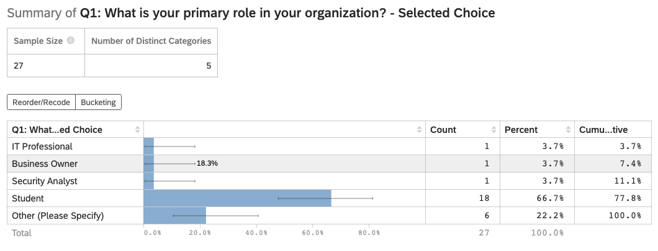
Figure 6
Q1
Q2_Exp
Regarding the years’ experience with cloud storage and security, the majority of respondents (44.4%, n = 12) indicated that they have less than 1 year experience, whereas the second highest majority (29.6%, n = 8) expressed that they have 4-7 years of experience. This number makes the most sense as the majority of respondents were students. However, this does highlight concern about education surrounding cloud technology and how it is used.
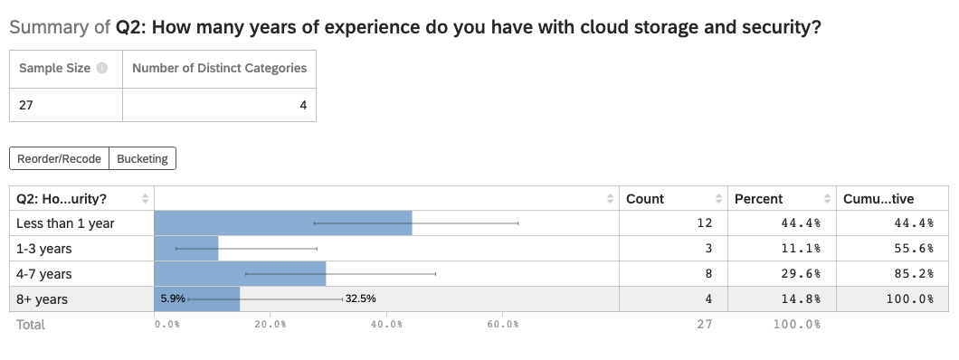
Figure 7
Q2

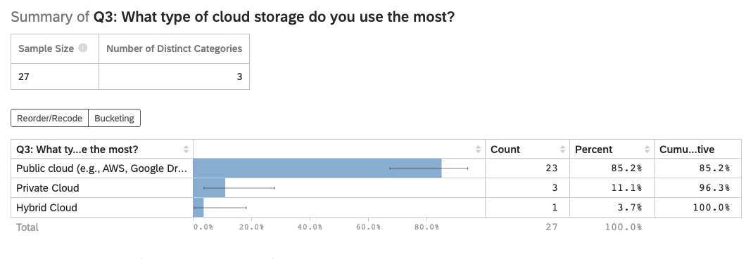
Q3_MostUsed
When it comes to the most used cloud storage architecture, as predicted (85.2%, n = 23), indicated that they use public clouds as opposed to a hybrid or private cloud. The other users of Private (11.1%, n=3), and hybrid (3.7%, n=1) indicate that there the majority of the market in cloud is pointed towards public facing cloud environments.
Figure 8
Q3

Q4.1_ControlOverData
In analyzing the results of Q4.1 the majority of participants (42.3%, n=11) indicated that they felt neutral towards having control over their data with the second highest majority (34.6%, n=9) expressing that they felt they had majority of the control over their data. This indicates that the general population does not have enough information to decide whether they have autonomy of their data or not.
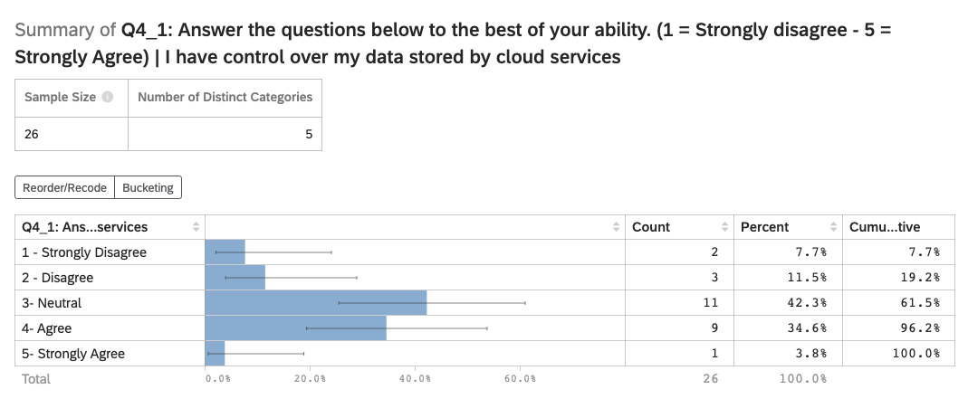
Figure 9
Q4.1
Q4.2_AutonomyFactor
Similar to the results of Q4.1, Q4.2 (See Figure 10 below) indicates that the majority (38.5%, n=10) feel as though they have a neutral standing as to whether or not autonomy over their data determines their cloud provider. The standout data here is the fact that the participants who indicated that they disagree (19.2%, n=5) directly matches the participants who indicated that they strongly agree (19.2%, n=5).
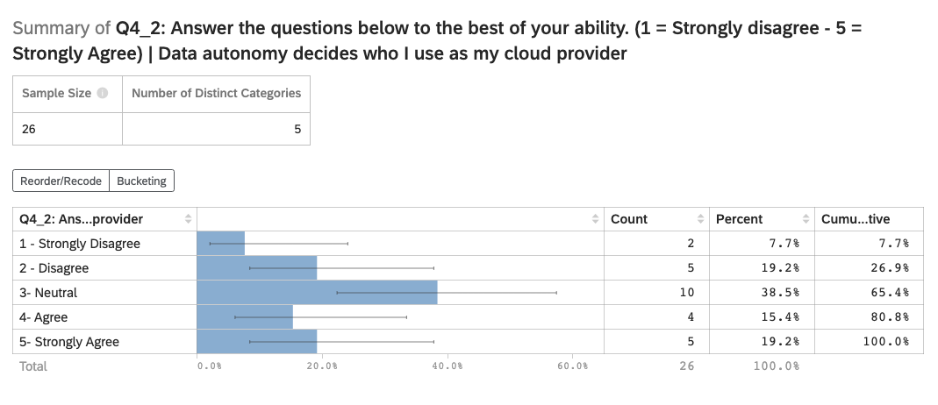
Figure 10
Q4.2
Q4.3_TrustAdherence
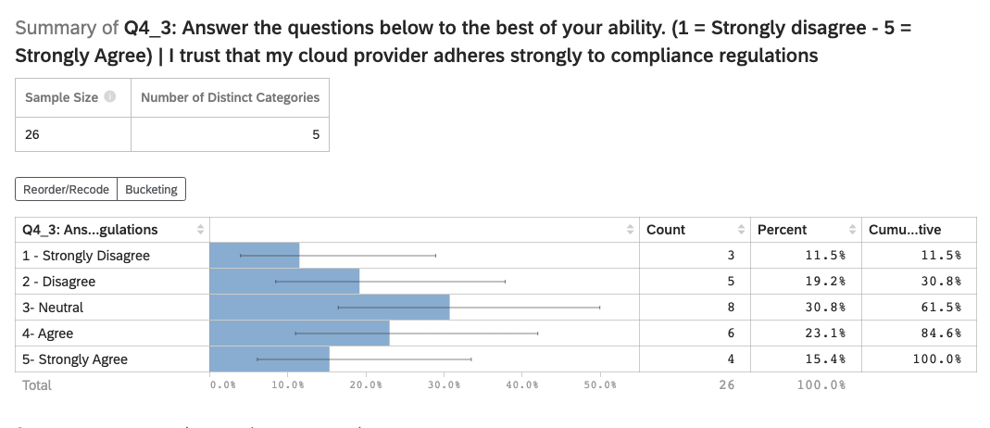
For the last section of Q4, the majority of participants (30.8%, n=8) expressed a neutral position as to whether or not they trust the security practices of their cloud provider. This is another indication that there needs to be further education in the general population in terms of what cloud security is, and why it matters.
Figure 11
Q4.3
Q5.1_PersonalPrivateOverPublic
For Q5.1 the majority of participants (50.0%, 11) agreed that they feel safe storing their personal data in a private cloud rather a corporate cloud. This suggests that there is a clear preference for private cloud solutions, but as the other responses indicate there is still slight concern or uncertainty as it relates to private cloud systems. This also indicates that there is room for further education and increased awareness in this area.
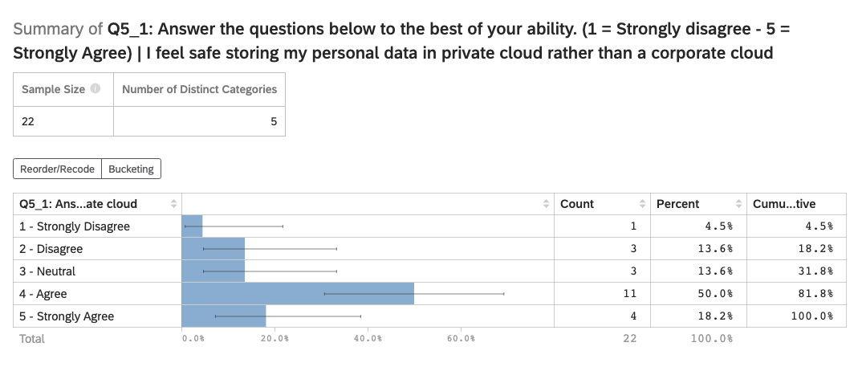
Figure 12
Q5.1

Q5.2_WorkPrivateOverPublic
For Q5.2, the standout data is that 50% or more of respondents (50%, n=11), selected either agree or strongly agree, showing that the majority of people feel safer with private cloud storage. The data ultimately indicates that there is positive leaning toward the safety of private cloud storage versus corporate alternatives.
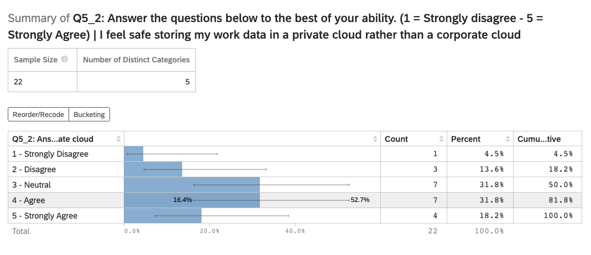
Figure 13
Q5.2
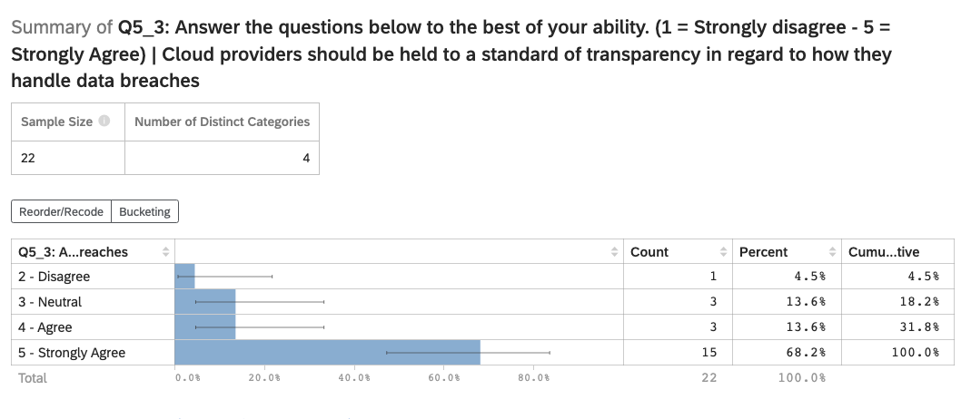
Q5.3_TransparencyBreaches
For Q5.3, the data shows overwhelming support for transparency, with 86.4% (n=19) of respondents agreeing or strongly agreeing that cloud providers should be held to a standard when handling data breaches.
Figure 14
Q5.3
Q6.1_SecondaryPrivateOverCorp
For Q6.1, a strong majority (68.2%, n = 15) preferred storing data in a private cloud over a corporate one, showing clear support for private cloud solutions. This reinforces the idea that end users prefer private over corporate proving consistency and a clear trend in participants responses.
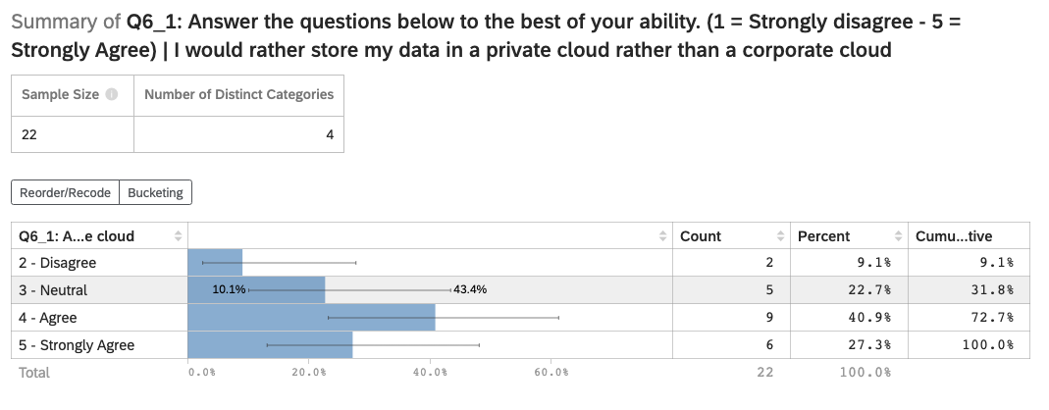
Figure 15
Q6.1
Q6.2_TooExpensive
For Q6.2, the majority of responses, (59.1%, n=13) agreed that setting up a private cloud seems too technical or expensive, suggesting that perceived complexity is a major barrier to adoption. Another statistic to point out is that 36.4% (n=8) feel neutral towards setting up a private cloud, indicating they feel that they have a base level of technical knowledge and skill.
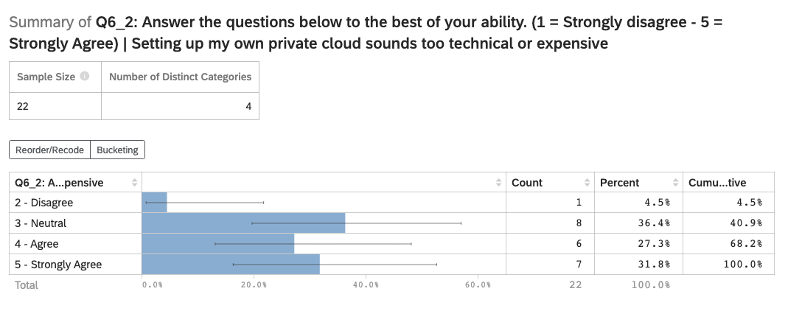
Figure 16
Q6.2
Q6.3_PrivateMoreSafe
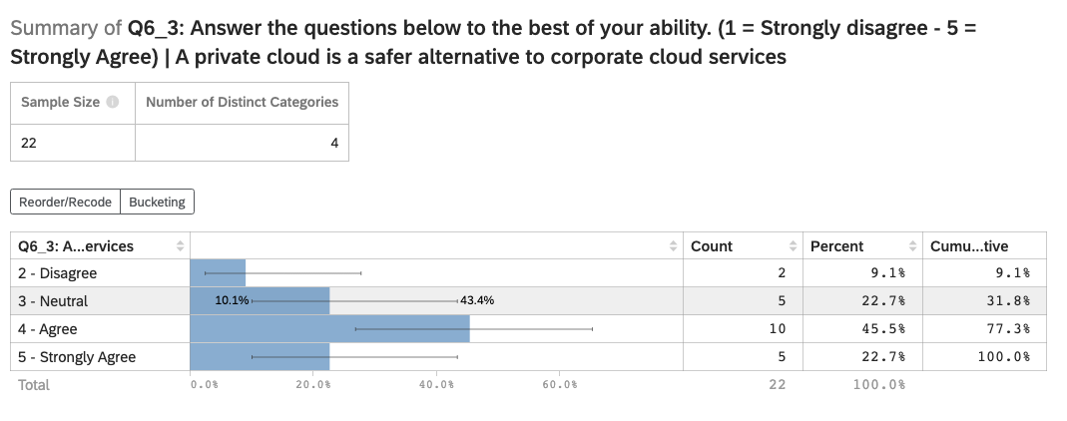
For Q6.3, the majority of participants (68.2%, n=15) of respondents agreed that a private cloud is a safer alternative to corporate cloud services, reinforcing strong user trust in private cloud security.
Figure 17
Q6.3

Q6.4_MaintainAutonomy
For Q6.4, there is was an overwhelming amount of support (81.8%, n=18) for maintaining data autonomy without relying on a third party, showing a strong support for self-managed cloud solutions.
Figure 18
Q6.4
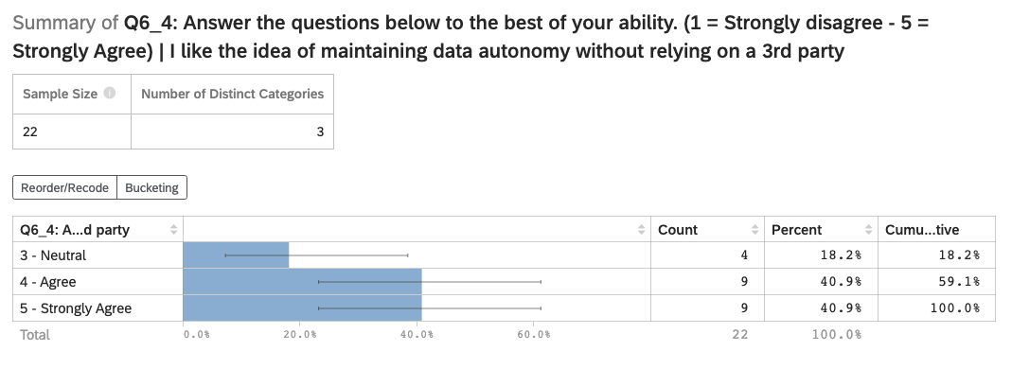
Q6.5_PayForMoreSecurity
Q6.5 shows that the majority (59.1%, n=13) of respondents are willing to pay more for a cloud service that guarantees privacy and security, emphasizing the importance users place on trust and data protection.

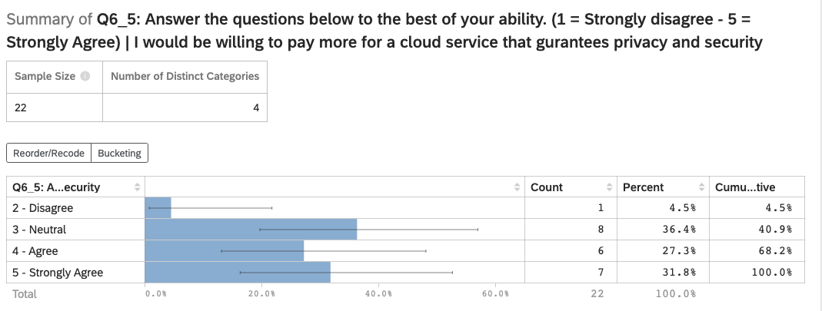
Figure 19
Q6.5
Q7.1_UnderstandRegulation
Q7.1 reveals that the second largest majority (31.8%, n=7) agreed that they understand data protection laws like GPDR or CCPA, while the largest majority of responses (54.5%, n = 12) disagreed, suggesting a significant knowledge gap around privacy regulations.
Figure 20
Q7.1
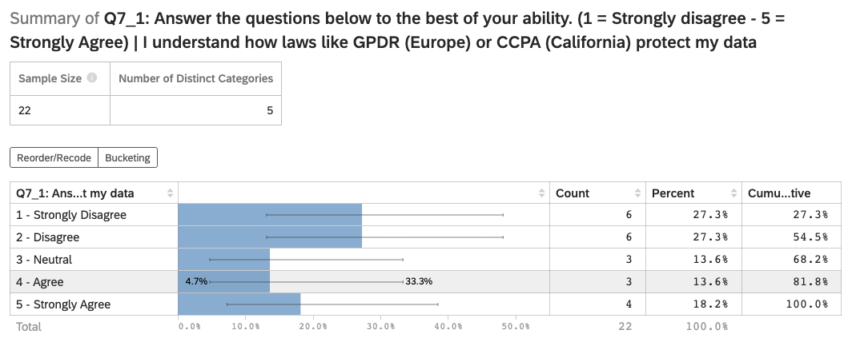
Q7.2_SecurityAdherenceBelief
Q7.2 shows that 45.5% (n =10) of respondents believe cloud providers follow data security regulations, while 31.8% (n=7) remained neutral, indicating moderate trust but lingering uncertainty.
Figure 21
Q7.2
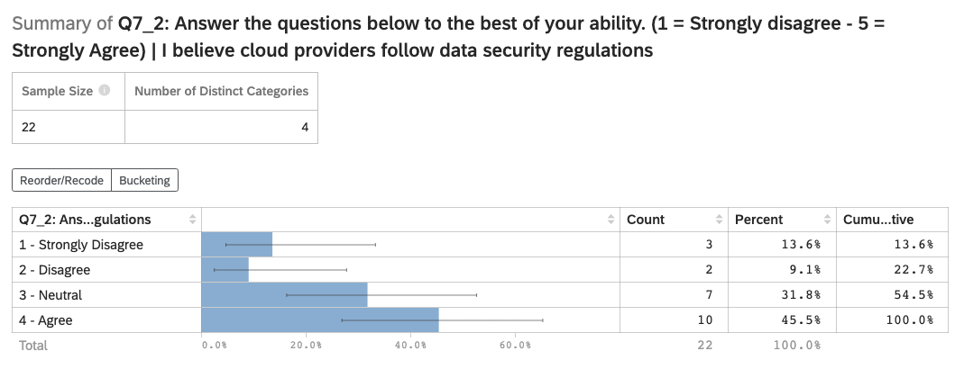
Q7.3_MoreLegislation
Q7.3 (See Figure 22 below) indicates strong support for tighter regulation with the overwhelming majority of responses (90.9%, n=20) of respondents agreeing that legislation should enforce stricter laws on how companies handle data.

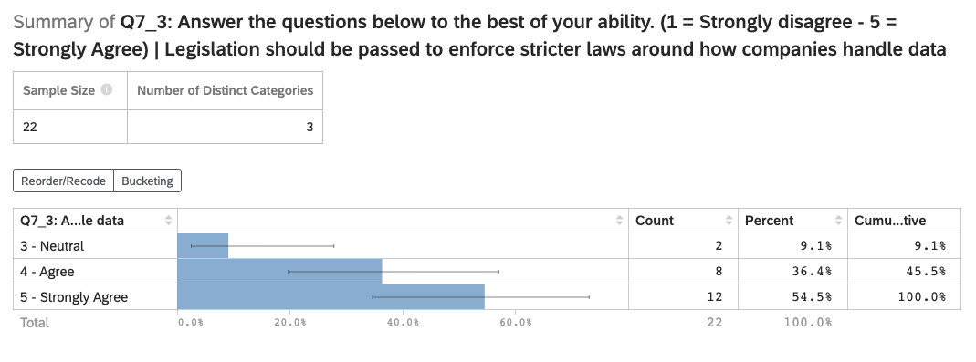
Figure 22
Q7.3
Q7.4_CheckPrivacyLawsBeforeUse
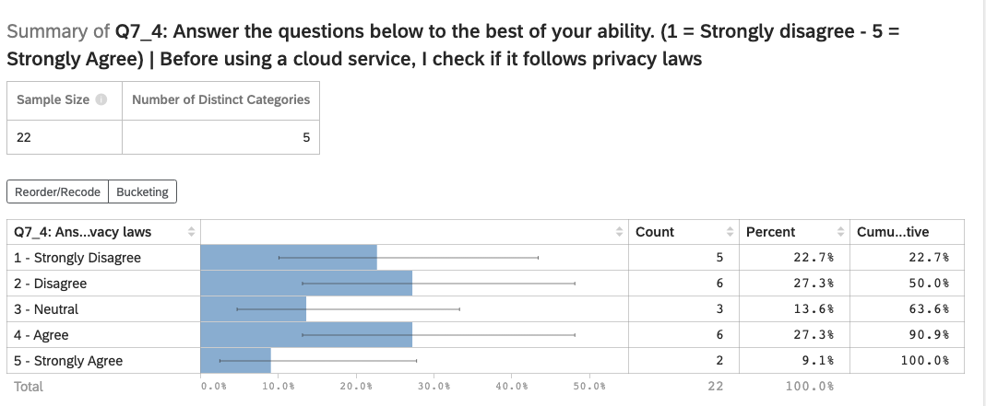
Q7.4 shows that only a small majority (36.4%, n=7) of respondents check if a cloud service follows privacy laws before using it, the majority (50%, n=11) disagreed, suggesting a gap between concern for privacy and actual user behavior.
Figure 23
Q7.4

Discussion
Interpreting Breach Trends in Public Cloud Infrastructure
The breach data analyzed in this research reveals a recurring vulnerability among even the world’s largest and most resource-rich organizations. With 27.5% of the Forbes Top 200 companies experiencing confirmed breaches, it is clear that scale and capital do not equate to security. The MITRE ATT&CK classification results further reveal that basic yet potent tactics like credential access and exfiltration continue to be effective against these enterprises. When organizations that arguably have the best tools at their disposal, still fall victim to preventable misconfigurations and phishing attacks, it demonstrates a systemic weakness in current public cloud infrastructure. This is not an anomaly; it is a clear and well-defined recurring pattern.
Furthermore, the Balloon Race dataset bolsters this systemic issue across nearly two decades. While the number of breaches may appear to decline, the sensitivity and scale of modern breaches are higher than ever. For a visual representation of this trend please refer to figures 4 and 5 in the figures portion of the paper. The reality of the situation is that there is a fundamental need for reevaluation of how we store, access, and secure data.
Bridging the Trust Gap: Perceptions vs. Reality in Cloud Security
When it comes to the public and their perception of modern cloud security, the water becomes murky. The survey that was conducted revealed widespread neutrality and uncertainty about data control, trust in providers, and understanding of security regulations. Despite the majority of participants indicating a preference for private cloud solutions, they also indicated that such systems seemed too technical or expensive. This highlights a clear a gap between interest and implementation, largely due to misconceptions and lack of education around viable alternatives.
Implications for Future Cloud Security Models
The future of cloud computing is a promising one but will further obfuscate the general populus understanding of cloud technology and modern security. Conceptual stacks such as decentralization of cloud structures and a more pointed approach to personalization of security is a must with the development of new attack methods against cloud-based systems. Ultimately, trust cannot be regained after it is lost due to a breach, it must be built into the architecture at the ground level. Locally centralized private clouds offer a shift in the accepted model, which would shift cloud providers from reactive, provider-controlled infrastructure to proactive, user-controlled systems.
This shift away from provider-based service to user-controlled service with locally centralized private clouds carries three core implications with it. The first being that it establishes security as a design principle, not just another box to check. Security must be local, physical, and logically segmented, not generalized and outsourced as it is in most cloud models today.
Secondly, it means that there will be a redefining of what it means to be “always connected” as systems must operate independently of public internet connections, reducing attack surface significantly.
Lastly, it puts data sovereignty to the forefront of the conversation, as that is what users and organizations deserve as it is a fundamental constitutional right to have control over your privacy. Especially in a society that is increasingly demanding systems where they have control over how and where their data is stored.
Localized models are not just an alternative, rather they are response to the structural limitations of public clouds.
The Case for Local Centralized Private Cloud Adoption
Localized, centralized private cloud models offer an attractive blend of control, autonomy, and resilience. The evidence in this paper makes the case clear: public clouds offer convenience at the expense of visibility and vulnerability, while local solutions offer visibility and control at a manageable cost when implemented correctly.
This model minimizes the reliance that end users and organizations have on large cloud providers, limits data exposure to third parties, and provides the flexibility to scale security controls based on need and regulation. Modern security technology practices such as RAID and AES-256 encryption can be deployed in a streamlined manner at a consumer level, with the goal of democratizing enterprise grade security. AI and blockchain are no longer reserved for large corporations, they can and should be implemented in local contexts to provide immutability, automation, and intelligent threat detection. There is no excuse to jeopardize the well-being and security of users and corporations by putting it behind a pay wall to meet profit margins.
User perception data from the survey results further support this. With over 80% expressing a desire to maintain data autonomy and more than half willing to pay more for privacy and security, it is time for industry and innovators to meet that demand with viable local first alternatives.
Limitations and Areas for Further Research
While the research introduces a strong case for localized private cloud structures, there are several limitations that exist within the research. The first limitation is the sample size, while the sample size was met (n >= 30), only 26 participants fully completed the survey implying that a larger and more geographically broad population could potentially result with more deep insights.
The second limitation is the lack of cost-benefit modeling within the research. Further economic analysis is needed to fully understand the long-term cost differences between public and private cloud models especially for subject matter experts (SMEs). It is a true fact that public cloud requires less initial investment from an economic standpoint and carries a long tail in terms of cost, whereas the localized private cloud model requires a stronger initial investment with a short tail in terms of cost.
The third limitation is the feasibility of adoption by the general public. As the data suggests, there is already a clear gap between end users and technology especially in terms of cloud computing. Attempting to explain the value of a localized private cloud model to an individual or organization that has already experienced failure with cloud models will still prove difficult regardless of the model of cloud technology that is being proposed to an end user or organization.
Despite these limitations, the research provides a strong foundation for further research into how localized cloud models can provide utility to the future of cloud computing. Localized private cloud structures are not just another cloud model to sell to end users, rather it is the answer to the battle over the right to privacy and digital sovereignty. In increasingly uncertain times especially in the United States, localized private cloud structures put the power back into the hands of the people and away from the conglomerates that seek to control our lives.

References
Trochim, W., Donnelly, J.P., & Arora, K. (2016). Research Methods: The Essential Knowledge Base (2nd Edition). Cengage.
Sun, Y., Zhang, J., Xiong, Y., & Zhu, G. (2014). Data Security and Privacy in Cloud Computing. *International Journal of Distributed Sensor Networks, 2014*, 1–9. https://doi.org/10.1155/2014/190903
Olowu, M., Yinka-Banjo, C., Misra, S., & Florez, H. (2019). A Secured Private-Cloud Computing System. In https://doi.org/10.1007/978-3-030-32475-9_27
Novaes Neto, N., Madnick, S. E., Moraes G. de Paula, A., & Malara Borges, N. (2020). A case study of the Capital One data breach. *SSRN Electronic Journal.*
Missio, M. (2022). *Custom cloud storage solutions based on Nextcloud: A case study implementation* (Master’s thesis). Politecnico di Torino, Department of Control and Computer Engineering (DAUIN). Retrieved from https://webthesis.biblio.polito.it/24601/
dailyhodl.com. (2024). Retrieved from https://dailyhodl.com/2024/05/10/jpmorgan-chase-suffers-data-breach-affecting-personal-information-of-451809-customers/
www.nbcnews.com. (2024). Retrieved from https://www.nbcnews.com/tech/security/chinas-icbc-worlds-biggest-bank-hit-cyberattack-rcna124635
www.bluefin.com. (2024). Retrieved from https://www.bluefin.com/bluefin-news/biggest-data-breaches-year-2024/
www.upguard.com. (2024). Retrieved from https://www.upguard.com/blog/biggest-data-breaches-us
blog.purestorage.com. (2024). Retrieved from https://blog.purestorage.com/purely-educational/the-10-biggest-data-breaches-of-2024-and-what-we-can-learn-from-them/
www.csoonline.com. (2024). Retrieved from https://www.csoonline.com/article/534628/the-biggest-data-breaches-of-the-21st-century.html
www.statista.com. (2024). Retrieved from https://www.statista.com/statistics/1535936/biggest-data-breaches-worldwide/
apnews.com. (2024). Retrieved from https://apnews.com/article/9a1e9500d0462112c422e0612f1f7085
www.reuters.com. (2024). Retrieved from https://www.reuters.com/sustainability/sustainable-finance-reporting/esg-watch-companies-complacent-about-cybercrime-despite-rise-risk-ai-2025-02-03/
secureframe.com. (2024). Retrieved from https://secureframe.com/blog/data-breach-statistics
www.wired.com. (2024). Retrieved from https://www.wired.com/story/infostealer-malware-password-theft
cybernews.com. (2024). Retrieved from https://cybernews.com/news/td-bank-improperly-accessed-data/
www.fiercepharma.com. (2024). Retrieved from https://www.fiercepharma.com/pharma/johnson-johnson-ibm-face-class-action-lawsuit-over-patient-data-breach
foresiet.com. (2024). Retrieved from https://foresiet.com/blog/unveiling-the-nestle-data-breach-a-deep-dive-into-r00tk1ts-threat
www.polymerhq.io. (2024). Retrieved from https://www.polymerhq.io/blog/human-error-triggers-mercedes-benz-sensitive-data-leak/
www.cbsnews.com. (2024). Retrieved from https://www.cbsnews.com/news/american-express-data-breach-amex/
www.bankinfosecurity.com. (2024). Retrieved from https://www.bankinfosecurity.com/sbi-investigates-reported-massive-data-leak-a-11986
www.darkreading.com. (2024). Retrieved from https://www.darkreading.com/ics-ot-security/pwn2own-2024-teslas-hacked-dozens-new-zero-days-evs
techcrunch.com. (2024). Retrieved from https://techcrunch.com/2024/02/14/bmw-security-lapse-exposed-sensitive-company-information-researcher-finds/
cybernews.com. (2024). Retrieved from https://cybernews.com/news/deutsche-telekom-lockbit-dozens-more-ransom-victims/
www.securityweek.com. (2024). Retrieved from https://www.securityweek.com/siemens-industrial-product-impacted-by-exploited-palo-alto-firewall-vulnerability/
cyberxtron.com. (2024). Retrieved from https://cyberxtron.com/blog/alleged-data-breach-of-lic-india-exposes-350-000-policyholders-information-on-dark-deep-web-forum--5743
cybernews.com. (2024). Retrieved from https://cybernews.com/news/general-motors-credential-stuffing-attack/
www.theregister.com. (2024). Retrieved from https://www.theregister.com/2024/03/01/ntt_boss_resigns_dataleak/
www.csidb.net. (2024). Retrieved from https://www.csidb.net/csidb/incidents/ef5a08c6-b131-4cb8-bd8f-721d4fd547cb/
cybersecuritynews.com. (2024). Retrieved from https://cybersecuritynews.com/hackers-claim-leak-of-oracle-data/
cisomag.com. (2024). Retrieved from https://cisomag.com/japan-confirms-defense-data-breach-after-cyberattack-on-mitsubishi-electric/
www.usnews.com. (2024). Retrieved from https://www.usnews.com/news/technology/articles/2024-10-22/explainer-what-we-know-about-the-data-breach-at-intesa-sanpaolo
www.redhotcyber.com. (2024). Retrieved from https://www.redhotcyber.com/en/post/ibm-hacked-threat-actor-888-reveals-thousands-of-employees-data-leak/
dojmt.gov. (2024). Retrieved from https://dojmt.gov/wp-content/uploads/Consumer-notification-letter-1391.pdf
www.securityweek.com. (2024). Retrieved from https://www.securityweek.com/cisco-confirms-security-incident-after-hacker-offers-to-sell-data/
cybermaterial.com. (2024). Retrieved from https://cybermaterial.com/sumitomo-mitsui-trust-bank-faces-data-risk/
aircraft.airbus.com. (2024). Retrieved from https://aircraft.airbus.com/en/newsroom/case-study/2024-11-5-actions-to-protect-your-aircraft-from-cyberattacks
www.bing.com. (2024). Retrieved from https://www.bing.com/search?q=was%20intel%20ahcked%20in%202024&qs=n&form=QBRE&sp=-1&ghc=1&lq=0&pq=was%20intel%20ahcked%20in&sc=12-19&sk=&cvid=359EB54AA4F443F79AA3B225B8B29B13&ghsh=0&ghacc=0&ghpl=
databreach.com. (2024). Retrieved from https://databreach.com/breach/us-bank-2024
www.pkware.com. (2024). Retrieved from https://www.pkware.com/blog/data-breach-report-february-2024-edition
www.surinenglish.com. (2024). Retrieved from https://www.surinenglish.com/spain/the-data-850000-iberdrola-customers-stolen-cyberattack-20240530083933-nt.html
www.theguardian.com. (2024). Retrieved from https://www.theguardian.com/business/article/2024/sep/05/china-detains-five-astrazeneca-staff-in-investigation-over-data-privacy-and-import-breaches
agportal-s3bucket.s3.amazonaws.com. (2024). Retrieved from https://agportal-s3bucket.s3.amazonaws.com/databreach/BreachA29328.pdf
bcsi.gov.bd. (2024). Retrieved from https://bcsi.gov.bd/unilever-data-leak-exposes-job-applicants/
www.securityweek.com. (2024). Retrieved from https://www.securityweek.com/ford-says-leaked-data-comes-from-supplier-and-is-not-sensitive/
www.classaction.org. (2024). Retrieved from https://www.classaction.org/data-breach-lawsuits/capital-one-fbcs-november-2024
www.hkma.gov.hk. (2024). Retrieved from https://www.hkma.gov.hk/eng/news-and-media/press-releases/2024/09/20240923-4/
eftm.com. (2024). Retrieved from https://eftm.com/2024/10/has-westpac-been-the-victim-of-a-cyber-attack-online-banking-blocked-for-overseas-customers-256166
www.jdsupra.com. (2024). Retrieved from https://www.jdsupra.com/legalnews/several-tokio-marine-hcc-companies-file-1502272
www.news.com.au. (2024). Retrieved from https://www.news.com.au/technology/online/security/popular-electric-vehicle-manufacturer-byd-responds-to-claims-atto-3-has-a-sim-card-that-can-call-you-without-knowing/news-story/56dcb8ef0a0087b9d96be64fd89b36a6
insidethemagic.net. (2024). Retrieved from https://insidethemagic.net/2024/07/disney-data-breach-emd1/
www.jdsupra.com. (2024). Retrieved from https://www.jdsupra.com/legalnews/metropolitan-life-insurance-company-2913826/
www.egress.com. (2024). Retrieved from https://www.egress.com/blog/phishing/salesforce-attacks-up-109-in-2024
cyberpress.org. (2024). Retrieved from https://cyberpress.org/targeting-brazilian-banking/
www.politico.com. (2024). Retrieved from https://www.politico.com/news/2024/12/03/chinese-hack-global-telecom-ongoing-00192410
www.bleepingcomputer.com. (2024). Retrieved from https://www.bleepingcomputer.com/news/security/dell-warns-of-data-breach-49-million-customers-allegedly-affected/
foresiet.com. (2024). Retrieved from https://foresiet.com/blog/hsbc-and-barclays-face-data-breach-confidential-information-leaked
www.reuters.com. (2024). Retrieved from https://www.reuters.com/business/fedex-experienced-network-disruptions-due-global-it-outage-2024-07-19/
gbhackers.com. (2024). Retrieved from https://gbhackers.com/threat-claiming-breach-data/
www.newsweek.com. (2024). Retrieved from https://www.newsweek.com/russian-hack-us-defense-contractor-ukraine-atacms-1952687
cybermaterial.com. (2024). Retrieved from https://cybermaterial.com/nordea-bank-websites-down-due-to-ddos-attack/#:~:text=On%20October%2025%2C%202024%2C%20Nordea%20Bank%20fell%20victim,encountering%20error%20messages%20that%20read%2C%20%E2%80%9CSomething%20went%20wrong.
www.ondatahub.com. (2024). Retrieved from https://www.ondatahub.com/2024/10/lowes-data-breach-analysis/
dailysecurityreview.com. (2024). Retrieved from https://dailysecurityreview.com/security-spotlight/duke-energy-data-breach-exposes-customer-information-what-you-need-to-know/
www.ashurst.com. (2024). Retrieved from https://www.ashurst.com/en/insights/caixa-bank-fined-5-million-euros-for-data-security-breach-on-customers-data-transfers/
cybernews.com. (2024). Retrieved from https://cybernews.com/security/schneider-electric-hit-by-ransomware-gang/

Tables
Table 1
Top Industry Breach Counts in 2024
Industry | Breach Count
Banking | 10
Technology | 7
Telecommunications | 6
Automotive | 5
Insurance | 4
Financial Services | 2
Energy | 2
Table 2
Forbes Top 200 Companies Analysis
Company | Industry | Region | Breached?
JPMorgan Chase | Banking | United States | Yes
Berkshire Hathaway | Conglomerate | United States | No
Saudi Arabian Oil Company | Oil & Gas | Saudi Arabia | No
ICBC | Banking | China | Yes
Bank of America | Banking | United States | No
Amazon | E-commerce & Technology | United States | Yes
China Construction Bank | Banking | China | No
Microsoft | Technology | United States | Yes
Agricultural Bank of China | Banking | China | No
Alphabet (Google) | Technology | United States | Yes
Toyota Motor | Automotive | Japan | No
Apple | Technology | United States | Yes
Bank of China | Banking | China | No
ExxonMobil | Oil & Gas | United States | No
HSBC Holdings | Banking | United Kingdom | No
Wells Fargo | Banking | United States | No
Shell Plc | Oil & Gas | United Kingdom | No
PetroChina | Oil & Gas | China | No
UnitedHealth Group | Healthcare | United States | No
Walmart | Retail | United States | No
Samsung Electronics | Electronics | South Korea | Yes
Chevron | Oil & Gas | United States | No
Goldman Sachs Group | Banking | United States | No
Meta Platforms (Facebook) | Technology | United States | Yes
TotalEnergies | Oil & Gas | France | No
Morgan Stanley | Banking | United States | No
Royal Bank of Canada (RBC) | Banking | Canada | No
Citigroup | Insurance | United States | No
Ping An Insurance Group | Telecommunications | China | Yes
China Mobile | Insurance | China | No
Allianz | Banking | Germany | No
BNP Paribas | Telecommunications | France | Yes
Verizon Communications | Banking | United States | No
China Merchants Bank | Banking | China | No
UBS | Banking | Switzerland | No
Santander | Telecommunications | Spain | Yes
AT&T | Technology | United States | No
Tencent Holdings | Banking | China | No
Mitsubishi UFJ Financial | Telecommunications | Japan | No
Comcast | E-commerce & Technology | United States | No
Alibaba Group | Oil & Gas | China | No
Sinopec | Automotive | China | No
Volkswagen Group | N/A | Germany | N/A
TD Bank Group | Banking | United States | Yes
Johnson & Johnson | Biotechnology | United States | Yes
Taiwan Semiconductor | Semiconductor | Taiwan | No
BP | Oil & Gas | United Kingdom | No
LVMH Moet Hennessy Louis Vuitton | Luxury Goods | France | No
Reliance Industries | Conglomerate | India | No
Nestle | Food & Beverage | Switzerland | Yes
AXA Group | Financial Services | France | No
Mercedes-Benz Group | Automotive | Germany | Yes
American Express | Financial Services | United States | Yes
Petrobras | Oil & Gas | Brazil | No
State Bank of India | Banking & Financial Services | India | Yes
Bank of Communications | Banking & Financial Services | China | No
Postal Savings Bank of China | Banking & Financial Services | China | No
Tesla | Automotive | United States | Yes
Procter & Gamble | Consumer Goods | United States | No
Stellantis | Automotive | Netherlands | No
BMW Group | Automotive | Germany | Yes
Deutsche Telekom | Telecommunications | Germany | Yes
Sumitomo Mitsui Financial | Banking and Financial Services | Japan | No
CVS Health | Healthcare and Retail | United States | No
HDFC Bank | Banking | India | No
BBVA-Banco Bilbao | Banking | Spain | No
Sony | Consumer Electronics and Entertainment | Japan | No
Siemens | Engineering and Technology | Germany | Yes
Commonwealth Bank | Banking | Australia | No
Life Insurance Corp. Of India | Insurance | India | Yes
General Motors | Automotive | United States | Yes
Nippon Telegraph & Tel | Telecommunications | Japan | Yes
Credit Agricole | Banking | France | Yes
Broadcom | Semiconductors | United States | No
PepsiCo | Food and Beverage | United States | No
The Home Depot | Retail | United States | No
Oracle | Technology | United States | Yes
Mitsubishi | Conglomerate | Japan | Yes
Roche Holding | Pharmaceuticals | Switzerland | N/A
Equinor | Energy | Norway | No
Elevance Health | Healthcare | United States | N/A
CNOOC | Energy | Hong Kong | N/A
Industrial Bank | Banking | China | No
Intesa Sanpaolo Assicura | Insurance | Italy | Yes
IBM | Technology | United States | No
Chubb | Insurance | Switzerland | No
Itau Unibanco Holding | Banking | Brazil | No
Anheuser-Busch InBev | Beverage | Belgium | No
AbbVie | Pharmaceuticals | United States | Yes
Cisco Systems | Technology | United States | Yes
Honda Motor | Automotive | Japan | No
Bank of Nova Scotia | Banking | Canada | No
Hyundai Motor | Automotive | South Korea | No
Enel | Energy | Italy | No
Cigna | Insurance | United States | No
Costco Wholesale | Retail | United States | No
Munich Re | Insurance | Germany | No
Zurich Insurance Group | Insurance | Switzerland | No
Novartis | Pharmaceuticals | Switzerland | No
Coco-Cola | Food and Beverage | United States | No
Ge Aerospace | Aerospace | United States | No
Caterpillar | Manufacturing | United States | No
John Deere | Manufacturing | United States | No
Bank of Montreal | Banking | Canada | No
Mizuho Financial | Banking | Japan | No
AIRBUS | Aerospace | France | No
Intel | Semiconductors | United States | No
Mitsui | Conglomerate | Japan | Yes
ConocoPhillips | Energy | United States | No
China State Construction Engineering | Construction | China | No
NVIDIA | Technology | United States | No
Rio Tinto | Mining | United Kingdom | No
CITIC | Conglomerate | Hong Kong | No
RTX | Aerospace | United States | No
Glencore International | Mining | Switzerland | No
BHP Group | Mining | Australia | No
China Life Insurance | Insurance | China | No
US Bancorp | Banking | United States | Yes
Hon Hai Precision | Electronics Manufacturing | Taiwan | Yes
Iberdrola | Energy | Spain | Yes
AstraZeneca | Pharmaceuticals | United Kingdom | No
Sanofi | Pharmaceuticals | France | Yes
Unilever | Consumer Goods | United Kingdom | Yes
Ford Motor | Automotive | United States | Yes
Capital One | Financial Services | United States | Yes
NAB - National Australia Bank | Banking | Australia | No
Apollo Global Management | Investment Management | United States | No
Visa | Financial Services | United States | No
UniCredit | Banking | Italy | No
Contemporary Amperex Technology | Energy Storage | China | No
American International Group | Insurance | United States | No
ANZ Group Holdings | Banking | Australia | No
VINICI | Construction | France | No
China Citic Bank | Banking | China | Yes
Thermo-Fisher Scientific | Life Sciences | United States | No
Charles Schwab | Financial Services | United States | No
Progressive | Insurance | United States | No
DBS | Banking | Singapore | No
Marathon Petroleum | Energy | United States | No
Generali Group | Insurance | Italy | No
ICICI Bank | Banking | India | No
Itochu | Conglomerate | Japan | No
Westpac Banking Group | Banking | Australia | Yes
United Parcel Service | Logistics | United States | No
Deutsche Bank | Banking | Germany | No
Candian Imperial Bank | Banking | Canada | No
China Shenhua Energy | Energy | China | No
Tokio Marine Holdings | Insurance | Japan | Yes
NextEra Energy | Energy | United States | No
Eni | Energy | Italy | No
BYD | Automotive and Electronics | China | Yes
ING Group | Banking | Netherlands | No
Lloyds Banking Group | Banking | United Kingdom | No
Walt Disney | Entertainment | United States | Yes
Phillips 66 | Energy | United States | No
MetLife | Insurance | United States | Yes
Salesforce | Technology | United States | No
Shanghai Pudong Development | Banking | China | No
Banco de Brazil | Banking | Brazil | No
AIA Group | Insurance | Hong Kong | No
Merck & Co. | Pharmaceuticals | United States | No
Abbott Laboratories | Healthcare | United States | No
China Telecom | Telecommunications | China | Yes
Dell Technologies | Technology | United States | Yes
Barclays | Banking | United Kingdom | Yes
Linde | Chemicals | United Kingdom | No
FedEx | Logistics | United States | Yes
Hitachi | Conglomerate | Japan | No
Accenture | Consulting and Technology | Ireland | Yes
Lockheed Martin | Aerospace and Defense | United States | Yes
L'Oreal | Consumer Goods | France | No
Nordea Bank | Banking | Finland | Yes
Eli Lilly | Pharmaceuticals | United States | No
KKR | Investment Management | United States | No
Phillips Morris International | Tobacco | United States | No
NatWest Group | Banking | United Kingdom | No
Valero Energy | Energy | United States | No
Enbridge | Energy | Canada | No
JD.com | E-Commerce | China | No
Bank of New York Mellon | Banking | United States | No
Vale | Mining | Brazil | No
GSK | Pharmaceuticals | United Kingdom | No
Prudential Financial | Financial Services | United States | No
Lowe's | Retail | United States | Yes
Charter Communications | Telecommunications | United States | No
Honeywell International | Conglomerate | United States | No
McKesson | Healthcare | United States | No
Duke Energy | Energy | United States | Yes
HCA Healthcare | Healthcare | Untied States | No
Medtronic | Healthcare | Ireland | No
Amgen | Biotechnology | United States | No
ENGIE | Energy | France | No
Southern Company | Energy | United States | No
CaixaBank | Banking | Spain | Yes
Manulife | Insurance | Canda | No
Danaher | Life Sciences | United States | No
Mondelez International | Food and Beverage | United States | No
Schneider Electric | Energy Management | France | Yes
Target | Retail | United States | No
Deutsche Post | Logistics | Germany | vv

Table 3
Balloon Races Data
Organization | Records Lost | year | date
Plex | 15,000,000 | 2022 | 22-Aug
Twitter | 5,400,000 | 2021 | 21-Dec
Shanghai Police | 500,000,000 | 2022 | 22-Jul
City of Amagasaki, Japan | 500,000 | 2022 | 22-Jun
Dubai Real Estate Leak | 800,000 | 2022 | 22-May
Heroku | 50,000 | 2022 | 22-Apr
Mailchimp | 106,586 | 2022 | 22-Apr
PayHere | 1,580,249 | 2022 | 22-Mar
CDEK | 18,218,203 | 2022 | 22-Mar
Washington State Dpt of Licensing | 257,000 | 2022 | 22-Feb
Red Cross | 500,000 | 2022 | 22-Jan
Open Subtitles | 100,000 | 2022 | 22-Jan
FlexBooker | 3,700,000 | 2022 | 22-Jan
LINE Pay | 133,000 | 2021 | 21-Dec
Robinhood | 5,000,937 | 2021 | 21-Nov
GoDaddy | 1,200,000 | 2021 | 21-Nov
Travelio | 471,376 | 2021 | 21-Nov
Acer | 3,000,000 | 2021 | 21-Oct
Brewdog | 200,000 | 2021 | 21-Oct
Nvidia | 100,000 | 2021 | 21-Mar
Okta | 100,000 | 2021 | 21-Jan
Experian SA | 24,000,000 | 2020 | Jul 2020
Royal Enfield | 420,873 | 2020 | Jan 2020
Avvo | 4,101,101 | 2019 | 19-Dec
Aimware | 305,470 | 2019 | 19-May
Twitch | 10,000,000 | 2021 | 21-Oct
Syniverse | 500,000,000 | 2021 | 21-Sep
Pandora Papers | 11,900,000 | 2021 | 21-Oct
Neiman Marcus | 4,600,000 | 2021 | 21-Sep
Epik | 15,000,000 | 2021 | 21-Sep
Thailand visitors | 100,000,000 | 2021 | 21-Sep
T-Mobile | 76,000,000 | 2021 | 21-Aug
Contact tracing data | 38,000,000 | 2021 | 21-Aug
Estonian gov | 280,000 | 2021 | 21-Jul
Guntrader | 111,000 | 2021 | 21-Jul
Linkedin | 700,000,000 | 2021 | 21-Jul
VW | 3,300,000 | 2021 | 21-Jun
MacDonalds | 10,000,000 | 2021 | 21-Jun
Air India | 4,500,000 | 2021 | 21-May
Omiai dating app | 1,710,000 | 2021 | 21-May
Amazon Reviews | 13,124,962 | 2021 | 21-May
Peloton | 3,000,000 | 2021 | 21-May
Digital Ocean | 10,000,000 | 2021 | 21-Apr
Park Mobile | 21,000,000 | 2021 | 21-Apr
Ubiquiti | 16,000,000 | 2021 | 21-Feb
Meet Mindful | 2,240,000 | 2021 | 21-Feb
Experian Brazil | 220,000,000 | 2021 | 21-Feb
Gab | 4,000,000 | 2021 | Mar 2021
Star Alliance | 16,000,000 | 2021 | Mar 2021
Facebook | 533,000,000 | 2021 | Mar 2021
Ledger | 270,000 | 2020 | Dec 2020
T-mobile | 200,000 | 2020 | Dec 2020
The Hospital Group | 1,000,000 | 2020 | Dec 2020
SolarWinds | 50,000,000 | 2020 | Dec 2020
Ho Mobile | 2,500,000 | 2020 | Dec 2020
Spotify | 500,000 | 2020 | Dec 2020
Drizly | 2,400,000 | 2020 | Sep 2020
GEDmatch | 1,400,000 | 2020 | Sep 2020
Call of Duty / Activision | 500,000 | 2020 | Sep 2020
Zhenhua | 2,400,000 | 2020 | Sep 2020
Cense AI | 2,500,000 | 2020 | Aug 2020
Nintendo | 300,000 | 2020 | Apr 2020
Pakistani mobile operators | 115,000,000 | 2020 | Apr 2020
US Marshals Service | 387,000 | 2020 | May 2020
db8151dd | 22,000,000 | 2020 | May 2020
EasyJet | 9,000,000 | 2020 | May 2020
Microsoft | 250,000,000 | 2020 | Jan 2020
Dutch Government | 6,900,000 | 2020 | Mar 2020
Virgin Media | 900,000 | 2020 | Mar 2020
Boots Advantage Card | 150,000 | 2020 | Mar 2020
Tesco Clubcard | 600,000 | 2020 | Mar 2020
Marriott Hotels | 5,200,000 | 2020 | Mar 2020
Zoom | 500,000 | 2020 | Apr 2020
Israeli government | 6,500,000 | 2020 | Feb 2020
MGM Hotels | 10,600,000 | 2020 | Feb 2020
Buchbinder Car Rentals | 5,000,000 | 2020 | Jan 2020

Figures

Figure 1 – Breach Status of Forbes Global 200 Companies (2024)

Figure 2 – Breach Count by Industry

Figure 3 – MITRE ATT&CK Categories by Count

Figure 4 – Total Breaches (2004-2022)

Figure 5 – Data Sensitivity Distribution

Figure 6 – Q1

Figure 7 – Q2
Figure 8 – Q3

Figure 9 – Q4.1


Figure 10 – Q4.2

Figure 11 – Q4.3


Figure 12 – Q5.1
Figure 13 – Q5.2
Figure 14 – Q5.3

Figure 15 – Q6.1


Figure 16 – Q6.2

Figure 17 – Q6.3


Figure 18 – Q6.4
Figure 19 – Q6.5

Figure 20 – Q7.1

Figure 21 – Q7.2

Figure 22 – Q7.3

Figure 23 – Q7.4

Figure 24 – Total Records Lost (Millions)

Appendices
Appendix A: Survey Instrument
(Tool being used: Qualtrics)
Survey Title: Cloud Security and Data Ownership Survey
Purpose
This survey aims to measure user perceptions of data privacy, control, and security in the cloud.
Section 1: Demographics
1. What is your primary role in your organization?
- IT Professional
- Business Owner
- Security Analyst
- Student
- Other (Please specify)
2. How many years of experience do you have with cloud storage and security?
- Less than 1 year
- 1-3 years
- 4-7 years
- 8+ years
3. What type of cloud storage do you use the most?
- Public cloud (e.g., AWS, Google Drive, OneDrive)
- Private Cloud
- Hybrid Cloud
- I don’t use cloud storage
Section 2: Data Control & Ownership
Goal: Get an idea of what the user perspective on data control and ownership is.
Likert Scale (1: Strongly Disagree – Strongly Agree)
1. I have control over my data stored by cloud services.
2. Data autonomy decides who I use as my cloud provider.
3. I trust that my cloud provider adheres strongly to compliance regulations.

Section 3: Trust in Cloud Security Providers
Goal: Gauge how much people trust what can be considered the public view of the cloud.
Likert Scale (1: Strongly Disagree – Strongly Agree)
1. I feel safe storing my personal data in a private cloud rather than a corporate cloud.
2. I feel safe storing my work data in a private cloud rather than a corporate cloud.
3. Cloud providers should be held to a standard of transparency in regard to how they handle data breaches.
Section 4: Perception of Localized Private Cloud Solutions
Goal: Understand how the average user with entry level technical knowledge views localized private cloud solutions.
Likert Scale (1: Strongly Disagree – Strongly Agree)
1. I would rather store my data in a private cloud than a corporate cloud.
2. Setting up my own private cloud sounds too technical or expensive.
3. A private cloud is a safer alternative to corporate cloud services.
4. I like the idea of maintaining data autonomy without relying on a 3rd party.
5. I would be willing to pay more for a cloud service that guarantees privacy and security.
Section 5: Awareness of Data Regulations & Compliance
Goal: Get an idea of where people stand in relation to current governmental compliance standards.
Likert Scale (1: Strongly Disagree – Strongly Agree)
1. I understand how laws like GPDR (Europe) or CCPA (California) protect my data.
2. I believe cloud providers follow data security regulations.
3. Legislation should be passed to enforce stricter laws around how companies handle data.
4. Before using a cloud service, I check if it follows privacy laws.

Appendix B: Document Analysis Guide
Document Title: Cloud Security in Forbes 200 Companies
Goal: Identify trends amongst the biggest companies in the US in terms of data breaches and provide quantitative results through charts and graphs to emphasize the current need for alternative solutions to current security solutions.

Context for MITRE Evaluation:
Sources:
https://attack.mitre.org/
https://www.forbes.com/lists/global2000/

“MITRE ATT&CK® is a globally accessible knowledge base of adversary tactics and techniques based on real-world observations. The ATT&CK knowledge base serves as a foundation for developing specific threat models and methodologies in the private sector, government, and the cybersecurity product and service community.” (MITRE, n.d.).

“With the creation of ATT&CK, MITRE aims to fulfill its mission of solving problems for a safer world by bringing communities together to develop more effective cybersecurity. ATT&CK is openly available to any individual or organization at no charge.” (MITRE, n.d.).

Data Points Tracked
- Company Name
- Industry of Company
- Region
- Breach Status
- Year of Breach (If Applicable)
- Cause of the breach
Data Points (Not Present)
- Source
Document Title: Balloon Race Data Breaches
Goal: To analyze company breaches and present the data quantitatively through charts and graphs to further support the main goal of identifying the weakness in public infrastructure in terms of internet security as a whole. The visual representation of this data will reinforce the importance of developing new standards of personal security on the cloud.
Source https://github.com/hguber/data230finalproj/blob/main/Balloon%20Race_%20Data%20Breaches%20-%20LATEST.xlsx

Data Points Tracked
- Organization
- Records Lost
- Year
- Date
Data Points (Not Present)
- Story
- Sector
- Interesting Story
- Data Sensitivity
- Displayed Records
- Source Name
- Source Link

