Automated Pneumonia Detection from Chest X-Ray Images

1. Introduction
This report presents the results of an automated pneumonia detection system developed using deep learning techniques on chest X-ray images. The objective is to classify X-rays as Normal or Pneumonia and compare the performance of different CNN architectures with explainability using Grad-CAM.

2. Dataset Description
Dataset used: Kaggle Chest X-Ray Pneumonia Dataset
Total images: 5,856 pediatric chest X-rays
Dataset split:
- Training samples: 5216 (Normal: 1341, Pneumonia: 3875)
- Validation samples: 16 (Normal: 8, Pneumonia: 8)
- Test samples: 624 (Normal: 234, Pneumonia: 390)

3. Model Performance Comparison
Model | Accuracy | ROC-AUC | Sensitivity | Specificity
DenseNet121 | 0.883 | 0.953 | 0.905 | 0.846
ResNet50 | 0.780 | 0.841 | 0.841 | 0.679

4. Detailed Evaluation Metrics (DenseNet121)
Confusion Matrix:
[[198, 36],
[37, 353]]
Classification Report:
Normal: Precision 0.84 | Recall 0.85 | F1-score 0.84
Pneumonia: Precision 0.91 | Recall 0.91 | F1-score 0.91
Overall Accuracy: 0.88
ROC-AUC: 0.953

5. Visual Results

Grad-CAM Visualization Comparison
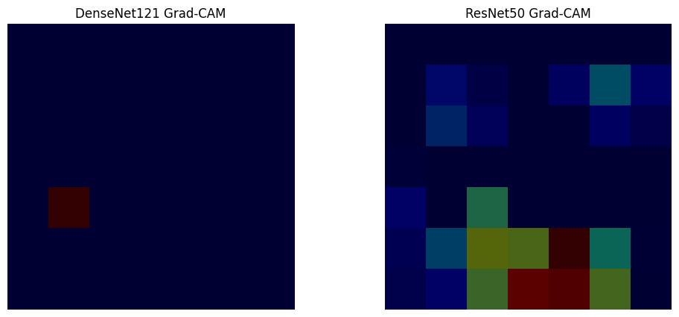

ROC Curve Comparison
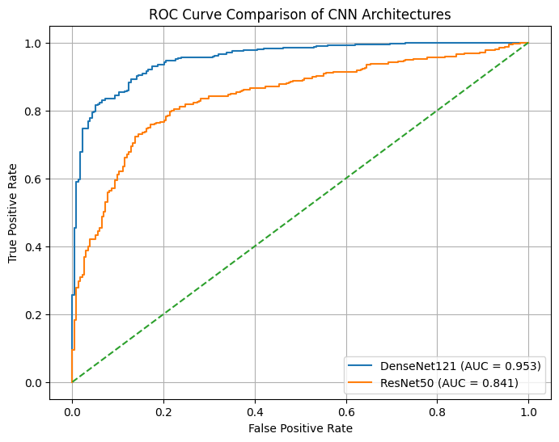
CNN Architecture Performance Comparison
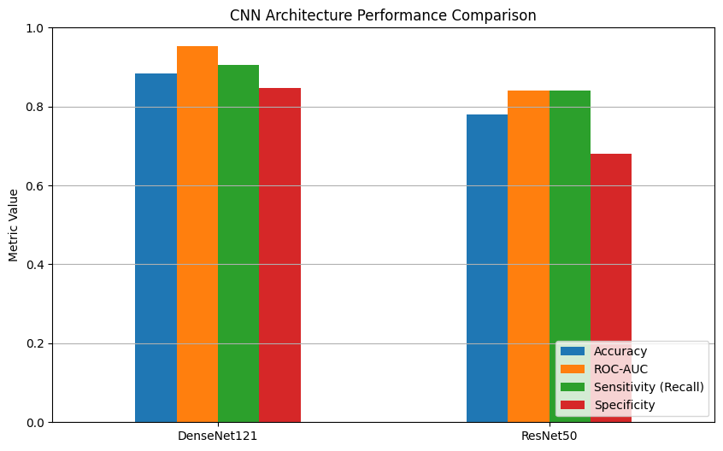

6. Discussion
DenseNet121 outperformed ResNet50 across all evaluation metrics, particularly in ROC-AUC and sensitivity, which are critical for medical diagnosis. Grad-CAM visualizations indicate that DenseNet focuses on compact and relevant lung regions, while ResNet shows broader but less precise activations.

7. Conclusion
The study demonstrates that transfer learning with DenseNet121 provides a robust and explainable solution for pneumonia detection from chest X-rays. Future work may involve fine-tuning deeper layers, incorporating uncertainty estimation, and validating on larger clinical datasets.

