Thao Tran, Dai Ho, William Boyd
ECE 485 F17
Final Project

MESI Cache simulation in C++

This program is a simulation of an L1 writeback cache for a 32 bit wide address computer using MESI coherence protocol. The L1 cache is backed by a shared L2 cache, and consists of a two way, set associative instruction cache and a four way associative data cache. Replacement is governed by LRU, which is tracked by bits in each way.
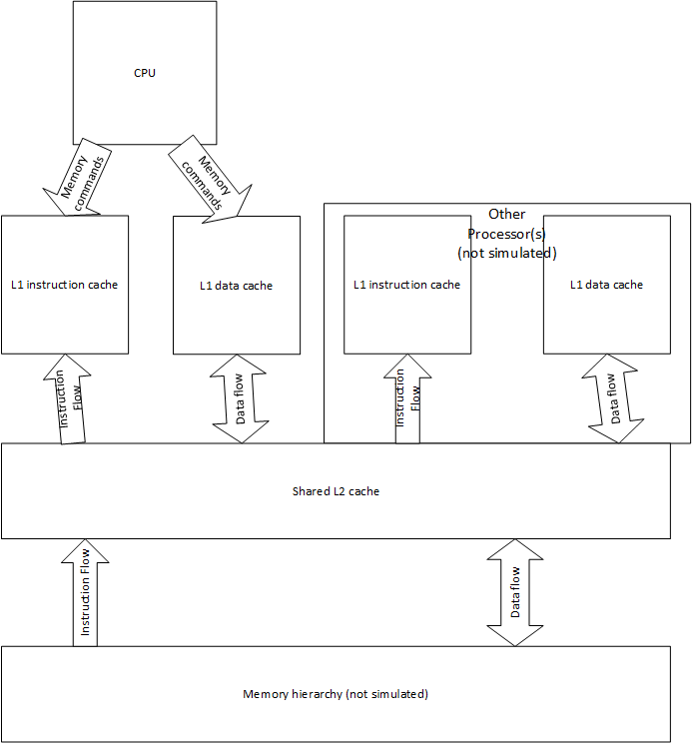
A. Black box representation of program simulation
For this simulation, we used a class to represent the L1 cache and a struct to represent each line in the cache. The L1_cache class has members to track cache hits and cache misses, and cache reads and cache writes. It also has members to track the hit rate for the cache, and a boolean member to track whether the program has been opened in verbose output mode. The L1_cache objects will hold a two dimensional array of cache_line objects that will correspond to the number of sets in the cache and the number of ways in the cache, respectively. The number of sets index will be used as the cache index, and will represent bits 19-6 of the 32 bit address. The number of ways index will represent the ways available at each set, and will have a value of four for the data cache and two for the instruction cache. The simulation takes as inputs a text file containing an integer command and a hex address, represented in characters, followed by a line break.

This simulation supports the following instructions in the format [instruction] [address] \n:
0 read data request to L1 cache
1 write data request to L1 cache
2 instruction fetch (read request to L1 instruction cache)
3 invalidate command from L2
4 data request from L2 (assumed to be in response to snoop)
8 clear the cache and reset all states and statistics
9 print contents and state of cache

The simulation reads addresses as hexadecimal numbers, and returns error if address is invalid (i.e. address contains g-z). It also assumes unspecified left bits are 0.

LRU is represented as a data member of the cache line struct, and is updated in the L1_cache functions as needed. Each function will update the LRU for all sets in the cache line. We use int 0-3 for data cache and int 0-1 for instruction cache, 0 being most recently used, and update members each time they are used by the processor. When updating the LRU of an already existent member in the cache, only the values of members who are listed higher (have lower LRU numbers) are updated. The eviction policy will write to L2 any line marked M.

The L1_cache will have a function to handle a read request command, a function to handle a write request command, a function to handle an instruction fetch command, a function to handle a data request from L2, and functions to clear the cache and print statistics. In addition, each function will have additional options to output more information if the verbose output option is specified.

The read request will check for cache hit, and on hit will increment a hit counter and a read counter. On miss, it will find an available cache line at the specified index or evict a cache line according to LRU protocol. If the evicted cache line has MESI bits M, the line will be written to L2 before the cache line is cleared. It will then set the MESI bit at the cache line to S. It will then perform necessary updates to the LRU at the index. On miss, the function will increment a miss counter and a read counter.

The write request function will check for a cache hit, and on hit will write to L2 and set MESI bit to S if the first write for the data. It will switch the MESI bit to M and not write to L2 if not the first write for this data. If no hit, it will find an available cache line or evict in accordance with LRU policy, and write back to L2 and set MESI bits to S. On hit the function will increment a write counter and a hit counter; on miss it will increment a write counter and a miss counter.

The instruction fetch function simply calls the read request function, and the size of the cacheline determines the behavior of the cache, i.e. the cache will have only two ways instead of four, and there are no writes to this cache.

Data requests from L2 are assumed to be in response to a snoop, so any data requested can be assumed to be in the MESI state M. Nevertheless, the function checks the MESI state and returns false if the address is not in MESI state M. If the address is in state M, the function writes data to the L2 and changes the MESI state to S. There are no statistics to update for this function.

The function to invalidate the address will check for MESI bit M, write the line back to L2 if MESI bit is M, then set MESI bit line to I if the line is not already set to I.

The function to clear the cache will reset all statistics tracking variables to zero and set all cache lines to zero. It will then set the MESI state for each line to I.

The print data command will print the contents of each set, the value of the tracking variables for each set, and will print the tracking statistics for each cache.

