KAVARO HOLDINGS LTD
Professional Website Development Proposal
A complete plan to build a premium, competitive, image-rich holding company website using Codex in VS Code.
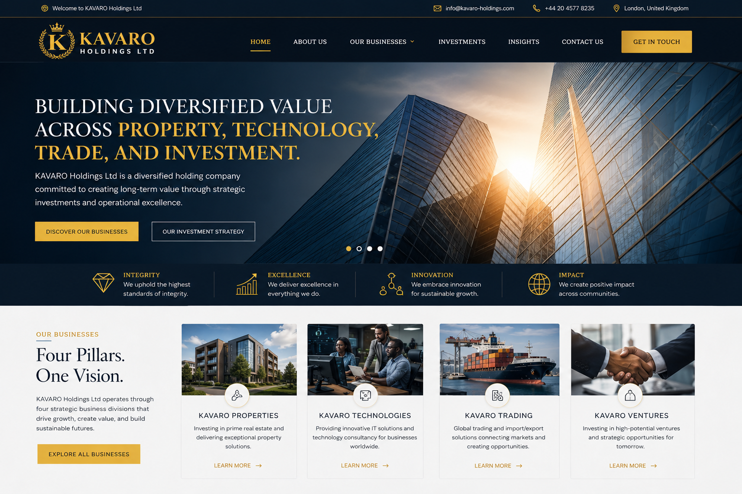
Prepared for: KAVARO Holdings Ltd | Brand Theme: Navy, Gold, White, Charcoal

1. Executive Summary
This proposal outlines how to actualise the KAVARO Holdings Ltd website shown in the design concept. The goal is to build a premium, trustworthy, corporate website that presents KAVARO as a diversified holding company focused on property, technology, trading, ventures, and long-term investment opportunities.
The website should not look like a small startup landing page. It should look like a serious corporate group with a professional logo, polished visuals, clear business divisions, strong calls to action, and a structure ready for future expansion.

2. Project Scope
Area | Requirement
Website Type | Corporate holding company website for KAVARO Holdings Ltd.
Technology | HTML, CSS, JavaScript, JSON data file, Git, GitHub, and GitHub Pages deployment.
Design Level | Premium corporate, responsive, polished, image-rich, and competitive.
Visual Assets | Use professionally generated images for all main website sections. No blank placeholders.
Logo | Create a polished KAVARO logo with crest/crown/K concept, gold on navy, plus white and transparent versions.
Deployment | GitHub repository with clean commits and optional GitHub Pages live link.

3. Brand Direction
The website should communicate strength, stability, excellence, trust, and global ambition.
- Primary colours: deep navy, premium gold, white, charcoal, and light grey.
- Logo style: luxury crest, letter K, crown, laurel, shield or globe-inspired detail.
- Typography: elegant serif for major headings and clean sans-serif for body text.
- Imagery: modern architecture, business meetings, technology teams, logistics/trading, partnership handshakes, and investment visuals.
- Tone: professional, confident, global, trustworthy, and future-focused.

4. Required Website Pages

Home
Hero section, brand statement, business pillars, values, featured divisions, investment focus, and call to action.

About Us
Company story, mission, vision, values, leadership/founder section, governance, and long-term ambition.

Our Businesses
Detailed sections for KAVARO Properties, Technologies, Trading, and Ventures.

Investments
Investment philosophy, target sectors, strategic partnerships, property growth, digital solutions, and acquisitions.

Insights
Professional blog/news page with business articles and company updates.

Contact Us
Validated contact form, contact details, enquiry categories, map/location area, and social links.

References
Ethical design statement confirming the website is original and only inspired by global corporate standards.

5. Professional Image and Asset Plan
Website Section | Image Needed | Purpose
Hero/Home | Glass corporate skyscrapers with sunrise/gold light | Creates premium first impression.
Properties | Modern residential/commercial building | Represents property investment.
Technologies | Professional technology team in office | Represents IT consultancy and innovation.
Trading | Cargo ship, port, logistics or warehouse | Represents import/export and trade.
Ventures | Professional handshake or boardroom partnership | Represents investments and strategic deals.
About | Corporate leadership/team or global city skyline | Builds trust and company identity.
Investments | Financial growth, boardroom analysis, or property portfolio image | Shows long-term value creation.
Contact | Professional office reception or London business district | Makes the company look established.

6. Functional Requirements
- Responsive navigation with mobile hamburger menu.
- Hero slider or hero image with strong CTA buttons.
- Business division cards loaded from a JSON file where appropriate.
- Contact form validation using JavaScript.
- Dynamic footer year.
- Scroll-to-top button.
- Accessible structure with headings, alt text, keyboard-friendly navigation, and readable contrast.
- SEO basics: title tags, meta descriptions, Open Graph tags, favicon, and structured page content.
- Clean README with setup and deployment instructions.

7. Recommended Project Structure
kavaro-holdings-website/
├── index.html
├── about.html
├── businesses.html
├── investments.html
├── insights.html
├── contact.html
├── references.html
├── styles/
│ └── style.css
├── scripts/
│ └── main.js
├── data/
│ └── businesses.json
├── images/
│ ├── logo-kavaro-gold.png
│ ├── logo-kavaro-white.png
│ ├── hero-corporate.jpg
│ ├── properties.jpg
│ ├── technologies.jpg
│ ├── trading.jpg
│ ├── ventures.jpg
│ └── investment.jpg
└── README.md

8. Ready-to-Use Codex Prompt
Create a complete premium corporate website for KAVARO Holdings Ltd based on the supplied website concept image. Build it using HTML, CSS, JavaScript, and JSON only. Create a GitHub repository named kavaro-holdings-website, then scaffold the project in VS Code.
The website must include index.html, about.html, businesses.html, investments.html, insights.html, contact.html, references.html, styles/style.css, scripts/main.js, data/businesses.json, images folder, and README.md.
Use a navy, gold, white, charcoal, and light grey corporate design. Create a professional KAVARO logo concept using the letter K, crown/crest/laurel style, and use professional generated images across all sections. Do not use placeholders, copied images, copied text, or copyrighted Dubai Holding assets. All content must be original for KAVARO Holdings Ltd.
Build the full website with responsive layout, mobile menu, contact form validation, business cards, investment sections, insights/blog cards, footer, scroll-to-top button, SEO meta tags, Open Graph tags, favicon references, accessibility alt text, and clean comments.
Make it visually competitive with global holding company websites. Commit the first complete version with the message: Initial complete KAVARO Holdings website, then push to GitHub.

9. Implementation Plan

Phase 1 - Brand Assets
Generate final logo, favicon, colour palette, image set, and visual identity rules.

Phase 2 - Project Setup
Create GitHub repo, folder structure, base HTML pages, CSS variables, and JS file.

Phase 3 - Page Build
Build Home, About, Businesses, Investments, Insights, Contact, and References pages.

Phase 4 - Visual Polish
Add section images, cards, hover effects, spacing, responsive layout, and premium finishing.

Phase 5 - Testing
Check mobile, tablet, desktop, forms, links, spelling, accessibility, and performance.

Phase 6 - Deployment
Push to GitHub, deploy to GitHub Pages, then connect a domain when ready.

10. Suggested Timeline
Stage | Estimated Time | Output
Brand/logo/images | 1-2 days | Logo pack and image library
Website build | 2-4 days | Complete multi-page website
Testing and refinement | 1-2 days | Responsive, polished version
Deployment | Same day | GitHub Pages live link

11. Acceptance Criteria
- The website must look complete and professional, not unfinished.
- No placeholder image boxes should remain in the final build.
- All navigation links must work correctly.
- The site must be responsive on mobile, tablet, and desktop.
- The contact form must validate required fields.
- Images must include meaningful alt text.
- The logo must appear correctly in header/footer and favicon format.
- The README must explain setup, structure, and deployment.
- The final project must be committed and pushed to GitHub.

12. Final Deliverables
- Complete source code repository on GitHub.
- Responsive KAVARO Holdings website.
- Professional logo files.
- Professional website images saved in the images folder.
- README.md documentation.
- Live GitHub Pages link or deployment-ready package.
- Future improvement list for adding domain, analytics, CMS, blog admin, and business email.

13. Strategic Recommendation
Start with a strong static website first. This is faster, cheaper, easier to maintain, and suitable for a new UK holding company. Later, KAVARO can add a CMS, investor portal, company news dashboard, multilingual pages, analytics, and separate subsidiary websites.
This project should position KAVARO Holdings Ltd as a serious and trusted corporate brand from day one.

