|  |  |
| --- | --- |
| eVisitor card | Abstract  No touch visitor entry card solution using UIPath Forms  Barkha Rastogi  rastogi.barkha6@gmail.com |

Contents

Inspiration 2

About eVisitor Card 2

Features 2

1. Generate the QR Code 2

2. Send the QR Code to visitor 2

3. Scan the QR Code 2

4. Validate the QR Code based on the details provided by visitors 2

5. Show camera window and take the photograph of the visitor 2

6. Generate entry card 2

7. Send digital entry card to the visitor over email 3

8. Delete the visitor details from google sheet 3

9. Add the visitor details in another google sheet to keep the details for future 3

Functionality Flowchart 4

Dependencies 4

Challenges I ran into 5

Future Improvement 5

# Inspiration

The motivation originated from the present circumstance where everyone is looking for minimal touch to the common things. Most organizations see visitors every day to their office regardless of whether it is an interview candidate, vendor, or salesman. And all the visitors will be accessing the same gadget either tablet, visitor register or any medium to collect visitor entry and common ID cards which may not be reasonable in this circumstance.

# About eVisitor Card

E-Visitor card digitizes the visitor check-in to the workplace premises. This solution sends the approval code (QR Code) to visitor. This QR Code will be validated upon visit without contacting any gadget. If the QR Code gets authorized, bot will snap the picture of visitor and will send the entry card over email.

E-Visitor card was made keeping the idea of no touch to the common things regardless of whether it is visitor register, electronic gadget or any other medium to take visitor entry.

# Features

## Generate the QR Code

Read the details from Google sheet and based on the email address generate the QR Code using Google Chart API.

## Send the QR Code to visitor

Using the built-in email functionality of UIPath sends the email to the visitor with the QR Code generated at the above step.

## Scan the QR Code

Show UIPath form with scan QR Code Button and on button click call python script to show the window to scan QR Code and once it finds the QR Code the code will return the content.

## Validate the QR Code based on the details provided by visitors

Based on the content returned from the above step, validate the content in visitor details Google sheet to check if any entry exists.

## Show camera window and take the photograph of the visitor

If visitor details exist in Google sheet, Call Python script to show the camera window and Security can take the photo by clicking on Enter button.

## Generate entry card

Get all the details of the visitor from Google sheet and show details in UIPath form for the Security to validate.

## Send digital entry card to the visitor over email

Once security check is done, Generate Pass button can be clicked on UIPath Forms and the screenshot of the form i.e. entry card will be sent to visitor over email.

## Delete the visitor details from google sheet

Delete the visitor details from Google sheet once the entry card has been issued.

## Add the visitor details in another google sheet to keep the details for future

Store the visitor details from the above step in variable and pass these values in Google sheet

# Functionality Flowchart

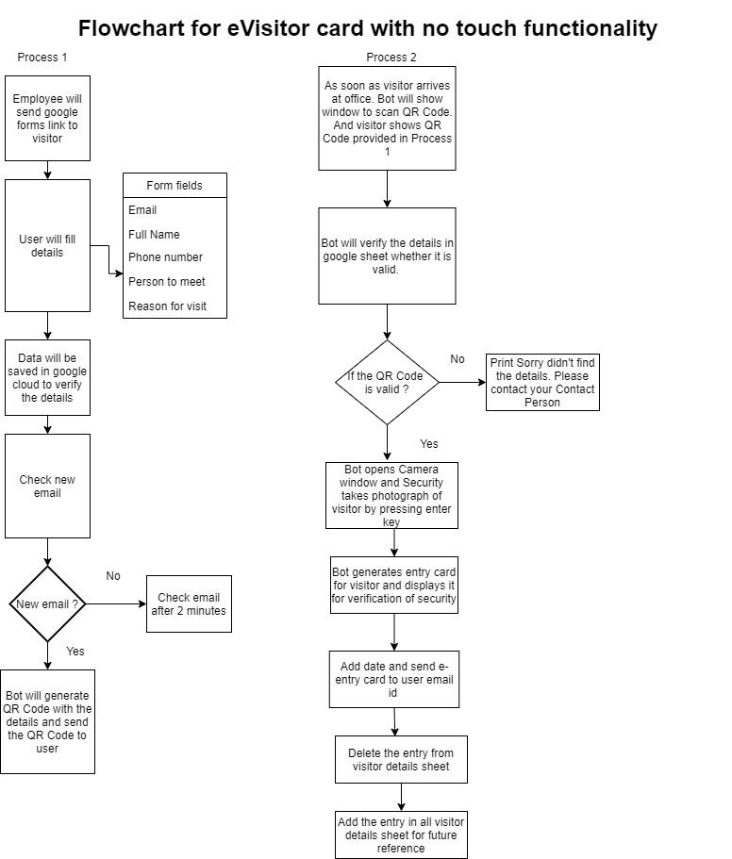

# Dependencies

* Python should be installed in the system where the bot needs to be executed
* Python path must be added to PATH system environment variable (Refer README.md for steps)
* The dependent python libraries should be installed which can be installed by running install.bat available in Prerequisites folder
* Integrated or External Camera

# Challenges I ran into

**Problem:** The challenge was to send the entry card over Gmail with the inline image (only for an image stored in the local machine) using the built-in email functionality where the image was getting displayed as blank however the same functionality was working fine while sending the email in outlook.

**Solution:** Used Invoke code (VB.NET code) to send the email with an inline image which is sending the email with an inline entry card to the visitor.

**Problem:** If the visitor detail is not valid, the UIPath form should be called again and wait for the button click but somehow the form waits for user input for first time but for second time it keeps on opening new forms. Attaching the workflow for reference.

**Solution:** As of now doesn’t call to UIPath form for second time simply message gets printed.



# Future Improvement

* Scanning Government ID
* Auto Face-detection