Functional Specification Document
LOCKEDME.COM

Version | Description of Change | Author | Date
1.0 | Initial Draft | Bramhaiah B Reddy | 22/01/2021

CONTENTS
1 INTRODUCTION 4
1.1 Purpose 4
1.2 Scope 4
1.3 Background 4
2 AGILE METHODOLOGY 5
3 FUNCTIONAL REQUIREMENTS 5
3.1 Context 5
3.2 User Requirements 5
3.3 Data Flow Diagrams 6
3.4 Logical Data Model/Data Dictionary 6
3.5 Functional Requirements 6

1.INTRODUCTION
This Document provides the overview of LOCKEDME.COM and its core capabilities.

Purpose
This document is reference for all stakeholders of the project and single source to track future enhancements.

Scope
This document only provides the overview of the App, Implementation approach and Effort Estimation.

Background
Company Lockers Pvt. Ltd. Aims to digitize the current offerings.lockedme.com is the MVP of the core capabilities.

2.AGILE METHODOLOGY

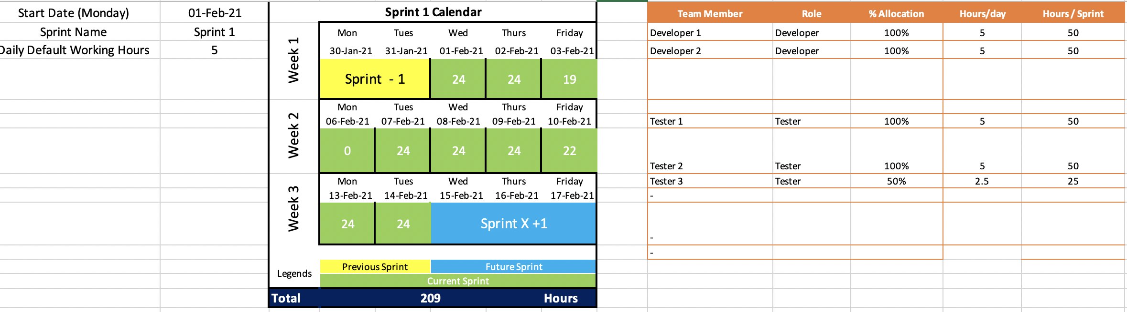

Total Developers : 2
Total QE : 2
Total hours 209
Total Sprints -2 (2 week sprint)

3.FUNCTIONAL CAPABILITIES

3.1 Context
At the core ,LockedMe.com provides users to manage their files at a given directory.

3.2 User Requirements
- List all the Files available in a given directory
- Add a new File to a Directory
- Delete an existing File from Directory
- Search for a given file from Directory

3.1Functional Requirements
Core Function requirements

3.1.1 Functional Requirements Group 1
Exhibit 4 - Sample Requirements Group 1
Section/ Requirement ID | Requirement Definition
FR1.0. | View all the Files in a directory
FR1.1 | Add the Files in a directory
FR1.2 | Delete the Files in a directory
FR1.3 | Search the Files in a directory

JAVA Concepts Used For Application
1)Static Methods with Loops(do-While, Switch) and Scanner class to get user Input and Display the Options
2)Interface defining the Key File operations that needs to be implemented in inherited class
3)Inheritance through implements of Interface for providing the implementation of core File operations
4)Lambda and streams from JAVA-8 to sort the file names in ascending order.
5)String Search “equals” method for File search.

