# Abstract

Industry 4.0 is the result of rapid technological advancement, dictated by Moore’s. Industry 4.0 seeks to enhance on Industry 3.0's automation by allowing devices to interact with one another, commonly known as the Internet of Things (IoT). Due to the widespread growth of IoT, various data from sensors is made accessible as what’s known as big data. Coupled with deep learning, these data are used to train machine models to make decisions. Resulting in an intelligent system that makes decisions without human involvement. Industry 4.0 has created an opportunity for a future where smart factories can leverage some of the most cutting-edge developing technology to automate and enhance many processes. Unmanned Aerial Vehicles (UAVs) is one such example. In Industry 4.0, UAVs have been deployed to perform task in smart factories that performs automatable and tedious tasks. Hence, this report aims to covers the usage and capabilities of UAVs in Industry 4.0. More specifically, the development and design of an intelligent UAV system for Industry 4.0.

# UAVs in industry 4.0

In Industry 4.0, autonomous UAVs are used to achieve a wide range of missions. Missions include warehouse operations – Inventory management, indoor intra-logistics, and inspections and surveillance[1]. Manufacturing – Inspection and maintenance [2]. For Warehouse management, UAVs are equipped with RFID scanners and Cameras for QR code and deployed to perform stock taking. Additionally, they have capabilities to transfer inventory from one location to another and lastly, check for pallet placement and detect theft. For Manufacturing, UAVs carry out inspection on equipment using infrared sensors to detect anomalies and cameras to deploy computer vision to detect cracks.

# Classification of UAVs

Generally, there are 4 categories of UAVs. In smart factories, multi-rotor drones are used due to the lower cost of investment and simpler flight dynamics, allowing for a 4- degrees of freedom (DoF) body. Figure 3A shows the categories of drones.

Figure 3A: Categories of UAVs

Additionally, the level of aerial autonomy can be further classified based on inputs, capabilities reactions and decisions. Currently, drones have reached Level 4A of autonomy, where is senses and navigates with the assistance of an external computer. Figure 3B shows the categories aerial autonomy.

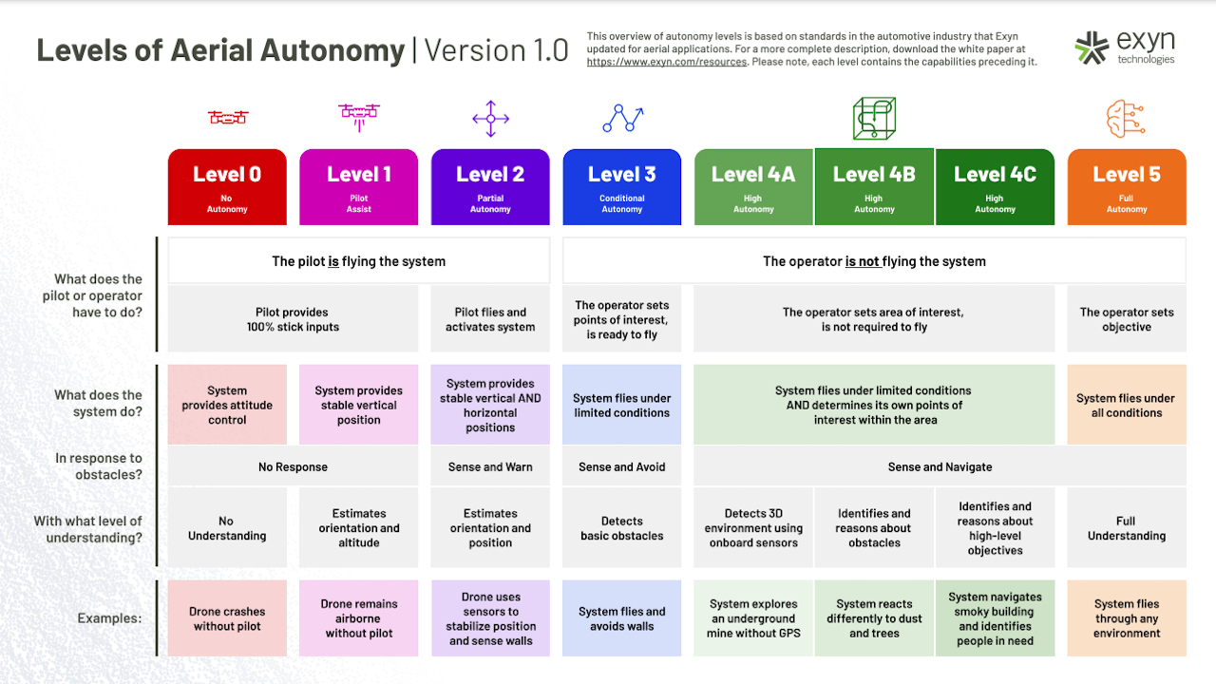

Figure 3B: Levels of autonomous UAV

In this report, more emphasis will be placed on the development of Level 4A UAVs in smart factories.

# Function principles of UAVs

In smart factories, UAVs operate in a Partially Observable, Stochastic, Collaborative, Multi-agent, Dynamic, and Continuous environment. Hence, smart factories UAVs must be goal based, utility agents. Agents are things that senses and act on the environment. Goal based agents have sensors to localize their position and aims to reduce their position to their goal. Utility agents aims to minimize the total costs which could be path time or power consumption, or various parameters based on pareto optimal points. By having sensors to detect objects or cameras to perform simultaneous localization and mapping (SLAM), the UAV should be able to run search algorithms such as A* to reach the end goal based on current state, as well as update its current state based on its perception from sensors. Figure 4A shows how SLAM is implemented. Figure 4B shows a graphical representation of A* algorithm.

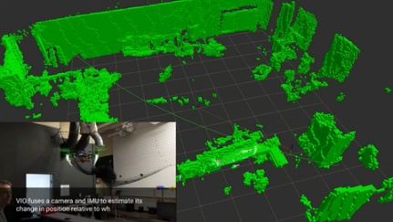

Figure 4A: Graphical representation of SLAM Figure Figure 4B: Graphical representation of A* Algo

Infinium Robotics is a company that develops collaborative drones for stock taking in smart factories. The UAVs are tethered to an Unmanned ground vehicle (UGV) where power and localization is provided. A ground control system (GCS) does path planning and transmits the path over to UGVs.

# Learning approach

# References

[1] L. Wawrla, O. Maghazei, and T. Netland, “Whitepaper-Applications of drones in warehouse operations Whitepaper Applications of drones in warehouse operations,” 2019, Accessed: Feb. 20, 2022. [Online]. Available: www.pom.ethz.ch

[2] M. Javaid, I. H. Khan, R. P. Singh, S. Rab, and R. Suman, “Exploring contributions of drones towards Industry 4.0”, doi: 10.1108/IR-09-2021-0203.