实现机制

（一）展示集成

1. 概述

TeamViewer在13版本之后客户端界面使用QT进行开发，使用QT可以为主流的几乎所有平台提供近乎一样的展示界面，例如Windows、Mac OS、Linux、iphone、Android、Windows Phone、Chrome OS，给予了一致的表示方式。

（b）范例

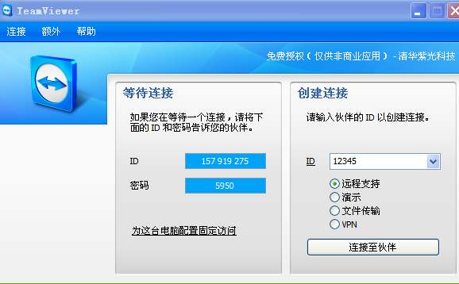

1. 功能集成
2. Group management
3. 概述

一个公司中存在来自不同部门的人的很多不同的group，需要对这些group进行创建、访问、删除等等的管理。

（b）外部服务接口

1. 获取所有的组

i.接入url：

/api/v1/users/<uID>/groups，可选参数：name、shared

Ii.接入方式：

GET

Iii.返回值：

发送请求：GET /api/v1/groups?name=Test

返回：

HTTP/1.1 200 OK

Content-Type: application/json

{ "groups" : [

{ "id" : "g53235",

"name" : "Testing",

"shared_with" : [

{ "userid" : "u631645",

"name" : "Ted",

"permissions" : "read"}],

"permissions" : "owned"

},

{ "id" : "g425123356",

"name" : "Test",

"owner" : {

"userid" : "u814464403",

"name" : "Tester" },

"permissions" : "readwrite"

}]

}

1. 创建组

i.接入url：

/api/v1/users/<uID>/groups，参数：name、pcpolicy_id

ii.接入方式：

POST

iii.返回值举例：

请求：

POST /api/v1/groups

Content-Type: application/json

{ "name" : "Test",

"policy_id": "5d93f008-3b1f-8472-8555-3549d5a68092" }

返回：

HTTP/1.1 200 OK

Content-Type: application/json

Location: https://webapi.teamviewer.com/groups/g425123356

{

"id" : "g425123356",

"name" : "Test",

"permissions" : "owned",

"policy_id": "5d93f008-3b1f-8472-8555-3549d5a68092" }

1. Session management

（a）获取session

i.接入url：

**/api/v1/sessions，参数：groupid、full_list**

ii.接入方式：

GET

iii.返回值举例：

发送请求：

GET /api/v1/sessions?groupid=g425123356&full_list=true

返回：

{

"sessions" : [

{"code" : "s31 328 542",

"groupid" : "g425123356",

"description" : "Hello, I have an issue with my printer, can you

please assist?",

"end_customer" : { "name" : "Peter Niedhelp", "email" : "help

me@example.com"

"assigned_userid" : "u7254190",

"end_customer_link" : https://getpilot.teamviewer.com/

"supporter_link" : https://getpilot.teamviewer.com/

"custom_api" : "{ "ticket_id" : "535824"

"support_session_type" : "Pilot"}, ...]

}

（b）创建session

i.接入url：

**/api/v1/sessions，参数：groupid、groupname**

ii.接入方式：

POST

iii.返回值举例：

HTTP/1.1 200 OK

Content-Type: application/json

Location: https://webapi.teamviewer.com/api/v1/sessions/s12-345-678

{"code" : "s12-345-678",

"state" : "open",

"groupid" : "g425123356",

"end_customer" : { "name" : "Max" },

"description" : "I have a problemwith myspace bar.",

"assigned_userid" : "u7254190",

"end_customer_link" : "https://getpilot.teamviewer.com/s12345678",

"supporter_link" : "https://getpilot.teamviewer.com/s12345678-

asfg1234asfg",

"valid_until" : "2013-10-30T12:03:29Z"

}

1. 工作流程

