**TOPIC : Recipe Recommendation and Meal Planning App**

***Objective :***

**1. Time-Saving:** Streamlines meal planning and recipe discovery.

**2. Promotes Healthy Eating :** Offers balanced meal suggestions and nutritional info.

**3. Reduces Food Waste:** Helps manage pantry inventory and create shopping lists.

**4. Inspires Variety:** Introduces diverse recipes for culinary exploration.

**5. Adapts to Dietary Needs:** Accommodates various dietary restrictions and preferences.

**6. Fosters Community:** Allows users to share recipes and engage with others.

**7. Tracks Nutrition:** Enables monitoring of calorie intake and macronutrient consumption.

**8. Integrates with Smart Devices:** Enhances cooking process with smart kitchen appliance integration.

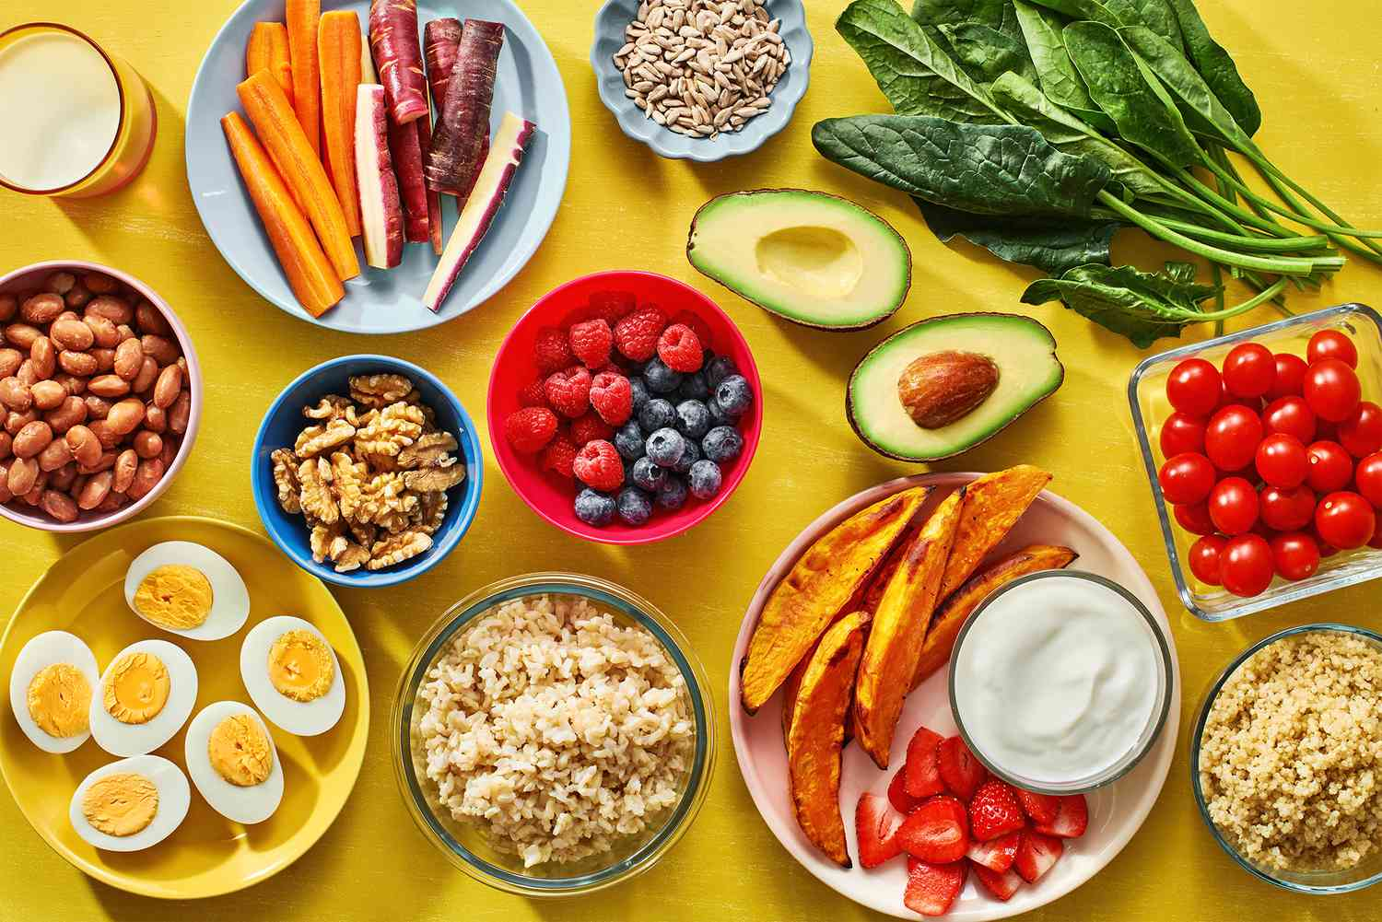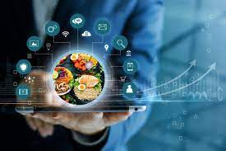

**Use-Cases :**

**1. Busy Professional :** Quickly browse personalized meal recommendations to save time on meal planning.

**2. Dietary Restriction :** Easily find gluten-free recipes with the app's filtering feature.

**3. Family Meal Planning** : Create a tailored meal plan and generate a shopping list for the whole family's needs.

**4. Cooking Enthusiast :** Discover unique recipes and share cooking tips with the app's community.

**5. Fitness Goal Tracking :** Log meals and monitor macronutrient intake to stay on track with fitness goals.

**6. Smart Kitchen Integration :** Follow recipes step-by-step on smart displays and control smart appliances for precise cooking.

**7. Special Occasion Planning**: Create a gourmet menu tailored to guests' preferences and dietary needs for a memorable dinner party.

**8. Pantry Inventory Management :** Receive recipe recommendations based on ingredients already available at home to minimize food waste.





**Technologies and Languages used : -**

The already submitted prototype is a webpage that is capable to be launched in local host

***Backend :***

The backend of our website is created with JavaScript

Required Dataset and recipes are fetched from the website named **“Edamam”** using its **API KEY** and **API_ID**

***Frontend :*** Basic HTML , CSS used followed by **SCSS** And **React** , **NodeJS**





---- Features ----

1. user can search the recipes based on the ingredient or the name

2. Various categories are sorted in the home page like “ chicken “ , “ vegan “ , “ dessert “ etc. User can visit the various options according their choice

3. For each recipe the ingredients or grocery items are mentioned separately in the page

4. The publisher Page is also mentioned below

5. Visiting the publisher page user can know about the source , tradition , nutritious elements in details.

**--Drawbacks-–**

1. Website has no specific database but uses another website api to fetch required data. Currently user can not upload and share their recipes.

2. Limitations for the items are a vital drawback of this system because the website has access for limited offers

3. Currently user is unable to search for meals according to their nutritious properties but according to the ingredient only.

**---Functionality----**

**1. App Component and Routing**

* **Purpose**: Sets up the main structure of the React application and defines routing logic.
* **Components**:
  + **App.js**: Contains the main functional component **App** which serves as the entry point.
  + Imports various page components like **Home**, **MealDetails**, **Error**, and **Category**, as well as reusable components like **Header** and **Sidebar**.
* **Routing**:
  + Utilizes React Router (**BrowserRouter**, **Routes**, **Route**) for defining routes.
  + Each route corresponds to a specific URL path and renders the associated component.



**2. Styling with SCSS**

* **Purpose**: Provides styling rules for the React application using SCSS.
* **Features**:
  + Imports the Raleway font from Google Fonts.
  + Defines variables for colors and font families.
  + Sets global styles and resets for consistency across browsers.
  + Defines utility classes for common layout and styling tasks.
  + Provides specific styles for sections like **.main-holder** and **.sc-title**.



**3. Root Component and Context Providers**

* **Purpose**: Initializes the React application and manages state using context providers.
* **Components**:
  + **index.js**: Initializes the application and renders the **App** component.
* **Context Providers**:
  + Wraps the **App** component with context providers (**SidebarProvider** and **MealProvider**).
  + These providers manage state related to sidebar and meal data.

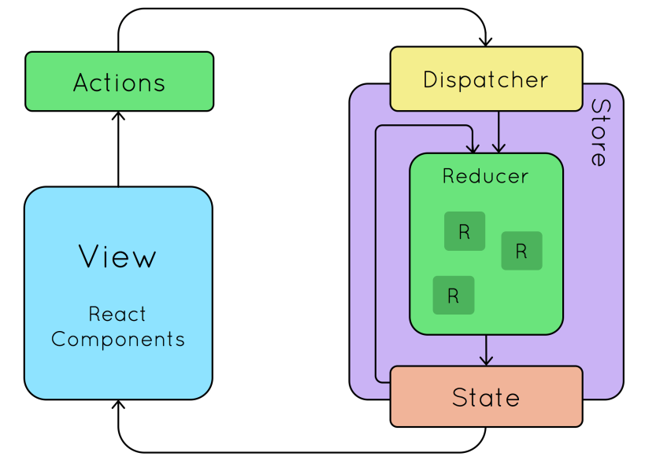

**4. Axios Instance Configuration**

* **Purpose**: Creates an Axios instance for making HTTP requests to TheMealDB API.
* **Features**:
  + Configures a base URL for API requests to **https://www.themealdb.com/api/json/v1/1/**.
  + This instance can be imported and used throughout the application to interact with the API.



**5. HTML Template for React Application**

* **Purpose**: Defines the HTML structure for the React application's entry point.
* **Features**:
  + Sets up essential meta tags for character encoding, viewport settings, and description.
  + Links to assets like favicon and manifest file, using the **%PUBLIC_URL%** placeholder for correct paths.
  + Provides a root element (**<div id="root"></div>**) for React to render components.
  + Includes instructions for enabling JavaScript and starting development or building production bundles in comments.

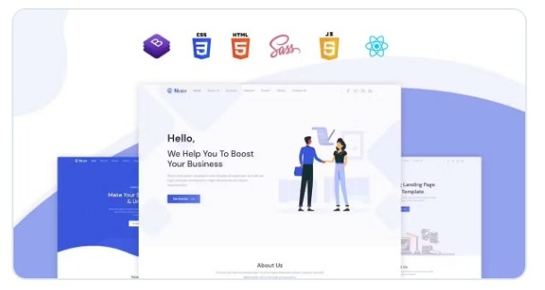

**Future Aspects of Our Projects**

1. **Personalized Recommendations**: Tailor recipe suggestions based on user preferences, dietary restrictions, and past choices, offering a customized culinary experience.

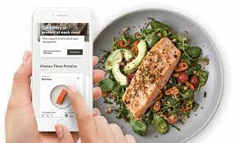

1. **User Profiles**: Enable users to save favorite recipes, set dietary preferences, and track cooking history for a personalized cooking journey.

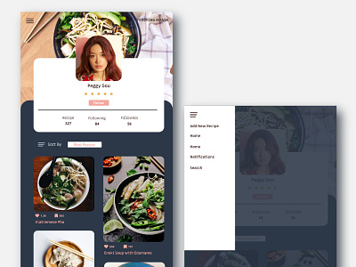

1. **Nutritional Information**: Provide detailed breakdowns of calories, macronutrients, and micronutrients, aiding users in making informed dietary decisions.
2. **Cooking Assistant**: Guide users through recipes with step-by-step instructions and visual aids, enhancing cooking skills and confidence.

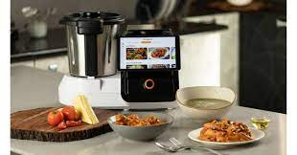

1. **Community Features**: Share recipes, meal plans, and cooking tips within the app's community, fostering collaboration and inspiration.
2. **Integration with Fitness Apps**: Sync meal plans with fitness tracking apps for a holistic health view and goal alignment.
3. **Subscription Model**: Offer premium features like exclusive recipes and ad-free browsing through subscription, enhancing user experience.
4. **Feedback Loop**: Collect user ratings and reviews to improve recipe recommendations and app features over time.
5. **Virtual Reality Cooking Experience**: Immerse users in virtual kitchens for an engaging and interactive cooking experience, blending technology with culinary artistry.
6. **Augmented Reality Ingredient Recognition**: Use AR technology for instant ingredient identification and nutritional information, revolutionizing ingredient sourcing and cooking preparation.

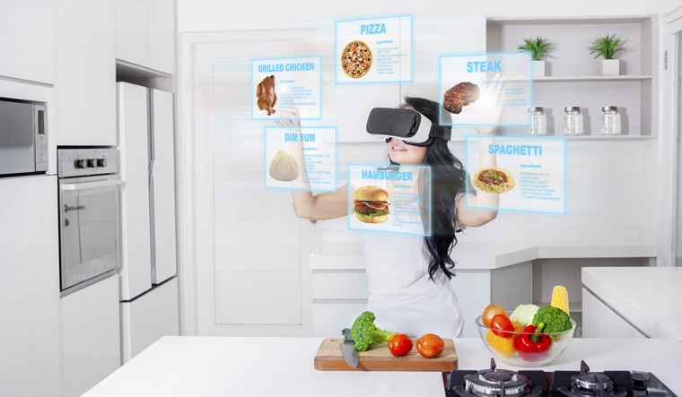

1. **Genetic Nutritional Analysis**: Offer personalized recipe recommendations based on genetic predispositions and nutritional needs, elevating nutrition to a personalized level.
2. **Voice-Activated Cooking Assistant**: Enable hands-free cooking experiences with voice commands, enhancing convenience and accessibility in the kitchen.
3. **Food Waste Reduction Tools**: Minimize food waste by suggesting recipes and providing tips for proper storage and preservation, promoting sustainability.
4. **AI-Generated Recipes**: Inspire creativity with AI-generated recipe ideas based on preferences and ingredient availability, pushing culinary boundaries.
5. **Meal Customization for Health Conditions**: Personalize recipes for specific health conditions, empowering users to manage their health through nutrition.



1. **Predictive Cooking Recommendations**: Anticipate users' needs with predictive analytics, offering timely recipe suggestions based on various factors.
2. **Ingredient Substitution AI**: Suggest ingredient substitutions based on dietary needs and availability, ensuring flexibility in cooking.
3. **Collaborative Cooking Challenges**: Engage users with cooking challenges and competitions, fostering community and camaraderie within the app.

**Conclusion :** In conclusion, this recipe recommendation and meal planning app offers a comprehensive and personalized culinary experience for users. By incorporating personalized recommendations, detailed nutritional information, seamless integration with smart devices, offline access, and a feedback loop for continuous improvement, the app empowers users to explore, plan, and enjoy their culinary journey with confidence. Additionally, the innovative use of augmented reality ingredient recognition adds a futuristic touch, revolutionizing the way users interact with ingredients and enhancing their cooking experience. Overall, this app serves as a valuable companion for home cooks, catering to their diverse needs and preferences while fostering a sense of community and culinary exploration.

-------------------------- The End -----------------------------