Results starting 1988

Table of Contents

# Appendix S1 Figure S1.

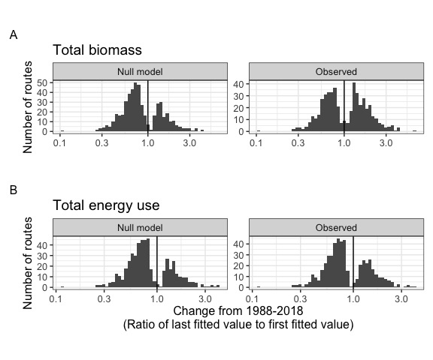

**Appendix S1 Figure S1**. Histograms showing the direction and magnitude of long-term trends for the null-model (left) and observed (right) changes in biomass (A) and energy use (B), for communities whose best-fitting model includes a significant slope and/or interaction term. Change is summarized as the ratio of the fitted value for the last year in the time series to the fitted value for the first year in the timeseries from the best-fitting model for that community. Values greater than 1 (vertical black line) indicate increases in total energy or biomass over time, and less than 1 indicate decreases.

# Appendix S1 Figure S2.

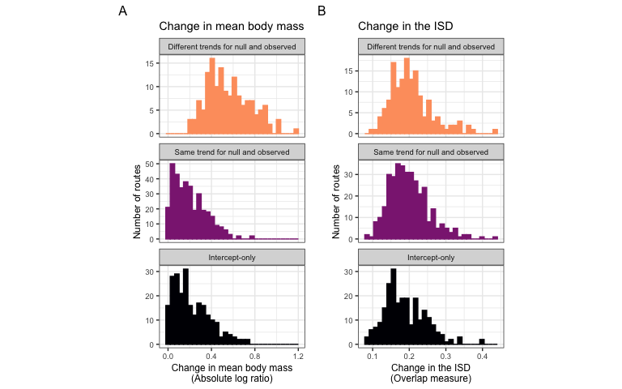

**Appendix S1 Figure S2.** Histograms of (A) change in mean body size from the first to the last five years of monitoring, and (B) overall change in the size structure for routes whose dynamics for total biomass were best-described using no temporal trend (bottom row; intercept-only model), separate trends for observed and null dynamics (middle row), or the same trend for observed and null dynamics (top row). Change in mean body size (A) is calculated as the ratio of the mean body size of all individuals observed in the last 5 years of the timeseries relative to the mean body size of all individuals observed in the first 5 years. Overall change in the ISD (B) is calculated as the degree of turnover between the ISDs for the first and last five years of the timeseries (see text).

# Appendix S1 Table S1.

| Currency | Selected model | Number of routes | Proportion of routes |
| --- | --- | --- | --- |
| Total biomass | Intercept-only | 238 | 0.32 |
| Total biomass | Trend, not decoupled | 352 | 0.48 |
| Total biomass | Decoupled trend | 149 | 0.20 |
| Total energy use | Intercept-only | 230 | 0.31 |
| Total energy use | Trend, not decoupled | 456 | 0.62 |
| Total energy use | Decoupled trend | 53 | 0.07 |

**Appendix S1 Table S1**. Table of the number and proportion of routes whose dynamics for total biomass and total energy use are best described by the following model types: no directional change (intercept-only model, biomass ~ 1 or energy use ~ 1); the same trend for null and observed dynamics (biomass ~ year or energy use ~ year); or different trends for observed and null dynamics (biomass ~ year * null or observed or energy use ~ year * null or observed).

# Appendix S1 Table S2.

| Currency | Proportion of increasing individuals-driven trends | Proportion of increasing observed trends | Number of routes with temporal trends |
| --- | --- | --- | --- |
| Total biomass | 0.33 | 0.49 | 501 |
| Total energy use | 0.30 | 0.35 | 509 |

*Appendix S1 Table S2*. The proportion of trends that are increasing (specifically, for which the ratio of the last fitted value to the first fitted value > 1) for individuals-driven and observed dynamics, for routes exhibiting temporal trends (either the same or different slopes for null and observed dynamics) in total biomass and total energy use. Trends that are not increasing are decreasing.

# Appendix S1 Table S3.

| Res.Df | RSS | Df | Sum of Sq | F | Pr(>F) |
| --- | --- | --- | --- | --- | --- |
| 736 | 20.81904 | NA | NA | NA | NA |
| 738 | 35.42466 | -2 | -14.60562 | 258.1708 | 0 |

**Appendix S1 Table S3**. ANOVA table comparing ordinary linear models of the form abs_log_ratio ~ best model type and abs_log_ratio ~ 1.

# Appendix S1 Table S4.

| categorical_fit | emmean | SE | df | lower.CL | upper.CL |
| --- | --- | --- | --- | --- | --- |
| Different trends for null and observed | 0.5587675 | 0.0137784 | 736 | 0.5317179 | 0.5858171 |
| Same trend for null and observed | 0.2012914 | 0.0089644 | 736 | 0.1836926 | 0.2188902 |
| Intercept-only | 0.2203741 | 0.0109019 | 736 | 0.1989715 | 0.2417766 |

**Appendix S1 Table S4.** Estimates (calculated using emmeans (Lenth 2021)) for the mean absolute log ratio of mean mass for routes whose dynamics for biomass were best-described by different model types.

# Appendix S1 Table S5

| contrast | estimate | SE | df | t.ratio | p.value |
| --- | --- | --- | --- | --- | --- |
| Different trends for null and observed - Same trend for null and observed | 0.3574762 | 0.0164379 | 736 | 21.747096 | 0.0000000 |
| Different trends for null and observed - (Intercept-only) | 0.3383935 | 0.0175697 | 736 | 19.260017 | 0.0000000 |
| Same trend for null and observed - (Intercept-only) | -0.0190827 | 0.0141142 | 736 | -1.352018 | 0.3669124 |

**Appendix S1 Table S5**. Contrasts for absolute log ratio of mean mass, calculated using emmeans (Lenth 2021).

# Appendix S1 Table S6

| Resid. Df | Resid. Dev | Df | Deviance | Pr(>Chi) |
| --- | --- | --- | --- | --- |
| 736 | 14.09240 | NA | NA | NA |
| 738 | 14.28236 | -2 | -0.1899672 | 0.9093878 |

*Appendix S1 Table S6*. ANOVA table comparing binomial generalized linear models of the form ISD_turnover ~ best model type and ISD_turnover ~ 1.

# References

Lenth, R. V. 2021. Emmeans: Estimated Marginal Means, aka Least-Squares Means.