Comparing results using 1989-2018 to results using 1988-2018 (739 routes; main analysis)

Figures are shown stacked to highlight differences.

Tables are shown stacked, with numerical differences highlighted in red.

Table of Contents

Figure 1. 2

Figure 2. 4

Table 1. 5

Table 2. 6

Table 3. 6

Table 4. 7

Table 5 8

Table 6 9

References 10

# Figure 1.

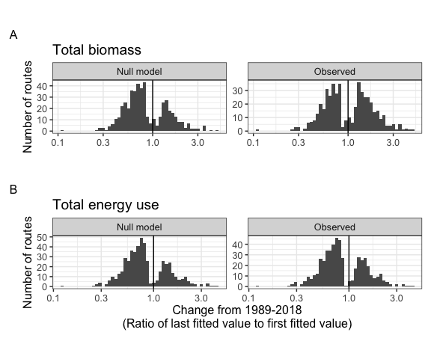

**Figure 1**. Histograms showing the direction and magnitude of long-term trends for the null-model (left) and observed (right) changes in biomass (A) and energy use (B), for communities whose best-fitting model includes a significant slope and/or interaction term. Change is summarized as the ratio of the fitted value for the last year in the time eries to the fitted value for the first year in the timeseries from the best-fitting model for that community. Values greater than 1 (vertical black line) indicate increases in total energy or biomass over time, and less than 1 indicate decreases.

# Figure 2.

1989-2018:

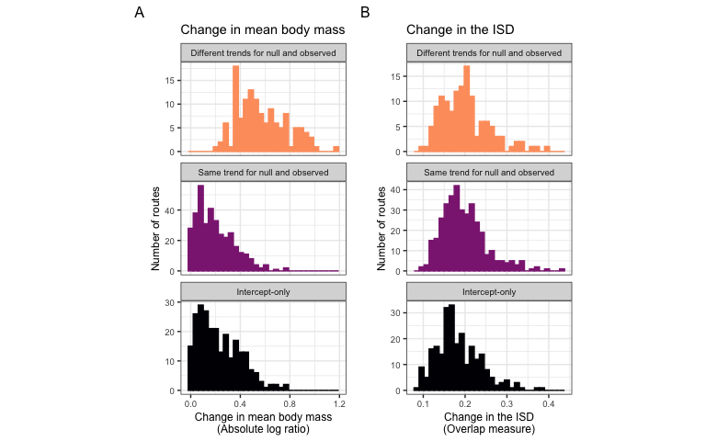

1988-2018:

**Figure 2.** Histograms of (A) change in mean body size from the first to the last five years of monitoring, and (B) overall change in the ize tructure for routes whose dynamics for total biomass were best-described using no temporal trend (bottom row; intercept-only model), separate trends for observed and null dynamics (middle row), or the ame trend for observed and null dynamics (top row). Change in mean body size (A) is calculated as the ratio of the mean body size of all individuals observed in the last 5 years of the timeseries relative to the mean body size of all individuals observed in the first 5 years. Overall change in the ISD (B) is calculated as the degree of turnover between the ISDs for the first and last five years of the timeseries (see text).

# Table 1.

**1989-2018:**

| Currency | Selected model | Number of routes | Proportion of routes |
| --- | --- | --- | --- |
| Total biomass | Intercept-only | 249 | 0.34 |
| Total biomass | Trend, not decoupled | 358 | 0.48 |
| Total biomass | Decoupled trend | 132 | 0.18 |
| Total energy use | Intercept-only | 223 | 0.30 |
| Total energy use | Trend, not decoupled | 465 | 0.63 |
| Total energy use | Decoupled trend | 51 | 0.07 |

**1988-2018:**

| Currency | Selected model | Number of routes | Proportion of routes |
| --- | --- | --- | --- |
| Total biomass | Intercept-only | 238 | 0.32 |
| Total biomass | Trend, not decoupled | 352 | 0.48 |
| Total biomass | Decoupled trend | 149 | 0.20 |
| Total energy use | Intercept-only | 230 | 0.31 |
| Total energy use | Trend, not decoupled | 456 | 0.62 |
| Total energy use | Decoupled trend | 53 | 0.07 |

**Table 1**. Table of the number and proportion of routes whose dynamics for total biomass and total energy use are best described by the following model types: no directional change (intercept-only model, biomass ~ 1 or energy use ~ 1); the ame trend for null and observed dynamics (biomass ~ year or energy use ~ year); or different trends for observed and null dynamics (biomass ~ year * null or observed or energy use ~ year * null or observed).

# Table 2.

**1989-2018:**

| Currency | Proportion of increasing individuals-driven trends | Proportion of increasing observed trends | Number of routes with temporal trends |
| --- | --- | --- | --- |
| Total biomass | 0.33 | 0.49 | 490 |
| Total energy use | 0.31 | 0.36 | 516 |

**1988-2018:**

| Currency | Proportion of increasing individuals-driven trends | Proportion of increasing observed trends | Number of routes with temporal trends |
| --- | --- | --- | --- |
| Total biomass | 0.33 | 0.49 | 501 |
| Total energy use | 0.30 | 0.35 | 509 |

*Table 2*. The proportion of trends that are increasing (specifically, for which the ratio of the last fitted value to the first fitted value > 1) for individuals-driven and observed dynamics, for routes exhibiting temporal trends (either the ame or different slopes for null and observed dynamics) in total biomass and total energy use. Trends that are not increasing are decreasing.

# Table 3.

**1989-2018:**

| Res.Df | RSS | Df | Sum of Sq | F | Pr(>F) |
| --- | --- | --- | --- | --- | --- |
| 736 | 20.67983 | NA | NA | NA | NA |
| 738 | 34.88562 | -2 | -14.20579 | 252.7937 | 0 |

**1988-2018:**

| Res.Df | RSS | Df | Sum of Sq | F | Pr(>F) |
| --- | --- | --- | --- | --- | --- |
| 736 | 20.81904 | NA | NA | NA | NA |
| 738 | 35.42466 | -2 | -14.60562 | 258.1708 | 0 |

**Table 3**. ANOVA table comparing ordinary linear models of the form abs_log_ratio ~ best model type and abs_log_ratio ~ 1.

# Table 4.

**1989-2018:**

| categorical_fit | emmean | SE | df | lower.CL | upper.CL |
| --- | --- | --- | --- | --- | --- |
| Different trends for null and observed | 0.5713225 | 0.0145897 | 736 | 0.5426801 | 0.5999650 |
| Same trend for null and observed | 0.1978479 | 0.0088592 | 736 | 0.1804556 | 0.2152401 |
| Intercept-only | 0.2308831 | 0.0106227 | 736 | 0.2100287 | 0.2517375 |

**1988-2018:**

| categorical_fit | emmean | SE | df | lower.CL | upper.CL |
| --- | --- | --- | --- | --- | --- |
| Different trends for null and observed | 0.5587675 | 0.0137784 | 736 | 0.5317179 | 0.5858171 |
| Same trend for null and observed | 0.2012914 | 0.0089644 | 736 | 0.1836926 | 0.2188902 |
| Intercept-only | 0.2203741 | 0.0109019 | 736 | 0.1989715 | 0.2417766 |

**Table 4.** Estimates (calculated using emmeans (Lenth 2021)) for the mean absolute log ratio of mean mass for routes whose dynamics for biomass were best-described by different model types.

# Table 5

**1989-2018:**

| contrast | estimate | SE | df | t.ratio | p.value |
| --- | --- | --- | --- | --- | --- |
| Different trends for null and observed - Same trend for null and observed | 0.3734747 | 0.0170688 | 736 | 21.880489 | 0.0000000 |
| Different trends for null and observed - (Intercept-only) | 0.3404395 | 0.0180472 | 736 | 18.863813 | 0.0000000 |
| Same trend for null and observed - (Intercept-only) | -0.0330352 | 0.0138321 | 736 | -2.388302 | 0.0451953 |

**1988-2018:**

| contrast | estimate | SE | df | t.ratio | p.value |
| --- | --- | --- | --- | --- | --- |
| Different trends for null and observed - Same trend for null and observed | 0.3574762 | 0.0164379 | 736 | 21.747096 | 0.0000000 |
| Different trends for null and observed - (Intercept-only) | 0.3383935 | 0.0175697 | 736 | 19.260017 | 0.0000000 |
| Same trend for null and observed - (Intercept-only) | -0.0190827 | 0.0141142 | 736 | -1.352018 | 0.3669124 |

**Table 5**. Contrasts for absolute log ratio of mean mass, calculated using emmeans (Lenth 2021).

# Table 6

**1989-2018:**

| Resid. Df | Resid. Dev | Df | Deviance | Pr(>Chi) |
| --- | --- | --- | --- | --- |
| 736 | 13.40443 | NA | NA | NA |
| 738 | 13.61574 | -2 | -0.21131 | 0.899735 |

**1988-2018:**

| Resid. Df | Resid. Dev | Df | Deviance | Pr(>Chi) |
| --- | --- | --- | --- | --- |
| 736 | 14.09240 | NA | NA | NA |
| 738 | 14.28236 | -2 | -0.1899672 | 0.9093878 |

*Table* *6*. ANOVA table comparing binomial generalized linear models of the form ISD_turnover ~ best model type and ISD_turnover ~ 1.

# References

Lenth, R. V. 2021. Emmeans: Estimated Marginal Means, aka Least-Squares Means.