CSE 511 Course Report
Project-2 Parallel File System
Haibo Zhang Chen Sun
Computer Science and Engineering Department, Penn State, 16801
{haibo, chensun}@cse.psu.edu

In this report, we will present how we design the Parallel File System (PFS) and implement using Linux Socket, pthread and other features of modern C++.

General Terms Paralllel File System, Metadata, Token Manager, Cache, Synchronization.

Keywords serializer, readers-writers, dining philosophers, disk-scheduler.

- Parallel File System

PFS as shared-disk file system for large computing clusters is a mature research area [1]. PFS is designed as client-server architecture with multiple servers which typically run on separate nodes and have disks attached to them. Each file in the PFS system is striped across the disks on the file servers and the application processes interact with the file system using a client library. The PFS also has a Metadata Manager which handles all the metadata associated with files. The Metadata Manager does not take part in the actual read/write operations. The client, file servers and the metadata manager need not run on different machines though running them on different machines generally results in higher performance.
The communication between various nodes in PFS system is implemented using sockets.
In this project, PFS is designed containing following four components: Metadata Manager, File Servers, Client and Client Cache.
In the following sections, we will discuss the design and implementation of the four components in detail.

- Metadata Manager
In our design, Metadata Manager contains two functional components: metadata manager and token manager.

2.1 Metadata Manager
For this project, we assume a flat file system consisting of only one root directory. And For each file in the directory, we maintain a data structure called Metadata.
Metadata contains the following information of a file: filename, file size, time of creation, time of last modification and file recipe.
File recipe is another data structure describing the file distribution. Each file is separated into different stripes, and each stripe is distributed onto different servers. At the same time, each stripes is separated into blocks, which is the building block of file in PFS.
Metadata Manager is designed to manage Metadata for each file.

2.2 Token Manager

The metadata manager also performs the task of a token manager for ensuring consistency in the system. The goal here is to guarantee single-node equivalent POSIX/UNIX consistency for file system operations across the system. Every file system operation acquires an appropriate read or write lock to synchronize with conflicting operations on other nodes before reading or updating any file system data. We implement block-range locking in order to allow parallel applications to write concurrently to different blocks of the same file. The token manager coordinates locks by handing out lock tokens. There are two types of lock tokens that are issued by the token manager: read tokens and write tokens. Multiple nodes can simultaneously acquire read tokens for the same file-block. However, block-range tokens for parallel writes are negotiated as follows. The first node to read/write a file acquires the block-range token for the whole file (zero to infinity). As long as no other nodes require access to the same file, all read and write operations are processed locally. When a second node begins writing to the same file it will need to revoke at least part of the block-range token held by the first node. When the first node receives a revoke request, it checks whether the file is still in use. If the file has since been closed, the first node will give up the whole token, and the second node will then be able to acquire a token covering the whole file. On the other hand, if the second node starts writing to a file before the first node closes the file, the first node will relinquish only part of its block-range token. If the first node is writing sequentially at offset o1 and the second node at offset o2, the first node will relinquish its token from o2 to infinity (if o2 > o1) or from zero to o1 (if o2 < o1)
- Client
We implement the following interface as public function of Client class in client.cc and client.hh:
- int pfs_create(const char *filename, int stripe_width);
- int pfs_open(const char *filename, const char mode);
- ssize_t pfs_read(int filedes, void *buf, ssize_t nbyte, off_t offset, int *cache_hit);
- ssize_t pfs_write(int filedes, const void *buf, size_t nbyte, off_t offset, int *cache_hit);
- int pfs_close(int filedes);
- int pfs_delete(const char *filename);
- int pfs_fstat(int filedes, struct pfs_stat *buf); // Check the config file for the definition of pfs_stat structure
When calling above interfaces, client will communicate with Metadata Manager and File Server using socket API. Concrete communication detail please refer to Communication section.
- Client Cache
The PFS uses local cache on each client having a default size of 2 MB. The client cache consists of (1) free space and (2) used space. The used space in the client cache can further be divided into blocks that have been modified (i.e. dirty blocks which have not been flushed to the server yet) or not. As part of the cache management scheme, we implement the following two threads:
Harvesters Thread: The job of the harvester thread is to maintain sufficient amount of free space in the client cache. Whenever the free space falls below a specific lower threshold, the harvester thread frees up memory from the used space based on an LRU policy till the amount of free space reaches an upper threshold.
Flusher Thread: The job of the flusher thread is to periodically (every 30 seconds) flush all the dirty blocks (modified blocks) back to the appropriate file servers.
We also implement a hashing scheme to map and look up the file blocks onto the cache using C++ STL interface unordered_map.

If the client has the appropriate tokens, and a read/write call issued by the client results in a cache hit, the operations should be performed on locally on the client cache. On the other hand, whenever there is a cache miss, the blocks need to be fetched from the file server which will then be cached locally on the client using the available free space. The client returns the information about a cache hit or miss for every read/write call using the Boolean argument cache_hit which is passed as a parameter to both the pfs_read() and pfs_write()function calls. If the client needs to acquire fresh tokens from the token manager for a read/write call, the file data need to be fetched from the file servers. Whenever a client is required to relinquish a part of its token, it needs to flush the dirty blocks to the file servers before relinquishing the tokens to the token manager.
- File Servers
There are a fixed number of file servers in the network. But each file server will first register to Metadata Manager. So Metadata Manager keeps record of how many active servers are there. Every file in the PFS is striped across a number of these file servers by Metadata Manager.
We simulate the file storage in memory as a hash table. Key of the hash table is filename and blockid, and value of the hash table is file content.
- Communication
We design class Listerner which is in charge of the communication between each node. For message between client, server and metadata manager, please refer to communication.xlsx file. Fig. 1 is a brief description of communication.xlsx.
Columns in communication.xslx represents message direction. For instance, C->M means the message goes from Client to Metadata Manager. Rows represents which action triggers the message. Color in communication.xslx represents the sequence of message sending. The sequence is (Yellow, Grass Green, Dark Green, Blue…).
Each messge contains following sections: operation code (OP), file name (FN), block id range(BID), file id(FD), file stat(STAT) and data(DATA).
Take the first row (“Create” row) as instance, if client want to create a file, it first sends message (operation code = C) to metadata manager. Metadata manager compute which stripe and blocks should distribute to which server. Then metadata manager sends message to corresponding servers (operation code = C). After creating file in its file system, each server sends acknowledge to metadata manager (operation code = AC). When metadata manager receives all acknowledge from related servers, it sends an acknowledge message to client (operation code = AC). By this time, creating file operation is down.

[1] Schmuck, Frank B., and Roger L. Haskin. "GPFS: A Shared-Disk File System for Large Computing Clusters." FAST. Vol. 2. 2002.

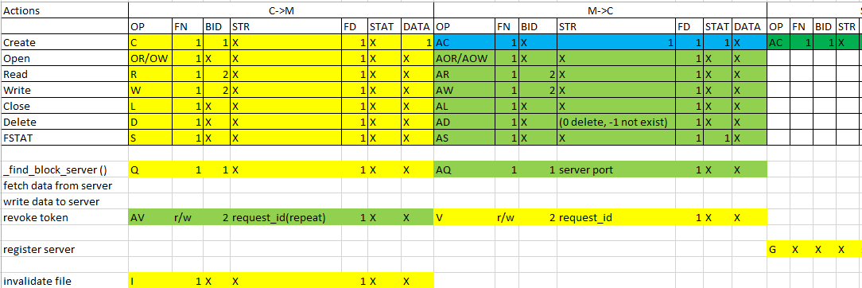
Fig. 1 Overview of communication.xslx

