This report shows the progress made so far in the development of the Data Visualization extensions, **highlighting the research, design choices, prioritization frameworks and first implementations.**

In the first weeks, I revised ITP1 materials and improved JavaScript skills through Udemy courses.

Then, **created a** [**Google Forms**](https://forms.gle/bUTzGUvkMgp6KCHM8) **on AI Usage to collect data. The challenge was the number of responses that may vary significantly.**

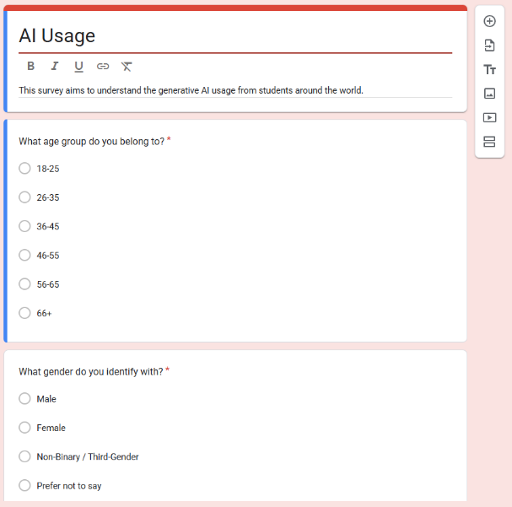

Figure 1 - AI Usage Survey

I also **analyzed the code and created a diagram** to understand the structure of the template.

Figure 2 – Code Diagram Draft

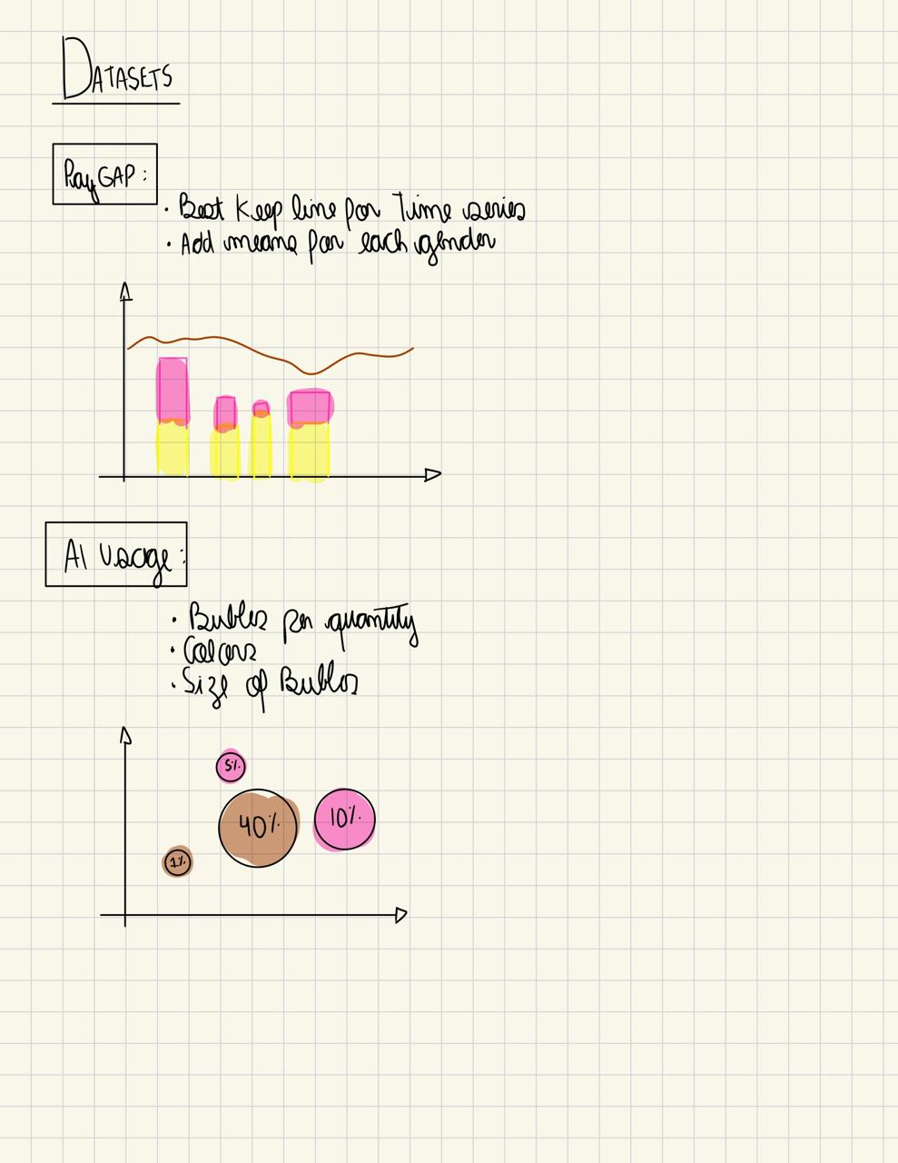

Figure 3 – Draft Datasets

Figure 4 – Draft Datasets

Figure 5 – Draft Datasets

Figure 6 – Draft Datasets

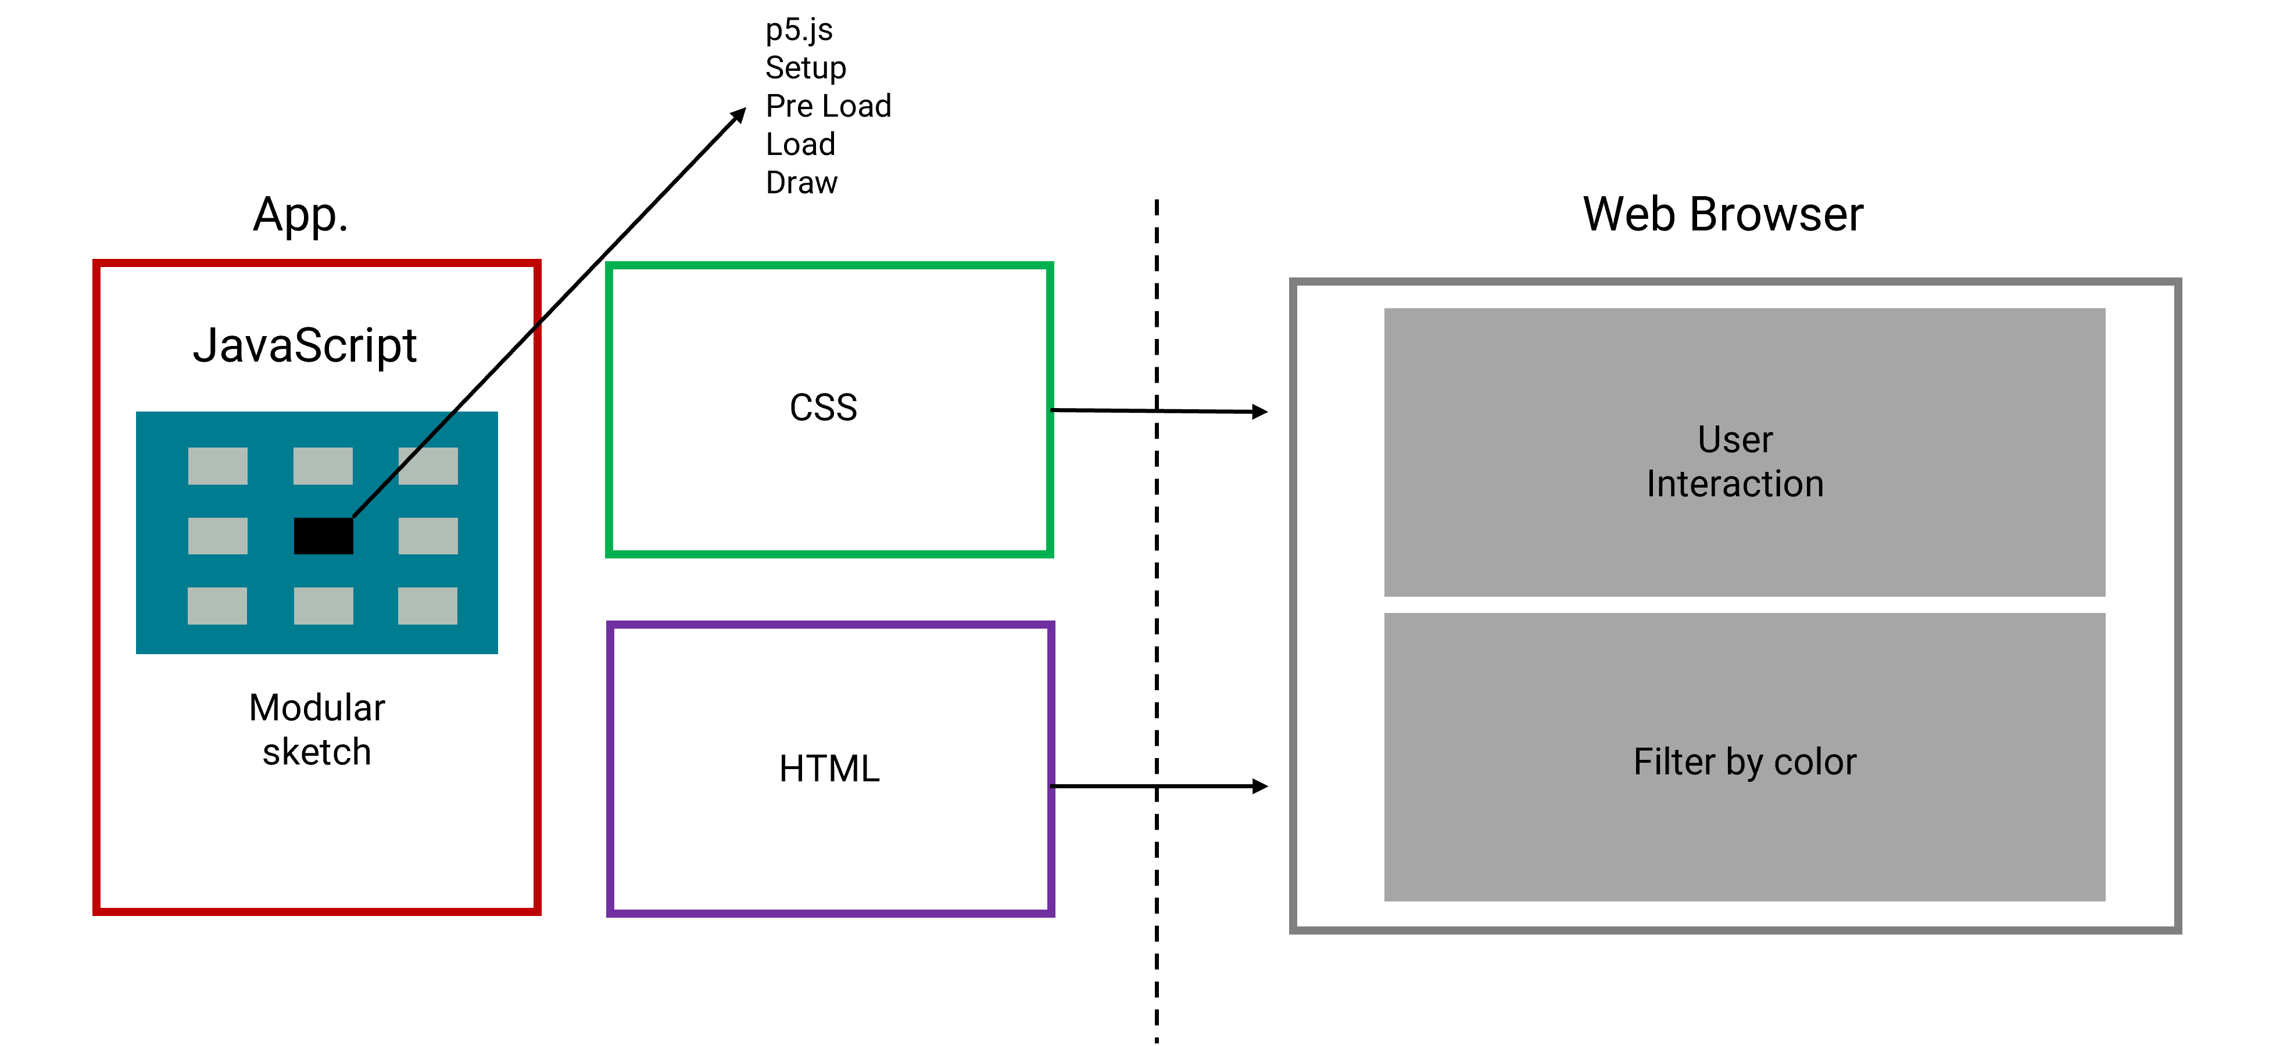

Figure 7 – Under the Hood

With **MoScOw method**, I set “Must” for core features, “Should” for improvements in chart clarity, “Could” for non-essential enhancements and “Haven’t” for tasks that might delay the project.

**For example, for the Tech Diversity Race (*Figure 8*), I would prioritize implementing charts first instead of creating a smooth transition in the pie charts, avoiding wasting time on less critical tasks and focusing on what really should be working properly.**

Figure 8 - Moscow Method: Tech Diversity Race

Moreover, with the **SWOT analysis**, I was able to identify where the extensions had strengths I could build on, and where weaknesses or threats could block progress.

**For example, I identified a potential threat on AI Usage (*Figure 9*), as depends on sample responses. To address this, I followed up with people to ensure completion within two weeks.**

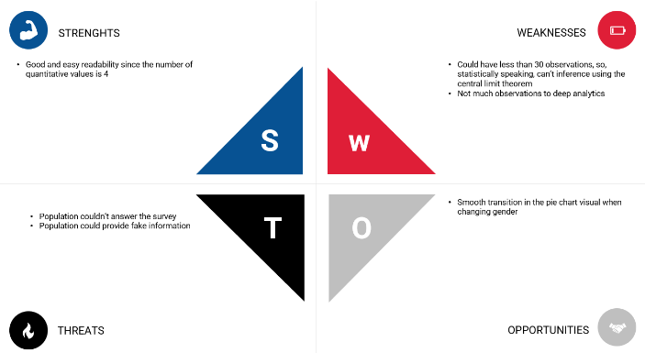

Figure 9 - SWOT: AI Usage

**For design, I selected the Roboto font,** since according to Colin Ware, in *Information Visualization: Perception for Design*, “sans-serif fonts such as Roboto enhance legibility in screen-based environments.”

**The colour palette was inspired by the** [**UoL**](https://www.london.ac.uk/)**’s** **website and color blind-friendly:**

Figure 10 – Color Palette

Additionally, I created the app mockup using [**Figma**](https://www.figma.com/).

Figure 11 – Figma Design

**So far, I have completed 68% of the project (measured by incorporating weight for each task from Gantt Chart, summing up to 100% for total completion)**, reaching 20h spent coding, totalizing over 1500 lines of JavaScript, **where I implemented both extensions presented in class, a modularized canvas menu bar, adjusted charts to the new canvas background, smooth transition of bar charts in Gender Pay GAP, Bubble chart for AI Usage, and added a tooltip in Race Tech Diversity chart.**

**After midterm**, I’ll focus on adding features **(e.g. mean per gender by week 12 for Diversity Race) and add the color blind-friendly colors**. This’ll be done by **reviewing my deliveries from a Gantt chart and breaking them into smaller and more granular tasks within the KANBAN board every week.** Each Friday I’ll create a new backlog according to the Gantt chart to plan the upcoming week.