**UCBEL0130DATA Group Project II**

**ServiceNow Data Requests Management App**

**Team**

**Elham Saboori**

**Nodira Mamatova**

**Bilwa Buchake**

**Prabhakar Muriki**

**Jayachandran John**

**Department of Quality (DoQ)**

**Division of Analytics and Clinical Effectiveness (ACE)**

**ServiceNow Data Requests Management Application**

**Introduction**

The Division of Analytics and Clinical Effectiveness functions to serve the needs of the Department of Quality and associated Quality & Safety initiatives. DoQ-ACE works with users to provide not just reports, but relevant and actionable analyses for and about quality improvement activities at the Organization.

**Purpose**

The ServiceNow Data Requests Management Application will serve as a web based portal for viewing, assigning priority and tracking all DoQ-ACE related data requests. This tool will allow the users to perform CRUD operations against the ServiceNow Data Requests dataset.

**High Level Workflow**

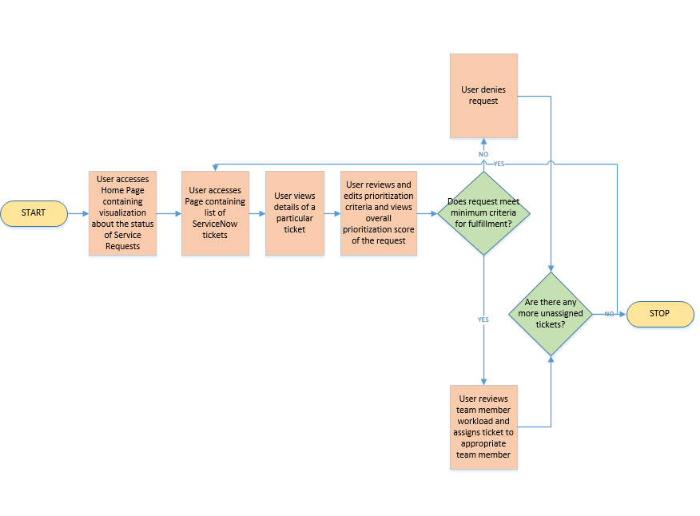

**System Components and Technical Requirements**

1. Data Model – MySQL
2. User Interface – HTML5, CSS3, Bootstrap 3.3, Javascript
3. Business logic/API – Flask, Python 3
4. Analysis Reports and Visualizations – Plotly, D3.js

**Appendix A: Prioritization Criteria**

|  |  |  |  |
| --- | --- | --- | --- |
| **The Division of Analytics and Clinical Effectiveness (DoQ-ACE) functions to serve the needs of the Department of Quality and associated Quality & Safety initiatives. DoQ-ACE works with users to provide not just reports, but relevant and actionable analyses for and about quality improvement activities at UCSF.** | | | |
|
|
|  |  |  |  |
| **Prioritization Algorithm** | | | |
|  | **Medical Center** | **Campus** | **Points** |
| Who is asking for or sponsoring the request? | President, CEO EVP | Dean Department Chair | 7 |
| VP Executive Director Director or Manager (DoQ) Analyst (DoQ) | Quality Champion Medical Director | 5 |
| Director (non-DoQ) | Division or Service Chief Administrative Director or equivalent | 3 |
| Manager (non-DoQ) | Attending MD | 2 |
| Analyst (non-DoQ) | Supervised trainee projects | 1 |
|  |  |  |  |
| **IMPACT** |  |  |  |
| What is the purpose/importance? | Joint Commission or CMS Purposes Corporate or Contractual Compliance California Department of Public Health  Internal / External Audits Other Regulatory/Compliance Purposes | | 7 |
| True North: Quality & Safety Pillar a) Improving Clinical Outcomes (Mortality-, External Rankings- or Service-specific clinical outcome-related) b) Achieving Zero Harm | | 5 |
| Vizient Clinical Data Base request | | 3 |
| Other Quality Improvement activities | | 2 |
| True North: non-Quality & Safety pillar(s) | | 1 |
|  |  |  |  |
| How long has the requester been waiting? | Approved requests waiting for one month | | 1 |
|  |  |  |  |
|  |  |  |  |
| **EFFORT** |  |  |  |
| Estimated number of hours to complete | < 20 hours | | 5 |
| 21 - 40 hours | | 4 |
| 40 - 80 hours | | 3 |
| 80 - 120 hours | | 2 |
| > 120 hours | | 1 |
|  |  |  |  |

**Appendix B: Current Tracking tool/ Decision Tree Template**

|  |  |  |  |  |  |
| --- | --- | --- | --- | --- | --- |
| **Categories** | **Definitions UCSF Health** | **Points** | **REQ0138700** | **REQ0138511** | **#3** |
| **Who is the Requester** |  |  | **Joyce Nacario** | **David Shimabukuro** |  |
| **Is the requester or sponsor from executive leadership?** | President, CEO EVP Dean Department Chair | 7 | No | No | No |
| **Is the requester or sponsor from senior leadership or DoQ staff?** | VP Executive Director Director or Manager (DoQ) Analyst (DoQ) Quality Champion Medical Director | 5 | Yes | Yes | No |
| **Is the requester a Administrative Director or Division/Service Chief?** | Director (non-DoQ) Division or Service Chief Administrative Director or equivalent | 3 | No | No | No |
| **Is this requester a Manager or Clinician?** | Manager (non-DoQ) Attending MD PharmD | 2 | No | No | No |
| **Is the requester a non-DoQ analyst or supervised trainee?** | Analyst (non-DoQ) Supervised trainee projects | 1 | No | No | No |
| **Is the request for Regulatory Purposes?** | Joint Commission or other CMS Purposes Corporate or Contractual Compliance California Department of Public Health  Internal / External Audits Other Regulatory/Compliance Purposes | 7 | No | No | No |
| **Is this request for the TN Quality & Safety pillar?** | Improving Clinical Outcomes Acheiving Zero Harm | 5 | Yes | No | No |
| **Is this request related to using data from the Vizient Clinical Data Base?** | Inpatient CDB/RM Non-inpatient CDB/RM Core Measures | 3 | No | No | No |
| **Is this request for other Quality Improvement priorities (not related to Q&S pillar)?** |  | 2 | No | No | No |
| **Is this request for a True North: non-Quality & Safety pillar(s)?** | Our People Patient Experience Financial Strength Strategic Growth Learning Health System | 1 | No | No | No |
| **Estimate # of Hours to complete** | From ACE team | 1-5 | 0<20hrs | 80-120hrs | >120hrs |
|  | **PRIORITIZATION POINTS** |  | **17** | **9** | **1** |
|  | **External Status** |  |  |  |  |
|  | **Internal Status** |  | Review 4/24 ACE huddle | Review 4/24 ACE huddle |  |
|  | **Approval Date** |  | **N/A** | **N/A** | **N/A** |
| **Other Action Items** |  |  |  |  |  |
| Notes |  |  |  |  |  |