UCBEL0130DATA Group Project II
ServiceNow Data Requests Management App

Team
Elham Saboori
Nodira Mamatova
Bilwa Buchake
Prabhakar Muriki
Jayachandran John

Department of Quality (DoQ)
Division of Analytics and Clinical Effectiveness (ACE)
ServiceNow Data Requests Management Application
Introduction
The Division of Analytics and Clinical Effectiveness functions to serve the needs of the Department of Quality and associated Quality & Safety initiatives. DoQ-ACE works with users to provide not just reports, but relevant and actionable analyses for and about quality improvement activities at the Organization.
Purpose
The ServiceNow Data Requests Management Application will serve as a web based portal for viewing, assigning priority and tracking all DoQ-ACE related data requests. This tool will allow the users to perform CRUD operations against the ServiceNow Data Requests dataset.
High Level Workflow
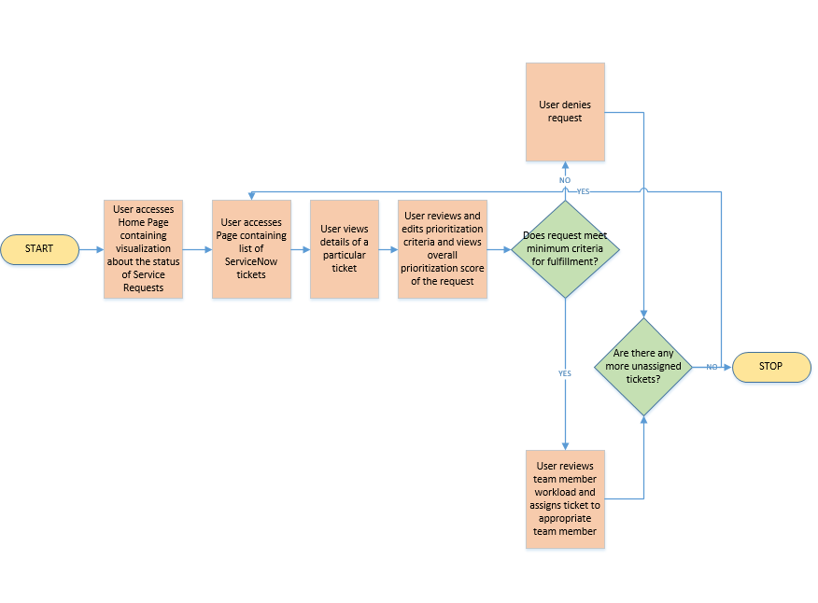

System Components and Technical Requirements
- Data Model – MySQL
- User Interface – HTML5, CSS3, Bootstrap 3.3, Javascript
- Business logic/API – Flask, Python 3
- Analysis Reports and Visualizations – Plotly, D3.js

Appendix A: Prioritization Criteria
The Division of Analytics and Clinical Effectiveness (DoQ-ACE) functions to serve the needs of the Department of Quality and associated Quality & Safety initiatives. DoQ-ACE works with users to provide not just reports, but relevant and actionable analyses for and about quality improvement activities at UCSF.
Prioritization Algorithm
 | Medical Center | Campus | Points
Who is asking for or sponsoring the request? | President, CEO  EVP | Dean  Department Chair | 7
Who is asking for or sponsoring the request? | VP  Executive Director  Director or Manager (DoQ)  Analyst (DoQ) | Quality Champion  Medical Director | 5
Who is asking for or sponsoring the request? | Director (non-DoQ) | Division or Service Chief  Administrative Director or equivalent | 3
Who is asking for or sponsoring the request? | Manager (non-DoQ) | Attending MD | 2
Who is asking for or sponsoring the request? | Analyst (non-DoQ) | Supervised trainee projects | 1
IMPACT
What is the purpose/importance? | Joint Commission or CMS Purposes  Corporate or Contractual Compliance  California Department of Public Health  Internal / External Audits  Other Regulatory/Compliance Purposes |  | 7
What is the purpose/importance? | True North: Quality & Safety Pillar  a) Improving Clinical Outcomes (Mortality-, External Rankings- or Service-specific clinical outcome-related)  b) Achieving Zero Harm |  | 5
What is the purpose/importance? | Vizient Clinical Data Base request |  | 3
What is the purpose/importance? | Other Quality Improvement activities |  | 2
What is the purpose/importance? | True North: non-Quality & Safety pillar(s) |  | 1
How long has the requester been waiting? | Approved requests waiting for one month |  | 1
EFFORT
Estimated number of hours to complete | < 20 hours |  | 5
Estimated number of hours to complete | 21 - 40 hours |  | 4
Estimated number of hours to complete | 40 - 80 hours |  | 3
Estimated number of hours to complete | 80 - 120 hours |  | 2
Estimated number of hours to complete | > 120 hours |  | 1

Appendix B: Current Tracking tool/ Decision Tree Template
Categories | Definitions UCSF Health | Points | REQ0138700 | REQ0138511 | #3
Who is the Requester |  |  | Joyce Nacario | David Shimabukuro
Is the requester or sponsor from executive leadership? | President, CEO  EVP  Dean  Department Chair | 7 | No | No | No
Is the requester or sponsor from senior leadership or DoQ staff? | VP  Executive Director  Director or Manager (DoQ)  Analyst (DoQ)  Quality Champion  Medical Director | 5 | Yes | Yes | No
Is the requester a Administrative Director or Division/Service Chief? | Director (non-DoQ)  Division or Service Chief  Administrative Director or equivalent | 3 | No | No | No
Is this requester a Manager or Clinician? | Manager (non-DoQ)  Attending MD  PharmD | 2 | No | No | No
Is the requester a non-DoQ analyst or supervised trainee? | Analyst (non-DoQ)  Supervised trainee projects | 1 | No | No | No
Is the request for Regulatory Purposes? | Joint Commission or other CMS Purposes  Corporate or Contractual Compliance  California Department of Public Health  Internal / External Audits  Other Regulatory/Compliance Purposes | 7 | No | No | No
Is this request for the TN Quality & Safety pillar? | Improving Clinical Outcomes  Acheiving Zero Harm | 5 | Yes | No | No
Is this request related to using data from the Vizient Clinical Data Base? | Inpatient CDB/RM  Non-inpatient CDB/RM  Core Measures | 3 | No | No | No
Is this request for other Quality Improvement priorities (not related to Q&S pillar)? |  | 2 | No | No | No
Is this request for a True North: non-Quality & Safety pillar(s)? | Our People  Patient Experience  Financial Strength  Strategic Growth  Learning Health System | 1 | No | No | No
Estimate # of Hours to complete | From ACE team | 1-5 | 0<20hrs | 80-120hrs | >120hrs
 | PRIORITIZATION POINTS |  | 17 | 9 | 1
 | External Status
 | Internal Status |  | Review 4/24 ACE huddle | Review 4/24 ACE huddle
 | Approval Date |  | N/A | N/A | N/A
Other Action Items
Notes

