* Overview
  + This is going to a be a streamlined news app. It will get data from the Guardian News API. The app will not display the stories but clicking on the story will allow the user to follow the story to be read an internet browser application. The user can choose from four types of news stories
* Non-Goals
  + You will not be able to read the content in the app
  + You will not be able to select the type of news you want
* Inspiration Screenshots
  + 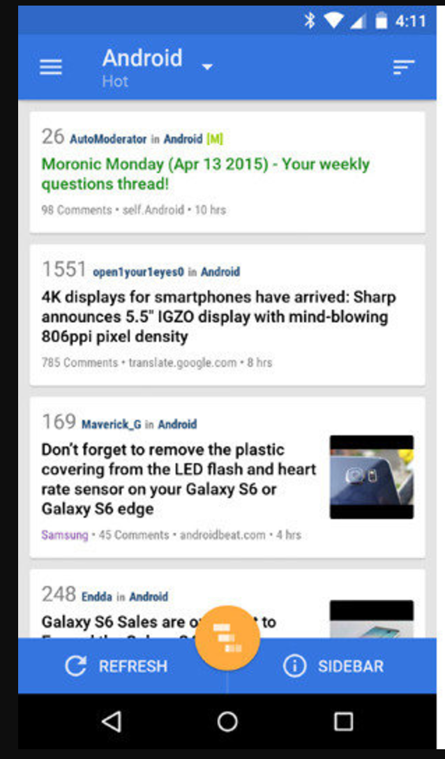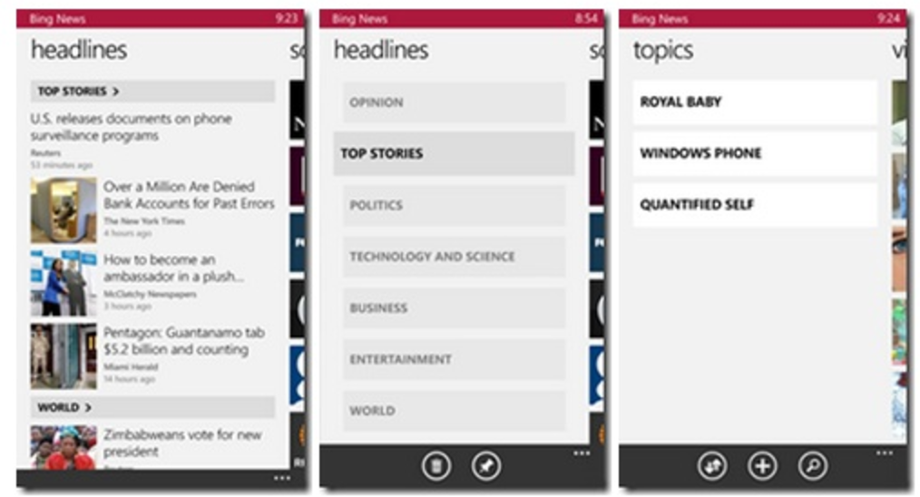
* Home page
  + The layout will be similar to the blue screenshot above.
  + IT WILL DISPLAY 10 NEWS STORIES
  + When connected to the internet
    - If no stories are found it will return a message stating that
    - IT WILL INCLUDE THE TITLE OF THE ARTICLE AND NAME OF SECTION IT BELONGS TO
      * If available include the author name and date published
  + When not connected to the internet
    - A message will be displayed staing an internet connection cannot be made
* Preferences page
* NEEDS
  + App contains a main screen which displays multiple news stories
  + Required fields include the title of the article and the name of the section that it belongs to.
  + Each list item on the main screen displays relevant text and information about the story.
  + Update manifest
* Tech Specs
  + Log tags
  + Loaders
  + API Query
    - Ensure permission
  + Preferences
  + List adapter
  + Custom list adapter
  + On click listener for choosing each item
  + URI builder if I want to allow custom queries
  + Website intent
    - Only off of main activity
  + Connection manager to get info about the connection
    - Only on main activity
  + Use a spinner to display loading progress
  + Values
    - Strings
      * Include activity names
      * No internet connection
    - Styles
  + News story class
    - Contains public getter methods
    - Title
      * String
      * “webTitle”
    - URL
      * String
      * “webUrl”
    - Section it belongs to
      * String
      * “sectionName”
    - Author
      * CANT DO
    - Date published
      * String
      * “webPublicationDate”
* Classes
  + Story adapter
    - Date formatter
    - Typical set view syntax
    - Date object
    - Consider if I want to include time
      * Format date
      * Format Time
        + GMT is 4 hours ahead.
        + If its 1pm here its 5pm there
    - Pass
  + Loader
    - Pass
  + Query API class
    - Fetch data
    - Create url object
      * Input: String
      * Output: URL object
    - Make http object
      * Input URL
      * Output: String
    - Read from string
      * Input is inputstring
      * Returns string output
    - Extract feature from JSON
      * Input string
      * Output list of stories
* Res folder
  + Layouts
    - Main activity
      * Will have four categories for different search quaries
        + Each activity will have a unique URL but all with parse the data the same way
      * Relative layout
        + Listview for stories
        + Textview to display feedback in edge cases
        + Progressbar for loading
    - List item
      * Horz linear layout
      * Use
* xmlns:tools="http://schemas.android.com/tools"
* Layout Practices
  + Text sizes are defined in sp
  + Lengths are defined in dp
  + Padding and margin is used appropriately, such that the views are not crammed up against each other.
* Functionality
  + Stories shown on the main screen update properly whenever new news data is fetched from the API.
  + Clicking on a story opens the story in the user’s browser
  + App queries the content.guardianapis.com api to fetch news stories related to the topic chosen by the student, using either the ‘test’ api key or the student’s key.
  + Networking operations are done using a Loader rather than an AsyncTask.
* Decesions to be made?
  + Can I fragment the app based on if the user wants different search queries
  + Settings activity
  + Have 4 main categories with a later option to add more
  + THE GOAL IS TO CREATE A MVP. FOR THE TIME STANDING, THERE WILL BE NO ADDITIONAL OPTIONS TO CREATE NEW CATEGORIES.
    - Will not format time

How to do this:

1. Build Top stories activity XML and JAVA
2. Set and use LOGTAG statements
3. Create News story class
4. Create adapter class and inflate the views
5. Create a category adapter class to swipe through each activity
6. Activity category xml page with linear layout, tab layout and viewpajer
7. Update permissions in manifest and add all activities to manifest
8. Use a static URL to practice parsing data
   1. Using log statements
   2. After successful use live URLS
   3. Set the onclick listener in the activity to start a website intent
9. Build other activities with their own unique URLS
10. set manifest to include other activity intents
11. Find a way to set, test and build parsing methods
    1. Make different query methods
12. Loaders
    1. Single Activity
    2. All Activities
13. Network check logic
14. No stories found
15. No connection found
16. Progress bar
17. Fix Quary logic to use loaders
18. Ensure all URLs accurate get storys per category
19. Format date and time
20. Update all other Fragments
21. Make visually pretty
22. Clean logic and code and get in regs

Raw data parsing:

{"response":{"status":"ok","userTier":"developer","total":23438,"startIndex":1,"pageSize":10,"currentPage":1,"pages":2344,"orderBy":"relevance","results":[{"id":"politics/2017/apr/18/theresa-may-rules-out-participating-in-tv-debates-before-election","type":"article","sectionId":"politics","sectionName":"Politics","webPublicationDate":"2017-04-18T17:20:59Z","webTitle":"Theresa May rules out participating in TV debates before election","webUrl":"https://www.theguardian.com/politics/2017/apr/18/theresa-may-rules-out-participating-in-tv-debates-before-election","apiUrl":"https://content.guardianapis.com/politics/2017/apr/18/theresa-may-rules-out-participating-in-tv-debates-before-election","isHosted":false},{"id":"politics/live/2017/mar/21/death-martin-mcguinness-reaction-politics-live","type":"liveblog","sectionId":"politics","sectionName":"Politics","webPublicationDate":"2017-03-21T17:29:43Z","webTitle":"Scottish parliament debates call for second independence referendum - Politics live","webUrl":"https://www.theguardian.com/politics/live/2017/mar/21/death-martin-mcguinness-reaction-politics-live","apiUrl":"https://content.guardianapis.com/politics/live/2017/mar/21/death-martin-mcguinness-reaction-politics-live","isHosted":false},{"id":"politics/2017/apr/19/bbc-and-itv-plan-leaders-debates-despite-mays-refusal-to-take-part","type":"article","sectionId":"politics","sectionName":"Politics","webPublicationDate":"2017-04-19T14:01:59Z","webTitle":"May 'open to other options' after ruling out head-to-head television debates","webUrl":"https://www.theguardian.com/politics/2017/apr/19/bbc-and-itv-plan-leaders-debates-despite-mays-refusal-to-take-part","apiUrl":"https://content.guardianapis.com/politics/2017/apr/19/bbc-and-itv-plan-leaders-debates-despite-mays-refusal-to-take-part","isHosted":false},{"id":"commentisfree/2017/apr/19/theresa-may-chickening-out-tv-debates-shameful-caroline-lucas","type":"article","sectionId":"commentisfree","sectionName":"Opinion","webPublicationDate":"2017-04-19T12:54:55Z","webTitle":"Chickening out of TV debates is shameful. Why is May avoiding us? | Caroline Lucas","webUrl":"https://www.theguardian.com/commentisfree/2017/apr/19/theresa-may-chickening-out-tv-debates-shameful-caroline-lucas","apiUrl":"https://content.guardianapis.com/commentisfree/2017/apr/19/theresa-may-chickening-out-tv-debates-shameful-caroline-lucas","isHosted":false},{"id":"us-news/2016/sep/26/presidential-debates-nixon-kennedy-1960","type":"article","sectionId":"us-news","sectionName":"US news","webPublicationDate":"2016-09-26T15:57:34Z","webTitle":"The Nixon-Kennedy presidential debates: from the archive, 1960","webUrl":"https://www.theguardian.com/us-news/2016/sep/26/presidential-debates-nixon-kennedy-1960","apiUrl":"https://content.guardianapis.com/us-news/2016/sep/26/presidential-debates-nixon-kennedy-1960","isHosted":false},{"id":"politics/2017/apr/19/theresa-may-accused-at-pmqs-of-running-scared-from-tv-debates","type":"article","sectionId":"politics","sectionName":"Politics","webPublicationDate":"2017-04-19T12:10:28Z","webTitle":"Theresa May accused at PMQs of running scared from TV debates","webUrl":"https://www.theguardian.com/politics/2017/apr/19/theresa-may-accused-at-pmqs-of-running-scared-from-tv-debates","apiUrl":"https://content.guardianapis.com/politics/2017/apr/19/theresa-may-accused-at-pmqs-of-running-scared-from-tv-debates","isHosted":false},{"id":"politics/live/2017/apr/26/general-election-2017-may-corbyn-final-pmqs-politics-live","type":"liveblog","sectionId":"politics","sectionName":"Politics","webPublicationDate":"2017-04-26T16:42:46Z","webTitle":"General election 2017: Theresa May and Jeremy Corbyn square off in final PMQs before election – politics live","webUrl":"https://www.theguardian.com/politics/live/2017/apr/26/general-election-2017-may-corbyn-final-pmqs-politics-live","apiUrl":"https://content.guardianapis.com/politics/live/2017/apr/26/general-election-2017-may-corbyn-final-pmqs-politics-live","isHosted":false},{"id":"commentisfree/2016/sep/23/presidential-debates-real-time-reactions-notifications-mobile","type":"article","sectionId":"commentisfree","sectionName":"Opinion","webPublicationDate":"2016-09-23T21:43:23Z","webTitle":"Get real-time reactions during the presidential debates | Guardian Mobile Innovation Lab","webUrl":"https://www.theguardian.com/commentisfree/2016/sep/23/presidential-debates-real-time-reactions-notifications-mobile","apiUrl":"https://content.guardianapis.com/commentisfree/2016/sep/23/presidential-debates-real-time-reactions-notifications-mobile","isHosted":false},{"id":"culture/shortcuts/2017/feb/06/the-next-doctor-who-a-black-bond-the-pop-culture-debates-that-never-end","type":"article","sectionId":"culture","sectionName":"Culture","webPublicationDate":"2017-02-06T07:00:20Z","webTitle":"The next Doctor Who, a black Bond … the pop culture debates that never end","webUrl":"https://www.theguardian.com/culture/shortcuts/2017/feb/06/the-next-doctor-who-a-black-bond-the-pop-culture-debates-that-never-end","apiUrl":"https://content.guardianapis.com/culture/shortcuts/2017/feb/06/the-next-doctor-who-a-black-bond-the-pop-culture-debates-that-never-end","isHosted":false},{"id":"us-news/2016/sep/25/us-presidential-debates-famous-moments","type":"article","sectionId":"us-news","sectionName":"US news","webPublicationDate":"2016-09-25T10:00:31Z","webTitle":"Make or break: the defining moments of presidential debates","webUrl":"https://www.theguardian.com/us-news/2016/sep/25/us-presidential-debates-famous-moments","apiUrl":"https://content.guardianapis.com/us-news/2016/sep/25/us-presidential-debates-famous-moments","isHosted":false}]}}

<http://content.guardianapis.com/search?q=debates&api-key=test>