Bruce Buckler, Kevin Deehan, Mark Quinn, Roland Lakatos

A1 School of Motoring  
website report

Design

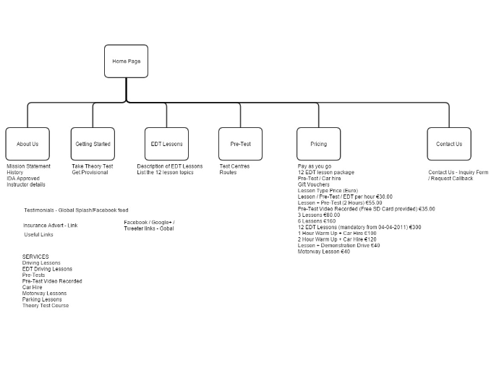

Before starting work on the website we created a diagram (above) to inform us where we were going with the project and what we would like to appear on each page.

We looked at other driving school websites for inspiration, like [www.http://prodrivingschool.ie](http://www.http://prodrivingschool.ie) and [http://www.startline.ie](http://www.startline.ie/).

We took some ideas on style and format from these websites and some of our own ideas. We did have some difficulty sourcing free pictures for our website, choice is not great. Also wanted to source pictures of people from non-Irish websites since this website is an actual driving school website that will be used professionally.

# Driving lessons website

Bruce:

* Website design - produced diagram of paging structure.
* Researched other driving school websites for best features.
* Written HTML and CSS files for website basic layout and navigation menu for 6 pages - **version 1.**
* Added 'Getting Started' page content and header image - **version 2.**
* Added responsiveness to CSS for different browser screen sizes - **version 3.**
* Added 'Contact Us' and 'About Us' page content, images for header and sidebar added - **version 4.**
* Added JavaScript for Contact Us form data validation and added slideshow on sidebar. using JavaScript, changed content pages lists from unordered to tabulated. - **version 5.**
* Incorporated iframes tag to prevent loading the complete page when navigating from one page to another. Images cleaned up and internal/external links added. Added ADI number with link - **version 6.**
* Added social media icons and links to footer. Styling added to all content pages with some additional images. Separate css files used to style the content pages called main.css. – **version 7**.
* Slideshow added to header section and associated bootstrap css & js files. Added copyright and contact email to footer. Validate the index.html – **version 8.**
* Html and CSS files validated by website checker and uploaded to webserver, URL http://a1schoolofmotoring.webege.com/ **- version 9.**
* Minor changes to header text, footer contact text, add few more comments to files and tested in chrome, firefox, internet explorer and safari browsers. Uploaded to webserver. – **Version – 10.**

Kevin:

* Researched content for EDT page from various other driving websites and the RSA website. Compiled the EDT page using a combination of the above and my own ideas. Uploaded copy onto our driving website.
* Added image of man (for variety) passing his driving test onto to Version 2 of EDT page.
* Linked page to RSA website for more information.
* Compiled report for A1 School of Motoring website.
* Researched contact forms for contact page.

Mark:

* Added a slideshow to the banner using bootstrap to complement the one on the sidebar
* Did the original driving test page and links to the RSA pages.
* Worked on colour and back ground for the website and font choices. We added a red back ground to the banner and changed the fonts around but reverted to the original colour and a simple background. We also changed the background to asphalt to fit with the driving theme but decided that the plain white looked better.
* Decided on a single font with different weights as it seems to be a current design theme that is both simple and professional.

Roland:

* Provided content for the pricing page.
* Suggested some ideas and design.
* Changes made to Contact Us form page, textarea tag styling altered.
* Changes to text header and footer contact text.