**Scenario 1**

**Title: Jess and Alex attempt the game Mancala and ultimately fail**

**Description:**

1. Initial Situation:

The board game, Mancala, resides on a table for Alex and Jess to pick up and attempt to play correctly. The following rules are provided in the manual:

Mancala Rules Per the Textbook:

* Setup: Two people, 36 pebbles, 6 houses per row, 3 pebbles per house, 2 stores.
* When players sit opposite, the store to their right is their store.
* Player selects one of his 6 houses and redistributes pebbles counter clockwise.
* If the last pebble lands in the store, player takes another turn.
* If the last pebble lands in an empty house, player takes all pebbles from opposite house and places them in their own store.

1. Players Jess and Alex sit at the table, open the Mancala box, and examine the board and the pieces.

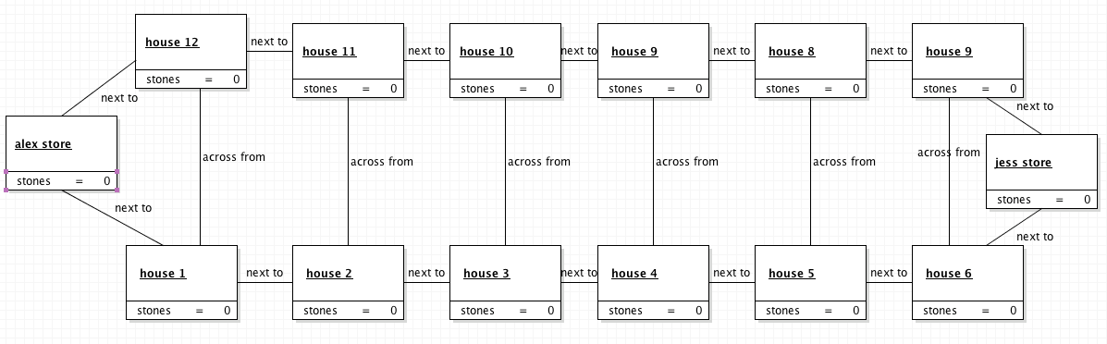

1. Jess hastily reads through the rules of the game and determines that the winner must obtain as many pebbles as possible into their store. Currently, Jess and Alex have 0 pebbles in their stores.

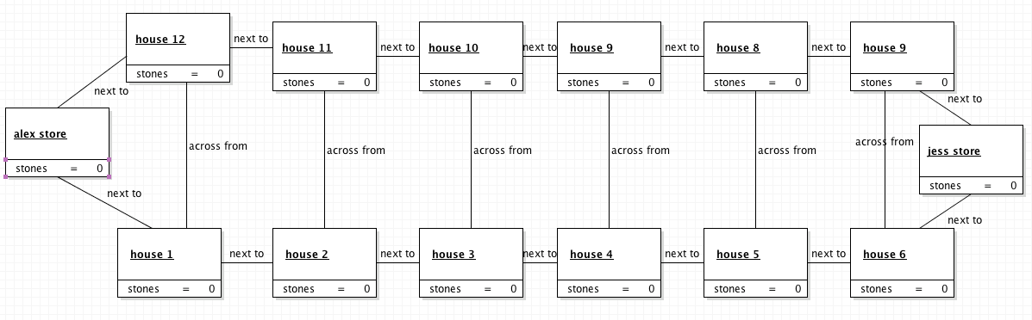

1. Jess grabs all 36 of the Mancala pebbles and places them into her own store (the large pit directly to her right).

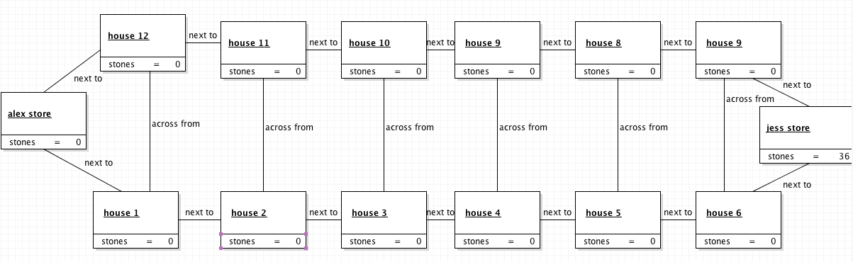

1. Jess declares herself the winner of the game and Alex exits.

**Scenario 2**

**Title: Kevin and Jess attempt the game of Mancala with a new approach and fail**

**Description:**

1. Initial Situation:

Kevin enters the game of Mancala in place of Alex after watching Jess and Alex fail the first time. He decides to thoroughly read through the rules of the game before attempting to play. The following rules are provided in the manual:

Mancala Rules Per the Textbook:

* Setup: Two people, 36 pebbles, 6 houses per row, 3 pebbles per house, 2 stores.
* When players sit opposite, the store to their right is their store.
* Player selects one of his 6 houses and redistributes pebbles counter clockwise.
* If the last pebble lands in the store, player takes another turn.
* If the last pebble lands in an empty house, player takes all pebbles from opposite house and places them in their own store.

1. Player Kevin examines the Mancala board, the pieces, and the rules manual.

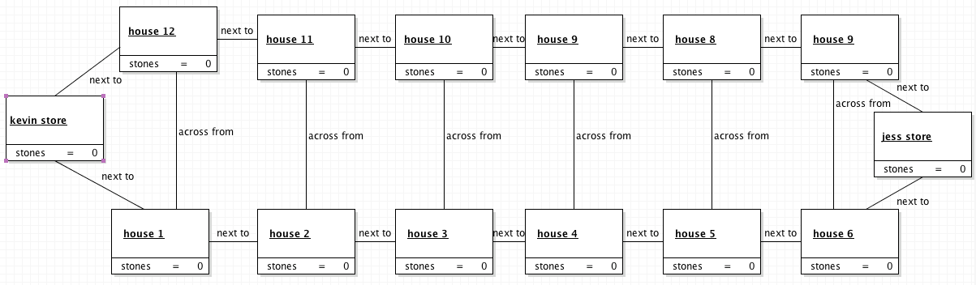

1. Kevin determines that the game was setup incorrectly by Alex and Jess and attempts to correctly setup the game by placing three pebbles per house in each of the six houses in each row.

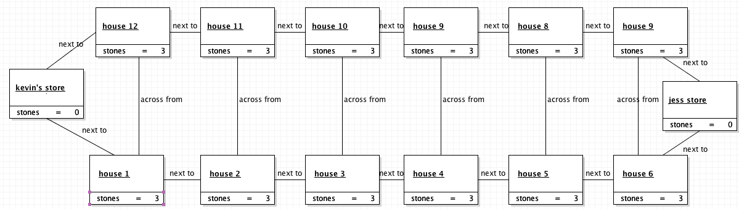

1. Kevin explains to Jess that each player starts their turn by choosing a house on their side and redistributing the pebbles, counter-clockwise, into the following houses. Jess understands.
2. Kevin and Jess play the game with the objective to avoid the other player’s store.
3. Kevin and Jess take 5-10 minute turns trying to figure out to how avoid giving each other points.

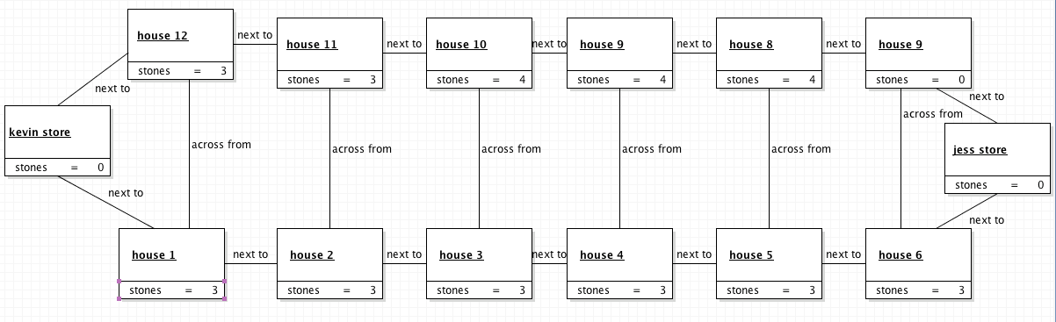

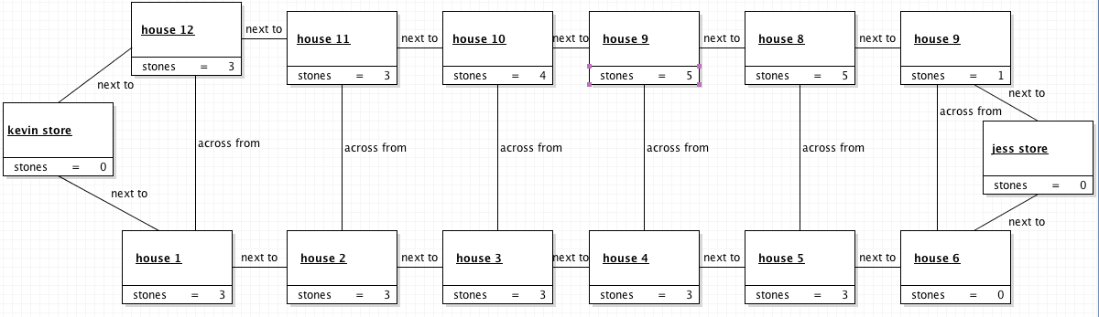

1. Kevin and Jess quit the game halfway through out of frustration.

**Scenario 3**

**Title: Jeff and Jess attempt the game of Mancala with a new approach and fail**

**Description:**

1. Initial Situation:

Jeff enters the game of Mancala in place of Alex and Kevin after watching Jess, Alex, and Kevin fail. He decides that Jess and Kevin’s approach to the game was close but missing a crucial rule; the end of the game. The following rules are provided in the manual:

1. Player Jeff examines the Mancala board, the pieces, and the rules manual.
2. Jeff determines that Kevin and Jess’s new assumption of the rules and setup were correct and sets up the board by placing three pebbles per house in each of the six houses in each row.

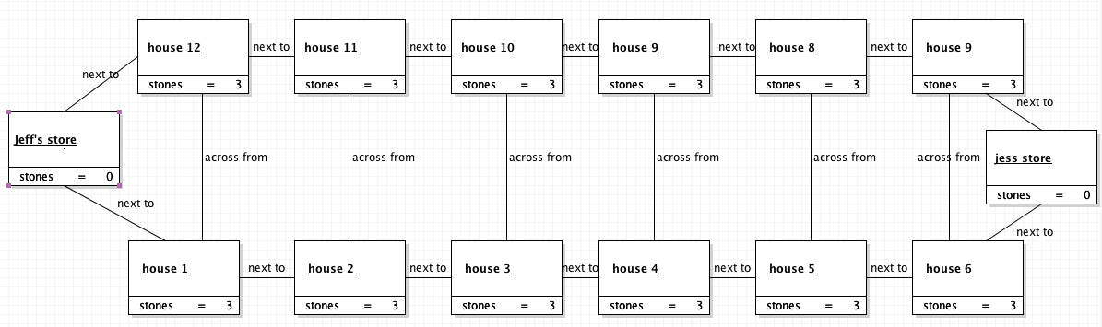

1. Jeff explains to Jess that he believes the game ends when the entire board is clear. Jess understands.
2. Jeff and Jess play the game following the rules previously described by Kevin and with a new end goal to clear the board.
3. 30 minutes of game play pass.
4. Jeff’s current board state: 0, 1, 1, 1, 0, 0, where the numbers represent the pebbles in each house of Jeff’s row. Jeff’s store contains 16 pebbles.

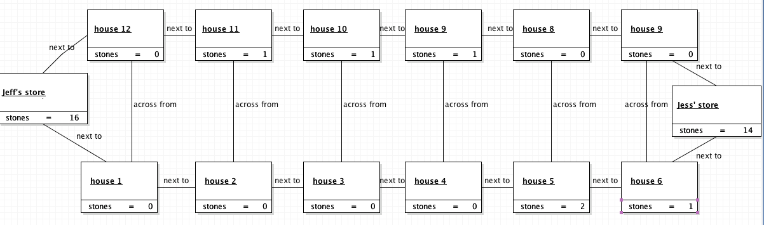

1. Jess’s current board state: 0, 0, 0, 0, 2, 1. Jess’s store contains 14 pebbles. It is Jess’s turn.



1. Jess takes her turn and starts with the house with two pebbles and places one in the house to the right and one in her store. Jess takes another turn.

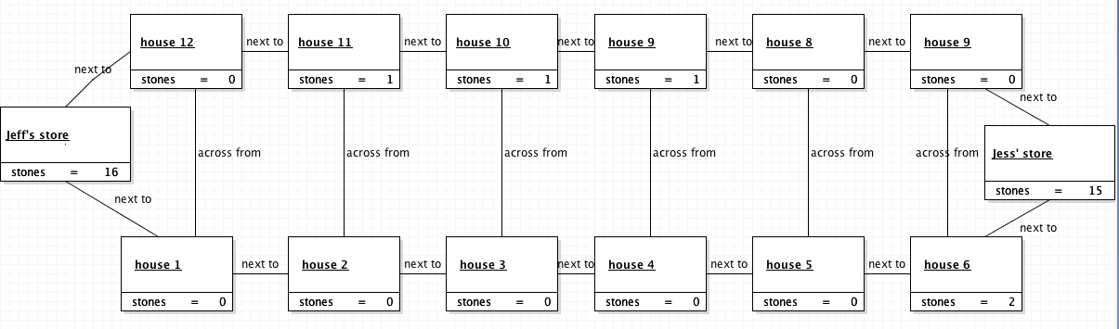

1. Jess’s board state is: 0, 0, 0, 0, 0, 2. She picks up the two remaining pebbles and places one in elher store and one in Jeff’s house on his side of the board. Jess’s board is empty at this point.

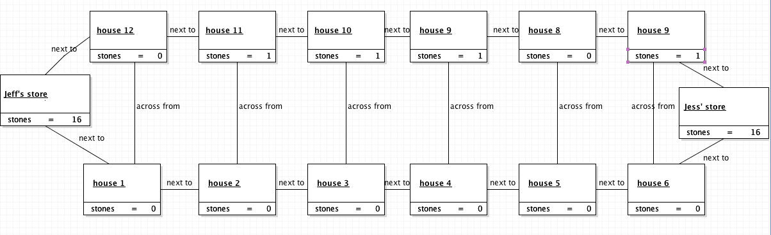

1. Jeff’s board state is 0, 1, 1, 1, 0, 1. It is Jeff’s turn.

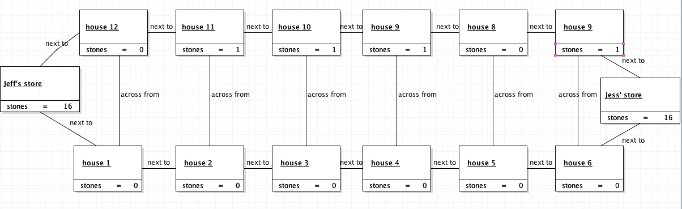

1. Jeff moves his first pebble to the next available house. It is Jeff’s turn.

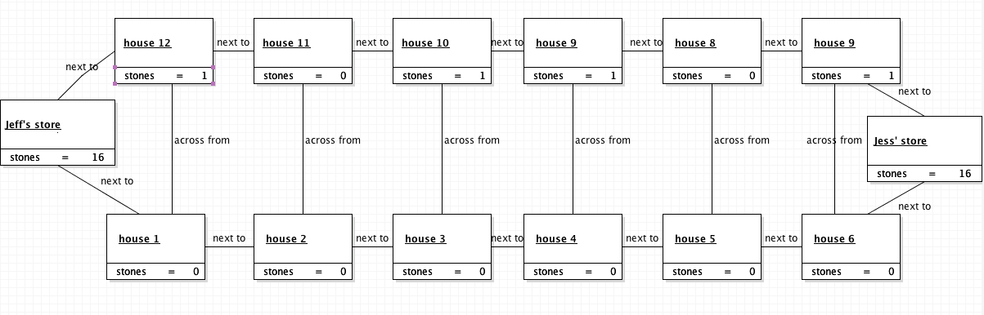

1. Jeff moves the pebble into his store. It is Jeff’s turn.

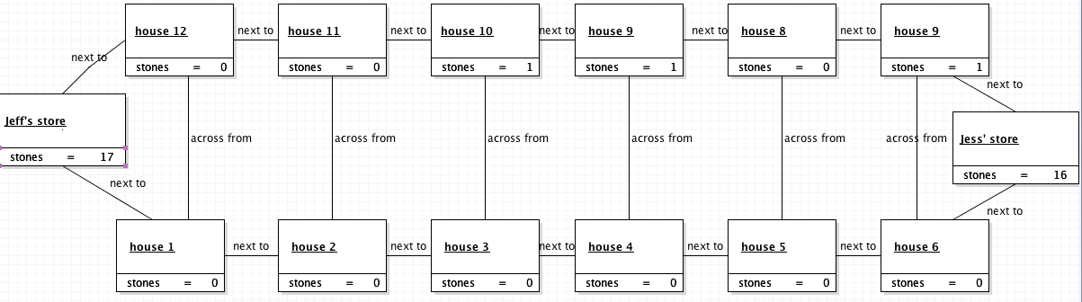

1. Jeff continues moving pebbles and taking turns until his side of the board is clear.

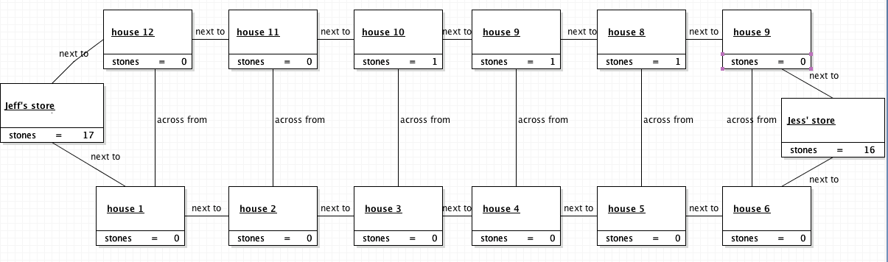

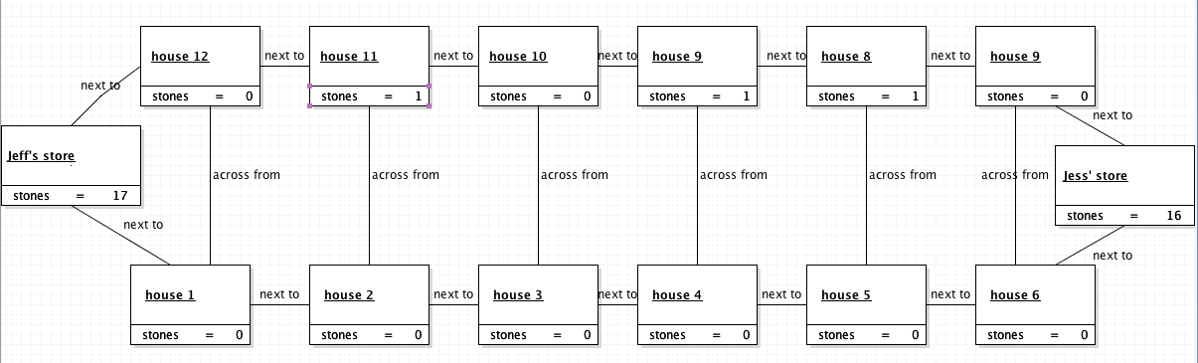

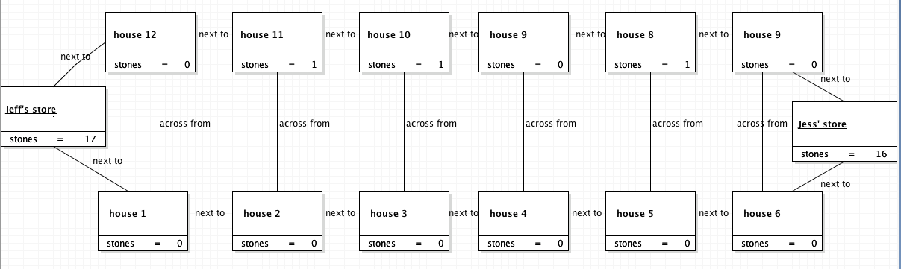

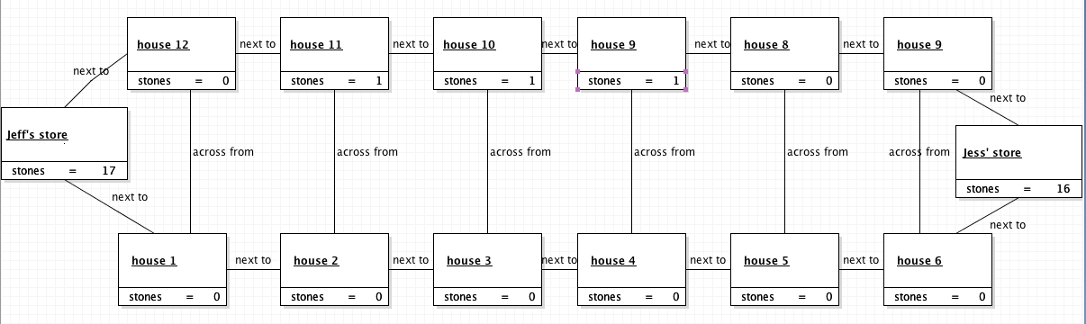

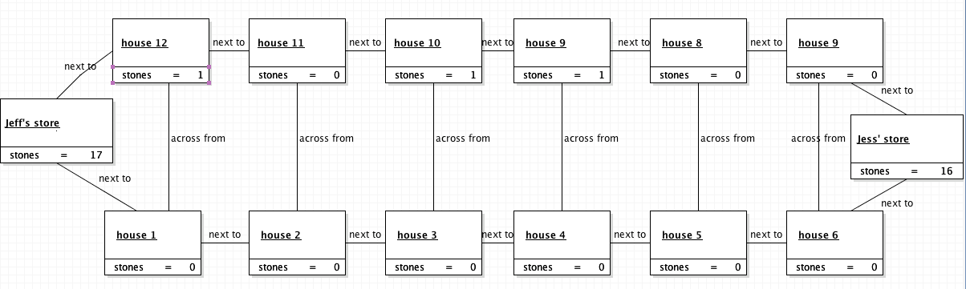

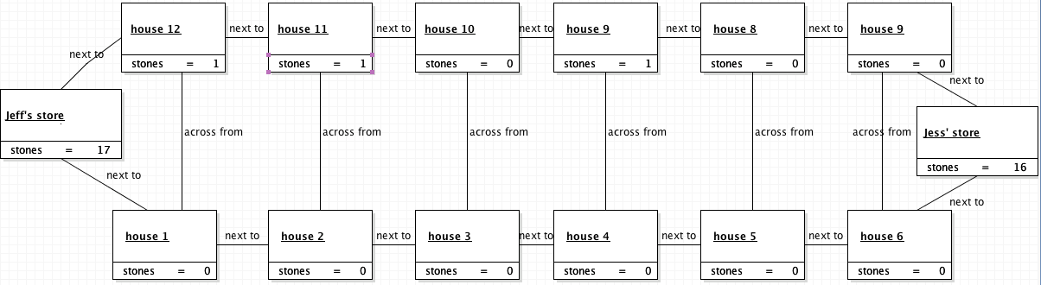

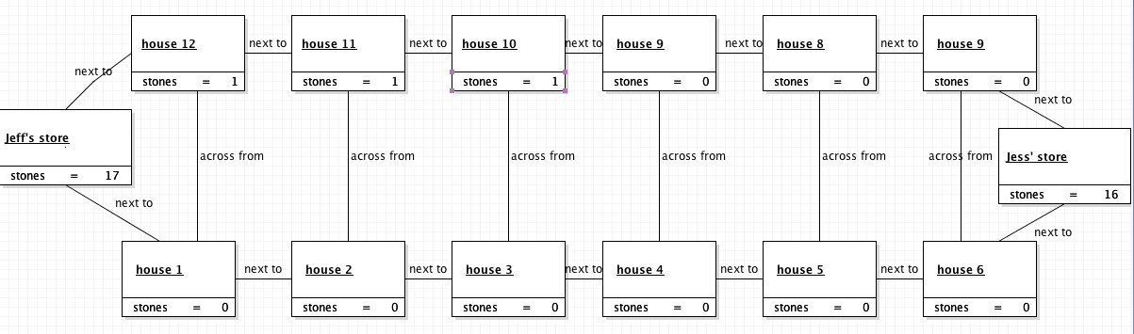

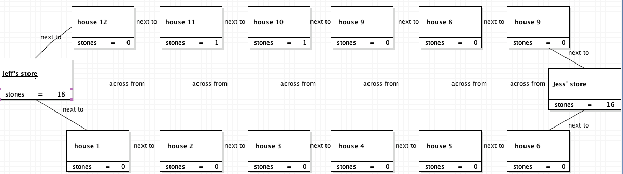

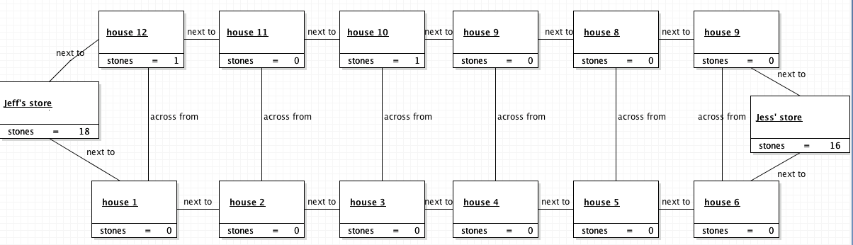

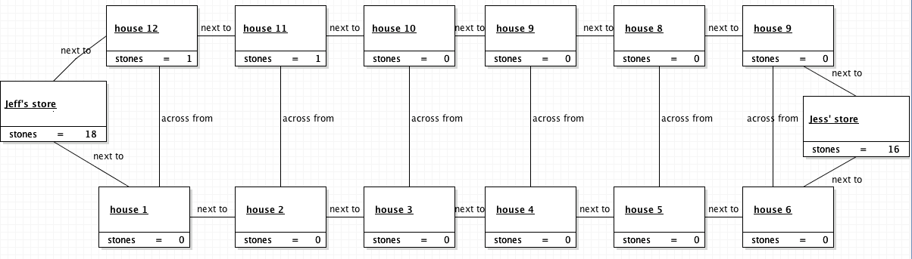

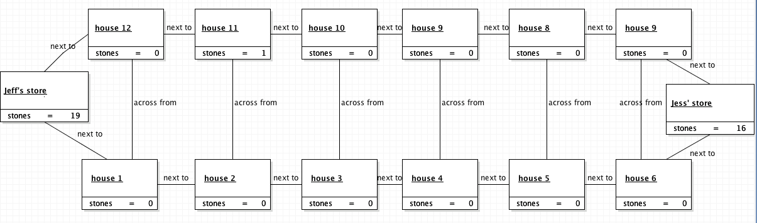

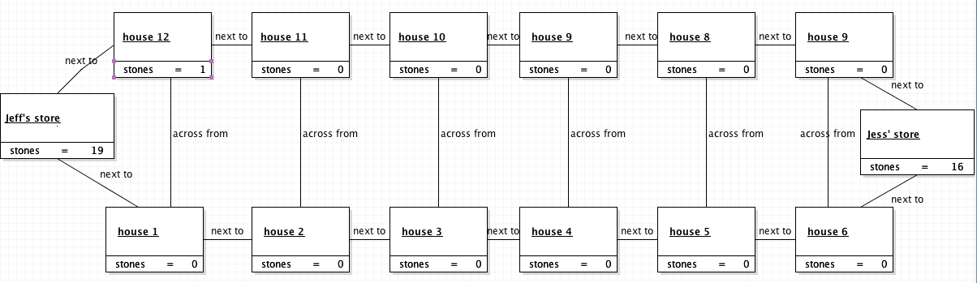

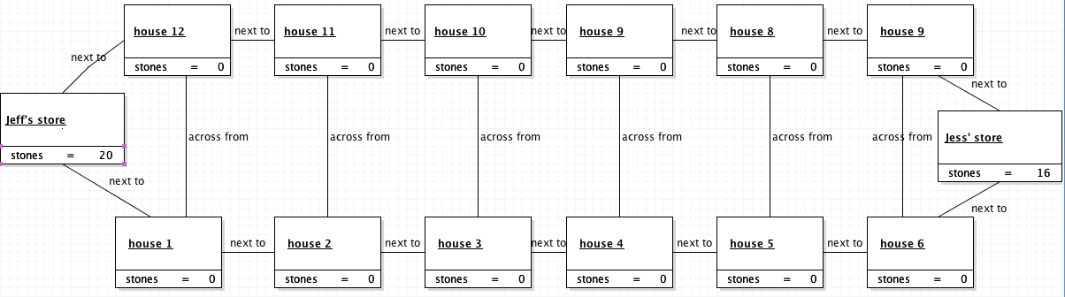

1. Jeff’s board state is 0,0,0,0,0,0. The game ends.

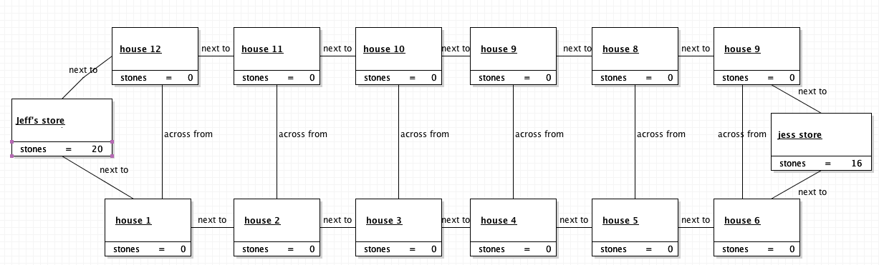

1. Jeff’s store contains 20 pebbles. Jess’s store contains 16. Jeff incorrectly wins the game. Jess exits.

**Scenario 4**

**Title: Alex rejoins the game of Mancala with new rules and successfully finishes the game correctly.**

**Description:**

1. Initial Situation:

After Jeff, Kevin, and Jess have all failed to play the game correctly per the rules manual, Alex researches more details regarding the rules of Mancala and rejoins the game against Jess. The original manual from the game provided the following rules.

Alex’s Additional Rules After Researching the Game:

* Players only place pebbles into their own store and never into an opponent’s store.
* The game ends when one row of the board is entirely clear of pebbles.
* The player with the most amount of pebbles in their store wins the game.

1. Player Alex sets up the board by placing three pebbles per house in each of the six houses in each row.

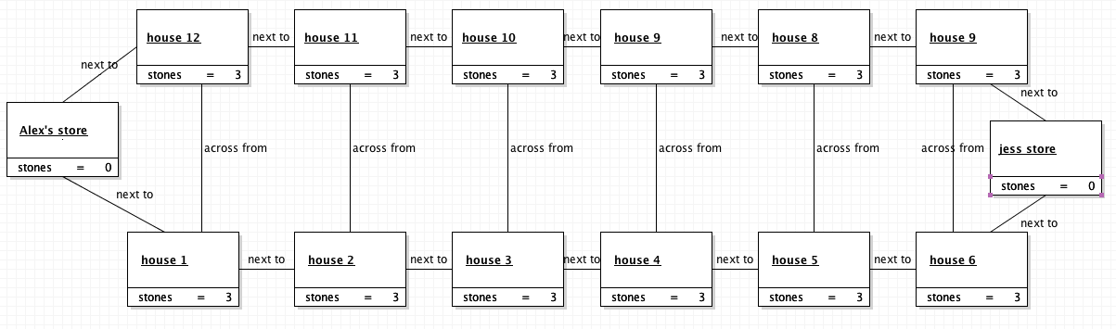

1. Alex explains the additional rules to Jess. Jess understands.
2. Alex and Jess play the game following the additional rules with the goal to clear their side of the board and end with the most pebbles in their store.
3. 30 minutes of game play pass.
4. Alex’s current board state: 0, 1, 1, 1, 0, 0, where the numbers represent the pebbles in each house of Alex’s row. Alex’s store contains 15 pebbles.

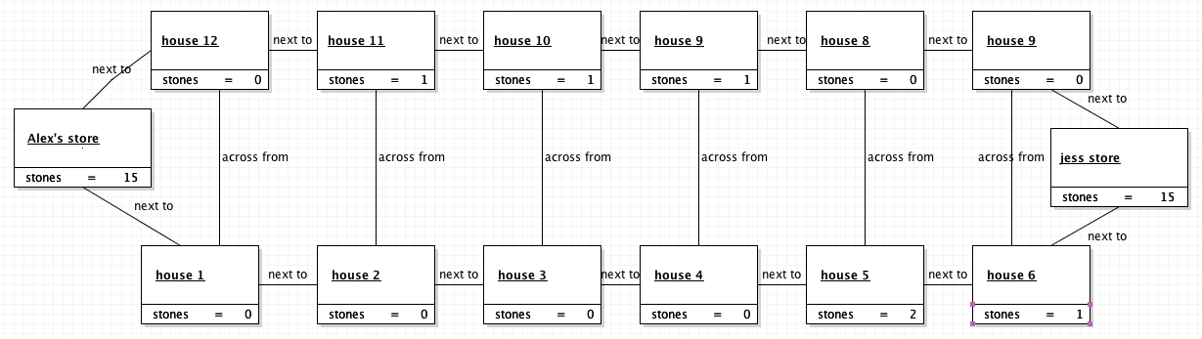

1. Jess’s current board state: 0, 0, 0, 0, 2, 1. Jess’s store contains 15 pebbles. It is Jess’s turn.

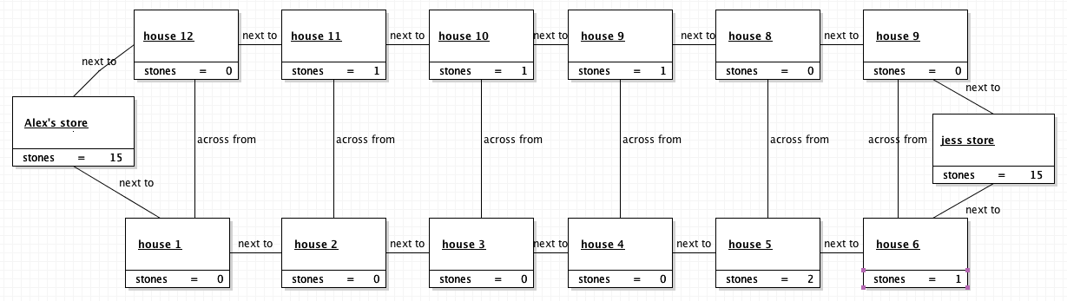

1. Jess takes her turn and starts with the house with two pebbles and places one in the house to the right and one in her store. Jess takes another turn.

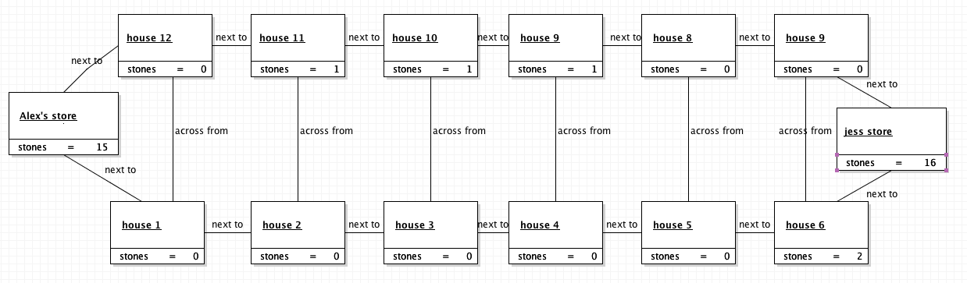

1. Jess’s board state is: 0, 0, 0, 0, 0, 2. She picks up the two remaining pebbles and places one in her store and one in Alex’s house on his side of the board. Jess’s board is empty at this point.

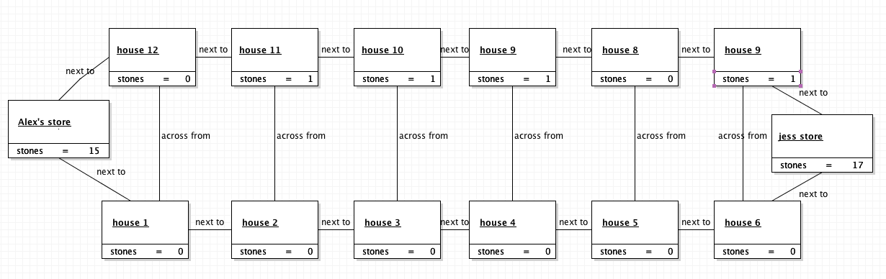

1. The game ends. Jess’s store contains 17 pebbles. Alex’s store contains 15. Jess correctly wins the game. All players exit.

**Scenario 5**

**Title: Alex and Jess attempt to play Mancala but the game infinitely loops**

**Description:**

1. Initial Situation:

The board game, Mancala, resides on a table for Alex and Jess to pick up and attempt to play correctly. The following rules are provided in the manual:

1. Players Jess and Alex sit at the table, open the Mancala box, and examine the board and the pieces.
2. Alex sets up the board by placing three pebbles per house in each of the six houses in each row.

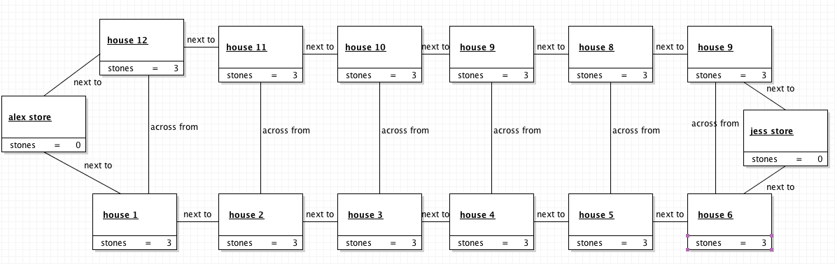

1. Alex and Jess play the game following only the rules described by the manual.
2. Alex’s board state is 3,3,3,3,3,3. Alex’s store contains 0 pebbles. Jess’s board state is 3,3,3,3,3,3. Jess’s store contains 0 pebbles. It is Alex’s turn.

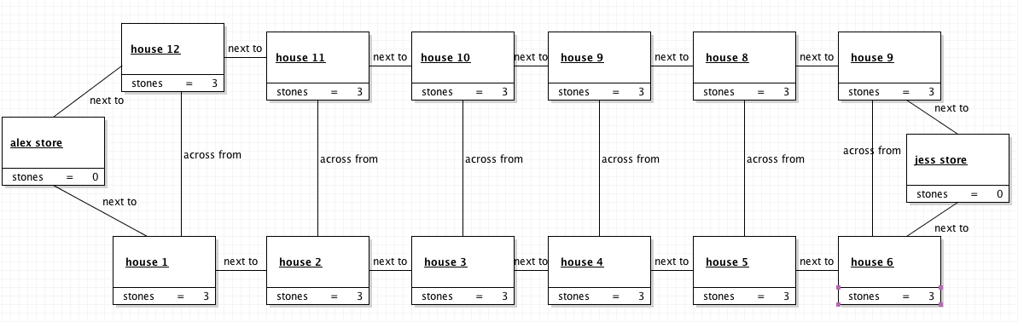

1. Alex redistributes his first 3 pebbles. His board state is: 0,3,3,3,3,3. His store contains 1 pebble. Jess’s board state is: 4,4,3,3,3,3. Jess’s store contains 0 pebbles. It is Jess’s turn.

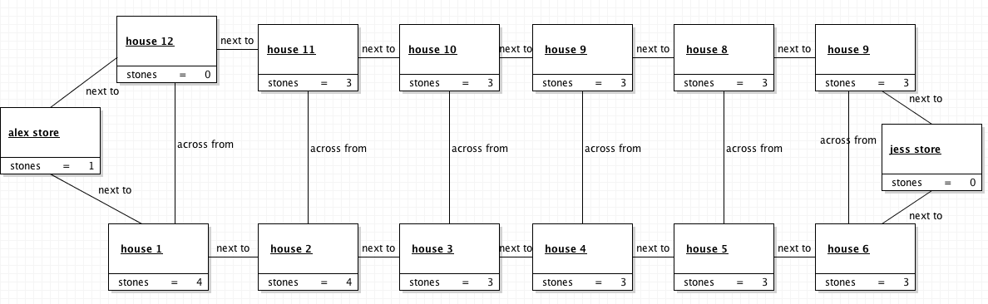

1. Jess redistributes her last 3 pebbles in her row. Jess’s board state is 4,4,3,3,3,0. Her store contains 1 pebble. Alex’s board state is 0,3,3,3,4,4. His store contains 1 pebble. It is Alex’s turn.

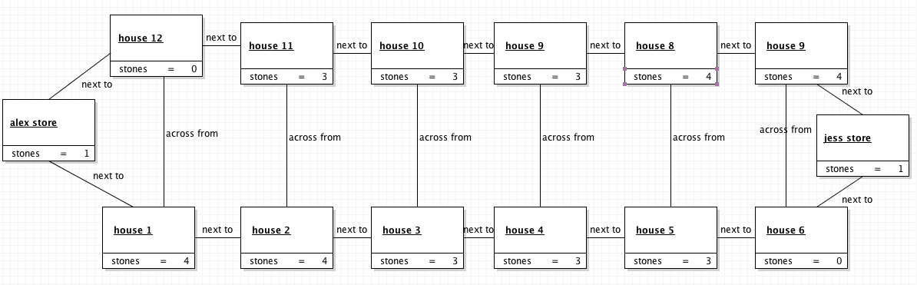

1. Alex redistributes the one pebble from his store. His board state is 0,3,3,3,4,4. His store contains 0 pebbles. Jess’s board state is: 5,4,3,3,3,0. Her store contains 1 pebble. It is Jess’s turn.

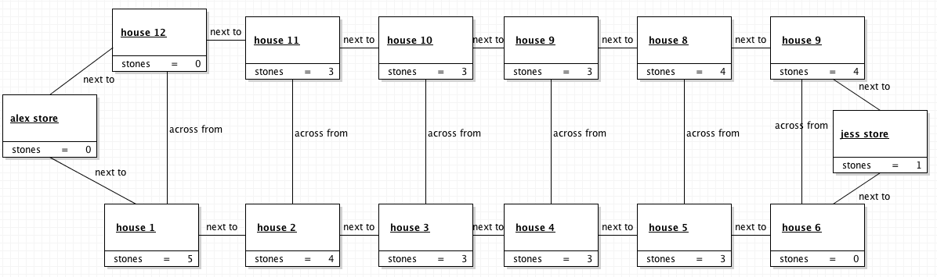

1. Jess redistributes the one pebble from her store. Her board state is 5,4,3,3,3,0. Her store contains 0 pebbles. Alex’s board state is: 0,3,3,3,4,5. His store contains 0 pebbles. It is Alex’s turn.

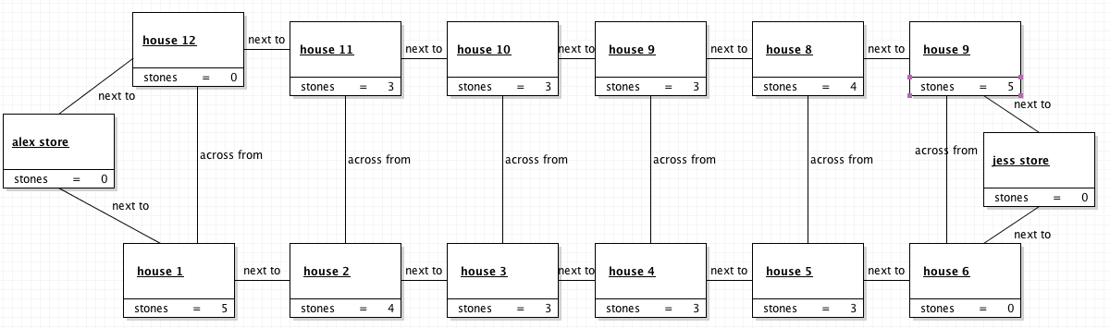

1. The game infinitely loops. Players Alex and Jess die playing Mancala.

**Scenario 6**

**Title: Alex successfully and legally wins the game**

**Description:**

1. Initial Situation:



1. There is one last turn remaining in the game of Mancala. Alex’s board state is: 0,1,0,0,0,0. His store contains 14 pebbles. Jess’s board state is: 4,1,2,0,0,0. Her store contains 14 pebbles. It is Alex’s turn.

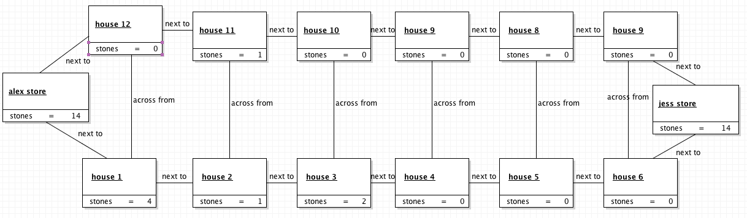

1. Alex moves his one pebble to the first empty house. Because it landed in an empty house, Alex grabs all 4 of Jess’s pebbles from her adjacent house along with his last pebble and places them in his store. Alex’s board state is 0,0,0,0,0,0. His store contains 19 pebbles. Jess’s board state is: 0,1,2,0,0,0. Her store contains 14 pebbles.

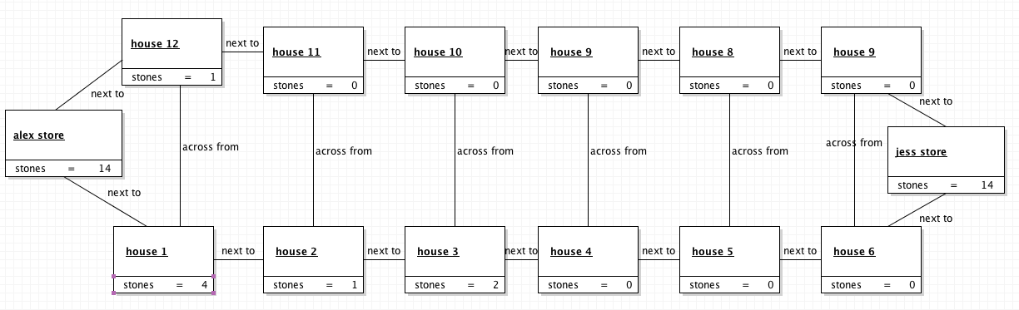

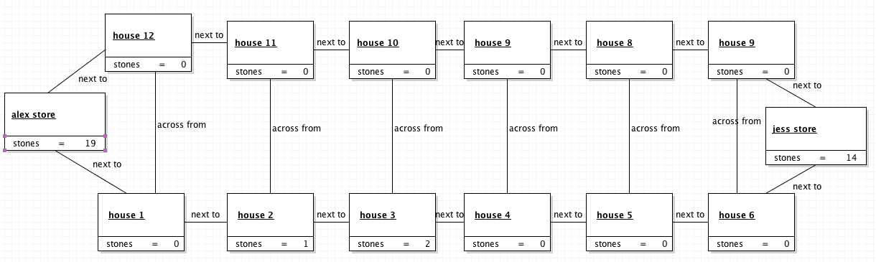

1. Because Alex cleared his side of the board, the game ends. Alex is declared the winner with 19 pebbles to Jess’s 14. Both players exit.

