BLUE REPORT
Gabapentin is not currently indicated for improving overall survival in glioblastoma and should be reserved for symptom control (e.g., seizures, neuropathic pain) only. While emerging retrospective data suggest a potential survival benefit, this remains investigational and is not part of standard care or NCCN guidelines.[1][2]

Question 1: Is gabapentin indicated for survival benefit?
Current evidence status: Recent retrospective studies have shown intriguing associations between gabapentin use and improved survival in glioblastoma patients. A 2024 ASCO abstract reported median overall survival of 20.8 months in gabapentin-treated patients versus 14.7 months in non-treated patients (HR 0.67, p=0.030), with a median daily dose of 600 mg (IQR 300-900 mg).[2] A 2025 Nature Communications study of 1,072 patients confirmed these findings, demonstrating that gabapentin (a thrombospondin-1 antagonist) was associated with reduced serum TSP-1 levels and improved survival.[1] The mechanistic rationale involves disrupting neuronal-glioma synaptic interactions that promote tumor growth.[3]
However, these findings are not ready for clinical implementation. The NCCN Central Nervous System Cancers Guidelines (updated December 2025) do not include gabapentin as a treatment option for glioblastoma.[4] The GLUGLIO trial (NCT05664464), a randomized phase Ib/II study testing gabapentin combined with other glutamate signaling inhibitors plus chemoradiotherapy, is currently recruiting but results are pending.[5] Until prospective randomized trial data are available, gabapentin should not be prescribed with the primary goal of improving survival.
Standard indications for gabapentin in glioblastoma patients remain seizure control and neuropathic pain management. NCCN guidelines recommend non-enzyme-inducing antiepileptic drugs like levetiracetam (preferred), topiramate, valproic acid, or lacosamide for seizure management, with gabapentin listed as an acceptable alternative due to lack of drug interactions.[4] The EANO guidelines similarly note that gabapentin offers advantages over classic antiepileptics due to lack of drug interactions.[6]

Question 2: Dosing and risk-benefit considerations in this patient
This patient is at exceptionally high risk for gabapentin-related adverse events given his age (80 years), ECOG 3 performance status, recent fall, cognitive impairment, gait disturbance, and concurrent dexamethasone use. The potential harms likely outweigh any speculative survival benefit.
Gabapentin risks in elderly patients with poor performance status:
Gabapentin is associated with significant neurocognitive and motor adverse effects in older adults, particularly those with frailty and impaired renal function. Key risks include:[7][8][9][10][11][12]
- Falls and fractures: Gabapentin use in older adults is associated with increased fall risk, particularly at doses ≥2,400 mg/day. A study of older adults with normal cognition found gabapentin initiation was associated with increased falls at follow-up (OR 2.51, 95% CI 1.19-5.31). Gabapentinoids are listed among fall-risk increasing drugs in the 2024 JAMA review on fall prevention.[8][10][7]
- Cognitive impairment and delirium: Gabapentin initiation in older adults is associated with cognitive decline (OR 1.55 for worsening CDR), functional status decline (OR 1.78), and altered mental status. In perioperative settings, gabapentin increased delirium risk (RR 1.28) and new antipsychotic use (RR 1.32), with highest risk in patients with chronic kidney disease and high comorbidity burden.[9][10][11]
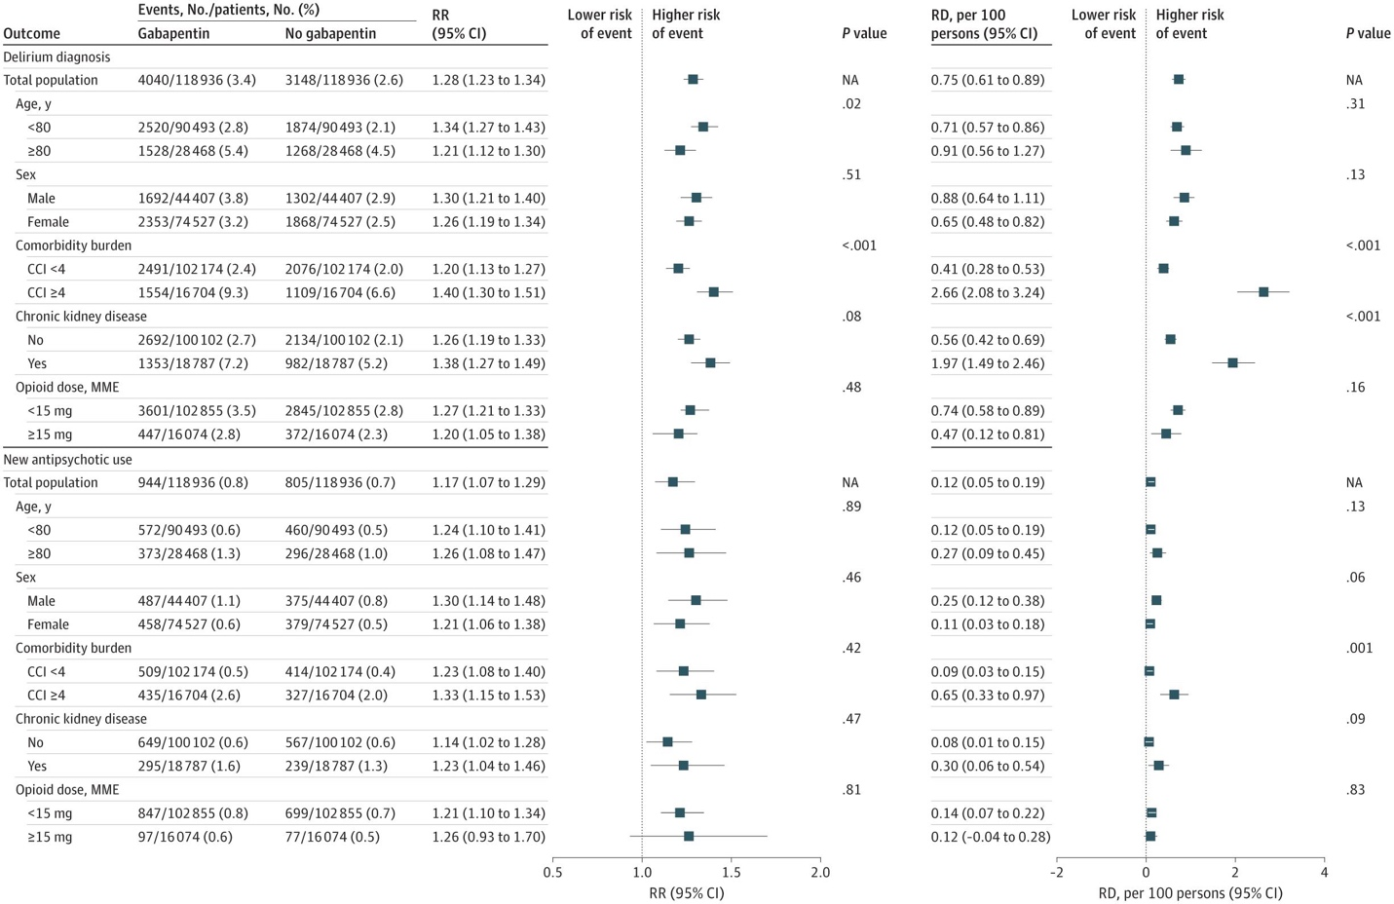Figure 2 Subgroup Analysis of the Association Between Perioperative Gabapentin Use and Delirium Diagnosis and New Antipsychotic Use undefined
- Sedation and gait disturbance: Common adverse effects include dizziness, somnolence, and gait disturbance, which would exacerbate this patient's existing shuffling gait and fatigue.[7][8]
- Renal considerations: Gabapentin is eliminated solely by the kidneys and requires dose adjustment for renal impairment. Older patients with CKD are at particularly high risk for altered mental status, falls, and fractures.[13][14][8][11]
Drug interaction with dexamethasone: While gabapentin itself does not have significant CYP450 interactions, dexamethasone is a CYP3A4 substrate and moderate inducer.[15][16][17] There are no direct pharmacokinetic interactions between gabapentin and dexamethasone reported in the literature, but both drugs independently cause sedation, cognitive impairment, and gait disturbance, potentially creating additive CNS effects.
Clinical recommendation for this patient:
Given this patient's ECOG 3 status, recent fall, marked cognitive impairment, and lack of seizures or neuropathic pain symptoms, gabapentin should not be initiated. The surgeon's suggestion appears to be based on preliminary retrospective data that has not been validated in prospective trials and is not part of standard care. If the family wishes to pursue this based on emerging evidence, they should be counseled that:
1. The survival benefit is unproven and investigational
2. The patient's frailty and recent fall place him at very high risk for serious adverse events (further falls, fractures, worsening cognition, aspiration)
3. If initiated despite these concerns, start at the lowest possible dose (100-300 mg daily) with close monitoring for sedation, confusion, and falls
4. The median dose in retrospective studies was 600 mg daily (range 300-900 mg), but this was not studied in ECOG 3 patients[2]
Alternative approach: Focus on optimizing quality of life through palliative care, minimizing dexamethasone dose to reduce steroid-related complications, and considering goals-of-care discussions given his progressive functional decline and poor prognosis.
Would you like me to explore the evidence for other supportive care interventions that might improve quality of life or functional status in this patient with advanced glioblastoma and declining performance status?

References
- Gabapentinoids Confer Survival Benefit in Human Glioblastoma. Bernstock JD, Mehari M, E Gerstl JV, et al. Nature Communications. 2025;16(1):4483. doi:10.1038/s41467-025-59614-4.
- Can targeting TSP-1 with gabapentin enhance survival in glioblastoma? A 20-year retrospective cohort study. Mehari M, Ambati V, Krishna S, et al. Journal of Clinical Oncology. 2024;42(Suppl 16):2048. doi:10.1200/JCO.2024.42.16_suppl.2048.
- Glioblastoma Remodelling of Human Neural Circuits Decreases Survival. Krishna S, Choudhury A, Keough MB, et al. Nature. 2023;617(7961):599-607. doi:10.1038/s41586-023-06036-1.
- Central Nervous System Cancers. National Comprehensive Cancer Network. Updated 2025-12-05.
- A Phase Ib/Ii Randomized, Open-Label Drug Repurposing Trial of Glutamate Signaling Inhibitors in Combination With Chemoradiotherapy in Patients With Newly Diagnosed Glioblastoma: The GLUGLIO Trial Protocol. Mastall M, Roth P, Bink A, et al. BMC Cancer. 2024;24(1):82. doi:10.1186/s12885-023-11797-z.
- EANO Guideline for the Diagnosis and Treatment of Anaplastic Gliomas and Glioblastoma. Weller M, van den Bent M, Hopkins K, et al. The Lancet. Oncology. 2014;15(9):e395-403. doi:10.1016/S1470-2045(14)70011-7.
- Risk Assessment and Prevention of Falls in Older Community-Dwelling Adults: A Review. Colón-Emeric CS, McDermott CL, Lee DS, Berry SD. JAMA. 2024;331(16):1397-1406. doi:10.1001/jama.2024.1416.
- The Primary Care Management of Chronic Kidney Disease (CKD) (2025). Jonathan Casey Brown DO MPH, Wendy Caesar-Gibbs RD, Cynthia Delgado MD FASN FNKF, et al. Department of Veterans Affairs.
- Perioperative Gabapentin Use and In-Hospital Adverse Clinical Events Among Older Adults After Major Surgery. Park CM, Inouye SK, Marcantonio ER, et al. JAMA Internal Medicine. 2022;182(11):1117-1127. doi:10.1001/jamainternmed.2022.3680.
- The Association of Gabapentin Initiation and Neurocognitive Changes in Older Adults With Normal Cognition. Oh G, Moga DC, Fardo DW, Abner EL. Frontiers in Pharmacology. 2022;13:910719. doi:10.3389/fphar.2022.910719.
- Gabapentin Dose and the 30-Day Risk of Altered Mental Status in Older Adults: A Retrospective Population-Based Study. Fleet JL, Dixon SN, Kuwornu PJ, et al. PloS One. 2018;13(3):e0193134. doi:10.1371/journal.pone.0193134.
- Gabapentinoids and Risk of Hip Fracture. Leung MTY, Turner JP, Marquina C, et al. JAMA Network Open. 2024;7(11):e2444488. doi:10.1001/jamanetworkopen.2024.44488.
- gabapentin. Food and Drug Administration. Updated date: 2025-05-23.
- GABAPENTIN. Food and Drug Administration. Updated date: 2025-04-12.
- Dexamethasone. Food and Drug Administration. Updated date: 2024-10-09.
- Dexamethasone. Food and Drug Administration. Updated date: 2024-03-30.
- Dexamethasone Is a Dose-Dependent Perpetrator of Drug-Drug Interactions: Implications for Use in People Living With HIV. Jacobs TG, Marzolini C, Back DJ, Burger DM. The Journal of Antimicrobial Chemotherapy. 2022;77(3):568-573. doi:10.1093/jac/dkab412.

