GUI Description: Procedural Terrain Generation and Lighting Assignment

The GUI for this assignment is fairly simple, comsisting of a set of program variables you can change, utilising AntTweakBar functionality. Navigation of the actual generated environment is by using the mouse and keyboard. Holding the right mouse button down and dragging allows you to rotate the current view, while the WASD keys allow you to go forward, backward, left and right, and the Q and E keys allow you to go up and down. T will display the highest and lowest current Perlin Noise samples before scaling. Holding down the M key will change the view to a wireframe, until the key is released.

The R key will reload all shaders when pressed, to use any changes made to them, used extensively for debugging shaders.

Hitting the Space bar will fire off one of four particle effects emitters, in sequence. There is also a minimum interval between firing of 1.0 second.

The program window appears as follows:
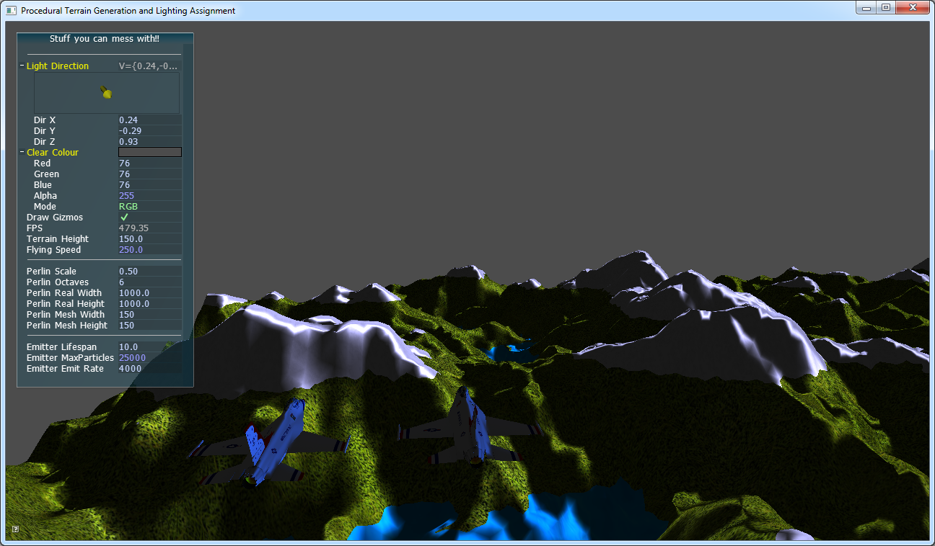
The AntTweakBar is on the left and shows the current frame rate, as well as allowing various program variables to be modified.

The displayed and modifiable variables are as follows:
Light Direction: This is the directional light for the terrain, and its values are relative to the terrain rather than the camera view, and also feeds into the model shaders.

Clear Colour: this is the background colour rendered in the absence of other geometry.

Draw Gizmos: simple tick box to turn the Gizmos drawing on and off. This is primarily just the original test grid

FPS: the current frame rate in Frames rendered Per Second. (display only)

Terrain Height: how much to scale the height of the terrain.

Flying Speed: how fast the camera moves. This also determines how fast the particle effects travel, as they use a percentage of the camera speed.

Terrain Generation and display options:
Perlin Scale: the Perlin Noise scale parameter for how much of the next octave will be added to the final sum.

Perlin Octaves: how many Perlin Noise Octaves to calculate.

Perlin Real Width: Width of the terrain in the world. (X-axis)

Perlin Real Height: Width of the other axis of the terrain in the world. (Z-axis)

Perlin Mesh Width: Width of the terrain mesh, and Perlin texture.

Perlin Mesh Height: Height of the terrain mesh, and Perlin texture.

Particle Emitter options:
Emitter Lifespan: How long the emitter will continue to emit particles for.

Emitter Max Particles: The maximum number of particles generated by the emitter.

Emitter Emit Rate: The rate at which the Emitter emits particles. (per second)

