# Lab 2 Pre-lab Example

## Team Information

**Lab number:** 2

**Date:** 2/24/2016

**Team Members:** Brett Bushnell, Sydney Clark, Ryan Trumpinski, Matt Dzurick

**Team Number/Name:** Team Member Responsibilities

**Software Design:** Ryan Trumpinski

**Hardware Design:** Brett Bushnell

**Quality Assurance:** Sydney Clark

**Systems Integrator:** Matt Dzurick

# Hardware

### Responsibility (2 pts)

Fill in the table below based on your responsibilities provided in the procedures and grading rubric. This will be what determines your individual grade for the lab.

|  |
| --- |
| Part 1 and 2 |
| The circuit diagram s complete.  Appropriate colors are chosen for the wire-wrapping portion. |

### Part 1 (3 pts)

Draw the schematics **or** create a table detailing the connections for Part 1 of Lab 2. Include colors for the wires in your diagrams.

# Quality Assurance

### Responsibility (2 pts)

Fill in the table below based on your responsibilities provided in the procedures and grading rubric. This will be what determines your individual grade for the lab.

|  |  |
| --- | --- |
| Part 1 | Part 2 |
| A circuit diagram for the circuit to test the pin initialization is provided  Picture, circuit diagram, or proof of at least two other tests is provided | Code for testing provided |

### Part 1 (2 pts)

List the tests that you intend to do based on the Lab 2 procedures. Describe the name of the test, the tool you intend to use, and a description of the test. Do this for each part in Lab 2.

|  |  |  |
| --- | --- | --- |
| Test Name | Tool | Description |
| Continuity Test | Digital Multi-meter | Test the connectivity on the connector and the header attached to the keypad |
| Keypad Test | Digital Multi-meter | test to see if the column pins will be pulled down when they are connected to the row pins |
| Component Test | Digital Multi-meter | Test and verify that the datasheet is correct in regards to which pin on the keypad is connected to which row |

### Part 2 (1 pts)

|  |  |  |
| --- | --- | --- |
| Test Name | Tool | Description |
| LCD Test | Oscilloscope, Digital Multi-meter | Test that if data is transmitted correctly from the wire-wrapped connections to the LCD |
| validatePassword() Test |  | Tests that the behavior for checking valid/invalid passwords is implemented correctly |
| database() Test |  | Tests that valid passwords are correctly stored |

# Software

### Responsibility (2 pts)

Fill in the table below based on your responsibilities provided in the procedures and grading rubric. This will be what determines your individual grade for the lab.

|  |  |
| --- | --- |
| Part 1 | Part 2 |
| Define statements are used  Use change notifications  Use open drain collector | Create a program to fulfill the requirements of the given state machine  Define states for code readability |

### Part 1 (2 pts)

List the relevant control registers for controlling the keypad and the LCD in Part 1 of Lab 2.

|  |  |
| --- | --- |
| Device: | Register(s): |
| Digital I/O | RG0, RF1, RD12 |
| Change Notification | PORTD, PORTG, PORTF |
| Open-Drain | RD11, RD14, RC2, RC4 |
| Data Direction | input |

Also describe the function of the microcontroller software as a finite-state machine in Part 1 of this lab.

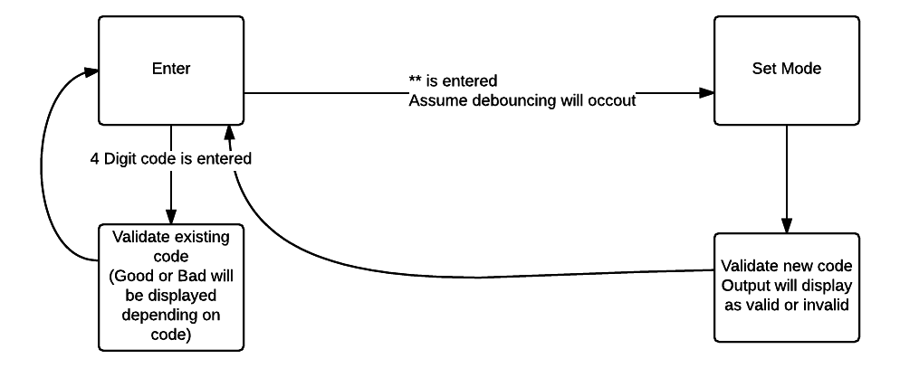

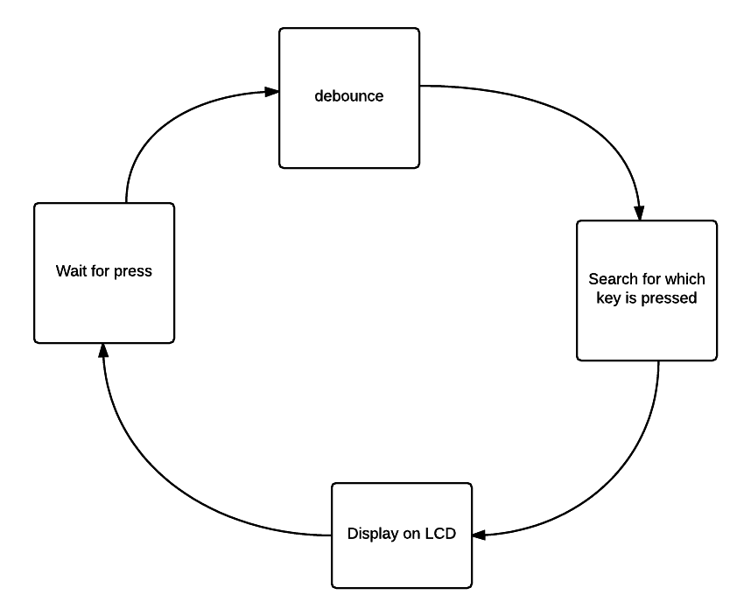

### Part 2 (1 pts)

List the relevant control registers for Part 2 of Lab 2.

|  |  |
| --- | --- |
| Device: | Register(s): |
| Timer | T1CONbits.TCKPS, PR1, IFS0bits.T1IF,TMR1 |
| Digital I/O | RG0, RF1, RD12 |

Also describe the function of the microcontroller software as a finite-state machine in Part 2 of this lab.