# Lab 2 Report

## Team Information

**Lab number:** 2

**Date:** 3/2/2016

**Team Members:** Brett Bushnell, Ryan Trumpinski, Sydney Clark, Matt Dzurick

**Team Number/Name:** WeDidTheThing/217 Team Member Responsibilities

**Software Design:** Ryan Trumpinski

**Hardware Design:** Brett Bushnell

**Quality Assurance:** Sydney Clark

**Systems Integrator:** Matt Dzurick

# Hardware

### Part 1

Draw the schematics or create a table detailing the connections for Part 1 of Lab 2.

### Part 2

Describe the cable that you will create for Part 2. Each connector should have a type and a **unique** identifying number. You can choose to use a table or use a diagram.

**Include a picture of any cables constructed for this lab.**

# Tests

### Part 1

List the tests and their outcomes that you intend to do based on the Lab 2 procedures. **Also include any pictures, screenshots, or schematics involved with each test.** Describe the name of the test, the tool you intend to use, and a description of the test. Do this for each part in Lab 2.

|  |  |  |  |
| --- | --- | --- | --- |
| Test Name | Tool | Description | Outcome |
| Continuity Test | Digital Multi-meter | Test the connectivity on the connector and the header attached to the keypad |  |
| Keypad Test | Digital Multi-meter | Test to see if the column pins will be pulled down when they are connected to the row pins |  |
| Component Test | Digital Multi-meter | Test and verify that the datasheet is correct in regards to which pin on the keypad is connected to which row |  |

For the software tests you have created **include code in the D2L submission.** However, your outcomes should be well-documented here. There is not time for your code to be tested once it is turned in. Therefore, make effort to show clearly what kind of test you did and what its outcome was. Take screen shots and include them here if you must.

|  |  |  |
| --- | --- | --- |
| Test Name | Input | Description |
| Configuration Test |  | Test that if you are using the correct configuration in the code |

### Part 2

# Software

### Part 1 FSM

### https://documents.lucidchart.com/documents/75576abb-d291-4fab-b7b3-58695089c676/pages/0_0?a=464&x=247&y=48&w=893&h=704&store=1&accept=image%2F*&auth=LCA%2006ba09a6ee78e724132ea8782de482ebddc8952e-ts%3D1457026940

### Part 2 FSM

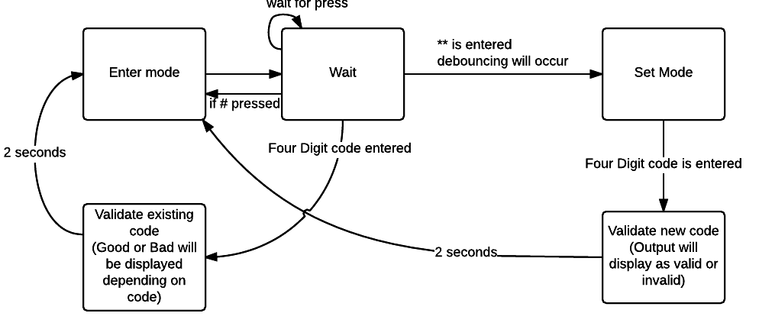

### Commit History

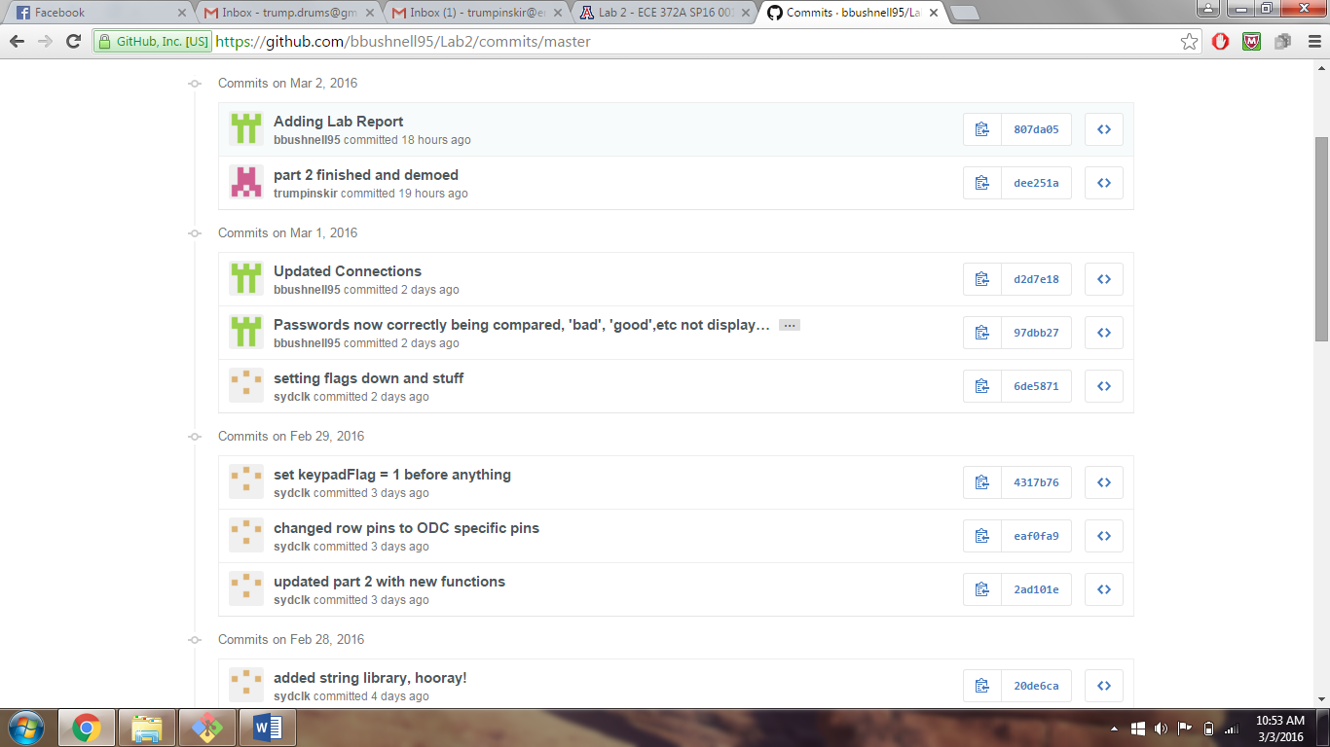

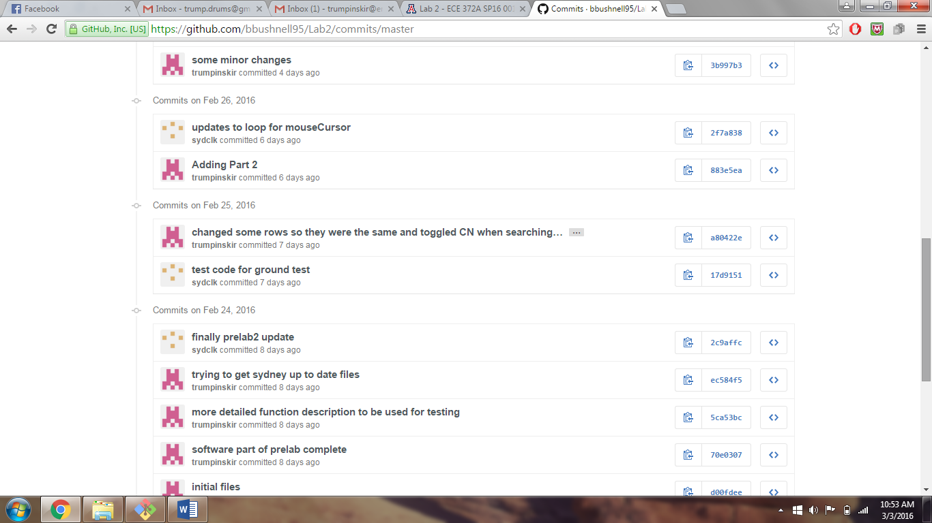

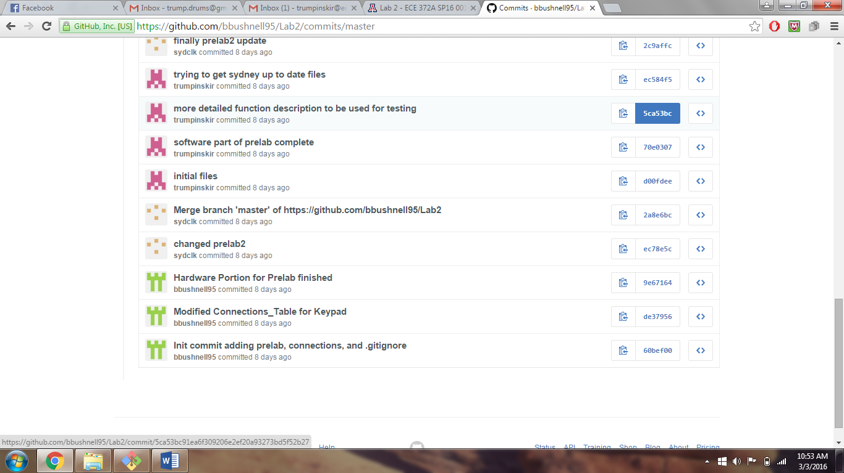

### Version Control

Include a screen shot of your commit history.