# Lab 3 Pre-lab Example

## Team Information

**Lab number:** Click here to enter text.

**Date:** Click here to enter a date.

**Team Members:** Click here to enter text.

**Team Number/Name:** Team Member Responsibilities

**Software Design:** Click here to enter text.

**Hardware Design:** Click here to enter text.

**Quality Assurance:** Click here to enter text.

**Systems Integrator:** Click here to enter text.

# Hardware

### Responsibility (2 pts)

Fill in the table below based on your responsibilities provided in the procedures and grading rubric. This will be what determines your individual grade for the lab.

|  |
| --- |
| Part 1 and 2 |
| * Connect H-Bridge With development board * Designate pins to connect OC modules to motor * Build robot and mount the development board, LCD, Battery, and H-bridge securely. * Make sure connections for H-Bridge, LCD, and Motors are permanent (wire-wrapping) |

### Part 1 (3 pts)

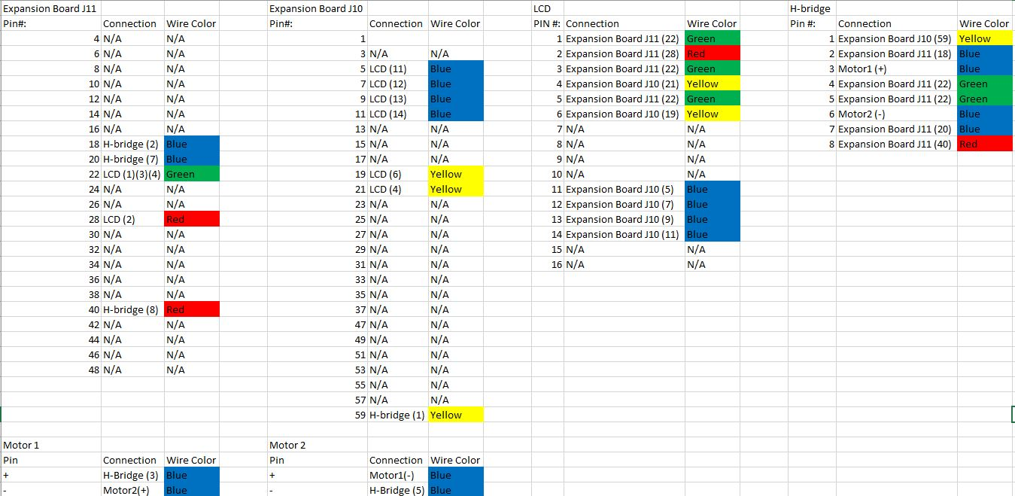

# Quality Assurance

### Responsibility (2 pts)

Fill in the table below based on your responsibilities provided in the procedures and grading rubric. This will be what determines your individual grade for the lab.

|  |  |
| --- | --- |
| Part 1 | Part 2 |
|  |  |

### Part 1 (2 pts)

List the tests that you intend to do based on the Lab 2 procedures. Describe the name of the test, the tool you intend to use, and a description of the test. Do this for each part in Lab 2.

|  |  |  |
| --- | --- | --- |
| Test Name | Tool | Description |
| Continuity Test | Digital Multi-meter | Test the connectivity on the connector and the header attached to the keypad |
| Keypad Test | Digital Multi-meter | test to see if the column pins will be pulled down when they are connected to the row pins |
| Component Test | Digital Multi-meter | Test and verify that the datasheet is correct in regards to which pin on the keypad is connected to which row |

You may also include any software tests that you intend to make.

|  |  |  |
| --- | --- | --- |
| Test Name | Input | Description |
| Configuration Test |  | Test that if you are using the correct configuration in the code |

### Part 2 (1 pts)

|  |  |  |
| --- | --- | --- |
| Test Name | Tool | Description |
| LCD Test | Oscilloscope, Digital Multi-meter | Test that if data is transmitted correctly from the wire-wrapped connections to the LCD |

# Software

### Responsibility (2 pts)

Fill in the table below based on your responsibilities provided in the procedures and grading rubric. This will be what determines your individual grade for the lab.

|  |  |
| --- | --- |
| Part 1 | Part 2 |
|  |  |

### Part 1 (2 pts)

List the relevant control registers for controlling the keypad and the LCD in Part 1 of Lab 2.

|  |  |
| --- | --- |
| Device: | Register(s): |
| Digital I/O |  |
| Change Notification |  |
| Open-Drain |  |
| Data Direction |  |

Also describe the function of the microcontroller software as a finite-state machine in Part 1 of this lab.

### Part 2 (1 pts)

List the relevant control registers for Part 2 of Lab 2.

|  |  |
| --- | --- |
| Device: | Register(s): |
| Timer |  |
| Digital I/O |  |

Also describe the function of the microcontroller software as a finite-state machine in Part 2 of this lab.