# Lab 3 Report

## Team Information

**Lab number:** 3

**Date:** 3/24/2016

**Team Members:** Brett Bushnell, Ryan Trumpinski, Sydney Clark, Matt Dzurick

**Team Number/Name:** WeDidTheThing/217 Team Member Responsibilities

**Software Design:** Ryan Trumpinski

**Hardware Design:** Brett Bushnell

**Quality Assurance:** Sydney Clark

**Systems Integrator:** Matt Dzurick

# Hardware

# Tests

# Software

For both FSM’s we are constantly polling the ADC buffer for a new voltage in either state. Every time the voltage changes we adjust the display and the OCxRS registers accordingly.

### Part 1 FSM

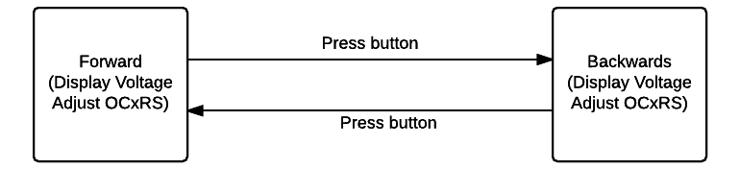

### Part 2 FSM

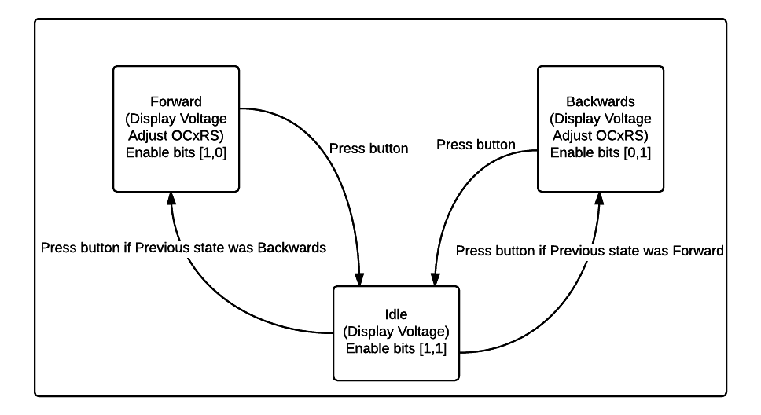

### Commit History

