Regional Operational Plan DF.#R.2019.XX

Estimation and Projection of Statewide Recreational Halibut Harvest

by

Sarah R. Webster

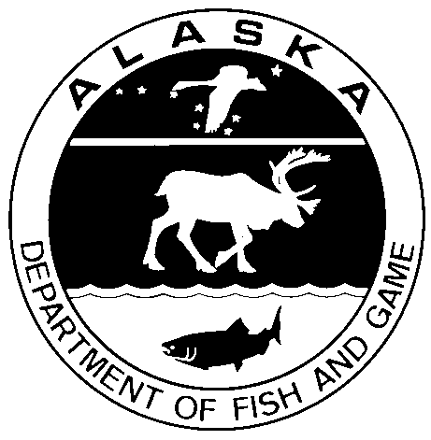

August 2019

Alaska Department of Fish and Game Divisions of Sport Fish and Commercial Fisheries

Symbols and Abbreviations

The following symbols and abbreviations, and others approved for the Système International d'Unités (SI), are used without definition in the following reports by the Divisions of Sport Fish and of Commercial Fisheries: Fishery Manuscripts, Fishery Data Series Reports, Fishery Management Reports, and Special Publications. All others, including deviations from definitions listed below, are noted in the text at first mention, as well as in the titles or footnotes of tables, and in figure or figure captions.

**Weights and measures (metric)**

centimeter cm

deciliter dL

gram g

hectare ha

kilogram kg

kilometer km

liter L

meter m

milliliter mL

millimeter mm

**Weights and measures (English)**

cubic feet per second ft3/s

foot ft

gallon gal

inch in

mile mi

nautical mile nmi

ounce oz

pound lb

quart qt

yard yd

**Time and temperature**

day d

degrees Celsius °C

degrees Fahrenheit °F

degrees kelvin K

hour h

minute min

second s

**Physics and chemistry**

all atomic symbols

alternating current AC

ampere A

calorie cal

direct current DC

hertz Hz

horsepower hp

hydrogen ion activity pH

(negative log of)

parts per million ppm

parts per thousand ppt,

‰

volts V

watts W

**General**

Alaska Administrative

Code AAC

all commonly accepted

abbreviations e.g., Mr., Mrs., AM, PM, etc.

all commonly accepted

professional titles e.g., Dr., Ph.D.,

R.N., etc.

at @

compass directions:

east E

north N

south S

west W

copyright ©

corporate suffixes:

Company Co.

Corporation Corp.

Incorporated Inc.

Limited Ltd.

District of Columbia D.C.

et alii (and others) et al.

et cetera (and so forth) etc.

exempli gratia

(for example) e.g.

Federal Information

Code FIC

id est (that is) i.e.

latitude or longitude lat or long

monetary symbols

(U.S.) $, ¢

months (tables and

figures): first three

letters Jan,...,Dec

registered trademark ®

trademark ™

United States

(adjective) U.S.

United States of

America (noun) USA

U.S.C. United States Code

U.S. state use two-letter abbreviations (e.g., AK, WA)

**Mathematics, statistics**

*all standard mathematical*

*signs, symbols and*

*abbreviations*

alternate hypothesis HA

base of natural logarithm *e*

catch per unit effort CPUE

coefficient of variation CV

common test statistics (F, t, χ2, etc.)

confidence interval CI

correlation coefficient

(multiple) R

correlation coefficient

(simple) r

covariance cov

degree (angular ) °

degrees of freedom df

expected value *E*

greater than >

greater than or equal to ≥

harvest per unit effort HPUE

less than <

less than or equal to ≤

logarithm (natural) ln

logarithm (base 10) log

logarithm (specify base) log2, etc.

minute (angular) '

not significant NS

null hypothesis HO

percent %

probability P

probability of a type I error

(rejection of the null

hypothesis when true) α

probability of a type II error

(acceptance of the null

hypothesis when false) β

second (angular) "

standard deviation SD

standard error SE

variance

population Var

sample var

Regional Operational plan DF.#R.2019-XX

**Estimation and Projection of Statewide Recreational Halibut Harvest**

by

Sarah R. Webster

Alaska Department of Fish and Game, Division of Sport Fish, Anchorage

Alaska Department of Fish and Game  
Division of Sport Fish, Research and Technical Services

333 Raspberry Road, Anchorage, Alaska, 99518-1565

August 2019

The Regional Operational Plan Series was established in 2012 to archive and provide public access to operational plans for fisheries projects of the Divisions of Commercial Fisheries and Sport Fish, as per joint-divisional Operational Planning Policy. Documents in this series are planning documents that may contain raw data, preliminary data analyses and results, and describe operational aspects of fisheries projects that may not actually be implemented. All documents in this series are subject to a technical review process and receive varying degrees of regional, divisional, and biometric approval, but do not generally receive editorial review. Results from the implementation of the operational plan described in this series may be subsequently finalized and published in a different department reporting series or in the formal literature. Please contact the author if you have any questions regarding the information provided in this plan. Regional Operational Plans are available on the Internet at: <http://www.adfg.alaska.gov/sf/publications/>

Sarah R. Webster

Alaska Department of Fish and Game

Division of Sport Fish, Research and Technical Services

333 Raspberry Road, Anchorage, Alaska, 99518-1565

This document should be cited as:

Webster, Sarah R. 2019. Estimation and projection of statewide recreational halibut harvest. Alaska Department of Fish and Game, Division of Sport Fish, Regional Operational Plan ROP.DF#R.YY-XX, Anchorage.

The Alaska Department of Fish and Game (ADF&G) administers all programs and activities free from discrimination based on race, color, national origin, age, sex, religion, marital status, pregnancy, parenthood, or disability. The department administers all programs and activities in compliance with Title VI of the Civil Rights Act of 1964, Section 504 of the Rehabilitation Act of 1973, Title II of the Americans with Disabilities Act (ADA) of 1990, the Age Discrimination Act of 1975, and Title IX of the Education Amendments of 1972.

**If you believe you have been discriminated against in any program, activity, or facility please write:**

ADF&G ADA Coordinator, P.O. Box 115526, Juneau, AK 99811-5526

U.S. Fish and Wildlife Service, 4401 N. Fairfax Drive, MS 2042, Arlington, VA 22203

Office of Equal Opportunity, U.S. Department of the Interior, 1849 C Street NW MS 5230, Washington DC 20240

**The department’s ADA Coordinator can be reached via phone at the following numbers:**

(VOICE) 907-465-6077, (Statewide Telecommunication Device for the Deaf) 1-800-478-3648,

(Juneau TDD) 907-465-3646, or (FAX) 907-465-6078

**For information on alternative formats and questions on this publication, please contact:**

ADF&G, Division of Sport Fish, Research and Technical Services, 333 Raspberry Rd, Anchorage AK 99518 (907) 267-2375

Signature/Title Page

|  |  |
| --- | --- |
| Project Title: | Estimation and Projection of Statewide Recreational Halibut Harvest |
| Project leader(s): | Sarah Webster, Fishery Biologist IV |
| Division, Region and Area | Division of Sport Fish, Research and Technical Services, Statewide |
| Project Nomenclature: |  |
| Period Covered: | September 1, 2019 through August 31, 2024 |
| Field Dates: | NA |
| Plan Type: | Category III |

**Approval**

|  |  |  |  |  |  |  |
| --- | --- | --- | --- | --- | --- | --- |
| Title |  | Name |  | Signature |  | Date |
| Project leader |  | Sarah Webster |  |  |  |  |
| Biometrician |  | Benjamin Buzzee |  |  |  |  |
| Research Coordinator |  | Kathrine Howard |  |  |  |  |
| Regional Supervisor |  | James Hasbrouck |  |  |  |  |

TABLE OF CONTENTS

Page

LIST OF TABLES iii

LIST OF FIGURES iii

LIST OF APPENDICES iii

Purpose 1

Background 1

Primary Objectives 4

Secondary Objectives 4

Methods 5

Study Design 5

Fishery Creel Sampling 5

Statewide Harvest Survey 5

Charter Logbook 5

Data Analysis 6

Primary Objective 1: Estimate unguided halibut yield in IPHC Areas 2C and 3A for the most recent year with final SWHS estimates. 6

Primary Objective 2: Estimate charter halibut yield in Areas 2C and 3A using logbook harvest data for the most recent year with complete data. 7

Secondary Objective 1: Produce preliminary estimates, or projections, of charter and unguided halibut harvest, release, and yield in Areas 2C and 3A for the current year. 8

Secondary Objective 2. Estimate charter and unguided halibut discard mortality in Areas 2C and 3A for the most recent year with complete data. 11

Secondary Objective 3: Produce preliminary estimates, or projections, of charter and unguided halibut discard mortality in Areas 2C and 3A for the current year. 18

Secondary Objective 4. Estimate the proportions of charter and unguided harvest (in numbers of fish) taken in Areas 2C and 3A prior to the average IPHC longline survey date during the previous year. 18

Secondary Objective 5: Estimate overall sport halibut harvest (charter and unguided combined) in Areas 3B and 4 (A – E combined) through the most recent year for which SWHS estimates are available. 19

Secondary Objective 6: Produce preliminary estimates, or projections, of overall sport halibut harvest in Areas 3B and 4 (A – E combined) for the current year. 19

Schedules and deliverables 19

Responsibilities 20

Literature Cited 21

Appendices 23

# LIST OF TABLES

Table Page

Table 1. Halibut reporting areas and sampled ports corresponding with each IPHC regulatory area. 6

Table 2. Example of projected charter harvest for 2017 using logbook data through July 31 to forecast harvest for the year and final harvest estimates using full logbook data. 10

Table 3. Approximate annual timeline of estimation and reporting tasks associated with halibut. 20

# LIST OF FIGURES

Figure Page

Figure 1. Statewide harvest of halibut (numbers of fish) as estimated by the ADF&G statewide mail survey, 1977-2017. 2

Figure 2. International Pacific Halibut Commission regulatory areas. 2

Figure 3. Estimates of the proportions of the catch that was kept (pKept) corresponding with the 10th and 90th percentiles for length (cm) in the harvest. Mean values for pKept are 0.221 at the 10th percentile, and 0.834 at the 90th percentile, indicated by dotted reference lines. Data are from creel surveys where length of released fish was recorded from measurements or angler estimates. Data were included for fisheries without size limits, or fisheries where the minimum size limit was well below the smallest fish retained (didn’t have a significant effect on the proportions kept). Species include red snapper Lutjanus *campechanus* (RS), striped bass *Morone saxatilis* (SB), northern pike *Esox lucius* (NP), yellow perch *Perca flavacens* (YP), walleye *Sander vitreus* (WE), black crappie Pomoxis *nigromaculatus* (BC), sunfish *Lepomis* spp. (SF), and channel catfish *Ictalurus punctatus* (CC). Sources include Chapman (2001), Donaldson et al. (2013), Jensen (2012), Jensen (2013), Meerbeek (2006), Minnesota DNR (no date), and Pelham (2004) 16

Figure 4. Example using 2017 length data from halibut harvested by unguided anglers in Homer to predict the length frequency of released halibut. In the upper figure, a logistic curve was fit to empirical points representing 22% retention at the 10th percentile for length (24 inches) and 83% retention at the 90th percentile for length (38 inches), subject to the condition that the predicted number of released fish (sum over length frequency in the lower figure) equals the final estimate of released fish for 2017. The mean weight of released fish is calculated from the release length frequency in the lower figure using the IPHC length-weight relationship 17

# LIST OF APPENDICES

Appendix Page

Appendix A1. Sample OpenBugs code and results of estimation of the standard error of average weight and yield for charter and unguided sectors in IPHC Area 2C in 2017 (Objective 1). 23

# Purpose

This plan describes the procedures by which multiple types of halibut sport fishery data from the Alaska Department of Fish and Game creel sampling programs, Statewide Harvest Survey, and Charter Logbook Program will be synthesized to provide estimates and projections of charter (guided, for-hire) and unguided recreational halibut harvest and discard mortality for Alaska. This information is provided annually to multiple federal agencies for halibut stock assessment, development of harvest policy, and evaluation of annual management measures for the charter fishery.

# Background

The marine waters of Southeast and Southcentral Alaska support a major recreational fishery for Pacific halibut *Hippoglossus stenolepis*. Recreational harvest of halibut has grown considerably since the mid-1970s. Skud (1975) estimated the entire Alaska recreational harvest at 10,000 fish in the mid-1970s. Estimates from the Alaska Department of Fish and Game (ADF&G) Statewide Harvest Survey (SWHS), range from about 23,000 fish statewide when the survey began in 1977 to a peak harvest of nearly 585,000 halibut in 2007 (Figure 1). The majority of the recreational harvest occurs in that portion of Southcentral Alaska making up International Pacific Halibut Commission (IPHC) Regulatory Area 3A, which stretches from Cape Spencer to the south end of Kodiak Island (Figure 2). Most of the remainder of the recreational harvest occurs in IPHC Regulatory Area 2C, which extends from Cape Spencer to the southern border of Southeast Alaska near Ketchikan. Recreational harvest is relatively minor in IPHC Regulatory Areas 3B and 4A-E (Figure 1). The halibut fishery and related tourism are extremely important to the economy of coastal communities, providing significant seasonal employment and income.

Several jurisdictions and agencies are involved in halibut management. The fishery is managed under the “Convention Between the United States and Canada for the Preservation of the Halibut Fishery of the North Pacific Ocean and Bering Sea” (Convention). Within the United States, the IPHC and National Marine Fisheries Service (NMFS) manage halibut under authority of the Northern Pacific Halibut Act of 1982 (Halibut Act). The Secretary of State and Secretary of Commerce have authority to approve regulations necessary to carry out the objectives of the Convention and Halibut Act. In addition, the North Pacific Fishery Management Council (NPFMC, Council) has authority to develop additional regulations for allocation of the halibut resource within Alaska. These regulations may not be in conflict with IPHC regulations. The ADF&G Commissioner, or an appointee thereof, is a designated voting member of the Council, and represents the state’s interests in allocation and management decisions.

Since the mid-1980s, ADF&G has assumed responsibility for collection of data from the recreational halibut fishery in order to advise federal management agencies such that decisions are made based upon the best available information. ADF&G provides the IPHC with harvest information annually for stock assessments, formulation of harvest strategies, and to aid in apportionment of quota recommendations among regulatory areas. ADF&G also provides this information to the Council and analyzes regulatory alternatives for management of the charter fishery.

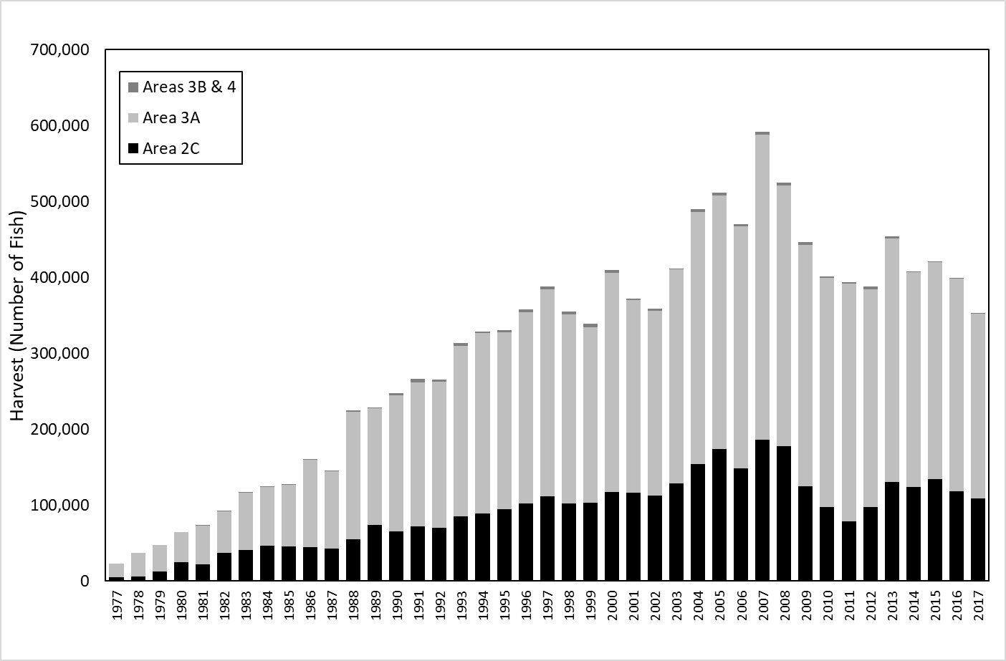

Figure 1. Statewide harvest of halibut (numbers of fish) as estimated by the ADF&G statewide mail survey, 1977-2017.

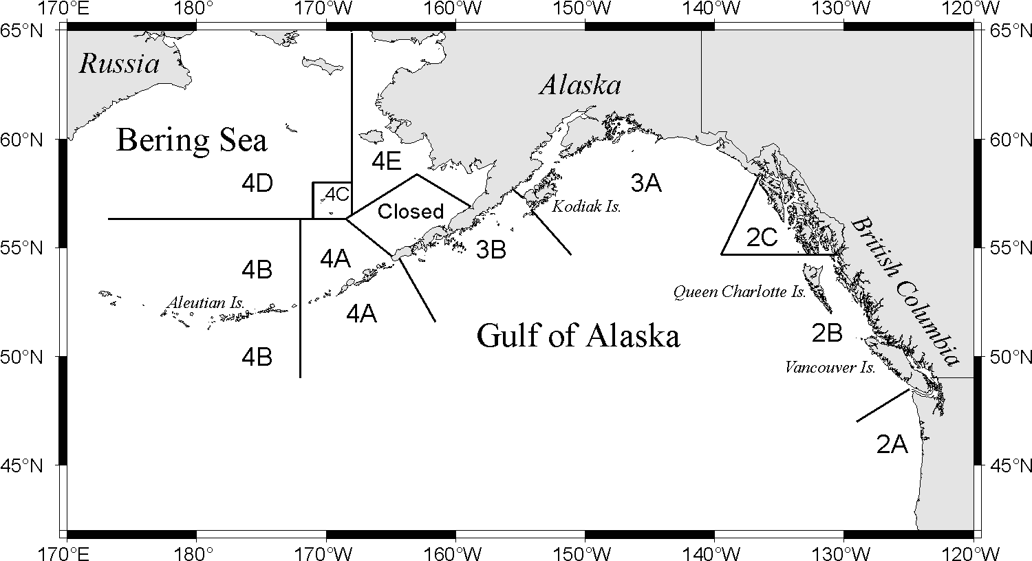

Figure 2. International Pacific Halibut Commission regulatory areas.

As mentioned earlier, the IPHC is responsible for assessing the halibut stock. The assessment includes estimation of spawning biomass and projections under alternate harvest strategies. Spawning biomass is projected using both fishery dependent and fishery independent sources, as well as auxiliary biological information. Since 2006 the IPHC has assessed the halibut population as a single stock with movement of fish between the Bering Sea and northern California. The coastwide stock is currently assessed using an ensemble of four models, combinations of short and long time series of available data and aggregated coastwide versus areas-as-fleets models. The four models give a range of estimates regarding current stock status and exhibit similar trends. The model results are weighted equally to derive integrated estimates of spawning biomass. Estimated coastwide halibut biomass is distributed to four biological regions (2, 3, 4, and 4B) using the IPHC’s Fishery Independent Setline Survey modelled weight-per-unit-effort (WPUE) of all sizes of Pacific halibut, weighted by the estimated habitat in each region. WPUE is estimated using a space-time model that integrates current and past data for each survey station as well as adjacent stations to get a smoothed estimate of WPUE. There are additional adjustments for harvest taken prior to the average survey date in each area and hook competition by other species. The spawning biomass of halibut declined continuously from the late 1990s to around 2011 due to a combination of relatively weak recruitments and a long-term decline in size at age. Since 2011 the stock has been relatively stable but is expected to decline in upcoming years under status quo levels of fishing mortality due to weak recruitment of cohorts currently contributing to the spawning biomass.

The increasing trend in sport harvest, implementation of catch shares in the commercial fishery, changes in the halibut stock, and ineffective management of the charter fishery led to an intense and prolonged allocation conflict between the commercial and charter sectors. In 2003, Guideline Harvest Levels (GHLs) were approved by the Council for the charter fisheries in Areas 2C and 3A. The GHLs were established as 125% of the average charter harvest from 1995-1999 and declined in stepwise fashion in proportion to declines in exploitable biomass. Management measures adopted by the Council for the Area 2C charter fishery were inadequate to keep pace with increases in effort and declines in biomass. Over the period 2004-2010, the GHL in Area 2C dropped from 1.432 M lb to 0.788 M lb along with decreases in exploitable biomass. Charter harvest in Area 2C exceeded the GHL every year from 2004 through 2010, with overages ranging from 22 to 115 percent. The GHL in Area 3A remained steady at 3.65 M lb from 2004 to 2010 and charter harvest only exceeded the GHL by a significant amount in 2007 (9.6%).

Allocation conflicts and GHL overages were subsequently addressed in two major Council actions. First, the Council approved a limited entry system for halibut charters that was implemented by NMFS in 2011. Limited entry permits were issued to participants that met qualification criteria based on historical (2004 or 2005) and recent (2008) participation in the charter fishery. Transferable or non-transferable permits were issued for regulatory areas 2C and 3A based on the number of qualifying boat-trips, and permits were endorsed for a specific number of clients based on past participation. Second, the Council approved a Catch Sharing Plan (CSP) in October 2012 that allocates harvest between the commercial and charter sectors, implements regulations to manage the charter fishery at the beginning of each season, and provides for temporary transfer (lease) of commercial quota for use by individual charter clients in order to harvest halibut in excess of specified bag or size limits placed on the charter fishery. The CSP also establishes the ADF&G charter logbook as the preferred accounting method for charter harvest, and specifies that waste (discard mortality) in the commercial and charter sectors counts toward each sector’s allocation. The CSP replaced GHL management in 2014.

Four ADF&G programs provide data on recreational halibut harvest in Alaska. The SWHS provides annual estimates of the number of halibut harvested and caught in charter and unguided fisheries. The number of fish released is estimated as the difference between catch and harvest. The Charter Logbook Program also provides data from the charter sector on the number of bottomfish anglers, the number of halibut kept and released, and spatial information on harvest and landings. Marine fishery monitoring programs in Southeast and Southcentral Alaska provide information on the sizes of fish harvested in Area 2C and Area 3A, respectively, and ancillary information including methods of capture, extent of effort, fishing location, and catch composition. Data from all four of these programs are used in concert to provide federal halibut management agencies with information for stock assessment, development of harvest policies, and evaluation of annual regulatory alternatives.

This operational plan describes the procedures by which these various data sources are combined on an annual basis to inform federal management agencies for assessment of the halibut stock and management of recreational halibut fisheries. This plan will include only procedures used for routine annual analyses and information requests and will not cover procedures used in special analyses. An example of the analyses of alternative charter management measures can be found in Webster and Powers 2019; requested analyses change on an annual basis depending on the previous year’s performance, preferences of the charter halibut management committee, and current stock status, and are therefore not included in this operational plan.

# Primary Objectives

The primary goal of this work is to provide Pacific halibut harvest estimates from the sport fisheries in Southeast and Southcentral Alaska to federal management agencies. Specific primary objectives are to:

1. Estimate unguided halibut yield (harvest in pounds) in IPHC Areas 2C and 3A for the most recent year with final SWHS estimates, with a relative precision of 15% (α = 0.05);
2. Estimate charter halibut yield in Areas 2C and 3A with a relative precision of 10% (α = 0.05), using Charter Logbook harvest data for the most recent year with complete data;

# SECONDary Objectives

The secondary goals of this work address routine annual federal information needs for halibut from the sport fisheries in Southeast and Southcentral Alaska. Specific secondary objectives are to:

1. Produce preliminary estimates, or projections, of charter and unguided halibut harvest, releases, and yield in Areas 2C and 3A for the current year;
2. Estimate charter and unguided halibut discard mortality in Areas 2C and 3A for the most recent year with complete data;
3. Produce preliminary estimates, or projections, of charter and unguided halibut discard mortality in Areas 2C and 3A for the current year;
4. Estimate the proportions of charter and unguided harvest (in numbers of fish) taken in Areas 2C and 3A prior to the average IPHC longline survey date during the previous year;
5. Estimate overall sport halibut harvest (charter and unguided combined) in IPHC Areas 3B and 4 (A – E combined) through the most recent year for which SWHS estimates are available; and
6. Produce preliminary estimates, or projections, of overall sport halibut harvest in Areas 3B and 4 (A – E combined) for the current year.

# Methods

## Study Design

As stated previously, this project does not involve any data collection *per se*, but rather relies on other projects and data sources to compile estimates. Final estimates and projections of halibut harvest will be compiled by sector (charter and unguided) and by halibut reporting areas, and then summed to obtain estimates for each IPHC regulatory area. In Southeast Alaska, the halibut reporting areas generally match the SWHS reporting areas (A – H) generally match the halibut reporting areas. Areas E (Juneau) and F (Haines/Skagway) are combined due to the overlap in fishing areas and lack of port sampling data from Area F. Charter harvest in Area G must be separated into two areas to correspond with the IPHC regulatory areas (2C and 3A) that intersect Area G; this is only necessary for the charter sector as the unguided sector rarely fishes in the 3A portion of Area G and is done using Logbook data. In Southcentral Alaska, some SWHS areas are further divided to better correspond with port sampling data. Specifically, the North Gulf Coast/Prince William Sound (PWS) area, SWHS Area J, is divided into Eastern PWS, Western PWS, and North Gulf Coast. The Area J SWHS questionnaire is specifically designed to capture this information. Harvest in Area J is partitioned according to the location where the fish are landed so that average weights estimated from ports of landing are properly matched to the estimated harvests. Similarly, estimates for Cook Inlet (SWHS Area P) are divided into Central Cook Inlet (CCI) and Lower Cook Inlet (LCI), though this is based on capture location, not landing location. The halibut reporting areas and corresponding ports and SWHS areas for each IPHC Regulatory Area are described in Table 1.

Table 1. Halibut reporting areas, sampled ports, and SWHS areas corresponding with IPHC Regulatory Areas.

|  |  |  |  |
| --- | --- | --- | --- |
| IPHC Area | SWHS Area | Sampled Port(s) | Halibut Reporting Area |
| 2C | A | Ketchikan | Ketchikan (A) |
|  | B | Craig, Klawock | Prince of Wales Island (B) |
|  | C | Petersburg, Wrangell | Petersburg/Wrangell (C) |
|  | D | Sitka | Sitka (D) |
|  | E | Juneau | Juneau/Haines/Skagway (EF) |
|  | F | Juneau (proxy) | Juneau/Haines/Skagway (EF) |
|  | G | Elfin Cove, Gustavus | Glacier Bay (G2C) |
|  |  |  |  |
| 3A | G | Elfin Cove, Gustavus | Glacier Bay (G3A) |
|  | H | Yakutat | Yakutat (H) |
|  | J | Valdez | Eastern PWS (EPWS) |
|  | J | Whittier | Western PWS (WPWS) |
|  | J | Seward | North Gulf Coast (NG) |
|  | P | Homer | Lower Cook Inlet (LCI) |
|  | P | Deep Creek, Anchor Point | Central Cook Inlet (CCI) |
|  | Q | Kodiak city | Kodiak (Q) |

## Fishery Creel Sampling

The harvest of charter and unguided halibut is sampled through onsite fishery monitoring programs in Southeast and Southcentral Alaska. Fork lengths of harvested halibut are measured and average net weight is estimated from weights predicted for each fish using the IPHC length-weight relationship (𝑊𝑛=0.00000692∙𝐿𝑓3.24 where Wn is net weight and Lf is fork length, Clark 1992). Charter skippers and unguided anglers are also interviewed to collect ancillary data including information on effort, spatial distribution of the harvest, proportions of fish cleaned at sea, and size categories of released fish in Southeast. Detailed descriptions of sampling and estimation methods for average weight are provided in the operational plans for each sampling project. For purposes of halibut estimation, the end products of this sampling are estimates of average weight (and standard error) by sector (charter and unguided) and port, the estimated proportion of unguided harvest that occurred prior to the average date of the IPHC longline survey, and estimated size distribution of released fish in 2C.

## Statewide Harvest Survey

Estimates of charter and unguided halibut catch and harvest, along with corresponding standard errors and confidence intervals, are provided through the SWHS. These estimates are summarized by halibut reporting area and IPHC area, and final estimates are typically provided to staff in September of the year following harvest. These charter and unguided estimates are not summarized in the published SWHS report but are obtained using the same methods.

## Charter Logbook

Charter logbook data are typically finalized by February or March of the year following harvest. Preliminary logbook data submitted for trips through July are available in September for use in harvest projections for the current year. In addition to estimating harvest, logbook data are used to project the proportion of charter harvest taken prior to the average IPHC longline survey date, calculate the proportion of charter harvest made up of second fish in the bag limit, calculate the average number of anglers per boat trip, etc. Logbook data used for harvest projections and comparisons to the SWHS are summarized by halibut reporting area (Table 1).

## Data Analysis

### Primary Objective 1: Estimate unguided halibut yield in IPHC Areas 2C and 3A for the most recent year with final SWHS estimates.

Yield for the unguided sector, *YU,* will be estimated for the previous year using final SWHS estimates of the number of halibut kept and average net weight (headed and gutted) estimated from creel sampling. Estimates will be done by subarea (Table 1) and summed to obtain estimates for each IPHC regulatory area 2C and 3A as follows:

|  |  |  |
| --- | --- | --- |
| $${\hat{Y}}_{U}=\sum_{a}{{\hat{H}}_{Ua}{\hat{\overline{w}}}_{Ua}}$$ | | (1) |
| where |  | |
| $${\hat{H}}_{Ua}$$ | = the estimated total number of halibut harvested by the unguided sector in subarea a, | |
| $${\hat{\overline{w}}}_{Ua}$$ | = the estimated mean weight of halibut harvested by the unguided sector in subarea a. | |
|  |  | |

The boundary between IPHC areas 3A and 2C bisects the Glacier Bay subarea. Unguided harvest estimates for the Glacier Bay subarea will be assumed to apply entirely to Area 2C because very little unguided harvest is taken in IPHC Area 3A and landed in the Glacier Bay subarea.

The variance of mean weight for the unguided sector $var({\hat{\overline{w}}}_{U})$ within each IPHC area will be estimated by Markov Chain Monte Carlo methods using the program OpenBugs[1]. Normal sampling error will be assumed for average weights and harvest estimates. The variances of yield estimates for the unguided sector in each IPHC area are also estimated by Markov Chain Monte Carlo methods using the program OpenBugs (example code in Appendix A1).

These procedures are expected to result in yield estimates for the unguided sector in each regulatory area with a relative precision of at least ±15% (α = 0.05), based on the relative precision of yield estimates in recent years. The precision of yield estimates is a function of the precision of SWHS harvest estimates and port sampling estimates of average weight.

Estimates of mean weights are derived from creel sampling of the harvest in Southeast and Southcentral regions. True random sampling of harvested halibut is not possible because sampling coverage is incomplete spatially and temporally, and because boats with harvested halibut arrive in port over a prolonged period and often simultaneously. Instead, creel sampling programs attempt to select vessels for sampling in proportion to their share of the harvest. Once a vessel is selected for sampling, all halibut from that vessel are measured.

Before 2011, the variances of mean weights were estimated using formulae for simple random sampling, even though size data were collected from the fishery using a cluster sampling design. These estimates were believed to underestimate the variance of mean weight, and therefore the variance of yield. Since 2011 the standard errors of mean weights for each port and sector have been estimated in the Southcentral Region using a two-stage bootstrap procedure, where the first stage selects days to sample, and the second stage selects vessels. Recent changes to the Southeast Region creel sampling program allow for estimation of standard errors of mean weight using closed form estimators appropriate for four-stage cluster sampling (Jaenicke et al. 2019).

Charter yield may be calculated using SWHS data for comparison to estimates based on logbook harvest (outlined in objective 2).

### Primary Objective 2: Estimate charter halibut yield in Areas 2C and 3A using logbook harvest data for the most recent year with complete data.

Until 2014, ADF&G provided federal halibut management agencies with estimates of sport fishery yield that used SWHS estimates of numbers of fish harvested. Meyer and Powers (2009) evaluated 2006-2008 logbook effort and harvest data through comparisons to an end-of-season survey at the angler-day level, comparisons to SWHS data for single-angler households at the annual level, comparisons to SWHS estimates at the IPHC area and subarea levels, and comparisons to onsite creel survey interview data at the vessel-trip level. These comparisons generally indicated that logbook data was useful for analyses of potential management actions such as changes in bag limits or annual limits. Effort reported in the logbook was similar to effort estimates from the SWHS, but reported harvest was generally higher than the SWHS estimates. Close agreement of logbook data with onsite interview data and data from single-angler households suggests that there may be incomplete reporting of harvest by multi-angler households in the SWHS, though this has not been verified. The report was presented to the Council and its Scientific and Statistical Committee (SSC) in October 2009. The SSC review was favorable and indicated that use of logbook data offered clear advantages over use of SWHS estimates.

Based on the perceived benefits of using logbooks, the Council approved a motion in April 2011 to use charter logbook data to monitor and manage the charter fleet under the CSP. Since implementation of the CSP in 2014, ADF&G has estimated charter yield using reported logbook harvest combined with estimates of average weight from creel sampling.

Charter yield YC will be estimated for each IPHC area using logbook data from each subarea as:

|  |  |  |
| --- | --- | --- |
| $${\hat{Y}}_{C}=\sum_{a}{H_{Ca} {\hat{\overline{w}}}_{Ca}}$$ | | (2) |
| where |  | |
| $$H_{Ca}$$ | = total harvest of halibut reported for clients, crew[2], and “comps” in subarea *a* (logbook data), | |
| $${\hat{\overline{w}}}_{Ca}$$ | = the estimated mean weight of charter halibut harvest in subarea *a*. | |

Charter halibut harvest will include any reported crew harvest even though crew harvest of halibut is not allowed in Areas 2C or 3A under the CSP. Whether this crew harvest is misreported client harvest or illegal crew harvest, the charter sector will be held accountable.

The boundary between IPHC areas 3A and 2C bisects the Glacier Bay subarea. Charter harvest has been growing in the Area 3A portion of the Glacier Bay subarea. Charter logbook data will be used to apportion the Glacier Bay subarea to waters in Area 3A (G3A) and Area 2C (G2C). For example, harvest in subarea G3A will be estimated as

|  |  |  |
| --- | --- | --- |
| $${\hat{H}}_{G3A}=p_{3A}{\hat{H}}_{GlacBay}$$ | | (3) |
| where |  | |
| $${\hat{H}}_{G3A}$$ | = the estimated number of halibut harvested by charter anglers in the IPHC Area 3A portion of the Glacier Bay subarea, | |
| $$p_{3A}$$ | = the proportion of charter harvest reported in logbooks landed at sites in the Glacier Bay subarea that was caught in IPHC area 3A, | |
| $${\hat{H}}_{GlacBay}$$ | = the reported number of halibut harvested in logbooks by charter anglers in the Glacier Bay subarea. | |

The variance of yield in the charter sector will be estimated as

|  |  |
| --- | --- |
| $${var(\hat{Y}}_{C})=\sum_{a}{H_{Ca}^{2} var({\hat{\overline{w}}}_{Ca})}.$$ | (4) |

These procedures are expected to provide estimates of charter yield with a relative precision of at least ±10% (α = 0.05), based on logbook-based yield estimates from recent years.

Overall mean weight of the sport harvest (charter and unguided combined) will be estimated as

|  |  |
| --- | --- |
| $$\hat{\overline{w}}= \hat{Y}/\hat{H} = {\sum_{g}{{\hat{Y}}_{g}}}/{\sum_{g}{{\hat{H}}_{g}}}$$ | (5) |

### 

with estimated variance approximated using the Delta method (Seber 1982, pages 7-8):

|  |  |
| --- | --- |
| $$var(\hat{\overline{w}})≈\frac{1}{{\hat{H}}^{2}}\left[\frac{var({\hat{H}}_{C}){\left[{\hat{\overline{w}}}_{C}{\hat{H}}_{U}-{\hat{Y}}_{U}\right]}^{2}}{{\hat{H}}^{2}}+\frac{var({\hat{H}}_{U}){\left[{\hat{\overline{w}}}_{U}{\hat{H}}_{C}-{\hat{Y}}_{C}\right]}^{2}}{{\hat{H}}^{2}}+var({\hat{\overline{w}}}_{C}){\hat{H}}_{C}^{2}+var({\hat{\overline{w}}}_{U}){\hat{H}}_{U}^{2}\right],$$ | (6) |

where subscripts *C* and *U* index the charter and unguided sectors, respectively.

### Secondary Objective 1: Produce preliminary estimates, or projections, of charter and unguided halibut harvest, release, and yield in Areas 2C and 3A for the current year.

Projections of halibut yield during the current year must be calculated in October for use in the IPHC stock assessment model and to develop IPHC staff recommendations for catch limits. In addition, these preliminary estimates are incorporated into projections of discard mortality (Secondary Objective 3) and forecasts of charter yield for the coming year that are used to evaluate alternative charter management measures (Webster and Powers 2018). Estimates must be calculated by sector because harvest in the charter and unguided sectors is handled differently in terms of catch limits. Although estimates of mean weight are available by October of each year, charter logbook data are incomplete and there is no estimate of the current year’s unguided harvest (in numbers of fish) available from the SWHS. In addition, there is no index from creel sampling that can be used to estimate charter or unguided harvest in season.

Charter Harvest:

Methods of projecting charter harvest for the current year have evolved as new types of data have come available. Beginning in 2014, the ADF&G logbook is the preferred data for counting charter harvest, and there is no longer a need to project SWHS estimates of charter harvest. The proportion of harvest taken through July is relatively consistent among years, but there appear to be weak trends in some subareas. Trends in the proportion of harvest through July would add systematic error to predictions based on linear models such as regression. A simple and flexible approach is to simply expand the harvest through July to an annual total based on a forecast of the proportion of harvest through July.

Charter harvest for the current year will be projected for each subarea using:

|  |  |  |
| --- | --- | --- |
| $${\hat{H}}_{Ca}=H_{Ja}/{\hat{p}}_{Ja}$$ | | (7) |
| where |  | |
| $$H_{Ja}$$ | = total harvest of halibut reported in logbooks for clients, crew, and “comps” through July 31 in subarea *a*, | |
| $${\hat{p}}_{Ja}$$ | = the exponential time series forecast of the proportion of charter harvest taken through July 31 of the current year in subarea *a*. | |

The reported harvest through July 31 (HJa) will be calculated for projections in October. This number may be slightly low due to logbook pages not yet filed. From 2011 to 2017, the reported harvest thru July 31, as calculated in October, was an average of 1.1% lower in Area 2C and 1.0% lower in Area 3A than the final values based on complete logbook data. This is a small error and would typically result in an underestimate of harvest and would be magnified when harvest through July 31 is expanded. Therefore, harvest is inflated by the recent average to account for late logbooks unless logbook data entry staff are confident that late reporting will be negligible.

The harvest proportions for each subarea ${\hat{p}}_{Ja}$ will be forecast using simple and double exponential smoothers in SAS Proc ESM (SAS 2011). Both exponential smoothers will be examined and the appropriate time series model will be identified using the Box and Jenkins (1976) procedure for ARIMA models as described in Chapter 7 of the SAS/ETS User Guide (SAS 2011). Models will be selected for each subarea based on examination of residuals and the Akaike Information Criteria corrected for small sample sizes. SAS procedure output provides the forecasts and their standard errors, which will be used to calculate $var\left({\hat{p}}_{Ja}\right).$

The variance of projected harvest within each subarea will be estimated using the delta method as

|  |  |
| --- | --- |
| $${var(\hat{H}}_{Ca})=H_{Ja}^{2} var\left(1/{{\hat{p}}_{Ja}}\right)= H_{Ja}^{2} \frac{1}{{\hat{p}}_{Ja}^{4}}var\left({\hat{p}}_{Ja}\right).$$ | (8) |

In 2017, the most recent year with final harvest estimates, the projection error ranged from -8.5% - 18.0% by halibut reporting area, with positive numbers indicating higher projected harvest than final harvest (Table 2). Regulatory area projection error was 1.5% in 2C and 0.7% in 3A.

Projected charter yield for each IPHC area will be estimated using Equation 2, replacing the final logbook harvest in each subarea $H_{Ca}$ with projected values ${\hat{H}}_{Ca}$.

The variances of yield estimates for the charter sector in each IPHC area are obtained by Markov Chain Monte Carlo methods using the program OpenBugs (example code in Appendix A1). Estimated logbook harvest and standard errors are used in lieu of SWHS numbers (final unguided estimates) for preliminary charter estimates.

Table 2. Example of projected charter harvest for 2017 using logbook data through July 31 to forecast harvest for the year and final harvest estimates using full logbook data.

|  |  |  |  |  |  |  |  |  |  |  |
| --- | --- | --- | --- | --- | --- | --- | --- | --- | --- | --- |
| IPHC area | Subarea | Harvest thru July $$H_{Ja}$$ | Adjustment Factor | Adjusted Harvest thru July | forecast ${\hat{p}}_{Ja}$ | SE (${\hat{p}}_{Ja}$) | Projected Harvest ${\hat{H}}_{Ca}$ | SE ( ${\hat{H}}_{Ca})$ | Final Harvest $H_{ca}$ | Projection Errora |
| Area 2C | A -Ketch | 5,589 | 1.012 | 5,658 | 0.623 | 0.030 | 9,079 | 441 | 8,590 | 5.7% |
|  | B - POW | 12,960 | 1.009 | 13,080 | 0.686 | 0.014 | 19,077 | 402 | 19,172 | -0.5% |
|  | C -Pburg | 1,176 | 0.991 | 1,165 | 0.604 | 0.028 | 1,929 | 88 | 1,974 | -2.3% |
|  | D - Sitka | 17,821 | 1.007 | 17,953 | 0.672 | 0.023 | 26,698 | 910 | 26,019 | 2.6% |
|  | EF - Jun | 4,902 | 1.006 | 4,932 | 0.590 | 0.033 | 8,358 | 461 | 8,123 | 2.9% |
|  | G - GlacB | 3,952 | 1.010 | 3,990 | 0.607 | 0.048 | 6,570 | 524 | 6,769 | -2.9% |
|  | Total 2C | 46,400 |  |  |  |  | 71,711 | 1,296 | 70,647 | 1.5% |
|  |  |  |  |  |  |  |  |  |  |  |
| Area 3A | G-GlacB | 1,374 | 0.999 | 1,372 | 0.723 | 0.107 | 1,899 | 281 | 1,609 | 18.0% |
|  | H - Yak | 1,661 | 1.006 | 1,671 | 0.572 | 0.043 | 2,923 | 220 | 3,196 | -8.5% |
|  | EPWS | 2,875 | 1.016 | 2,922 | 0.743 | 0.048 | 3,932 | 252 | 4,090 | -3.9% |
|  | WPWS | 2,521 | 1.011 | 2,549 | 0.681 | 0.047 | 3,741 | 260 | 3,737 | 0.1% |
|  | Ngulf | 21,593 | 1.005 | 21,699 | 0.682 | 0.031 | 31,822 | 1,431 | 32,576 | -2.3% |
|  | LCI | 41,061 | 1.007 | 41,357 | 0.664 | 0.018 | 62,319 | 1,702 | 60,845 | 2.4% |
|  | CCI | 21,371 | 1.010 | 21,589 | 0.733 | 0.016 | 29,438 | 643 | 28,850 | 2.0% |
|  | QR | 3,958 | 1.002 | 3,966 | 0.523 | 0.025 | 7,580 | 360 | 7,761 | -2.3% |
|  | Total 3A | 96,414 |  |  |  |  | 143,654 | 2,397 | 142,664 | 0.7% |

a Projection error is calculated as (projection – final) / final x 100

Unguided Harvest:

Lacking any in-season measure of harvest in either region, time series methods will be used to project unguided harvest for the current year. In October 2012, the Council’s SSC recommended using auto-regressive integrated moving average (ARIMA) models. Unguided yield YU will be projected using the combination of time series forecasts of the number of fish harvested and mean weights from the current year as follows:

|  |  |  |
| --- | --- | --- |
| $${\hat{Y}}_{U}=\sum_{a}{{\hat{H}}_{Ua}{\hat{\overline{w}}}_{Ua}}$$ | | (9) |
| where |  | |
| $${\hat{Y}}_{U}$$ | = the projected unguided halibut yield, | |
| $${\hat{H}}_{Ua}$$ | = the time series forecast of unguided halibut harvest for subarea *a*, and | |
| $${\hat{\overline{w}}}_{Ua}$$ | = the estimated mean weight of halibut harvested by unguided anglers in subarea *a*. | |

The variances of yield estimates for the unguided sector in each IPHC Regualtory area are obtained by Markov Chain Monte Carlo methods using the program OpenBugs (example code in Appendix A1).

Appropriate time series models will be identified using the Box and Jenkins (1976) procedure for ARIMA models as described in Chapter 7 of the SAS/ETS User Guide (SAS 2011). Models will be selected for each subarea based on examination of residuals and the Akaike Information Criteria corrected for small sample sizes.

Because time series methods rely on historical patterns and trends, forecast errors can occur from changes in factors that affect the harvest, such as the economy, bag and size limits for the halibut fishery, targeting of other marine species, etc. Changes in bag limits are much more likely for the charter sector because it is managed under a GHL, while at present the unguided sector has no annual harvest cap. Methods for forecasting harvest will be re-evaluated if there are any substantial changes to management structures.

### Secondary Objective 2. Estimate charter and unguided halibut discard mortality in Areas 2C and 3A for the most recent year with complete data.

The IPHC strives to document and include all fishery removals in the annual stock assessment. Since 2014, the IPHC’s annual estimates of fishery removals have included commercial harvest, longline survey harvest, estimates of bycatch mortality in non-halibut fisheries, discard mortality in the halibut longline fishery (mortality of sublegal fish released and fish that die on lost or abandoned gear), subsistence harvest, sport harvest, and discard mortality in the sport fishery. Bycatch and discard mortality are estimated separately for halibut ≥ 26 inches (O26) and halibut < 26 inches in length (U26). Only the O26 discard mortality is included in allocations to the commercial and charter sectors; however, the IPHC requests data on both size categories for catch accounting and is currently working towards incorporating the U26 mortality into the sector allocations. Interest in release mortality has intensified with implementation of charter size and bag limit restrictions and changes to commercial observer coverage in recent years.

In April 2012 the IPHC requested that ADF&G develop and implement data collection programs to permit estimation of discard mortality in the recreational fishery. The department responded that it presently lacks the fiscal resources to implement sampling of released fish, and will use modeling based on available data and assumptions to produce the best possible estimates of release mortality in recreational halibut fisheries. The department previously undertook this type of modeling effort in 2007 (Meyer 2007), using available SWHS estimates of the numbers of released fish, an assumed mortality rate based on hook use data, and modeling of the size distribution of released fish. The approach was reviewed by the NPFMC’s SSC. Although modeling of the size distribution of released fish relied on strong assumptions, the SSC concluded that the approach provided “reasonable estimates of discard mortalities for different gear types based on existing literature.”[3] The following modeling approach is similar to the one used in 2007.

Release mortality *R* will be calculated for each sector (charter and unguided) and subarea using the basic equation:

|  |  |
| --- | --- |
| $$R\left(lb\right)= \hat{N}∙DMR∙\hat{\overline{w}}$$ | (10) |

where

|  |  |
| --- | --- |
| $$\hat{N}$$ | = the estimated number of fish released from SWHS or logbook, |
| *DMR* | = the assumed mortality rate due to capture, handling, and release, and |
| $$\hat{\overline{w}}$$ | = the estimated mean net weight (in pounds) of released fish. |

Estimated Number of Released Fish:

Estimates of the number of released halibut are available from the SWHS and from logbooks. Consistent with the Council’s intentions with respect to charter harvest, logbook data are used for release mortality estimates for the charter sector. The SWHS release estimates will be used for estimates for the unguided sector. Now that discard mortality is included in the charter allocation, there is a strategic incentive for charter operators to underreport numbers of released fish. Logbook, SWHS, and creel sampling data are examined annually to look for changes that may indicate underreporting.

Discard Mortality Rate:

There are no published estimates of the mortality rate of halibut or closely related species caught and released in a recreational fishery. Several studies have shown that hooking morality is highly dependent on hooking location and deeply hooked fish have higher mortality rates; circle hooks are less likely to become lodged deep in the fish than j-hooks or other common hook types (Meyer 2007). Meyer (2007) derived mortality rates using hook type (circle versus other) as the primary factor. The rates were derived as weighted estimates of a 3.5% mortality rate for halibut released on circle hooks and a 10% mortality rate for halibut released on all other hook types, weighted by the proportions of released fish caught on each hook type. The 3.5% rate was the midpoint of Peltonen’s (1969) best estimate of 2-5% for 75-119 cm halibut in “excellent” condition caught on longline gear with J-hooks, tagged, and held in cages. This is the mortality rate the IPHC assumes for halibut caught on longline gear and released in excellent condition (Kaimmer and Trumble 1998, Williams 1998). Because most sport-caught halibut are caught on circle hooks and played for a short period of time, use of this rate for the sport fishery was considered to be conservative. The 10% mortality rate for halibut caught on hook types other than circle hooks was assigned based on results of a literature review of release mortality in a variety of marine fishes. The weighting factors for mortality on each hook type were obtained using creel survey data on the numbers of halibut released from circle and other hook types collected in Southeast and Southcentral regions in 2007. Hook type data were also collected in 2008 in Southeast, and every year since 2007 in Southcentral.

In 2007, mortality rates were estimated for each sector and subarea of Areas 2C and 3A and then weighted by the proportions of released fish in each IPHC area (SWHS estimates) to derive overall mortality rate estimates for each sector and IPHC area. The calculated rates were then rounded up as a precautionary measure to account for other factors such as rough handling or multiple recaptures of the same fish. These derived estimates were 5% for Area 3A charter-caught halibut, 6% for Area 2C charter and Area 3A unguided, and 7% for Area 2C unguided halibut. Mortality rates are periodically re-evaluated using available hook data from more recent years, along with logbook data (charter) or SWHS estimates (unguided) for the weighting among subareas. To date, is has not led to any changes in the estimated mortality rates.

Estimating Mean Net Weight:

There are no data available on the lengths of individual released halibut in sport fisheries in Alaska. However, the creel sampling program in Southeast Alaska has collected data on the number of released halibut by size category in Area 2C since 2012, the first year of the reverse slot size limit. The size categories in 2018, under a U38-O80 reverse slot limit were (1) ≤ 38 inches, (2) greater than 38 but less than 80 inches, and (3) ≥ 80 inches. The reverse slot limit has changed most years since 2014 to maximize fishing opportunity while minimizing fishing overages, and size classes are adjusted accordingly. No size class information is collected in Area 3A.

Since size data are not available on individual fish, reasonable estimates of the average weight of released fish for each sector in each IPHC area and subarea will be derived using a modeling approach similar to Meyer (2007). Two slightly different approaches will be used to estimate average weight, depending on available data. For the unguided sector in Areas 2C and 3A and charter sector in Area 3A, where no size data are available, the mean weight of released fish will be obtained entirely through modeling. First, a logistic curve will be constructed to represent the probability of retaining a halibut as a function of its length, or *pL*:

|  |  |
| --- | --- |
|  | (11) |

where

|  |  |
| --- | --- |
| $$p_{∞}$$ | = the theoretical maximum retention probability ($p_{∞}$ ≤ 1), |
| $$κ$$ | = a slope parameter, and |
| *L* | = length to the nearest inch (for compatibility with size limits), and |
| $$γ$$ | = the length at the inflection point of the curve. |

This retention probability will be used to infer the average weight of released fish in each sector, IPHC area, and subarea. First the total harvest at length *HL* (in numbers of fish) will be calculated as the product of the harvest estimate from either the logbook (charter) or SWHS (unguided) and the estimated length composition of the charter or unguided harvest from creel sampling. Due to a significant difference in the average weight of halibut cleaned at sea and cleaned in port in the charter fishery in Homer, average weights are estimated separately and interview data are used to apportion numbers of harvested fish cleaned at sea and in port to estimate an overall average weight for that subarea (Failor 2016). Catch at length, which includes halibut kept and released, will be estimated as *HL/pL*, and the number of fish released at length *NL* will be obtained by subtraction:

|  |  |
| --- | --- |
| $$N_{L}=\left(\frac{H_{L}}{p_{L}}\right)-H_{L} = H_{L}\left(\frac{1}{p_{L}}-1\right)$$ | (12) |

Mean weight of U26 and O26 released halibut will then be calculated separately for all fish < 26 inches and fish ≥ 26 inches in length as:

|  |  |
| --- | --- |
| $$\hat{\overline{w}}=\frac{1}{N_{L}}\sum_{L}{N_{L}{\hat{\overline{w}}}_{L}}$$ | (13) |

where ${\hat{\overline{w}}}_{L}=6.921×{10}^{-6}{L(cm)}^{3.24}$, the IPHC length-weight relationship (Clark 1992).

Without length data on released halibut, the *pL* curve (Equation 11) cannot be fit in the usual manner. Instead, the curve will be fit to two empirical data points derived from fisheries for other species where both retained and released fish were measured (or lengths were estimated). These data indicate a general pattern where an average of about 22% of the catch was retained at the 10th percentile for length in the harvest, and an average of 83% of the catch was retained at the 90th percentile for length of retained fish (Figure 3). These percentages at the 10th and 90th percentiles for length will be used as targets to fit the logistic curve. The *κ* and *γ* parameters will be obtained using Excel Solver by minimizing the sum of the absolute values of the relative difference between the predicted and target proportions at the 10th and 90th percentiles, under the constraint that the predicted number of released fish ($\sum{N_{L}}$) equals the estimate of released fish from the logbook (charter) or SWHS (unguided). Lacking any size data, the asymptote parameter *p∞* will be fixed arbitrarily at 0.95 to reflect the possibility that 5% of exceptionally large fish are released (some anglers release large fish out of concern for meat quality or conservation of large females). Once the logistic curve is fit, the length frequency and average weight of released fish is calculated using Equations 12 and 13. Figure 4 provides an example from the unguided fishery in Homer (Lower Cook Inlet) fit to data for 2017.

The logistic curve that predicts the probability of keeping a fish based on its size cannot be used for all charter-caught halibut in Area 2C because regulations require that all halibut within the protected slot be released. However, size class information described earlier is available for halibut released in the Area 2C charter fishery. This information can be integrated with the modeling approach to improve the estimates of average weight. First, the observed proportions of released fish in each size category will be used to apportion the total estimated number of releases by size. The logistic curve procedure described above will be used to estimate mean weight of released halibut below the lower protected slot limit. For halibut in the protected slot, and halibut above the protected slot, the mean weight will be assumed to equal the average weight of halibut in this length range in 2010, the last year for which there was no size limit. Both estimation procedures are possible because in prior years, the predicted percentage of halibut kept at the lower slot was close to the maximum of 0.95.

Because the logistic modeling is done as a function of length, it allows for calculations of release mortality for fish less than 26 inches (U26) and fish ≥26 inches (O26). This will allow for equal treatment of these components in the sport, commercial, and bycatch sectors.

The estimates of mean weight using these methods may be conservative (high). The numbers of released fish are predicted directly from the numbers of harvested fish using the curve representing the proportion of catch retained. Therefore, the minimum size of released fish cannot be less than the minimum size of harvested fish. Undoubtedly, some halibut are released that are smaller than the smallest halibut retained and measured. Therefore, use of the logistic curve may underestimate the numbers of U26 fish released and overestimate their average weight. Fixing *p∞* at 0.95 may result in underestimation or overestimation of the average weight of released fish, but this would likely be a small effect because relatively few exceptionally large fish would be released.

Without ample size data on individual released fish, this modeling approach is approximate and depends on a number of assumptions. The methods, assumptions, hook type data, and literature on survival rates will be reviewed annually and revisions will be made as appropriate in order to provide the most realistic estimates of release mortality possible. In addition, changes in annual management measures, such as size limits, may force revision of calculation methods.

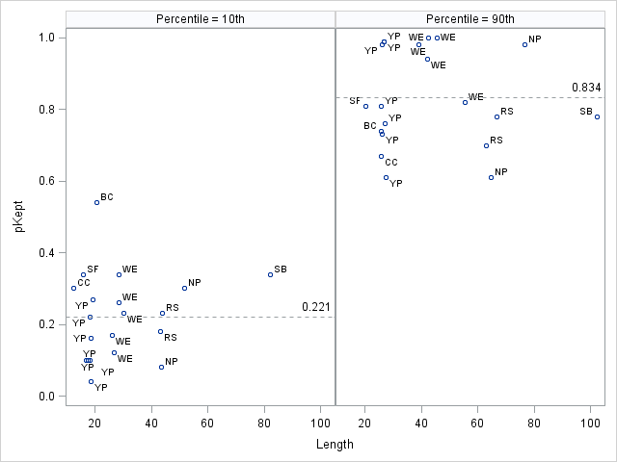

Figure 3. Estimates of the proportions of the catch that was kept (pKept) corresponding with the 10th and 90th percentiles for length (cm) in the harvest. Mean values for pKept are 0.221 at the 10th percentile, and 0.834 at the 90th percentile, indicated by dotted reference lines. Data are from creel surveys where length of released fish was recorded from measurements or angler estimates. Data were included for fisheries without size limits, or fisheries where the minimum size limit was well below the smallest fish retained (didn’t have a significant effect on the proportions kept). Species include red snapper Lutjanus *campechanus* (RS), striped bass *Morone saxatilis* (SB), northern pike *Esox lucius* (NP), yellow perch *Perca flavacens* (YP), walleye *Sander vitreus* (WE), black crappie Pomoxis *nigromaculatus* (BC), sunfish *Lepomis* spp. (SF), and channel catfish *Ictalurus punctatus* (CC). Sources include Chapman (2001), Donaldson et al. (2013), Jensen (2012), Jensen (2013), Meerbeek (2006), Minnesota DNR (no date), and Pelham (2004).

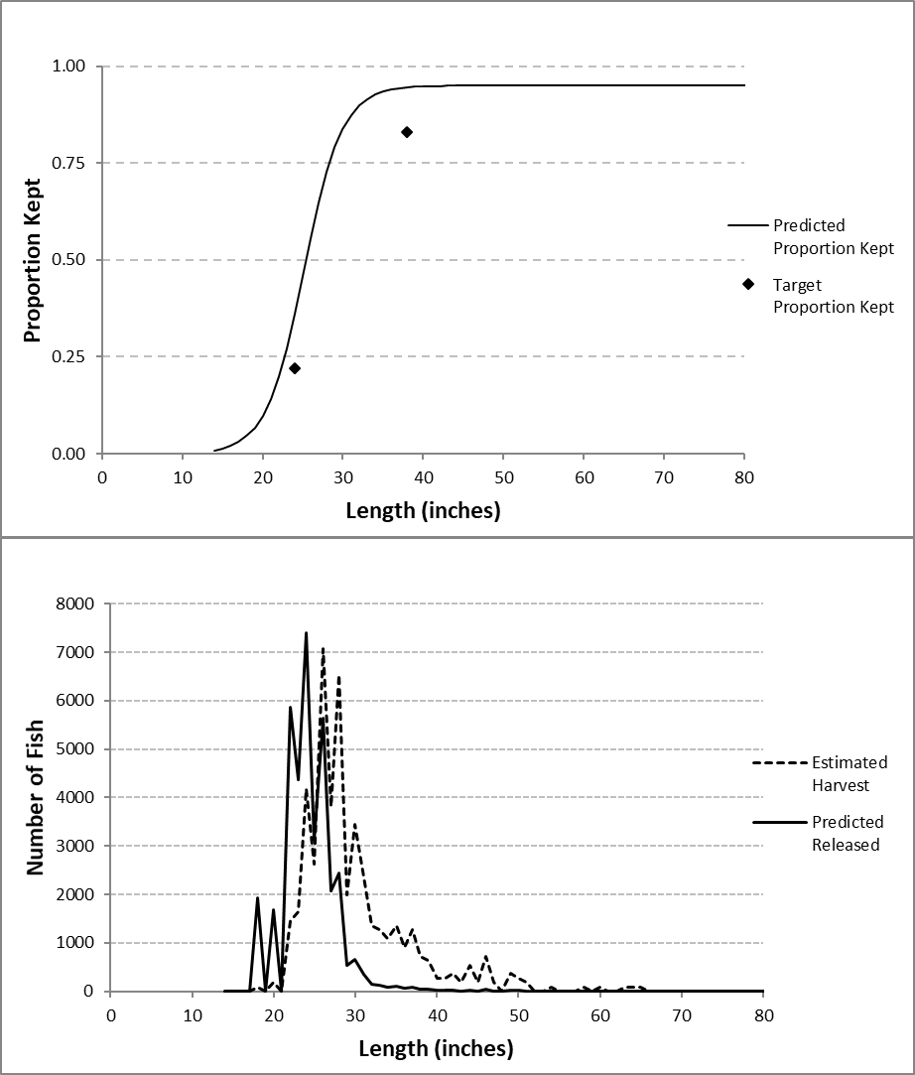

Figure 4. Example using 2017 length data from halibut harvested by unguided anglers in Homer to predict the length frequency of released halibut. In the upper figure, a logistic curve was fit to empirical points representing 22% retention at the 10th percentile for length (24 inches) and 83% retention at the 90th percentile for length (38 inches), subject to the condition that the predicted number of released fish (sum over length frequency in the lower figure) equals the final estimate of released fish for 2017. The mean weight of released fish is calculated from the release length frequency in the lower figure using the IPHC length-weight relationship.

### Secondary Objective 3: Produce preliminary estimates, or projections, of charter and unguided halibut discard mortality in Areas 2C and 3A for the current year.

These estimates will use the same methods as for Objective 4, replacing final estimates of harvest and release (in numbers of fish) with preliminary estimates for the current year. Preliminary estimates of harvest and release for the current year will be obtained as described under Objective 3.

### Secondary Objective 4. Estimate the proportions of charter and unguided harvest (in numbers of fish) taken in Areas 2C and 3A prior to the average IPHC longline survey date during the previous year.

The IPHC conducts a longline survey of the halibut population from California to the Bering Sea. Modelled survey WPUE is used as an index of relative stock trends in the stock assessment model. This index, when weighted by the area of halibut habitat and adjusted for other factors, is also used to produce the best available estimates of the stock distribution by biological region. The IPHC adjusts the survey WPUE for fishery removals that occur before the middle of the survey (Stewart and Webster 2018).

Therefore, the IPHC annually requests estimates of the proportions of sport harvest taken before the average date of the longline survey in Area 2C and Area 3A. The average dates of the longline survey are provided by the IPHC after the surveys are complete. The IPHC has stated that there is no need to partition reported harvest by size class or base the estimated proportions on biomass units (R. Webster., IPHC, personal communication). Therefore, estimates of the proportion of harvest will be based on numbers of fish, assuming that the size composition of the harvest is constant over the course of the fishing season.

The charter and unguided proportions of harvest prior to the average survey date will be estimated using different methods. Complete charter logbook data for the previous year are available by October; therefore, the charter before-survey (BS) harvest proportion is calculated for each IPHC area using charter logbook harvest information. For the unguided fishery, creel survey interview data are the only source of information on the timing of harvest. The marine fishery monitoring programs in Southeast region will provide estimates of the BS proportions of unguided harvest for each port, with the procedures for estimation described in the program’s operational plan (Jaenicke et al. 2019). The Southcentral Groundfish Harvest Assessment Program will collect information on the numbers of fish harvested by date during angler interviews as described in the program’s operational plan (Failor 2016). These interview data will be used to calculate the proportion of harvest prior to the mean survey date in each port. The unguided proportions for each port will then be weighted by the estimated unguided harvest for each halibut reporting area (from Objective 1) to estimate the overall proportion for each IPHC area.

Finally, the BS proportions for the sport fishery as a whole will be computed as a weighted mean of the charter and unguided BS proportions, using charter and unguided harvests (from Objectives 1 and 2) as weighting factors. Because the IPHC will use these point estimates only as one component of an adjustment to survey WPUE, no effort will be made to evaluate the uncertainty of these estimates and no values are established for desired precision.

### Secondary Objective 6: Estimate overall sport halibut harvest (charter and unguided combined) in Areas 3B and 4 (A – E combined) through the most recent year for which SWHS estimates are available.

These estimates will be obtained by summing site-specific halibut harvest estimates from SWHS Area R (Naknek River Drainage-Alaska Peninsula). The site-specific estimates are found in detailed harvest printouts available on the ADF&G Docushare site. Each site code will be classified into IPHC Area 3B or Area 4, and estimates summed by area. Area 4 is not currently broken out by Regulatory Area (A – E) due to the extremely low harvest and low response rate in this region (estimated 368 fish, 6,000 lbs in 2017). The majority of harvest in Area 4 is in Regulatory Area 4A. Areas 4B and 4E typically have very small amounts of reported harvest and in most years no harvest is reported in area 4C or 4D. Charter and unguided harvest will be combined because the numbers of survey responses are typically insufficient to generate reliable estimates for each sector (K. Sundet, ADF&G RTS, personal communication), and because there are no separate catch limits or regulations for the charter sector in these areas. Variances of harvest estimates are not available at the site specific level, and will not be presented to the IPHC. Because ADF&G does not sample the sport harvest in these areas, the average weight of Kodiak sport harvest will be used as a proxy for average weight in Areas 3B and 4 to estimate yield in each Regulatory Area using the same methods outlined in Primary Objective 1 (Equation 1). Specifically, average weight from the unguided sector in Kodiak will be used because it is unaffected by size limits.

**Secondary Objective 6: Produce preliminary estimates, or projections, of overall sport halibut harvest in Areas 3B and 4 (A – E combined) for the current year.**

Preliminary harvest projections for the current year in areas 3B and 4 are needed by the IPHC for inclusion in the current year’s stock assessment model. The total sport harvest (charter and unguided combined) will be projected in numbers of fish using the Box and Jenkins (1976) ARIMA time series method as described under Secondary Objective 1. The time series of available harvest estimates stretches back to 1991 for both areas. Harvest has been relatively small, on the order of a few thousand fish in each area, and highly variable from year to year. Because of this variability, the Box and Jenkins procedure typically finds no significant autoregressive or moving average components and identifies a naïve model (forecast = previous year’s harvest) as the best.

# Schedules and deliverables

Most of the estimates and projections in this plan are intended to be delivered on an annual basis. Many of the objectives address information needs for the annual halibut stock assessment by the IPHC. These elements are delivered in an annual letter to the IPHC, usually sent in late October, and presented at the IPHC annual meeting in January. Finalized harvest estimates for the previous year are typically posted on the NPFMC website and presented at the October Charter Halibut Management Committee meeting (subsidiary body of the NPFMC) and the December NPFMC meeting.

Reports documenting final SWHS-based estimates of halibut harvest and yield, length composition, and spatial distribution of harvest are prepared on an intermittent basis in cooperation with staff from Region 1 and Region 2. Halibut sampling and estimation is supported by General Funds, so there are no Federal Aid contract requirements for reports. These reports have been published as ADF&G Special Publications or as NOAA grant reports. The most recent version of this report included final harvest estimates for the years 2008-2013 and was published as an ADF&G Special Publication.

The estimation and projection methods documented in this plan will also be incorporated, as needed, into evaluations of alternative harvest strategies identified for analysis by the Charter Halibut Management Committee (e.g. Webster and Powers 2018). Management alternatives selected for analysis vary on an annual basis, are not known in advance, and are therefore not documented in this Operational Plan. Analysis of alternative management measures will proceed with guidance from the project biometrician and, as necessary, review by the Council’s SSC.

Table 3. Approximate annual timeline of estimation and reporting tasks associated with halibut.

|  |  |
| --- | --- |
| Time frame | Task |
| Jul - Aug | Review SWHS preliminary estimates of halibut harvest for previous year. |
| Sept - Oct | Finalize previous year’s harvest and release mortality estimates. |
| Calculate harvest and release mortality projections for current year. |
| Estimate charter and unguided harvest prior to the mean IPHC survey date for the previous year. |
| Submit annual letter to IPHC containing information needed for stock assessment. |
| Meet with Halibut Charter Management Committee to present removals estimates and solicit candidate management measures to analyze for the coming year. |
|  | Commence analysis of management measures, including harvest forecasts under each alternative scenario. |
| Nov - Dec | Finalize analysis of management measures. Attend IPHC Interim meeting to obtain harvest targets and provide details on recreational harvest information, upon request. |
|  | Attend NPFMC meeting to present finalized harvest estimates, harvest projections for the current year, and analysis of alternative management measures. |
| Jan | Attend IPHC Annual Meeting, present recreational fishery information and analysis of alternative management measures. |
| Feb - Jun | Project planning, report completion.  Revise operational plan, including review of estimations methods and data inputs.  Assist NPFMC and NMFS staff with analyses related to pending halibut actions. |

# Responsibilities

Sarah Webster (Fishery Biologist):

Primarily responsible for coordination of operational planning, development of methods, coordination and compilation of data components, producing estimates, and reporting.

In coordination with the Commissioner’s office, serves as principal Sport Fish Division contact to the IPHC, NPFMC, and NMFS on technical issues concerning halibut catch estimation and other analyses needed for allocation and management of halibut. Reviews ADF&G marine fishery monitoring programs to ensure collection of appropriate data for federal assessments and management, produces estimates of recreational halibut harvest and analyzes alternative management measures for the charter fishery. Presents sport fishery information at regular meetings of the NPFMC and IPHC, and coordinates responses to routine information requests from various stakeholders.

Benjamin Buzzee (Biometrician):

Serves as primary consulting biometrician, providing technical advice and assistance with methods of estimation, forecasting, and modeling. Assists with preparation of the operational plan as well as letters, reports, or presentations of halibut harvest estimates and projections.

Michael Jaenicke (Fishery Biologist), Diana Tersteeg (Research Analyst), Martin Schuster (Fishery Biologist) and Marian Ford (Fishery Biologist):

Oversee collection of halibut fishery data from the Southeast and Southcentral region catch monitoring programs. Provide raw and summarized data as needed, and provide estimates of average weight and the proportion of harvest taken prior to the average survey date, by port. Assist with final report preparation, attend meetings of federal management agencies, and assist with presentation of data.

Mike Martz (Research Analyst):

Provides annual summaries of SWHS estimates of charter and unguided sport halibut harvest (and standard error) by halibut reporting area. May provide special analyses or summaries as part of broader efforts to evaluate the quality of logbook or mail survey estimates.

Robert Powers (Program Coordinator):

Provides annual summaries of charter logbook data on harvest, releases, and effort. Provides information, upon requests, on businesses, vessels, and guides from registration programs. Provides additional summaries or analyses for evaluation of alternative charter management measures.

# Literature Cited

Box, G. E. P. and G. M. Jenkins. 1976. Time series analysis: forecasting and control. Holden-Day, San Francisco.

Chapman, B. 2001. Angler creel survey of a 110 mile segment of the Minnesota River, 1 May 1998-31 October 1998. Minnesota Department of Natural Resources, Division of Fisheries, Federal Aid Sport Fish Restoration Act Completion Report, F29-R(P)-18.

Clark, W. G. 1992. Validation of the IPHC length-weight relationship for halibut. International Pacific Halibut Commission, Report of Assessment and Research Activities 1991, pp. 113-116.

Donaldson, D. et al. 2013. For-hire electronic logbook pilot study in the Gulf of Mexico, Final Report. Report to the Marine Recreational Information Program Operations Team, July 2012. [http://www.st.nmfs.noaa.gov/  
Assets/recreational/pdf/Charter_Boat_Logbook_Project_report.pdf](http://www.st.nmfs.noaa.gov/Assets/recreational/pdf/Charter_Boat_Logbook_Project_report.pdf), accessed September 2014.

Failor, B. 2016. Operational Plan: Assessment of Pacific halibut and groundfish harvest in Southcentral Alaska, 2016-2018. Alaska Department of Fish and Game, Division of Sport Fish, Regional Operational Plan ROP.SF.2A.2016.20, Anchorage.

Jaenicke. M., D, Tersteeg, and J. Huang. 2019. Operational Plan: Southeast Alaska marine boat sport fishery harvest studies, 2019. Alaska Department of Fish and Game, Division of Sport Fish, Regional Operational Plan, SF.1J.2019.05, Anchorage.

Jensen, E. 2012. Completion report: Mille Lacs Lake creel survey report for open water season of 2011 and winter season of 2010-2011. Minnesota Department of Natural Resources. Federal Aid by the Sport Fish Restoration Act to Minnesota F-29R(P)-29,30.

Jensen, E. 2013. Completion report: Mille Lacs Lake creel survey report for open water season of 2012 and winter season of 2011-2012. Minnesota Department of Natural Resources. Federal Aid by the Sport Fish Restoration Act to Minnesota F11AF00174.

Kaimmer, S. M. and R. J. Trumble. 1998. Injury, condition, and mortality of Pacific halibut following careful release by Pacific cod and sablefish longline fisheries. Fisheries Research 38:131-144.

Meerbeek, J. R. 2006. Estimating angler pressure, catch rates, structure of catch, recreation use, and walleye exploitation on Fish Lake reservoir, St. Louis County, Minnesota using a stratified random, roving creel survey. Influence of fishing location choice on fishing success during the early 2005-06 ice-fishing season on Fish Lake Reservoir. Minnesota Department of Natural Resources, Section of Fisheries. Federal Aid Sportfish Restoration Program, Completion Report, Grant No. U-4-NA-1.

Meyer, S. 2007. Halibut discard mortality in recreational fisheries in IPHC Areas 2C and 3A. Unpublished discussion paper for North Pacific Fishery Management Council, October 2007 meeting. <http://www.fakr.noaa.gov/npfmc/PDFdocuments/halibut/HalibutDiscards907.pdf>.

Meyer, S. 2014. Estimation and projection of statewide halibut harvest. Alaska Department of Fish and Game, Division of Sport Fish, Regional Operational Plan ROP.SF.4A.2014.08, Anchorage.

Meyer, S. and B. Powers. 2009. Evaluation of Alaska charter logbook data for 2006-2008. Unpublished report to the North Pacific Fishery Management Council, October 2009. Alaska Department of Fish and Game, Homer. <http://www.fakr.noaa.gov/npfmc/PDFdocuments/halibut/logbookeval909.pdf>

Minnesota DNR. Year unknown. Experimental/special regulation proposal form for Big Sandy Lake walleye to implement a slot limit in 2011. Unpublished document at [www.bslassociation.org/uploads/  
bigsandy_walleye.pdf](http://www.bslassociation.org/uploads/bigsandy_walleye.pdf), accessed September 2014.

Pelham, M. 2004. Buffalo Lake summer creel survey, May 1, 2003 to October 31, 2003. Minnesota Department of Natural Resources, Division of Fisheries. Federal Aid Sport Fish Restoration Act, Completion Report, F-29-R(P)-23.

Peltonen, G.J. 1969. Viability of Tagged Pacific Halibut. International Pacific Halibut Commission, Seattle, Washington. Scientific Report No. 52.

SAS Institute Inc. 2011. SAS/ETS® 9.3 User’s Guide. SAS Institute Inc., Cary, NC.

Seber, G. A. F. 1982. The estimation of animal abundance (and related parameters), second edition. Charles Griffin and Company, Limited, London and High Wycombe.

Skud, B. E. 1975. The sport fishery for halibut: development, recognition, and regulation. International Pacific Halibut Commission, Technical Report No. 13. Seattle. <http://www.iphc.int/publications/techrep/tech0013.pdf>

Stewart, I. and R. Webster. 2018. Overview of data sources for the Pacific halibut stock assessment, harvest policy, and related analyses. International Pacific Halibut Commission, Seattle, Washington. 2019 Annual Meeting Document IPHC-2019-AM095-08.

Webster, S. and R. Powers. 2018. Analysis of Management Options for the Area 2C and 3A Charter Halibut Fisheries for 2019. Unpublished report to the North Pacific Fishery Management Council. December 2018. Alaska Department of Fish and Game, Division of Sport Fish, Anchorage. https://www.npfmc.org/wp-content/PDFdocuments/halibut/Charter/2018/2019_Mgt_Analysis.pdf

Williams, G. H. 1998. Pacific halibut discard mortality rates in the 1990-1996 Alaskan groundfish fisheries, with recommendations for monitoring in 1998. International Pacific Halibut Commission, Report of Assessment and research Activities 1997, pp. 243-255.

# Appendices

Appendix 1. Sample OpenBugs code and results of estimation of the standard error of average weight and yield for charter and unguided sectors in IPHC Area 2C (Objective 1).

**Stratified Halibut Mean Weight: Area 2C, 2017 Final**

*weighted by estimated SWHS harvest at individual ports*

*Xse are bootstrap standard errors*

N=weighting variable, subject to meas errors Nse (harvest in this case),

X=variable of interest, subject to meas errors Xse (mean length and mean weight in this case)

H=number of strata (ports)

**model** {

for (h in 1:H) {

N[h] ~ dnorm(0,1.0E-24)

X[h] ~ dnorm(0,1.0E-12)

Nhat[h] ~ dnorm(N[h],Ntau[h])

Xhat[h] ~ dnorm(X[h],Xtau[h])

Ntau[h] <- 1 / Nse[h] / Nse[h]

Xtau[h] <- 1/Xse[h]/Xse[h]

}

X.weighted <- inprod(N[],X[])/sum(N[])

Yield <- inprod(N[],X[])

}

**Initial Values**

H=6

list(X=c(20,20,20,20,20,20),N=c(10000,10000,10000,10000,10000,10000))

**Data and Results**

MeanWeight,charter,2017

list(H=6, Xhat=c(11.514806,10.174969,21.298184,13.496975,10.331803,19.250541),

Xse=c(0.37163,0.31447,0.9291,0.39845,0.39929,1.13671),

Nhat=c(3771,10474,2831,19204,5452,6325),

Nse=c(419,835,437,1157,657,662))

**mean sd MC_error val2.5pc median val97.5pc start sample**

X.weighted 13.47 0.2747 0.0012 12.95 13.47 14.02 101 49900

Yield 647400.0 27800.0 122.7 593200.0 647400.0 702200.0 101 49900

MeanWeight,private,2017

list(H=6, Xhat=c(17.651808,15.820386,22.554594,16.455425,15.455035,29.509728),

Xse=c(0.89967,1.65963,1.72522,5.00315,0.63599,1.9259),

Nhat=c(7843,8748,11995,6891,13546,11794),

Nse=c(1204,1000,1204,1481,1605,1305))

**mean sd MC_error val2.5pc median val97.5pc start sample**

X.weighted 20.03 0.8681 0.003971 18.33 20.04 21.72 101 49900

Yield 1.218E+6 81850.0 358.5 1.061E+6 1.216E+6 1.383E+6 101 49900

1. http://mathstat.helsinki.fi/openbugs/HomeFrames.html
2. Charter operators have reported small amounts of crew harvest from both IPHC areas during years or times when crew harvest was prohibited by state Emergency Order or federal regulations.
3. SSC report, page 5, October 1-3, 2007 (http://www.fakr.noaa.gov/npfmc/PDFdocuments/minutes/SSC1007.pdf).