Regional Operational Plan CF.4K.2019.XX

Operational Plan: Reproductive parameters of black rockfish *Sebastes melanops* from the Kodiak Area, 2019-2020.

by

Carrie Worton

and

Tyler Polum

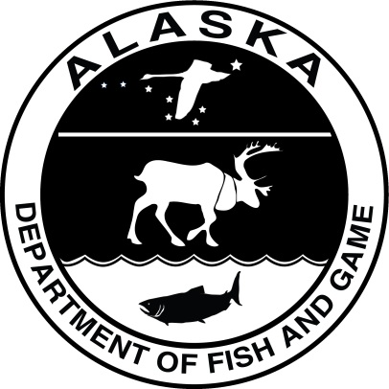

August 2019

Alaska Department of Fish and Game Divisions of Sport Fish and Commercial Fisheries

Symbols and Abbreviations

The following symbols and abbreviations, and others approved for the Système International d'Unités (SI), are used without definition in the following reports by the Divisions of Sport Fish and of Commercial Fisheries: Fishery Manuscripts, Fishery Data Series Reports, Fishery Management Reports, and Special Publications. All others, including deviations from definitions listed below, are noted in the text at first mention, as well as in the titles or footnotes of tables, and in figure or figure captions.

**Weights and measures (metric)**

centimeter cm

deciliter dL

gram g

hectare ha

kilogram kg

kilometer km

liter L

meter m

milliliter mL

millimeter mm

**Weights and measures (English)**

cubic feet per second ft3/s

foot ft

gallon gal

inch in

mile mi

nautical mile nmi

ounce oz

pound lb

quart qt

yard yd

**Time and temperature**

day d

degrees Celsius °C

degrees Fahrenheit °F

degrees kelvin K

hour h

minute min

second s

**Physics and chemistry**

all atomic symbols

alternating current AC

ampere A

calorie cal

direct current DC

hertz Hz

horsepower hp

hydrogen ion activity pH

(negative log of)

parts per million ppm

parts per thousand ppt,

‰

volts V

watts W

**General**

Alaska Administrative

Code AAC

all commonly accepted

abbreviations e.g., Mr., Mrs., AM, PM, etc.

all commonly accepted

professional titles e.g., Dr., Ph.D.,

R.N., etc.

at @

compass directions:

east E

north N

south S

west W

copyright ©

corporate suffixes:

Company Co.

Corporation Corp.

Incorporated Inc.

Limited Ltd.

District of Columbia D.C.

et alii (and others) et al.

et cetera (and so forth) etc.

exempli gratia

(for example) e.g.

Federal Information

Code FIC

id est (that is) i.e.

latitude or longitude lat. or long.

monetary symbols

(the Interior. https://www.doi.gov/subsistence/fisheries) $, ¢

months (tables and

figures): first three

letters Jan,...,Dec

registered trademark ®

trademark ™

United States

(adjective) U.S.

United States of

America (noun) USA

U.S.C. United States Code

U.S. state use two-letter abbreviations (e.g., AK, WA)

**Mathematics, statistics**

*all standard mathematical*

*signs, symbols and*

*abbreviations*

alternate hypothesis HA

base of natural logarithm *e*

catch per unit effort CPUE

coefficient of variation CV

common test statistics (F, t, χ2, etc.)

confidence interval CI

correlation coefficient

(multiple) R

correlation coefficient

(simple) r

covariance cov

degree (angular ) °

degrees of freedom df

expected value *E*

greater than >

greater than or equal to ≥

harvest per unit effort HPUE

less than <

less than or equal to ≤

logarithm (natural) ln

logarithm (base 10) log

logarithm (specify base) log2, etc.

minute (angular) '

not significant NS

null hypothesis HO

percent %

probability P

probability of a type I error

(rejection of the null

hypothesis when true) α

probability of a type II error

(acceptance of the null

hypothesis when false) β

second (angular) "

standard deviation SD

standard error SE

variance

population Var

sample var

Regional Operational plan CF.4K.2019.XX

**Operational Plan: Reproductive parameters OF Black ROCKFISH *sebastes melanops* From the Kodiak area, 2019-2020**

by

Carrie Worton

Alaska Department of Fish and Game, Division of Commercial Fisheries, Kodiak

Tyler Polum

Alaska Department of Fish and Game, Division of Sport Fisheries, Kodiak

Alaska Department of Fish and Game  
Division of Commercial Fisheries

August 2019

The Regional Operational Plan Series was established in 2012 to archive and provide public access to operational plans for fisheries projects of the Divisions of Commercial Fisheries and Sport Fish, as per joint-divisional Operational Planning Policy. Documents in this series are planning documents that may contain raw data, preliminary data analyses and results, and describe operational aspects of fisheries projects that may not actually be implemented. All documents in this series are subject to a technical review process and receive varying degrees of regional, divisional, and biometric approval, but do not generally receive editorial review. Results from the implementation of the operational plan described in this series may be subsequently finalized and published in a different department reporting series or in the formal literature. Please contact the author if you have any questions regarding the information provided in this plan. Regional Operational Plans are available on the Internet at: <http://www.adfg.alaska.gov/sf/publications/>

Carrie L. Worton,

Alaska Department of Fish and Game, Division of Commercial Fisheries

351 Research Court, Kodiak, AK 99615, USA

Tyler Polum,

Alaska Department of Fish and Game, Division of Sport Fish

351 Research Court, Kodiak, AK 99615, USA

This document should be cited as:

Worton, C. L., and T. Polum. 2019. Operational Plan: Reproductive parameters of black rockfish Sebastes melanops from the Kodiak Area, 2019-2020. Alaska Department of Fish and Game, Division of Commercial Fisheries, Regional Operational Plan ROP.CF.4K.2019.XX, Kodiak.

The Alaska Department of Fish and Game (ADF&G) administers all programs and activities free from discrimination based on race, color, national origin, age, sex, religion, marital status, pregnancy, parenthood, or disability. The department administers all programs and activities in compliance with Title VI of the Civil Rights Act of 1964, Section 504 of the Rehabilitation Act of 1973, Title II of the Americans with Disabilities Act (ADA) of 1990, the Age Discrimination Act of 1975, and Title IX of the Education Amendments of 1972.

**If you believe you have been discriminated against in any program, activity, or facility please write:**

ADF&G ADA Coordinator, P.O. Box 115526, Juneau, AK 99811-5526

U.S. Fish and Wildlife Service, 4401 N. Fairfax Drive, MS 2042, Arlington, VA 22203

Office of Equal Opportunity, U.S. Department of the Interior, 1849 C Street NW MS 5230, Washington DC 20240

**The department’s ADA Coordinator can be reached via phone at the following numbers:**

(VOICE) 907-465-6077, (Statewide Telecommunication Device for the Deaf) 1-800-478-3648,

(Juneau TDD) 907-465-3646, or (FAX) 907-465-6078

**For information on alternative formats and questions on this publication, please contact:**

ADF&G, Division of Sport Fish, Research and Technical Services, 333 Raspberry Rd, Anchorage AK 99518 (907) 267-2375

Signature Page

|  |  |
| --- | --- |
| Project Title: | Reproductive parameters of black rockfish *Sebastes melanops* in the Kodiak Area, 2019-2020 |
| Project leader(s): | Carrie Worton, Tyler Polum |
| Division, Region, and Area | Division of Commercial Fisheries and Division of Sport Fish, Region IV, Kodiak |
| Project Nomenclature: |  |
| Period Covered | 2019-2020 |
| Field Dates: | July 2019 – February 2020 |
| Plan Type: | Category II |

**Approval**

|  |  |  |  |  |  |  |
| --- | --- | --- | --- | --- | --- | --- |
| Title |  | Name |  | Signature |  | Date |
| Co-Principal Investigator |  | Carrie Worton |  |  |  |  |
| Co-Principal Investigator |  | Tyler Polum |  |  |  |  |
| Biometrician |  | Ben Williams |  |  |  |  |
| Fishery Scientist I |  | Katherine Howard |  |  |  |  |
| Research Coordinator |  | Ben Daly |  |  |  |  |
| Research Coordinator |  | Timothy McKinley |  |  |  |  |

TABLE OF CONTENTS

Page

LIST OF TABLES ii

LIST OF FIGURES ii

LIST OF APPENDICES iii

ABSTRACT 1

INTRODUCTION 1

Purpose 1

Background 1

OBJECTIVES 3

METHODS 3

Study Area 3

Field collections and sampling 3

Specimen processing 4

Biological Sampling 4

Juvenile Rockfish Sampling 5

Fecundity Sampling 5

Histological Preparation and Procedure 6

Age Determination 7

Data Analysis 7

Length and Age at Maturity 7

Growth 7

Fecundity 7

Gonadalsomatic Index (GSI) and Hepatosomatic Index (HSI) 8

SCHEDULE AND DELIVERABLES 8

RESPONSIBILITIES 8

REFERENCES CITED 9

TABLES AND FiGURES 12

APPENDIX A. Rockfish Identification Guides 16

APPENDIX B. Sampling forms 21

# LIST OF TABLES

Table Page

Table 1.–Rockfish macroscopic maturity stages with descriptions for both female and males. 13

Table 2.–Microscopic description of maturity stages for rockfish. Descriptions and terminology follow Moser (1967), Bowers (1992), Nichol and Pikitch (1994), Bobko and Berkeley (2004), and Shaw et al. (2012). 14

# LIST OF FIGURES

Figure Page

Figure 1.–Map of the Kodiak Area with management districts for commercial black rockfish fisheries. 14

# LIST OF APPENDICES

Appendix A1.–Rockfish identification guide for black, dark, and dusky rockfish. 17

Appendix A2.–Black vs dark rockfish identification guide. 18

Appendix A3.–External sex determination of rockfish. 19

Appendix A4.–Muscle tissue sampling location. 20

Appendix B1.–ADF&G Rockfish sampling location information form. 21

Appendix B2.–Alaska Department of Fish and Game fish ticket codes for Statewide fisheries 2016. 22

Appendix B3.–Black rockfish reproductive maturity sampling form. 23

Appendix B4.–Juvenile rockfish identification form. 24

Appendix B5.–Rockfish fecundity sampling form. 25

Appendix B6.–Rockfish maturity histological results form. 26

# ABSTRACT

Reproductive parameters are critical components of fishery stock assessment models that directly influence estimates of spawning biomass used to determine fishery harvest levels. There is limited data on the reproductive biology of black rockfish *Sebastes melanops* in Alaska. The purpose of this project is to sample age and length of maturity, fecundity, growth, and determine timing of maturity (phenology) for used in fishery stock assessment models with the goal of developing an abundance-based management strategy for fisheries in the Kodiak Area.

Key words: Black rockfish, *Sebastes melanops*, maturity, fecundity, stock assessment, Kodiak, Alaska.

# INTRODUCTION

Stock assessment research and a long term state-wide management strategy for black rockfish *Sebastes melanops* were identified by Alaska Department of Fish and Game (ADF&G) managers and researchers from both the Commercial Fishery and Sport Fish Divisions during 2019 Rockfish Interdivisional Workshops as a priority for funding opportunities. The goal of this project is to develop an abundance-based management strategy for the Westward Region’s Kodiak Area black rockfish commercial and sport fisheries through estimating contemporary reproductive parameters for use in fishery stock assessment models to better inform region-wide harvest levels and further the development of an interdivisional management strategy.

# Purpose

In 2019 and 2020, sampling black rockfish *S. melanops* reproductive parameters will be performed in the Kodiak Area by ADF&G in an ongoing effort to inform and develop a district-level, abundance-based management strategy for black rockfish. Reproductive parameters are used in conjunction with abundance estimates to inform harvest-level decisions by fishery managers. Estimates of contemporary reproductive parameters, including age and size at maturity, growth, reproductive seasonality, fecundity, and gonad and liver indices, will be used to describe the reproductive condition of the stock and inform a Spawning Potential Ratio (SPR) model used in annual evaluations of guideline harvest levels (GHLs) in the commercial fishery and harvest limits in the sport fishery.

Key words: black rockfish, *Sebastes melanops,* age and size of maturity, growth, seasonality, fecundity, stock assessment, Kodiak Area.

# Background

The Westward Region black rockfish commercial fishery is the largest in Alaska both geographically and in terms of harvest, covering all waters within the Kodiak, Chignik, and South Alaska Peninsula management areas and the state waters of the Bering Sea-Aleutian Islands Management Area. Full management authority of black rockfish was transferred from Federal agencies to the State of Alaska in 1998 (Lunsford et al. 2009). Existing commercial GHLs for black rockfish are based on an average of historic commercial fishery harvests and divided between each district in order to distribute effort within each management area (Stichert 2009). Black rockfish are slow growing, long-lived, have a low natural morality and high age of maturity, which makes them sensitive to overfishing (Worton and Rosenkranz 2003). As such, it is unknown if current harvest levels are sustainable. The need for abundant-base management has become increasingly important as sport fish harvests continue to increase, despite reductions in fishing bag limits (Polum et al. 2019). In addition, the age distribution of fish sampled in the commercial fishery indicate that the majority of the fish are being harvested at or before the onset of maturity (Worton and Rosenkranz 2003).

Part of the State of Alaska’s management responsibility includes conducting stock status assessments of exploited fish populations with the goal of managing for sustainability (Carlile 2005), and as part of this on-going effort, ADF&G has initiated stock assessment research that has included collecting basic life history information on black rockfish reproduction; age and size of maturity, fecundity, and seasonality (Worton and Urban 2005). These biologically based parameters are commonly used in stock assessment models for West Coast rockfish fisheries in estimating reproductive potential of a stock and providing harvest rate reference points for fishery management plans (Clark 1991; Dorn 2001; Hilborn et al. 2002). The SPR model, which measures the ratio of the spawning biomass per recruit of a fished and unfished population, is used as a proxy for fishing at maximum sustainable yield (FMSY), and is intended to provide a harvest rate in which protects stocks from overfishing (Dorn 2001).

Assessing reproductive parameters both spatially and temporally becomes important, as age and length at maturity are known to vary geographically (Wyllie Echeverria 1987; Bobko and Berkeley 2004), and reproductive timing can affect reproductive success in terms of the onset of maturity and the timing of spawning for offspring survival (Lowerre-Barbieri et al. 2011). Previous studies in California suggest black rockfish mature between 6-8 year old (Wyllie Echeverria 1987). In Kodiak Alaska, the length and size at which 50% of the females are mature have been initially estimated 46.3 cm fork length and 9.8 years for females (Worton and Urban 2005). While, Oregon black rockfish females were estimated to reach 50% maturity at 39.4 cm FL and 7.5 years of age (Bobko and Berkeley 2004). Female parturition (the release of larvae) and fecundity are also likely to vary with latitude and changes in oceanographic conditions (Bobko and Berkeley 2004; Worton and Urban 2005).

The effects of changing environmental conditions on these reproductive parameters for black rockfish in Alaska are largely unknown. Climate-related changes are shown to strongly affect the dynamics of key commercial species in the fisheries of Alaska, and has specifically been detected in the recruit per spawner time series in rockfish in the GOA (Low 2008). Monitoring the recruitment per spawning biomass relationship is considered one way to monitor the effects of climate change (Low 2008). With warming ocean conditions, stresses on rockfish reproduction may include reduction in reproductive capacity which could include increased incidence of abortive maturity, shifts in size and age at maturity and phenology, and changes in fecundity (Lowerre-Barbieri et al. 2011).

Rockfish may not successfully spawn every year (Nichol and Pikitch 1994), as they can go through abortive maturity or skip spawning (i.e. non-annual spawning). Atresia occurs when females abort reproductive development and reabsorb advanced oocytes. While emerging research suggests incidence of skip spawning is widespread among many fishes (Rideout and Tomkiewicz 2011), including deep-water rockfish (Conrath 2017), these reproductive conditions are thought to serve primarily as an energy savings during years of poor nutrition and/or response to unsuitable environmental conditions (Hunter and Macewicz. 1985). The extent of unsuccessful reproduction in black rockfish becomes important when estimating parameters for stock assessment models, as this could yield misleading or incorrect estimates of length and age at maturity and reproductive potential of the spawning population.

In this study we will estimate reproductive parameters necessary to best inform stock assessment models that are currently being developed for black rockfish in the Kodiak Area. This study will occur concurrently with studies being conducted in other parts of Alaska (Blain-Roth et al. 2019; Schroeder et al. 2019) and provide a better understanding of the latitudinal and Gulf-wide differences in rockfish reproduction and also inform the feasibility of a statewide management plan for black rockfish.

In a coordinated effort between Commercial and Sport Fisheries Divisions in the Westward Region, we will be collecting black rockfish reproductive parameter information with the goal of updating the female age and size at maturity estimates, estimates of fecundity, growth, and timing of maturity (phenology).

# OBJECTIVES

The objectives of the reproductive parameters of black rockfish project are as follows:

1. Collect monthly random stratified samples of up to 500 female black rockfish, from July 2019 through February 2020 from the Kodiak Area and obtain data on fishing sampling effort, depth of capture, and water temperature.
2. Obtain data on length, fish weight, age, gonad and liver weights, and collect stomach contents and tissues for analysis.
3. Determine reproductive condition through histological analysis and sampling for fecundity.
4. Characterize reproductive status and estimate key reproductive parameters needed for stock assessments including, length and age at 50% maturity, timing of maturation (phenology), growth, and fecundity.
5. Compare historical reproductive samples to current data and evaluate temporal differences.

# METHODS

## Study Area

Samples of black rockfish will be obtained from the Kodiak Area which includes all waters of Alaska (0-3 nmi) south of a line extending east from Cape Douglas (58°51.10′ N. lat), west of 150° W. long, north of 55°30.00′ N lat, and north and east of a line extending 135° southeast for three miles from a point near Kilokak Rocks at 57°10.34′ N. lat, 156°20.22′ W. long (the longitude of the southern entrance of Imuya Bay), then due south (Figure 1). Based on historic fishing effort, the majority of the samples will most likely be taken closest to the port of Kodiak and from the Eastside of Kodiak, which includes the Afognak, Northeast, Eastside, and Southeast districts of the Kodiak Area.

## Field collections and sampling

Black rockfish samples will be collected when possible, from the commercial and sport fish dockside landings. When dockside samples aren’t available, day trips (approximately 4 days per month) will be conducted on ADF&G department vessels to collect rockfish samples. Rockfish will be targeted mainly using hook and line sampling methods utilizing a variety of hook sizes and at a range of depths. Smaller fish will be targeted using herring jigs or nets deployed in shallow rocky habitat. Species identification guides will be used to confirm species documentation (Byersdorfer and Watson 2010). Specific dockside sampling guides, outlining key morphological differences between black, dark, and dusky rockfish, will also aid in this task (Appendix A1 and A2). Female rockfish will initially be identified from external examination of external genital opening (located posterior to the anus and anterior to the urinary opening) and the shape of the urogenital papilla will be used to determine sex (Appendix A3). Location, depth (m), start and stop times of each fishing event or drift, weather/sea conditions, water temperature (°C) at average fish depth (m), habitat type description (rocky, kelp, sandy bottom, etc.), numbers of each species captured, number of each gear type, and number of hooks per jig will be recorded on the *ADF&G Rockfish Sampling Location Information Form* (Appendix B1). ADF&G species codes and gear codes can be found in Appendix B2. To assess length and age at maturity, the stratified random sampling method of taking a fixed number of fish from a given length group will be applied (Morgan and Hoenig 1997). Female black rockfish will be sampled, 3 fish per 1.0 cm fork length (FL) increments, for each month (approximately 70-75 fish per month) of the study, with a total study goal of approximately 500 fish. A size tally sheet will be used to keep track of retained rockfish when sampling in the field.

## Specimen processing

### Biological Sampling

Processing of specimens will occur in ADF&G’s Kodiak laboratory. All data will be recorded on the *Black Rockfish Reproductive Maturity Sampling Form* (Appendix B3). A sample number will be assigned to each fish starting with 001 and continue in sequential order until the end of the study. Species misidentification and errors is sex determination will occasionally occur and mistakenly be included in the sample brought into the lab. These fish will be included in the dataset and assigned a sequential number along with the target female black rockfish, but only processed for length, weight, macroscopic maturity condition, and age determination. Specimen processing will consist of the following:

1. All fish will be sexed, weighed (+1.0 g), measured to fork length (FL; +1.0 mm). Specimens that are bled before sampling will need to be converted to whole weight (whole weight = bled weight x 1.02) and a note made on the specimen form.
2. Both ovaries will be carefully removed and weighed together (+0.01 g), and a maturity stage (Table 1) will be assigned based on macroscopic examination from criteria established by Westrheim (1975).
3. A photo of both ovaries, with the corresponding label, will be taken for a macroscopic maturity stage reference and the file saved with in the following file format: *year_month_day_ADF&G species code_sample no.jpg*
4. The ovaries will be placed in a cloth bag with the label and preserved in Glyo-FixxTM fixative solution (or 10% sodium acetate-buffered formalin) for later histological analysis. For large, mature, thick ovaries, you may need to inject the preservative into the center of the ovary with a syringe to ensure that the internal tissue is fixed. If the entire ovary is not fixed, the quality of the tissue sample will degrade.
5. The entire liver will be removed, weighed (+0.01 g), recorded, and then discarded.
6. A sample of the stomach contents will be collected whenever possible. The stomach will be examined and if contents are present they will be emptied into a “whirl pack” bag, labeled, and stored in the freezer in the Kodiak ADF&G laboratory for later analysis. A sampled stomach will be indicated with a Y/N notation on the sampling form next to the appropriate specimen.
7. After the liver and ovaries are removed, the remaining organs will be removed and the gutted weight (+ 1.0 g) of the fish will be recorded.
8. The two sagittal otoliths will then be removed, cleaned, dried, and stored in plastic otolith bags for later age determination.
9. A muscle tissue sample (with skin removed) will be collected from the left upper dorsal area of the fish just below the dorsal fin rays (Appendix A4). The tissue sample, approximately 2.5 cm2 (1 in2) will be put in a Ziplock bag, frozen, and stored for future stable isotope analysis.
10. Presence of the parasite *Sarcotaces arcticus* should also be recorded and photographed. *S. articus* is an endoparasitic copepod encysted in the skin near the anal and reproductive tissue. Although common in several rockfish species, prevalence in black rockfish is unknown, as only recently has it been documented in Kodiak black rockfish commercial fishery. For more information see:

<http://kodweb.fishgame.state.ak.us/index/Wiki:Research_Projects:Histology:Reproductive_Parasites.index>

### Juvenile Rockfish Sampling

Black rockfish <30 cm are rarely captured with regular hook in line gear. These juvenile fish usually inhabit nearshore, shallow rocky habitats. To sample these size classes of fish use herring jigs, beach seines, or other nets. Identification can be difficult, therefore use identification guides specific of juvenile rockfish (Matarese et al. 1989; Orr et al. 1998). An example of juvenile sampling and characteristics that are important for speciating rockfish can be found at *Juvenile rockfish identification form* (Appendix B4)*.*

### Fecundity Sampling

Fecundity, the number of advanced oocytes per ovary pair will be estimated for black rockfish and sampled opportunistically. Only ovaries that are in the later stages of vitellogensis (stages 3-5) will be used in fecundity estimation. The ovaries will be processed by using procedures modified from Bobko and Berkeley (2004) and (Lowerre-Barbieri and Barbieri 1993) to separate eggs and embryos from the ovary sac and the connective tissue. Each ovary will be lightly fixed (2% buffered formalin) and the weight recorded after fixing the tissues (+0.01 g). Ovaries will be manually manipulated and rinsed through a series of sieves from 1.0 mm mesh size down to 0.25 mm mesh size, and the freed eggs collected in the fine-mesh sieve. All the eggs in the sieves are to be patted dry and placed under a hood for at least one hour (until no moisture is seen on paper towel) and then weighed (+0.1 g). The remaining ovary sac and connective tissue should also be patted dry and weighed (+0.1 g). The weight of the dry sieves will be subtracted from the total weight of the sieve with eggs to get the total egg weight. A minimum of three egg subsamples will be randomly collected from the filtered eggs and placed in 3 separate gridded glass petri dishes and weighed (+0.001 g). The number of eggs in each subsample will be counted under a dissecting microscope and absolute fecundities (total number of eggs per female) and relative fecundities will be estimated. The number of subsamples counted will increase until the coefficient of variation for the mean density of oocytes is less than or equal to 5% (See *Data Analysis* section). All data will be recorded on the *Rockfish fecundity sampling form* (Appendix B5).

### Histological Preparation and Procedure

Histological processing of all female ovaries will be done to verify the macroscopic maturity stage. Once the ovary tissue is fixed (minimum 48 h), samples from one of the ovaries will be processed and embedded in paraffin, sectioned to 6 µm, mounted on a slide and stained with hematoxylin and counterstained with eosin y. Using a scalpel, a cross-section of approximately 5.0 mm will be sliced from the middle of one ovary, while carefully maintaining the ovary shape and keeping ovary wall intact. The section of tissue will be placed in megacassettes and labeled using a SHUR/Mark™ marking pen (made for histological use) and should include capture date, species code, and sample number. For small samples, use a biopsy pad to line the megacassette to prevent the tissue from falling out. For large ovaries, where a cross section my not fit in one megacassette, cut the tissue in half and preserved separately and label appropriately. Each histological slide will be examined and maturity stage assigned based on microscopic cellular criteria (Table 2) described for rockfish (Moser 1967; Bower 1992; Nichol and Pikitch 1994; Shaw et al. 2012). Each slide sample will be scanned using a compound microscope. The presence of each oocyte stages will be determined, along with types and rates of atresia, maturity stage, and whether the fish is deemed mature or immature and recorded on the *Rockfish maturity histological results form* (Appendix B6). Images of the 5 largest, most advanced oocytes, that are deemed sectioned in the center, will be recorded using Infinity Analyze and Capture software (Teledyne Lumenera, Ottawa, Canada), saved (file format: *year_month_day_species code_sample no._image number*) and the magnification at which the picture was taken, recorded on the histology form. Image Pro Premier (Media Cybernetics, Inc., Rockville, U.S.A) will be used to measure the mean diameter of each advanced oocytes from these images in which the application automatically measures at every 2° intervals passing through the centroid of the cell after drawing a line around the perimeter of the cell. Fish oocytes diameters will be used to help in defining the maturity stage, as oocytes larger than 220 µm are generally considered mature. Details of these methods can be found at:

<http://kodweb.fishgame.state.ak.us/index/Wiki:Research_Projects:Histology:Histology_Procedures.index>

<http://kodweb.fishgame.state.ak.us/view/Wiki:Research_Projects:Histology:Image-Pro_measurements_of_histology_samples>

### Age Determination

Age determination will be assessed by Kodiak regional staff using an established break and burn method (Chilton and Beamish 1982). Precision testing within and between age readers will be conducted on 20% of the samples.

## Data Analysis

### Length and Age at Maturity

Estimates of length and age at which 50% of female black rockfish are mature ( and ) will be determined using the logistic regression model described by Gunderson et al. (1980) and Nichol and Pikitch (1994),

[1]

where is the proportion of fish that is mature in a given length (mm) or age and and are parameters that describe the model. Parameters will be estimated by nonlinear least-squares regression (R Core Team 2017). The predicted length and age at ( and ) at 50% maturity () are calculated as,

[2]

The 95% confidence limits for and will be obtained by solving the equation for the upper and lower 95% confidence limits around when

### Growth

Parameters for the von Bertalanffy growth model () (Quinn and Deriso 1999) will be estimated using non-linear least squares regression model,

, [3]

where is length at age .

### Fecundity

Fecundity analysis will follow described by Murua et al. (2003), Bobko and Berkeley (2004), and Blain-Roth et al. (2019). The number of eggs or oocytes in the subsamples are used to estimate the absolute fecundity ( using the following:

, [4]

where the number of oocytes (for each subsample will be divided by the subsample weight ( and summed over all of the samples (, then divided by the total number of samples to estimate the mean oocyte density . The number of subsamples counted will be optimized to ensure the coefficient of variation for the mean oocyte density of is less than or equal to 5%.

, [5]

where s is the standard deviation of the mean oocyte density. The mean oocyte density is then multiplied by the ovary weight to obtain the *AF*.

*.* [6]

The relative fecundity (*RF*) will be estimated by dividing the AF by the gonad-free fish weight (:

, [7]

where is total weight minus gonad weight.

### Gonadalsomatic Index (GSI) and Hepatosomatic Index (HSI)

To evaluate the ovarian and hepatic conditions of the fish, the following indices will be calculated: Gonadalsomatic Index (GSI) and Hepatosomatic Index (HSI). For each female, the GSI will be estimated by dividing the gonad weight by the ovary-free body weight (Bobko and Berkeley 2004):

GSI = (gonad weight/ovary-free body weight) x 100. [9]

Fish store energy in the form of glycogen in the liver, so relative size of the livers is correlated with nutritional state of the fish (Busacker et al. 1990) and considered an excellent measure of fish condition (Jensen 1979; Lambert and Dutil 1997). For each female, the HSI will be estimated by dividing the liver weight by the gutted fish weight (Busacker et al. 1990; Blain-Roth et al. 2019):

HSI = (liver weight/gutted fish weight) x 100. [10]

# SCHEDULE AND DELIVERABLES

|  |  |
| --- | --- |
| Date | Activity |
| July 2019 - February 2020 | Field collections and specimen processing |
| March 2020 | Age determination |
| April - June 2020 | Analysis and report writing |

# RESPONSIBILITIES

|  |  |
| --- | --- |
| Personnel | Responsibility |
| Carrie Worton FB III | Co-investigator, coordinate data collection, training, analysis, and report writing |
| Tyler Polum FB III | Co-investigator, coordinate data collection, analysis, analysis, and report writing |
| Philip Tschersich FB II | Data collection, data processing, analysis, and report writing |
| Rob Baer FB I | Data collection, data processing |
| Mark Witteveen II | Data collection, data processing |
| Michelle Stratton FB I | Data collection, data processing |
| Sonya El-Mejjati FBII | Otolith processing |

# REFERENCES CITED

Blain-Roth, B. J., D. E. Arthur, A. St Saviour, J. Baumer, and B. Buzee. 2019. Operational plan: Reproductive and biological sampling of yelloweye rockfish (*Sebastes ruberrimus*) and black rockfish (*Sebastes melanops*) from Prince William Sound and the Northern Gulf of Alaska. Alaska Department of Fish and Game, Regional Operational Plan ROP.SF.2A.2019.09, Anchorage.

Bobko, S. J., and S. A. Berkeley. 2004. Maturity, ovarian cycle, fecundity, and age-specific parturition of black rockfish (*Sebastes melanops*). Fishery Bulletin 102:418-429.

Bowers, M. J. 1992. Annual reproductive cycle of oocytes and embryos of yellowtail rockfish *Sebastes flavidus* (Family Scorpaenidae). Fishery Bulletin 90:231-242.

Busacker, G. P., I. R. Adelman, and E. M. Goolish. 1990. Growth. Pages 372 [*In*] C. B. Schreck and P. B. Moyle, (eds.). Methods for fish biology. American Fisheries Society, Bethesda Maryland.

Byersdorfer, S., and L. J. Watson. 2010. Field guide to common marine fishes and invertebrates of Alaska. Alaska Sea Grant College Program, University of Alaska Fairbanks.

Carlile, D. 2005. An assessment of age determination needs and sample sizes for groundfish fisheries managed by the State of Alaska. Alaska Department of Fish and Game, Special Publication No. 05-12, Anchorage.

Chilton, D. E., and R. J. Beamish. 1982. Age determination for fishes studied by the groundfish program at the Pacific Biological Station.Canadian Special Publication. Fisheries and Aquatic Science 60.

Clark, W. G. 1991. Groundfish exploitation rates based on life history parameters. Canadian Journal of Fisheries and Aquatic Science 48:734-750.

Conrath, C. L. 2017. Maturity, spawning omission, and reproductive complexity of deepwater rockfish. Transaction of American Fisheries Society 146:495-507.

Dorn, M. W. 2001. Advice on West Coast rockfish harvest rates from Bayesian Meta-Analysis of stock-recruit relationships. North American Journal of Fisheries Management 22:280-300.

Gunderson, D. R., P. Callaham, and B. Goiney. 1980. Maturation and fecundity of four species of *Sebastes*. Marine Fisheries Review 43:74-79.

Hilborn, R., A. Parma, and M. Maunder. 2002. Exploitation rate reference points for West Coast rockfish: Are they robust and are there better alternatives? North American Journal of Fisheries Management 22:365-375.

Hunter, J. R., and B. J. Macewicz. 1985. Rates of atresia in the ovary of captive and wild northern anchovy, *Engraulis mordax*. Fishery Bulletin 83:119-136.

Jensen, A. J. 1979. Energy content analysis from weight and liver index measurements of immature pollock (*Pollachius virens*). Journal of Fishery Research Board of Canada 36:1207-1213.

Lambert, Y., and J. Dutil. 1997. Can simple condition indices be used to monitor and quantify seasonal changes in the energy reserves of Atlantic cod (*Gadus morhua*)? Canadian Journal of Fisheries and Aquatic Science 54(Suppl. 1):104-112.

Low, L. L. 2008. United States of America - Alaska Region. Pages 163-205 [*In*] R. J. Beamish, (ed). Impacts of climate and climate change on the key species of the fisheries in the North Pacific. PICES Scientific Report No. 35.

Lowerre-Barbieri, S. K., and L. Barbieri. 1993. A new method of oocyte separation and preservation for fish reproduction studies. Fishery Bulletin 91:165-170.

Lowerre-Barbieri, S. K., K. Ganias, F. Saborido-Rey, H. Murua, and J. R. Hunter. 2011. Reproductive timing in marine fishes: Varibility, temporal scales, and methods. Marine and Coastal Fisheries: Dynamics, Management, and Ecosystem Science 3:71-91.

Lunsford, C. R., S. K. Shotwell, and D. H. Hanselman. 2009. Gulf of Alaska pelagic shelf rockfish. Pages 926-992 [*In*] Stock Assessment and Fishery Evaluation Report for the groundfish fisheries of the Gulf of Alaska. Compiled by the GOA Groundfish Plan Team. North Pacific Fishery Management Council, 605 West 4th Ave., Anchorage, AK, 99501.

Matarese, A. C., J. A. W. Kendall, D. M. Blood, and B. M. Vinter. 1989. U. S. Department of Commerce, NOAA Technical Report. National Marine Fisheries Servive 80, 652 p.

Morgan, M. J., and J. M. Hoenig. 1997. Estimating maturity-at-age from length stratified sampling. Journal of Northwest Atlantic Fishery Science 21:51-63.

Moser, H. G. 1967. Seasonal histological changes in the goands of *Sebastodes paucispinis* Ayres, and ovoviviparous Teleost (Family Scorpaenidae). Journal of Morphology 123:329-354.

Murua, H., G. Kraus, F. Saborido-Ray, P. R. Witthames, A. Thorsen, S. Junquera. 2003. Procedures to estimate fecundity of marie fish species in relation to their reproductive strategy. Journal of Northwest Atlantic Fishery Science 33:33-54.

Nichol, D. G., and E. K. Pikitch. 1994. Reproduction of darkblotched rockfish off the Oregon coast. Transaction of American Fisheries Society 123:469-481.

Orr, J. W., M. A. Brown, and D. C. Baker. 1998. Guide to rockfishes (Scorpaenidae) of the Genera *Sebastes*, *Sebastolobus*, and *Adelosebastes* of the North Pacific Ocean. U. S. Department of Commerce, NOAA Technical Memorandum NMFS-AFSC-95, 46p.

Polum, T., M. Witteveen, M. Stratton, and M. Evans. 2019. Report on selected sport fisheries of the Kodiak Management Area, 2008–2017. Alaska Department of Fish and Game, Fishery Management Report No. 19-04, Anchorage.

Quinn II, T. J., and R. B. Deriso. 1999. Growth and fecundity. Quantitative Fish Dynamics. Oxford University Press, New York, p. 133.

R Core Team. 2017. R. A language and enviornment for statical computing. R Foundation for Statistical Computing, Vienna, Austria. URL <https://www.R-project.org/>.

Rideout, R. M., and J. Tomkiewicz. 2011. Skipped spawning in fishes: More common than you might think. Marine and Coastal Fisheries: Dynamics, Management, and Ecosystem Science 3:176-189.

Schroeder, K., T. Tydingco, C. Schwanke, K. Reppert, and B. Buzzee. 2019. Operational Plan: Reproductive and biological sampling of black rockfish (*Sebastes melanops*) from Southeast Alaska and the Southern Gulf of Alaska. Alaska Department of Fish and Game, Regional Operational Plan ROP.SF.1J.2019.06, Anchorage.

Shaw, F. R., J. F. Morado, V. C. Lowe, and S. F. McDermott. 2012. An atlas of reproductive development in rockfishes, genus *Sebastes*. NOAA Professional Paper NMFS 14, 77p.

Stichert, M. A. 2009. Fishery management plan for commercial black rockfish fisheries in the Kodiak, Chignik, and South Alaska Peninsula Areas, 2010. Alaska Department of Fish and Game, Fishery Management Report No. 09-49, Anchorage.

Westrheim, S. J. 1975. Reproduction, maturation, and identificaiton of larvae of some *Sebastes* (Scorpaenidae) species in the northeast Pacific Ocean. Journal of the Fisheries Research Board of Canada 32: 2399-2411.

Worton, C., and D. Urban. 2005. Life history parameters of black rockfish in the Kodiak Area. [*In*] Nearshore marine research in Alaska (IV): Final comprehensive progress report. Pages 43-53. NOAA Cooperative Agreement NA16FN2808. Alaska Department of Fish and Game, Division of Commercial Fisheries, Juneau.

Worton, C. L., and G. E. Rosenkranz. 2003. Sex, age, and growth of black rockfish *Sebastes* *melanops* from a newly exploited population in the Gulf of Alaska, 1993-1999. Alaska Fishery Research Bulletin 10:14-27.

Wyllie Echeverria, T. 1987. Thirty-four species of California rockfishes: maturity and seasonality of reproduction. Fishery Bulletin 85:229-250.

TABLES AND FiGURES

Table .­­–Rockfish macroscopic maturity stages with descriptions for both female and males.

|  |  |  |  |  |  |
| --- | --- | --- | --- | --- | --- |
| **Females** | | | **Males** | | |
| Maturity | Maturity | Macroscopic description of ovaries | Maturity | Maturity | Macroscopic description of ovaries |
| Code | Stage | Code | Stage |
| 1 | immature | very small size, translucent pink ovaries | 1 | immature | very small, string-like, translucent |
|  |  |  |  |  |  |
| 2 | maturing | small size, translucent or opaque, yellow or pink | 2 | developing | small size, translucent, white testes |
|  |  |  |  |  |  |
| 3 | mature | large ovary, yellow opaque eggs | 3 | mature | medium size, swollen, brown to white |
|  |  |  |  |  |  |
| 4 | hydrated/fertilized | translucent eggs, eggs run easily | 4 | spawning | large size, white, swollen testes |
|  |  |  |  |  | with milt flowing when pressure |
| 5 | eyed | large ovaries, translucent yellow or gray with |  |  | applied to testes |
|  |  | embryos and larvae (eyed embryos look black) |  |  |  |
|  |  |  | 5 | spent | large to medium size, swollen brown |
| 6 | spent | large, flaccid, red ovaries. A few |  |  | testes with white center and milt in |
|  |  | larvae may be present |  |  | in sperm duct |
|  |  |  |  |  |  |
| 7 | resting | moderate size, firm, red-gray, some | 6 | resting | medium size, flat, tan or brown testes |
|  |  | black blotches (residual larvae) |  |  |  |

Table .–Microscopic description of maturity stages for rockfish. Descriptions and terminology follow Moser (1967), Bowers (1992), Nichol and Pikitch (1994), Bobko and Berkeley (2004), and Shaw et al. (2012).

|  |  |  |
| --- | --- | --- |
| Maturity code | Maturity stage | Histological description |
| 1 | Immature | Densely packed oogonial nests and developing oocytes. Small oocyte cells (<150 µm). |
|  |  | Ooocyte cytoplasm predominantly basophilic (uniform stained dark blue) with a large nucleolus. |
|  |  | Stages of oogenesis include ON, EP, and LP. |
|  |  | Secondary oocyte growth initiated; transparent oil vacuoles forming in cytoplasm surrounding the nucleus. |
| 2 | Maturing | Secondary oocytes more prevalent shape of oocytes more spherical. Oocyte diameter 150-260 µm. |
|  |  | Oil vacuoles increase in size in the mid-cortex region of the cytoplasm. Cytoplasm pale blue or light gray. |
|  |  | ON and EP oocytes still present but LP oocytes predominant. |
|  |  | Small nucleoli around inner margins of nuclear membrane become more numerous and uniform. |
|  |  | Initial yolk accumulation; cortical alveoli form in the cortical cytoplasm (less prominent or absent in *Sebastes*). |
| 3 | Mature | Vitellogenesis begins with appearance of esoinophilic yolk granules (red/pink stained) in cortical cytoplasm. |
|  |  | Oogonia (EP) and developing oocytes (EP and LP) still present. Advanced oocytes have a diameter 260-600 µm. |
|  |  | Yolk granules increase in number and size as they coalesce into yolk globules. |
|  |  | Oil vacuoles increase in number and size forming a layer in the cytoplasm; randomly disperse in the later stages. |
|  |  | Migratory nucleus (MN) stage; nucleus moves towards the periphery of the cell and a large oil vacuole forms. |
|  |  | Spermatozoa sometimes found near or attached to the outer surface of follicles. Atretic vitellogenic may occur. |
| 4 | Hydrated/fertilized | Ovulation begins, stored spermatozoa are released and fertilization starts. ON, EP, and LP present. Embryos 800 µm. |
|  |  | Yolk globules coalesce to a uniform translucent fluid (pink stained); oil vacuole coalesces to form a single oil vacuole. |
|  |  | Follicles appear irregular shaped and shrunken away from oocyte; postovulatory follicles (POF) present in ovary. |
| 5 | Eyed | Presence of developing larvae with black pigmented eyes and bodies with skeletal and muscle development. |
|  |  | Yolk mass is absorbed in late larval stage; oil droplet usually present. |
|  |  | Collapsed post ovulatory follicles (POF) visible and ON and LP present. |
| 6 | Spent | Collapsed follicles and atretic oocytes throughout ovary. ON and LP present within extensive network of red blood cells. |
|  |  | Thin stretched out ovary wall. Residual larvae may still reside in the ovary. |
| 7 | Resting | Reorganization of cellular structures. Looks very similar to immature/maturing stages. |
|  |  | Collapsed follicles and atretic oocytes may still appear in the early stages. |
|  |  | Oogonial growth from ON to oocytes. |
| Atresia | Process | Contraction of cytoplasm until nucleus is absorbed resulting in an empty follicle |
|  | Alpha | Changes in oocyte shape and size with increasing size of granulosa cells (GR) that begin penetrating into the oocyte. |
|  | Beta | All cytoplasm and yolk are resorbed (cell compacting); entire cavity is filled with increasing number and size of GR. |
|  | Gamma | Follicle smaller and has bright red hue from disintegrating GR when H&E stained. |
|  | Delta | Atretic ooctyes shrink until small groups of GR remain as dark orange-brown pigment when H&E stained. |

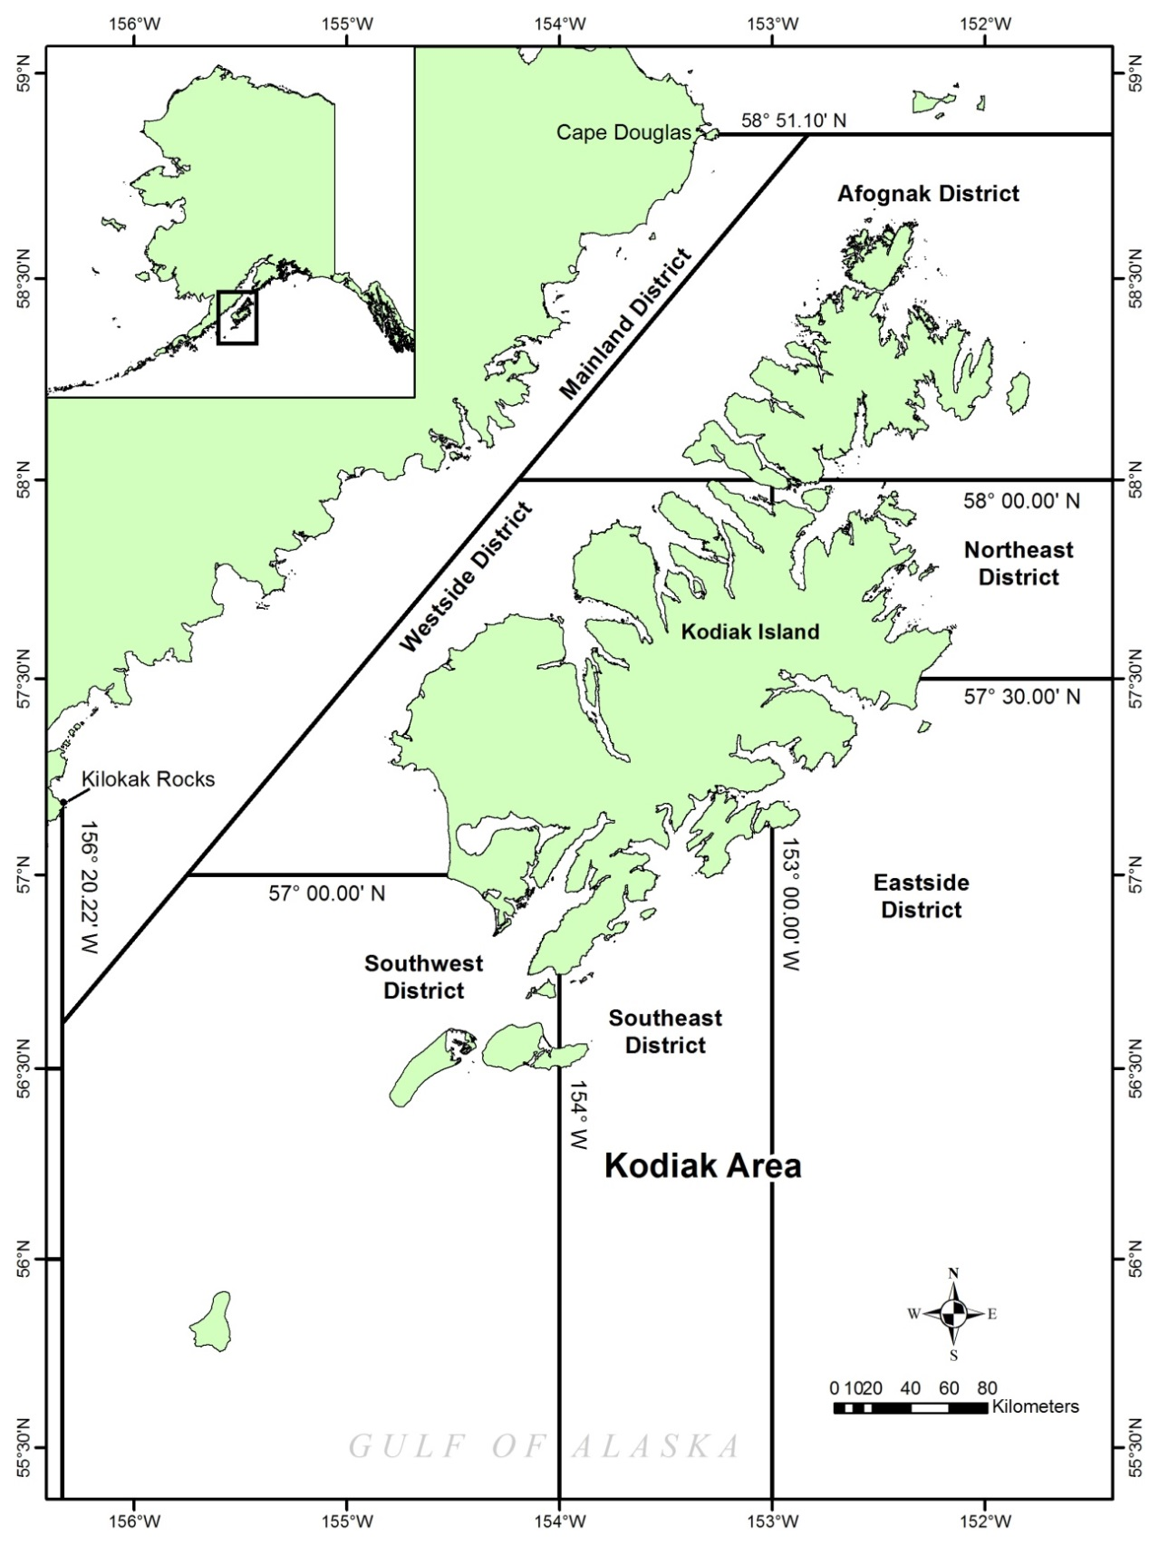

Figure .–Map of the Kodiak Area with management districts for commercial black rockfish fisheries.

APPENDIX A. Rockfish Identification Guides

Appendix A.–Rockfish identification guide for black, dark, and dusky rockfish.

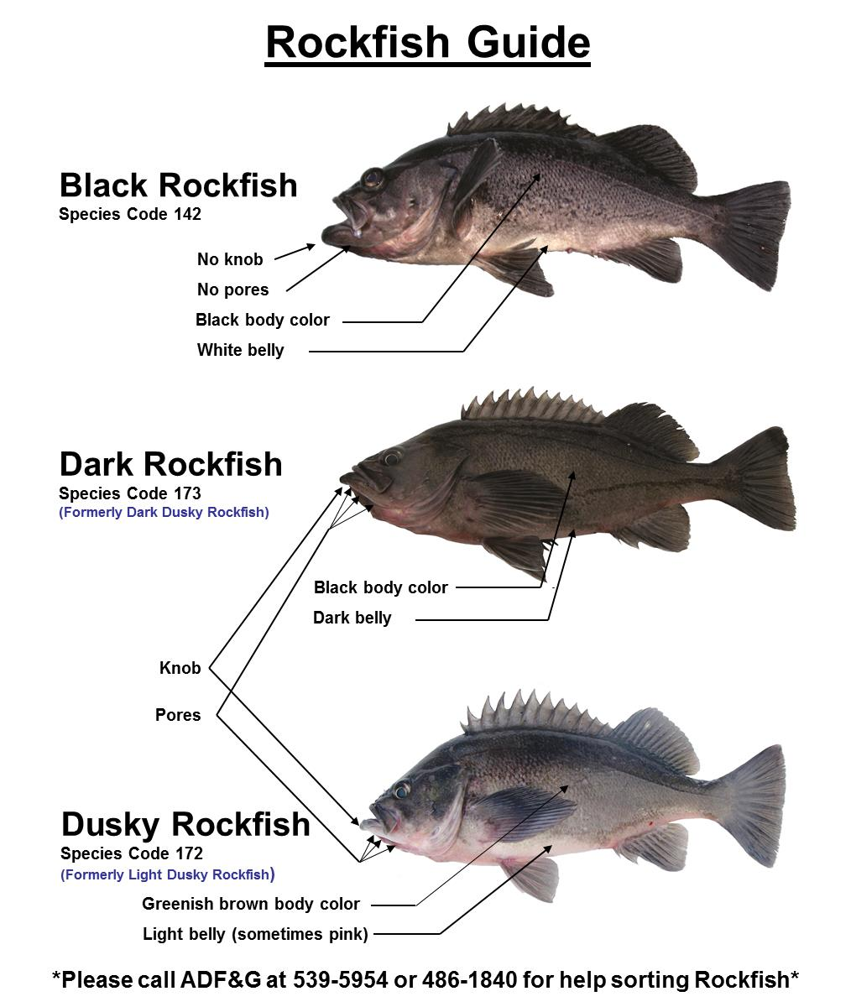

Appendix A.–Black vs dark rockfish identification guide.

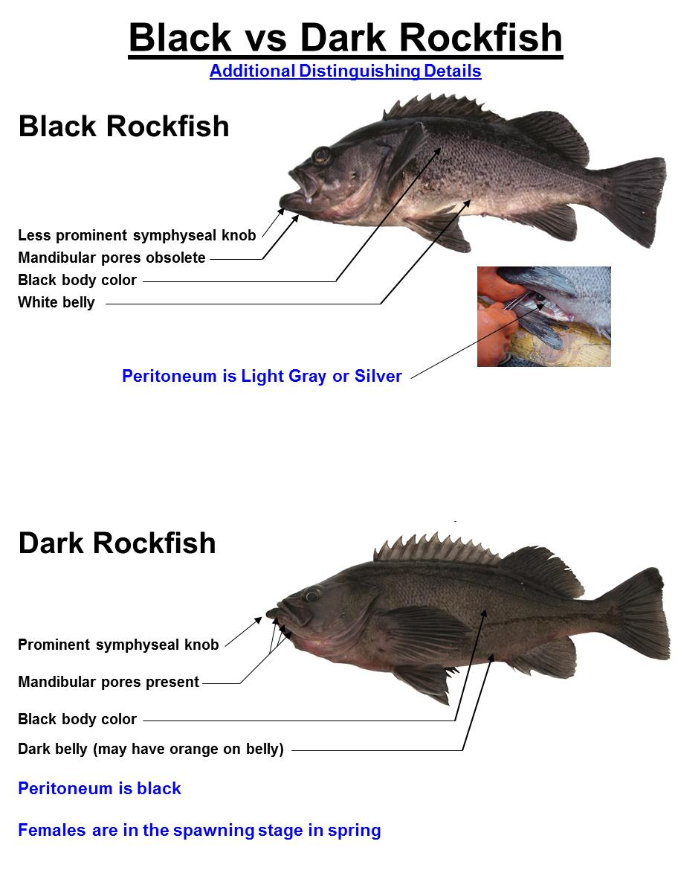

Appendix A.–External sex determination of rockfish.

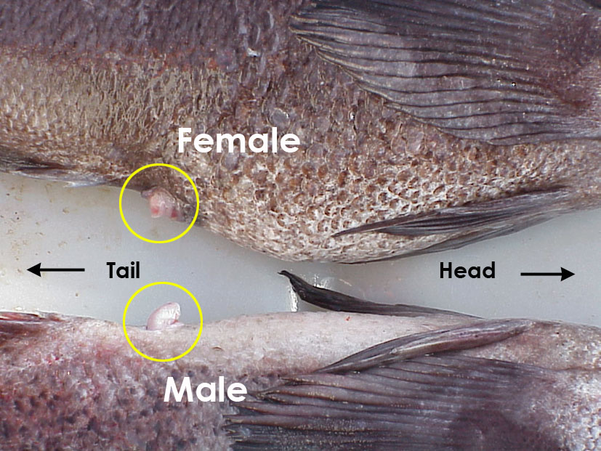

Mature female dark rockfish (top) and male black rockfish (bottom) urogential papillae.

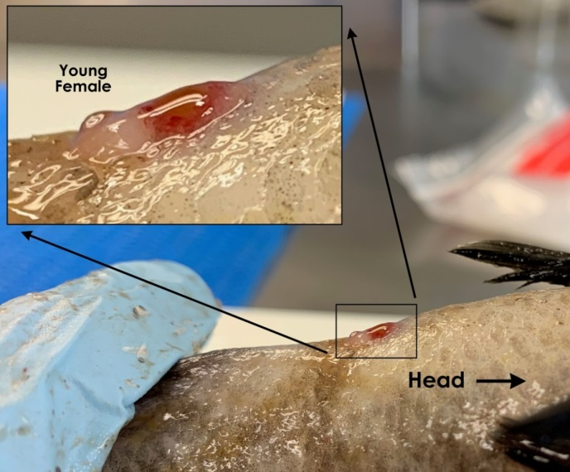 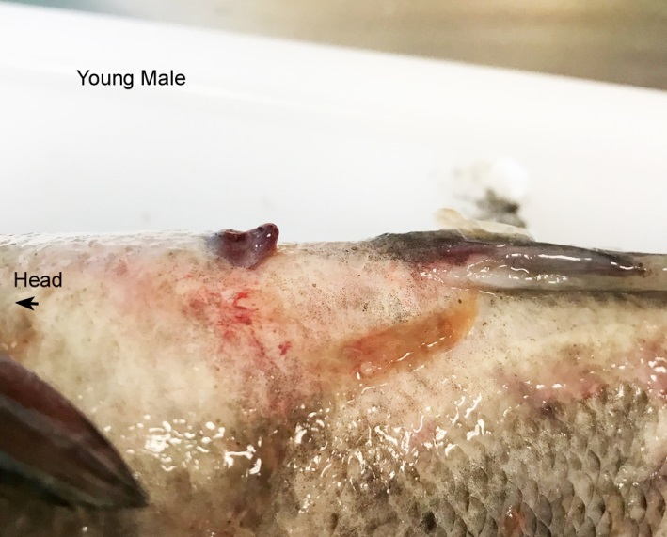

A comparison of the urogenital papillae of a juvenile female black rockfish (left), with close up (insert) and a young male (right).

Appendix A.–Muscle tissue sampling location.

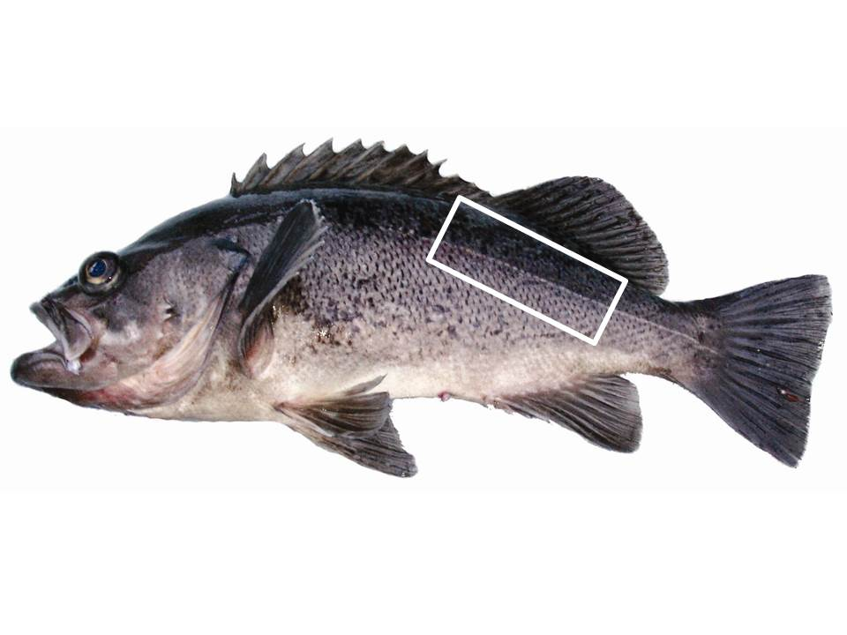

The preferred sampling location of muscle tissue (without skin) for isotope analysis is below the dorsal fin rays.

APPENDIX B. Sampling forms

Appendix B.–ADF&G Rockfish sampling location information form.



Appendix B.–Alaska Department of Fish and Game fish ticket codes for Statewide fisheries 2016.

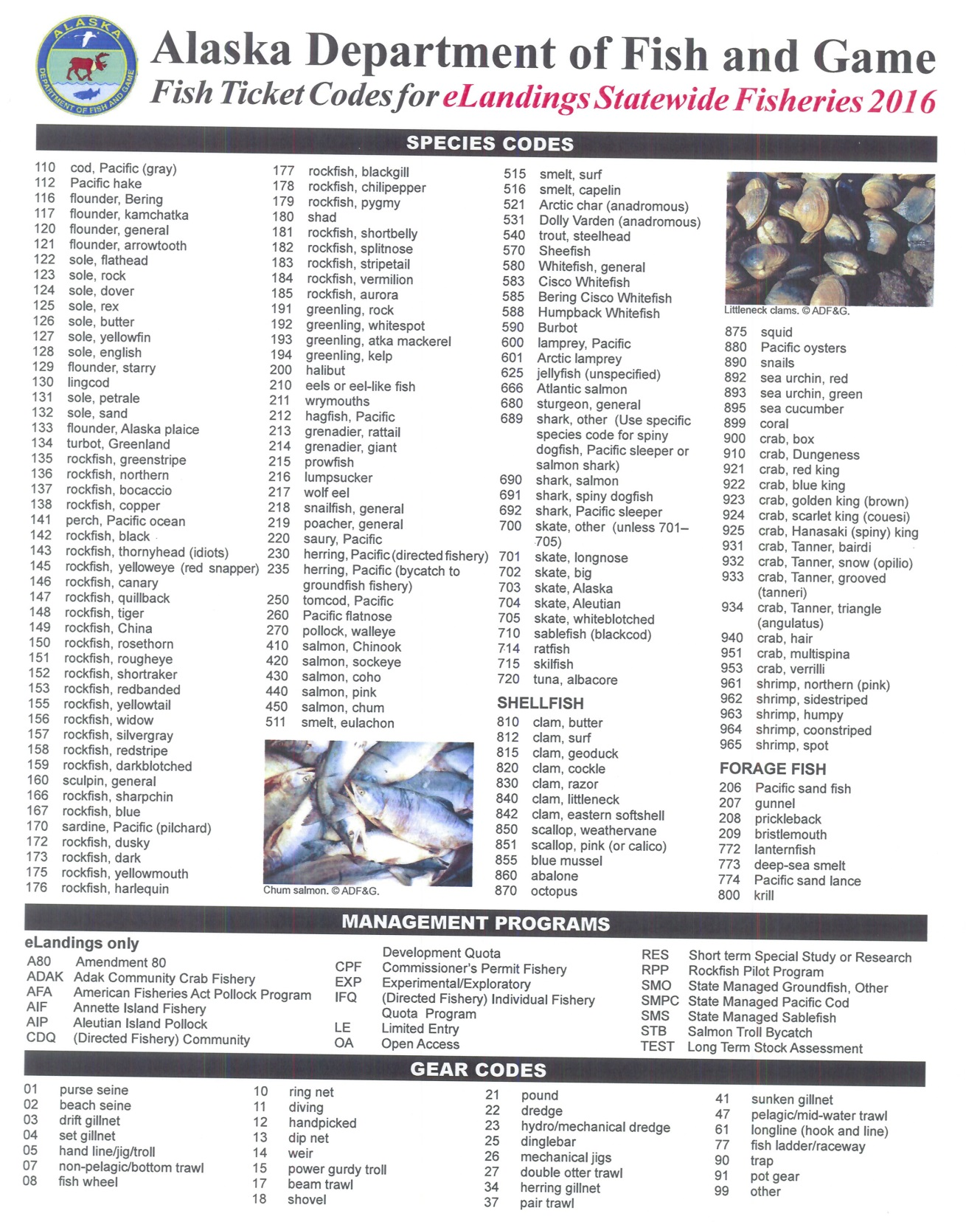

Appendix B.–Black rockfish reproductive maturity sampling form.



Appendix B.–Juvenile rockfish identification form.



Appendix B.–Rockfish fecundity sampling form.



Appendix B.–Rockfish maturity histological results form.

