FY 2007 OPERATIONAL PLAN
Upper Cook inlet Salmon personal use harvest monitoring
Principal Investigators: | Kristine Dunker, Fishery Biologist III
 | Kirk Brogdon, Analyst Programmer V
Assisting Personnel: | Pat Hansen, Biometrician III
 | Margaret Nussbaum, Administrative Clerk III
 | Diane Novinska, Administrative Clerk II
 | Sabrina Pulu, Administrative Clerk II

Title | Approval Signature |  | Date
Project Manager
Co-project Manager
Consulting Biometrician
Area Manager
Regional Research Supervisor
Regional Supervisor
Final Biometric Review

Table of Contents
Page
List of Tables ii
List of Figures ii
List of Appendices ii
INTRODUCTION 1
OBJECTIVEs 2
STUDY DESIGN 2
DATA COLLECTION 4
DATA REDUCTION 5
Permit Design 7
DATA ANALYSIS 8
project personnel responsibilities, SCHEDULES AND REPORTing 10
LITERATURE CITED 11
Project Budget 11

List of Tables
Table Page
1. Number of permits issued and response rates by mailing, 2000-2006. 12
2. Salmon harvests, standard errors and relative precision in Upper Cook Inlet Personal Use Fisheries, 2000-2006. 13
3. Flounder harvests, standard errors and relative precision in Upper Cook Inlet Personal Use Fisheries, 2006. 16

List of Figures
Figure Page

1. Number of personal use permits issued in Upper Cook Inlet in 1996-2006 . 17

List of Appendices
Appendix Page
A. 2006 Upper Cook Inlet personal use salmon permit. 18

B. Reminder letter to be mailed to nonrespondents. 21

C. Cook Inlet personal use fishing regulations, 2007. 24
D. Keypunching Instructions. 27
E. File structure for personal use salmon databases. 37

INTRODUCTION
Prior to the state’s subsistence priority law in 1978, individuals could meet their needs for fish under the subsistence fishing regulations in Cook Inlet. Court actions changed the definition of subsistence in 1978 and precluded some from participating in customary and traditional subsistence fisheries. The Board of Fisheries (BOF) countered these court changes by creating a new fishery class called “personal use” in areas that have a surplus of salmon beyond escapement, subsistence, commercial and sport needs. The intent of personal use fishing regulations are to permit the taking of fish when that take does not jeopardize the sustained yield of the resource and does not negatively impact an existing resource use or is in broad public interest (Alaska Administrate Code (5 AAC 77.001)).
With the establishment of area personal use fisheries, management plans and regulations governing harvest opportunities were implemented to ensure salmon harvests are sustainable. Harvest monitoring is essential for sustained yield salmon management.
There are four personal use salmon fisheries that occur in Upper Cook Inlet (UCI) above Anchor Point:
- gill netting at the mouth of the Kasilof River from June 15 through June 24,
- dip netting at the mouth of the Kasilof River from June 25 through August 7,
- dip netting at the mouth of the Kenai River from July 10 through July 31, and
- dip netting at the mouth of Fish Creek opened by emergency order only.
A single permit authorizes a resident participation in all four fisheries. This permitting process identifies an Alaskan household and assigns a uniquely numbered harvest record to each permit. Permit regulations require returning the harvest record to the Department by August 15, 2007. A permit holder may obtain their annual limit of 25 salmon per head of household and 10 additional salmon per listed dependent. Each household permit is allowed the incidental take of 10 flounders. Since 1996, both permits issued and salmon harvest in the personal use fisheries in Upper Cook Inlet have increased to approximately 22,000 permits (Table 1), and harvests have exceeded 375,000 salmon (Table 2).
The timing of these personal use fisheries capitalizes on sockeye salmon abundance. Often sockeye salmon comprises more than 95% of the total salmon harvest in the personal use fisheries of Upper Cook Inlet (Table 2). With few exceptions, participants are allowed to harvest all species of salmon, but Chinook salmon must be released in the dipnet fisheries of the Kasilof River and Fish Creek. The harvest of only one Chinook salmon per permit is allowed in the Kenai River dipnet fishery. Effective in 2005, the Board of Fisheries granted the harvest of flounder under this salmon permit with a household limit of ten flounder. Methods, means, dates and period duration are in regulation to provide predictable fishing opportunities (5 AAC 77.540). Additionally, managers possess authority to increase or decrease fishing time or area in times of above average or below average returns for conservation purposes. Nelson et al. (1999) provides a historical perspective of personal use salmon fishery development in Upper Cook Inlet and Reimer and Sigurdsson (2004) provide a historical harvest report from 1996-2003.

OBJECTIVEs
- Estimate participation (household days fished) in each of the four personal use fisheries. All estimates of participation will be within 5% of true value 95% of the time.
- Estimate sockeye salmon harvest in each of the four personal use fisheries. Estimates of sockeye salmon harvest from the Kasilof dipnet, Kenai dipnet, and the Kasilof gillnet fishery will be within 5% of true values 95% of the time. Estimates from the Fish Creek dipnet fishery will be within 20% of true values 95% of the time.
- Estimate Chinook salmon harvest in the Kenai dipnet and the Kasilof gillnet fishery. Estimates of Chinook salmon harvest will be within 10% of true values 95% of the time.
- Estimate coho salmon harvest in the Kasilof and Kenai dipnet fisheries. Estimates of coho salmon harvest will be within 15% of true values 95% of the time.
- Estimate pink salmon harvest in the Kasilof and Kenai dipnet fisheries. Estimates of pink salmon harvest will be within 15% of true values 95% of the time.

In addition to the above objectives the following task will also be completed in 2007:
Estimate the incidental harvest of flounder in each of the four personal use fisheries.
To accomplish the above objectives and task we will print and distribute adequate numbers of personal use permits so Alaskan households may participate in Upper Cook Inlet personal use fisheries.
Reimer and Sigurdsson (2004) reported positive growth in participation in UCI personal use fisheries during six of the seven years, with annual growth varying from 2% to 10% during the years of 1996-2003. Growth in participation continued to increase by 12% with approximately 21,900 permits being issued in 2004 and in 2005. In 2006, the number of permits issued decreased to 18,563 (Figure 1). Despite the decrease in 2006, the anticipated demand for personal use permits in 2007 has the potential to exceed 24,000 permits.

STUDY DESIGN
Area license vendors issue household permits to Alaskan residents who whish to participate in the Upper Cook Inlet salmon personal use fisheries. Previous year’s vendors in the Mat-Su, Anchorage, and Kenai Peninsula will be contacted to determine if they desire to continue issuing permits in 2007. Permits are available at Fish and Game offices in Palmer, Anchorage, Soldotna, and Homer. Permit quantities sent or delivered to vendors will be based on the number of permits issued in 2006. The total number of permits issued is a crucial number for proper harvest and participation estimation; therefore, the project manager is responsible for maintaining accurate records and providing these data to processing staff and the project biometrician. The permit has two components. The top half or “vendor copy” contains the permit holder’s address and license information, and the bottom half is the participant’s harvest recording document that must be in possession while participating in the fishery. Permit halves are returned to the Department at different times. License vendors and Department offices return the vendor copy to Research and Technical Services (RTS) in Anchorage for key punching on a monthly basis. Information to be keypunched from the top portion of the permit includes: permit number, permit holder’s name and address, sport fishing license number, driver’s license number, the number of household members, and allowable harvest (Appendix A). This information will be utilized to contact permit holders that have not returned the bottom half of the permit with their harvest and participation information. One of the conditions of the permit requires households to return their permit by August 15, 2007. The vendor copy is also used to estimate the number of permits issued.
Unfortunately, a few vendors will not return all of the top portions of issued permits. If we do not receive all the vendor copies, the number of permits issued will need to be estimated. Some permits will be returned for which we have no corresponding vendor copy, these are considered “orphan permits”. Assuming the “orphan permits” have the same response rate as the voluntary returns for which we have a vendor copy we will apply this response rate to the “orphan permits” to estimate the total number of permits issued for which we have no vendor copy. In the past we received approximately 50 orphan permits a year. Since there are fewer than 70 vendors issuing permits, it will be possible to contact vendors during, and at the end of the season to minimize the loss of permit holder contact information.
Permit holders must record their participation and harvest by day on the permit and return the permit to the Department by August 15, 2007. Permit holders who do not return their permits will receive up to two courtesy reminders. A reminder letter and a copy of the permit will be mailed to non-respondents by September 15, 2007 and again a month later to those permits holders that have not responded to the first reminder notice (Appendix B). A hiatus of four weeks was considered appropriate to allow non-respondent permit holders to reply.
We expect 21,000 permits to be issued in 2007, which is similar to the number of permits issued in 2006. Rates of household permit returns were consistent between 2000-2003, and there was improvement in the rate of return in 2005 and 2006. In 2004 the hiatus between courtesy reminders was not strictly followed and the response rate by mailing varied from other years. The average return rate over the last 7 years (excluding 2004) was used to estimate the number of permits returned by mailing. Applying the average return rate of 53.2%, approximately 11,200 households are expected to return their permit by the 15 August reporting deadline. Accordingly, about 9,800 households will be sent a reminder letter by September 15, 2007. Approximately 5,450 second reminders will be sent to households during mid-October. If return rates follow the average we anticipate that after two courtesy mailings a total of 18,000 permits will be returned in 2007.
In 1997 the department used four mailings to investigate non-response bias of personal use permits. Estimated harvest and standard error of sockeye salmon narrowed after the returns from the first reminder mailing and then remained stable with remaining mailings two through four, except for the Kasilof dip net fishery. The harvest estimate for each fishery did not significantly change after incorporating responses from the second mailing.
Beginning in 1998, two reminders have been mailed to permit holders who do not return their permits by the 15 August deadline. All participation and harvest information reported by permit-holders who promptly return their permits and those permits returned before the second reminder letter will be treated as a census of “compliant” households. Information obtained by permit-holders who return their permits after the second reminder letter is mailed will be treated as a sample of “non-compliant” households.
Estimates of participation and harvest by non-compliant households will be obtained by first calculating the mean participation (household days fished) and harvest of each species for all households that return completed permits after the second reminder mailing. Mean estimates will be expanded to include all non-respondents.
Total estimates of participation and harvest by species for each fishery will be obtained by summing the estimates for the non-compliant households with the corresponding information obtained from permits returned by the compliant households.
Information from the 2000-2006 personal use permit-holders (Table 2) was used to predict the sampling variances and related levels of relative precision. If 2007 return rates remain high, then the precision levels should well exceed the desired objective criteria listed in the objectives.
As noted above, the levels of precision achieved by this project have been substantially better than the objective criterion. Two causes for the high precision are:
- the assumption that about 50% of permit holders will comply with the reporting deadline, these households account for more than 50% of the harvest, and this component of the total harvest estimate is measured with no sampling error; and
- issuing reminders to all non-compliant households leads to relatively precise estimates of this component of the harvest.
As such, the precisions that we expect for the 2007 survey may not be as good as predicted if any of these factors change dramatically.
Issuing reminders to all non-compliant households is not directed at obtaining the goal objective criteria, but rather to ensure that all households with personal use permits are treated equally (so that each household is given the same opportunity to comply with reporting requirements prior to the 2008 season).

DATA COLLECTION
All Alaskan households with a valid Alaska resident sport fishing license, as well as those who are exempt from licensing (PID), qualify to receive a permit. All listed household members are eligible to participate under their household permit.
Permits will be issued at Fish and Game offices in Anchorage, Soldotna, Palmer, and Homer. Fish and Game license vendors in the Mat-Su, Anchorage, and Kenai Peninsula area who issued Cook Inlet personal use permits in 2006 also will also issue permits in 2007. New vendors may request to issue Cook Inlet personal use permits. Permits (Appendix A) are sequentially numbered and perforated horizontally across the middle. Identifying information (permittees name, address, telephone number, sport fishing license number, total number of household members, total household salmon harvest limit, and Alaska driver’s license number) will be completed on the top half of the permit. The number of household members and their names will also be recorded on the bottom half of the permit at the issuing office or license vendor. The issuing officer will write the total household salmon harvest limit on both halves of the permit and sign the top half. The applicant will also sign the top half of the permit. The Department or the license vendor will retain the top half (the vendor copy) of the permit with the identifying information. The bottom half will be issued to the permittee. License vendors will be given postage-paid envelopes to use to mail the vendor copies of their issued permits to RTS each month. They will be asked to return all vendor copies and unused permits to RTS by mid September. Vendors will be sent a letter and then contacted by phone or in person after the fishery closes in the beginning of August to remind them to send in their vendor copies.
Permit holders will record all fishing activity by their household on the permit, including which fishery, dates fished, salmon harvest by species and flounder harvested (Table 3, Appendix C). A check box is also provided for households that did not participate. When the permit holder’s household completes fishing, they will return the permit to Fish and Game, either by hand-delivery to a Fish and Game office or by attaching postage and mailing it to the address printed on the back of the permit.
Vendor copies will be keypunched during the summer. As completed permits are returned, harvest and effort information from them will also be keypunched. These completed permits will be marked as returned in the database.
Non-respondents will be identified and the first reminder letter (Appendix B) will be mailed by September 15, 2007. Non-respondents to this first mailing will be identified, and a second reminder letter will be mailed to the non-respondents by October 15, 2007.
In the rare chance more than one permit has been issued to an individual or household, the name, address, sport fishing license and or driver’s license number will be used to detect multiple permits prior to sending a reminder letter. Permit holders with multiple permits will only receive one set of reminder letters.
The permit holder’s name and permit number will be printed on the reminder letter. The reminder letter will also contain a blank copy of the harvest information portion of the permit, in case the permit holder has lost or misplaced the original.
A second reminder will be issued to permit holders who do not respond to the first reminder. RTS/IM staff will be responsible for creating a file containing names, addresses and permit numbers for fishers to receive reminder permits. A mailing service will be used to merge this information into a form letter and mail the reminder permits.
Records from returned permits will be keyed and the mailing to which they responded will be identified. Note that some respondents will send their original permit although they are responding to a reminder letter. The date of the response will be used to identify the response and not the form the response is returned on. For purposes of data entry, all forms will be electronically scanned and identified with a unique identifier (permit number). This same identifier will be used to identify the source of data in all database records.

DATA REDUCTION
RTS staff will keypunch the identifying information from the permit applications and harvest information when returned (Appendix D and E).
To reduce duplication of reminders, permit applications will be searched for identical fishing license numbers and/or identical driver’s license numbers recorded on more than one permit. If matching numbers are detected, all but one of the permits will be marked as “duplicate” in the database so that the total count of participants will be correct and so the person will only be contacted once in each reminder. The permit number that replaces the original will be coded in the “dupapp” field of the original permit.
As permits return with harvest information, permit information will be keypunched and entered into the database. If a permit holder returns two copies of their permit all the information will be entered into “raw” database tables. This table contains information from all permits and harvest reports that are processed. The table is then filtered for duplicate or invalid permits and harvest reports and records copied to “corrected” database tables. The corrected tables will be used for all reporting, the “raw” tables will be used to monitor complete and accurate entry of information.
Current software programming identifies outliers during the keypunching process. Erroneous information, keystroke errors, and outliers are identified in comparison to established criteria listed below. Identified errors are flagged and checked by comparing the keypunched data to the permit itself. If the keyed data accurately reflects what is written on the permit then no changes will be made. Lists of flagged records remaining after all corrections are made will be given to the project leader for further evaluation. Only those records that meet all checks will be placed in the “corrected” database tables.
- Records marked as having no vendor card (NOVENDCARD=1) but there is a fishing license or drivers license number coded.
- Outliers: Harvests that are higher than the legal limit allowed for the household. Harvests of more than one Chinook salmon or over 100 salmon or more than 10 flounders.
- On occasion, gear is not recorded in the Kasilof River fisheries. Dates of the participation and harvest will be used to correct this omission. The Kasilof gillnet fishery is open from June 15–24 and the dip net fishery is open from June 25 through August 7. Accordingly, harvest and participation recorded during June 15-24 in the Kasilof with an unspecified gear will be assumed to be Kasilof gill net. Harvest and participation recorded after June 24 in the Kasilof with an unspecified gear will be assumed to be Kasilof dip net.
- Unreasonable dates: Look for dates that are not from 1990 (the year used for unknown dates), or the current year. Those should be changed to the current year or 1990. All 1990 dates should be the first of the month, if not they should be checked and probably changed to the current year.
- Dates outside legal season: Look for records not within the allowable time periods for the fishery.
Fishery |  | Start Date |  | End Date
Kasilof Gill Net |  | June 15 |  | June 24
Kasilof Dip Net |  | June 25 |  | Aug 7
Kenai River Dip Net |  | July 10 |  | July 31
Fish Creek Dip Net |  | Announced by EO

In 2002-2006 the Fish Creek personal use dip net fishery did not open because of low sockeye escapements. Staff is uncertain if Fish Creek will open for personal use in 2007.
- Permits that cannot be identified as returned, but have harvest data: Look for permits that do not have harvrptlog marked (meaning harvest record returned), but do have harvest data (either a harvest date or fish harvested) or are marked True in the “did not fish” field.
- Duplicates without replacements: Look for permits that are marked as duplicates but have no final, replacement permit associated with them.
- Duplicates with harvest or participation: Look for permits that are marked as duplicates but have a harvest date, harvest, or “did not fish” information. This information needs to be transferred to the final, replacement permit. (See the paragraph about two copies of one permit, above).
- Permits that are marked as returned blank (BLANKRPT=1), but there is a harvest date or harvest.
- No mailing: Look for permits that have harvest data or did not fish = true, but are not assigned to a mailing.
- Permits apparently incorrectly marked as returned: Look for permits that are marked as returned (harvrptlog = true or are assigned to a mailing), but are not duplicates, have no harvest data, are not marked did not fish = True.
- Permits that have harvest records but are not in the permit file. Every permit in the harvest file must have a record in the permit file.

Permit Design
Since the inception of the UCI personal use permit program in 1996, the vast majority of returned permits have been filled out correctly. However, every year a number of permits are returned that are incomplete or contain erroneous or impossible information. From 1996 – 2004 permit holders were required to write in the date, location and harvest by species for each day of fishing. Every year several permits were returned with the location identified as “KR”. If the harvest date was between July 10 and July 31 it was impossible to know if the true location was the Kenai River or the Kasilof River. In an attempt to reduce the number of errors in identifying the location, the 2005 permit required the permit holder to simply circle the location where they fished on a given day (Kenai River, Fish Creek, or Kasilof River). Also in 2005 a watermark indicating month/day was added to the date column to more precisely instruct the permit holder on the format of the date. While problems with incomplete dates were reduced with the addition of the watermark, surprisingly, the change from requiring the permit holder to write the location to circling the location was problematic. In 2005 17% of the harvest records had unknown harvest locations (a 300% increase from previous years).
The 2006 permit design was modified to reduce the unknown harvest location problem. Supervisory and project staff reviewed several permit designs and favored the design that replaced circling the fishery location with a check box to identify the fishing location. This design modification was suggested by W. Romberg (ADF&G personal communication) and was intended to make the permit more intuitive and thereby increase the number of complete responses, even if the permit holder did not read the instructions. This permit design was successful and resulted in unknown harvest location in less than 2% of the harvest records, fewest records with unknown harvest locations since the project began. Therefore, this same permit design will be used again in 2007 (Appendix A).

DATA ANALYSIS
Because some vendors do not return all of their permits, the total number of permits issued will be estimated as:
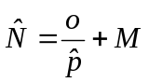 | (1)
where:
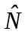 = | the total number of household permits issued,
= | the number of permits issued and returned by households before the first reminder letter, but with no vendor card (the “orphan permits”),
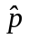 = | 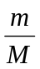= | the response rate before the first reminder letter among households with vendor cards,
= | the number of permits returned before the first reminder letter mailing with vendor cards,
 = | the total number of permits with vendor cards.
With variance estimated as:
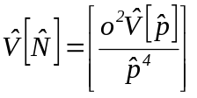 , | (2)
where,
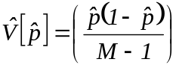 .
The estimated number of permits issued will then be divided in 4 groups:
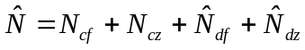 , | (3)
where:
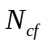= | the number of compliant households who reported fishing,
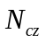= | the number of compliant households who reported they did not fish,
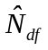= | 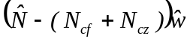,
 | the estimated number of non-compliant households who fished,
 | where 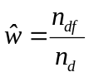
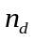 = the number of non-compliant households responding to the last reminder,
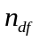 = the number of non-compliant households who responded to the last reminder and reported fishing, and
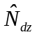= | the estimated number of non-compliant households who reported they did not fish.
 | 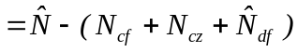
Harvest for each species or participation for each site is estimated by the following procedure (with subscripts denoting parameter of estimation deleted for simplicity):
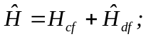 | (4)
where:
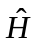 = | estimated total harvest or participation;
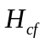 = | harvest or participation reported by compliant households, and;
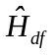 = | estimated harvest by non-compliant households = 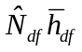
where 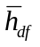 = the mean harvest or participation per household for non-compliant households that fished
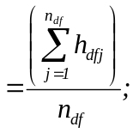
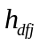 = | reported harvest by household j that responded, was non-compliant, and fished
= | the number of households that responded, were non-compliant, and fished.

Variance will be calculated as (Goodman 1960):
, | (5)
where:
, | (6)
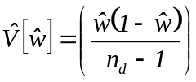,
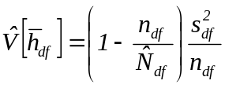 , and | (7)
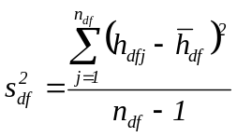 . | (8)
Standard errors are simply the square root of the variance estimate.

Project Personnel responsibilities, SCHEDULES AND rEPORTing
Principal Investigator: Supervises all aspects of the project and coordinates with all project staff to ensure that project milestones are on schedule. Primary author of the project operational plan, reports, correspondence with license vendors and permit holders. Responsible for permit modifications, permit distribution and tracking, issuing reminders, contracting printing services and project budgeting.
Analyst Programmer: Assists the principal investigator with all programming aspects of the database application used for project permitting, harvest reporting and data archiving. Conducts data quality reviews prior to finalizing the database and develops data files for principal investigator and project biometrician.
Project Biometrician: Assists the principal investigator with data analysis, reporting and operational planning.
Key Punch Clerk Supervisor: Assists the principal investigator by supervising the data entry process. Ensures that permit information and harvest reporting are entered into the database according to the operational plan and conducts daily quality control measures of all key punching clerks entering permit or harvest information into the database.

The following milestones must be met to keep the survey on schedule:
- Project staff designs, modify and reviews 2007 permit prior to March 2007.
- 2007 Permits are printed and delivered to the office by the last week of March, 2007 making them available to residents during the Anchorage Sportsmen Show.
- Permits are bundled and distributed to area offices and vendors by the first week of June. Permits for Anchorage vendors are distributed to vendors by RTS staff and the project biologist. Permits for Mat-Su and Kenai Peninsula vendors are distributed by the area offices and/or the project biologist.
- Vendor portions of 2007 permits will be collected from license vendors by August 31, 2007.
- All permit holder identification information from the top copies of the permits will be keypunched by September 10, 2007. Permit and harvest information is key punched on an opportunistic bases from June 1 through September 10.
- Non-respondents will be identified and first reminder letter mailed by September 15, 2007.
- Non-respondents from the first mailing will be identified and second reminder letter mailed to the non-respondents by October 15, 2007.
- License numbers and harvest and participation information from respondents to the second reminder will be keypunched by November 15, 2007.
- Final, clean data set, along with metadata and log of the edits will be given to project leader by December 15, 2007.
- Annual summary tables of participation and harvest will be available for management purposes in February 2008.

LITERATURE CITED

Alaska Administrative Code. Fish and Game Laws and Regulations, 2004-2005 edition. LexisNexis, Charlottesville, VA.
Goodman, L. A. 1960. On the exact variance of products. Journal of the American Statistical Association 55: 708-713.
Nelson, D., D. Athons, P. Berkhahn, and S. Sonnichsen 1999. Area management report for the recreational fisheries of the Kenai Peninsula, 1995-1997. Alaska Department of Fish and Game, Fishery Management Report No. 99-3, Anchorage.
Reimer, A.M. and D. Sigurdsson. 2004. Upper Cook Inlet personal use salmon fisheries, 1996-2003. Alaska Department of Fish and Game, Fishery Data Series Report No. 04-31, Anchorage.

Project Budget
Code | Line Item | Cost (K)
100 | Personal Services | 43.0
200 | Travel | 1.0
300 | Contractual | 10.8
400 | Commodities | 0.0
500 | Equipment | 0.0
700 | Grants | 0.0
Total |  | 54.8

Budget Manager: Kristine Dunker, Fishery Biologist

Project Personnel:
Name | Job Class | Months Budgeted
Kirk Brogdon | Analyst Programmer V | 1.0
Diane Novinska | Administrative Clerk II | 4.0
Sabrina Pulu | Administrative Clerk II | 2.0
Kristine Dunker | Fishery Biologist III | 1.0
Total |  | 8.0

Table 1.-Number of permits issued and response rates by mailing, 2000-2006.
 |  | 2000 | 2001 | 2002 | 2003 | 2004 | 2005 | 2006 | Average
Permits Issued (estimated) |  | 16,107 | 16,915 | 17,568 | 19,110 | 21,910 | 21,905 | 18,563 | 18,868
Voluntary Returnsa |  | 50.1% | 50.3% | 50.9% | 50.8% | 48.6% | 58.7% | 62.8% | 53.2%
Returned after first reminder |  | 24.6% | 23.0% | 18.6% | 19.0% | 9.5% | 19.1% | 19.7% | 19.1%^{b}
Returned after second reminder |  | 9.6% | 11.7% | 12.4% | 13.4% | 22.9% | 10.0% | 6.7% | 12.4%^{b}
Non-response |  | 15.7% | 14.9% | 18.1% | 16.7% | 19.0% | 12.2% | 10.8% | 15.3%^{b}
Total |  | 100.0% | 99.9% | 100.0% | 99.9% | 100.0% | 100% | 100.0%
a Voluntary households are those that voluntarily returned their completed permits without being mailed a reminder letter.
^{b} 2004 not included in the average.

Table 2. Salmon harvests, standard errors and relative precision in Upper Cook Inlet Personal Use Fisheries, 1996-2006.

Fish Creek Dip Net
 |  | Days Open |  | Days Fished |  |  | Sockeye |  |  | Chinook |  |  | Coho |  |  | Pink |  |  | Chum |  |  | Total
Year |  | Days Open |  | Estimate | RPª |  | Estimate | RPª |  | Estimate | RPª |  | Estimate | RPª |  | Estimate | RPª |  | Estimate | RPª |  | Estimate | RPª
1996 |  | 22 |  | 3,749 | 2% |  | 17,260 | 2% |  | 37 | 42% |  | 2,414 | 2% |  | 331 | 5% |  | 153 | 6% |  | 20,195 | 2%
1997 |  | 13 |  | 991 | 7% |  | 3,277 | 5% |  | 0 |  |  | 63 | 16% |  | 53 | 26% |  | 4 | 49% |  | 3,397 | 5%
1998 |  | 15 |  | 1,141 | 4% |  | 4,036 | 5% |  | 1 | 0% |  | 649 | 6% |  | 80 | 25% |  | 29 | 14% |  | 4,795 | 5%
1999 |  | 16 |  | 432 | 7% |  | 1,083 | 25% |  | 0 |  |  | 17 | 35% |  | 12 | 114% |  | 0 |  |  | 1,112 | 25%
2000 |  | 16 |  | 1,054 | 5% |  | 6,925 | 6% |  | 0 |  |  | 958 | 15% |  | 83 | 28% |  | 29 | 20% |  | 7,995 | 6%
2001 |  | 3 |  | 131 | 10% |  | 436 | 18% |  | 0 |  |  | 18 | 76% |  | 2 | 0% |  | 1 | 0% |  | 457 | 18%
2002 |  | 0
2003 |  | 0
2004 |  | 0
2005 |  | 0
2006 |  | 0

Kasilof River Dip Net
 |  | Days Open |  | Days Fished |  |  | Sockeye |  |  | Chinook |  |  | Coho |  |  | Pink |  |  | Chum |  |  | Total
Year |  | Days Open |  | Estimate | RPª |  | Estimate | RPª |  | Estimate | RPª |  | Estimate | RPª |  | Estimate | RPª |  | Estimate | RPª |  | Estimate | RPª
1996 |  | 27 |  | 1,300 | 3% |  | 11,197 | 2% |  | 50 | 4% |  | 334 | 11% |  | 103 | 4% |  | 17 | 0% |  | 11,701 | 2%
1997 |  | 27 |  | 1,091 | 6% |  | 9,737 | 3% |  | 35 | 11% |  | 90 | 7% |  | 19 | 21% |  | 19 | 10% |  | 9,900 | 3%
1998 |  | 27 |  | 3,421 | 2% |  | 45,161 | 2% |  | 134 | 4% |  | 731 | 5% |  | 610 | 8% |  | 74 | 85% |  | 46,710 | 2%
1999 |  | 27 |  | 3,611 | 2% |  | 37,176 | 3% |  | 127 | 8% |  | 286 | 34% |  | 264 | 9% |  | 52 | 30% |  | 37,905 | 3%
2000 |  | 27 |  | 2,622 | 3% |  | 23,877 | 3% |  | 134 | 10% |  | 1,004 | 3% |  | 841 | 9% |  | 34 | 0% |  | 25,890 | 3%
2001 |  | 27 |  | 3,382 | 2% |  | 37,612 | 3% |  | 138 | 9% |  | 766 | 6% |  | 307 | 9% |  | 23 | 0% |  | 38,846 | 3%
2002 |  | 44 |  | 4,020 | 2% |  | 46,769 | 2% |  | 106 | 11% |  | 1197 | 10% |  | 1,862 | 8% |  | 139 | 10% |  | 50,073 | 2%
2003 |  | 44 |  | 3,874 | 1% |  | 43,870 | 2% |  | 57 | 14% |  | 592 | 16% |  | 286 | 14% |  | 30 | 7% |  | 44,835 | 2%
2004 |  | 44 |  | 4,432 | <1% |  | 48,315 | 1% |  | 44 | 13% |  | 668 | 6% |  | 396 | 7% |  | 90 | 11% |  | 49,515 | 1%
2005 | ^{b} | 44 |  | 4,500 | <1% |  | 43,151 | <1% |  | 16 | 12% |  | 538 | 6% |  | 658 | 4% |  | 102 | 4% |  | 44,465 | <1%
2006 |  | 44 |  | 5,763 | <1% |  | 56,144 | <1% |  | 55 | 4% |  | 1,057 | 3% |  | 992 | 2% |  | 105 | 7% |  | 58,353 | <1%

Table 2.–Page 2 of 3.

Kasilof River Gillnet
 |  | Days Open |  | Days Fished |  |  | Sockeye |  |  |  | Chinook |  |  |  |  |  | Coho |  |  |  |  | Pink |  |  | Chum |  |  | Total
Year |  | Days Open |  | Estimate | RPª |  | Estimate | RPª |  |  | Estimate |  | RPª |  |  |  | Estimate |  | RPª |  |  | Estimate | RPª |  | Estimate | RPª |  | Estimate | RPª
1996 |  | 5 |  | 582 | 5% |  | 9,506 | 3% |  |  |  | 46 |  | 13% |  |  |  | 0 |  |  |  | 8 | 0% |  | 1 | 0% |  | 9,561 | 3%
1997 |  | 5 |  | 815 | 6% |  | 17,997 | 3% |  |  |  | 65 |  | 6% |  |  |  | 1 |  | 0% |  | 102 | 13% |  | 3 | 65% |  | 18,168 | 3%
1998 |  | 5 |  | 1,075 | 4% |  | 15,975 | 5% |  |  |  | 126 |  | 11% |  |  |  | 0 |  |  |  | 15 | 52% |  | 12 | 163% |  | 16,128 | 5%
1999 |  | 10 |  | 1,287 | 6% |  | 12,832 | 6% |  |  |  | 442 |  | 12% |  |  |  | 25 |  | 16% |  | 10 | 0% |  | 10 | 0% |  | 13,319 | 6%
2000 |  | 13 |  | 1,252 | 4% |  | 14,774 | 4% |  |  |  | 514 |  | 6% |  |  |  | 9 |  | 0% |  | 17 | 23% |  | 10 | 0% |  | 15,324 | 4%
2001 |  | 8 |  | 1,001 | 4% |  | 17,201 | 4% |  |  |  | 174 |  | 7% |  |  |  | 6 |  | 0% |  | 11 | 0% |  | 7 | 140% |  | 17,399 | 4%
2002 |  | 10 |  | 1,025 | 3% |  | 17,980 | 3% |  |  |  | 192 |  | 5% |  |  |  | 12 |  | 0% |  | 30 | 13% |  | 13 | 60% |  | 18,227 | 3%
2003 |  | 10 |  | 1,206 | 3% |  | 15,706 | 3% |  |  |  | 400 |  | 6% |  |  |  | 107 |  | 0% |  | 9 | 0% |  | 4 | 0% |  | 16,226 | 3%
2004 |  | 10 |  | 1,272 | 2% |  | 25,417 | 2% |  |  |  | 163 |  | 5% |  |  |  | 58 |  | 44% |  | 6 | 33% |  | 0 | 0% |  | 25,644 | 2%
2005 | ^{c} | 11 |  | 1,506 | 1% |  | 26,609 | 1% |  |  |  | 87 |  | 2% |  |  |  | 326 |  | 3% |  | 16 | 12% |  | 1 | 0% |  | 27,039 | 1%
2006 |  | 10 |  | 1,724 | 1% |  | 28,867 | 1% |  |  |  | 287 |  | 1% |  |  |  | 420 |  | 7% |  | 11 | 0% |  | 6 | 0% |  | 29,591 | 1%

Kenai River Dip Net
 |  | Days Open |  | Days Fished |  |  | Sockeye |  |  |  | Chinook |  |  |  |  |  | Coho |  |  |  |  | Pink |  |  | Chum |  |  | Total
Year |  | Days Open |  | Estimate | RPª |  | Estimate | RPª |  |  | Estimate |  | RPª |  |  |  | Estimate |  | RPª |  |  | Estimate | RPª |  | Estimate | RPª |  | Estimate | RPª
1996 |  | 27 |  | 10,503 | 1% |  | 102,821 | 1% |  |  |  | 295 |  | 3% |  |  |  | 1,932 |  | 3% |  | 2,404 | 3% |  | 175 | 11% |  | 107,627 | 1%
1997 |  | 22 |  | 11,023 | 2% |  | 114,619 | 1% |  |  |  | 364 |  | 7% |  |  |  | 559 |  | 7% |  | 619 | 4% |  | 58 | 17% |  | 116,219 | 1%
1998 |  | 18 |  | 10,802 | 1% |  | 103,847 | 1% |  |  |  | 254 |  | 8% |  |  |  | 1,011 |  | 12% |  | 1,032 | 12% |  | 85 | 7% |  | 106,229 | 1%
1999 |  | 22 |  | 13,738 | 1% |  | 149,504 | 1% |  |  |  | 488 |  | 5% |  |  |  | 1,009 |  | 21% |  | 1,666 | 8% |  | 102 | 25% |  | 152,769 | 1%
2000 |  | 22 |  | 12,354 | 1% |  | 98,262 | 1% |  |  |  | 410 |  | 9% |  |  |  | 1,449 |  | 8% |  | 1,457 | 10% |  | 193 | 31% |  | 101,771 | 1%
2001 |  | 22 |  | 14,772 | 1% |  | 150,766 | 1% |  |  |  | 638 |  | 5% |  |  |  | 1,555 |  | 13% |  | 1,326 | 5% |  | 155 | 24% |  | 154,440 | 1%
2002 |  | 22 |  | 14,840 | 1% |  | 180,028 | 1% |  |  |  | 606 |  | 4% |  |  |  | 1,721 |  | 7% |  | 5,662 | 4% |  | 551 | 13% |  | 188,568 | 1%
2003 |  | 22 |  | 15,263 | 1% |  | 223,580 | 1% |  |  |  | 1,016 |  | 3% |  |  |  | 1,332 |  | 10% |  | 1,647 | 12% |  | 249 | 17% |  | 227,824 | 1%
2004 |  | 22 |  | 18,513 | <1% |  | 262,831 | <1% |  |  |  | 792 |  | 2% |  |  |  | 2,661 |  | 5% |  | 2,103 | 3% |  | 387 | 6% |  | 268,773 | <1%
2005 |  | 22 |  | 20,977 | <1% |  | 295,496 | <1% |  |  |  | 997 |  | 1% |  |  |  | 2,512 |  | 2% |  | 1,806 | 1% |  | 321 | 1% |  | 301,132 | <1%
2006 | ^{d} | 20 |  | 12,685 | <1% |  | 127,630 | <1% |  |  |  | 1,034 |  | 1% |  |  |  | 2,235 |  | 1% |  | 11,127 | 1% |  | 551 | 3% |  | 142,577 | <1%
Table 2.–Page 3 of 3.

Unknown Fishery
 |  | Days Open |  | Days Fished |  |  | Sockeye |  |  |  | Chinook |  |  |  |  |  | Coho |  |  |  |  | Pink |  |  | Chum |  |  | Total
Year |  | Days Open |  | Estimate | RPª |  | Estimate | RPª |  |  | Estimate |  | RPª |  |  |  | Estimate |  | RPª |  |  | Estimate | RPª |  | Estimate | RPª |  | Estimate | RPª
1996 |  |  |  | 472 | 14% |  | 4,761 | 19% |  |  |  | 24 |  | 57% |  |  |  | 131 |  | 55% |  | 127 | 57% |  | 4 | 147% |  | 5,047 | 18%
1997 |  |  |  | 1,003 | 10% |  | 3,310 | 16% |  |  |  | 0 |  | 0% |  |  |  | 64 |  | 43% |  | 51 | 81% |  | 4 | 147% |  | 3,429 | 16%
1998 |  |  |  | 921 | 8% |  | 7,562 | 7% |  |  |  | 34 |  | 29% |  |  |  | 294 |  | 51% |  | 196 | 19% |  | 20 | 0% |  | 8,106 | 7%
1999 |  |  |  | 684 | 6% |  | 7,994 | 9% |  |  |  | 51 |  | 19% |  |  |  | 76 |  | 18% |  | 126 | 3% |  | 4 | 0% |  | 8,251 | 8%
2000 |  |  |  | 648 | 7% |  | 5,429 | 10% |  |  |  | 44 |  | 58% |  |  |  | 218 |  | 54% |  | 84 | 26% |  | 24 | 123% |  | 5,799 | 10%
2001 |  |  |  | 1,339 | 5% |  | 12,673 | 6% |  |  |  | 188 |  | 18% |  |  |  | 292 |  | 20% |  | 175 | 27% |  | 90 | 74% |  | 13,418 | 6%
2002 |  |  |  | 1,339 | 4% |  | 14,846 | 5% |  |  |  | 166 |  | 12% |  |  |  | 341 |  | 14% |  | 916 | 17% |  | 54 | 29% |  | 16,323 | 5%
2003 |  |  |  | 1,325 | 3% |  | 15,675 | 3% |  |  |  | 238 |  | 21% |  |  |  | 219 |  | 13% |  | 140 | 13% |  | 88 | 20% |  | 16,360 | 3%
2004 |  |  |  | 1,143 | 2% |  | 13,527 | 3% |  |  |  | 99 |  | 6% |  |  |  | 366 |  | 14% |  | 210 | 9% |  | 502 | 5% |  | 14,227 | 3%
2005 |  |  |  | 270 | 1% |  | 4,520 | 2% |  |  |  | 32 |  | 6% |  |  |  | 39 |  | 5% |  | 40 | 10% |  | 4 | 0% |  | 4,635 | 2%
2006 | ^{e} |  |  | 371 | 2% |  | 3,406 | 3% |  |  |  | 29 |  | 6% |  |  |  | 47 |  | 14% |  | 304 | 9% |  | 84 | 5% |  | 3,870 | 3%

Upper Cook Inlet Personal Use Fisheries Total
 |  | Days Open |  | Days Fished |  |  | Sockeye |  |  |  | Chinook |  |  |  |  |  | Coho |  |  |  |  | Pink |  |  | Chum |  |  | Total
Year |  | Days Open |  | Estimate | RPª |  | Estimate | RPª |  |  | Estimate |  | RPª |  |  |  | Estimate |  | RPª |  |  | Estimate | RPª |  | Estimate | RPª |  | Estimate | RPª
1996 |  |  |  | 16,606 | 1% |  | 145,545 | 1% |  |  |  | 452 |  | 5% |  |  |  | 4,811 |  | 2% |  | 2,973 | 3% |  | 350 | 7% |  | 154,131 | 1%
1997 |  |  |  | 14,923 | 2% |  | 148,940 | 1% |  |  |  | 464 |  | 5% |  |  |  | 777 |  | 7% |  | 844 | 6% |  | 88 | 13% |  | 151,113 | 1%
1998 |  |  |  | 17,360 | 1% |  | 176,581 | 1% |  |  |  | 549 |  | 5% |  |  |  | 2,685 |  | 7% |  | 1,933 | 7% |  | 220 | 30% |  | 181,968 | 1%
1999 |  |  |  | 19,752 | 1% |  | 208,589 | 1% |  |  |  | 1,108 |  | 5% |  |  |  | 1,413 |  | 17% |  | 2,078 | 6% |  | 168 | 18% |  | 213,356 | 1%
2000 |  |  |  | 17,930 | 1% |  | 149,267 | 1% |  |  |  | 1,102 |  | 5% |  |  |  | 3,638 |  | 6% |  | 2,482 | 7% |  | 290 | 24% |  | 156,779 | 1%
2001 |  |  |  | 20,625 | 1% |  | 218,688 | 1% |  |  |  | 1,138 |  | 4% |  |  |  | 2,637 |  | 8% |  | 1,821 | 5% |  | 276 | 28% |  | 224,560 | 1%
2002 |  |  |  | 21,224 | 1% |  | 259,623 | 1% |  |  |  | 1,070 |  | 3% |  |  |  | 3,271 |  | 5% |  | 8,470 | 3% |  | 757 | 10% |  | 273,191 | 1%
2003 |  |  |  | 21,668 | 1% |  | 298,831 | 1% |  |  |  | 1,711 |  | 4% |  |  |  | 2,250 |  | 7% |  | 2,082 | 10% |  | 371 | 13% |  | 305,245 | 1%
2004 |  |  |  | 25,360 | <1% |  | 350,091 | <1% |  |  |  | 1,098 |  | 2% |  |  |  | 3,754 |  | 4% |  | 2,715 | 2% |  | 502 | 5% |  | 358,160 | <1%
2005 |  |  |  | 27,253 | <1% |  | 369,776 | <1% |  |  |  | 1,132 |  | <1% |  |  |  | 3,415 |  | 2% |  | 2,520 | 1% |  | 428 | 1% |  | 377,271 | <1%
2006 | ^{d} |  |  | 20,543 | <1% |  | 216,047 | <1% |  |  |  | 1,405 |  | 1% |  |  |  | 3,759 |  | 1% |  | 12,434 | 1% |  | 746 | 3% |  | 234,391 | <1%
ª Relative precision (SE *1.96)/estimate
^{b} EO 2-RS-1-12-05 extended area and hours of dip netting from June 25 to July 31.
^{c} EO 2-S-1-05 extended gillnetting from June 24 to June 25.
^{d} EO 2-RS-1-16-06 closed dip netting at the mouth of the Kenai river on July 21st; EO 2-RS-1-34-06 re-opened dip netting at the mouth of the Kenai river on July 31st; EO 2-RS-1-37-06 re-opened dip netting at the mouth of the Kenai river from August 3rd through August 10th.
^{e} In 2006 a follow-up phone survey was conducted to distribute the “Unknown Fishery” harvest between the Kenai and the Kasilof Dip Net fishery.
Table 3. Flounder harvests, standard errors and relative precision in Upper Cook Inlet Personal Use Fisheries, 2005-2006.
 |  | Days Open | Days Fished |  |  |  | Flounder
Year |  | Days Open | Est. | SE | RPª |  | Est. | SE | RPª
Fish Creek Dip Net
2005 |  | 0 |  |  |  |  | 0
2006 |  | 0 |  |  |  |  | 0
Kasilof Dip Net
2005^{b} |  | 44 | 4,500 | 9 | <1% |  | 322 | 3 | 2%
2006 |  | 44 | 5,763 | 10 | <1% |  | 215 | 2 | 2%
Kasilof Gill Net
2005^{c} |  | 11 | 1,506 | 6 | 1% |  | 101 | 1 | 2%
2006 |  | 10 | 1,724 | 5 | 1% |  | 162 | 2 | 2%
Kenai River Dip Net
2005 |  | 22 | 20,977 | 18 | <1% |  | 1,572 | 5 | 1%
2006^{d} |  | 20 | 12,685 | 16 | <1% |  | 1,913 | 11 | 1%
Unknown Fishery
2005 |  |  | 270 | 2 | 1% |  | 29 | 2 | 14%
2006 |  |  | 371 | 2 | 2% |  | 45 | 3 | 13%
Upper Cook Inlet Personal Use Fisheries Total
2005 |  |  | 27,253 | 21 | <1% |  | 2,024 | 6 | 1%
2006 |  |  | 20,543 | 20 | <1% |  | 2,335 | 12 | 1%
ª Relative precision (SE *1.96)/estimate
^{b} EO 2-RS-1-12-05 extended area and hours of dip netting from June 25 to July 31.
^{c} EO 2-S-1-05 extended gillnetting from June 24 to June 25.
^{d} EO 2-RS-1-16-06 closed dip netting at the mouth of the Kenai river on July 21st; EO 2-RS-1-34-06 re-opened dip netting at the mouth of the Kenai river on July 31st; EO 2-RS-1-37-06 re-opened dip netting at the mouth of the Kenai river from August 3rd through August 10th.

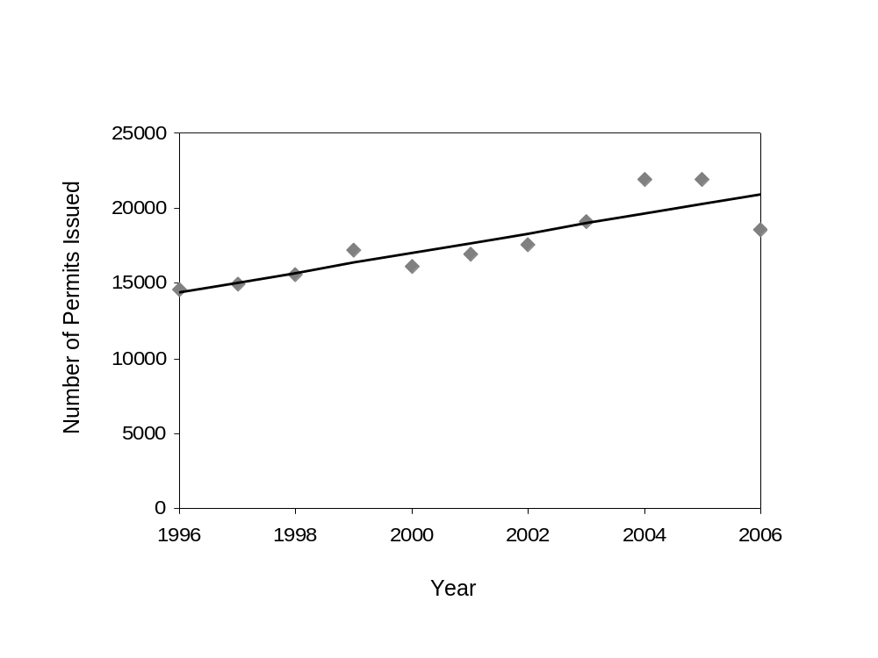

Figure 1. Number of personal use permits issued in Upper Cook Inlet in 1996-2006.

Appendix A – 2007 Personal Use Permit
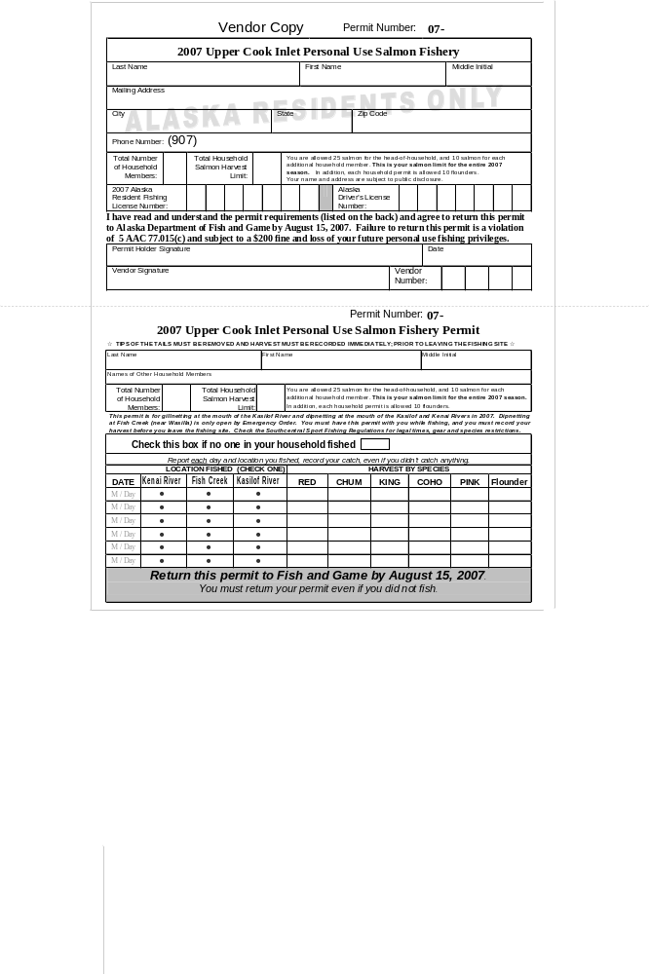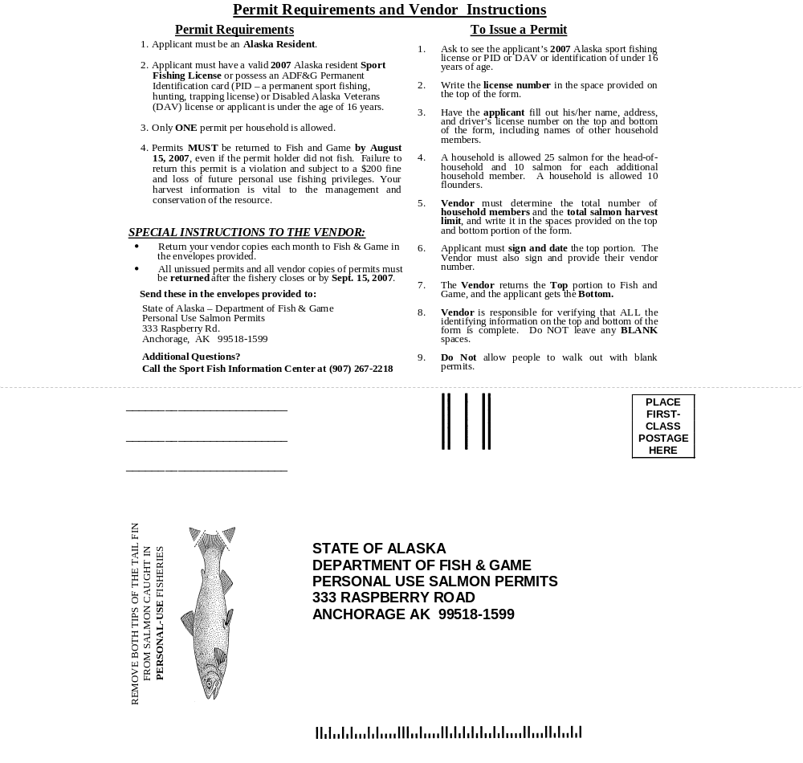

Appendix B -Reminder letter to be mailed to nonrespondents

PRST STD
U.S. Postage PAID
Anchorage, AK

STATE OF ALASKA

DEPARTMENT OF FISH & GAME
Personal Use Salmon Permits
333 raspberry road
Anchorage AK 99518-1599

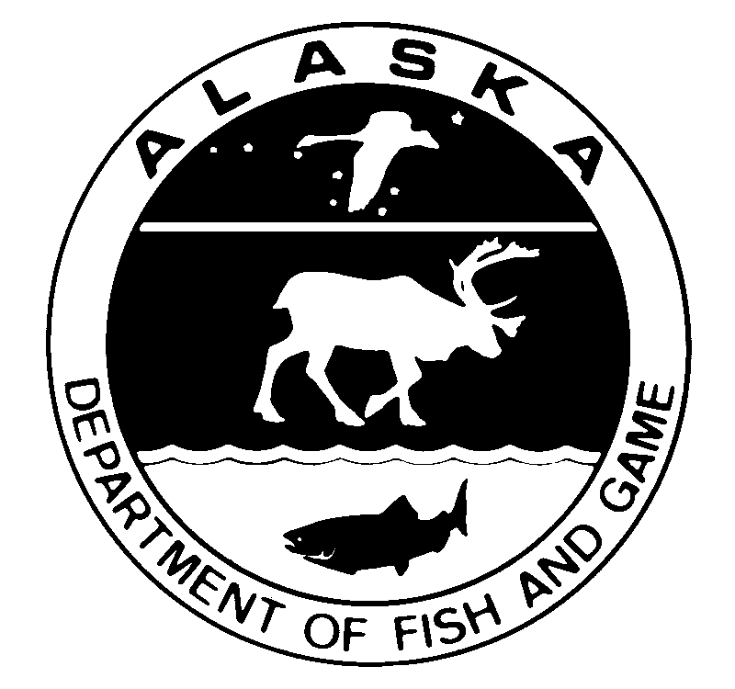
2007 Upper Cook Inlet Personal Use Salmon Fishery-Reminder

Dear Permit Holder, 07 – XXXXX - 1st
Our records indicate that you have not returned your 2007 Upper Cook Inlet Personal Use Salmon permit. Please take a few minutes to return the original permit or use the form below. Your harvest information is vital to continuing salmon management and personal use fishing opportunities in the future.
Remember that you must return your permit, even if you did not fish. Failure to return your permit is a violation of 5 AAC 77.015(c) and subject to a $200 fine and loss of your future personal use fishing privileges.
Total Number of Household members: |  |  | Total Household Salmon Harvest Limit: |  |  |  | You are allowed 25 salmon for the head-of-household, and 10 salmon for each additional household member. This is your limit for the entire 2006 season.  In addition, each household permit is allowed 10 flounders.
Check this box if no one in your household fished
Report each day and location you fished, record your catch, even if you didn’t catch anything.
LOCATION FISHED (CHECK ONE) |  |  |  |  |  | HARVEST BY SPECIES
Date | Kenai River |  | Fish Creek | Kasilof River |  | RED |  | CHUM | KING | COHO | PINK | Flounder
m / Day
m / Day
m / Day
m / Day
m / Day
m / Day
YOU MUST RETURN YOUR PERMIT EVEN IF YOU DID NOT FISH.

Place
first-class
Postage
Here


STATE OF ALASKA

DEPARTMENT OF FISH & GAME
Personal Use Salmon Permits
333 raspberry road
Anchorage AK 99518-1599

STATE OF ALASKA

DEPARTMENT OF FISH & GAME

Personal Use Salmon Permits
333 raspberry road
Anchorage AK 99518-1599

Appendix C - Cook Inlet personal use Fishing Regulations, 2007
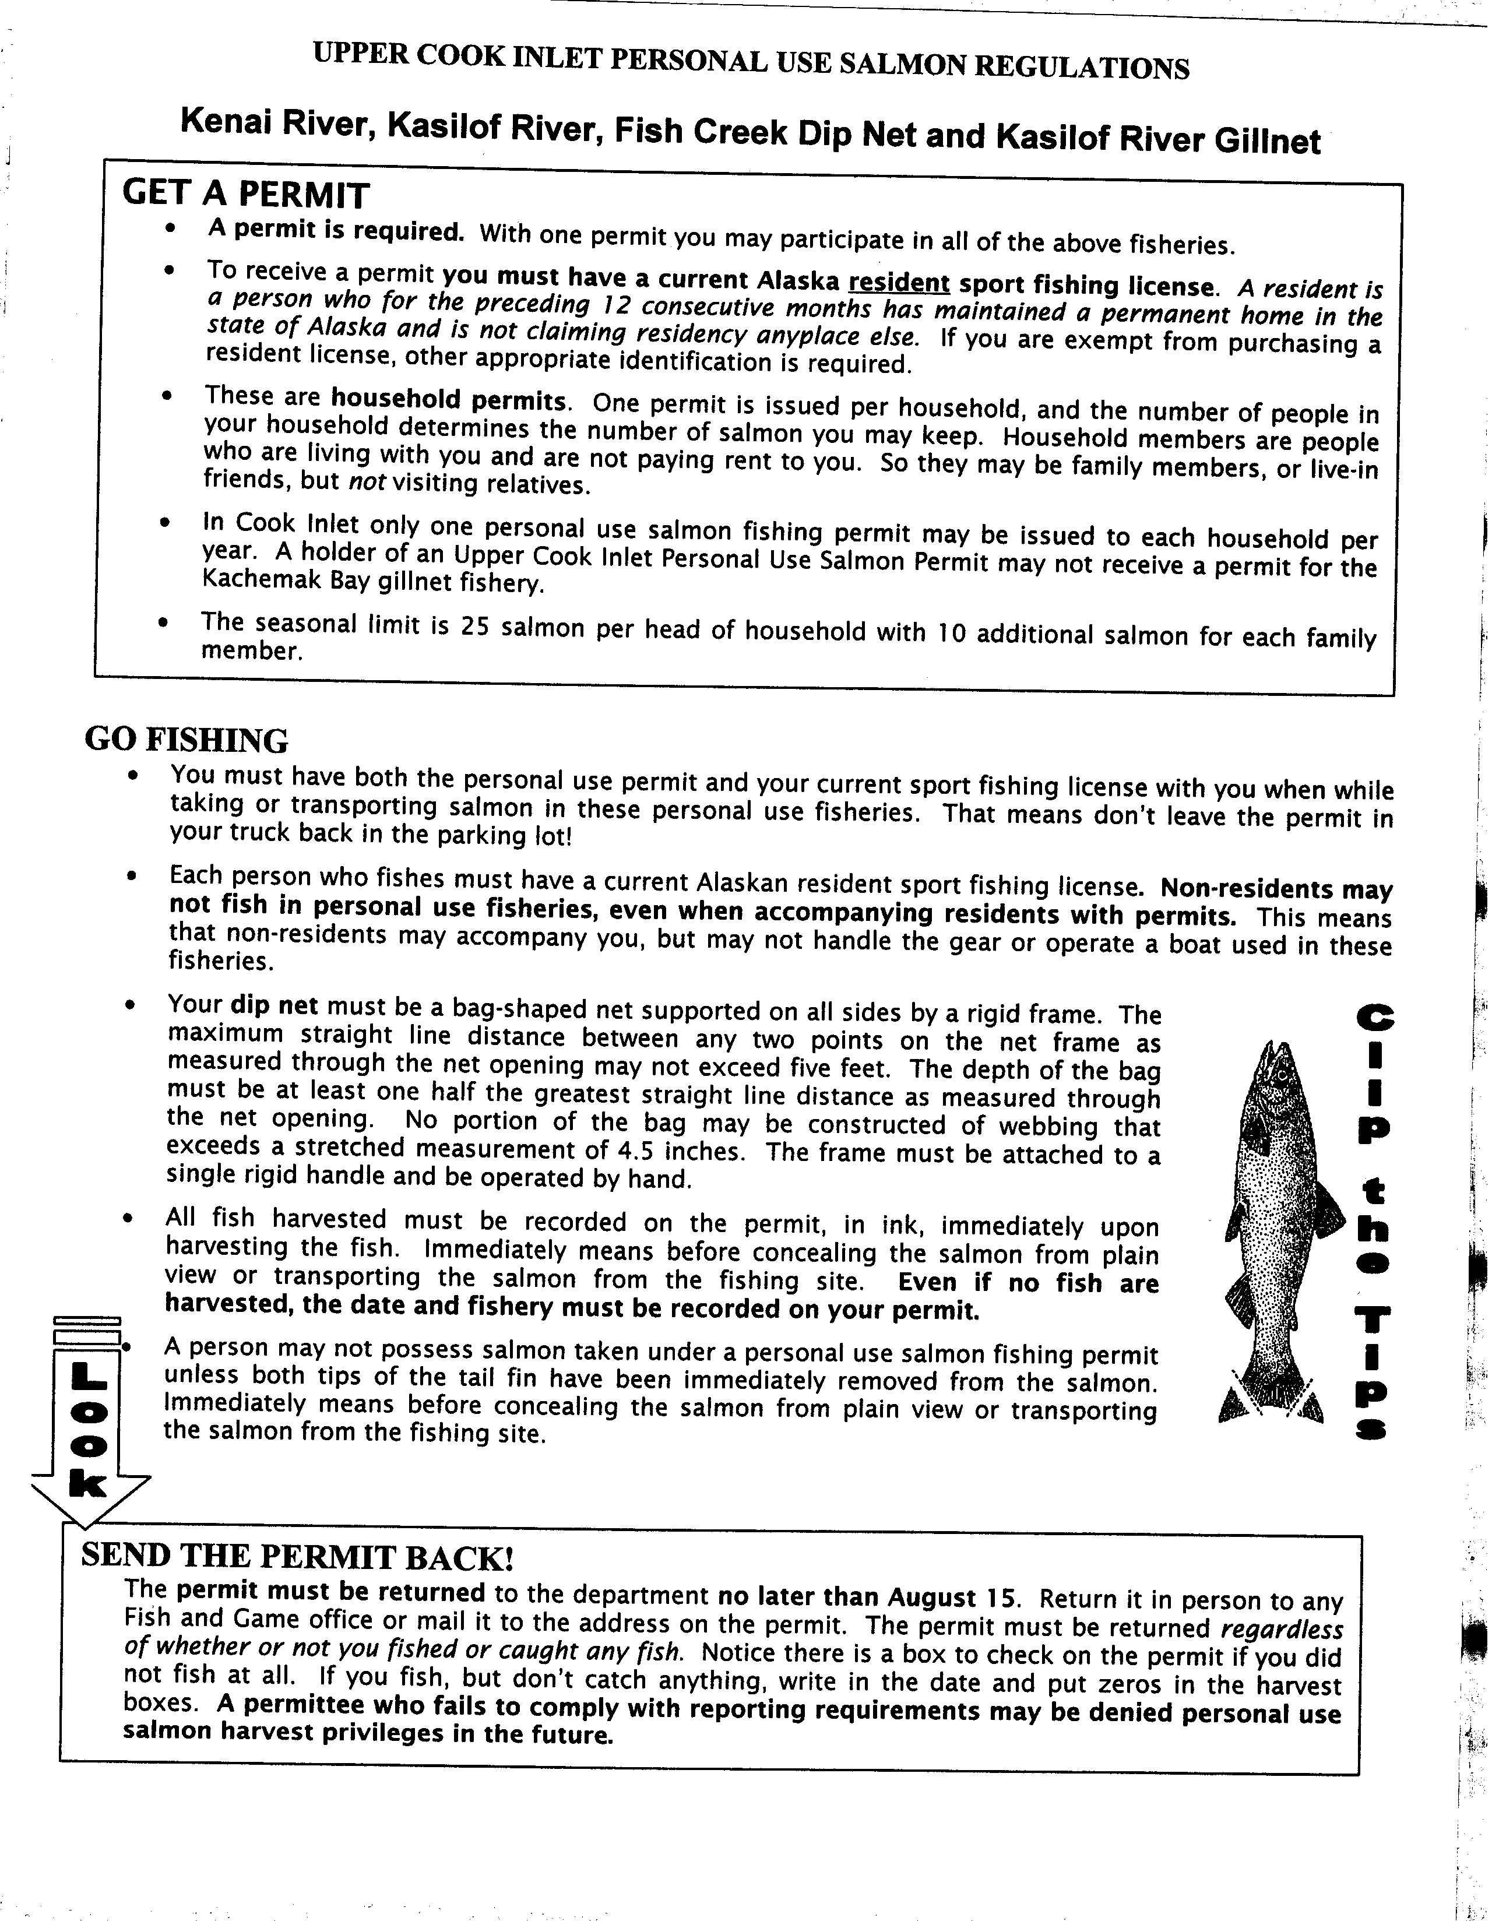
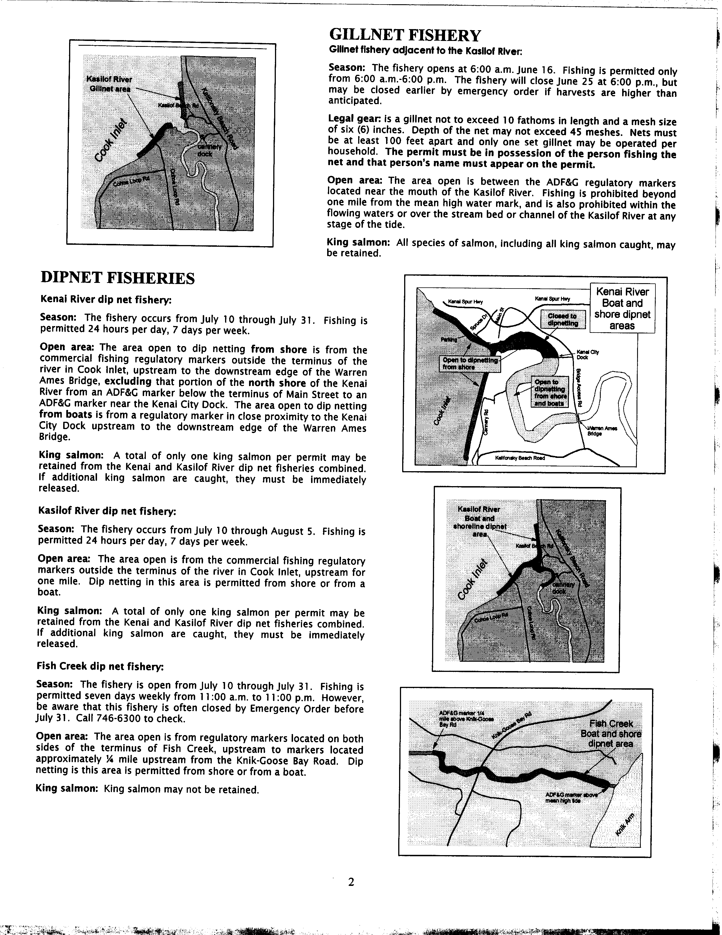

Appendix d - Keypunching instructions

2007 Cook Inlet Personal Use Salmon

Data Entry Instructions

Overview
The Cook Inlet Personal Use Salmon Project is key punched by the Anchorage ADF&G Sport Fish RTS Data Entry staff using an Intranet based application. The application consists of HTML pages written in Cold Fusion that allow entry, editing and deletion of permit holder and harvest information. Access to this application is through the ADFG Intranet and restricted based on user ID as to what functions are allowed. Data from the entry application goes directly into two MS SQL “raw” tables - one for the permit holder information (CISLPMXX) and one for the harvest information (CISLHVXX). These tables are part of the CISALXX database.

Permit Holder Entry
Access to the Permit Entry system is through the ADF&G Intranet Site Index Main Menu Permits section:

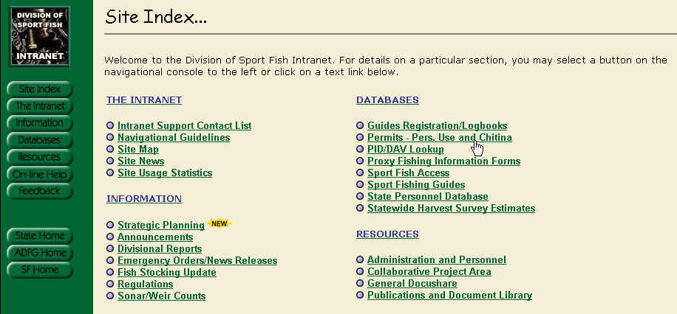

Once selected, you should see the following screen:
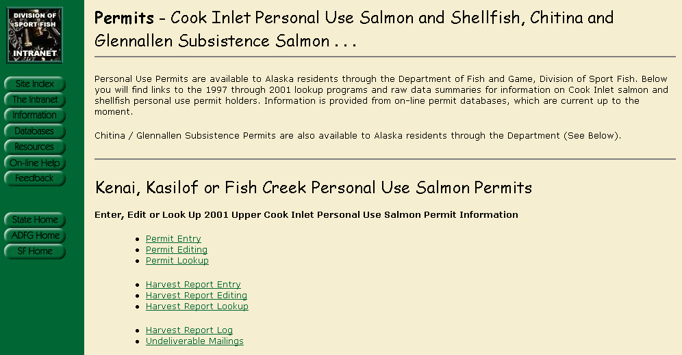

Selecting Permit Entry will bring up a screen in which you enter the Permit Number that is stamped on the bottom right of the Permit itself and whatever ID number that is written in the ADL / ID box on the permit. This number will be searched through the previous years database, PID database and Sports License Database (in that order) to try and fill the applicable fields.

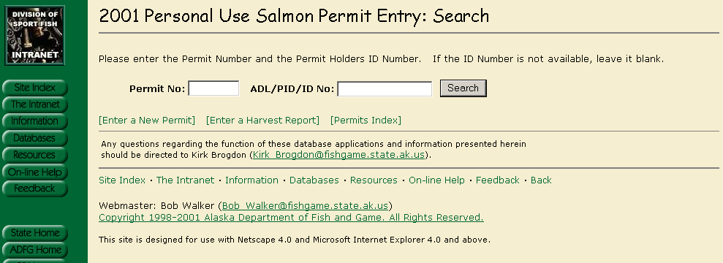

Note that the year (2007) and the addition of flounder are the only changes in data entry structure.

If a record is found, you will see a display showing the Name and ID number as well as an indication as to what Database the information was found. If the Information appears to be the same person that you are entering for, click on any field in the box to auto fill the permit with as much information as possible.

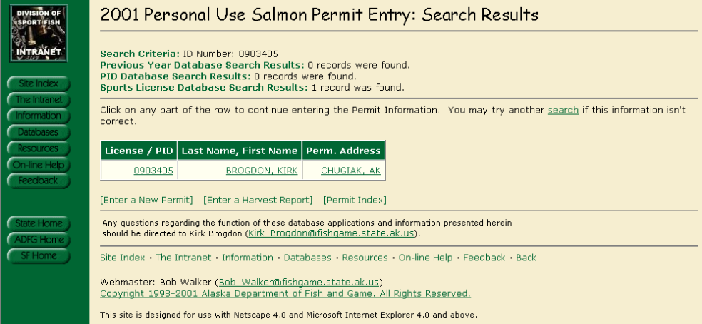
Which should bring up the following screen in which you can complete and/or edit based on the written permit. If there is no information available then the same screen will come up but all of the fields will be blank.
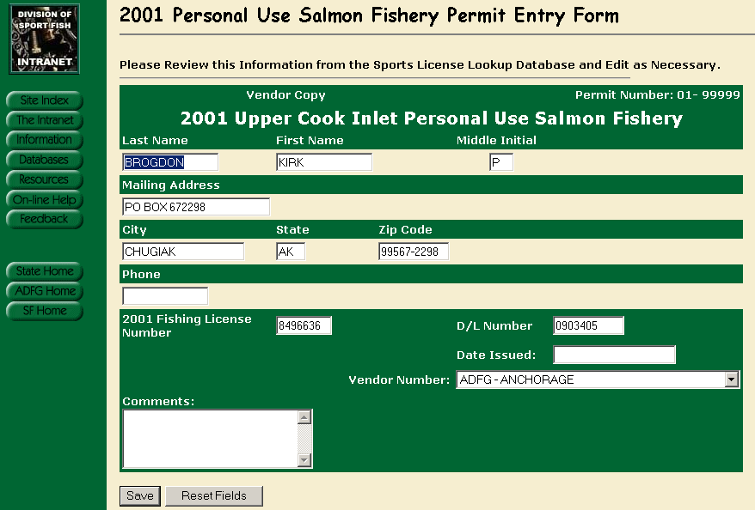

Once filled out, click on the Save button and you should see the following:

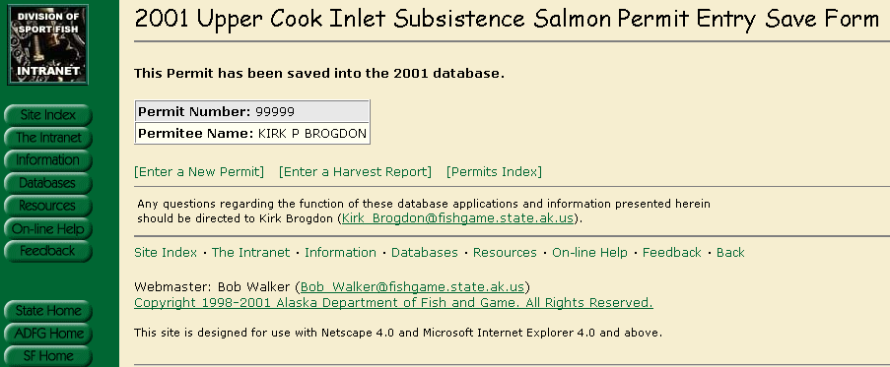

Miscellaneous Permit Entry Notes

Required Fields:
- Date Issued
If the Date Issued is left blank, the Entry Clerk is prompted that it must be filled in and to enter ‘01/01/yyyy’ if the actual permit does not have an issued date on it.

Permit Editing

From the same screen that you select Permit Entry, there is a link for Permit Editing. When selected, you should see a similar screen as the Entry screen plus there will be check boxes for Did Not Fish, Blank Report and No Success.

Permit Lookup

From the same screen that you select Permit Entry, there is a link for Permit Lookups. This screen will display all the Permit Information but will not allow any edits or deletions. There is also a link to display the actual scanned image of a returned Harvest Report.

Harvest Report Entry
From the same screen that you select Permit Entry, there is a link for Harvest Reporting. When selected, you should see the following screen:
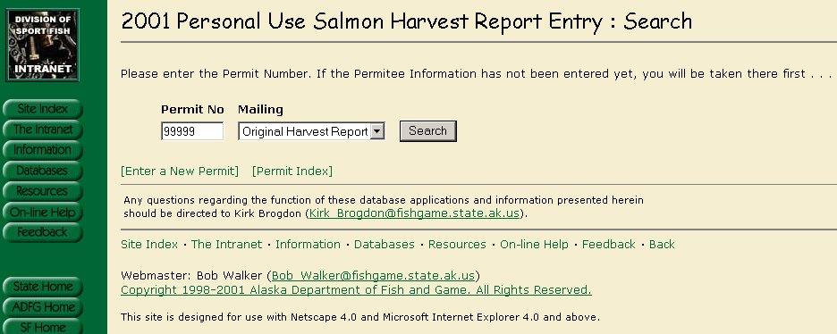
Enter the Permit Number and select the Mailing from the Drop Down list – The default is the original. You should see the following after clicking on Search:
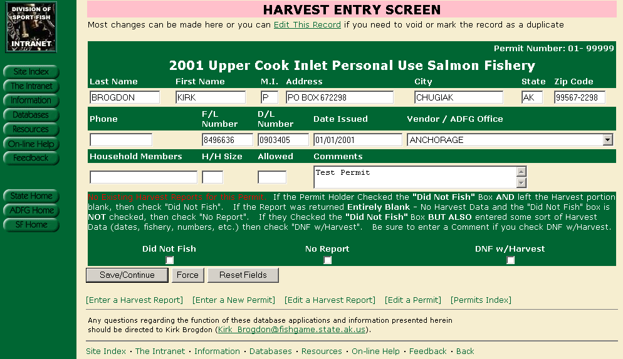

At this point, you have the opportunity to check the “Did Not Fish”, “No Report” (blank) or “DNF with Harvest” boxes – We often receive harvest reports with the “Did Not Fish” box checked but they also enter Harvest (or attempted harvest) information. From the Harvest Report, enter the Allowable harvest, Household size and Household members if available. You can edit any Permit Info shown if necessary, otherwise click on “Save/Continue”.

You should now be on the following screen:

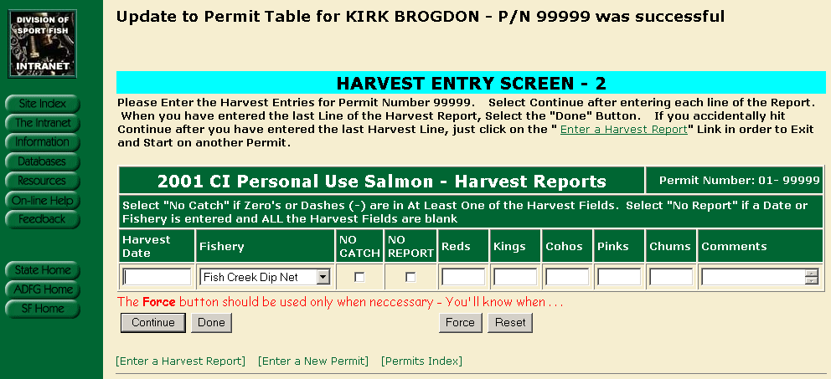

Enter the harvest date as shown on the form. If the date is blank, enter 01/01/1990. If the date shows just the month, enter that month followed by 01/1990. If they have zeros in one or more fields (and nothing else) then that is considered “No Catch” and you should check that box. If they have nothing at all other than a date or location, then that would be considered “No Report” and you should check that box. All of the fields coincide with the actual printed form that the Permit Holder has filled out. Flounders will be added to the data entry structure, prior to data entry in 2005. This screen is built so that you can enter one harvest record (line) at a time. Once you have entered the line, click on continue. Once you do, you should see the following:

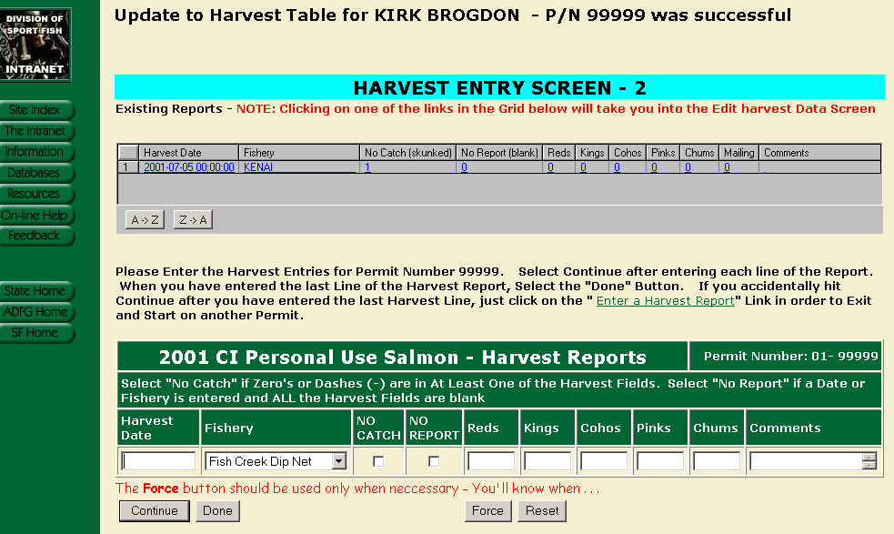

Note that the upper part of the screen shows the harvest entry that you just added (plus any other existing harvest entries for the permit). This upper part of the screen can actually take you into the harvest edit screen for the permit that you are currently working on (should you realize that you keyed a mistake). Otherwise, keep entering each line of the harvest report until you are on the last one. On the last entry, select “Done” rather than continue (if you click on continue after your last harvest entry, just click on the “Enter a Harvest Report” or one of the other links at the bottom of the page).

Miscellaneous Harvest Report Entry Notes

There are numerous data checks that are performed each time you select “Continue” or “Done” in an attempt to alleviate keying errors. Examples are:

- No harvest numbers entered but “No Catch” or “No Report” is not selected
- “No Catch” or “No Report” is selected but there is a value in one of the harvest fields.
- If any one line totals more than the allowed harvest value

Examples 1 and 2 cannot occur and must be changed. Example 3 could be an actual representation of what is reported and will be accepted if the user submits with the “Force” button. A detailed error message will be presented to the user explaining the problem and how to proceed.

Harvest Reports Returned Before Permit is Entered

It is possible that a permit holder will return their harvest report before an entry is made into the permit table. The following screen will appear if that happens:

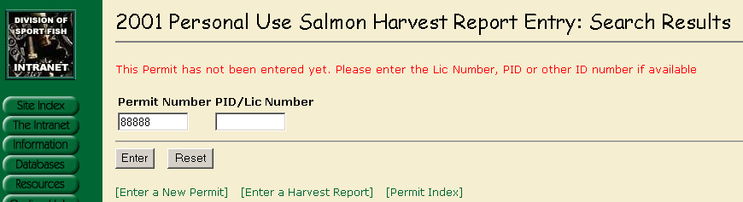

The permit can be entered as normal using the information on the front side of the harvest report. Once that is completed then the harvest report can be entered.

Harvest Report Editing
From the same screen that you select Harvest Report Entry, there is a link for Editing. When selected, you should see the following:
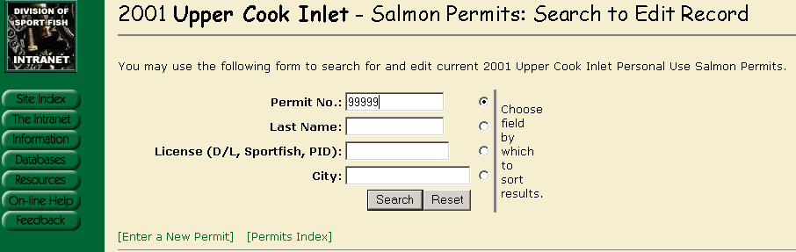
Entering the permit number will bring up the following:
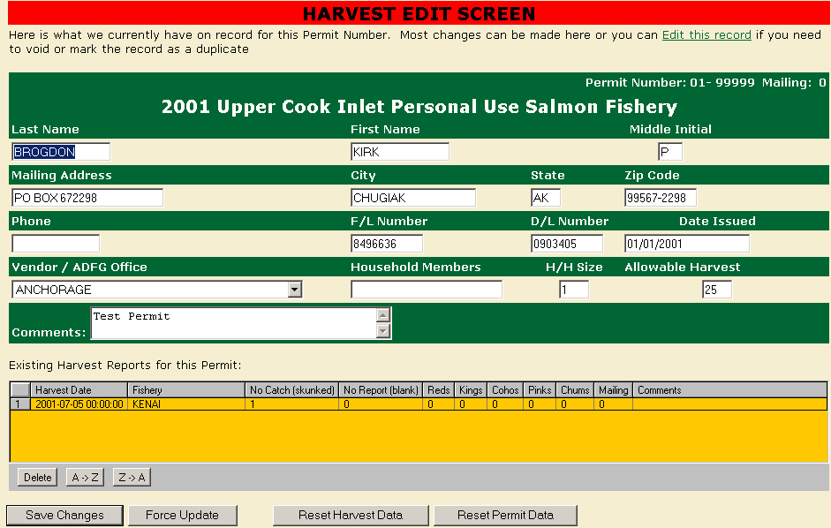
The harvest information can be edited or deleted directly from this screen. If the record needs to be voided, marked as a duplicate or changed to “Did not Fish” or “Blank Report” then the permit itself needs to be edited – not the harvest report. This can be done through the main menu or by using the link at the top of the page (Edit this record).
Note – If harvest data exists then the application will not allow the change to “Did Not Fish” or “Blank Report” until the Harvest Data is deleted.

Appendix E - File Structure for personal use salmon databases

Table and Field Information for Database I:\DP\CISALMXX\CISAL_SQL.DBC
Cook Inlet Personal Use Salmon Permit Process - Corrected and Final Data
02/12/2004 - kpbrogdon

Respondent Harvest Table:

Table: CISLHVXXC
Number of records:
Num Field Name Type Width Dec Nulls Default
1 HVRECID I 4 0 No
2 PERMITNO I 4 0 No
3 NOCATCH L 1 0 No
4 NOHRVRPT L 1 0 No
5 HARVDATE T 8 0 Yes
6 RED I 4 0 No
7 KING I 4 0 No
8 COHO I 4 0 No
9 PINK I 4 0 No
10 CHUM I 4 0 No
11 FISHERY C 20 0 No
12 KEYDATE T 8 0 No
13 KEYID C 16 0 No
14 YEAR I 4 0 No
15 MAILING I 4 0 No
16 EDITED L 1 0 No
17 COMMENTS C 20 0 Yes
-----
113

Additional Field Information For Corrected Harvest Table CISLHVXXC:

HVRECID
Comment: Unique Harvest Record ID as copied from the Raw Harvest
Table

PERMITNO
Comment: Permit Holders Permit Number.

NOCATCH
Comment: Flag indicating that an unsuccessful attempt was made on
this particular day.

NOHRVRPT
Comment: A date or fishery was indicated but all harvest fields are
blank - if zeros or dashes are shown, then this would be a
nocatch.

HARVDATE
Comment: Date that the actual Harvest or attempted harvest took
place.

RED
Comment: Total Red salmon harvested on this day

KING
Comment: Total King salmon harvested on this day

COHO
Comment: Total Coho salmon harvested on this day

PINK
Comment: Total Pink salmon harvested on this day

CHUM
Comment: Total Chum salmon harvested on this day

FISHERY
Comment: Valid Fishery - Choices are Kenai, Kasilof or Fish Creek.
All others are recorded as "Unknown"

KEYDATE
Comment: Date that the Harvest report was keyed by Data Entry

KEYID
Comment: Key ID of Data Entry clerk that enters the Harvest Report.

YEAR
Comment: Fishing Year that the Permit is valid for.

MAILING
Comment: Mailing value of the Harvest Report. This can be 0, 1 or 2.
If harvest data is received on different mailings with
identical Harvest

EDITED
Comment: Extraneous field. Not used

COMMENTS
Comment: Misc comments from Data Entry - Any comments enclosed in
[BRACKETS] are programatic changes made during the
conversion process.

Field Information for Corrected Permit Holder Information (XX Pertains to Year)

Respondent Permit Table (Vendor Copy)
Table: CISLPMXXC
Number of records:
Num Field Name Type Width Dec Nulls Default
1 PMRECID I 4 0 No
2 PERMITNO I 4 0 No
3 FIRST_NAME C 15 0 Yes
4 LAST_NAME C 15 0 Yes
5 INITIAL C 1 0 Yes
6 ADLNO C 10 0 Yes
7 LICENSE_NO C 7 0 Yes
8 ADDRESS C 30 0 Yes
9 CITY C 30 0 Yes
10 STATE C 2 0 Yes
11 ZIPCODE C 10 0 Yes
12 PHONE C 13 0 Yes
13 HHMEMBERS C 50 0 Yes
14 FAMILYSI I 4 0 Yes
15 ALLOWED I 4 0 Yes
16 BLANKRPT L 1 0 No
17 NOTFISH L 1 0 No
18 OFFICE C 20 0 Yes
19 DUPPREF I 4 0 Yes
20 KEYDATE T 8 0 Yes
21 KEYID C 15 0 Yes
22 DATEISS T 8 0 Yes
23 MAILING I 4 0 No
24 STATUS C 3 0 No
25 COMMENTS C 50 0 Yes
26 YEAR I 4 0 No
-----
321

Additional Field Information For Corrected Permit Holder Information CISLPMXXC:

PMRECID
Comment: Unique Record ID from the Raw Permit Table

PERMITNO
Comment: Unique Permit Number - Only Permits that responded are
included in the table

FIRST_NAME
Comment: Permit Holders First Name

LAST_NAME
Comment: Permit Holders Last Name

INITIAL
Comment: Permit Holders Middle Initial

ADLNO
Comment: Permit Holders Drivers License Number

LICENSE_NO
Comment: Permit Holders Fishing License Number

ADDRESS
Comment: Permit Holders Street Address

CITY
Comment: Permit Holders Resident City

STATE
Comment: Permit Holders Resident State

ZIPCODE
Comment: Permit Holders Resident Zipcode

PHONE
Comment: Permit Holders Resident Phone Number

HHMEMBERS
Comment: All additional Household Members that are eligible to fish
under this Permit

FAMILYSI
Comment: Permit Holders Total Family Size - This value can be
calculated if it is not filled in by the vendor providing
allowable Harvest and/or HHmembers exist. If not, Family
Size and Allowed are set to NULL

ALLOWED
Comment: Permit Holders Allowable Harvest - This value can be
calculated if it is not filled in by the vendor providing
Family Size and/or HHmembers exist. If not, Family Size and
Allowed are set to NULL

BLANKRPT
Comment: Flag indicating that a Harvest Report was received but was
completly blank. No harvest values and the "Did Not Fish"
box was not checked.

NOTFISH
Comment: Flag indicating that a Harvest Report was received and the
"Did Not Fish" box was checked.

OFFICE
Comment: Issuing ADFG Office or licensed Vendor

DUPPREF
Comment: Permit numbers that refer to this permit as the master

KEYDATE
Comment: Date that the Permit was originally keyed into the Raw data
table.

KEYID
Comment: Keyid of the original data entry clerk that entered the
permit into the raw data table.

DATEISS
Comment: Date that the Permit was issued by either an ADFG office or
a licensed vendor

MAILING
Comment: Mailing value that the Permit Holder responded to. Values
are "0" for the Original, "1" for the First , "2" for the
Second Reminder. Not necessarily the same as what was
physically turned in as an Original will often be sent in
after a reminder is recd.

STATUS
Comment: Harvest Report Status for the permit. "N" indicates Did Not
Fish, "U" indicates Unknown (Blank Harvest Report) and "H"
indicates actual Harvest data was received.

COMMENTS
Comment: Misc Comments. Any comments inside of [brackets] notate
programatic changes from the Raw data to the corrected ( ie:
family size and allowable harvest corrections)

YEAR
Comment: Harvest Year that the Permit reflects.

Non Respondent Permit Holder Information (Permits Issued but no Report Returned):

Table: CISLPMXXZ
Number of records: 14418
Num Field Name Type Width Dec Nulls Default
1 PMRECID I 4 0 No
2 PERMITNO I 4 0 No
3 FIRST_NAME C 15 0 Yes
4 LAST_NAME C 15 0 Yes
5 INITIAL C 1 0 Yes
6 ADLNO C 10 0 Yes
7 LICENSE_NO C 7 0 Yes
8 ADDRESS C 30 0 Yes
9 CITY C 30 0 Yes
10 STATE C 2 0 Yes
11 ZIPCODE C 10 0 Yes
12 PHONE C 13 0 Yes
13 HHMEMBERS C 50 0 Yes
14 FAMILYSI I 4 0 Yes
15 ALLOWED I 4 0 Yes
16 BLANKRPT L 1 0 No
17 NOTFISH L 1 0 No
18 OFFICE C 20 0 Yes
19 DUPPREF I 4 0 Yes
20 KEYDATE T 8 0 Yes
21 KEYID C 15 0 Yes
22 DATEISS T 8 0 Yes
23 MAILING I 4 0 No
24 STATUS C 3 0 No
25 COMMENTS C 50 0 Yes
26 YEAR I 4 0 No
-----
321

Field Information should be identical to CISHPMXXC with the
exception that all records are for Non Respondent Permit Holders.
There should be no Harvest Records, Did Not Fish or Blank Reports
for any permits in CISHPMXXZ. Status value is "Z" as opposed to
"H", "N" or "U".

