컴퓨터학부 20142468 허경영

1. 소스코드

#include <stdio.h>

#include <stdlib.h>

#include <unistd.h>

#include <sys/time.h>

#define SEC_TO_MICRO 1000000

int main(int argc, char* argv[]){

struct timeval begin_t, end_t;

int i;

gettimeofday(&begin_t, NULL);

if(argc < 2){

fprintf(stderr, "Usage: %s <file1> <file2> .. <fileN>\n",argv[0]);

exit(1);

}

for(i=1; i<argc; i++){ // argv 들에 access 할 수 있는지 확인

if(access(argv[i], F_OK) < 0){

fprintf(stderr, "%s doesn't exist\n",argv[i]);

continue;

}

if(access(argv[i], R_OK) == 0)

printf("User can read %s\n",argv[i]);

if(access(argv[i], W_OK) == 0)

printf("User can write %s\n",argv[i]);

if(access(argv[i], X_OK) == 0)

printf("User can execute %s\n",argv[i]);

}

gettimeofday(&end_t, NULL);

end_t.tv_sec -= begin_t.tv_sec;

if(end_t.tv_usec < begin_t.tv_usec){

end_t.tv_sec--;

end_t.tv_usec += SEC_TO_MICRO;

}

end_t.tv_usec -= begin_t.tv_usec;

printf("Runtime: %ld:%ld\n",end_t.tv_sec, end_t.tv_usec);

exit(0);

}

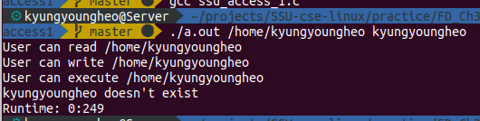2. 실행결과